City of London Corporation Air Quality Annual Status Report for 2024
Date of publication: May 2025
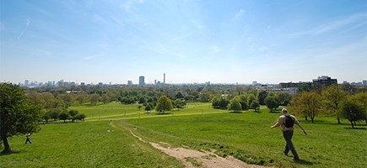
This report provides a detailed overview of air quality in the City of London during 2024. It has been produced to meet the requirements of the London Local Air Quality Management statutory process.
Contact details:
Paul Bentley, Air Quality Officer
Ruth Calderwood, Air Quality Manager
Email: cityair@cityoflondon.gov.uk

Contents
Abbreviations 5
1. Air Quality Monitoring 7
1.1 Locations 7
1.2 Comparison of Monitoring Results with AQOs 14
2. Action to Improve Air Quality 37
2.1 Air Quality Management Areas 37
2.2 Air Quality Action Plan Progress 39
3. Planning Update and Other New Sources of Emissions 63
* Statistics for planning applications decided upon in 2024 63
3.1 New or significantly changed industrial or other sources 63
4. Additional Activities to Improve Air Quality 64
4.1 The City of London Corporation Fleet 64
4.3 Pan-London NRMM Auditing Project 64
4.4 Air Quality Alerts 65
Appendix A Details of Monitoring Site Quality QA/QC 66
A.1 Automatic Monitoring Sites 66
A.2 Diffusion Tubes 66
A.3 Adjustments to the Ratified Monitoring Data 69
Appendix B Full Monthly Diffusion Tube Results for 2024 71
Appendix C Maps of Monitoring Locations and AQMAs 74

Tables
Table A. Summary of National Air Quality and International Standards, Objectives and Guidelines 6
Table B. Details of Automatic Monitoring Sites for 2024 7
Table C. Details of Non-Automatic Monitoring Sites for 2024: Long Term Sites 8
Table D. Details of Non-Automatic Monitoring Sites for 2024: Bank Area 9
Table E. Details of Non-Automatic Monitoring Sites for 2024: Transport Strategy Diffusion Tube Sites 10
Table F. Details of Non-Automatic Monitoring Sites for 2024: City Area 11
Table G. Details of Non-Automatic Monitoring Sites for 2024: St Martin’s Le Grand Regeneration Project 13
Table H. Annual Mean NO₂ Monitoring Results: Automatic Monitoring (µg m⁻³) 14
Table I. Annual Mean NO₂ Monitoring Results: Long Term Diffusion Tube Sites 16
Table J. Annual Mean NO₂ Monitoring Results: Bank Diffusion Tube Sites 16
Table K. Annual Mean NO₂ Monitoring Results: Transport Strategy Diffusion Tube Sites 18
Table L. Annual Mean NO₂ Monitoring Results: City Area Diffusion Tube Sites 19
Table M. Annual Mean NO₂ Monitoring Results: St Martin’s Le Grand Regeneration Project Diffusion Tubes 22
Table N. NO₂ Automatic Monitoring Results: Comparison with 1-hour Mean AQO, Number of 1-Hour Means > 200 μg m⁻³ 30
Table O. Annual Mean PM₁₀ Automatic Monitoring Results (μg m⁻³) 31
Table P. PM₁₀ Automatic Monitoring Results: Comparison with 24-Hour Mean AQO, Number of PM₁₀ 24-Hour Means > 50 μg m⁻³ 33
Table Q. Annual Mean PM_{2.5} Automatic Monitoring Results (μg m⁻³) 34
Table R. O₃ Automatic Monitoring Results 36
Table S. Declared Air Quality Management Areas 38
Table T. Delivery of Air Quality Action Plan Measures 39
Table U. Planning requirements met by planning applications in the City of London in 2024* 63
Table V. Local Bias Factor Results 67
Table W. Bias Adjustment Factor 68
Table X. Non-Automatic Monitoring Data Adjustment 70
Table Y. NO₂ 2024 Diffusion Tube Results (µg m⁻³) 71
Figures
Figure A. Annual Mean NO₂ Monitoring Results: Automatic Monitoring Sites 15
Figure B. Annual Mean NO₂ Monitoring Results: Long Term Diffusion Tubes 24
Figure C. Annual Mean NO₂ Monitoring Results: Bank Area Diffusion Tubes 25
Figure D. Annual Mean NO₂ Monitoring Results: Transport Strategy Diffusion Tubes 26
Figure E. Annual Mean NO₂ Monitoring Results: City Area Diffusion Tubes 1 27
Figure F. Annual Mean NO₂ Monitoring Results: City Area Diffusion Tubes 2 28
Figure G. Annual Mean NO₂ Monitoring Results: St Martin’s Le Grand Diffusion Tubes 29
Figure H. Annual Mean PM₁₀ Monitoring Results 32
Figure I. Annual Mean PM_{2.5} Monitoring Results 35
Figure J. Map of Non-Automatic Monitoring Sites 74
Figure K. Map of Automatic Monitoring Sites 75

Abbreviations
Abbreviation | Description
AMCT | Annual Mean Concentration Target
AQAP | Air Quality Action Plan
AQMA | Air Quality Management Area
AQN | Air Quality Neutral
AQO | Air Quality Objective
AQG | Air Quality Guideline
AQP | Air Quality Positive
BEB | Buildings Emission Benchmark
CAB | Cleaner Air Borough
DTDPT | Diffusion Tube Data Processing Tool
EA | Environment Agency
EV | Electric Vehicle
GLA | Greater London Authority
LAEI | London Atmospheric Emissions Inventory
LAQM | Local Air Quality Management
LLAQM | London Local Air Quality Management
NRMM | Non-Road Mobile Machinery
PLA | Port of London Authority
PM₁₀ | Particulate matter less than 10 micron in diameter
PM_{2.5} | Particulate matter less than 2.5 micron in diameter
SPD | Supplementary Planning Document
SPG | Supplementary Planning Guidance
TEB | Transport Emissions Benchmark
TfL | Transport for London
WHO | World Health Organisation

Table A. Summary of National Air Quality and International Standards, Objectives and Guidelines
Pollutant | Standard / Objective / Guideline | Averaging Period | Date⁽¹⁾
Nitrogen dioxide (NO₂) | 200 μg m⁻³ not to be exceeded more than 18 times a year | 1-hour mean | 31 Dec 2005
Nitrogen dioxide (NO₂) | 40 μg m⁻³ | Annual mean | 31 Dec 2005
Nitrogen dioxide (NO₂) | WHO AQG⁽²⁾: 10 μg m⁻³ | Annual mean
Particles (PM₁₀) | 50 μg m⁻³ not to be exceeded more than 35 times a year | 24-hour mean | 31 Dec 2004
Particles (PM₁₀) | WHO AQG⁽²⁾: 45 μg m⁻³ not to be exceeded more than 3-4 times a year | 24-hour mean
Particles (PM₁₀) | 40 μg m⁻³ | Annual mean | 31 Dec 2004
Particles (PM₁₀) | WHO AQG⁽²⁾: 15 μg m⁻³ | Annual mean
Particles (PM_{2.5}) | 10 μg m⁻³⁽³⁾ | Annual mean | 2040
Particles (PM_{2.5}) | London Mayoral Objective⁽⁴⁾: 10 μg m⁻³ | Annual mean | 2030
Particles (PM_{2.5}) | WHO AQG⁽²⁾: 5 μg m⁻³ | Annual mean
Particles (PM_{2.5}) | Target of 15% reduction in concentration at urban background locations | 3-year mean | Between 2010 and 2021
Particles (PM_{2.5}) | WHO AQG⁽²⁾: 15 μg m⁻³ | 24-hour mean
Sulphur dioxide (SO₂) | 266 μg m⁻³ not to be exceeded more than 35 times a year | 15-minute mean | 31 Dec 2005
Sulphur dioxide (SO₂) | 350 μg m⁻³ not to be exceeded more than 24 times a year | 1-hour mean | 31 Dec 2004
Sulphur dioxide (SO₂) | 125 μg m⁻³ mot to be exceeded more than 3 times a year | 24-hour mean | 31 Dec 2004
Sulphur dioxide (SO₂) | WHO AQG⁽²⁾: 40 μg m⁻³ not to be exceeded more than 3-4 times a year | 24-hour mean
Notes:
- Date by which to be achieved by and maintained thereafter
- 2021 World Health Organisation Air Quality Guidelines
- Environmental Target Regulations under the Environment Act 2021
- London Mayoral Objective

Air Quality Monitoring
1.1 Locations
Table B. Details of Automatic Monitoring Sites for 2024
Site ID | Site Name | Site Type | X OS Grid Ref (Easting) | Y OS Grid Ref (Northing) | Pollutants Monitored | In AQMA? | Monitoring Technique | Distance to Relevant Exposure (m) ⁽¹⁾ | Distance to kerb of nearest road (m) ⁽²⁾ | Inlet Height (m)
CT2 | Farringdon Street | Roadside | 531623 | 181238 | PM_{2.5} | Yes | BAM | N/A | 2.5m | 2m
CT3 | The Aldgate School | Urban Background | 533484 | 181190 | NO₂, PM₁₀ PM_{2.5} | Yes | Chemiluminescent and BAM | 0m | N/A | 1.5m
CT4 | Beech Street | Roadside | 532167 | 181857 | PM₁₀ | Yes | BAM | 10m | 3m | 3m
CT4 ⁽³⁾ | Beech Street | Roadside | 532176 | 181862 | NO₂ | Yes | Chemiluminescent | 0m | 1.5m | 2m
CT9 | Guildhall | Urban Background | 532471 | 181424 | O₃ | Yes | UV Absorption | N/A | N/A | 25m
CTA | Bell Wharf Lane | Roadside | 532495 | 180791 | NO₂, PM₁₀ | Yes | Chemiluminescent and BAM | 0m (NO₂)  N/A (PM₁₀) | 10.5m | 1.5m
Notes:
(1) 0m if the monitoring site is at a location of exposure (e.g. installed on the façade of a residential property).
(2) N/A if not applicable
(3) Listed as CT4a within the Automatic Data Entry System to allow differentiation between pollutants monitored at CT4.

Table C. Details of Non-Automatic Monitoring Sites for 2024: Long Term Sites
Diffusion Tube ID | Site Name | Site Type | X OS Grid Ref (Easting) | Y OS Grid Ref (Northing) | Pollutants Monitored | In AQMA? | Distance to Relevant Exposure (m) ⁽¹⁾ | Distance to kerb of nearest road (m) ⁽²⁾ | Tube Co-located with a Continuous Analyser? | Tube Height (m)
CL5 | St. Bartholomew’s Hospital Courtyard | Urban Background | 531901 | 181571 | NO₂ | Yes | 0m | N/A | No | 1.5m
CL38 | St. Andrew’s Church, Queen Victoria Street | Roadside | 531851 | 180962 | NO₂ | Yes | N/A | 2m | No | 2.75m
CL39 | St. Dunstan’s Church, Fleet Street | Roadside | 531235 | 181155 | NO₂ | Yes | N/A | 2m | No | 1.5m
CL40 | Guinness Trust Estate, Mansell Street | Roadside | 533794 | 181026 | NO₂ | Yes | 0m | 5.5m | No | 2m
CL55 | Speed House, Barbican Centre | Urban Background | 532482 | 181799 | NO₂ | Yes | 4.5m | N/A | No | 10m
Notes (applicable to Tables C-G):
(1) 0m if the monitoring site is at a location of exposure (e.g. installed on the façade of a residential property).
(2) N/A if not applicable.

Table D. Details of Non-Automatic Monitoring Sites for 2024: Bank Area
Diffusion Tube ID | Site Name | Site Type | X OS Grid Ref (Easting) | Y OS Grid Ref (Northing) | Pollutants Monitored | In AQMA? | Distance to Relevant Exposure (m) ⁽¹⁾ | Distance to kerb of nearest road (m) ⁽²⁾ | Tube Co-located with a Continuous Analyser? | Tube Height (m)
Bank 1 | Cannon Street | Kerbside | 532641 | 180914 | NO₂ | Yes | N/A | 0.3m | No | 2m
Bank 2a ⁽³⁾ | Queen Victoria Street | Kerbside | 532591 | 181073 | NO₂ | Yes | N/A | 1m | No | 2m
Bank 3 | King Street | Kerbside | 532465 | 181171 | NO₂ | Yes | N/A | 0.5m | No | 2m
Bank 5 | Magistrates Court | Roadside | 532647 | 181092 | NO₂ | Yes | 15m | 3.7m | No | 2m
Bank 6 | King William Street | Kerbside | 532791 | 180986 | NO₂ | Yes | N/A | 0.5m | No | 2m
Bank 8 | Lombard Street | Kerbside | 532853 | 181019 | NO₂ | Yes | N/A | 1m | No | 2m
Bank 11 | Cornhill-Royal Exchange | Kerbside | 532785 | 181119 | NO₂ | Yes | N/A | 0.5m | No | 2.2m
Bank 12 | Threadneedle Street | Kerbside | 532804 | 181164 | NO₂ | Yes | N/A | 0.7m | No | 2.2m
Bank 13 | 31 Old Broad Street | Kerbside | 533036 | 181376 | NO₂ | Yes | N/A | 1m | No | 2m
Bank 14 | Wormwood Street | Kerbside | 533077 | 181448 | NO₂ | Yes | N/A | 0.5m | No | 2m
Bank 15 | 3 London Wall | Kerbside | 532915 | 181513 | NO₂ | Yes | N/A | 0.5m | No | 2m
Bank 16 | 81 London Wall | Kerbside | 532670 | 181555 | NO₂ | Yes | 2m | 0.75m | No | 2m
Bank 17 | 55 Moorgate | Roadside | 532684 | 181442 | NO₂ | Yes | N/A | 2m | No | 2m
Bank 18 | 85 Gresham Street | Kerbside | 532503 | 181304 | NO₂ | Yes | N/A | 0.5m | No | 2m
Bank 19 | Lothbury | Roadside | 532705 | 181268 | NO₂ | Yes | N/A | 2.2m | No | 2m
Bank 20a ⁽⁴⁾ | Princes Street | Kerbside | 532682 | 181196 | NO₂ | Yes | N/A | 1m | No | 2.2m
Bank 22 | Gracechurch Street | Kerbside | 533010 | 181058 | NO₂ | Yes | N/A | 1m | No | 2m
Notes:
(3) Monitoring location Bank 2 moved to the opposite side of Queen Victoria Street at beginning of 2023 due to a lamppost being removed, renamed 2a.
(4) Monitoring location Bank 20 moved to the opposite side of Princes Street at beginning of 2024 due to a lamppost being removed, renamed 20a.
Table E. Details of Non-Automatic Monitoring Sites for 2024: Transport Strategy Diffusion Tube Sites
Diffusion Tube ID | Site Name | Site Type | X OS Grid Ref (Easting) | Y OS Grid Ref (Northing) | Pollutants Monitored | In AQMA? | Distance to Relevant Exposure (m) ⁽¹⁾ | Distance to kerb of nearest road (m) ⁽²⁾ | Tube Co-located with a Continuous Analyser? | Tube Height (m)
T2 | Byward Street | Roadside | 533294 | 180688 | NO₂ | Y | 6.5m | 3.5m | No | 2m
T3 | Seething Lane | Roadside | 533385 | 180722 | NO₂ | Y | N/A | 3.2m | No | 2m
T4 | Crosswall | Kerbside | 533513 | 180941 | NO₂ | Y | N/A | 1m | No | 2m
T5 | Minories | Kerbside | 533600 | 181165 | NO₂ | Y | N/A | 0.5m | No | 2m
T6 | Stoney Lane | Roadside | 533549 | 181345 | NO₂ | Y | 12m | 2.5m | No | 2m
T7 | Heneage Lane | Urban Centre | 533418 | 181257 | NO₂ | Y | N/A | 12m | No | 2m
T10 | St Mary Axe | Kerbside | 533239 | 181152 | NO₂ | Y | N/A | 1m | No | 2m
T13 | Blackfriars Bridge | Kerbside | 531644 | 180857 | NO₂ | Y | N/A | 0.5m | No | 2m
T14 | Victoria Embankment | Kerbside | 531197 | 180826 | NO₂ | Y | N/A | 0.5m | No | 2m
T15a ⁽⁵⁾ | Fleet Street | Kerbside | 531422 | 181160 | NO₂ | Y | N/A | 8m | No | 1.9m
T16 | Ludgate Hill | Kerbside | 531769 | 181167 | NO₂ | Y | N/A | 0.5m | No | 2m
T17 | Museum of London | Kerbside | 532251 | 181571 | NO₂ | Y | N/A | 0.5m | No | 2m
T18 | London Wall | Kerbside | 532240 | 181559 | NO₂ | Y | N/A | 0.5m | No | 2m
T20 | The Fable | Kerbside | 531592 | 181563 | NO₂ | Y | N/A | 0.5m | No | 2m
T21 | North Old Bailey | Kerbside | 531804 | 181395 | NO₂ | Y | N/A | 0.5m | No | 2m
T23 | The Gherkin | Roadside | 533263 | 181248 | NO₂ | Y | N/A | 2m | No | 2m
Notes:
(5) Monitoring location T15 moved further back from Fleet Street in 2024 due to a lamppost being removed, renamed T15a.

Table F. Details of Non-Automatic Monitoring Sites for 2024: City Area
Diffusion Tube ID | Site Name | Site Type | X OS Grid Ref (Easting) | Y OS Grid Ref (Northing) | Pollutants Monitored | In AQMA? | Distance to Relevant Exposure (m) ⁽¹⁾ | Distance to kerb of nearest road (m) ⁽²⁾ | Tube Co-located with a Continuous Analyser? | Tube Height (m)
TAS 1/2/3 | The Aldgate School NO_{x} Analyser | Urban Background | 533484 | 181190 | NO₂ | Yes | 0m | N/A | Yes | 1.5m
BWL 1/2/3 | Bell Wharf Lane NO_{x} Analyser | Roadside | 532495 | 180791 | NO₂ | Yes | N/A | 10.5m | Yes | 1.5m
WW | Walbrook Wharf | Roadside | 532540 | 180786 | NO₂ | Yes | N/A | 2.5m | No | 3m
PLA5 | Southwark Bridge | Urban Centre | 532412 | 180709 | NO₂ | Yes | N/A | N/A | No | 2m
LS | Liverpool Street | Urban Centre | 533147 | 181574 | NO₂ | Yes | N/A | 0.5m | No | 2m
FA | Fenchurch Avenue | Urban Centre | 533236 | 181040 | NO₂ | Yes | N/A | 1.1m | No | 2m
FL | Fetter Lane | Roadside | 531276 | 181261 | NO₂ | Yes | N/A | 1.5m | No | 2m
OS3 | St Pauls | Urban Centre | 532132 | 181108 | NO₂ | Yes | 15m | 35m | No | 2m
OS6 | Finsbury Circus | Roadside | 532939 | 181609 | NO₂ | Yes | N/A | 0.5m | No | 2m
OS7 | Christchurch Greyfriars Church Garden | Urban Background | 531974 | 181382 | NO₂ | Yes | N/A | 38m | No | 2m
GY | Goodmans Yard | Roadside | 533703 | 180913 | NO₂ | Yes | N/A | 6m | No | 2m
CT | Citigen | Roadside | 531634 | 181692 | NO₂ | Yes | N/A | 2m | No | 2m
N1 | Hatching Dragons | Urban Background | 532164 | 181641 | NO₂ | Yes | 0m | N/A | No | 2m
N2 | Bright Horizons | Urban Background | 532210 | 181975 | NO₂ | Yes | 0m | 1.5m | No | 2.1m
SPS2 | St Pauls School Front Railings | Roadside | 532175 | 181150 | NO₂ | Yes | 9m | 3.5m | No | 2m
CLS2 | Boys School Sports Access Ramp | Urban Background | 532051 | 180900 | NO₂ | Yes | 0m | 40m | No | 2m
CHS1 | Charterhouse Square School | Roadside | 531988 | 181881 | NO₂ | Yes | 0m | 3m | No | 2m
CSG | Cheapside Sunken Garden | Roadside | 532174 | 181214 | NO₂ | Yes | N/A | 10m | No | 2m
TC | Temple Church Courtyard | Urban Background | 531254 | 181044 | NO₂ | Yes | N/A | N/A | No | 2m
BG | Bishopsgate | Kerbside | 533295 | 181622 | NO₂ | Yes | N/A | 0.9m | No | 1.9m
MS | Middlesex Street | Kerbside | 533539 | 181488 | NO₂ | Yes | 7m | 0.5m | No | 2m
HC | Holborn Circus | Kerbside | 531413 | 181556 | NO₂ | Yes | N/A | 0.9m | No | 1.9m
PLA7 | Tower Millennium Pier | Urban Centre | 533384 | 180517 | NO₂ | Yes | N/A | N/A | No | 2.2m
BS1 | Aldersgate Street | Kerbside | 532105 | 181967 | NO₂ | Yes | 25m | 0.5m | No | 2m
BS18 | London Wall/ Moorgate | Kerbside | 532706 | 181571 | NO₂ | Yes | 16m | 1m | No | 2m
BS20 | Wood Street | Roadside | 532412 | 181685 | NO₂ | Yes | 15m | 2.2m | No | 2m
BS21 | Goswell Road | Kerbside | 532101 | 182074 | NO₂ | Yes | 2m | 0.5m | No | 2.1m
LEN 1 | Giltspur Street | Roadside | 531872 | 181621 | NO₂ | Yes | 10m | 5.5m | No | 2m
LEN 3 | Beech Street, Near Barbican Station | Roadside | 532117 | 181840 | NO₂ | Yes | 17m | 2.5m | No | 2m
LEN 4 | Aldersgate | Kerbside | 532117 | 181714 | NO₂ | Yes | N/A | 0.5m | No | 2m
LEN 6 | Whitecross Street/Beech Street | Roadside | 532443 | 181966 | NO₂ | Yes | N/A | 1.5m | No | 2m
LEN 9 | London Wall/ Brewers Hall Gardens | Kerbside | 532435 | 181558 | NO₂ | Yes | 11m | 0.5m | No | 2m
LEN 15 | Fann Street | Kerbside | 532144 | 182013 | NO₂ | Yes | 20m | 2m | No | 2m

Table G. Details of Non-Automatic Monitoring Sites for 2024: St Martin’s Le Grand Regeneration Project
Diffusion Tube ID | Site Name | Site Type | X OS Grid Ref (Easting) | Y OS Grid Ref (Northing) | Pollutants Monitored | In AQMA? | Distance to Relevant Exposure (m) ⁽¹⁾ | Distance to kerb of nearest road (m) ⁽²⁾ | Tube Co-located with a Continuous Analyser? | Tube Height (m)
SM1 | Wood Street | Kerbside | 532312 | 181270 | NO₂ | Yes | N/A | 0.5m | No | 1.95m
SM2 | Cheapside East | Kerbside | 532210 | 181217 | NO₂ | Yes | N/A | 0.9m | No | 2.1m
SM3 | Cheapside West | Kerbside | 532154 | 181260 | NO₂ | Yes | N/A | 0.5m | No | 2m
SM4 | Cheapside/ Newgate Street | Kerbside | 532095 | 181285 | NO₂ | Yes | N/A | 0.8m | No | 2m
SM5 | Newgate Street East | Kerbside | 531980 | 181331 | NO₂ | Yes | N/A | 0.6m | No | 2m
SM6 | Newgate Street West | Kerbside | 531898 | 181353 | NO₂ | Yes | N/A | 1m | No | 2m
SM7 | King Edward Street | Kerbside | 532025 | 181371 | NO₂ | Yes | N/A | 0.9m | No | 2m
SM8 | Postman's Park West | Roadside | 532041 | 181468 | NO₂ | Yes | 10m | 4.7m | No | 2m
SM9 | Little Britain | Kerbside | 532038 | 181534 | NO₂ | Yes | N/A | 0.7m | No | 1.9m
SM10 | Montague Street | Kerbside | 532082 | 181578 | NO₂ | Yes | N/A | 0.8m | No | 2.1m
SM11 | Postman's Park East | Kerbside | 532143 | 181492 | NO₂ | Yes | N/A | 0.5m | No | 2m
SM12 | St Martin's Le Grand North | Kerbside | 532138 | 181425 | NO₂ | Yes | N/A | 0.5m | No | 2m
SM13 | St Martin's Le Grand South | Kerbside | 532143 | 181371 | NO₂ | Yes | N/A | 0.7m | No | 2m
SM14 | St Martin's Le Grand/ Cheapside | Kerbside | 532137 | 181316 | NO₂ | Yes | N/A | 0.7m | No | 2m

1.2 Comparison of Monitoring Results with AQOs
Table H. Annual Mean NO₂ Monitoring Results: Automatic Monitoring (µg m⁻³)
Site ID | X OS Grid Ref (Easting) | Y OS Grid Ref (Northing) | Site Type | Valid data capture for monitoring period %^{(a)} | Valid data capture 2024 %^{(b)} | 2018 | 2019 | 2020 | 2021 | 2022 | 2023 | 2024
CT3 | 533484 | 181190 | Urban Background | 86.7 | 86.7 | 32 | 33 | 22 | 23 | 22.8 | 21.5 | 20.1
CT4 | 532176 | 181862 | Roadside | 99.6 | 99.6 | 69 | 62 | 29 | 31 | 40.6 | 36.1 | 36.5
CTA | 532495 | 180791 | Roadside | 99.7 | 99.7 | - | - | - | - | - | 31.6 | 30.0
Notes:
The annual mean concentrations are presented as μg m⁻³.
Exceedances of the NO₂ annual mean AQO of 40 μg m⁻³ are shown in bold.
NO₂ annual means in excess of 60 μg m⁻³, indicating a potential exceedance of the NO₂ hourly mean AQS objective are shown in bold and underlined.
All means have been “annualised” in accordance with LLAQM Technical Guidance if valid data capture for the calendar year is less than 75% and greater than 25%.
Concentrations are those at the location of monitoring and not those following any fall-off with distance adjustment.
(a) Data capture for the monitoring period, in cases where monitoring was only carried out for part of the year.
(b) Data capture for the full calendar year (e.g. if monitoring was carried out for six months the maximum data capture for the full calendar year would be 50%).

Figure A. Annual Mean NO₂ Monitoring Results: Automatic Monitoring Sites
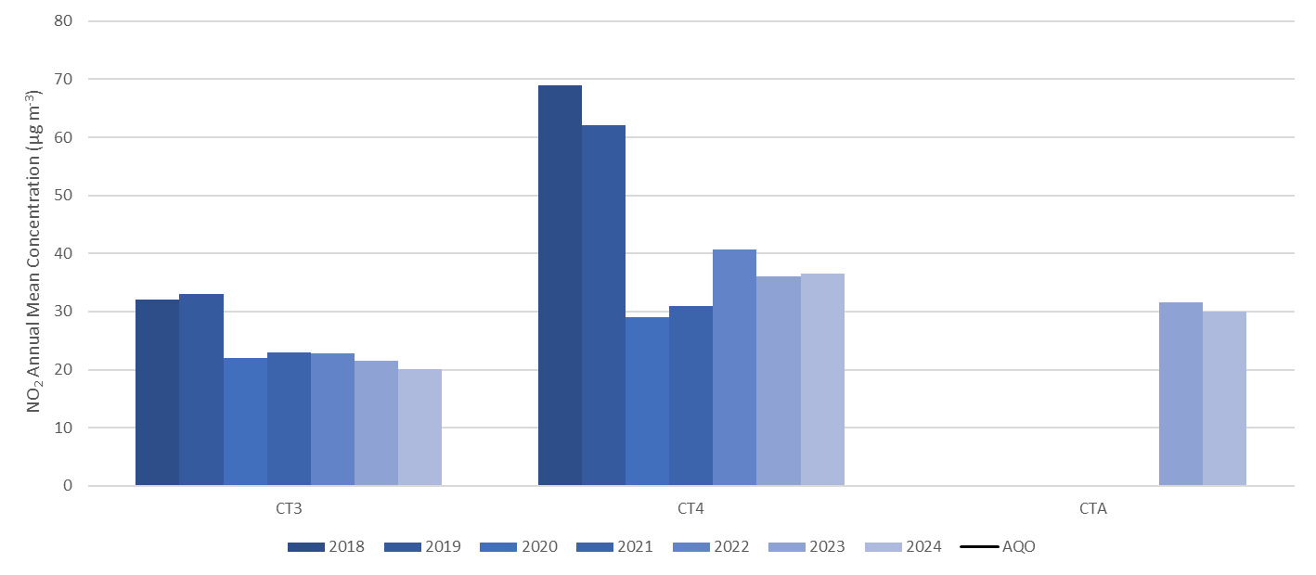
All three automatic monitoring stations were compliant with the annual mean AQO in 2023. Concentrations have remained consistent at CT3 for a five-year period, and the second year of monitoring at CTA shows consistency from 2023 to 2024. CT4 has recorded the highest annual mean concentration across the three sites in each of the past seven years. The 2023 and 2024 concentrations at CT4 were below the annual mean AQO, showing a slight reduction from the non-compliant year of 2022.

Table I. Annual Mean NO₂ Monitoring Results: Long Term Diffusion Tube Sites
Diffusion Tube ID | X OS Grid Ref (Easting) | Y OS Grid Ref (Northing) | Site Type | Valid Data Capture for Monitoring Period (%)(¹) | Valid Data Capture 2024 (%)(²) | 2018 | 2019 | 2020 | 2021 | 2022 | 2023 | 2024
CL5 | 531901 | 181571 | Urban Background | 100.0 | 100.0 | 50 | 42 | 33 | 31 | 32.2 | 33.9 | 28.1
CL38 | 531851 | 180962 | Roadside | 100.0 | 100.0 | 50 | 41 | 28 | 28 | 30.0 | 27.5 | 27.7
CL39 | 531235 | 181155 | Roadside | 100.0 | 100.0 | 70 | 57 | 31 | 36 | 37.4 | 38.4 | 38.7
CL40 | 533794 | 181026 | Roadside | 100.0 | 100.0 | 46 | 39 | 33 | 27 | 27.0 | 26.0 | 27.2
CL55 | 532482 | 181799 | Urban Background | 90.6 | 90.6 | 31 | 28 | 19 | 19 | 19.5 | 18.9 | 19.3
Table J. Annual Mean NO₂ Monitoring Results: Bank Diffusion Tube Sites
Diffusion Tube ID | X OS Grid Ref (Easting) | Y OS Grid Ref (Northing) | Site Type | Valid Data Capture for Monitoring Period (%)(¹) | Valid Data Capture 2024 (%)(²) | 2018 | 2019 | 2020 | 2021 | 2022 | 2023 | 2024
Bank 1 | 532641 | 180914 | Kerbside | 83.0 | 83.0 | 50 | 40 | 38 | 37 | 38.0 | 38.1 | 42.1
Bank 2a | 532591 | 181073 | Kerbside | 75.0 | 75.0 | - | - | - | - | - | 27.5 | 26.4
Bank 3 | 532465 | 181171 | Kerbside | 100.0 | 100.0 | 52 | 47 | 30 | 30 | 28.1 | 29.1 | 25.9
Bank 5 | 532647 | 181092 | Roadside | 100.0 | 100.0 | 53 | 56 | 36 | 32 | 33.4 | 28.6 | 26.0
Bank 6 | 532791 | 180986 | Kerbside | 75.0 | 75.0 | 61 | 61 | 42 | 35 | 36.2 | 32.8 | 30.0
Bank 8 | 532853 | 181019 | Kerbside | 92.5 | 92.5 | 56 | 45 | 30 | 28 | 28.1 | 26.8 | 25.3
Bank 11 | 532785 | 181119 | Kerbside | 100.0 | 100.0 | 62 | 41 | 26 | 27 | 28.7 | 26.1 | 26.4
Bank 12 | 532804 | 181164 | Kerbside | 32.1 | 32.1 | 62 | 42 | 31 | 28 | 28.7 | 25.9 | 22.6
Bank 13 | 533036 | 181376 | Kerbside | 75.0 | 75.0 | 53 | 45 | 28 | 26 | 26.8 | 25.4 | 25.8
Bank 14 | 533077 | 181448 | Kerbside | 92.5 | 92.5 | 57 | 49 | 32 | 32 | 35.5 | 31.6 | 29.4
Bank 15 | 532915 | 181513 | Kerbside | 58.5 | 58.5 | 65 | 53 | 33 | 38 | 37.1 | 37.7 | 30.6
Bank 16 | 532670 | 181555 | Kerbside | 81.1 | 81.1 | 62 | 53 | 36 | 41 | 39.9 | 37.0 | 31.8
Bank 17 | 532684 | 181442 | Roadside | 90.6 | 90.6 | 66 | 52 | 36 | 36 | 34.4 | 33.5 | 32.1
Bank 18 | 532503 | 181304 | Kerbside | 92.5 | 92.5 | 52 | 46 | 30 | 30 | 27.1 | 29.3 | 28.6
Bank 19 | 532705 | 181268 | Roadside | 83.0 | 83.0 | 45 | 39 | 24 | 24 | 23.5 | 25.8 | 22.4
Bank 20a | 532682 | 181196 | Kerbside | 90.6 | 90.6 | - | - | - | - | - | - | 30.6
Bank 22 | 533010 | 181058 | Kerbside | 34.0 | 34.0 | 62 | 51 | 33 | 36 | 41.8 | 34.4 | 41.1
Table K. Annual Mean NO₂ Monitoring Results: Transport Strategy Diffusion Tube Sites
Diffusion Tube ID | X OS Grid Ref (Easting) | Y OS Grid Ref (Northing) | Site Type | Valid Data Capture for Monitoring Period (%)(¹) | Valid Data Capture 2024 (%)(²) | 2018 | 2019 | 2020 | 2021 | 2022 | 2023 | 2024
T2 | 533294 | 180688 | Roadside | 100.0 | 100.0 | 67 | 51 | 33 | 40 | 38.3 | 36.8 | 34.9
T3 | 533385 | 180722 | Roadside | 49.1 | 49.1 | 71 | 57 | 41 | 46 | 45.1 | 46.1 | 39.5
T4 | 533513 | 180941 | Kerbside | 75.0 | 75.0 | 50 | 44 | 26 | 27 | 30.0 | 27.3 | 28.8
T5 | 533600 | 181165 | Kerbside | 100.0 | 100.0 | 62 | 49 | 36 | 37 | 39.5 | 37.6 | 38.1
T6 | 533549 | 181345 | Roadside | 84.9 | 84.9 | 40 | 39 | 25 | 25 | 27.4 | 23.8 | 26.4
T7 | 533418 | 181257 | Urban Centre | 83.0 | 83.0 | 42 | 33 | 25 | 25 | 26.0 | 24.1 | 23.6
T10 | 533239 | 181152 | Kerbside | 90.6 | 90.6 | 50 | 42 | 24 | 25 | 23.7 | 24.7 | 23.9
T13 | 531644 | 180857 | Kerbside | 100.0 | 100.0 | 62 | 56 | 41 | 38 | 37.3 | 38.1 | 36.2
T14 | 531197 | 180826 | Kerbside | 100.0 | 100.0 | 68 | 57 | 36 | 38 | 39.9 | 38.2 | 35.6
T15a | 531422 | 181160 | Kerbside | 58.5 | 58.5 | - | - | - | - | - | - | 33.3
T16 | 531769 | 181167 | Kerbside | 83.0 | 83.0 | 61 | 50 | 31 | 31 | 34.2 | 31.1 | 31.6
T17 | 532251 | 181571 | Kerbside | 92.5 | 92.5 | 66 | 55 | 36 | 35 | 36.7 | 38.1 | 35.7
T18 | 532240 | 181559 | Kerbside | 41.5 | 41.5 | 65 | 52 | 36 | 36 | 36.8 | 32.0 | 30.6
T20 | 531592 | 181563 | Kerbside | 100.0 | 100.0 | 58 | 51 | 35 | 30 | 35.7 | 32.8 | 30.8
T21 | 531804 | 181395 | Kerbside | 92.5 | 92.5 | 73 | 56 | 36 | 43 | 44.4 | 42.3 | 41.6
T23 | 533263 | 181248 | Roadside | 64.2 | 64.2 | - | - | - | 27 | 26.0 | 22.1 | 24.6
Table L. Annual Mean NO₂ Monitoring Results: City Area Diffusion Tube Sites
Diffusion Tube ID | X OS Grid Ref (Easting) | Y OS Grid Ref (Northing) | Site Type | Valid Data Capture for Monitoring Period (%)(¹) | Valid Data Capture 2024 (%)(²) | 2018 | 2019 | 2020 | 2021 | 2022 | 2023 | 2024
TAS 1/2/3 ⁽³⁾ | 533484 | 181190 | Urban Background | 100.0 | 100.0 | 39 | 33 | 22 | 24 | 22.9 | 22.5 | 24.0
BWL 1/2/3 ⁽³⁾ | 532495 | 180791 | Roadside | 100.0 | 100.0 |  |  |  |  |  | 29.8 | 29.7
WW ⁽⁴⁾ | 532540 | 180786 | Roadside | 92.5 | 92.5 | 77 | 64 | 41 | 44 | 49.8 | 48.9 | 46.2
PLA5 | 532412 | 180709 | Urban Centre | 83.0 | 83.0 | 41 | 35 | 29 | 31 | 33.9 | 31.4 | 29.4
LS | 533147 | 181574 | Urban Centre | 92.5 | 92.5 | 71 | 52 | 35 | 35 | 30.9 | 34.8 | 32.1
FA | 533236 | 181040 | Urban Centre | 83.0 | 83.0 | 36 | 35 | 26 | 25 | 24.4 | 20.6 | 22.7
FL | 531276 | 181261 | Roadside | 90.6 | 90.6 | 56 | 44 | 29 | 30 | 31.3 | 28.2 | 30.9
OS3 | 532132 | 181108 | Urban Centre | 66.0 | 66.0 | 41 | 39 | 24 | 24 | 26.3 | 25.9 | 27.7
OS6 | 532939 | 181609 | Roadside | 100.0 | 100.0 | - | - | - | 25 | 24.9 | 23.3 | 22.8
OS7 | 531974 | 181382 | Urban Background | 100.0 | 100.0 | - | - | - | 27 | 27.2 | 26.9 | 26.2
GY | 533703 | 180913 | Roadside | 75.0 | 75.0 | - | 44 | 25 | 28 | 28.3 | 27.7 | 28.2
CT | 531634 | 181692 | Roadside | 100.0 | 100.0 | - | - | 30 | 30 | 30.0 | 31.6 | 32.3
N1 | 532164 | 181641 | Urban Background | 100.0 | 100.0 | - | - | 22 | 22 | 22.8 | 23.1 | 21.6
N2 | 532210 | 181975 | Urban Background | 92.5 | 92.5 | - | - | 24 | 21 | 20.6 | 19.8 | 19.9
SPS2 | 532175 | 181150 | Roadside | 100.0 | 100.0 | - | 42 | 31 | 28 | 30.3 | 31.6 | 32.7
CLS2 | 532051 | 180900 | Urban Background | 100.0 | 100.0 | - | - | 21 | 23 | 24.0 | 21.4 | 21.0
CHS1 | 531988 | 181881 | Roadside | 100.0 | 100.0 | - | - | - | 25 | 24.7 | 23.4 | 22.4
CSG | 532174 | 181214 | Roadside | 0 | 0 | - | - | - | - | 27.4 | 28.7 | -
TC | 531254 | 181044 | Urban Background | 81.1 | 81.1 | - | - | - | - | 21.4 | 22.8 | 20.6
BG | 533295 | 181622 | Kerbside | 92.5 | 92.5 | - | - | - | - | - | - | 24.7
MS | 533539 | 181488 | Kerbside | 75.0 | 75.0 | - | - | - | - | - | - | 24.0
HC | 531413 | 181556 | Kerbside | 100.0 | 100.0 | - | - | - | - | - | - | 33.9
PLA7 | 533384 | 180517 | Urban Centre | 50.9 | 50.9 | - | - | - | - | - | - | 26.2
BS1 | 532105 | 181967 | Kerbside | 66.0 | 66.0 | - | 47 | 37 | 39 | 43.5 | 37.0 | 37.4
BS18 | 532706 | 181571 | Kerbside | 67.9 | 67.9 | - | 52 | 34 | 37 | 36.1 | 34.3 | 31.9
BS20 | 532412 | 181685 | Roadside | 92.5 | 92.5 | - | 29 | 23 | 24 | 20.7 | 22.0 | 20.2
BS21 | 532101 | 182074 | Kerbside | 100.0 | 100.0 | - | - | 31 | 36 | 34.7 | 34.2 | 33.8
LEN 1 | 531872 | 181621 | Roadside | 100.0 | 100.0 | 43 | 38 | 28 | 27 | 28.5 | 28.2 | 27.5
LEN 3 | 532117 | 181840 | Roadside | 83.0 | 83.0 | 62 | 50 | 33 | 30 | 36.7 | 36.8 | 34.7
LEN 4 | 532117 | 181714 | Kerbside | 92.5 | 92.5 | 57 | 47 | 41 | 35 | 43.0 | 35.3 | 33.8
LEN 6 | 532443 | 181966 | Roadside | 100.0 | 100.0 | 42 | 40 | 23 | 25 | 26.2 | 26.0 | 26.2
LEN 9 | 532435 | 181558 | Kerbside | 41.5 | 41.5 | 49 | 42 | 29 | 36 | 31.7 | 33.0 | 28.8
LEN 15 | 532144 | 182013 | Kerbside | 90.6 | 90.6 | 41 | 36 | 23 | 23 | 24.6 | 22.9 | 21.5
Table M. Annual Mean NO₂ Monitoring Results: St Martin’s Le Grand Regeneration Project Diffusion Tubes
Diffusion Tube ID | X OS Grid Ref (Easting) | Y OS Grid Ref (Northing) | Site Type | Valid Data Capture for Monitoring Period (%)(¹) | Valid Data Capture 2024 (%)(²) | 2018 | 2019 | 2020 | 2021 | 2022 | 2023 | 2024
SM1 | 532312 | 181270 | Kerbside | 100.0 | 100.0 | - | - | - | - | - | 24.0 | 24.9
SM2 | 532210 | 181217 | Kerbside | 90.6 | 90.6 | - | - | - | - | - | 32.7 | 32.5
SM3 | 532154 | 181260 | Kerbside | 90.6 | 90.6 | - | - | - | - | - | 34.4 | 31.3
SM4 | 532095 | 181285 | Kerbside | 84.9 | 84.9 | - | - | - | - | - | 38.3 | 36.9
SM5 | 531980 | 181331 | Kerbside | 75.0 | 75.0 | - | - | - | - | - | 40.2 | 35.9
SM6 | 531898 | 181353 | Kerbside | 92.5 | 92.5 | - | - | - | - | - | 34.1 | 32.2
SM7 | 532025 | 181371 | Kerbside | 100.0 | 100.0 | - | - | - | - | - | 37.0 | 32.7
SM8 | 532041 | 181468 | Roadside | 81.1 | 81.1 | - | - | - | - | - | 32.5 | 28.6
SM9 | 532038 | 181534 | Kerbside | 64.2 | 64.2 | - | - | - | - | - | 34.2 | 30.7
SM10 | 532082 | 181578 | Kerbside | 90.6 | 90.6 | - | - | - | - | - | 39.8 | 34.8
SM11 | 532143 | 181492 | Kerbside | 90.6 | 90.6 | - | - | - | - | - | 39.7 | 38.5
SM12 | 532138 | 181425 | Kerbside | 100.0 | 100.0 | - | - | - | - | - | 42.4 | 39.0
SM13 | 532143 | 181371 | Kerbside | 90.6 | 90.6 | - | - | - | - | - | 38.8 | 39.2
SM14 | 532137 | 181316 | Kerbside | 75.0 | 75.0 | - | - | - | - | - | 38.1 | 37.3
☒ Annualisation has been conducted where data capture is <75% and >25% in line with LLAQM.TG19.
☒ Diffusion tube data has been bias adjusted.
☒ Reported concentrations are those at the location of the monitoring site (bias adjusted and annualised, as required), i.e. prior to any fall-off with distance correction.
Notes:
The annual mean concentrations are presented as µg m⁻³.
Exceedances of the NO₂ annual mean objective of 40µg m⁻³ are shown in bold.
NO₂ annual means exceeding 60µg m⁻³, indicating a potential exceedance of the NO₂ 1-hour mean objective are shown in bold and underlined.
Means for diffusion tubes have been corrected for bias. All means have been “annualised” in accordance with LLAQM Technical Guidance if valid data capture for the calendar year is less than 75% and greater than 25%.
Concentrations are those at the location of monitoring and not those following any fall-off with distance adjustment.
(1) Data capture for the monitoring period, in cases where monitoring was only carried out for part of the year.
(2) Data capture for the full calendar year (e.g. if monitoring was carried out for 6 months, the maximum data capture for the full calendar year is 50%).
(3) TAS and BWL are sites of triplicate diffusion tubes co-located at CT3 and CTA. The results presented are an average of the triplicate tubes at each site.
(4) Prior to 2023 WW was a triplicate co-location site. Since February 2023 only a single tube has been exposed per monitoring period.
Figure B. Annual Mean NO₂ Monitoring Results: Long Term Diffusion Tubes
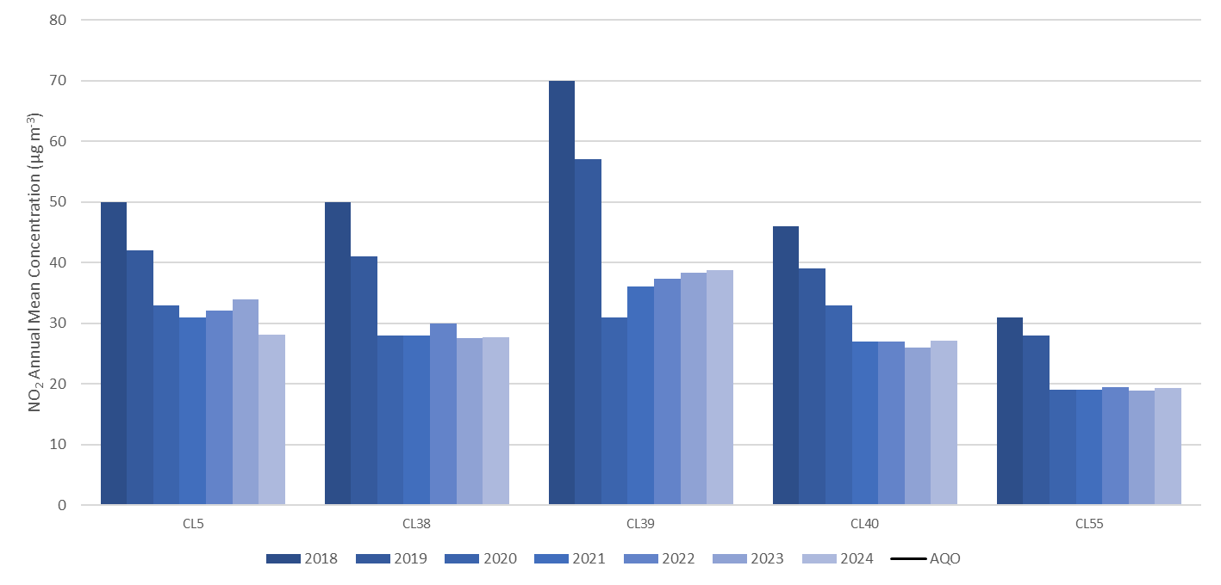
All long-term monitoring sites remain compliant with the annual mean AQO, with the last exceedances experienced in 2019.Whilst CL38, CL40 and CL55 have remained consistent for the past five years, CL5 experienced a reduction in 2024 and CL39 has experienced a gradual increase in annual mean concentrations since 2020.
Figure C. Annual Mean NO₂ Monitoring Results: Bank Area Diffusion Tubes
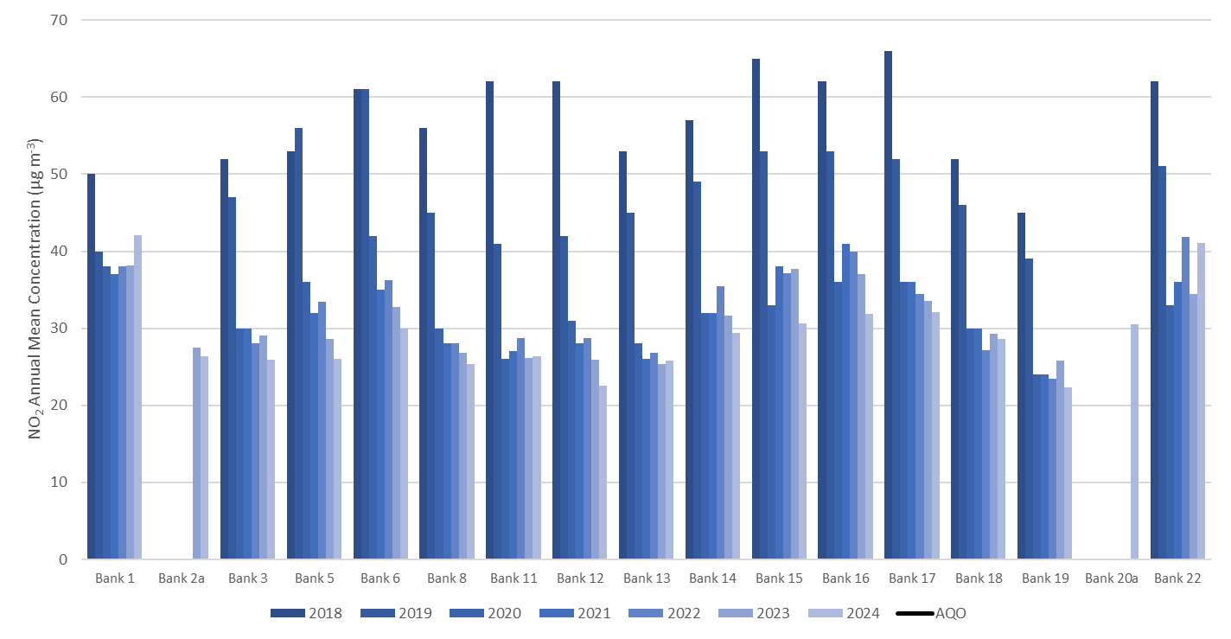
After all monitoring sites associated with the Bank Regeneration project achieved compliance with the annual mean AQO in 2023, two sites exceeded the AQO in 2024; Bank 1 and Bank 22. Both non-compliant sites have previously exceeded the annual mean AQO and are located on arterial routes that surround the Bank junction.
Figure D. Annual Mean NO₂ Monitoring Results: Transport Strategy Diffusion Tubes
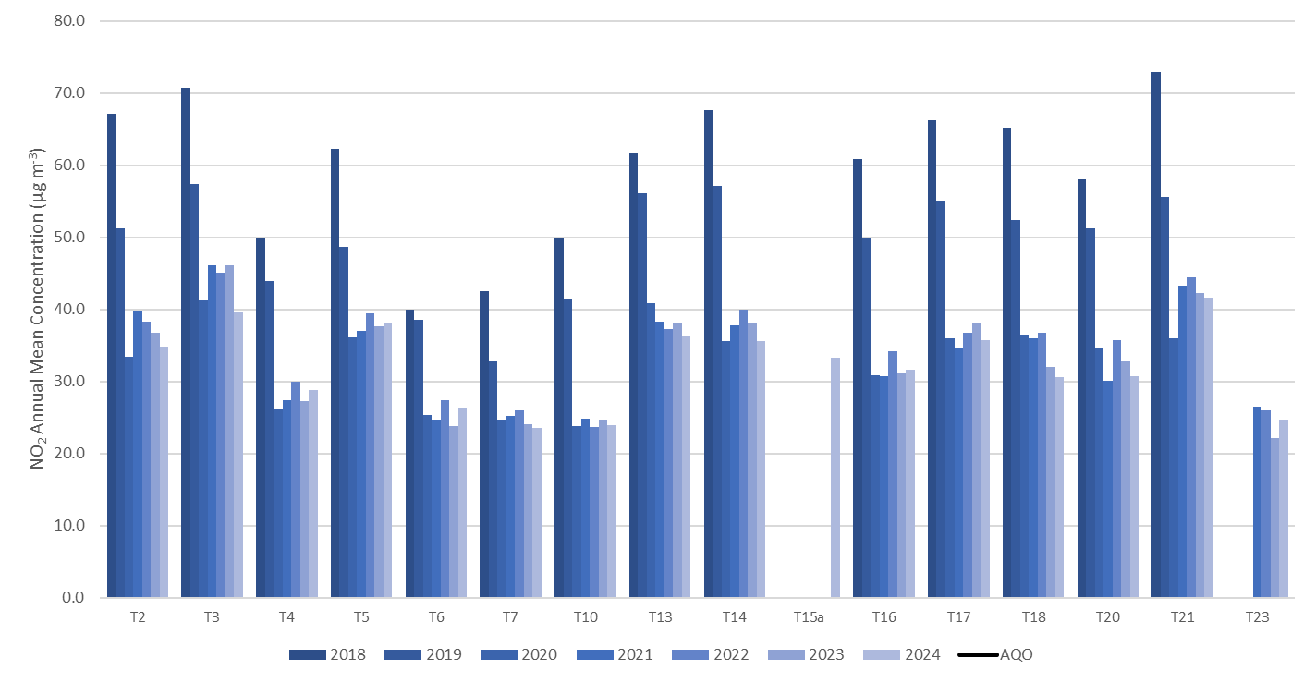
NO₂ diffusion tubes were deployed in 2018 to measure the impacts of the City of London Corporation 2019 Transport Strategy, now revised to 2024. All sites are roadside locations, and in 2024 all but one site complied with the annual mean AQO. T3 complied for the first time since its inception in 2024, albeit by 0.5 µg m⁻³.
Figure E. Annual Mean NO₂ Monitoring Results: City Area Diffusion Tubes 1
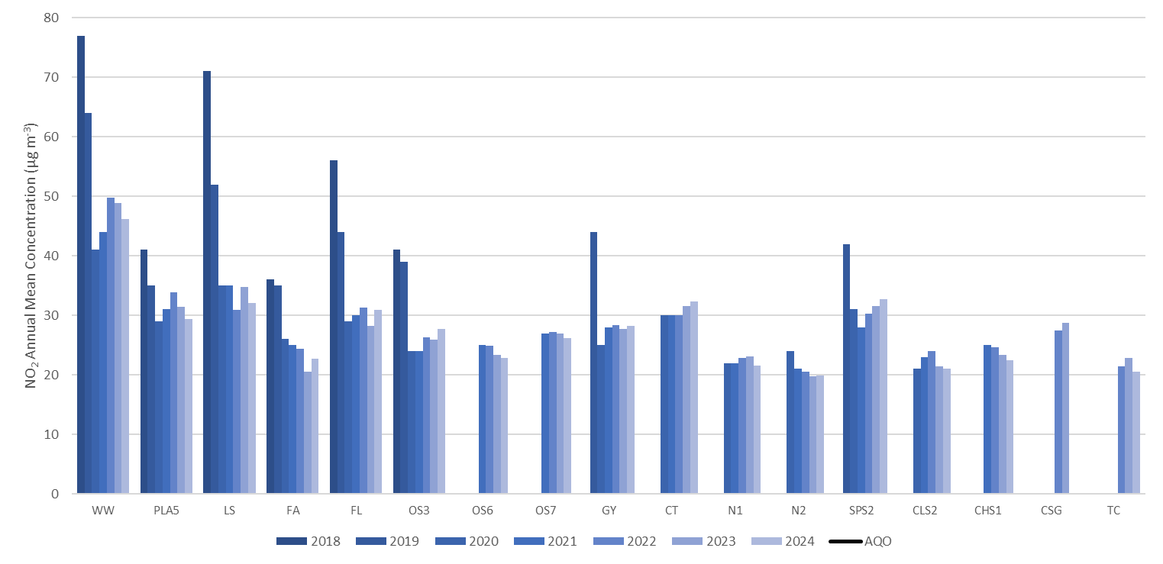

Figure F. Annual Mean NO₂ Monitoring Results: City Area Diffusion Tubes 2
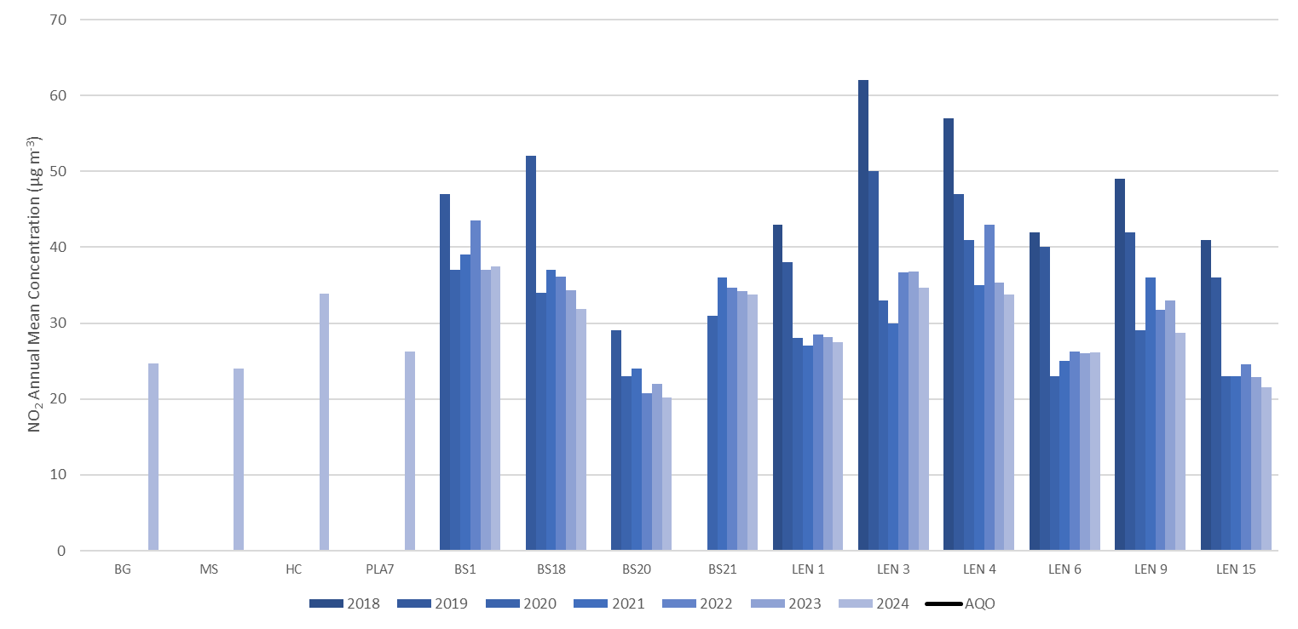
WW continues to record the highest NO₂ annual mean concentration within the Square Mile. 2024 was the lowest annual mean concentration recorded at the site, outside of Covid-19 impacted years of 2020 and 2021. However, at 46.2 µg m⁻³ it is still above the AQO. Four new monitoring locations were introduced in 2024, all of these complied with the annual mean AQO.
Figure G. Annual Mean NO₂ Monitoring Results: St Martin’s Le Grand Diffusion Tubes
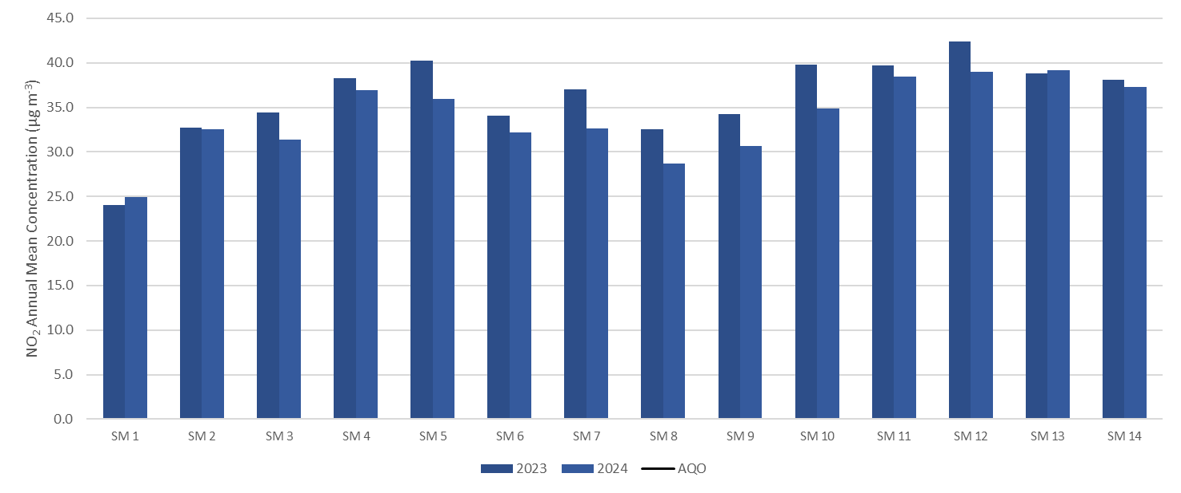
NO₂ diffusion tubes were deployed in 2023 at a number of locations close to St Martin’s Le Grand to provide baseline concentration data for a large redevelopment project. All sites are either kerbside or roadside locations. Two sites exceeded the annual mean AQO in 2023, and all sites were compliant in 2024. The scale of monitoring was reduced at the start of 2025, with redevelopment works commencing in April 2025.
Table N. NO₂ Automatic Monitoring Results: Comparison with 1-hour Mean AQO, Number of 1-Hour Means > 200 μg m⁻³
Site ID | X OS Grid Ref (Easting) | Y OS Grid Ref (Northing) | Site Type | Valid data capture for monitoring period %(ª) | Valid data capture 2024 %(^{b}) | 2018 | 2019 | 2020 | 2021 | 2022 | 2023 | 2024
CT3 | 533484 | 181190 | Urban Background | 86.7 | 86.7 | 0 | 0 | 0 | 0 | 0 | 0 | 0
CT4 | 532176 | 181862 | Roadside | 99.6 | 99.6 | 27 | 7 | 0 | 0 | 0 | 0 | 0
CTA | 532495 | 180791 | Roadside | 99.7 | 99.7 | - | - | - | - | - | 0 | 0
Notes
Results are presented as the number of 1-hour periods where concentrations greater than 200 μg m⁻³ have been recorded.
Exceedance of the NO₂ short term AQO of 200 μg m⁻³ over the permitted 18 hours per year are shown in bold.
If the period of valid data is less than 85%, the 99.8th percentile of 1-hour means is provided in brackets.
(a) Data capture for the monitoring period, in cases where monitoring was only carried out for part of the year
(b) Data capture for the full calendar year (e.g. if monitoring was carried out for six months the maximum data capture for the full calendar year would be 50%)
2024 was the fifth consecutive year where no hourly NO₂ concentrations greater than 200 µg m-³ were recorded within the Square Mile. In addition, the 1-hour AQO has been complied with for six consecutive years. Due to the increasing length of time that the 1-hour NO₂ AQO has been achieved, and in accordance with LLAQM guidance of AQMA revocation based upon at least three years of robust monitoring data, GLA guidance was sought with regards to the 1-hour NO₂ designation of the City of London AQMA. At the current time the GLA have advised for all AQMA designations to remain in place.

Table O. Annual Mean PM₁₀ Automatic Monitoring Results (μg m⁻³)
Site ID | X OS Grid Ref (Easting) | Y OS Grid Ref (Northing) | Site Type | Valid data capture for monitoring period %(ª) | Valid data capture 2024 %(^{b}) | 2018 | 2019 | 2020 | 2021 | 2022 | 2023 | 2024
CT3 | 533484 | 181190 | Urban Background | 89.7 | 89.7 | 21 | 19 | 16 | 16 | 16.8 | 14.9 | 16.0
CT4 | 532167 | 181857 | Roadside | 99.1 | 99.1 | 24 | 22 | 18 | 15 | 17.3 | 15.2 | 15.4
CTA | 532495 | 180791 | Roadside | 99.4 | 99.4 | - | - | - | - | 19.5 | 16.6 | 16.2
Notes
The annual mean concentrations are presented as μg m⁻³.
Exceedances of the PM₁₀ annual mean AQO of 40 μg m⁻³ are shown in bold.
All means have been “annualised” in accordance with LLAQM Technical Guidance, if valid data capture is less than 75% and more than 25%.
(a) Data capture for the monitoring period, in cases where monitoring was only carried out for part of the year.
(b) Data capture for the full calendar year (e.g. if monitoring was carried out for six months the maximum data capture for the full calendar year would be 50%).

Figure H. Annual Mean PM₁₀ Monitoring Results
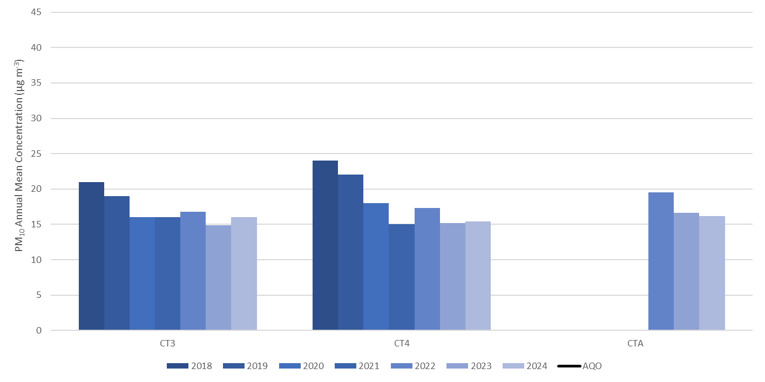
All PM₁₀ monitoring sites continue to comply with the annual mean AQO. Concentrations at all sites between 2023 and 2024 are very similar, with each site close to achieving the 2021 WHO annual mean AQG.

Table P. PM₁₀ Automatic Monitoring Results: Comparison with 24-Hour Mean AQO, Number of PM₁₀ 24-Hour Means > 50 μg m⁻³
Site ID | X OS Grid Ref (Easting) | Y OS Grid Ref (Northing) | Site Type | Valid data capture for monitoring period %^{(a)} | Valid data capture 2024 %^{(b)} | 2018 | 2019 | 2020 | 2021 | 2022 | 2023 | 2024
CT3 | 533484 | 181190 | Urban Background | 89.7 | 89.7 | 3 | 7 | 1 | 1 | 3  (25.7) | 0 | 0
CT4 | 532167 | 181857 | Roadside | 99.1 | 99.1 | 9 | 6 | 2 | 0 | 3 | 0 | 0
CTA | 532495 | 180791 | Roadside | 99.4 | 99.4 | - | - | - | - | 0 (27.8) | 5 | 0
Notes
Exceedances of the PM₁₀ 24-hour mean objective (50 μg m⁻³ over the permitted 35 days per year) are shown in bold.
Where the period of valid data is less than 85% of a full year, the 90.4th percentile is provided in brackets.
(a) data capture for the monitoring period, in cases where monitoring was only carried out for part of the year
(b) data capture for the full calendar year (e.g. if monitoring was carried out for six months the maximum data capture for the full calendar year would be 50%).
All PM₁₀ monitoring sites continue to comply with the 24-hour mean AQO. The AQO was last exceeded in 2016, and 2024 was the first year where no 24-hour periods with a concentration of >50 µg m⁻³ were recorded.

Table Q. Annual Mean PM_{2.5} Automatic Monitoring Results (μg m⁻³)
Site ID | X OS Grid Ref (Easting) | Y OS Grid Ref (Northing) | Site Type | Valid data capture for monitoring period %^{(a)} | Valid data capture 2024 %^{(b)} | 2018 | 2019 | 2020 | 2021 | 2022 | 2023 | 2024
CT2 | 531623 | 181238 | Roadside | 96.8 | 96.8 | 16 | 14 | 12 | 12 | 11.9 | 9.5 | 9.0
CT3 | 533484 | 181190 | Urban Background | 87.7 | 87.7 | 12 | 12 | 12 | 11 | 13.2 | 8.5 | 9.4
Notes
The annual mean concentrations are presented as μg m⁻³.
Exceedances of the PM_{2.5} annual mean concentration target (AMCT) of 10 μg m⁻³ (to be achieved by 2040, London Mayoral Objective to be achieved by 2030) are shown in bold.
All means have been “annualised” in accordance with LLAQM Technical Guidance, if valid data capture is less than 75% and more than 25%.
(a) Data capture for the monitoring period, in cases where monitoring was only carried out for part of the year.
(b) Data capture for the full calendar year (e.g. if monitoring was carried out for six months the maximum data capture for the full calendar year would be 50%).

Figure I. Annual Mean PM_{2.5} Monitoring Results
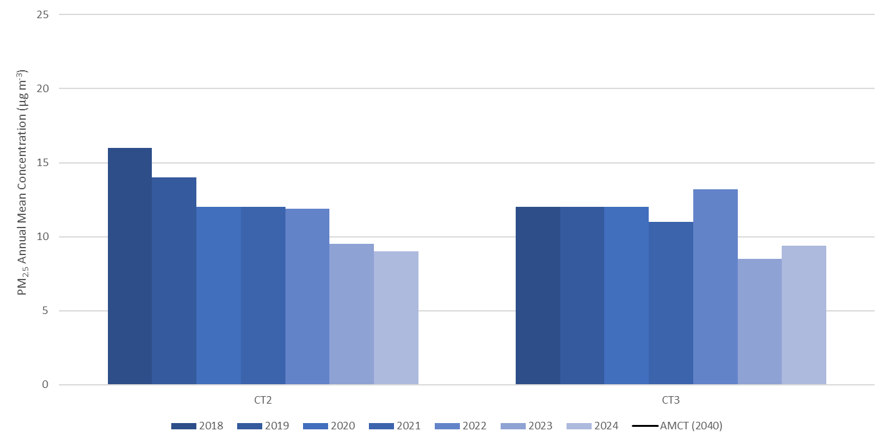
Both sites present an overall decline between 2018 and 2024. It should be noted that the 2022 annual mean for CT3 was annualised due to data capture being less than 75%. In refence to the AMCT and Mayoral Objective of 10 µg m⁻³, to be achieved by 2024 and 2030 respectively, both CT2 and CT3 were compliant in 2023 and 2024.

Table R. O₃ Automatic Monitoring Results
Site ID | X OS Grid Ref (Easting) | Y OS Grid Ref (Northing) | Site Type | Valid data capture for monitoring period %^{(a)} | Valid data capture 2024 %^{(b)} | 2018 | 2019 | 2020 | 2021 | 2022 | 2023 | 2024
CT9 | 532471 | 181424 | Urban Background | 99.1 | 99.1 | - | - | - | - | 54.1 | 54.4 | 53.4
Notes
The annual mean concentrations are presented as μg m⁻³.
(1) Data capture for the monitoring period, in cases where monitoring was only carried out for part of the year.
(2) Data capture for the full calendar year (e.g., if monitoring was carried out for six months the maximum data capture for the full calendar year would be 50%).
Although the monitoring and reporting of O₃ is not a requirement under LLAQM, the City Corporation procured and installed an O₃ analyser during 2022. The analyser is located within the Guildhall on the 6th floor and has been operational since the 26th of March 2022 with the aim to compare long term trends of O₃ within the Square Mile.

Action to Improve Air Quality
  - Air Quality Management Areas
An AQMA is declared when there is an exceedance or likely exceedance of an AQO. After declaration, the authority should prepare an AQAP within 12 months. The AQAP should specify how AQOs will be achieved and maintained and provide dates by which measures will be carried out.
A summary of AQMAs declared by the City Corporation is presented in Table S. Appendix C provides maps of the AQMA and the air quality monitoring locations. It should be noted that LLAQM guidance (Box 1.1 of LLAQM.TG (19)) details locations where AQOs apply, based on an AQO averaging time. The City Corporation is striving for AQO compliance at all monitoring locations regardless of short-term or long-term exposure.
At the time of writing, the AQMA is to remain with all three current designations for the following reasons:
- NO₂ annual mean: There continues to be a small number of monitoring locations within the Square Mile that report a concentration greater than the annual mean objective of 40 µg m⁻³.
- NO₂ 1-hour mean: Compliance with the 1-hour mean objective has been achieved since 2019. This designation was reviewed with the GLA in 2024. The Mayor of London has committed to meet the WHO’s latest guidelines for NO₂ and PM_{2.5} as soon as possible, therefore the GLA has advised against reducing or revoking any designated AQMAs.
- PM₁₀ 24-hour mean: As per LLAQM guidance, any AQMA for particulate matter should only be revoked following three years of continual compliance with the WHO AQG for PM_{2.5} (2005 guidance). As presented in Table Q, this has not yet been achieved.
Table S. Declared Air Quality Management Areas
AQMA Name | Date of Declaration | Pollutants and Air Quality Objectives | One Line Description | Is air quality in the AQMA influenced by roads controlled by Highways England? | Level of Exceedance: Declaration | Level of Exceedance: Current Year | Number of Years Compliant with Air Quality Objective | Name and Date of AQAP Publication | Web Link to AQAP
City of London AQMA | 26/01/2001 | NO₂ annual mean | The entire Square Mile is designated as an AQMA | N/A* | 118.0 µg m⁻³ | 46.2 µg m⁻³ | - | City of London Air Quality Strategy 2025-2030, January 2025 | City of London Corporation AQAP
City of London AQMA | 26/01/2001 | NO₂ 1-hour mean | The entire Square Mile is designated as an AQMA | N/A* | 597 1-hour periods > 200 µg m⁻³ | No exceedance | Six | City of London Air Quality Strategy 2025-2030, January 2025 | City of London Corporation AQAP
City of London AQMA | 26/01/2001 | PM₁₀ 24-hour mean | The entire Square Mile is designated as an AQMA | N/A* | 60 24-hour periods > 50 µg m⁻³ | No exceedance | Eight | City of London Air Quality Strategy 2025-2030, January 2025 | City of London Corporation AQAP
☒ The City of London Corporation confirm the information on UK-Air regarding their AQMA is up to date.
☒ The City of London Corporation confirm that all current AQAPs have been submitted to GLA.
* National Highways Strategic Road Network does not operate in central London. There are several Transport for London Road Network (TLRN) roads that pass through the Square Mile; A10, A201, A3211, A1210/11.

  - Air Quality Action Plan Progress
Table T provides a brief summary of the City Corporation’s progress against the AQAP, showing progress made against the measures in 2024. 2024 was the last year for which the 2019-2024 City of London Air Quality Strategy was relevant. During 2024, a new AQAP was developed, and the 2025-2030 City of London Air Quality Strategy was adopted in January 2025. Due to this the completion date of 2024 has been logged for the 2019-2024 City of London Air Quality Strategy measures, and the first update on the 2025-2030 City of London Air Quality Strategy will be completed in the Annual Status Report for 2025.
The three key measures detailed at the top of Table T are relevant to the new AQAP, showing key areas of focus for the City Corporation in 2025.
Table T. Delivery of Air Quality Action Plan Measures
Measure | LLAQM Action Matrix Theme | Action | Estimated / Actual Completion Date | Organisations Involved | Progress  - Emissions/Concentration data  - Benefits  - Negative impacts / Complaints
- | Monitoring and other core statutory duties | Adopt the updated City of London Corporation Air Quality Strategy 2025 - 2030 | 2025-2030 | City of London Corporation  Statutory Consultees | A revised Air Quality Action Plan was adopted in January 2025 outlining a five-year strategy to improve air quality within the Square Mile.
16 | Emissions from developments and buildings | Revise the City Corporation Supplementary Planning Guidance for Air Quality. | 2026 | City of London Corporation | A new Supplementary Planning Guidance document is to be developed in 2025 with the aim for adoption in-line with the City Plan 2040.
27 | Public health and awareness raising | Work with schools and nurseries in the Square Mile | 2025 | City of London Corporation  Schools within the Square Mile | Within 2025 the Travel for Life programme is to be encouraged at all schools within the Square Mile. Also, the Mayor of London’s School Filters programme will be implemented at relevant schools.
1 | Public health and awareness raising | Ensure that adequate and appropriate monitoring is undertaken across the City of London to fulfil statutory obligations  and make good quality data available to the public. | 2024 | City of London Corporation | Automatic monitoring is completed by two PM_{2.5}, three PM₁₀, one O₃ and three NO₂ continuous analysers. All sites are serviced and audited in line with national guidance. The data is ratified by Ricardo and made available to the public via the Air Quality England website.  During 2024 there were 85 LLAQM monitoring locations where NO₂ diffusion tubes were deployed.  CT2 is to be upgraded in 2025 with a new PM_{2.5} analyser replacing the existing BAM, and NO₂ and benzene analysers to be installed.
2 | Public health and awareness raising | Use air quality data to generate pollution alerts and messages using a range of media such as the free CityAir Smart Phone App. | 2024 | City of London Corporation  Mayor of London | The air quality monitoring data is used to provide current information on air quality through the City Corporation CityAir App. It is also used to support the AirTEXT service.
3 | Public health and awareness raising | Publish an annual report of air quality data on the City Corporation web site. | 2024 | City of London Corporation | The 2023 Annual Status Report is available on the City Corporation website.  The 2024 report will be made available on the web site following GLA approval.
4 | Public health and awareness raising | Continue to make live data from continuous air quality monitors available to the public on the London Air Quality Network web site. | 2024 | City of London Corporation | All automatic monitoring data is available to the public via the Air Quality England website.  This has moved from the London Air Quality Network website due to a contractual change.
5 | Public health and awareness raising | Support the testing of new air quality sensors to establish their degree of accuracy. | 2024 | City of London Corporation | During 2024 we supported the City of London Girls school to trial an air pollution sensor, running it alongside CT3 to assess its accuracy.
6 | Public health and awareness raising | Undertake an annual assessment of air quality to ensure levels of nitrogen dioxide in 90% of the Square Mile meet health-based Limit Values and WHO Guidelines by 2025. | 2024 | City of London Corporation | An area compliance assessment was undertaken for the year 2023, which was the latest year with a completed set of ratified data.  The area of the Square Mile to comply with the NO₂ AQO limit value and 2001 WHO AQG in 2023 was 94%, this is a significant increase from 2019 when it was 67%.
7 | Public health and awareness raising | Continue to place air quality as an important political priority and support the outcomes of the City Corporate Plan and local and London-wide action. | 2024 | City of London Corporation  Institute of Environmental Sciences | The City Corporation provides the chair for the Environmental Policy Implementation Community (EPIC) steering group.  The City Corporation chaired the annual EPIC conference which was attended by over 100 people.
8 | Emissions from developments and buildings | Provide information on reducing emissions from buildings for City Corporation facilities managers and investment property managers. | 2024 | City of London Corporation | A guidance document ‘Combustion plant: Recommendations for best practice’ is available on the City Corporation’s website.  The webinar that accompanied the combustion plant guidance for facility managers has been converted to an educational video, available to view on YouTube via a requested link.  Two case studies on standby generators in the Square Mile were undertaken in 2024 to understand their usage and emissions.
9 | Emissions from developments and buildings | Reduce emissions of air pollutants from buildings owned by the City Corporation. | 2024 | City of London Corporation | When compared to the 2023, electricity consumption in our buildings reduced by 3.8% and gas consumption increased by 2%. However, the long-term trend is very good as since the 2018/19 baseline, emissions of carbon from our own operations have reduced by 65%.
10 | Cleaner transport | Review the provision of electric vehicle charging across City Corporation sites including residential estates. | 2024 | City of London Corporation  City of Westminster  Royal Borough of Kensington and Chelsea | EV charging infrastructure plan recommendations still being delivered.  Progressing a partnership bid with City of Westminster and Royal Borough of Kensington and Chelsea to the Office for Zero Emission Vehicles to secure funding which will help to fund additional charge points.
11 | Borough fleet actions | Ensure that, subject to operational requirements, 100% of vehicles owned or leased by the City Corporation are electric or hybrid by 2025. | 2024 | City of London Corporation | The following vehicle purchasing hierarchy is implemented:  - fully electric  - plug in hybrid  - petrol hybrid  - Euro VI petrol  - Euro VI diesel.  We continue to reduce the size of our fleet whilst increasing the number of electric vehicles. We currently have 46 fully electric and hybrid vehicles.  The Fleet Operator Recognition Scheme (FORS) is a voluntary accreditation scheme designed to help fleet operators improve standards in their organisation. Bronze, Silver, or Gold accreditation is awarded to organisations based on a range of criteria including emissions and fuel efficiency. The City Corporation has been awarded the Gold FORS accreditation standard for over a decade.
12 | Borough fleet actions | Continue to trial low and zero emission technology. | 2024 | City of London Corporation | We continue to trial electric vehicles as they come onto the market. Following successful trials, refuse collection is undertaken using five all electric refuse collection vehicles.
13 | Delivery servicing and freight | Continue to encourage zero emission vehicles through the supply chain. | 2024 | City of London Corporation | A menu of options relating to air quality is included within the City Corporation Responsible Procurement Strategy:  - Set ambitious targets for the reduction of nitrogen oxides, PM₁₀ and PM_{2.5} emissions from vehicles over the life of the contract.  - Set an ambitious target for increasing the use of zero tailpipe emission vehicles over the life of the contract.  - Set a target for a reduction in the number of motorised vehicle trips that form part of the services.  - Develop a logistics approach that avoids vehicle movements during peak congestion and pedestrian footfall times, 07:00–10:00, 12:00–14:00, 16:00–19:00.  - Use technology that supports air quality improvement e.g., gear shift indictors, stop-start ignition, software to monitor green driving.  - Green driver training for Contractor Staff used on the Contract, offer safer urban driving courses to drivers.  - Other innovative action to support the Air Quality Strategy that the City Corporation would reasonably deem of an equivalent level of ambition.
14 | Borough fleet actions | Require electric or hybrid vehicles as a default for the Corporate taxi contract, together with annual emission reduction targets. | 2024 | City of London Corporation  Addison Lee | The City Corporation has a contract with Addison Lee which has a fleet of 1,000 fully electric taxis and has recently added 600 new, zero-emission capable (ZEC) multi-vans to replace the remaining diesel people carriers.
15 | Borough fleet actions | Require zero emission and electric or hybrid vehicles as a default for courier contracts, together with annual emission reduction targets. | 2024 | City of London Corporation | For deliveries within five miles of Guildhall and Barbican areas, the current Courier Contract requires the use of zero emission transport. The contract for national and international parcels requires the use of safe, low-emission and zero emission modes of transport wherever possible.
16 | Public health and awareness raising | Continue to ensure that all relevant Corporate strategies and policies reflect the importance of improving local air quality and reducing exposure. | 2024 | City of London Corporation | The air quality team works very closely other teams, so air quality is considered in decision making. This includes Planning, Transportation, Public Realm, Highways, Recycling and Waste, Open Spaces, Procurement, Remembrancers, Public Health, Climate Action, and Fleet Management.  The team is part of a Corporate Strategy Forum which has been set up to share best practice.  The Corporate Plan 2024 to 2029 includes a performance measure to assess progress towards WHO AQGs. This supports the outcome Leading Sustainable Environment.
17 | Public health and awareness raising | Work with London Councils and other stakeholders to develop proposals for legislation to help improve air quality across London. | 2024 | City of London Corporation  London Councils | The Emission Reduction (Local Authorities in London) Private Members Bill was introduced to the House of Lords by Lord Tope in October 2019, and again in January 2020.  The Bill fell when parliament was dissolved in May 2024. However, its contents are still used to press for new powers to assist London Boroughs with obligations under the Environment Act 2021.
18 | Public health and awareness raising | Continue to work closely with the Greater London Authority and Transport for London on policies to improve air quality and ensure that all actions support the aims and objectives of the Mayor’s Environment Strategy. | 2024 | City of London Corporation  GLA  TfL | We continue to be part of the Mayor of London NRMM enforcement project and provide information pertinent to the Beyond Construction Project.  We work with a range of London Boroughs on a Mayor of London funded pan London idling engine programme. We also provide support for a pan London project to gather data on mobile generators used in street works, filming, markets and events.
19 | Public health and awareness raising | Continue to collaborate with London Boroughs and London Councils on action to improve air quality. | 2024 | City of London Corporation  GLA  TfL  EA  PLA  UK Health Security Agency  London Boroughs | We hosted and chaired four virtual meetings of the London Air Quality Steering Group. These were attended by representatives from the GLA, EA, PLA, London Councils, UK Health Security Agency and Lead London Air Quality Cluster co-ordinators.  We also represent London local authorities on behalf of the Steering Group at the London Air Quality and Health Delivery Group.  We have attended, and chaired in turn, quarterly Central London Cluster group meetings throughout 2024.
20 | Public health and awareness raising | Support Universities with research into the health impacts of air pollution, to increase understanding of the sources of pollution and the effectiveness of interventions to reduce pollution. | 2024 | City of London Corporation  Air Pollution Research in London | We sit on the Air Pollution Research in London committee which identifies priority areas for research to improve air quality in London and other major cities, supports the development of new scientific research and communicates the latest research findings.  Research into the impact of urban form on air pollution is ongoing.
21 | Public health and awareness raising | Continue to support the Third Sector to deliver air quality improvement projects and raise awareness amongst London’s communities. | 2024 | City of London Corporation  Institute of Environmental Sciences | We supported the development of the Institution of Environmental Sciences UK Guidance for local authorities on Air Quality and Climate Change.
22 | Public health and awareness raising | Support the Port of London Air Quality Strategy through air quality monitoring and in taking wider action to reduce emissions from vessels on the river Thames. | 2024 | City of London Corporation  PLA | NO₂ monitoring took place adjacent to the river in 2024 to supplement monitoring undertaken by the PLA.  Meetings are held with the PLA to discuss options for joint working.
23 | Public health and awareness raising | Continue to support the Cross-River Partnership in its delivery of air quality projects in central London. | 2024 | City of London Corporation  Cross River Partnership | The City Corporation provides the co-chair for Cross River Partnership.
24 | Public health and awareness raising | Continue to support the Environment Agency with action to improve air quality, including the implementation of the Medium Combustion Plant Directive. | 2024 | City of London Corporation  GLA  EA  London Boroughs | We continue to collate data from a range of sources including planning applications to compile a list of combustion plant in the Square Mile which is used to inform research into the sources of NO_{x} and PM_{2.5} in the Square Mile.  We commissioned a case study to understand the operating regime and the applicability of MCP regulations to back-up generators used within the Square Mile.  We liaise with the EA on the potential risk of increased emissions due to the use of generators to provide electricity to the grid during power outages. We have supported the establishment of a roundtable of local authorities to engage with the EA on issues around Medium Combustion Plant and data centres. Three meetings were held in 2024.
25 | Public health and awareness raising | Continue to engage with and support the Business Community to become Air Quality Champions and reduce their impact on local air pollution. | 2024 | City of London Corporation | We assisted with the delivery and judging of the ‘Air Quality and Climate Change’ award for the Clean City Awards Scheme. Through this partnership we continued to share our air quality resources for businesses with a wider network.  We continue to support the City Business Alliances, working in partnership to improve information about the health impacts of air pollution and how businesses can help to improve local air quality.
26 | Cleaner transport | Support the Mayor of London with the effective implementation of the Ultra-Low Emission Zone. | 2024 | City of London Corporation  GLA  TfL | We are continuing to strive towards 100% ULEZ compliance, operating a ‘Transition to Zero Emission Fleet policy’, a decision-making hierarchy which applies to all purchased, leased, and hired vehicles operated by the City Corporation.
27 | Cleaner transport | Work with the taxi industry to reduce empty running of taxis within the Square Mile. | 2024 | City of London Corporation | No progress on measure.
28 | Cleaner transport | Urge Transport for London to prioritise Zero Emission Capable buses on routes through the City of London. | 2024 | City of London Corporation  GLA  TfL | There are 35 bus routes that pass through the Square Mile. Of these routes, over 97% operate a mix of hybrid and fully electric vehicles.
29 | Public health and awareness raising | Ensure that Healthy Street Plans have air quality improvement targets and that the air quality impact of major transport and public realm schemes are measured. | 2024 | City of London Corporation | All major road schemes are assessed for air quality impacts and air quality is factored in as a key objective to all Healthy Street Plans.  Wide scale air quality monitoring continues to be used to assess the impacts of street schemes including Bank on Safety/ All Change at Bank, the Pedestrian Priority Streets programme and the wider Transport Strategy.
30 | Localised solutions | Introduce Local Zero Emission Zones by 2022. | 2024 | City of London Corporation | Beech Street zero emission street was piloted from March 2020 to September 2021. Following consultation, the decision was made to discontinue with the scheme and instead incorporate traffic related air quality improvements into wider traffic management schemes in the area.
31 | Localised solutions | Implement a wide range of action through the City Corporation Transport Strategy to reduce the exposure of pedestrians to transport generated air pollution in the Square Mile. | 2024 | City of London Corporation | Continuing to increase km of pedestrian priority streets – currently have 28km with targets for 35km by 2030 and 55km by 2044.  Construction underway on pedestrian priority improvements to King William Street.  Widened pavements (650m² more space) and improved crossings at Threadneedle Street now complete.  Construction has started on St Paul’s Gyratory transformation.  Healthy Streets Plans have been produced for three areas, one in progress, and four more will be produced by 2027/28.  Continue to make improvements for walking and wheeling and new routes through Section 278 planning obligations, including on the riverside walkway and Barbican highwalk.  Conducting a review of the timings of existing pedestrian priority zones to ensure they are still working to prioritise people walking and wheeling.  Further information can be found in the Transport Strategy 2024/25 Annual Report and the 2025/26 – 2030/31 Transport Strategy Delivery Plan.
32 | Localised solutions | Pilot an ultra-low emission vehicle street. | 2024 | City of London Corporation | Beech Street zero emission street was piloted from March 2020 to September 2021. Following consultation, the decision was made to discontinue with the scheme and instead incorporate traffic related air quality improvements into wider traffic management schemes in the area.
33 | Localised solutions | Assess the suitability of rolling out LEN pilot projects at other locations across the Square Mile. | 2024 | City of London Corporation | The Low Emission Neighbourhood Legacy report was completed and effective measures that were identified have been incorporated into a range of operations.
34 | Delivery servicing and freight | Implement a wide range of action, through the City Local Plan and the City Corporation Transport Strategy, and Freight and Servicing SPD to reduce emissions from freight vehicles in the Square Mile. | 2024 | City of London Corporation  Business Improvement Districts  Zero Emissions Network  GLA  TfL | We are continuing to stipulate Delivery and Servicing Management Plans as part of S106 agreements for new developments and are working to increase the data collection and monitoring of this.  We are working with Business Improvement Districts to promote consolidation for freight deliveries to existing buildings.  Ideas for use of Minories car park and Walbrook Wharf have not progressed, but we continue to have discussions about potential locations for last mile delivery hubs.  We have joined the Zero Emissions Network, which aims to decarbonise local via a network of cargo bike share, cargo bike grants, and events that promote air quality improvements or active travel.
35 | Cleaner transport | Implement a range of actions through the City Corporation Transport Strategy and City Local Plan to support and encourage cycling. | 2024 | City of London Corporation | The Threadneedle Street cycle lane is now complete.  Installation of a northbound cycle lane between the junction with Lothbury/Gresham Street and Moorgate will be completed in 2025/26.  Junction improvements at Moorgate/Ropemaker Street and Moorgate/London wall are due to be completed by 2028/29.  Construction has begun on St Paul’s Gyratory transformation.  Micromobility parking programme will provide an estimated 1,400 new spaces for e-scooters and dockless cycles by 2026.  We continue to work with the City of London Police on road danger reduction campaigns and will work with TfL on their Highway Code campaigns.  We are helping to organise the 2025 London Cycling Festival and co-host the annual London Walking, Wheeling and Cycling Conference.
36 | Cleaner transport | Install additional publicly accessible electric vehicle (EV) rapid charge points by 2025. | 2024 | City of London Corporation | Up to five locations for new charging points will be put to market in 2025/26. Delivery of the locations will be dependent on the market take up.
37 | Cleaner transport | Through the City Local Plan require the installation of rapid charge points in new developments. | 2024 | City of London Corporation | We ensure that electric vehicle charging facilities are installed in accordance with our parking and servicing standards.
38 | Localised solutions | Ensure that improving air quality and reducing exposure is an integral part of all major transport and public realm schemes and that all schemes incorporate greening where possible. | 2024 | City of London Corporation | All major transport and public realm schemes are reviewed for air quality impacts and air quality monitoring and modelling is carried out were necessary.  Detailed monitoring has been undertaken to assess the impact of proposed changes to the road layout around St Martins Le Grand. Particulate monitoring was undertaken adjacent to a London underground vent shaft in the locality to assess the potential impact on users of the space from any particles coming from the tube network.
39 | Localised solutions | Continue to take a wide range of action to discourage unnecessary vehicle engine idling in the Square Mile. | 2024 | City of London Corporation | The City Corporation has the provision to issue Fixed Penalty Notices or Penalty Charge Notices for unnecessary vehicle engine idling.  Civil Enforcement Officers (CEOs) take enforcement action. The CEOs will ask a driver to turn their engine in the first instance. If the driver refuses, the CEO can issue a warning notice for a first offence to the driver. This approach is in line with guidance issued by the government. If the vehicle has been issued with a previous warning notice for the same contravention, then a Penalty Charge Notice (PCN) is issued. In 2024 three warning notices and one PCNs were issued.
40 | Cleaner transport | Ensure City Corporation parking charges favour low and zero emission vehicles in the City of London. | 2024 | City of London Corporation | Both on street and off-street vehicle parking charges now reflect vehicle emissions. Older, more polluting vehicles pay a higher charge to park with electric or hydrogen or hybrid paying the lowest tariff.
41 | Emissions from developments and buildings | Continue to assess all planning applications for air quality impact. | 2024 | City of London Corporation | All planning applications are reviewed for air quality impacts, with conditions recommended where necessary.  All major developments require an Air Quality Impact Assessment. This has been incorporated into the draft City Plan 2040 and will be included in a revised Air Quality SPD.  The pre app guidance for air quality is constantly reviewed and updated where required.
42 | Emissions from developments and buildings | Encourage the use of non-combustion technology during construction and in the operation of new developments. | 2024 | City of London Corporation | The emerging City Plan 2040 aligns with the commitment in the City Corporation’s Climate Action Strategy to support the achievement of net zero for the Square Mile by 2040. It reflects the London Plan in prioritising non combustion and zero emissions heating and energy systems.  Following the adoption of the City Plan 2040, an updated Air Quality SPD will be finalised.  All planning applications are reviewed by air quality officers and alternatives to diesel backup generators are required to be assessed.
43 | Emissions from developments and buildings | Apply stringent emission standards for combustion plant where non-combustion plant is not feasible in new developments. | 2024 | City of London Corporation | Due to sustainable planning requirements, the majority of planning applications for commercial developments received propose zero emissions heating solutions, most commonly heat pumps, instead of combustion plant.  If combustion plant is installed, conditions are applied requiring plant to meet specified NOx emissions standards.
44 | Emissions from developments and buildings | Ensure that where possible chimney stacks terminate above the height of the nearest building. | 2024 | City of London Corporation | The City Corporation Air Quality SPD requires a consideration of combustion flue location and emission discharge velocity at the planning stage to ensure appropriate provision has been made. We set conditions to require that chimneys are a minimum of 1m above building height.  We respond to applications for chimney height approval as they arise.
45 | Emissions from developments and buildings | Require all new developments to be air quality neutral as a minimum and developments subject to an Environmental Impact Assessment to be Air Quality Positive in line with the requirements of the emerging London Plan. | 2024 | City of London Corporation | All major developments must submit an AQN Assessment. All AQN Assessments are reviewed by an air quality officer to ensure the benchmarks are met, or relevant mitigation is provided.  We have updated our pre-application advice to include the requirement for AQP Assessments for Environmental Impact Assessment development. This has been included in the emerging City Plan 2040 and will be reflected in the Air Quality SPD update.
46 | Emissions from developments and buildings | Update the City Corporation Supplementary Planning Document for Air Quality to reflect new policies and requirements of the City Local Plan and London Plan. | 2024 | City of London Corporation | The City of London submitted the proposed submission draft City Plan 2040 to the Secretary of State in August 2024. Examination in Public Hearings are currently ongoing.  Once adopted, the new Plan will replace the Local Plan 2015.  A draft updated SPD is being produced in preparation for the adoption of the City Plan 2040.
47 | Emissions from developments and buildings | Ensure emissions from construction sites are minimised through close management and control. | 2024 | City of London Corporation  GLA | Construction sites are required to follow the City of London Code of Practice for Deconstruction and Construction Sites. We work with construction companies during the development of the proposals for construction practice proposals to minimise emissions and respond promptly to complaints.  Site audits of NRMM are undertaken through the pan London project, funded by the Mayor of London, and supplemented by the City Corporation. In 2024, 42 site audits were completed.  Our Code of Practice for Deconstruction and Construction Sites encourages sites to secure an electrical supply for sites well in advance of works. Membership of the NRMM Project ensures that where alternative fuels and power sources are not available, sites use the least-polluting diesel equipment possible.  Our guide to low emission and alternative technology and fuels is available on our webpages to support the uptake of lower emission NRMM for use during construction and street works, filming, and other events.
48 | Emissions from developments and buildings | Regularly update the City Corporation best practice guidance on minimising emissions from construction and demolition in order to reflect best practice. | 2024 | City of London Corporation | We continue to provide updated comments for the Air Quality Chapter of the Code of Practice for Deconstruction and Construction Sites.
49 | Emissions from developments and buildings | Enforce the Mayor of London NRMM requirements on construction sites as a minimum. | 2024 | City of London Corporation  GLA | We continue to be a member of the pan London NRMM project. Our sites are audited regularly for compliance with NRMM requirements by the project team and City Corporation officers. A range of sources are used to identify active demolition and construction sites, including planning and information from construction levy officers.  During 2024, 42 audits were undertaken. 73% were self-compliant with 27% compliant.
50 | Emissions from developments and buildings | Introduce a Stage V emission limit for NRMM on construction sites by 2025 where available. | 2024 | City of London Corporation | The proportion of NRMM over 37kW that is Stage V compliant continues to increase across the Square Mile. Generators have to be Stage V as Stage IV generators are not produced.  A Stage V restriction will be implemented London wide from 2030, prior to this, officers will continue to promote the use of Stage V NRMM across all construction sites within the Square Mile.
51 | Emissions from developments and buildings | Investigate options for reducing emissions from NRMM used in street works, filming, and other events. | 2024 | City of London Corporation | A City Corporation guide to low emission alternative technology and fuels is available on our webpages to support the uptake of lower emission NRMM for use during street works, filming, and other events.  We are supporting the London-wide project to document what NRMM is currently being used for licensed works such as film events, street works and waste transfer sites.  We obtain information on the number and size of generators including the number of Stage V generators used whilst filming in the Square Mile. The information is collated by the Sustainability /Generator app which is used by filming teams to log their current generator locations and usage.  We have previously included presentations at the Considerate Contractors Street Works Scheme workshops for utilities and contractors working in the Square Mile. The scheme rewards good practice through various awards.  In 2024 Vorboss Limited was awarded the Environment Award and nominated for the innovation award, winning with an energy efficient, low-emission, electrified splicing bike. The adapted electric cargo bike can move quickly around the Square. The vehicle reduces emissions and congestion in the streets.
52 | Emissions from developments and buildings | Examine options for reducing emissions from existing combustion plant in the Square Mile. | 2024 | City of London Corporation | An increase in Stage V generators in the Square Mile has been noted. Information is provided to construction sites during NRMM audits regarding additional options such as battery storage and hybrid systems to supplement the use of, and the reduce the dependency on diesel generators.  In addition to the pan-London NRMM guidance for construction sites, the city’s Low Emission NRMM Guide is available through the City Corporation website.
53 | Emissions from developments and buildings | Improve the understanding of the use of emergency generators in City of London buildings being used for Demand Side Response and Short-Term Operating Reserve. | 2024 | City of London Corporation | An independent assessment of generator use, and potential impact on emissions of pollutants was conducted in 2024, and the work will be further developed in 2025
54 | Emissions from developments and buildings | Continue to ensure that emissions from chimneys are dispersed as far as possible using the provisions of the Clean Air Act 1993. | 2024 | City of London Corporation | No applications were received in 2024.
55 | Emissions from developments and buildings | Ensure compliance with emission control requirements for the City Corporation’s prescribed processes. | 2024 | City of London Corporation | All permitted processes premises are inspected in line with their risk rating and the recommended inspection schedule. There is one dry cleaning operation and Barts energy centre is also permitted.  In 2024, an inspection was completed for one dry cleaner, which was scored as a low risk.
56 | Emissions from developments and buildings | Promote and enforce smoke control provisions detailed in the City of London Various Powers Act 1954 and 1973 and the Clean Air Act 1993. | 2024 | City of London Corporation | The City Corporation’s air quality webpages include information on the Domestic Solid Fuels Standards regulations in addition to the responsibilities required within a smoke control area.  We inspected all shops likely to sell manufactured solid fuels and wood to check that the correct labelling was displayed. All premises were compliant in 2024.  Our factsheet ‘Smoke Control from Food Premises’, which provides information on smoke provisions and advice to food premises on exempt appliances and authorised fuels, is also available on the City Corporation’s website and has been shared with restaurants cooking with solid fuels. Restaurants have been inspected to check that authorised fuels or exempt appliances are being used.
57 | Public health and awareness raising | Make greater use of Public Health Networks to disseminate information about air quality. | 2024 | City of London Corporation | We support the Mayor of London’s air pollution alerts to schools and GP practice, amplifying this message through alerts issued on X and Bluesky.  We have created a factsheet for health professionals summarising the health impacts of air pollution and providing tools and guidance for how to minimise exposure to air pollution. It is available to download from the City Corporation website.  A Defra Air Quality Grant funded project was completed in 2024. This was tailored to bolster the confidence of healthcare professionals in advising patients on how to minimise exposure to air pollution and where to find further information and guidance.  Following the completion of this project we continue to attend meetings with the wider Public Health Network and promote legacy work.
58 | Public health and awareness raising | Assess options to improve and further develop the free CityAir Smart Phone App and continue to support and promote the AirText service. | 2024 | City of London Corporation | We continue to support and promote AirTEXT.
59 | Public health and awareness raising | Disseminate information about air quality through various channels such as social media, the City Corporation web site, and an e-newsletter. | 2024 | City of London Corporation | We continue to promote air quality messaging through our X, Bluesky and Linkedin accounts, monthly e-newsletters, and our website pages.
60 | Public health and awareness raising | Develop an action plan, in support of the Mayor of London’s air pollution forecasting service, to reduce exposure on days of high and very high levels of air pollution. | 2024 | City of London Corporation | We support the dissemination of the Mayor of London air pollution forecasting system and take opportunities as they arise to raise the profile of air quality.
61 | Public health and awareness raising | Increase awareness of air pollution amongst the City of London residential community. | 2024 | City of London Corporation  London Boroughs of Hackney, Newham, Tower Hamlets  Defra | The City Corporation, in collaboration with the London Boroughs of Hackney, Newham, Tower Hamlets secured funding from the Defra Air Quality Grant scheme in 2021/2022.  The funding was awarded to deliver an awareness-raising project that aimed to disseminate information on air quality and methods of reducing exposure to pollution to help people better manage their health. One of the outcomes of the project was a brand-new web-based tool that helps users to better manage their health by providing information about air pollution and easy access to the latest monitoring data.  Touch screens were installed at Artizan Library and Barbican Library in March 2024 to allow residents to interact and explore the webtool and help increase awareness of air pollution in the residential community.  To mark the end of the project, a celebration event, showcasing the projects outcome was hosted in April 2024. 85 guests attended.  Over the course of 2024, the air quality team had a presence at 23 events presenting opportunities to engage directly with residents and supply information relating to air quality. The events ranged from air quality pop-ups with AQ sensors to cycle safety events and library sessions.
62 | Public health and awareness raising | Run events in support of National Clean Air Day. | 2024 | City of London Corporation | Pop-up events: 57 people attended.  Engaged with 90 school children during an assembly.  Over 60 pieces of air-aware merchandise promoting air-aware were given out.  Air quality stall hosted at school Summer Fayre.  Over 50 air quality resources were given out.  The air quality team networked with health care practitioners and promoted the online resources available for clinicians to enhance their knowledge on air quality.
63 | Public health and awareness raising | Develop plans for improving air quality and reducing the exposure to pollution of children who attend schools and nurseries in the City of London. | 2024 | City of London Corporation | Monitoring reports are produced annually for each school and nursery based on monitoring data from the sites or at nearby comparable locations. These reports are provided to the respective schools and nurseries.
64 | Public health and awareness raising | Continue to support Barts Health NHS and other health care facilities to reduce their own impact on local air pollution and assist vulnerable patients in reducing their exposure to pollution. | 2024 | City of London Corporation  London Boroughs of Hackney, Newham, Tower Hamlets  Defra | We obtained joint funding with the London Boroughs of Hackney, Tower Hamlets, and Newham to improve messaging around air quality for communities. The project focused on training healthcare professionals and creating patient resources, creating a community-based app, Air Quality Champions, and providing training to Health Practitioners on air pollution. This project completed in 2024.  As part of the wider project, the City of London Corporation led on a pilot project for pharmacists to have a face-to-face quality conversation with children and their families, around asthma care and the impacts of air pollution on their health, and what simple steps they can take to help reduce their exposure. By May 2025, 625 conversations had taken place.
65 | Public health and awareness raising | Continue to work with businesses to raise awareness of air pollution amongst workers. | 2024 | City of London Corporation | The City Corporation runs an annual Clean City Award Scheme for City businesses. The winner of the Air Quality and Climate Action Award for 2024 was the Leadenhall Building. This achievement reflects ongoing efforts to reduce emissions, improve air quality, and promote responsible practices throughout the building’s operations. Heart of the City continues to promote air quality resources for businesses and work continues with the City Business Improvement Districts.

Planning Update and Other New Sources of Emissions
Table U. Planning requirements met by planning applications in the City of London in 2024*
Condition | Number
Number of planning applications where an air quality impact assessment was reviewed for air quality impacts | 12
Number of planning applications required to undertake construction dust monitoring and reporting. | Nine new sites commenced that were required to monitor dust.  Data accessed via a number of sources; online tool, scheduled reports, excel raw data.
Number of CHPs/Biomass boilers refused on air quality grounds | 0
Number of CHPs/Biomass boilers subject to GLA emissions limits and/or other restrictions to reduce emissions as detailed in Air Quality Neutral LPG (london.gov.uk) point 3.1.5. | 0
Number of developments required to install Ultra-Low NO_{X} boilers | 1
Number of developments where an AQ Neutral building and/or transport assessments undertaken | 15
Number of developments where the AQ Neutral building and/or transport assessments not meeting the benchmark and so required to include additional mitigation | 0
Number of planning applications with S106 agreements including other requirements to improve air quality | 0
Number of planning applications with CIL payments that include a contribution to improve air quality | 0
NRMM: Central Activity Zone, Canary Wharf and Opportunity Areas  Number of planning applications decided upon in 2024 with conditions related to NRMM included.  Number of developments registered at www.nrmm.london.  Number of audits (based on the pan-London project report)  % of sites unregistered prior to audit  % of sites compliant with Stage IV of the Directive and/or exemptions to the policy. | 27 conditions included  42 registered, as of 07/04/25  42 audits  0% sites  100% sites
* Statistics for planning applications decided upon in 2024
3.1 New or significantly changed industrial or other sources
No new or significantly changed sources identified.

Additional Activities to Improve Air Quality
4.1 The City of London Corporation Fleet
The City Corporation has been reducing emissions from its own fleet for several years. This has been achieved by improved management, a reduction in size of the fleet and the purchase of newer, cleaner vehicles. The City Corporation owns or leases 111 vehicles / plant. The majority of these are not used in the Square Mile. At the time of writing, 46 of the vehicles are fully electric or hybrid.
Since January 2016, a policy has been in place that diesel vehicles cannot be purchased or leased if there are low or zero tailpipe emission options available. A fuel hierarchy is in place for new vehicles:
- Full electric.
- Plug-in hybrid.
- Petrol hybrid (regenerative braking).
- Petrol.
- Diesel Fleet (Euro VI) Operator Recognition Scheme Accreditation.
4.2 Planning Enforcement
All relevant planning applications are reviewed in terms of air quality. A weekly General Development Order is sent to the Air Quality Team. This is reviewed to identify those applications that require review. Officers ensure that all relevant developments are assessed, and conditions recommended, should the development be approved.
4.3 Pan-London NRMM Auditing Project
The City Corporation will continue to support the pan-London NRMM enforcement project in 2025. A standard condition is applied to a Decision Notice where NRMM is to be used for the demolition/deconstruction/construction of a proposed development to ensure that the requirements of the NRMM Low Emissions Zone are met. Officers review planning applications to identify when the NRMM condition should be applied. A precautionary approach is taken where it may not be known at the planning stage if NRMM is to be used, with the condition being set.
The condition is as follows:
Prior to the commencement of the development, the developer/ construction contractor shall sign up to the Non-Road Mobile Machinery Register. The development shall be carried out in accordance with the Mayor of London Control of Dust and Emissions during Construction and Demolition SPG July 2014 (Or any subsequent iterations) to ensure appropriate plant is used and that the emissions standards detailed in the SPG are met. An inventory of all NRMM used on site shall be maintained and provided to the Local Planning Authority upon request to demonstrate compliance with the regulations.
4.4 Air Quality Alerts
We continue to support airTEXT (https://www.airtext.info/). We also cascade the Mayor’s air quality alert messages and issue air quality alerts through our own smartphone App CityAir.
  - Air Quality Positive
There were four planning applications decided upon in 2024 that required an Environmental Impact Assessment. Three of these submitted an AQP assessment, the fourth was a Section 73 application that wasn’t related to an air quality condition.
Of the three AQP assessments, the Air Quality Positive Matrix was only completed fully for one application, the Innovation and Futureproofing section was not included for two applications. This is consistent with the majority of AQP assessments received by the City Corporation.
We are happy for the GLA to include any of the AQP assessments received as case studies for workshops and guidance documents. Please contact Paul Bentley to discuss this.

Appendix A Details of Monitoring Site Quality QA/QC
A.1 Automatic Monitoring Sites
In 2024, the City Corporation employed the services of a Data Management Unit, Ricardo, and an Equipment Support Unit, Matts Monitors, to ensure that data is accurate, and the analysers are maintained. Additionally, Officers at the City Corporation act as the Local Site Operator for all sites to carry out the routine tasks required for each type of analyser.
The tasks assigned to each team are as follows:
Data Management Unit | Equipment Support Unit
- Analysis of day-to-day data.  - Identification of analyser faults.  - Data ratification.  - Biannual site audits. | - Reactive site maintenance.  - Biannual site servicing.  - LSO training.
Local Site Operator
NO_{x} Analysers (API and Ecotech) | PM Analysers (BAM)
- Calibrations and filter changes; biweekly for CT4 and CTA, four-weekly for CT3.  - Provision of calibration gas. | - Cleaning the inlet head; collector assembly monthly, acceleration assembly and sharp cut cyclone quarterly.  - Tape changes every 60 days.  - Leak check on every LSO visit.  - Cleaning the nozzle and vane on every tape change and dictated by leak check results.
PM₁₀ Monitoring Adjustment
All BAM monitoring data has been corrected in line with guidance provided in LLAQM.TG (19). All PM data is corrected, where required, by Ricardo, and is currently accessible through the Air Quality England and Air Aware websites.
A.2 Diffusion Tubes
- The diffusion tubes utilised by the City Corporation in 2024 were supplied and analysed by Gradko International Laboratory.
- The preparation method used was 50% Triethanolamine in Acetone preparation method and analysis of diffusion tubes was completed using U.V. Spectrophotometry.
- Gradko International Ltd is a UKAS accredited laboratory and participates in the AIR-PT Scheme (a continuation of the Workplace Analysis Scheme for Proficiency) for NO₂ tube analysis and the Annual Field Inter-Comparison Exercise. These provide strict performance criteria for participating laboratories to meet, thereby ensuring NO₂ concentrations reported are of a high calibre. The lab follows the procedures set out in the Harmonisation Practical Guidance.
- Results of laboratory precision for 2024:
  - Gradko 50% TEA in acetone tube precision for 2024 returned 100% good precision, 11 studies.
  - Latest AIR NO₂ PT Scheme results: 75-100% for all 2014 results available at the time of writing (AR062/63).
- Bias adjustment factor from the National Bias Adjustment Spreadsheet available on the LAQM Support Website (Spreadsheet Version Number: 04/25); 0.88 based on 12 studies.
- Two local co-location studies were undertaken during 2024: one roadside at CTA and one urban background at CT3.
Factor from Local Co-location Studies
During 2024 two co-location studies were undertaken with triplicate diffusion tubes at the CT3 and CTA automatic monitoring sites. Local bias adjustment factors have been calculated for each site using the DTDPT provided by the LAQM Helpdesk.
The results of both studies have been submitted to the LAQM Helpdesk for inclusion within the National Diffusion Tube Bias Adjustment Factor Spreadsheet. The results presented below are based on ratified automatic monitoring data up to the 31st of December 2024, and provisional data thereafter.
Table V. Local Bias Factor Results
Site ID | Triplicate Diffusion Tube Mean (µg m⁻³) | Automatic Monitoring Mean (µg m⁻³) | Bias A | Bias B
CT3 | 26.2 | 20.3 | 0.77 | 29%
CTA | 33.7 | 30.3 | 0.9 | 12%
Following the procedure as detailed in LLAQM.TG (19) the average of the two local bias adjustment factors is 0.83.
Discussion of Choice of Factor to Use
The national bias adjustment factor has been used to adjust all 2024 diffusion tube annual mean concentrations. This is consistent with bias adjustment factors used within previous years. Due to the changing monitoring environment across the Square Mile, using a larger dataset (national) rather than the two local studies completed in 2024 provides a more robust structure for bias adjustment.
Table W. Bias Adjustment Factor
Year | Local or National | If National, Version of National Spreadsheet | Adjustment Factor
2024 | National | 04/25 | 0.88
2023 | National | 03/24 | 0.83
2022 | National | 03/23 | 0.82
2021 | National | 03/22 | 0.83
2020 | National | 03/21 | 0.82
2019 | National | 03/20 | 0.87
2018 | National | 03/19 | 0.92
2017 | National | 03/18 | 0.97

A.3 Adjustments to the Ratified Monitoring Data
Short-term to Long-term Data Adjustment
In accordance with LLAGM.TG (19) any relevant monitoring sites have been annualised. The DTDPT has been utilised to complete the required annualisation calculations. As per guidance provided by the LAQM Helpdesk, any diffusion tubes that had nine months of results, but <75% of data capture, have not been annualised.
For 2024 monitoring data there were 13 diffusion tube sites that required annualisation. This compares to 11 diffusion tube monitoring sites that required annualisation for 2023 monitoring data.
Distance Adjustment
Due to the simplistic nature of the NO₂ fall off with distance tool distance, distance adjustment has not been completed for any of the NO₂ monitoring locations. The Square Mile is a complex urban environment with a network of roads, multiple pollutant sources, and an ever-changing landscape of buildings. Limitation 7 within the tool states that the calculator can only be used where the influence of one road is present. Due to this, and the influence of buildings not considered within the calculations, the methodology is not relevant to the NO₂ monitoring completed within the Square Mile.

Table X. Non-Automatic Monitoring Data Adjustment
Site ID | Annualisation Factor:  London Bloomsbury | Annualisation Factor:  London Westminster | Annualisation Factor:  London North Kensington | Annualisation Factor:  CT3 | Average Annualisation Factor | Raw Data Annual Mean (µg m⁻³) | Annualised Annual Mean (µg m⁻³) | Comments
Bank 12 | 0.9138 | 0.9549 | 0.9293 | 0.9071 | 0.9263 | 27.7 | 25.7
Bank 15 | 0.9738 | 1.0194 | 0.9996 | 0.9666 | 0.9898 | 35.1 | 34.8
Bank 22 | 1.0901 | 1.0980 | 1.1459 | 1.1633 | 1.1243 | 41.5 | 46.7
OS3 | 1.0117 | 1.0105 | 1.0122 | 1.0012 | 1.0089 | 31.2 | 31.5
PLA7 | 0.8966 | 0.9279 | 0.9063 | 0.8974 | 0.9071 | 32.8 | 29.8
BS1 | 1.0657 | 1.1161 | 1.1065 | 1.0919 | 1.0951 | 38.9 | 42.5
BS18 | 1.0234 | 1.0218 | 1.0239 | 0.9949 | 1.0160 | 35.6 | 36.2
LEN 9 | 0.9414 | 0.9792 | 0.9636 | 0.9520 | 0.9591 | 34.1 | 32.7
T3 | 0.9314 | 0.9129 | 0.9212 | 0.9422 | 0.9269 | 48.4 | 44.9
T15a | 1.0510 | 1.0156 | 1.0285 | 1.0255 | 1.0302 | 36.7 | 37.9
T18 | 0.9414 | 0.9792 | 0.9636 | 0.9520 | 0.9591 | 36.3 | 34.8
T23 | 1.0418 | 1.0307 | 1.0653 | 1.0173 | 1.0388 | 27.0 | 28.0
SM9 | 0.9889 | 0.9720 | 0.9692 | 0.9561 | 0.9716 | 35.9 | 34.9

Appendix B Full Monthly Diffusion Tube Results for 2024
Table Y. NO₂ 2024 Diffusion Tube Results (µg m⁻³)
DT ID | X OS Grid Ref  (Easting) | Y OS Grid Ref (Northing) | Jan | Feb | Mar | Apr | May | June | Jul | Aug | Sept | Oct | Nov | Dec | Annual Mean:  Raw Data | Annual Mean: Annualised and Bias Adjusted  (0.88) | Annual Mean: Distance Corrected to Nearest Exposure | Comment
CL5 | 531901 | 181571 | 38.9 | 44.4 | 38.5 | 29.8 | 24.5 | 26.3 | 28.4 | 27.9 | 24.6 | 31.8 | 35.4 | 32.3 | 31.9 | 28.1 | -
CL38 | 531851 | 180962 | 36.9 | 31.2 | 29.4 | 29.2 | 34.5 | 27.5 | 28.5 | 28.0 | 34.9 | 34.4 | 36.1 | 26.6 | 31.4 | 27.7 | -
CL39 | 531235 | 181155 | 41.2 | 41.6 | 42.2 | 43.1 | 45.6 | 51.9 | 44.9 | 44.1 | 49.1 | 43.1 | 41.3 | 39.2 | 43.9 | 38.7 | -
CL40 | 533794 | 181026 | 37.9 | 33.8 | 29.8 | 23.8 | 30.6 | 29.8 | 29.1 | 28.4 | 29.1 | 29.6 | 34.5 | 34.0 | 30.9 | 27.2 | -
CL55 | 532482 | 181799 | 25.8 | 21.8 | 22.4 | 19.9 | 22.1 | 17.4 | 17.1 |  | 19.4 | 24.9 | 27.4 | 23.1 | 21.9 | 19.3 | -
Bank 1 | 532641 | 180914 | 47.0 | 43.4 | 47.7 | 36.7 | 53.4 | 44.2 | 58.8 | 46.5 | 55.4 |  |  | 45.4 | 47.9 | 42.1 | -
Bank 2a | 532591 | 181073 |  |  | 32.3 | 20.5 | 27.8 | 25.1 | 28.4 |  | 27.9 | 34.3 | 38.8 | 35.0 | 30.0 | 26.4 | -
Bank 3 | 532465 | 181171 | 37.1 | 28.5 | 25.3 | 21.4 | 28.9 | 26.1 | 28.1 | 26.1 | 30.9 | 32.3 | 40.6 | 28.0 | 29.4 | 25.9 | -
Bank 5 | 532647 | 181092 | 32.7 | 33.3 | 26.0 | 23.2 | 28.9 | 28.5 | 25.5 | 27.5 | 30.4 | 32.5 | 37.7 | 28.2 | 29.5 | 26.0 | -
Bank 6 | 532791 | 180986 | 40.3 | 35.1 | 36.1 | 32.2 | 36.7 | 29.0 | 29.3 |  | 29.9 | 37.9 |  |  | 34.1 | 30.0 | -
Bank 8 | 532853 | 181019 | 34.2 | 32.6 | 30.7 | 21.4 | 29.5 |  | 26.0 | 24.3 | 19.6 | 32.3 | 37.7 | 28.3 | 28.8 | 25.3 | -
Bank 11 | 532785 | 181119 | 34.7 | 32.2 | 28.8 | 25.1 | 28.6 | 19.3 | 29.3 | 29.9 | 31.5 | 33.0 | 34.6 | 32.5 | 30.0 | 26.4 | -
Bank 12 | 532804 | 181164 | 33.0 | 29.1 | 25.4 | 23.2 |  |  |  |  |  |  |  |  | 27.7 | 22.6 | -
Bank 13 | 533036 | 181376 | 30.4 |  | 28.1 | 26.1 | 30.5 |  | 28.6 | 22.6 |  | 34.1 | 37.9 | 25.5 | 29.3 | 25.8 | -
Bank 14 | 533077 | 181448 | 35.5 | 37.2 | 34.4 | 31.3 | 36.1 | 30.2 |  | 28.8 | 31.6 | 39.2 | 36.0 | 27.3 | 33.4 | 29.4 | -
Bank 15 | 532915 | 181513 | 32.1 | 40.3 | 36.9 | 36.2 | 40.5 | 25.1 |  |  |  |  |  | 34.8 | 35.1 | 30.6 | -
Bank 16 | 532670 | 181555 | 43.7 |  | 36.1 | 41.3 |  | 39.4 | 25.9 | 22.0 | 34.0 | 33.3 | 47.8 | 38.4 | 36.2 | 31.8 | -
Bank 17 | 532684 | 181442 | 45.6 | 39.3 | 34.2 | 31.5 | 29.1 | 31.7 | 40.8 | 33.9 | 38.6 | 36.2 | 40.2 |  | 36.5 | 32.1 | -
Bank 18 | 532503 | 181304 | 35.9 | 35.2 | 30.2 | 28.9 | 31.5 | 28.4 |  | 29.9 | 35.4 | 36.1 | 35.8 | 29.9 | 32.5 | 28.6 | -
Bank 19 | 532705 | 181268 | 30.9 | 24.9 | 25.5 | 21.6 | 26.1 | 21.3 | 25.9 |  | 27.1 | 26.6 |  | 24.4 | 25.4 | 22.4 | -
Bank 20a | 532682 | 181196 | 42.1 |  | 39.2 | 35.6 | 35.7 | 36.7 | 33.7 | 28.9 | 31.9 | 33.1 | 36.8 | 28.3 | 34.7 | 30.6 | -
Bank 22 | 533010 | 181058 |  |  |  |  |  |  | 40.6 | 40.4 | 43.4 | 41.6 |  |  | 41.5 | 41.1 | -
TAS1 | 533484 | 181190 | 30.9 | 30.0 | 26.2 | 22.1 | 25.3 | 19.0 | 20.4 | 19.0 | 22.9 | 31.5 | 37.2 | 29.1 | - | - | - | Triplicate Site with TAS1, TAS2 and TAS3 - Annual data provided for TAS3 only
TAS2 | 533484 | 181190 | 33.4 | 33.5 | 27.8 | 22.9 | 26.8 | 21.8 | 20.7 | 17.6 | 23.4 | 27.3 | 30.7 | 26.4 | - | - | - | Triplicate Site with TAS1, TAS2 and TAS3 - Annual data provided for TAS3 only
TAS3 | 533484 | 181190 | 31.5 | 32.6 | 30.1 | 24.4 | 26.5 | 21.7 | 21.4 | 19.0 | 22.2 | 30.2 | 35.4 | 31.8 | 26.5 | 23.3 | - | Triplicate Site with TAS1, TAS2 and TAS3 - Annual data provided for TAS3 only
WW | 532540 | 180786 | 47.0 | 53.5 | 60.4 | 48.9 | 51.7 | 52.1 | 62.6 | 55.0 |  | 54.0 | 48.7 | 44.2 | 52.6 | 46.2 | -
PLA5 | 532412 | 180709 | 37.1 | 36.3 |  | 31.1 | 36.6 | 22.0 | 31.2 | 26.1 | 37.0 |  | 43.8 | 32.8 | 33.4 | 29.4 | -
LS | 533147 | 181574 | 44.5 | 33.6 | 35.5 | 35.5 | 40.8 |  | 31.0 | 30.2 | 40.4 | 34.6 | 40.5 | 34.7 | 36.5 | 32.1 | -
FA | 533236 | 181040 | 31.1 | 28.6 |  | 21.5 |  | 21.7 | 21.7 | 19.6 | 23.8 | 28.8 | 34.8 | 26.7 | 25.8 | 22.7 | -
FL | 531276 | 181261 | 38.9 | 34.3 | 34.9 | 26.0 | 32.0 | 36.6 | 37.6 | 34.9 | 35.3 | 37.3 | 38.7 |  | 35.1 | 30.9 | -
OS3 | 532132 | 181108 | 33.8 |  | 31.8 | 28.7 | 30.9 | 28.0 |  | 30.4 |  |  | 32.2 | 33.6 | 31.2 | 27.7 | -
OS6 | 532939 | 181609 | 44.8 | 27.5 | 25.2 | 15.4 | 25.4 | 23.1 | 20.8 | 19.1 | 24.3 | 27.7 | 31.6 | 25.4 | 25.9 | 22.8 | -
OS7 | 531974 | 181382 | 37.0 | 30.8 | 27.0 | 29.2 | 30.4 | 27.6 | 23.5 | 21.0 | 31.2 | 31.5 | 38.7 | 29.7 | 29.8 | 26.2 | -
GY | 533703 | 180913 | 38.7 | 34.3 | 30.9 | 26.0 |  | 30.0 | 23.8 | 27.8 |  |  | 41.3 | 35.9 | 32.1 | 28.2 | -
CT | 531634 | 181692 | 44.5 | 41.1 | 44.0 | 40.4 | 35.7 | 36.3 | 33.4 | 31.0 | 36.6 | 33.6 | 33.6 | 30.7 | 36.7 | 32.3 | -
N1 | 532164 | 181641 | 29.5 | 28.1 | 24.4 | 15.7 | 24.8 | 21.2 | 22.9 | 20.6 | 24.8 | 28.8 | 27.8 | 25.5 | 24.5 | 21.6 | -
N2 | 532210 | 181975 | 26.9 | 27.7 | 24.5 | 17.1 | 19.6 | 17.8 |  | 14.2 | 19.2 | 24.6 | 27.8 | 29.0 | 22.6 | 19.9 | -
SPS2 | 532175 | 181150 | 41.5 | 38.7 | 35.5 | 32.9 | 36.2 | 34.2 | 36.1 | 35.7 | 36.9 | 35.3 | 42.7 | 39.8 | 37.1 | 32.7 | -
CLS2 | 532051 | 180900 | 27.8 | 22.2 | 21.3 | 20.9 | 23.7 | 19.3 | 22.2 | 20.5 | 26.1 | 29.2 | 30.1 | 22.4 | 23.8 | 21.0 | -
CHS1 | 531988 | 181881 | 33.6 | 27.8 | 27.0 | 21.2 | 23.2 | 22.4 | 20.1 | 23.4 | 21.2 | 29.9 | 28.5 | 27.8 | 25.5 | 22.4 | -
CSG ⁽¹⁾ | 532174 | 181214 |  |  |  |  |  |  |  |  |  |  |  |  |  | - | -
TC | 531254 | 181044 | 31.9 |  | 21.0 | 19.4 |  | 16.6 | 21.0 | 19.1 | 22.1 | 27.1 | 31.5 | 23.8 | 23.4 | 20.6 | -
BG | 533295 | 181622 | 37.2 | 27.4 | 29.9 | 26.9 | 30.9 | 17.9 | 24.1 | 20.9 | 26.8 | 34.9 |  | 32.0 | 28.1 | 24.7 | -
MS | 533539 | 181488 | 32.9 | 31.9 | 29.0 |  | 22.9 | 22.4 |  | 21.1 | 23.7 |  | 34.2 | 27.9 | 27.3 | 24.0 | -
HC | 531413 | 181556 | 44.8 | 42.9 | 43.6 | 36.5 | 38.1 | 34.9 | 37.1 | 33.3 | 36.3 | 41.4 | 42.7 | 30.3 | 38.5 | 33.9 | -
PLA7 | 533384 | 180517 | 36.2 | 33.6 | 32.3 | 28.2 |  |  |  |  |  | 34.6 |  | 32.0 | 32.8 | 26.2 | -
BWL1 | 532495 | 180791 | 35.4 | 34.7 | 30.6 | 31.3 | 33.1 | 34.9 | 34.6 | 31.3 | 35.4 | 35.4 | 40.7 | 31.4 | - | - | - | Triplicate Site with BWL1, BWL2 and BWL3 - Annual data provided for BWL3 only
BWL2 | 532495 | 180791 | 35.0 | 34.4 | 31.7 | 29.6 | 33.8 | 32.2 | 32.5 | 34.1 | 35.7 | 36.3 | 39.1 | 32.0 | - | - | - | Triplicate Site with BWL1, BWL2 and BWL3 - Annual data provided for BWL3 only
BWL3 | 532495 | 180791 | 38.2 |  | 32.2 | 29.3 | 34.2 | 35.5 | 33.7 | 29.3 | 36.1 | 34.6 | 37.6 | 31.0 | 33.9 | 29.9 | - | Triplicate Site with BWL1, BWL2 and BWL3 - Annual data provided for BWL3 only
BS1 | 532105 | 181967 | 48.2 | 44.8 | 40.3 | 35.1 | 38.0 | 33.9 | 35.4 | 35.0 |  |  |  |  | 38.9 | 37.4 | -
BS18 | 532706 | 181571 |  |  | 32.3 | 36.4 | 39.8 | 35.1 |  | 29.9 |  | 38.1 | 41.0 | 32.6 | 35.6 | 31.9 | -
BS20 | 532412 | 181685 | 26.9 | 24.1 |  | 19.2 | 22.4 | 17.6 | 19.3 | 18.3 | 21.0 | 25.5 | 29.6 | 28.5 | 22.9 | 20.2 | -
BS21 | 532101 | 182074 | 43.1 | 43.2 | 36.5 | 35.7 | 40.6 | 38.4 | 36.1 | 30.8 | 41.4 | 35.6 | 43.3 | 35.9 | 38.4 | 33.8 | -
LEN 1 | 531872 | 181621 | 35.7 | 38.0 | 35.5 | 27.7 | 27.2 | 25.0 | 26.3 | 24.7 | 28.4 | 34.0 | 39.3 | 32.7 | 31.2 | 27.5 | -
LEN 3 | 532117 | 181840 | 44.0 | 43.0 | 44.1 |  | 36.9 | 35.7 | 38.0 | 35.4 | 40.0 |  | 38.7 | 38.4 | 39.4 | 34.7 | -
LEN 4 | 532117 | 181714 | 42.7 | 36.9 | 37.3 | 34.9 | 38.4 | 37.8 | 36.2 | 35.7 |  | 38.1 | 45.6 | 38.6 | 38.4 | 33.8 | -
LEN 6 | 532443 | 181966 | 33.9 | 31.4 | 35.1 | 30.4 | 25.7 | 23.0 | 27.3 | 26.9 | 28.3 | 31.3 | 33.9 | 29.8 | 29.7 | 26.2 | -
LEN 9 | 532435 | 181558 | 41.4 | 32.7 | 32.9 | 29.5 | 33.8 |  |  |  |  |  |  |  | 34.1 | 28.8 | -
LEN 15 | 532144 | 182013 | 31.1 | 25.3 | 27.4 | 19.9 |  | 19.4 | 19.8 | 17.5 | 22.8 | 25.7 | 31.0 | 28.7 | 24.4 | 21.5 | -
T2 | 533294 | 180688 | 43.8 | 41.4 | 37.7 | 42.2 | 43.1 | 36.6 | 40.4 | 34.8 | 42.3 | 38.6 | 40.5 | 34.1 | 39.6 | 34.9 | -
T3 | 533385 | 180722 | 55.7 |  | 40.9 |  | 49.2 |  | 47.8 |  |  |  | 51.8 | 45.2 | 48.4 | 39.5 | -
T4 | 533513 | 180941 | 37.5 | 43.0 | 36.9 | 28.4 | 33.4 |  | 25.8 | 24.9 |  |  | 35.8 | 28.6 | 32.7 | 28.8 | -
T5 | 533600 | 181165 | 45.6 | 47.3 | 42.1 | 36.0 | 41.7 | 42.0 | 48.9 | 43.5 | 41.8 | 45.0 | 47.0 | 39.2 | 43.3 | 38.1 | -
T6 | 533549 | 181345 | 37.6 | 33.4 | 31.6 | 21.9 | 28.8 |  | 25.6 | 21.8 |  | 32.9 | 37.9 | 27.8 | 29.9 | 26.4 | -
T7 | 533418 | 181257 | 33.4 | 32.1 |  | 24.4 | 25.8 | 21.6 | 22.4 | 21.0 | 24.0 |  | 34.0 | 29.0 | 26.8 | 23.6 | -
T10 | 533239 | 181152 | 31.2 | 31.2 | 24.6 | 21.6 | 26.5 | 19.6 | 24.7 |  | 26.1 | 32.2 | 30.5 | 30.6 | 27.2 | 23.9 | -
T13 | 531644 | 180857 | 42.6 | 41.6 | 42.5 | 33.3 | 42.9 | 41.3 | 41.6 | 42.0 | 42.9 | 44.3 | 43.2 | 35.4 | 41.1 | 36.2 | -
T14 | 531197 | 180826 | 42.3 | 44.8 | 42.8 | 35.7 | 39.6 | 42.2 | 40.8 | 39.2 | 39.4 | 36.5 | 43.0 | 38.9 | 40.4 | 35.6 | -
T15a | 531422 | 181160 |  |  |  |  |  | 39.7 | 39.0 | 37.9 | 35.2 | 33.7 | 39.5 | 32.1 | 36.7 | 33.3 | -
T16 | 531769 | 181167 | 36.4 | 35.1 | 36.1 | 31.1 | 37.7 | 32.3 |  | 32.7 | 38.1 | 38.4 | 41.0 |  | 35.9 | 31.6 | -
T17 | 532156 | 181528 | 44.1 | 39.7 |  | 34.7 | 41.9 | 40.2 | 41.5 | 41.1 | 37.5 | 43.1 | 43.1 | 39.0 | 40.5 | 35.7 | -
T18 | 532251 | 181571 | 39.2 | 39.2 | 37.8 | 30.9 | 34.4 |  |  |  |  |  |  |  | 36.3 | 30.6 | -
T20 | 531592 | 181563 | 43.6 | 42.0 | 38.0 | 33.8 | 35.8 | 30.3 | 31.4 | 27.4 | 28.0 | 37.9 | 35.7 | 35.4 | 34.9 | 30.8 | -
T21 | 531804 | 181395 | 51.5 | 50.1 | 52.0 | 45.1 | 50.5 | 46.9 |  | 42.4 | 46.3 | 48.7 | 47.7 | 38.8 | 47.3 | 41.6 | -
T23 | 533263 | 181248 |  |  | 28.7 | 22.2 | 26.8 | 21.1 | 22.4 |  | 25.8 |  | 38.4 | 30.3 | 27.0 | 24.6 | -
SM1 | 532312 | 181270 | 32.3 | 32.2 | 29.5 | 22.4 | 28.0 | 21.5 | 25.2 | 25.3 | 27.5 | 30.4 | 37.2 | 28.0 | 28.3 | 24.9 | -
SM2 | 532210 | 181217 | 41.2 | 40.2 | 39.1 | 29.7 | 35.2 | 31.6 | 37.0 | 36.8 | 37.1 | 35.9 | 42.7 |  | 36.9 | 32.5 | -
SM3 | 532154 | 181260 | 41.4 | 31.3 | 32.1 | 36.0 | 40.2 | 32.9 | 31.9 | 27.1 | 41.5 |  | 46.2 | 31.3 | 35.6 | 31.3 | -
SM4 | 532095 | 181285 |  | 45.4 | 39.1 | 39.2 | 39.8 | 41.5 |  | 35.5 | 45.2 | 42.5 | 44.0 | 47.2 | 41.9 | 36.9 | -
SM5 | 531980 | 181331 | 36.8 | 47.1 | 42.6 | 38.9 | 41.4 | 39.6 | 39.0 | 38.7 |  | 43.2 |  |  | 40.8 | 35.9 | -
SM6 | 531898 | 181353 | 39.7 | 35.6 | 34.9 | 36.2 | 43.4 | 34.5 |  | 28.9 | 39.6 | 37.0 | 42.4 | 29.7 | 36.5 | 32.2 | -
SM7 | 532025 | 181371 | 36.4 | 38.4 | 36.1 | 33.6 | 32.7 | 38.8 | 37.5 | 31.9 | 40.4 | 40.1 | 43.3 | 36.3 | 37.1 | 32.7 | -
SM8 | 532041 | 181468 | 34.0 | 39.7 | 33.0 | 26.4 | 33.3 | 29.6 | 30.3 |  | 30.5 | 33.6 | 35.3 |  | 32.6 | 28.6 | -
SM9 | 532038 | 181534 | 38.9 | 41.0 |  | 28.2 |  | 30.2 | 34.2 |  | 36.3 |  | 40.5 | 37.9 | 35.9 | 30.7 | -
SM10 | 532082 | 181578 | 42.5 | 45.8 | 37.4 | 33.4 | 41.6 | 40.1 | 39.1 | 34.2 | 36.0 | 41.0 | 44.6 |  | 39.6 | 34.8 | -
SM11 | 532143 | 181492 | 41.9 | 51.2 | 45.7 | 42.4 | 43.6 | 46.0 | 41.9 |  | 39.1 | 41.2 | 45.7 | 41.9 | 43.7 | 38.5 | -
SM12 | 532138 | 181425 | 49.3 | 47.9 | 45.6 | 42.9 | 50.1 | 43.1 | 43.3 | 38.1 | 42.6 | 40.6 | 43.6 | 44.6 | 44.3 | 39.0 | -
SM13 | 532143 | 181371 | 47.6 | 44.8 | 45.5 | 44.1 | 45.9 | 43.6 | 47.5 | 40.3 | 43.0 |  | 48.8 | 38.4 | 44.5 | 39.2 | -
SM14 | 532137 | 181316 | 46.3 | 42.4 |  | 40.6 | 49.5 | 36.6 | 42.6 | 34.5 | 46.5 | 42.6 |  |  | 42.4 | 37.3 | -
☒ All erroneous data has been removed from the NO₂ diffusion tube dataset presented in Table Y.
☒ Annualisation has been conducted where data capture is <75% and >25% in line with LLAQM.TG19.
☐ Local bias adjustment factor used.
☒ National bias adjustment factor used.
☐ Where applicable, data has been distance corrected for relevant exposure in the final column.
☒ The City of London Corporation confirm that all 2024 diffusion tube data has been uploaded to the Diffusion Tube Data Entry System.
Notes:
Exceedances of the NO₂ annual mean objective of 40µg m⁻³ are shown in bold.
NO₂ annual means exceeding 60µg m⁻³, indicating a potential exceedance of the NO₂ 1-hour mean objective are shown in bold and underlined.
See Appendix A for details on bias adjustment and annualisation.
(1) Due to construction works at Cheapside Sunken Garden monitoring was not completed in 2024.

Appendix C Maps of Monitoring Locations and AQMAs
Figure J. Map of Non-Automatic Monitoring Sites
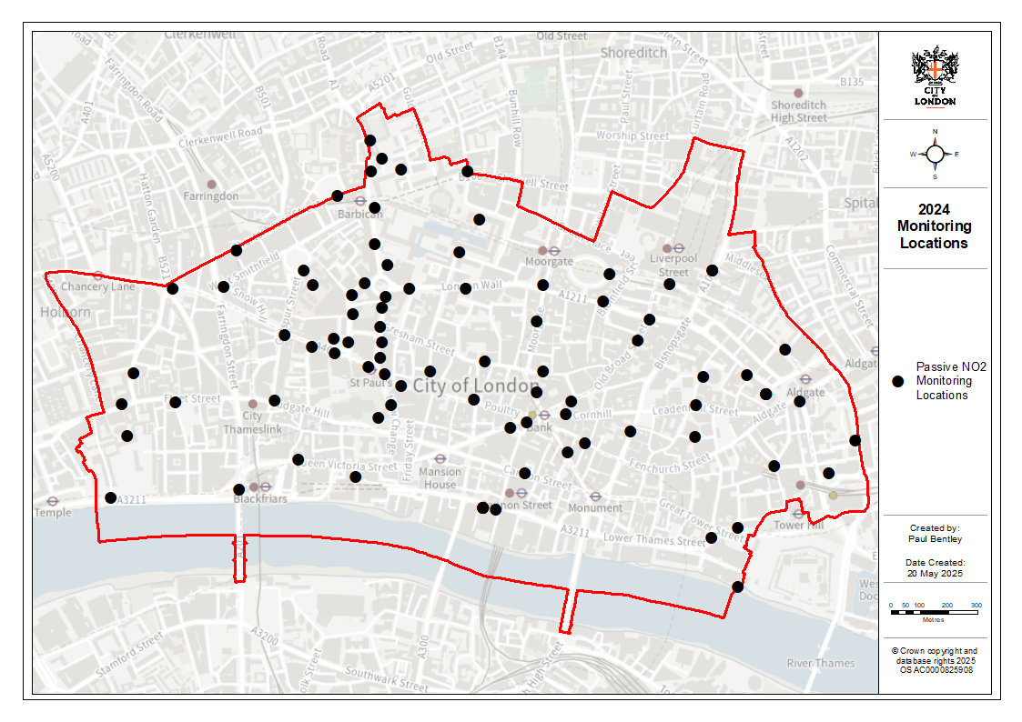
Figure K. Map of Automatic Monitoring Sites
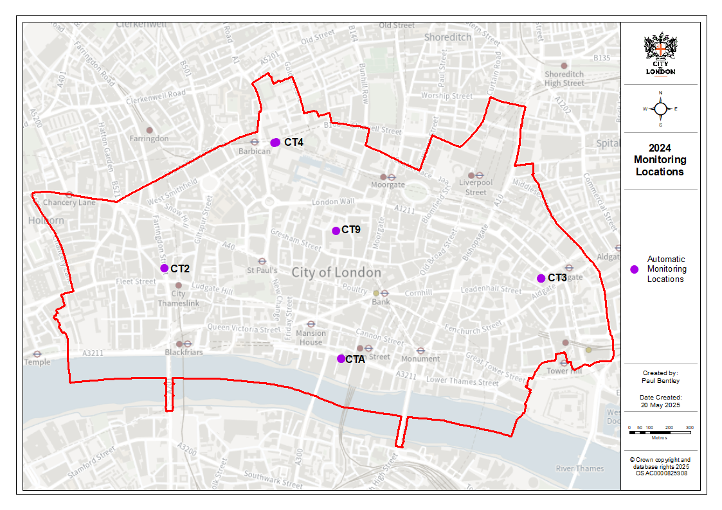

LLAQM Policy and Technical Guidance 2019 (LLAQM.TG(19))

