
2025 Air Quality Annual Status Report (ASR)
In fulfilment of Part IV of the Environment Act 1995 Local Air Quality Management, as amended by the Environment Act 2021
Date: June 2025

Information | Solihull Metropolitan Borough Council Details
Local Authority Officer | A Clover
Department | Economy and Infrastructure
Address | Council House, Manor Square, Solihull
Telephone | 0121 704 8000
E-mail | planning@solihull.gov.uk
Report Reference Number | ASR2025
Date | 20/6/2024

Local Responsibilities and Commitment

This ASR was prepared by the Development Management Department of Solihull Metropolitan Borough Council (hereafter referred to as Solihull MBC) with the support and agreement of the following officers and departments:

- CLAUDE
- Climate Change and Sustainability
- Public Health
- Planning Design and Engagement
- Sustainable Travel & Highway Management
- Solihull Active Team
- Transport & Infrastructure Commissioning
- UK Central (ULEV, Programme Development and other specialist teams)
- External organisations and partners – for example West Midlands Combined Authority (WMCA), University of Birmingham (UoB) and its WM-Air and WM-Net Zero teams, Transport for West Midlands (TfWM) along with other key action delivery partners

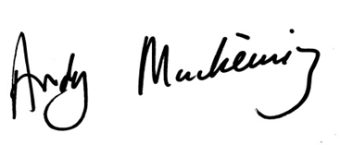

This ASR has been approved by:
The Cabinet Portfolio Holder - Climate Change & Planning, Councillor Andy Mackiewicz
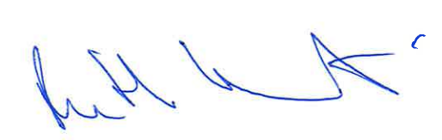

This ASR has been signed off by:
Director of Public Health, Ruth Tennant

If you have any comments on this ASR please send them to Amanda Clover at:
ECONOMY & INFRASTRUCTURE DIRECTORATE
Solihull Metropolitan Borough Council
Development Management
Council House, Manor Square
Solihull B91 3QB

Telephone: 0121 704 8008

planning@solihull.gov.uk

Executive Summary: Air Quality in Our Area

Air Quality in Solihull MBC

Breathing in polluted air affects our health and costs the NHS and our society billions of pounds each year. Air pollution is recognised as a contributing factor in the onset of heart disease and cancer and can cause a range of health impacts, including effects on lung function, exacerbation of asthma, increases in hospital admissions and mortality.
Air pollution particularly affects the most vulnerable in society, children, the elderly, and those with existing heart and lung conditions. Low-income communities are also disproportionately impacted by poor air quality, exacerbating health and social inequalities.
Table ES 1 provides a brief explanation of the key pollutants relevant to Local Air Quality Management and the kind of activities they might arise from.
Table ES 1 - Description of Key Pollutants
Pollutant | Description
Nitrogen Dioxide (NO₂) | Nitrogen dioxide is a gas which is generally emitted from high-temperature combustion processes such as road transport or energy generation.
Sulphur Dioxide (SO₂) | Sulphur dioxide (SO₂) is a corrosive gas which is predominantly produced from the combustion of coal or crude oil.
Particulate Matter  (PM₁₀ and PM_{2.5}) | Particulate matter is everything in the air that is not a gas.  Particles can come from natural sources such as pollen, as well as human made sources such as smoke from fires, emissions from industry and dust from tyres and brakes.  PM₁₀ refers to particles under 10 micrometres. Fine particulate matter or PM_{2.5} are particles under 2.5 micrometres.

Actions to Improve Air Quality

Whilst air quality has improved significantly in recent decades, there are some areas where local action is needed to protect people and the environment from the effects of air pollution.
Clean air is vital for people’s health and the environment and essential for making Solihull a welcoming place to live and work. A prosperous borough and sustainable economy relies on a cleaner, healthier environment that benefits residents and businesses.
We pride ourselves on being a Council that is small enough to care, but big enough to make a difference. We work closely with our public sector partners, businesses, the voluntary sector and communities to improve the lives of the people we serve. Our residents are at the heart of everything we do, and we always put them first.
The council’s on-going monitoring programme has demonstrated that relevant (including residential) exposures comply with national Air Quality Objectives for Nitrogen Dioxide (NO₂). This means that DEFRA do not require us to declare an Air Quality Management Area (AQMA).
None of our monitoring sites have recorded any exceedances of NO₂ for the past 5 years (though it is noted that data gathered during the Covid pandemic is not representative of normal traffic patterns or pollution impacts). Currently, nearly all our sites have concentrations that sit well below national objective levels, with most recording annual mean concentrations around the 20 μg/m³, half the value of the objective level of 40 μg/m³.
However, we have still been busy with air quality initiatives and projects across the borough.

Main Pollutants of concern

The main pollutants that we have focussed on historically at Solihull MBC have been those related to road traffic, hence previous Annual Status Reports (ASRs) have reviewed Nitrogen Dioxide (NO₂) with additional scrutiny over particulate matter pollution. Our focus now includes looking at fine particulate (PM_{2.5}) levels within the borough, given the associated impact on public health.
Solihull’s Clean Air Strategy was substantially revised in 2024 and reflects our work and commitment towards improving air quality. It focusses on both NO₂ and fine particulate matter PM_{2.5} pollution. The new Air Quality Strategy (2024 – 2028) steers us through the next 5 years and on towards new targets and ambitions. It includes key actions that the council will be taking to achieve better air quality across Solihull. This will benefit everyone’s health both now and in the future.
The strategy outlines how we will improve the way we monitor air quality and how we provide information to the public, making sure that robust air quality data is available to view online. It also details how we will work with a range of partners to tackle air pollution from transport, housing and other areas as well as how we support schools and businesses to reduce their levels of air pollution.
Improving the way the council communicate on air quality has been at the heart of our 2024 strategy revision and a key goal has been to improve the way we share our information on health, monitoring, data, maps and forecasts.
We know tackling air pollution is not something Solihull MBC can do on our own and that we all have a role to play in improving our local environment. We need to ensure the council takes our residents and businesses along with us on this journey of knowledge, understanding, education and ultimately, change.

Geographical areas of Solihull where we focus on air pollution
Ministerial Direction along the A45
Air quality is generally good in Solihull compared to national levels, however, historically, Solihull MBC has been required to take steps to address air quality impacts on a footpath, running alongside sections of the A45, Coventry Road (East / West between Junction 6 of the M42 and the Clock Interchange Island). The council were required, via Ministerial Direction, to take necessary steps to mitigate this issue.
A package of behaviour change measures were agreed with government ministers, then as part of wider M42 Junction 6 works, a pedestrian bridge over the A45 (and an improved footpath leading north) were delivered. Access to those sections of the A45 footpath showing elevated pollution have been closed for some years.

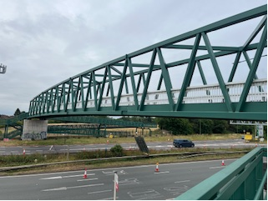
Photograph showing the new pedestrian and cyclist bridge over the A45 Coventry Road near Bickenhill, delivered as part of the National Highways M42 DCO road improvement scheme

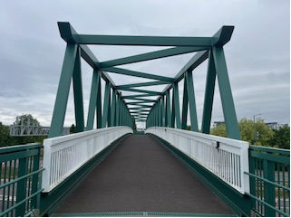
A view of the new footbridge 64-metre span steel structure that provides a safe route for pedestrians and cyclists across the dual-carriageway below.

Concentrations at the Ministerial Direction location have been monitored below the annual average NO₂ objective level (of 40 μg/m³) for the last 5 years, though during the Covid pandemic it is acknowledged that traffic levels were not representative of normal traffic patterns. Defra are currently in the process of exiting Solihull from their Ministerial Direction responsibilities, in recognition of the fact that:
- Solihull MBC have fulfilled all mitigation obligations
- footpath users have been removed from areas of elevated traffic pollution
- monitoring data demonstrates improved air quality along the footpath
The council shall continue to monitor A45 footpath areas as long as we are able to do so (and until Junction 6 works remove footpaths and monitoring locations altogether).
Having delivered the required mitigations our dedicated Sustainable Travel Team funding and projects are now due to end August 2025.
We note that a small number of diffusion tube monitoring sites along the A45 have shown slight increases in NO₂ concentrations for 2024. These increases have been associated with the west bound (southern) carriageway. All three sites with slightly increased concentrations have potentially been impacted by local construction works during 2024.
A new retail facility was constructed near to tubes AB37-39 and lane closures, traffic management and utilities diversions were carried out close to our two Clock Lane tube sites, AB23 and AB28-30 (as part of the M42 Junction 6 improvements) in 2024. The lamppost hosting tubes AB28-30 has now been decommissioned by highways engineers as improvement works take up local land and grass verges (see photograph below which was taken near diffusion tube site AB23.
While we shall be keeping tube AB23 in situ for 2025, we will not be re-introducing tubes AB28-30 locally until construction works are completed. We also note that data from AB23 may well be influenced by nearby construction works, traffic management, heavy goods vehicle use and the operation of Non-Road Mobile machinery (NRMM) in addition to existing A45 traffic emissions.

Photograph taken from site AB23, AB28-30 tubes are now decommissioned
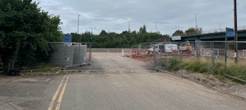
General trends in air pollution in Solihull
By reviewing the latest 2024 NO₂ data from Solihull’s annual diffusion tube monitoring programme we can see what impact local and wider traffic patterns have on pollutant concentrations in the area (more detail is given later in this report).
In nearly all cases, 2024 results show lower pollutant concentrations than corresponding levels recorded for 2023.
We are aware that our ASR includes the reporting of data from a number of diffusion tubes, which can be confusing, and we have found it easier to analyse and discuss diffusion tube results by gathering similar tube locations (or the types of emissions they are monitoring) together in discreet areas. We hope this helps everyone understand how the council are interpreting our 2024 data.
We have segregated tubes into distinct north, central (2 zones) east and west areas. These designated areas are defined by the blue, green (2 zones), pink and lilac polygons respectively (shown maps below – see coloured and labelled areas). More information on these areas and pollutant levels are given in Appendix A. Monitoring Results of this report.
Each area hosts the following tubes:
- Area 1 (Blue) (North) tubes AB1,5 and AC1,4,8
- Area 2 Green (Elmdon) tubes AB4, AC6, AC7, AC11 and triplicate sites AB49-51 and AC13-15
- Area 2 Green (A45) AB23 and triplicate sites AB28-30, AB31-33, AB34-36, AB37-39, AB40-42, AB43-45, AB46 - 48,
- Area 3 Pink (West) tubes AB6, AB8, AB9, AB17, AB24, AC5, AC9 and AC12
- Area 4 Lilac (East) tubes AB21, AC2, AC3, and AC10

Solihull Council Map(s) of Nitrogen Dioxide (NO2) diffusion tube locations and areas
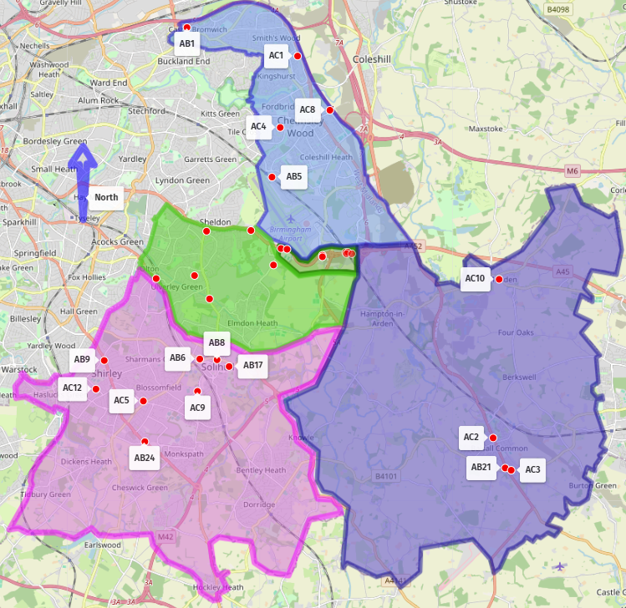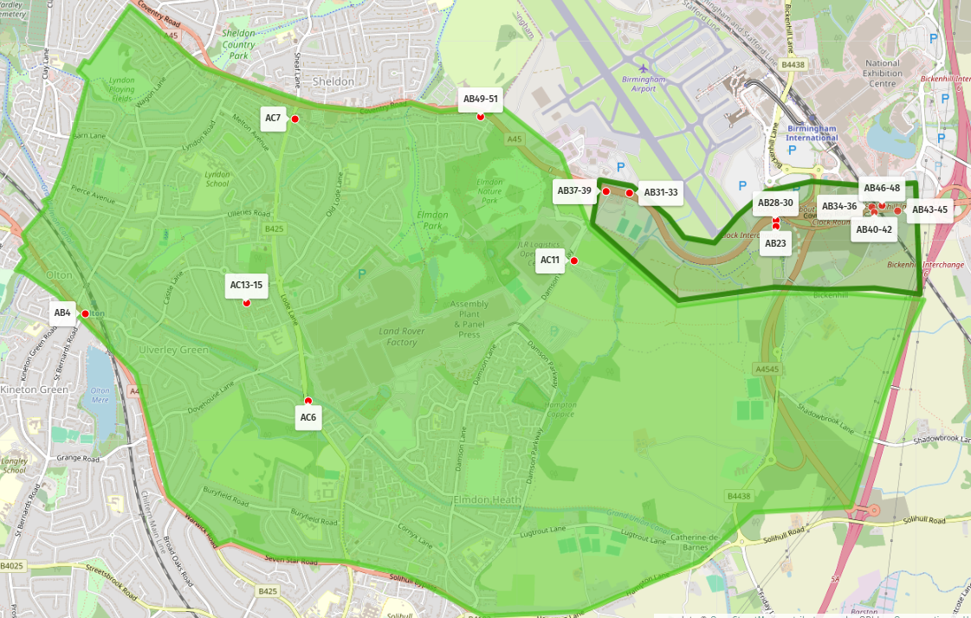
Area 2(A45)
Area 2(Elmdon)
Area 2(Elmdon)
Area 1(N)
Area 4 (E)
Area 3(W)
Area 2(A45)
For monitoring locations in the central green areas (Area 2 Sheldon and A45), a number of tubes are located at sites that front directly on to the A45, Coventry Road. Some of these sites may have been affected by significant traffic management and lane closures resulting in traffic congestion and queuing during the M42 improvement works or ongoing HS2 construction works.
Whilst this means that results should be treated with caution, 2024 data continues to replicate previous ASR findings, with the highest concentrations of NO₂ being recorded at a set of triplicate tubes located back of pavement on the section of the A45 carriageway implicated in our Ministerial Direction (tubes AB46-48), see Diffusion tube Annual Mean NO₂ Monitoring Results. This triplicate site is compliant with NO₂ objective levels, for the 2024 data year, and there are no receptors near this monitoring location.

Key Improvements to air quality in Solihull (2024)

In our 2024 ASR the council identified 3 key actions for the delivery of air quality improvements. These have been completed and were fully rolled out within anticipated timescales

Action 1 – Delivery of Low-cost Sensors
Solihull MBC worked closely with the West Midlands Combined Authority (WMCA) in securing, locating and delivering a new Defra funded region wide low-cost PM_{2.5} sensor network in 2024 (including PM₁₀, PM₁ and NO₂ monitoring capabilities). A network of approximately 80 sensor locations were agreed with Local Authority partners before deployment across the region. All the data gathered from the units can be accessed on the WMCA data platform or via links from partner organisations including via Solihull MBC webpages.
The network has only been up and running since December 2024, so no analysis is provided yet (or via this ASR report) however the network is already providing greater spatial resolution and clarity on air pollutant concentrations and events across the region. This is helping the WMCA and local authorities gain a greater understanding of air quality within the region, at the same time providing the public with easily accessible information on pollutant concentrations through a public facing data platform.
The sensor data feeds into a centralised dashboard for the public to see, and near real time air quality data is available with other relevant air quality datasets for the region. The data platform is hosted on a WMCA data platform, which also provides a wide range of local air quality information to the public and regional partners about air quality matters, for example there is a section on ‘In my Area’. The information will help raise awareness on how to minimise and reduce the emission of pollutants and how to limit personal exposure.
The website is linked to Solihull’s own webpages and collectively has facilitated a significant improvement in knowledge and information sharing across all partners and the public.
Alongside the data platform, the WMCA webpages also provides detailed health and air pollution information. The ‘How to improve air quality’ and ‘Find out more’ tabs take users to a host of related supporting information, videos and resources such as literacy training.

Action 2 – Hotspot investigation

For a number of years and alongside our A45 review work, Solihull Council has been working with research fellows at the University of Birmingham (UoB) via the ‘WM-Air’ team (a West Midlands Air Quality Improvement Programme). The team have produced high resolution Atmospheric Dispersion Model System (ADMS) models of the borough.
Pollution models were produced as early as 2019 (from 2016 baseline data) showing region wide concentrations of NO₂ and PM_{2.5.} WM-Air models have repeatedly shown a significant ‘hotspot’ in the northwest region of the borough.
The council queried the hotspot findings (for both NO₂ and PM_{2.5}) and deployed dedicated passive diffusion tube monitors to gather NO₂ data at the hotspot location. Triplicate (three tube) monitoring was used at site AC13-15 to add confidence to monitoring results).
Results were reviewed monthly and showed that recorded site concentrations did not correspond with elevated modelled NO₂ levels (see our 2024 ASR). This year’s monitoring results have, for a second year running, demonstrated that monitored data is recording concentrations at a fraction of what is being predicted in models.
Results for tubes AC13-15 (Table A.4) specific to our hotspot area of the borough
Diffusion Tube ID | Site Type | 2023 NO₂ concentrations μg/m³ | 2024 NO₂ concentrations μg/m³
AC13, AC14, AC15 | Urban Background | 10.6 | 10.9

Modelled NO₂ outputs currently predict 29 μg/m³ (2019 baseline data) at the triplicate diffusion tube array which has recorded actual annual concentrations of between 10.6 and 10.9 μg/m³ (2023 - 2024).
Alongside passive diffusion tube monitoring, short term automatic NO₂ and PM_{2.5} fine particulate matter spot checks were carried out by the WM-Air team, with the support from the WMCA.
A photograph of a UoB research vehicle monitoring pollutants in Solihull 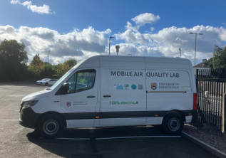
Photograph provided courtesy of the WM-Air team and University of Birmingham

Again, this validation / verification exercise did not support the elevated concentrations predicted at this hotspot location and in fact provided a strong indication that PM_{2.5} and NO₂ concentrations at the Solihull MBC hotspot site were not significantly elevated from the broader urban background levels. While acknowledging that this was a short-term assessment, it was concluded that the data provides additional evidential support for the querying of model outputs (and reinforces concerns over data anomalies).
In summary, regional modelled data is not currently considered reliable at the hotspot location.
Investigations have now prompted Solihull MBC officers to seek out information from The UK National Atmospheric Emissions Inventory (NAEI) database. Despite further help and liaison with specialist software and modelling professionals, Solihull MBC have not secured a satisfactory response or remedy to what the council consider to be erroneous NAEI data inputs / algorithms (producing flawed modelling outputs).
We are now working with the same specialists to ensure that future regional modelling is fully informed by these issues (and that the verification exercises address any associated data anomalies). We are currently awaiting updated versions of regional pollution maps.
It should be noted that NAEI / Defra data sets are used universally in air quality modelling and prediction packages and so this problem will continue to be a significant issue for Solihull MBC. We are aware of the issue and are ready to give advice to all those who might query this anomaly including specialists, residents and elected members.
Solihull MBC have now rationalised our diffusion tube monitoring as part of our model validation checks. Our triplicate tubes have now been re-distributed to three different locations, at the very heart of elevated hotspot zones, to check that data continues to show no elevated levels above broader urban background levels. The council want to ensure we have access to the most representative and accurate monitoring data and to ensure we target the right areas for the monitoring of pollutants.
In addition to diffusion tube monitoring, priority has been given to the rollout of the PM_{2.5} region wide sensor network at or near to the hotspot investigation site. This will further corroborate previous validation findings and help us quickly identify and analyse any elevated concentrations that may require further-more detailed review.

Action 3 – Improving our communication
In May 2025 Solihull MBC refreshed its air quality webpages. We recognised the need to improve how we share information and data with all our residents, businesses, community groups, charities and other partners.
A screenshot of Solihull Council's Air Quality overview page
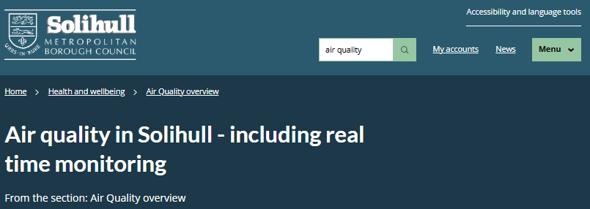
The council have chosen subject headings that are specific to Solihull, to help website visitors navigate the resources and information. We have liaised closely with the WMCA to ensure that we share consistent, complimentary messaging.
A screenshot of Solihull Council's Air Quality overview page themes and options
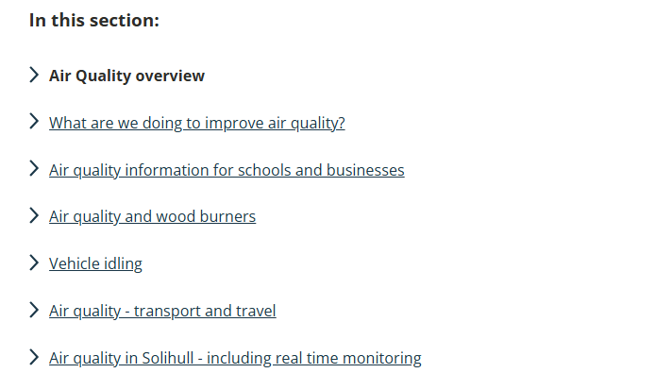
Webpage updates have been done in step with the WMCA’s air quality information hub and data platform development. Websites now link and share consistent messaging to ensure both local and wider regional information is not only accessible and informative but can also be access from multiple websites and links.
There is important work being undertaken right across the wider combined authority area, and it is important to recognise that users are likely to want to access not only their own local information but also air quality information for nearby towns and cities. This may well be the case where residents live in one location but regularly travel or work in a neighbouring area.

Key Priorities for air quality improvement in 2025

The following are Solihull MBC’s key priorities for the coming year:

2025 Key Action 1 – continue to work on how we communicate and improve our air quality messaging

We know that one of the most important routes to securing air quality improvement in our borough is to take our residents, businesses and stakeholders with us on this journey. However, we also need to understand, prioritise and address the inequalities and health burdens that poorer air quality presents to our more vulnerable customers. We also recognise that information and advice is constantly changing, due to advances in knowledge, research, technology and innovation. We want to make sure our communities stay up to date on air quality related matters.
We have therefore decided to shift and maintain our ‘communicating with the public’ priority from Number 3 to Number 1, and to carry out ongoing review of how we disseminate important information. We need to know how best to manage and monitor our web presence, how we advise better on the health impacts (for example with forecasting and pollution event alerts) and how we can best reach all sections of our community. The WMCA has already done some valuable work, looking at what makes messaging successful and what ‘myth busting’ strategies are best received by the public.
Solihull have also been liaising with WMCA on progressing towards the rollout of an online / subscription based and region wide health alert system. We think it is important that officers can give this work package the necessary time and resource commitments needed. By prioritising it in our ASR we hope to ensure our communications methods are continually improving for our Solihull customers.
The three main communication areas we wish to focus on for this work in 2025 / 2026 are:
- An alert system that will help all of us, but especially those with pre-existing health conditions such as asthma or respiratory complications, be aware when pollution events in the West Midlands pose a health risk. We hope the alert system will inform those most affected by air pollution and allow them to make informed decisions about outdoor activity and exposure. We also want people to use the interface in a way that demonstrates links between pollution events and its sources, and to advise on how we can all minimise our own contributions, especially in the context of local pollution events.

- Web content & guidance on EV charging and infrastructure. Solihull MBC webpages will be reviewed to address topics such as EV ownership and charging and good practice (e.g. how to maintain good battery health). The council acknowledges that dedicated resources are needed to ensure content is continually reviewed so that it remains comprehensive and also relevant. Once live, new webpages will provide helpful information on all EV related matters, with an emphasis on infrastructure and charging but also to include updates as the market and technologies evolve and EV ownership continues to climb.

- Indoor air pollution, wood burning and anti-idling messaging. We will improve how we inform on these key areas of indoor air quality. Alongside this work we will undertake peer review of regional and neighbouring air quality communications and programmes, to see what further information we can provide, what messages are working well, and where our communication should focus

2025 Key Action 2 - Rolling out our EV charging infrastructure
We can only achieve a switch to electric fleet and achieve the aims of Solihull’s ‘Going Electric’ plan if every vehicle has access to the right charging infrastructure. This means that access to public charging is essential and must be accessible for all. So, in addition to providing better web-based information and advice on EV ownership and use, we’re working with charge point operators and landowners to ensure that public charging is safe, secure and accessible and can be used without the need for multiple apps and RFID cards. Wherever possible we’ll require roaming payment methods or contactless with simple to understand user tariffs and no separate payment for parking.
Destination car parking provides the opportunity to match desired dwell time with charging speed ensuring that car parks and nearby businesses achieve their desired turnover, and drivers get a charged car without making a trip specifically for charging. Supermarkets, retail parks, pub chains and public car parks are already offering charging across the borough and the council have entered into a contract with a Charge Point Operator to install and operate a charging network.
The Council has updated it’s EV energy demand forecast out to 2035 in light of the Zero Emission Vehicle mandate, which came into force in January 2024, and increased usage year on year of the Council’s public charging infrastructure.
Up to 500 charging spaces are set to be commissioned by 2026 supported by c.£800k grant funding obtained through the West Midlands LEVI Pilot Project and with remaining capital costs privately financed.
Following the 2023 opening of Europe’s largest EV charging hub at the NEC, featuring 32 high powered chargers under a solar PV canopy, 150 pre-bookable standard AC chargers and associated café and toilet facilities, the roll out of rapid charging infrastructure has continued, on a privately funded basis, along the key route network and at commercial destinations across the borough.

2025 Key Action 3 – Indoor Air Quality research project
The council wants to make sure we identify the impacts and behaviours associated with not only outdoor but also indoor air pollution. We want to better understand, and then communicate, how pollution levels change over time, how they are influenced by daily activities and how periods of elevated pollution exposure can be minimised. People spend around 90% of their time indoors, so this project and its data is essential for taking the next steps in understanding and adopting actions to improve air quality inside our homes.
The project is closely supported by research and monitoring carried out by WM-Net Zero, which is funded by an award from the Wellcome Trust for advancing climate mitigation policy solutions with health co-benefits in G7 countries. This initiative aims to bring together research organisations and policy bodies with a clear opportunity to influence climate mitigation policies with substantial health impacts
The council and WM-Net Zero team are in the early planning stages of a ‘Solihull Indoor Air Quality Monitoring Project’ in some of our social housing homes in Solihull.
Sensors will be placed in the kitchens and living rooms of selected homes in Solihull to track PM_{2.5}, CO₂, temperature, and humidity to help us understand how everyday household activities — like cooking, cleaning, and ventilation — impact indoor air.
By comparing air quality before and after retrofitting, we can see whether home upgrades help reduce pollution exposure or if additional improvements — such as better ventilation — make crucial differences. The data collected will supplement the council’s existing understanding of housing and health and enable us to better inform our own plans and the way we do things.

Our key large infrastructure projects

Like many towns and cities across the country, road transport represents a significant source of air pollution in Solihull, and hence a challenge in terms of reducing traffic related congestion and pollution. Whilst we are already one of the best-connected destinations in Europe, we are perfectly positioned to benefit from significant new investment in our transport network, bringing with it benefits to our economy, environment and health.
Solihull Council is on a journey of ‘managed growth’ through the promotion of ‘UK Central’ bringing together all of the economic assets of the borough including regional business parks, town centres, industry, the Airport, future HS2 and the NEC. The council is determined to make this vision of ‘managed growth’ a reality.
Solihull is making the case for investment and demonstrating how we will manage growth in a sustainable way, working alongside the WMCA. We need to have a clear transport strategy for the arrival of HS2 and future development opportunities.
As the first station north of London, HS2 will highlight the need for more investment in Solihull’s local transport network. The Council is keen to capitalise on this prominence to secure improvements across the borough. The ambition behind Solihull Connected is to plan for balanced investment in transport infrastructure that still caters for cars, while emphasising alternatives.
Solihull’s Transport Strategy was updated in 2023 to reflect shifts in travel patterns and behaviours and to ensure it remains responsive to the needs of the borough, now and into the future. The strategy is accompanied by a detailed Delivery Plan with key investment priority areas including the HS2 Growth Strategy and Local Plan Review, connecting UKC growth centres, supporting access to business parks and housing sites, promoting a transformation in public transport, cycling improvements, increasing road network reliability and resilience and creating innovative local community transport initiatives.
Supporting these strategies are a number of large-scale transport initiatives, the major schemes are listed below. They seek to improve sustainable transport and low emission travel, increase capacity, reduce congestion and benefit air quality alongside improving access for cyclists and walkers
M42 Junction 6 Improvements - Development Consent Order (DCO) (Action 19)
Since 2021, National Highways have been working on a £282 million improvement project at junction 6 of the M42. The project is designed to increase capacity and reduce congestion, improve links to Birmingham Airport and other key businesses and access for cyclists and walkers. The improvements will also support economic growth in the area where investment has been constrained by poor journey times and traffic congestion.
Works include a new 2.4km dual carriageway link road; a new junction on the M42 motorway, Junction 5A; a new pedestrian footbridge over the A45; bridge replacement and realignment of the existing local road network.
The road is now known as the A4545 and was opened to the public during December 2024. Works are still taking place, but the scheme is now nearing completion. Full details can be found on the National Highways web site at M42 Junction 6 improvements to view latest updates.

A45/Damson Parkway
Approximately 1.5km to the west of the M42 DCO scheme there are planned A45 / Damson Parkway junction improvement works. The junction is one of the busiest in Solihull, serving not only Birmingham Airport, but also a major car manufacturer in the area, hence relevant to two large employers, one being a major transport hub.
The new junction arrangement includes bus priority measures, through the implementation of a bus lane, and improved facilities for cyclists and pedestrians, which will complement wider measures to encourage a shift away from car use. This project is currently at the Final Business Case (FBC) stage, with delivery anticipated to commence later in 2025.

HS2
HS2 is one of the largest infrastructure projects ever undertaken in this country, and will transform connectivity and economic performance at local, regional, and national levels. Solihull will be served by a new HS2 station, to act as a hub for the wider region. Whilst growth and development plans provide a rare opportunity for significant economic growth and benefits for Solihull, it is vital to ensure the trips generated by these developments do not have an adverse impact on the regional transport network and environment.
A set of environmental controls (Environmental minimum requirements (EMRs)) were adopted by all HS2 contractors and haulage route users, as approved by the Secretary of State for Transport. Full details can be found here: HS2 EMRs
HS2 have committed to using Euro VI classification vehicles for their construction work, Euro VI being the current and most recent vehicle emissions standard. By insisting that all HGVs working on the project comply with the project’s standards, HS2 Ltd hopes it will encourage its suppliers to invest in new, cleaner, and more efficient vehicles. The company has also placed stipulations on other vehicles, cars and vans.

Plans for Balsall Common Relief Road
The Balsall Common Multi Modal Package comprises of two distinct, but related elements:
• A relief road that can take through traffic away from the centre of the settlement, and
• A package of active travel and public realm measures to make sustainable travel in and around the settlement more attractive and discourage ‘through traffic’ using Kenilworth Road.
Planning applications that include elements of the Balsall Common multi modal package are currently being considered by the council.

Other key air quality improvements

Delivery of Solihull Councils Air Quality Strategy and Action Plan
Solihull Council’s updated Air Quality Strategy was published in September 2024 and outlines the steps that will be taken over the next four years to improve air quality across the borough
Front cover of Solihull’s Air Quality Strategy 2024 – 2028

Publication followed full consultation with local residents and businesses. It highlighted the council’s ambition to improve air quality monitoring and share information with the public.
Reviewing and updating then publishing Solihull’s latest Air Quality Strategy (AQS) 2024 - 2028 has been a key priority of the council.
The AQS is an effective response to the new duties imposed on the Council including those introduced by the government’s new PM_{2.5} targets.

The six key areas of focus in the AQS
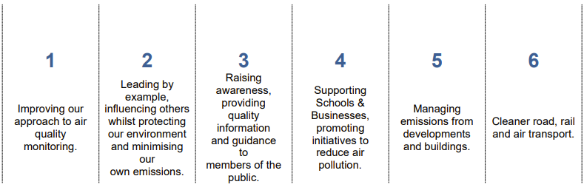

The AQS covers the following themes:
Improving our approach to air quality monitoring.
We constantly review ways to make improvements and rationalise our monitoring programme and we now do a full review of diffusion tube sites at the end of each calendar year (with consultation with the monitoring & evaluation team at Defra/JAQU). The roll-out of the WMCA sensor network across the borough has also improved our monitoring capabilities.
Leading by example
Solihull’s exciting future is to shift towards a low-carbon economy, and our robust plans to reach net zero emissions by 2041 as a borough, recognises that we all need to adapt our lifestyles and behaviours to live more sustainably.
The council continue to provide leadership for air quality policy and action across Solihull, through our active travel and schools programme, whilst continuing to explore and work with other organisations and the public to encourage action on air quality and climate change.
Raising awareness
We have committed to raising public awareness on the health impact of air pollution in our updated Air Quality Strategy (2024-2028). We want to encourage the community to take actions to reduce their contributions to local air quality emissions and be able to protect the most vulnerable. We have refreshed our website in conjunction with the WMCA centralised dashboard (for regional air quality information near real time air quality data).
Supporting schools and businesses promoting initiatives to reduce air pollution
We have an ambitious programme of supporting both schools and businesses to develop and promote initiatives to reduce air pollution. This is planned to continue in the near future.
Our dedicated Sustainable Travel Team delivers the following projects and services:
- Sustainable travel business support.
- School Streets and Engines off, Young lungs at work.
- School lessons, assemblies and walking to school initiatives.
- Bikeability cycle training, Cycling 4 Everyone and Adult ‘Cycle Training & Fix’ sessions.
- Cycle Hire Scheme – ‘Try before you Bike.
- Breathe Easy Campaign
- Green School Awards and ModeShift STARS
- School Park and Stride / Walking Buses
Managing emissions from developments and buildings
We ensure proposals for new developments include air quality screening to identify potential impacts on air quality forming an integral part of our development control responsibilities.
In the heart of Solihull, our new Town Centre Heat Network will be delivered.
An Energy Services Company (ESCo) known as Solihull Energy Limited has been established and has contracted with Vital Energi Ltd to Design, Build, Operate and Maintain (DBOM) the energy centre and network for the next 15 years. The ESCo will be responsible for managing individual contracts and customer agreements associated with the Town Centre Energy Network.
Cleaner Road, Rail and Air Transport
Alongside the wider council’s transport policies, and the large infrastructure projects detailed above, Solihull MBC have a strategic approach to identifying long-term cycling networks and core walking zones within major district centres and employment zones (see Local Cycling and Walking Infrastructure Plan (LCWIP). Key corridors form the basis of long-term cycling routes, and core walking zones will improve pedestrian environments in areas with current or potential high footfall.
The council are progressing the rollout of EV charging infrastructure as a priority and are working closely with the West Midlands Combined Authority (WMCA) to deliver this key infrastructure shift. Solihull remains committed to our Net Zero Action Plan (NZAP) and we maintain a goal for all council service vehicles to have zero tail pipe emissions by 2030.

Conclusions and Priorities

SMBC has not declared any Air Quality Management Areas (AQMAs) and we endeavour to ensure that the air quality objectives are met in Solihull. This remains our major priority in our air quality work. No exceedances of the air quality objectives were recorded in 2024.
SMBC are pleased to note that a review of NO₂ data for the 2024 calendar year shows an overall downward trend across the borough. As was the case in 2024, we note that a small number of sites along the A45 have shown slight increases in NO₂ concentrations however results may have been impacted by local construction works on the A45 / M42.
The ongoing review of monitoring locations and tube results shall continue throughout 2025 to ensure the council has access to accurate and representative data so that we can carry out meaningful trend analysis. We also need to ensure we are deploying passive monitoring where it is most effective and needed.
The council have introduced some new monitoring sites for 2025. Alongside our passive assessment of pollutants, we are now able to review results from the WMCA low-cost sensor network (Defra funded). While data is not MCERTS (Environment Agency Monitoring Certification Scheme) accredited, it provides valuable insight into local pollution patterns. Real time monitors will be in situ for a minimum period of five years,
Priority locations were identified in Solihull as part of our diffusion tube deployment programme alongside the WMCA low-cost sensor rollout, so that we could review reported hotspots within Solihull. Together with the WMCA, the council has completed investigations into model outputs and data sourcing via review of monitoring results. We are now confident that external NAEI data anomalies are leading to hotspot reporting which is erroneous. Monitoring confirms a lack of evidence of a pollution hotspot to the north-west of the borough.
SMBC are pleased to confirm that our two key 2024 ASR priorities, aimed at:
- improving our PM_{2.5} monitoring and reporting capabilities, and
- investigation of modelled hotspot
have therefore been delivered. These have been achieved through close partnership working with the WMCA.
Our air quality webpages are now more accessible and seek to steer users to look at how they can minimise their exposure to air pollution whilst reducing their own contributions to emissions. Our updated webpages align with WMCA data platform information where users can gain further understanding on regional air pollution matters.
Solihull recognises that in 2021 the World Health Organization (WHO) revised its global air quality guidelines. Current air quality standards are less strict for all pollutants than the WHO air quality guideline levels. The council continues to work with the WMCA and all local partners to establish the best course of action for the region in responding to appropriate air quality targets and ambitions. Work is ongoing in this area. The installation of the low-cost sensor network will provide invaluable qualitative data to support decision making.

How to get Involved

Our 2024 ‘Action 3 - Improving our communication’ sought to overhaul how we communicate air quality issues to the general public (please see Key Improvements noted in earlier sections).
Alongside our improved online air quality information and our Air Quality overview landing page and links, we have a large resource of other related information on the Council’s ambitions for environmental improvement.
Your future Solihull is the Council's climate change and sustainability campaign. The site provides access to key Council policies which relate to climate change and sustainability in addition to tips and information for the public to help make Solihull more sustainable, look after the natural environment and collectively reduce emissions.
The webpages currently host a large array of information. We have a dedicated area entitled ‘How you can help”, where we further explore various air quality action themes, alongside the following subject headings:

A screenshot of Solihull Council's 'Your future Solihull' webpage and the various themes


The pages detail events, community activities and how to get involved, we even have podcasts to listen to.
Our Policies section shows an extensive array of documents and initiatives that Solihull has been involved with over the last few years.
For those wishing to be updated on information across the region the public can register for updates from WMCA Environment Team. Their Air Quality Framework Document also gives detailed information on the legislation, regional policy and delivery plans.

The WMCA has also developed an Air Quality Literacy Training programme specifically designed for West Midlands Local Authority officers and elected members to gain a better understanding of air quality, but the programme could easily be used by members of the public who have a keen interest in gaining additional knowledge of air quality matters. The programme enables subscribers to consider air quality in their home, travel and working environment, helping us all move towards improved air quality and health.
Residents can also obtain more air quality information on the following websites:
- DEFRAs UK-AIR: Air information Resource
https://uk-air.defra.gov.uk
- Environmental Protection UK Air Pollution website
https://www.environmental-protection.org.uk/policy-areas/air-quality/about-air-pollution/
- Action Group ‘Mums for Lungs’ which started in London in 2017 is now active across the UK and has been involved in a number of workshops and events in the West Midlands. Their website discusses air pollution themes, campaigns and programmes for action, providing a resource for anyone wishing to get more involved
https://www.mumsforlungs.org/

- Solihull Council have taken part in related Clean Air Day and Clean Night activities for a number of years. These are events co-ordinated by Action For Clean Air via Global Action Plan* (*please be advised the Global Action Plan website includes rapidly changing and flashing images).

The WMCA and a number of local partners (including WM-Air and WM-Net zero) have used Action for Clean Air calendar events to host workshops and conferences during 2024.

Table of Contents
Local Responsibilities and Commitment i
Executive Summary: Air Quality in Our Area iii
Air Quality in Solihull MBC iii
Actions to Improve Air Quality iv
Main Pollutants of concern iv
Geographical areas of Solihull where we focus on air pollution v
Key Improvements to air quality in Solihull (2024) x
Key Priorities for air quality improvement in 2025 xv
Our key large infrastructure projects xviii
Other key air quality improvements xxi
Conclusions and Priorities xxiv
How to get Involved xxv
1 Local Air Quality Management 1
2 Actions to Improve Air Quality 2
2.1 Air Quality Management Areas 2
2.2 Progress and Impact of Measures to address Air Quality in Solihull MBC 2
2.3 PM_{2.5} – Local Authority Approach to Reducing Emissions and/or Concentrations 26
3 Air Quality Monitoring Data and Comparison with Air Quality Objectives and National Compliance 29
3.1 Summary of Monitoring Undertaken 29
3.1.1 Automatic Monitoring Sites 29
3.1.2 Non-Automatic Monitoring Sites 29
3.2 Individual Pollutants 30
3.2.1 Nitrogen Dioxide (NO₂) 30
3.2.2 Particulate Matter (PM₁₀) 31
3.2.3 Particulate Matter (PM_{2.5}) 31
Appendix A: Monitoring Results 32
Appendix B: Full Monthly Diffusion Tube Results for 2024 40
Appendix C: Supporting Technical Information / Air Quality Monitoring Data QA/QC 44
New or Changed Sources Identified Within Solihull MBC 2024 44
Other 45
Additional Air Quality Works Undertaken by Solihull MBC During 2024 48
QA/QC of Diffusion Tube Monitoring 48
Diffusion Tube Annualisation 48
Diffusion Tube Bias Adjustment Factors 48
NO₂ Fall-off with Distance from the Road 49
QA/QC of Automatic Monitoring 49
Appendix D: Map(s) of Monitoring Locations and AQMAs 50
Appendix E: Summary of Air Quality Objectives in England 52
Glossary of Terms 53
References 54

Figures
Figure A.1 North – Map of Area 1 (North) Diffusion Tubes 35
Figure A.2 North –Trends in Annual Mean NO₂ Concentrations for Area 1 (North) 35
Figure A.3 Elmdon - Map of Area 2 (Elmdon) Diffusion Tubes 36
Figure A.4 Elmdon – Trends in Annual Mean NO₂ Concentrations for Area 2 (Elmdon) 36
Figure A.5 A45 - Map of Area 2 (A45) Diffusion Tubes 37
Figure A.6 A45 - Trends in Annual Mean NO₂ Concentrations for Area 2 (A45) 37
Figure A.7 West – Map of Area 3 (West) Diffusion Tubes 38
Figure A.8 West –Trends in Annual Mean NO₂ concentrations in Area 3 (West) 38
Figure A.9 East – Map of Area 4 (East) Diffusion Tubes 39
Figure A.10 East – Trends in Annual Mean NO₂ concentrations in Area 4 39

Figure D.1a – Map of Non-Automatic Monitoring Sites 50
Figure D.1b – Map of Non-Automatic Monitoring Sites; Area 2 (Elmdon) and Area 2 (A45) 51
Tables
Table 2.2 – Progress on Measures to Improve Air Quality 22

Table A.1 – Details of Automatic Monitoring Sites 32
Table A.2 – Details of Non-Automatic Monitoring Sites 32
Table A.3 – Annual Mean NO₂ Monitoring Results: Automatic Monitoring (µg/m³) 33
Table A.4 – Annual Mean NO₂ Monitoring Results: Non-Automatic Monitoring (µg/m³) 33

Table B.1 – NO₂ 2024 Diffusion Tube Results (µg/m³) 40

Table C.1 – Bias Adjustment Factor 49

Table E.1 – Air Quality Objectives in England 52

Local Air Quality Management
This report provides an overview of air quality in Solihull Metropolitan Borough Council (Solihull MBC) during 2024. It fulfils the requirements of Local Air Quality Management (LAQM) as set out in Part IV of the Environment Act (1995), as amended by the Environment Act (2021), and the relevant Policy and Technical Guidance documents.
The LAQM process places an obligation on all local authorities to regularly review and assess air quality in their areas, and to determine whether or not the air quality objectives are likely to be achieved. Where an exceedance is considered likely the local authority must declare an Air Quality Management Area (AQMA) and prepare an Air Quality Action Plan (AQAP) setting out the measures it intends to put in place in order to achieve and maintain the objectives and the dates by which each measure will be carried out. This Annual Status Report (ASR) is an annual requirement showing the strategies employed by Solihull MBC to improve air quality and any progress that has been made.
The statutory air quality objectives applicable to LAQM in England are presented in Table E.1.

Actions to Improve Air Quality
  - Air Quality Management Areas
Air Quality Management Areas (AQMAs) are declared when there is an exceedance or likely exceedance of an air quality objective. After declaration, the authority should prepare an Air Quality Action Plan (AQAP) within 18 months. The AQAP should specify how air quality targets will be achieved and maintained and provide dates by which measures will be carried out.
Solihull MBC currently does not have any declared AQMAs. A local Air Quality Strategy called ‘The Solihull Air Quality Strategy 2024 - 2028’ is in place to prevent and reduce polluting activities.
  - Progress and Impact of Measures to address Air Quality in Solihull MBC
Defra’s appraisal of last year’s 2024 ASR concluded:
- “The conclusions reached are accepted for all sources and pollutants, on the proviso that the grammatical and formatting errors in the report are corrected prior to publication on the council’s website”.
This has been actioned and the 2024 ASR is available to view on our website
- “The Council used robust QA/QC procedures in 2023 but clear justification as to why the national bias factor was used over the local bias factor should be provided”.
This has been addressed in this 2025 ASR – See QA/QC of Automatic Monitoring
- “Comments from previous ASR appraisals have not been included and responded to in detail. This is encouraged for future reports”.
This has been addressed here, in this 2025 ASR
- “The Council has included sign off from the Director of Public Health. This is welcomed”.
No further comment or action required
- “The Council has provided detailed description of measures being taken forward by the council to tackle air quality in the borough. This is useful to understand the progress that has taken place in the current reporting year. This level of detail is encouraged for future reports”
We have sought to further improve the level of detail provided in this 2025 ASR.
- “The deployment of the diffusion tubes did not adhere with the Defra diffusion tube calendar. The Council should aim to adhere to the calendar in the future reporting years”.
For the 2025 reporting year, the Defra diffusion tube calendar has been used.
- “SMBC has included clear trend graphs. This is commended”.
We have sought to further improve graphics in this 2025 ASR
- “The Council has included a good PM_{2.5} section. The inclusion of the PHOF D01 indicator is welcome to understand trends in the borough. The council also commissioned an additional study relating to PM_{2.5} across the council area. This is encouraging to see”
This has been replicated in this 2025 ASR
- “There are a few minor formatting issues in the report. Whilst they don’t affect the readability of the report the council should check future reports for such errors:
- a. There are some referencing errors.
- b. Pollutant names and units are not appropriately subscripted throughout the text, tables, and figures (e.g. PM2.5 instead of PM_{2.5}.)
- c. In Table A.3, the ‘In AQMA? Which AQMA?’ column has not been filled in correctly. It states, ‘no in an AQMA’, which doesn’t make sense. This should be amended to just ‘No’ because SMBC doesn’t haven’t any AQMAs.
- d. Inconsistencies with the formatting of headings”.
“These have been actioned, and the 2024 ASR is available to view on our website. Queries have been raised with the LAQM helpdesk over formatting queries to resolve issues for 2025 submissions”
- “The Council has included a map of their monitoring stations. However, the labels overlap, which effects the readability. The council could used zoomed in maps to show the locations in better detail. This map would also benefit from a north arrow, scale arrow and legend”.
Solihull felt they had addressed this issue in the 2024 submission. Further work will now be undertaken to ensure requirement is followed to the letter.

Updates on actions identified in our 2024 Annual Status Report
Updates on air quality actions are provided below. This is an update on previous actions cited in the 2024 ASR. Where actions are completed this shall be noted in Table 2.2 – Progress on Measures to Improve Air Quality. Many are key completed measures:

- Measure 1 – New low-cost sensor array to measure PM_{2.5} within SMBC borough (discussed in detail earlier)
Completed. 12 low-cost sensors have been deployed across Solihull. A total of approximately 80 low-cost sensors are now located across the WMCA.

The sensors measure Particulates (PM₁₀, PM_{2.5} and PM₁), Nitrogen Dioxide (NO₂), and Ground level ozone (O₃). Information on the pollutants monitored by the sensor network can be reviewed on the WMCA data platform to span the periods of interest (data available from December 2024).

An interactive map allows all sensors to be viewed and by clicking on the relevant monitoring location, near real time concentrations of pollutant can be viewed for the most recent time period. The Data Platform is compatible with mobile and tablet browsing, though a web browser is recommended for downloading data.

- Measure 2 - NO₂ and PM_{2.5} Hotspot identification in SMBC (discussed in detail earlier)
- Completed. A full investigation of the Solihull modelled hotspot has been undertaken and conclusions drawn up. These have been reviewed alongside air quality specialists, and all are agreed that NAEI data is causing an erroneous hotspot to be identified in Solihull.

- Measure 3 - Improving SMBC air quality web presence in tandem with WMCA webpage development and data platform (discussed in detail earlier)
Completed (and further work ongoing- see 2025 key measures). Solihull MBC webpages have been significantly improved to include health and air pollution information, reports and data alongside links to the new WMCA air quality data platform (with graphs and data interrogation tools).

- Measure 4 - Solihull Air Quality Strategy (AQS) and associated Action Plan
Completed. The revised Solihull Air Quality Strategy and associated Action Plan (2024-2028) has been completed and was published late summer of 2024.

- Measure 5 - WMCA Behaviour Change project.
Completed. Following a comprehensive funding award from Defra to the WMCA, an Air Quality Behavioural Change Programme was commissioned by the WMCA August 2023 - March 2025.

The programme involved the design, implementation and evaluation of 7 air quality behaviour change campaigns within each constituent authority, with fine particulate matter (PM_{2.5}) being the pollutant of primary focus due to its ill health effects.

Solihull’s Project - An air quality consultation with pharmacists to promote behaviour change among individuals with pre-existing health conditions produced key findings and recommendations as part of the final reporting and will inform future actions

- Measure 6 – Indoor Air Quality research project (discussed in detail earlier and now 2025 Key priority 3)
Ongoing as programmed. The scope and outline of measure 6 was finalised back in 2024 however, due to it’s remit not only to research indoor air quality and pollutant concentrations, but also to aid improved indoor air quality knowledge and understanding (for project participants) the council have decided to have this as a Key 2025 priority.

The behaviour change elements were deemed to be transferable across the domestic settings and so the measure was thought to provide the necessary focus for future work on indoor air quality improvement.

This Solihull project is part of a wider WM-Net Zero / University of Birmingham / WMCA programme aimed at better understanding indoor air pollution by placing monitors in the kitchens and living rooms of selected homes to track pollutants and other metrics. These sensors help us understand how everyday household activities, like cooking, cleaning, and ventilation, impact indoor air.

- Measure 7 - Solihull Local Plan
Local Plan Withdrawn. On 13 May 2021 the Council submitted the Local Plan to the Secretary of State (via the Planning Inspectorate) for it to be independently examined.
On 4 September 2024 the Inspectors appointed to examine the plan recommended that it be withdrawn. The matter was considered at Full Council on 8 October 2024 and it was resolved that the plan was to be withdrawn. Further information and details of all actions following original submission can be found on our Solihull Local Plan - Examination in Public

The Council has now withdrawn the plan and launched a fresh call for sites exercise in November 2024 to form part of our future new Local Plan review. Timescales will be updated as further information is provided.

- Measure 8 - Town Centre Heat Network
Ongoing as programmed. Background and update: Solihull Town Centre Low Carbon Energy Network project has been given the go-ahead following approval of the business case by Cabinet in October 2023. Funding for this carbon saving scheme has been provided by the Government’s Heat Networks Investment Programme (HNIP) and the WMCA along with borrowing from the National Wealth Fund.

The scheme demonstrates the Council’s commitment to using innovative renewable energy solutions by investing in low carbon heat and power and forms part of a wider strategic approach that Solihull Council is developing to help decarbonise the borough over the next twenty years.

The Energy Network, including the construction of a new Energy Centre at Tudor Grange Park, will provide low carbon heat and power (electricity) to a range of public and private sector customers within Solihull town centre, including Council owned buildings, education campuses and commercial offices.

Connecting to the network will facilitate the decommissioning of existing gas boilers and/or fossil fuel use, some systems being older heating and power systems that are more polluting. Potential future connections to forthcoming high-density housing will also reduce the need for individual homes to have their own boilers / heating systems. This will have benefits in terms of Nitrogen Dioxide (NO₂) and small Particulate Matter (PM₁₀ and smaller) emissions for all networked buildings and will facilitate a significantly greater height for stack emissions and pollutant dispersion.

An Energy Services Company (ESCo) known as Solihull Energy Limited has been established and has contracted with Vital Energi Ltd to Design, Build, Operate and Maintain (DBOM) the energy centre and network for the next 15 years. The ESCo will be responsible for managing individual contracts and customer agreements associated with the Town Centre Energy Network.

Works are underway on a site adjacent to Tudor Grange Leisure Centre to build the new energy centre and works across the town centre is being completed at pace to install series of underground pipework that will provide heat and power to the Phase 1 customers.

The project is on track to start supplying heat and power in early 2026 and the construction programme is on schedule.

- Measure 9 - Installation of new public EV charging (discussed in detail earlier as Key priority 2 )
Progressing as programmed. We can only achieve an improved vehicle fleet and significantly increase the switch to electric cars if every vehicle has access to the right fuel and charging infrastructure, and we acknowledge that urgent delivery of EV infrastructure is not only essential but must be accessible to all.

Solihull MBC want to make clear to all our communities that this is a key priority

- Measure 10 – Increase in council EV fleet
Ongoing as programmed. Solihull remains committed to becoming a Net Zero Council and will require all vehicles operated for the purpose of delivering Council services to be capable of operating with zero tailpipe emissions by 2030.

An increasing proportion of the fleet operated by contract partners is also shifting to zero tailpipe emission operations, including environmental services, community social care and parking enforcement vehicles.

Current arrangements for operation and overnight storage of the Council’s own fleet make full fleet electrification particularly challenging until a new central depot location is developed or alternative charging arrangements can be developed off-site.

In the interim the council are replacing vehicles with battery electric alternatives as contracts are refreshed, and we build out the workplace and depot charging infrastructure to support the fleet decarbonisation transition. Eight care homes had EV chargers fitted in 2023, and further chargers are planned for more social care workplaces in 2025.

- Measure 11 - A45 Behaviour Change Project
Due to be completed August 2025 as programmed. The Sustainable Travel Business Support Team are delivering a three-year behaviour change project to August 2025 funded by DEFRA. The project targets businesses in close proximity to the A45, with the aim of encouraging and incentivising sustainable transport and improving air quality in the area.

Businesses are supported to conduct staff travel surveys and develop a travel plan and can access grants to improve cycling facilities and install EV charging points. SMBC officers can deliver events and activities to support travel plan actions and commuters are incentivised to make fewer single occupancy car journeys with access to:
- Free public transport passes
- e-Bike loans
- Love To Ride Solihull challenges
- Free cycle training and cycle maintenance
- Walking incentives and walk leader training
In addition, the team worked on the new Supplementary Planning Documents (SPD) discussed in Measure 40 (Table 2.2) which has now been published and provides guidance to developers of both residential and commercial schemes.

- Measure 12 – Home working
Delivered year on year. ‘Smarter working’ is now embedded in Solihull MBC working policies. Our smarter working approach combines flexible, modern working practices with a culture of trust. It enables employees to use our digital skills and technology, where we work, and flexible working patterns. This has the benefit of reducing the need to attend office in person and hence car use and journeys.

- Measure 13 – School Streets
Ongoing and to continue. Many schools across the borough experience a number of traffic related issues at the beginning and end of each school day. Our School Streets project aims to address such issues by limiting traffic in the streets surrounding schools at key times, creating a predominantly car free zone.

We aim to create a safer, more pleasant environment for everyone around schools. The scheme promotes active travel to school by walking and cycling, which in turn, will help to reduce congestion and pollution in the area.

The benefits of the scheme include:
- an increase in walking and cycling and active lifestyles for pupils and parents/carers
- a reduction in traffic speed, congestion and pollution around the school gates which will aid children and parents when accessing school
- improvements in levels of childhood obesity
- provide a tool to allow the Council to proactively respond to parking related concerns raised by parents and residents
School Streets is currently running at 11 sites.

- Measure 14 – Engines off: Young lungs at Work
- Ongoing and to continue. ‘Engines off – Young lungs at work’ is an anti-idling campaign. Anti-idling is a challenging issue to address, with limited powers to tackle anti-idling and engine switch off, so we are pleased to have had 24 schools taking part so far. In October 2024 we piloted an intense project at one school site where local residents had raised concerns.

Following on from the success, we are now intending to target multiple schools within an area identified as having high levels of parent engine idling.

This approach can also be extended to other areas identified as having a problem such as outside hospitals, doctors, shops, level crossings etc.

- Measure 15 - School lessons, assemblies and walking to school initiatives
Ongoing and to continue. Solihull council officers regularly go into schools to support lessons and the school curriculum. We have delivered a number of clean air assemblies in primary schools and also Year 5 clean air lessons encouraging children to make changes that can improve air quality reaching over 4,000 children.

For Year 6 pupils, the council deliver our New Roads initiative to children as they transition to secondary schools and for many, become independent travellers for the first time. The initiative focuses on air quality and how the children’s future travel choices can make a difference. In the summer term of 2024, 31 sessions were delivered to 930 Y6 pupils.

Walk to School weeks are now run in May and October. In May 2024 over 7,000 children and their families signed up, followed in October 2024 with approximately 5,500.

The council has worked closely with a number of its schools and colleges to develop Green School Travel Plans and 17 schools currently have national accreditation for their School Travel Plans, 13 have received a Green Level and 4 have Bronze.

- Measure 16 - Community Cycle Hubs
Ongoing, to be reviewed 2026 when contract ends. Solihull Council continue to collaborate with local partners and communities on the ‘Bike It Solihull’ project. This is a community recreational cycling project which offers increased cycling opportunities to Solihull residents, through utilising four community cycling hubs in local parks.

The project aims to break down barriers for people wanting to ride a bike and to support people into suitable activities, whatever their capabilities or previous cycling experience. The cycling activity programme delivered from the hubs is primarily aimed at entry-level participation for new and returning riders, to increase their cycling skills and confidence, so that they can progress to cycling independently whether this be for leisure or travel.

A focus on volunteering and partnership working and the upskilling of more community members is proving to be a sustainable option for the delivery of local cycling activities.

- Measure 17 - Autonomous vehicles
Ongoing and extended. Solihull Council have successfully delivered the Solihull and Coventry Automated Links Evolution (SCALE) £5.6m project, ending in June 2025. The project was one of six UK-side, DfT-funded autonomous vehicle pathfinder projects. The three-shuttle system was installed at the NEC and provided extensive learning for how to integrate automated shared transport into existing public transport systems, with the target of reduced cost and therefore more appealing, frequent and flexible services. The Council have been successful in securing a £1.4m enhancement to the project to extend the scope and delivery to March 2026.

In the period the Council also delivered two feasibility studies exploring new public transport services using autonomous technology, with the focus to bring forward investment as soon as practicably possible.

For further information visit Solihull & Coventry Automated Links Evolution (SCALE) project.

- Measure 18 – Lift Share scheme
Under review. The Liftshare scheme, which Birmingham Airport Ltd was previously part of alongside other businesses in the area, has not been operational at the Airport since Covid. However, employee travel surveys have showed strong interest. Lift sharing will be re-introduced in 2025 once necessary documents have been finalised.

Solihull MBC has taken forward a number of direct measures during the current reporting year of 2024 in pursuit of improving local air quality. Details of all measures completed, in progress or planned are set out in Table 2.2. 45 measures are included within Table 2.2, with the type of measure and the progress Solihull MBC have made during the reporting year of 2024 presented. Where there have been, or continue to be, barriers restricting the implementation of the measure, these are also presented within Table 2.2.
Table 2.2 includes measures that we expect to be completed over the course of the next reporting year (a review of the impact of these measures are also included in the table)
A summary of measures contained in Table 2.2 (that are not covered in previous sections and updates in this report) are therefore as follows:

- Action 19 - M42 Junc 6 Improvements - Development Consent Order (DCO)
Near completion. See ‘Our key large infrastructure projects’ section for a detailed update on this action.

- Action 20 - A45 / Damson Parkway junction improvement works
At Final Business Case (FBC) stage. See ‘Our key large infrastructure projects’ section for a detailed update on this action.

- Action 21 – Balsall Common Relief Road
Relates to current planning application (see PL/2023/01520/PPOL) which is pending decision.
A section of the relief road infrastructure is currently under consideration as part of an outline planning application for a large housing led mixed use scheme. Proposals are pending determination. Outline application only covers a limited section of the relief road.

Financial contributions as part of planning applications in the Balsall Common area are anticipated to provide S106 monies towards the Multi Modal package.

- Action 22 - Network of cycle and walking routes
Completed and ongoing. Our Cycling and Walking Strategy, and an associated Local Cycling and Walking Infrastructure Plan (LCWIP), was established as part of the Council’s transport strategy, Solihull Connected. Our ‘Your Future Solihull – Cycling and Walking’ webpages have dedicated information on Cycling and Walking summary and all our related documents, including our Cycling and Walking Strategy, are available in one place on our dedicated Policy webpages.

The Cycling and Walking Strategy presents the Council’s overall approach to active travel in the borough and sets out our vision for how we will deliver cycling and walking infrastructure, how we will improve the capability and confidence of our residents to cycle and walk more often, and how we will ensure new developments cater for cycling and walking.

The Cycling and Walking Strategy is a key step in our approach to accommodate growth in travel demand on our network while maintaining Solihull’s special character.

Key aims of the Cycling and Walking Strategy are to:
•set the overall vision for cycling and walking in Solihull
•set a clear standard for cycling and walking infrastructure
•ensure major developments consider active travel and sustainable approaches to transport
•embed cycling and walking initiatives into local policy

Alongside the comprehensive new strategy, a Local Cycling and Walking Infrastructure Plan (LCWIP) has also been developed. This is a detailed document that provides a strategic approach to identify a long-term Cycling Network Plan and a number of core walking zones (CWZs) within major district centres and employment zones. The LCWIP has identified key corridors within the local network which will form the basis of a long-term Cycling Network Plan for the Borough. The CWZs have been identified to improve the pedestrian environment in areas with current or potential high footfall.

In addition to the two segregated cycle lanes, connecting Solihull Town Centre with Knowle and Shirley, which were created through use of Active Travel Funding (ATF), with further funding allocated via the City Region Sustainable Transport Settlement (CRSTS) to extend and make permanent. We can also report on the Blythe Valley Cycle Route, a new shared use cycle and walking route to connect the large residential area of Monkspath to the Blythe Valley Business Park. The new connection also provides access to employees at the business park to retail centres near the Stratford Road / M42 junction 4.

Following our Highways Team securing c£1m of funding from Active Travel England and the Department for Transport (DfT), we saw improvements to several walking routes across the borough, that link and enhance routes between residential areas and schools and colleges. These include widening of footways, new crossing facilities and removing barriers to walking and cycling”.

- Action 23 - Increase cycle parking spaces
Ongoing. Solihull is actively working to increase cycle parking spaces in the borough as part of its broader cycling and walking strategy. For example, Solihull Railway Station has seen its cycle parking capacity double with a mix of two-tiered and traditional Sheffield stands.

This expansion is aimed at providing more commuters with the option to park their bikes and potentially reduce traffic congestion and parking fees.

- Action 24 - Average speed camera enforcement: Villages of Balsall Common, Berkswell, Hampton-in-Arden & Meriden
Completed March 2025. In partnership with West Midlands Police, Solihull MBC Council is implementing average speed camera systems to enhance road safety. These systems are replacing older, less effective safety cameras.

Average speed cameras are being installed in various locations, including A34 Stratford Road and villages like Berkswell, Hampton in Arden, Meriden, and Balsall Common. The cameras are designed to monitor average speeds between fixed points, encouraging drivers to adhere to speed limits and creating a safer environment.

Driving behaviours can impact on air quality, especially when high acceleration and breaking and increased ‘stop-start’ leads to localised congestion and higher vehicle emissions.

- Actions 25 and 26 - New pedestrian crossing facilities
Due to be fully completed March 2026. The Council are improving pedestrian safety with the removal of some uncontrolled crossings and the installation of new pedestrian crossings with additional traffic calming measures. 5 No. new pedestrian crossing facilities have already been installed by the end of 2025. There are also plans to instal a further 9 No. new pedestrian crossing facilities by March 2026.

Changes have been made following consultation with the public.

- Action 27 - Traffic calming Catherine de Barnes
Completed March 2025. Catherine de Barnes village has seen increases in traffic volumes and speeds as a result of several developments in the area, including the National Highways M42 DCO Junction 6 scheme.

Traffic calming measures have been requested by residents and Hampton in Arden Parish Council to alleviate some of these impacts.

Officers have engaged with National Highways and the Parish Council to identify suitable traffic calming measures and village gateway treatments.

The introduction of traffic calming measures on the local roads can help to reduce vehicle speeds and improve driving behaviours. This has multiple benefits for the local community including safer pedestrian journeys.

- Action 28 - Lobby for Metro Line and safeguard land
Ongoing. A new tram route is being built that will extend the network to East Birmingham, improving connections for local people and unlocking billions of pounds in private sector investment.

Funding for the project – which will kickstart Birmingham’s Sports Quarter regeneration project – has been made available to the West Midlands Combined Authority as part of a £2.4 billion Government boost to the West Midlands transport network.

The Metro extension is the key to unlocking local investment plans which aim to release the area’s untapped potential for economic growth and help tackle poverty in one of the UK’s most deprived areas, creating thousands of jobs and opportunities for local people. It is also expected to be the catalyst for £3bn of wider investment, delivering more than 1,500 new homes and creating over 8,000 jobs

Solihull MBC know that wider plans to take the tram route from the Sports Quarter to the airport would unlock even more investment and growth across East Birmingham and North Solihull, bringing real change for local people through better jobs, better homes and better opportunities in life.

It could unlock around £10 billion of private investment, 55,000 new jobs and 7,700 homes helping to tackle the area’s long-standing inequalities.

- Action 29 - Increase ultra-low emission buses and
Action 30 - Work on bus ‘Enhanced Partnership’

Ongoing. The widespread use of buses in many of Solihull’s urban areas, particularly where there is high uptake and footfall, has prioritised a drive to improve the emission standards of these vehicles alongside encouraging more efficient operation of bus services. Electric buses have the potential to give significant further improvements to emission standards and the long duration which many buses are in operation increases these benefits.

However, the operating challenges of an EV bus network must also be considered: commercially available vehicles have less range than their diesel counterparts and, for most bus operating cycles, need topping up with charge during the day.

Solihull is seeing a widespread increase in electric buses, particularly with the roll-out of new zero-emission vehicles by National Express West Midlands. These buses are part of a larger regional initiative to electrify the bus fleet and reduce carbon emissions.

As noted earlier, Solihull is also experimenting with self-driving electric shuttles as part of the Solihull & Coventry Automated Links Evolution (SCALE) project.

- Actions 31 – 34 - Cycle training and fix sessions
Ongoing. Free adult, child and family cycle training opportunities (and bike maintenance workshops) are delivered by various partners including Solihull MBC, Bikeability, Cycling UK and TfWM and at various locations.
Training activities are supported by Solihull MBC’s own bike fleets so that those who do not have access to a bike can take part.

- Action 35 - Cycle Hire Scheme – ‘Try before you Bike’)
Ongoing. Solihull MBC has teamed up with Peddle My Wheels to offer Solihull residents the ‘Try before you Bike’ scheme. Part of the West Midlands Cycle and Walk Programme, this innovative scheme offers a flexible approach to hiring or buying a bike without the initial cost of purchasing a new bike and accessories.

- Action 36 - Breathe Easy Campaign
Ongoing. Schools campaign to promote the various travel alternatives available when travelling to school to reduce vehicle emissions and traffic pollution exposure.

- Action 37 - Annual SMBC Green School Awards
Annual award, ongoing. Every year the council celebrates our Greener Solihull School Awards where we celebrate schools’ outstanding commitment to sustainable and greener practices, challenge pupils and teachers to learn more about the environment, and enable them to take action to make their school more eco-friendly.

Solihull schools continue to lead the way on climate change action with more than a dozen school celebrated for their efforts at the annual Greener Solihull School Awards in 2024.

- Action 38 - Modeshift Stars
Ongoing. Solihull MBC encourage all education establishments to develop their travel plans on the ModeShift STARS platform.

Schools can use of free and comprehensive travel planning tool which makes it easy for schools to create and maintain their own travel plans.

- Action 39 - School Park and Stride and Walking Bus
Ongoing. Park and Stride is an initiative for schools experiencing a problem with parental parking outside schools. Rather than parking close to the school gates, parents are encouraged to park further away from school and walk the rest of the journey.

A Walking Bus is a great idea to encourage children to adopt a healthier way to travel to school and helps tackle the problems associated with school gate parking.

Our Sustainable Travel Team help set up Walking Bus or Park and Stride schemes across Solihull and can give support with route planning, risk assessments and the training of adult supervisors. They provide support to parents, teachers and governors at schools.

For a comprehensive list of the current school initiatives provided by the council (many are presented in this report, however other schemes may be available or introduced in the near future) please visit our Sustainable travel and road safety in schools webpages.

- Action 40 - Solihull Travel Planning Guidance for Developers in Solihull
Completed. This document was published in 2024 and provides detailed guidance for developers on their requirements to promote travel demand management as part of development proposals. This is implemented through a Travel Plan (TP), supported by a Transport Assessment (TA) or Transport Statement (TS) submitted as part of the planning application.

This document serves as a guide for developers and other stakeholders to steer them through the Travel Plan process and to promote consistency and best practice in travel planning across Solihull.

- Action 41 - Investigation into Co-location of EV charging and monitoring equipment
Ongoing. We shall continue to review the potential for air quality monitoring equipment to share locations and power with EV charging equipment.

- Action 42 - Vehicles delivering council services have zero emissions
Completed and ongoing. Companies delivering services on behalf of the Council will be required to make the switch to zero tailpipe emissions vehicles as contracts are awarded and renewed, with all vehicles delivering Council services expected to emit 0g CO₂e/km by the end of 2030.

This change has already started happening with the Parking Enforcement Team putting electric cars and mopeds, making overnight use of Council owned chargers in the Town Centre car parks overnight.

- Action 43 Fleet decarbonisation strategy
Planned for 2026. Now that the council has undertaken its fleet review we plan to prepare a fleet decarbonisation strategy for 2026. This will look specifically at low emissions vehicle viability in our LGV/HGV fleet (including waste and highways) and will feed into the Council's fleet management plan.

It will identify, and where necessary specify, that for certain vehicles, only Ultra-Low-Emissions Vehicles (ULEV) are permitted and will enable the corporate switch to ULEV.

- Action 44 Install Workplace charging
Ongoing. Solihull MBC has installed electric vehicle (EV) charging points at the Council House and some have already been installed elsewhere. The council is planning to install more across their workplaces in 2025 / 2026. The Council House chargers are available for public use during evenings and weekends.

The initiative is part of a broader effort to support the adoption of electric vehicles in Solihull and reduce carbon emissions from transport.

- Action 45 - High density social housing EV charging
Planned. Solihull Council is hoping to expand our electric vehicle (EV) charging infrastructure to support everyone who may need it. Drivers may use a mix of private, public and shared charging provision and the council want to ensure that in areas of high-density housing, car owners can also access local and convenient charging. Placing infrastructure close to high rise / tower block parking areas presents clear benefits in terms of maximising the uptake and use of this valuable infrastructure resource.

A number of newly categorised actions and identified measures (that appear in our latest Air Quality Strategy (AQS) and the associated Action Plan (AQSAP) for 2024 - 2028 are included in Table 2.2. These may be reported separately, as part of future updates to our Strategy or as part of this and future annual status reporting. Some further information and detail on these measures can therefore be found in our Air Quality Strategy and Action Plan, 2024 - 2028.
Solihull MBC has provided in formation and details of measures to be completed over the course of the next reporting year alongside those measures are longer term strategies and commitments in Table 2.2 below.
Solihull MBC worked to implement historical, current and future measures in partnership with the following stakeholders (and will continues to work with these and any new stakeholders, depending on the scope and reach of future schemes):
- Residents of Solihull
- Schools across Solihull
- West Midland Combined Authority (WMCA)
- University of Birmingham WMAir programme team (and WM-Net Zero team)
- Transport for West Midlands (TfWM)
- Birmingham Airport
- National Exhibition Centre (NEC)
- Public Health representatives and the NHS
- UK Health Protection Agency
- Defra, JAQU

The principal challenges and barriers to implementation of measures, that Solihull MBC anticipates facing are:
• fleet refresh and emission standards delivering reductions in pollutants
• the mix of diesel vehicles travelling in and around Solihull
- managing air quality implications of major new developments and large projects, ensuring controls are adequately controlled both prior and during operational phases of schemes
• vehicle idling at various locations across the borough especially at school sites, where parents leave engines running outside school premises
• encouraging future travel behaviour and confidence in the use of public transport (this is made harder when public transport provision is interrupted and compromises confidence in travel across the West Midlands and the wider area)

Progress on the following measures has been slower than expected:
Solihull Local Plan
The Council remains committed to having an adopted Local Plan in place as soon as possible. An updated Local Plan will enable the council to address important air quality aspects.
On 13 May 2021, the Council submitted the Local Plan to the Secretary of State (via the Planning Inspectorate) for it to be independently examined.
On 4 September 2024, the Inspectors appointed to examine the plan recommended that it be withdrawn. The matter was considered at Full Council on 8 October 2024, and it was resolved that the plan with be withdrawn.
Solihull Council is preparing a new Local Plan updates and information is available on our First step towards Solihull’s next Local Plan webpage.
Table 2.1 – Progress on Measures to Improve Air Quality
Measure No. | Measure Title | Category | Classification | Year Measure Introduced in AQAP | Estimated / Actual Completion Date | Organisations Involved | Funding Source | Funding Status | Estimated Cost of Measure | Measure Status | Reduction in Pollutant / Emission from Measure | Key Performance Indicator | Progress to Date | Comments / Barriers to Implementation
2025 No.1 Key Priority | Air quality communications work  - WMCA alert system  -EV information and web content  - messaging reviews | Public Information and promoting low emission transport | Via the Internet and other information channels | 2025 | 2026 - 2030 | SMBC, WMCA, ICT specialists | In house resource and (revenue from Ev charging contracts and LEVI capability funding) alongside Defra/WMCA | Some elements Funded others partially funded | £10k - £50k | Implementation | Behaviour change leading to reduced emissions and reduced exposure from improved knowledge | Review of SMBC and WMCA webpages - Information continually reviewed as relevant and comprehensive | Programme underway -Some website elements live / some new content / some for periodic reviewed | Alert system will have its own limitations on outreach, messaging and efficacy and for EV updates will be required as market and technologies evolve
2025 No.2 Key Priority | Installation of new public EV charging points | Transport Planning and Infrastructure | Procuring alternative Refuelling infrastructure to promote Low Emission Vehicles, EV recharging, Gas fuel recharging | 2021 | 2026 | SMBC/Charge Point Operators | Variety of sources inc. private sector, Gov grant (LEVI, CRSTS) | Funded | > £10m | Partly implemented | Reduced vehicle emissions | Availability / Zero emission energy supplied | Implementation on-going | More charging points should influence car purchasing
2025 No.3 Key Priority | Indoor Air Quality research and behaviour change project in partnership with WM-Net Zero | Planning/Implementation | Other | 2024 | 2026 | SMBC, WMCA, WM-Net Zero | In house resourced alongside Defra / WMCA funding | Funded | £10k - £50k | In | Behaviour change leading to reduced exposure to indoor air quality | Emission reductions and uptake in behaviour change | Planning and Implementation | Finding houses?
2024  No.1 Key Measure | New low-cost sensor array to measure PM_{2.5} within SMBC borough | Policy Guidance and Development Control / Public Information | Regional Groups Co-ordinating programmes to develop Area wide Strategies to reduce emissions and improve air quality | 2023/24 | 2025 | SMBC, WMCA, WMAir, alongside regional and constituent Local Authorities | Part of WMCA/Defra Air Quality Grant and LA resource | Funded | £1m shared across a number of WMCA projects | Completed | Action is to aid Air Quality Strategy and Action Plan focus and future inform monitoring programme | Delivered | Action forms part of a wider WMCA Framework Delivery Plan. Scheme is underway | Securing safe and accessible public or private sites
2024  No.2 Key Measure | NO₂ and PM_{2.5} Hotspot identification in SMBC | Policy Guidance and Development Control | Regional Groups Co-ordinating programmes to develop Area wide Strategies to reduce emissions and improve air quality | 2023/24 (Measure to go into new Air Quality Strategy and Action Plan | 2025 | SMBC, WMCA, WMAir, alongside regional and constituent Local Authorities | Part of WMCA/Defra Air Quality Grant funding and LA resource | Funded | £1m shared across a number of WMCA projects | Completed and further supporting investigations ongoing | No actual reduction but important investigation into validation of predictions and model outputs | Validation, review and update of modelling inputs and outputs | Equipment and project investigation agreed, siting of monitoring to be secured | Securing a representative site to host monitoring equipment
2024  Key Measure No.3 | Improving SMBC air quality web presence in tandem with WMCA webpage development and data platform | Public Information | Via the Internet | 2023/24 (Measure to go into new Air Quality Strategy and Action Plan | 2024 | SMBC, WMCA, ICT specialists | In house resourced alongside Defra funded | Funded | £10k - £50k | Completed | Behaviour change leading to reduced emissions from modal shift etc | Delivery of new SMBC and WMCA webpages | Programme underway to develop web resources | Specialist technical support needed to navigate necessary ICT criteria
4 | Solihull Air Quality Strategy and associated Action Plan | Policy Guidance and Development Control | Air Quality Planning and Policy Guidance | 2023/2024 | 2024 | SMBC | In house | n/a | <£10k | Completed | Unable to determine | Approval and publication of Strategy and associated Action Plan | Nearly complete pending appropriate sign-off | Strategy requires necessary approval
5 | WMCA Behaviour Change project. | Public Information | Other | 2024 | 2024 | WMCA, SMBC and external consultants | Part of WMCA/Defra Air Quality Grant and LA resource | Funded | £1m shared across a number of WMCA projects | planning | Unable to determine | Completed. Project delivery and outcomes documented | Initial project focus and scope discussed with consultants | Uptake of offer by target groups
6 | Indoor air quality research project | Public Information | Other | 2024 | 2024 | SMBC, WMCA and University of Birmingham | Part WMCA / Defra Air Quality Grant and University funding | Funded | Research funding dependant of uptake (total not known) | planning | Unable to determine | Completed. Project delivery and outcomes documented | Initial project focus and scope discussed with university | Uptake of offer by target homes
7 | Solihull Local Plan | Policy Guidance and Development Control | Other policy | 2019 | 2024 | SMBC | In house | n/a | <£10k | planning | Dependant on schemes coming forward | Not delivered – Local | Submitted to inspectorate, examination is paused. | SMBC seeks the resumption of examination
8 | Town Centre Heat Network | Promoting low emission plant | Procurement of combustion sources | 2018 | 2025/2026 | SMBC and Developers | Consortium of Developers | No | Funded | planning | Unable to determine | Business case concluded. Appointment of DBOM contractor July 2024 Project closure report | Planning | Some years to completion
9 | Installation of new public EV charging points | Promoting Low Emission Transport | Procuring alternative Refuelling infrastructure to promote Low Emission Vehicles, EV recharging, Gas fuel recharging | 2021 | 2026 | SMBC/Charge Point Operators | Variety of sources inc. private sector, Gov grant (LEVI, CRSTS) | Funded | > £10m | Partly implemented | Reduced vehicle emissions | Usage to be reviewed | Implementation on-going | More charging points should influence car purchasing
10 | Increase in council EV fleet | Promoting low emission transport | Company Vehicle Procurement -Prioritising uptake of low emission vehicles | 2021 | On-going – zero tail pipe emissions by 2030 | SMBC tender process (Lease companies) | n/a | Tender process | Cost neutral (higher capital costs offset by reduced operational costs) | Planning | Reduced vehicle emissions | Updated fleet | Some vehicles have been updated | Operational challenges related to depot charging infrastructure and specialist vehicle availability
11 | A45 Behaviour Change Project | Promoting Travel Alternatives | Workplace Travel Planning | 2023 | 2025 | SMBC/Partners | Defra grant as part of Ministerial Direction | £100k - £500k | Ongoing | Modal shift and reduced vehicle emissions | Documented outcomes and Defra sign off | Good number of incentives | Uptake of offer by target business | Uptake of offer by target businesses
12 | Home working | Promoting travel alternatives | Facilitate home working | 2019 | On-going | SMBC | n/a | n/a | <£10k | Ongoing | Reduced vehicle emissions | Home working is constantly reviewed by CEO and heads of service | High numbers of staff working from home | Corporate decisions to be made to determine forward planning
13 | School Streets | Traffic management | Reduction of speed limit, 20 mph zones | 2017 | 2024 | SMBC | ATF3 | Funded | £15k for each individual school | Partly implemented | Reduced vehicle emissions and improved safety around schools | Reduced vehicle emissions | Planning stage | Scheme extended to more schools
14 | Engines Off: Young Lungs at Work | Traffic  management | Anti-idling enforcement | 2019 | On-going | SMBC | n/a | n/a | Dependant on resource requirements and officer time | Partly implemented | Reduced vehicle emissions | Reduced vehicle emissions | Not quantified | Needs constant re-enforcement
15 | School lessons, assemblies and walking to school initiatives | Promoting travel alternatives | Promotion of walking | 2020 | On-going | SMBC | n/a | n/a | Dependant on resource requirements and officer time | On-going | Reduced vehicle emissions | Reduced vehicle emissions | Good uptake | Encourage walking
16 | Community Cycle Hubs | Promoting travel alternatives | Promotion of cycling | 2021 | On-going through community involvement | SMBC / British Cycling places to ride | British Cycling places to ride | No | n/a | Delivered focus now on volunteering & partnership working | On-going continued delivery | Reduced vehicle emissions | Reduced vehicle emissions | Good uptake
17 | Autonomous Vehicles | Promoting Low Emission Transport/ Promoting travel alternatives | Other | 2023 | 2025 | The project is part of the Council’s wider Low Carbon Future Mobility programme | combined government and industry funding | Funded | 1m - £10m | Ongoing | Reduced vehicle emissions | Reduced vehicle emissions | Ongoing
18 | Liftshare scheme | Alternatives to private vehicle use | Lift share scheme | 2019 | On-going | SMBC, NEC, Birmingham airport and Business Park, Resorts World | n/a | n/a | < £10k | On going | Reduced vehicle emissions | Reduced vehicle emissions | Ongoing
19 | M42 Junc 6 Improvements - Development Consent Order (DCO) | Traffic management | Strategic Highway Improvements | Scheme approved 2020 | 2025 | National Highways / Solihull MBC | National Highways | Fully funded | >10m | Implementation | Reduced vehicle emissions | Traffic congestion reduction | Scheme nearing completion | None
20 | A45 / Damson Parkway junction improvement works | Traffic management | UTC, Congestion management, traffic reduction | Scheme awaiting approval | 2027 | Solihull MBC | CRSTS | Fully funded | >10m | Final Business Case | Reduced vehicle emissions | Traffic congestion reduction | Final Business Case nearing completion | None
21 | Balsall Common Relief Road | Transport planning & infrastructure | UTC, Congestion management, traffic reduction | Local Plan dependant | To be confirmed | Homes England / Solihull MBC / WMCA | To be confirmed | No funding | >10m | Outline Business Case | Reduced vehicle emissions on main High Street | Traffic congestion reduction | Pre-scheme design | Cost
22 | Network of cycle and walking routes | Transport planning & infrastructure | Cycle network | 2020 | On-going | Solihull MBC | CRSTS | Partially funded | >10m for the network | Outline Business Case | Reduced vehicle emissions in congested junction | Modal shift to cycling | Scheme design | Public perception
23 | Increase cycle parking spaces | Transport planning & infrastructure | Cycle network | 2020 | On-going | Solihull MBC | Other | Partially funded | £500k - £1m | As required | Reduced vehicle emissions | Modal shift to cycling | Site identification | Public perception
24 | Average speed camera enforcement – Villages of Balsall Common, Berkswell, Hampton-in-Arden & Meriden | Traffic management | Other | 2025 | March 2025 | Solihull MBC | HS2 Road Safety Fund | Fully funded | £100k - 500k | Complete and operational | Reduced vehicle emissions | Traffic speed reduction | Complete | Securing a representative site to host monitoring equipment
25 | 5 No. new pedestrian crossing facilities | Traffic management | Other | 2024/25 | March 2025 | Solihull MBC | CRSTS LNIP capital allocation | Fully funded | £100k - 500k | Complete | Modal shift and reduced vehicle emissions | Modal shift to walking | All sites complete | Specialist technical support needed to navigate necessary ICT criteria
26 | 9 No. new pedestrian crossing facilities | Traffic management | Other | 2025/26 | March 2026 | Solihull MBC | CRSTS LNIP, HS2 Road Safety Fund and ATF5 funding allocations | Fully funded | £100k - 500k | Implementation | Modal shift and reduced vehicle emissions | Modal shift to walking | Cabinet approval received,2 sites complete. 4 sites in public consultation, leaving 3 in planning stage. | Specialist technical support needed to navigate necessary ICT criteria
27 | Traffic calming Catherine de Barnes | Traffic management | Other | 2025 | March 2025 | Solihull MBC | National Highways | Fully funded | £100k - 500k | Complete | Reduced vehicle emissions | Traffic speed reduction | Complete | Securing safe and accessible public or private sites
28 | Lobby for Metro Line and safeguard land | Transport planning & infrastructure | Public transport improvements-interchanges stations and services | 2025 | On-going | WMCA | To be confirmed | No funding | >10m | Feasibility | Safeguarding land and infrastructure provision for low emission transport | Modal shift to public transport | Feasibility | Cost
29 | Increase ultra-low emission buses | Promoting low emission transport | Public Vehicle Procurement -Prioritising uptake of low emission vehicles | 2020 | On-going | Bus companies / TfWM | DfT / Bus operators | As applicable | >10m | Implementation | Improved public transport and reduced emissions | Improved air quality | Current phase nearing completion | Cost of vehicles and charging station
30 | Work on bus ‘Enhanced Partnership’ | Alternatives to private vehicle use | Other | 2022 | On-going | Bus companies / TfWM / Solihull MBC | Solihull MBC | Fully funded | £500k - £1m | Implementation | Improved public transport and reduced emissions | Modal shift to public transport | Bus Enhanced Partnership live | None
31 | Adult Cycle Training & Fix sessions | Promoting travel alternatives | Promotion of Cycling | 2024 | 2024 | SMBC/Cycling UK | Cycling UK via TfWM | Funded | £20,500 | Complete | Modal shift and reduced vehicle emissions | Sessions run / attendance | 83 sessions run/ engagement 213 people | Short delivery time
32 | Cycle training | Promoting travel alternatives | Promotion of Cycling | 2019/20/21 | On-going | Bikeability Trust, Solihull Schools, public | ATE / Bikeability Trust | Funded | £250,000 | On-going | Reduced vehicle emissions | Reduced vehicle emissions | Seeking exceptional uptake in comparison to national figures (awaiting result ) | Reduced vehicle emissions
33 | Purchase of fleet bikes and child cycle training | Promoting travel alternatives | Promotion of Cycling | 2024 | 2025 | SMBC | Capability fund Tranche 2 | funded | £10,000 | Completed | Modal shift and reduced vehicle emissions | Participation and bike uptake levels | 444 children participated | Good Uptake
34 | Cycle training. School & public (adult/child) | Promoting travel alternatives | Promotion of Cycling | 2025 | 2025 | SMBC | Capability fund Tranche 3 | funded | £14,500 | Will completed Summer 2025 | Reduced vehicle emissions | Greater participation in school cycle training | 464 participated to date | Good uptake
35 | Launch of Cycle Hire Scheme – ‘Try before you Bike’ | Promoting travel alternatives | Promotion of Cycling | 2025 | On-going | SMBC/Peddle my Wheels | Capability Fund Tranche 2 & 3 | Funded | £31,000 | On-going | Modal shift and reduced vehicle emissions | Regular hire and purchase of bike stock | 2 launch events and 3 bikes hired to date | Reaching receptive audiences
36 | Breathe Easy campaign? | Promoting travel alternatives | Clean air awareness | 2024 | On-going | SMBC | n/a | n/a | Officer time | On-going | Reduced vehicle emissions | Fewer car journeys to school | Delivered to oner 1,000 children | Officer time required to deliver
37 | Annual SMBC Green School Awards | Promoting sustainability | Promoting green initiatives | 2024 | On-going | Local businesses/ SMBC | Local businesses | funded | £1,300 | On-going | Greener schools | School Participation | 13 schools participated and over 60 children attended event | More funding and would like to make funding more formal
38 | ModeShift STARS | Promoting travel alternatives | Promoting sustainable travel | 2024 | On-going | ModeShift | ATE | Funded | Officer time | On-going | Modal Shift and reduced vehicle emissions | More sustainable journeys to school | 18 schools participating | Schools committing time
39 | School Park and Stride/ Walking Bus | Promoting travel alternatives | Promoting walking to school | 2024 | On-going | SMBC/ Schools | n/a | n/a | Officer and school staff time | On-going | Modal shift and reduced vehicle emissions | Fewer car journeys to school | 4 walking busses and numerous suggested Park&Stride locations | School committing time to promote
40 | SPD for Travel Planning | Promoting travel alternatives | Promoting sustainable travel | 2024 | On-going | SMBC | n/a | n/a | Officer time | On-going | Reduced vehicle emissions | Fewer car journeys to school | In progress | Concerns over staffing to continue delivery
41 | Investigation into Co-location of EV charging and monitoring equipment (see AQS Action Plan) | Transport Planning and Infrastructure | Other | 2024 | Investigations to be reviewed 2025 / 2026 | SMBC/Charge Point Operators | Variety of sources inc. private sector, Gov grant (LEVI, CRSTS) | Under investigation | Under investigation | Planning | N/A will be information resource | Availability and uptake | Still at investigation phase | Accuracy, technology review and cost need to be assessed
42 | Vehicles delivering council services have zero emissions | Promoting low emission transport | Company Vehicle Procurement -Prioritising uptake of low emission vehicles | 2025 | 2030 | SMBC / Key Suppliers | Supplier funded | Not Funded | N/A | Planning | Reduced vehicle emissions | Proportion of non-SMBC operated fleet with zero tailpipe emissions | Guidance in development | Specialist vehicle availability / feasibility. Access to charging infrastructure
43 | Fleet decarbonisation strategy | Transport Planning and Infrastructure | Company Vehicle Procurement -Prioritising uptake of low emission vehicles | 2025 | 2026 | SMBC / Key Suppliers / MNZH | SMBC / MNZH grant | Not Funded | £10k - £50k | Planning | N/A strategic work | N/A strategic work | Fleet review complete | Procurement and infrastructure strategies in planning
44 | Install Workplace charging | Transport Planning and Infrastructure | Company Vehicle Procurement -Prioritising uptake of low emission vehicles | 2025 | 2030 | SMBC (charge point operator / consultancy) | SMBC / Gov grant (Workplace Charging Scheme) | Partially Funded | £100k - £500k | Planning | Reduced vehicle emissions | Availability / Zero emission energy supplied | Ongoing – demand led | Partially implemented. Main work to follow on from strategy
45 | High density social housing EV charging | Transport Planning and Infrastructure | Procuring alternative Refuelling infrastructure to promote Low Emission Vehicles, EV recharging, Gas fuel recharging | 2025 | 2027/28 | SMBC / SCH / Charge point operator | Gov grant (CRSTS for EVI) | Not Funded | £1.25 million | Planning | Reduced vehicle emissions | Availability / Zero emission energy supplied | Scoping | Availability of grant finding for intended purpose.

To reiterate the 2025 Key priorities at Solihull MBC for the coming year are:
- 2025 Key Action 1 - Further improve our air quality messaging
- 2025 Key Action 2 - Roll out our EV charging infrastructure
- 2025 Key Action 3 - Learn from our indoor air quality research project
  - PM_{2.5} – Local Authority Approach to Reducing Emissions and/or Concentrations
As detailed in Policy Guidance LAQM.PG22 (Chapter 8) and the Air Quality Strategy, local authorities are expected to work towards reducing emissions and/or concentrations of fine particulate matter (PM_{2.5})). There is clear evidence that PM_{2.5} (particulate matter smaller than 2.5 micrometres) has a significant impact on human health, including premature mortality, allergic reactions, and cardiovascular diseases.
The council has scrutinised the 2021-based Defra background maps (for years 2021 to 2025). We can advise that for the geographical grid square nearest to our Solihull Council House, PM_{2.5} can be seen to be gradually reducing over the five-year period. A review of 2026 predictions shows that this decline is anticipated to continue.
The Defra background maps do not show any areas of Solihull that exceed the 2020 Stage 2, EU Limit Value for PM_{2.5} (an annual average concentration of 20 μg/m³) or indeed the interim 12 μg/m³ target for 2028.
Modelling PM_{2.5}
The council recognises that pollution from fine particulate matter is important, as is understanding where it comes from and how levels vary across the borough. Our partnership with research fellows at the University of Birmingham, ‘WM-Air’ - the West Midlands Air Quality Improvement Programme, have helped us with the production of high-resolution Atmospheric Dispersion Model System (ADMS) models of both Solihull and the wider West Midlands area.
While the latest WM-Air model outputs (2019 baseline data, published 2024) have produced a hotspot location that has now been found to be problematic, wider PM_{2.5} model outputs continue to indicate that PM_{2.5} levels do not exceed 2020 Stage 2, EU Limit Value for PM_{2.5} (an annual average concentration of 20 μg/m³).
In 2024 modelling outputs were used to inform the location of the WMCA low-cost sensor network for PM_{2.5}. While NO₂, PM₁₀ and PM₁ pollutants are also monitored by the sensors, PM_{2.5} was the primary focus for monitoring.
Monitoring PM_{2.5}
Defra approved PM_{2.5} monitoring units can be expensive to install and require significant resources to service and maintain and so Solihull Council have liaised closely with the WMCA to realise the council’s ambitions to improve the borough’s PM_{2.5} monitoring capabilities. The Combined Authority listened carefully to our concerns and as part of the WMCA Air Quality Framework Reference Document, confirmed a number of initiatives that will help both Solihull and the wider region progress PM_{2.5} improvement agendas. The 2023 document can be viewed here Air Quality Framework Reference Document.
Solihull MBC now have a number of new low-cost PM_{2.5} sensors that, along with other neighbouring authorities, forms a network of monitors right across the West Midlands.
Solihull have realised ambitions to create close ties between our website and the WMCA platform, to ensure residents and businesses can gain the maximum amount of information and support for those who want to better understand the health implications of air pollution, and to learn more about what they can do to improve theirs and other’s exposures. The websites and information provides a dedicated focus on PM₁₀ and PM_{2.5} and data is also available for PM₁ metrics.
PM_{2.5} and health impacts
The Public Health Outcomes Framework (PHOF) is a Department of Health tool which sets out key indicators on the state of public health and includes an indicator relating to air pollution from fine particulate matter, (PM_{2.5}); indicator ‘D01 Fraction of mortality attributable to particulate air pollution’. It reports the estimated fraction of all cause adult mortality attributable to anthropogenic particulate air pollution.
Latest published figures for Solihull show a decrease in our 2024 D01 figure (from 6.03% to 5.4%) This 5.4% figure is slightly higher than figures reported for the West Midlands region (5.1%) and the average figure reported for England in 2022 (5.2%).
PHOF D01 was last updated 4 February 2025. A ‘new method’ is quoted in PHOF tables for D01, which may account for some changes in reported data, and the council also recognise that PHOF figures are likely to include statistics for a densely populated area of Solihull where model outputs and predictions highlight a contested hotspot (discussed in detail earlier, see 2024 Action 2 – Hotspot investigation)
As stated previously, Solihull Council recognises the need to monitor PM_{2.5} and we are pleased that real-time monitoring results can be access directly by both officers at the council and the public. Subscribers to the new proposed WMCA alert system (which will include alerts for PM_{2.5}) will also help provide the public with information about local / regional air quality levels of fine particulate.
Our PM_{2.5} air quality actions (and our dedicated AQSAP) includes actions to:
- Work alongside other council departments so that key policies impact on air quality and exposure reduction
- Deliver better information, campaigns and steps that people can take within the borough to reduce their PM_{2.5} exposure
- Ensure that the Public Health perspective is integrated into Local Plan reviews
- Continue to work with local businesses, schools and other institutions on travel planning and publicity campaigns about traffic idling

Table 2.2 above lists the measures Solihull have and are continuing to take, to better understand, assess and then to address PM_{2.5} issues.
Smoke Control Areas
Solihull MBC currently have a number of Smoke Control Areas (SCAs) in place which can be viewed here: Online Maps. To view Smoke Control Areas (SCAs) users will need to switch on the relevant overlay using the following button
As SCAs help control how people burn solid fuels and how they use wood burning stoves and open fireplaces (which are sources of particulate matter and other indoor and outdoor air pollution), the orders can help control problems with PM_{2.5} pollution within the borough. Solihull MBC is currently reviewing our approach to SCA designations. We hope to have an update available for the 2026 ASR.

Air Quality Monitoring Data and Comparison with Air Quality Objectives and National Compliance
This section sets out the monitoring undertaken within 2024 by Solihull MBC and how it compares with the relevant air quality objectives. In addition, monitoring results are presented for a five-year period between 2020 and 2024 to allow monitoring trends to be identified and discussed.
The council are working towards ensuring all our sites have at least 5 years of historical data (to enable trend analysis). Nearly all our sites have achieved this for our 2024 data set, apart from our more recent additions at AC11, AC12 and AC13-15, which were only added at the start of 2023. AC11 was added to the network at the request of local residents. AC 12 was introduced because one of our tube locations on Stratford Road was being tampered with and so we chose to deploy this tube at another location to the south of Solihull Town Centre. AC13-15 were deployed to gather data on the reported hotspot.
  - Summary of Monitoring Undertaken

Automatic Monitoring Sites
Solihull MBC does not currently undertake automatic (continuous) monitoring at any sites during 2024.

Non-Automatic Monitoring Sites
Solihull MBC undertook non- automatic (i.e. passive) monitoring of NO₂ at 31 sites during 2024. Table A.2 in Appendix A presents the details of the non-automatic sites.
A full review of passive diffusion tube monitoring of NO₂ is undertaken each year prior to securing annual supply contracts. This is to remove sites where diffusion tubes are no longer considered to be providing representative data, are being repeatedly vandalised (or found to be missing) or are recording consistently very low concentrations of NO₂. This review was undertaken in late 2024 with full consultation with the relevant monitoring and evaluation teams in Defra and JAQU.

Maps showing the location of the monitoring sites are provided in Appendix D. Further details on Quality Assurance/Quality Control (QA/QC) for the diffusion tubes, including bias adjustments and any other adjustments applied (e.g. annualisation and/or distance correction), are included in Appendix C.
  - Individual Pollutants
The air quality monitoring results presented in this section are, where relevant, adjusted for bias, annualisation (where the annual mean data capture is below 75% and greater than 25%), and distance correction. Further details on adjustments are provided in Appendix C.

Nitrogen Dioxide (NO₂)
Table A.2 and Table A.4 in Appendix A compare the ratified and adjusted monitored NO₂ annual mean concentrations for the past five years with the air quality objective of 40µg/m³. Note that the concentration data presented represents the concentration at the location of the monitoring site, following the application of bias adjustment and annualisation, as required (i.e., the values are exclusive of any consideration to fall-off with distance adjustment).
For diffusion tubes, the full 2024 dataset of monthly mean values is provided in Appendix B. Note that the concentration data presented in Table B.1 does not include any distance corrected values, these were not deemed necessary in the Diffusion Tube Data Processing Tool (DTDPT).
Table A.4 shows historical data for periods of between 4 and 5 years for trend analysis except for Tubes AC11–15 which are more recent monitoring location deployments.
The AC13-15 triplicate site (located to investigate WMAir ADMS modelling predictions) recorded 2023 and 2024 annual mean NO₂ concentration levels of 10.6 and 10.9 µg/m³ respectively (bias adjusted). Model predictions indicated the same location to have annual mean NO₂ concentration of 29 µg/m³ (for both 2023 and 2024). This disparity has been part of the recent 2024 hotspot investigation.
Table A.3 – Annual Mean NO₂ Monitoring Results: Automatic Monitoring (µg/m³)

Table A.3 – Annual Mean NO2 Monitoring Results: Automatic Monitoring (µg/m³)
No automatic monitoring carried out by Solihull MBC in 2024
Table A.4 in Appendix A compares the ratified and adjusted monitored NO₂ annual mean concentrations for the past five years with the air quality objective of 40µg/m³. Note that the concentration data presented represents the concentration at the location of the monitoring site, following the application of bias adjustment and annualisation, as required (i.e. the values are exclusive of any consideration to fall-off with distance adjustment).
For diffusion tubes, the full 2024 dataset of monthly mean values is provided in Appendix B. Note that the concentration data presented in Table B.1 includes distance corrected values, only where relevant.

Particulate Matter (PM₁₀)
Solihull MBC do not carry out automatic monitoring of PM₁₀

Particulate Matter (PM_{2.5})
High resolution Atmospheric Dispersion Model (ADMS) air quality model has been produced to explore the air quality context for Solihull area. The results indicate that PM_{2.5} levels do not exceed the EU Limit Value for PM_{2.5} (an annual average concentration of 20μg/m³).
A new low-cost sensor network was deployed in December 2024. Solihull MBC will discuss with Defra whether the 2026 ASR should include a review of this data (which is unlikely to be subject to MCERTS accreditation).

Appendix A: Monitoring Results
Table A.1 – Details of Automatic Monitoring Sites
No automatic monitoring carried out by Solihull MBC in 2024
Table A.2 – Details of Non-Automatic Monitoring Sites
Diffusion Tube ID | Site Name | Site Type | X OS Grid Ref (Easting) | Y OS Grid Ref (Northing) | Pollutants Monitored | In AQMA? Which AQMA? | Distance to Relevant Exposure (m) ⁽¹⁾ | Distance to kerb of nearest road (m) ⁽²⁾ | Tube Co-located with a Continuous Analyser? | Tube Height (m)
AB1 | Kingsleigh Drive | Roadside | 414274 | 289972 | NO₂ | No | 0.0 | 11.4 | No | 1.9
AB4 | Olton Library | Roadside | 413332 | 282209 | NO₂ | No | 0.0 | 5.6 | No | 1.9
AB5 | Elm Farm Avenue | Suburban | 416937 | 285346 | NO₂ | No | 0.0 | 15.0 | No | 2.1
AB6 | Streetsbrook Road | Roadside | 414698 | 279709 | NO₂ | No | 0.0 | 11.4 | No | 2.0
AB8 | Warwick Road (Town Centre) | Roadside | 415229 | 279699 | NO₂ | No | 0.0 | 4.8 | No | 2.0
AB9 | Stratford Road (West) | Roadside | 411740 | 279645 | NO₂ | No | 0.0 | 3.2 | No | 2.0
AB17 | New Road, Solihull | Roadside | 415622 | 279481 | NO₂ | No | 0.0 | 2.8 | No | 1.9
AB21 | Kenilworth Road (shared) | Roadside | 424203 | 276372 | NO₂ | No | 0.0 | 20.1 | No | 2.0
AB23 | Clock Lane nr A45 | Roadside | 418495 | 282882 | NO₂ | No | 0.0 | 4.5 | No | 1.8
AB24 | Stratford Road (nr Dog Kennel Lane) | Roadside | 413003 | 277140 | NO₂ | No | 0.0 | 10.6 | No | 1.9
AB28, AB29, AB30 | A45 Clock Lane  A, B and C | Roadside | 418502 | 282925 | NO₂ | No | 40.0 | 3.3 | No | 2.3
AB31, AB32, AB33 | A45 Nr Tristar  A, B and C | Roadside | 417400 | 283125 | NO₂ | No | 20.0 | 4.0 | No | 2.4
AB34, AB35, AB36 | A 45 Nr Arden  A, B and C | Roadside | 419216 | 283027 | NO₂ | No | 60.0 | 4.3 | No | 2.1
AB37, AB38, AB39 | A45 nr Old Damson Lane A, B and C | Roadside | 417223 | 283137 | NO₂ | No | 0.0 | 6.9 | No | 1.6
AB40, AB41, AB42 | A45 Church Lane  A, B and C | Roadside | 419228 | 282984 | NO₂ | No | 135.0 | 3.1 | No | 2.4
AB43, AB44, AB45 | A45 Church Lane  2A, 2B and 2C | Roadside | 419409 | 282998 | NO₂ | No | 100.0 | 3.1 | No | 2.4
AB46, AB47, AB48 | A45 Longacre  A, B and C | Roadside | 419282 | 283028 | NO₂ | No | 35.0 | 3.1 | No | 2.4
AB49, AB50, AB51 | Coventry Road  A, B, C (off main A45) | Roadside | 416282 | 283689 | NO₂ | No | 0.0 | 7.1 | No | 2.0
AC1 | Orkney Croft | Roadside | 417716 | 289086 | NO₂ | No | 0.0 | 2.6 | No | 1.9
AC2 | Kenilworth Road (Centre) | Roadside | 423813 | 277291 | NO₂ | No | 0.0 | 12.7 | No | 1.9
AC3 | Kelsey Lane | Roadside | 424386 | 276292 | NO₂ | No | 0.0 | 17.3 | No | 1.7
AC4 | Bosworth Drive | Roadside | 417180 | 286880 | NO₂ | No | 0.0 | 8.2 | No | 1.9
AC5 | Longmore Road | Roadside | 412966 | 278409 | NO₂ | No | 0.0 | 5.9 | No | 1.9
AC6 | Lode Lane nr canal | Roadside | 415001 | 281564 | NO₂ | No | 0.0 | 10.3 | No | 1.7
AC7 | Old Lode Lane | Roadside | 414894 | 283671 | NO₂ | No | 0.0 | 12.3 | No | 1.7
AC8 | Ryeclose Croft | Roadside | 418705 | 287436 | NO₂ | No | 0.0 | 7.8 | No | 1.9
AC9 | Whitefields Road | Roadside | 414644 | 278698 | NO₂ | No | 0.0 | 17.5 | No | 1.9
AC10 | Darlaston Row | Roadside | 423979 | 282210 | NO₂ | No | 0.0 | 20.1 | No | 1.9
AC11 | Old Damson Lane | Roadside | 416984 | 282619 | NO₂ | No | 0.0 | 12.2 | No | 1.7
AC12 | Hurdis Road | Roadside | 411493 | 278780 | NO₂ | No | 0.0 | 11.1 | No | 1.7
AC13, AC14, AC15 | Redfern Close  A, B and C | Urban Background | 414535 | 282293 | NO₂ | No | 5.0 | 25.5 | No | 2.3
Notes:
(1) 0m if the monitoring site is at a location of exposure (e.g. installed on the façade of a residential property).
(2) N/A if not applicable.

Table A.3 – Annual Mean NO₂ Monitoring Results: Automatic Monitoring (µg/m³)
No automatic monitoring carried out by Solihull MBC in 2024
Table A.4 – Annual Mean NO₂ Monitoring Results: Non-Automatic Monitoring (µg/m³)
Diffusion Tube ID | X OS Grid Ref (Easting) | Y OS Grid Ref (Northing) | Site Type | Valid Data Capture for Monitoring Period (%) ⁽¹⁾ | Valid Data Capture 2024 (%) ⁽²⁾ | 2020 | 2021 | 2022 | 2023 | 2024
AB1 | 414274 | 289972 | Roadside | 100.0 | 100.0 | 16.7 | 17.9 | 17.0 | 16.7 | 15.9
AB4 | 413332 | 282209 | Roadside | 100.0 | 100.0 | 22.0 | 22.9 | 22.2 | 20.9 | 20.9
AB5 | 416937 | 285346 | Suburban | 100.0 | 100.0 | 15.3 | 15.0 | 14.6 | 14.6 | 14.2
AB6 | 414698 | 279709 | Roadside | 100.0 | 100.0 | 17.0 | 18.9 | 18.6 | 18.2 | 17.6
AB8 | 415229 | 279699 | Roadside | 100.0 | 100.0 | 20.5 | 23.0 | 20.4 | 20.3 | 19.3
AB9 | 411740 | 279645 | Roadside | 100.0 | 100.0 | 25.1 | 26.2 | 25.2 | 23.3 | 22.1
AB17 | 415622 | 279481 | Roadside | 92.5 | 92.5 | 17.2 | 19.8 | 19.4 | 18.1 | 18.0
AB21 | 424203 | 276372 | Roadside | 100.0 | 100.0 | 10.3 | 10.6 | 10.2 | 8.6 | 8.7
AB23 | 418495 | 282882 | Roadside | 100.0 | 100.0 | 13.2 | 14.5 | 15.7 | 13.5 | 14.3
AB24 | 413003 | 277140 | Roadside | 100.0 | 100.0 | 15.2 | 16.5 | 15.6 | 13.1 | 12.8
AB28, AB29, AB30 | 418502 | 282925 | Roadside | 100.0 | 100.0 | 15.1 | 22.0 | 22.1 | 21.0 | 22.0
AB31, AB32, AB33 | 417400 | 283125 | Roadside | 100.0 | 100.0 | 26.6 | 25.6 | 27.6 | 26.8 | 26.8
AB34, AB35, AB36 | 419216 | 283027 | Roadside | 100.0 | 100.0 | 32.8 | 32.0 | 34.9 | 35.2 | 32.2
AB37, AB38, AB39 | 417223 | 283137 | Roadside | 100.0 | 100.0 | 21.3 | 22.5 | 21.6 | 21.3 | 22.1
AB40, AB41, AB42 | 419228 | 282984 | Roadside | 100.0 | 100.0 | 23.8 | 26.3 | 27.7 | 27.3 | 25.6
AB43, AB44, AB45 | 419409 | 282998 | Roadside | 100.0 | 100.0 | 27.2 | 29.9 | 31.1 | 29.6 | 28.1
AB46, AB47, AB48 | 419282 | 283028 | Roadside | 100.0 | 100.0 | 36.3 | 34.4 | 37.0 | 37.9 | 35.7
AB49, AB50, AB51 | 416282 | 283689 | Roadside | 100.0 | 100.0 | 17.7 | 17.2 | 16.5 | 15.6 | 15.7
AC1 | 417716 | 289086 | Roadside | 90.6 | 90.6 | 18.0 | 19.8 | 18.1 | 17.9 | 17.6
AC2 | 423813 | 277291 | Roadside | 100.0 | 100.0 | 12.1 | 12.3 | 12.8 | 10.9 | 10.1
AC3 | 424386 | 276292 | Roadside | 100.0 | 100.0 | 10.1 | 10.9 | 10.4 | 9.4 | 8.8
AC4 | 417180 | 286880 | Roadside | 100.0 | 100.0 | 16.8 | 17.1 | 16.5 | 15.0 | 14.9
AC5 | 412966 | 278409 | Roadside | 100.0 | 100.0 | 15.9 | 17.1 | 16.4 | 15.7 | 14.9
AC6 | 415001 | 281564 | Roadside | 100.0 | 100.0 | 15.7 | 16.6 | 15.1 | 15.4 | 14.3
AC7 | 414894 | 283671 | Roadside | 90.6 | 90.6 | 19.2 | 20.9 | 19.6 | 19.0 | 18.3
AC8 | 418705 | 287436 | Roadside | 100.0 | 100.0 | 16.7 | 17.8 | 16.4 | 15.6 | 15.0
AC9 | 414644 | 278698 | Roadside | 100.0 | 100.0 | 10.8 | 11.2 | 11.2 | 9.9 | 9.3
AC10 | 423979 | 282210 | Roadside | 100.0 | 100.0 | 18.2 | 18.7 | 20.1 | 17.1 | 16.8
AC11 | 416984 | 282619 | Roadside | 100.0 | 100.0 |  | 12.6 | 12.6 | 12.3 | 12.0
AC12 | 411493 | 278780 | Roadside | 100.0 | 100.0 |  | 12.2 | 12.0 | 11.3 | 11.1
AC13, AC14, AC15 | 414535 | 282293 | Urban Background | 100.0 | 100.0 |  |  |  | 10.6 | 10.9
☒ Annualisation has been conducted where data capture is <75% and >25% in line with LAQM.TG22
☒ Diffusion tube data has been bias adjusted
☒ Reported concentrations are those at the location of the monitoring site (bias adjusted and annualised, as required), i.e. prior to any fall-off with distance correction
Notes:
The annual mean concentrations are presented as µg/m³.
Exceedances of the NO₂ annual mean objective of 40µg/m³ are shown in bold.
NO₂ annual means exceeding 60µg/m³, indicating a potential exceedance of the NO₂ 1-hour mean objective are shown in bold and underlined.
Means for diffusion tubes have been corrected for bias. All means have been “annualised” as per LAQM.TG22 if valid data capture for the full calendar year is less than 75%. See Appendix C for details.
Concentrations are those at the location of monitoring and not those following any fall-off with distance adjustment.
(1) Data capture for the monitoring period, in cases where monitoring was only carried out for part of the year.
(2) Data capture for the full calendar year (e.g. if monitoring was carried out for 6 months, the maximum data capture for the full calendar year is 50%).

Figure A.1 North – Map of Area 1 (North) Diffusion Tubes
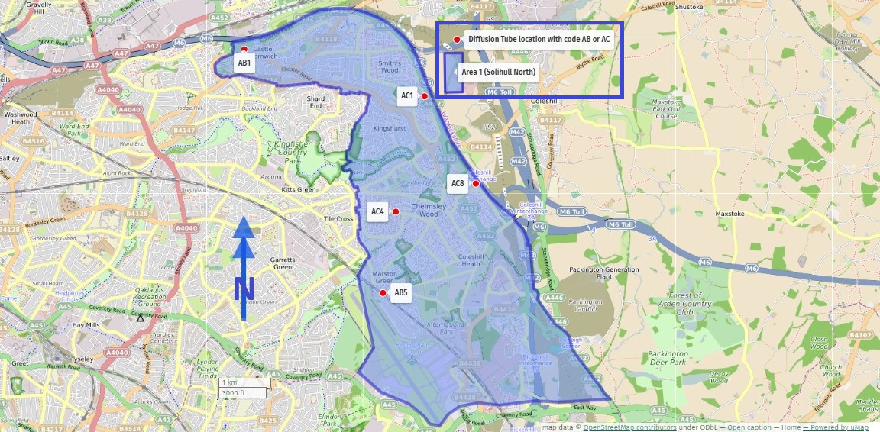
For the locations of all Solihull MBC 31 diffusion tube locations please see Appendix D: Map(s) of Monitoring Locations and AQMAs

Figure A.2 North –Trends in Annual Mean NO₂ Concentrations for Area 1 (North)

Area 1 Trend analysis - Figure A.1 presents NO₂ annual mean concentrations for sites AB1, AB5, AC1, AC4 and AC8 between 2018 and 2024. There are no exceedances of the annual mean objective level of 40 μg/m3 in any year (concentrations are at, or below, the 20 µg/m3 level) and there is a general trend of reduction experienced across the sites.

Figure A.3 Elmdon - Map of Area 2 (Elmdon) Diffusion Tubes
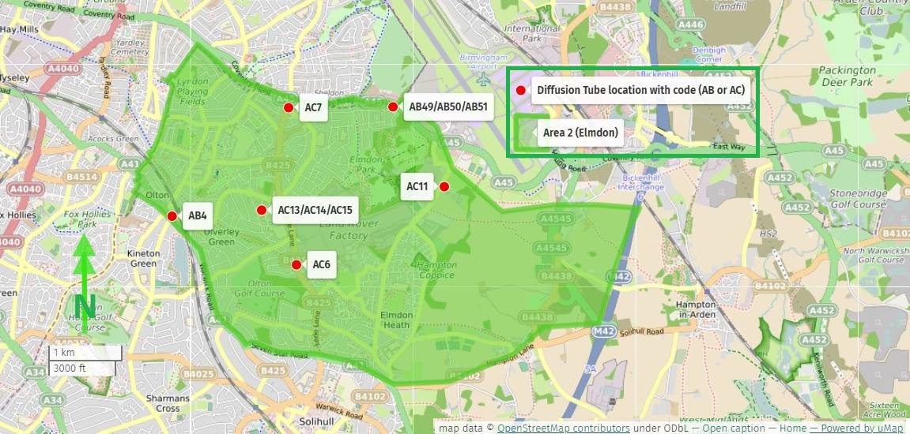
For the locations of all Solihull MBC 31 diffusion tube locations please see Appendix D: Map(s) of Monitoring Locations and AQMAs

Figure A.4 Elmdon – Trends in Annual Mean NO₂ Concentrations for Area 2 (Elmdon)

Area 2 (Elmdon) trend analysis - Figure A.4b presents NO₂ annual mean concentrations for sites AB4, AC6, AC7and AC11, alongside AB49-51 and AC13-15 (triplicate sites), between 2018 and 2024. There are no exceedances of the annual mean objective level of 40 μg/m³ in any year (concentrations are at, or near the 20 µg/m³ level) and there is a general trend of reduction for some sites while other are showing a negligible increase.

Figure A.5 A45 - Map of Area 2 (A45) Diffusion Tubes
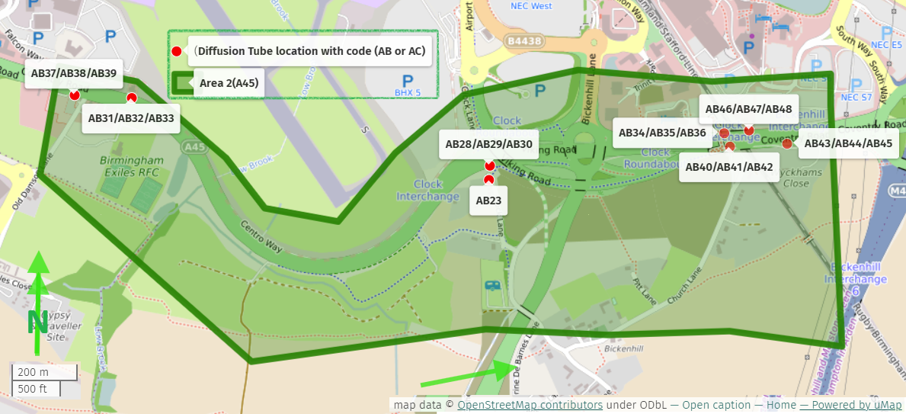
For the locations of all Solihull MBC 31 diffusion tube locations please see Appendix D: Map(s) of Monitoring Locations and AQMAs

Figure A.6 A45 - Trends in Annual Mean NO₂ Concentrations for Area 2 (A45)

Area 2 (A45) trend analysis - Figure A.6d presents NO₂ annual mean concentrations for sites AB23 and triplicate sites: AB28-30, AB31-33, AB34-36, AB37-39, AB40-42, AB43-45, AB46 - 48, between 2019 and 2024. There are no exceedances of the annual mean objective level of 40 μg/m³ in any year. There are reductions in concentrations for some sites, while others are showing a negligible increase. The two highest reporting NO₂ diffusion tube locations within the Solihull borough are AB34-36 and AB46-48, both of these sites are showing a reduction in concentrations of 3 and 2.2 μg/m³ respectively.

Figure A.7 West – Map of Area 3 (West) Diffusion Tubes
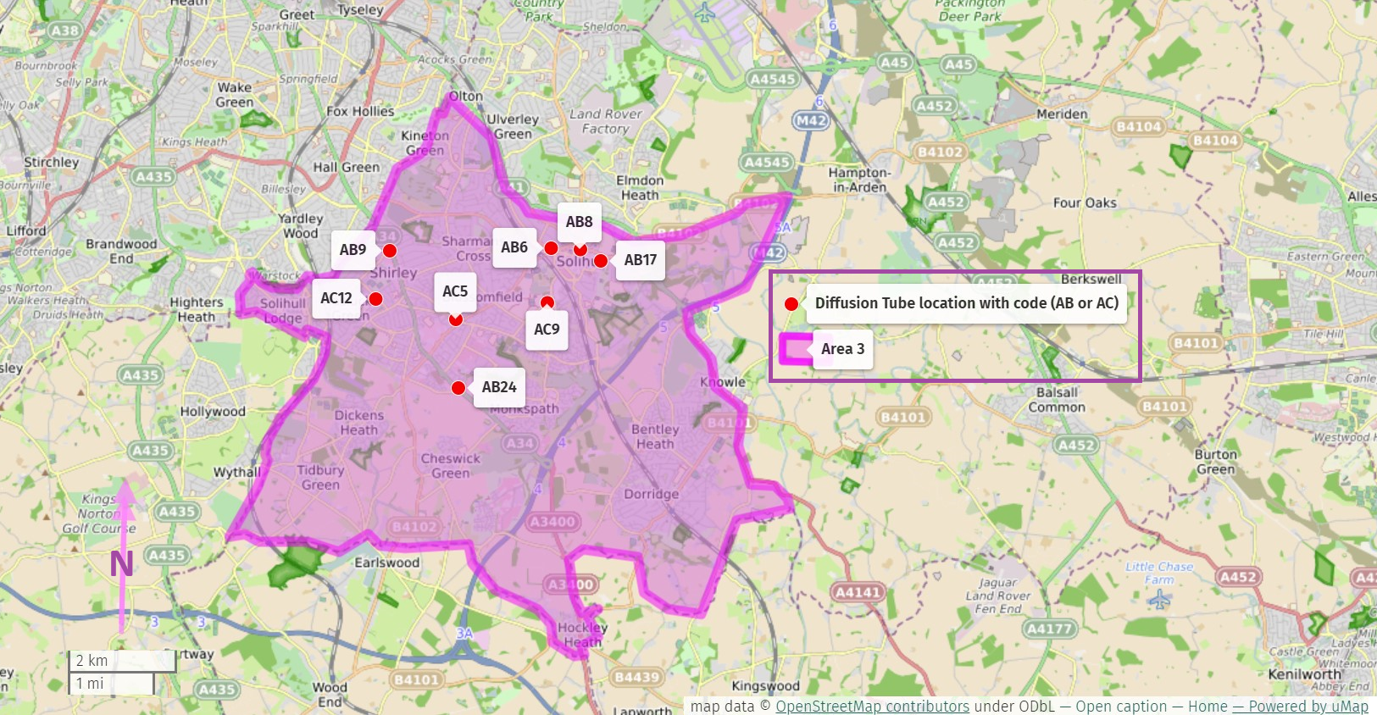
For the locations of all Solihull MBC 31 diffusion tube locations please see Appendix D: Map(s) of Monitoring Locations and AQMAs

Figure A.8 West –Trends in Annual Mean NO₂ concentrations in Area 3 (West)

Area 3 Trend analysis - Figure A.8b presents NO₂ annual mean concentrations for sites AB6, AB8, AB9, AB17, AB24, AC5, AC9 and AC12 between 2018 and 2024. There are no exceedances of the annual mean objective level of 40 μg/m³ in any year (2024 concentrations are now near or below 20 µg/m³). There have not been any increases in concentrations across sites for the past 4 years.

Figure A.9 East – Map of Area 4 (East) Diffusion Tubes
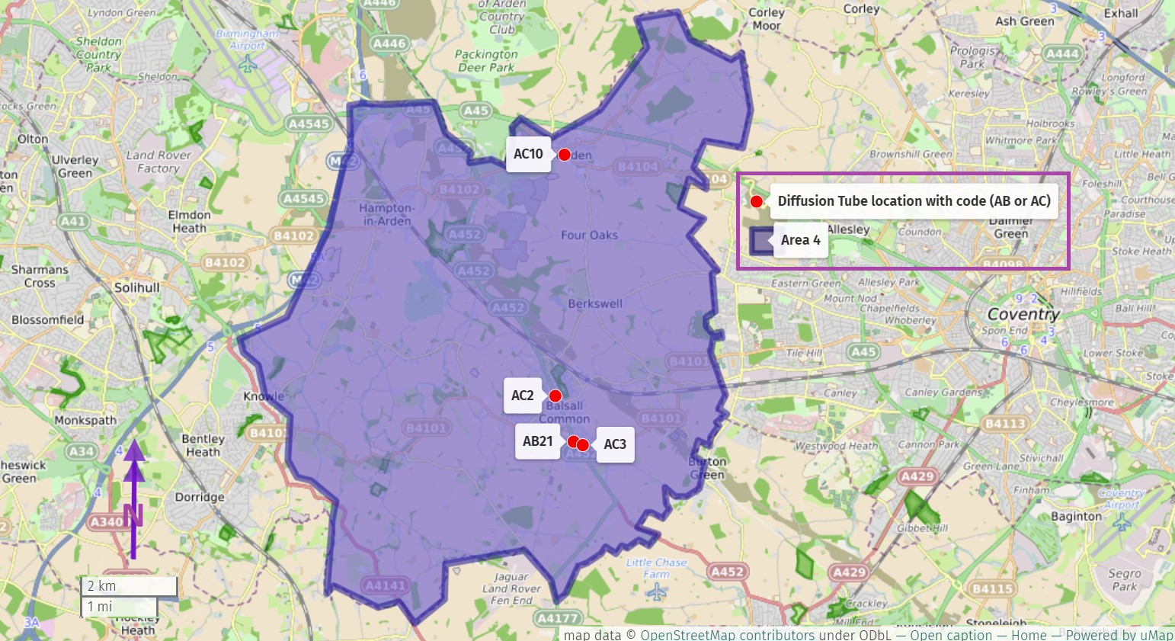

Figure A.10 East – Trends in Annual Mean NO₂ concentrations in Area 4

Area 4 Trend analysis - Figure A.4b presents NO₂ annual mean concentrations for sites AB21, AC2, AC3, and AC10 between 2019 and 2024. There are no exceedances of the annual mean objective level of 40 μg/m3 in any year (2024 concentrations show site concentrations are between 10 and 15 µg/m³). The sites show a general reduction in concentrations across sites for the past 3 years. AB21 is our lowest concentration site which sits behind a very high hedge, Solihull MBC have taken the decision to remove this site from the 2025 monitoring pool so that our sites better represent façade concentrations.

Appendix B: Full Monthly Diffusion Tube Results for 2024
Table B.1 – NO₂ 2024 Diffusion Tube Results (µg/m³)

DT ID | X OS Grid Ref (Easting) | Y OS Grid Ref (Northing) | Jan | Feb | Mar | Apr | May | Jun | Jul | Aug | Sep | Oct | Nov | Dec | Annual Mean: Raw Data | Annual Mean: Annualised and Bias Adjusted  <(x.x)> | Annual Mean: Distance Corrected to Nearest Exposure | Comment
AB1 | 414274 | 289972 | 21.2 | 19.4 | 15.9 | 14.1 | 17.3 | 13.7 | 15.2 | 13.2 | 20.1 | 20.2 | 26.4 | 20.6 | 18.1 | 15.9
AB4 | 413332 | 282209 | 30.7 | 24.1 | 18.9 | 21.4 | 22.6 | 21.3 | 20.5 | 18.8 | 27.1 | 24.0 | 30.3 | 24.9 | 23.7 | 20.9
AB5 | 416937 | 285346 | 17.6 | 16.8 | 15.0 | 13.3 | 12.7 | 13.0 | 15.6 | 14.0 | 17.4 | 20.5 | 21.2 | 15.9 | 16.1 | 14.2
AB6 | 414698 | 279709 | 26.6 | 19.9 | 19.6 | 17.6 | 20.4 | 16.2 | 17.4 | 16.0 | 20.8 | 23.6 | 23.8 | 18.5 | 20.0 | 17.6
AB8 | 415229 | 279699 | 29.8 | 23.1 | 17.5 | 20.3 | 22.5 | 16.0 | 16.9 | 17.0 | 28.7 | 21.8 | 28.6 | 20.5 | 21.9 | 19.3
AB9 | 411740 | 279645 | 30.0 | 25.8 | 23.3 | 22.4 | 26.3 | 23.0 | 23.3 | 19.1 | 27.9 | 26.6 | 30.8 | 22.8 | 25.1 | 22.1
AB17 | 415622 | 279481 | 27.9 | 19.9 | 17.0 | 17.4 | 19.7 | 17.2 |  | 15.8 | 21.8 | 21.3 | 25.6 | 21.4 | 20.5 | 18.0
AB21 | 424203 | 276372 | 14.6 | 11.9 | 9.6 | 7.8 | 9.0 | 5.5 | 6.2 | 4.9 | 10.3 | 11.1 | 16.1 | 11.4 | 9.9 | 8.7
AB23 | 418495 | 282882 | 22.4 | 15.1 | 12.9 | 13.8 | 16.8 | 14.8 | 14.2 | 11.8 | 20.5 | 15.7 | 22.1 | 14.8 | 16.3 | 14.3
AB24 | 413003 | 277140 | 20.9 | 16.4 | 13.6 | 12.0 | 13.2 | 11.2 | 12.3 | 10.7 | 15.4 | 15.9 | 19.0 | 13.5 | 14.5 | 12.8
AB28 | 418502 | 282925 | 33.8 | 26.2 | 20.5 | 24.7 | 26.0 | 24.7 | 23.0 | 17.0 | 33.0 | 24.7 | 35.3 | 24.0 | - | - |  | Triplicate Site with AB28, AB29 and AB30 - Annual data provided for AB30 only
AB29 | 418502 | 282925 | 28.5 | 23.0 | 15.2 | 23.6 | 25.1 | 24.1 | 22.0 | 20.8 | 29.3 | 24.2 | 31.0 | 22.2 | - | - |  | Triplicate Site with AB28, AB29 and AB30 - Annual data provided for AB30 only
AB30 | 418502 | 282925 | 33.2 | 22.8 | 17.7 | 25.2 | 21.8 | 23.0 | 22.4 | 18.7 | 34.4 | 25.0 | 31.5 | 24.3 | 25.0 | 22.0 |  | Triplicate Site with AB28, AB29 and AB30 - Annual data provided for AB30 only
AB31 | 417400 | 283125 | 35.6 | 30.4 | 26.4 | 25.2 | 32.8 | 29.0 | 29.8 | 22.1 | 29.3 | 36.2 | 40.0 | 27.0 | - | - |  | Triplicate Site with AB31, AB32 and AB33 - Annual data provided for AB33 only
AB32 | 417400 | 283125 | 35.1 | 32.0 | 25.6 | 25.9 | 33.6 | 27.6 | 26.2 | 28.8 | 32.4 | 32.6 | 35.9 | 27.7 | - | - |  | Triplicate Site with AB31, AB32 and AB33 - Annual data provided for AB33 only
AB33 | 417400 | 283125 | 30.6 | 31.5 | 29.4 | 26.8 | 33.3 | 29.0 |  | 25.9 | 32.8 | 33.0 | 39.0 | 28.3 | 30.4 | 26.8 |  | Triplicate Site with AB31, AB32 and AB33 - Annual data provided for AB33 only
AB34 | 419216 | 283027 | 39.5 | 39.1 | 37.5 | 33.0 | 37.9 | 32.1 | 39.7 | 33.8 | 30.6 | 42.3 | 39.3 |  | - | - |  | Triplicate Site with AB34, AB35 and AB36 - Annual data provided for AB36 only
AB35 | 419216 | 283027 | 37.2 | 37.6 | 37.2 | 32.8 | 37.8 | 36.9 | 41.3 | 38.7 | 29.7 | 41.3 | 32.1 | 34.1 | - | - |  | Triplicate Site with AB34, AB35 and AB36 - Annual data provided for AB36 only
AB36 | 419216 | 283027 | 38.9 | 40.3 | 31.1 | 28.9 | 40.6 | 35.7 | 39.9 | 36.2 | 35.3 | 43.8 | 41.8 | 31.4 | 36.6 | 32.2 |  | Triplicate Site with AB34, AB35 and AB36 - Annual data provided for AB36 only
AB37 | 417223 | 283137 | 27.0 | 22.7 | 21.0 | 15.6 | 27.5 | 25.1 | 24.1 | 20.8 | 28.7 | 26.5 | 30.0 | 24.4 | - | - |  | Triplicate Site with AB37, AB38 and AB39 - Annual data provided for AB39 only
AB38 | 417223 | 283137 | 32.2 | 22.0 | 23.3 | 23.3 | 25.2 | 26.9 | 24.4 | 19.5 | 29.6 | 27.7 | 32.5 | 22.8 | - | - |  | Triplicate Site with AB37, AB38 and AB39 - Annual data provided for AB39 only
AB39 | 417223 | 283137 | 30.0 | 22.9 | 21.5 | 25.2 | 26.9 | 24.6 | 23.9 | 20.3 | 29.6 | 27.0 | 28.9 | 22.2 | 25.2 | 22.1 |  | Triplicate Site with AB37, AB38 and AB39 - Annual data provided for AB39 only
AB40 | 419228 | 282984 | 31.0 | 22.9 | 23.5 | 28.5 | 33.2 | 26.0 | 25.8 | 22.3 | 42.2 | 28.2 | 33.4 | 27.2 | - | - |  | Triplicate Site with AB40, AB41 and AB42 - Annual data provided for AB42 only
AB41 | 419228 | 282984 | 36.1 | 22.7 | 25.3 | 28.5 | 35.1 | 29.1 | 23.9 | 23.1 | 40.9 | 30.9 | 38.4 | 26.3 | - | - |  | Triplicate Site with AB40, AB41 and AB42 - Annual data provided for AB42 only
AB42 | 419228 | 282984 | 29.2 | 23.6 | 23.6 | 28.9 | 32.7 | 25.9 | 24.4 | 21.7 | 43.1 | 27.7 | 35.5 | 26.3 | 29.1 | 25.6 |  | Triplicate Site with AB40, AB41 and AB42 - Annual data provided for AB42 only
AB43 | 419409 | 282998 | 40.5 | 27.8 | 28.5 | 23.4 | 39.3 | 31.6 | 29.1 | 26.4 | 30.4 | 34.7 | 34.5 | 25.9 | - | - |  | Triplicate Site with AB43, AB44 and AB45 - Annual data provided for AB45 only
AB44 | 419409 | 282998 | 38.6 | 25.8 | 27.9 | 32.6 | 38.2 | 32.9 | 29.2 | 25.0 | 45.6 | 34.9 | 32.9 | 29.0 | - | - |  | Triplicate Site with AB43, AB44 and AB45 - Annual data provided for AB45 only
AB45 | 419409 | 282998 | 40.4 | 25.4 | 24.0 | 29.5 | 37.4 | 29.5 | 29.4 | 24.2 | 40.8 | 34.4 | 40.1 | 28.7 | 31.9 | 28.1 |  | Triplicate Site with AB43, AB44 and AB45 - Annual data provided for AB45 only
AB46 | 419282 | 283028 | 37.6 | 43.7 | 38.4 | 36.6 | 42.9 | 44.6 | 46.4 | 36.2 | 38.2 | 48.6 | 46.8 | 35.5 | - | - |  | Triplicate Site with AB46, AB47 and AB48 - Annual data provided for AB48 only
AB47 | 419282 | 283028 | 42.1 | 39.7 | 39.7 | 34.2 | 44.3 | 45.4 | 44.9 | 38.5 | 33.5 | 46.0 | 39.9 | 37.9 | - | - |  | Triplicate Site with AB46, AB47 and AB48 - Annual data provided for AB48 only
AB48 | 419282 | 283028 | 41.1 | 40.3 | 38.5 | 36.4 | 41.9 | 42.8 | 43.1 | 43.8 | 39.0 | 47.1 | 37.6 | 28.3 | 40.6 | 35.7 |  | Triplicate Site with AB46, AB47 and AB48 - Annual data provided for AB48 only
AB49 | 416282 | 283689 | 26.0 | 21.6 | 15.8 | 14.9 | 14.5 | 10.3 | 12.4 | 11.2 | 20.1 | 20.5 | 24.0 | 21.6 | - | - |  | Triplicate Site with AB49, AB50 and AB51 - Annual data provided for AB51 only
AB50 | 416282 | 283689 | 24.0 | 21.2 | 16.5 | 16.0 | 16.4 | 10.0 | 12.0 | 11.2 | 18.3 | 21.5 | 24.5 | 22.7 | - | - |  | Triplicate Site with AB49, AB50 and AB51 - Annual data provided for AB51 only
AB51 | 416282 | 283689 | 25.1 | 20.3 | 15.9 | 14.7 | 16.5 | 11.0 | 12.4 | 11.1 | 18.3 | 19.4 | 28.4 | 21.3 | 17.8 | 15.7 |  | Triplicate Site with AB49, AB50 and AB51 - Annual data provided for AB51 only
AC1 | 417716 | 289086 | 22.6 | 19.9 | 19.1 | 18.0 | 20.5 | 11.0 | 17.0 |  | 19.3 | 24.5 | 28.3 | 20.1 | 20.0 | 17.6
AC2 | 423813 | 277291 | 14.2 | 11.9 | 11.8 | 9.8 | 12.1 | 6.0 | 9.4 | 6.4 | 12.0 | 13.5 | 20.5 | 10.7 | 11.5 | 10.1
AC3 | 424386 | 276292 | 15.0 | 10.8 | 9.2 | 7.9 | 9.0 | 7.5 | 7.7 | 6.8 | 10.5 | 10.4 | 16.5 | 8.5 | 10.0 | 8.8
AC4 | 417180 | 286880 | 22.6 | 19.8 | 15.7 | 13.2 | 16.9 | 12.8 | 15.0 | 12.0 | 15.9 | 21.7 | 21.6 | 15.2 | 16.9 | 14.9
AC5 | 412966 | 278409 | 24.6 | 19.0 | 16.9 | 15.5 | 17.3 | 13.2 | 13.8 | 10.3 | 17.7 | 16.7 | 24.3 | 13.8 | 16.9 | 14.9
AC6 | 415001 | 281564 | 25.2 | 19.7 | 14.5 | 15.6 | 13.7 | 12.3 | 13.2 | 12.1 | 14.8 | 17.3 | 20.7 | 16.6 | 16.3 | 14.3
AC7 | 414894 | 283671 | 28.8 |  | 13.2 | 19.9 | 21.6 | 18.1 | 19.6 | 16.1 | 21.2 | 20.6 | 28.9 | 20.9 | 20.8 | 18.3
AC8 | 418705 | 287436 | 21.6 | 17.1 | 15.9 | 14.1 | 19.4 | 11.6 | 13.9 | 11.6 | 17.6 | 20.4 | 24.3 | 17.1 | 17.0 | 15.0
AC9 | 414644 | 278698 | 14.0 | 13.1 | 8.2 | 8.5 | 10.5 | 6.9 | 8.4 | 7.1 | 11.3 | 13.8 | 15.3 | 10.4 | 10.6 | 9.3
AC10 | 423979 | 282210 | 20.0 | 21.9 | 15.2 | 17.2 | 17.6 | 16.9 | 16.2 | 17.2 | 18.6 | 22.3 | 28.8 | 17.4 | 19.1 | 16.8
AC11 | 416984 | 282619 | 21.0 | 13.8 | 11.8 | 12.2 | 13.0 | 10.9 | 11.3 | 9.2 | 14.4 | 14.1 | 19.8 | 12.4 | 13.7 | 12.0
AC12 | 411493 | 278780 | 18.9 | 14.4 | 12.1 | 10.9 | 11.5 | 7.5 | 8.8 | 7.7 | 13.1 | 14.1 | 18.7 | 13.9 | 12.7 | 11.1
AC13 | 414535 | 282293 | 15.5 | 14.4 | 13.4 | 9.2 | 10.7 | 7.6 | 8.9 | 7.2 | 14.0 | 15.1 | 12.3 | 15.1 | - | - |  | Triplicate Site with AC13, AC14 and AC15 - Annual data provided for AC15 only
AC14 | 414535 | 282293 |  | 15.1 | 11.5 | 10.2 |  | 7.9 | 8.6 | 8.6 | 13.8 | 14.1 | 20.9 | 12.4 | - | - |  | Triplicate Site with AC13, AC14 and AC15 - Annual data provided for AC15 only
AC15 | 414535 | 282293 | 17.1 | 14.3 | 13.3 | 10.1 |  | 8.1 | 8.8 | 8.2 | 15.4 | 15.3 | 19.9 | 13.0 | 12.4 | 10.9 |  | Triplicate Site with AC13, AC14 and AC15 - Annual data provided for AC15 only
☒ All erroneous data has been removed from the NO₂ diffusion tube dataset presented in Table B.1
☒ Annualisation has been conducted where data capture is <75% and >25% in line with LAQM.TG22
☐ Local bias adjustment factor used
☒ National bias adjustment factor used
☒ Where applicable, data has been distance corrected for relevant exposure in the final column
☒ Solihull MBC confirm that all 2024 diffusion tube data has been uploaded to the Diffusion Tube Data Entry System
Notes:
Exceedances of the NO₂ annual mean objective of 40µg/m³ are shown in bold.
NO₂ annual means exceeding 60µg/m³, indicating a potential exceedance of the NO₂ 1-hour mean objective are shown in bold and underlined.
See Appendix C for details on bias adjustment and annualisation.

Appendix C: Supporting Technical Information / Air Quality Monitoring Data QA/QC

New or Changed Sources Identified Within Solihull MBC 2024

A number of sources were identified by Solihull in our 2023 ASR (2022 data) as providing a potential to impact air quality. Some of these sources remain in 2023, and may include sources that are already operational, have planning permission granted or have been identified at an earlier stage of the planning process. Sources may include additional road traffic, static or standby plant, biomass, or industrial processes, etc.

The M42 Junction 6 Development Consent Order (DCO) 2020
The scheme has been in development since March 2016 with a DCO application being made at the end of 2018, with a hearing held between May and November 2019. The Examining Authority’s (ExA) recommendations on the scheme were submitted to the Secretary of State (SoS) for Transport in February 2020 and the SoS’s decision (one of granted consent) was published on the 21st of May 2020.
It is not known if the construction phases of the scheme (or related traffic management and lane closures etc.) has affected air quality however there are a number of diffusion tubes local to this scheme that should capture any increased pollution potential.

HS2
HS2 is one of the largest infrastructure projects ever undertaken in this country, and will transform connectivity and economic performance at local, regional, and national levels. Solihull will be served by a new HS2 station, which will function as a hub for the wider region; consequently, generating significant numbers of access and egress trips to destinations both in the immediate vicinity of the station, and also places further afield in the West Midlands and beyond.
To make the most of the opportunity presented by HS2, SMBC has created UK Central which is an economic development programme that seeks to capitalise on the opportunities afforded to the Borough by HS2 and wider growth plans.
While these growth and development plans provide a rare opportunity for significant economic growth and benefits for Solihull, it is vital to ensure the extra trips generated by these developments do not have an adverse impact on the transport network and environment. It is therefore important that Solihull works closely with its neighbours.

Other
Planning applications have been given approval for a number of major developments in the borough, these can be found by following the link below and by typing in the application number PL/…../… link: Solihull Council planning application search.

PL/2024/01189/VAR - Amendments to reserved matters permission dated 24.11.2023 (PL/2022/01660/PPRM) for the erection of residential dwellings with parking, internal access roads, landscaping and all other details required by condition No. 1 relating to the reserved matters of landscaping, appearance, layout and scale pursuant to planning permission reference PL/2022/01812/VAR. Namely: Modifications to layout and landscaping.
Land Rear Of 86 Meriden Road, Hampton in Arden, Solihull

PL/2023/02360/VAR - Variation of Condition 1 following planning permission dated 27th October 2022 (PL/2022/01395/PPFL) for Demolition of the original public house and the erection of ten semi-detached, three bedroomed, two storey dwellings. NAMELY: for minor material changes to floor plans and materials.
The Punch Bowl, 1 Wheeley Moor Road, Kingshurst, Solihull B37 6LB

PL/2023/02054/VAR - Remove condition Nos. 21 (private rental only) and 22 (management company details) on planning approval PL/2021/03246/PPFL for the demolition of 64-66 Station Road and redevelopment to provide gateway building with commercial space at ground floor level and up to 50 apartments with shared facilities and roof garden (Resubmission of PL/2023/01617/VAR).
Development Site 20 - 66 Station Road, Solihull, B91 3RX

PL/2023/01173/PPOL - Outline application for residential development for the construction of up to 95 dwellings with associated infrastructure and open space with all matters reserved except access.
Oak Farm, Hampton Lane, Catherine De Barnes, Solihull, B92 0JB

PL/2022/02282/PPFL - Development of 75 affordable dwellings and associated works on land at Maxstoke Lane, Meriden.
Land Off Maxstoke Lane, Meriden, Solihull

PL/2022/01274/PPFL - Ground and first floor extensions to the former Arran Medical Centre to form 14 No. apartments with associated landscaping and parking.
Arran Medical Centr, Mull Croft, Smiths Wood, Solihull, B36 0PU

PL/2023/02519/PPFL - Retrospective application for the reduction in overall footprint with the removal of the main workshop and replacement of two smaller workshops; revised footprint of the proposed office building; and additional welfare facilities including two toilet blocks, a canteen and GPS and training facility following planning approval PL/2020/01612/PPFL.
Berkswell Quarry, Cornets End Lane, Meriden, Solihull CV7 7LH

PL/2024/00062/PPFL - Ground mounted solar development including extension to clubhouse for a plant room and associated works.
1220 Warwick Road, Knowle, Solihull, B93 9LN

PL/2024/00011/PPFL - 48-bedroom extension to the existing Village Hotel Solihull including reconfiguration of the existing car park, landscaping and associated works.
De Vere Village Hotel, Dog Kennel Lane, Shirley, Solihull, B90 4JG

PL/2023/02358/VAR - Variation of Condition 1 (drawings) and 9 (removal of buildings) of planning permission dated 24th March 2023(PL/2022/01187/PPFL) for development at the existing garden centre and commercial horticultural nursery incorporating new polytunnels, kiosk and two barns and landscaping/maintenance services. NAMELY: for changes to layout and retention of buildings.
Hampton Garden Nurseries, Eastcote Lane, Hampton in Arden, Solihull, B92 0AS

PL/2023/02228/PPFL - Erection of boarding queuing area.
Terminal Building, Airport Way, Birmingham Airport, Solihull, B26 3RT

PL/2023/02079/MAJFOT - 14 bay golf driving range, video room, ball wash, entrance reception.
West Midlands Golf Club, Marsh House Farm Lane, Barston, Solihull, B92 0LB

PL/2023/02066/MAROT - Reserved Matters application under the Town and Country Planning (Development Management Procedure) (England) Order 2015 (as amended) for: Details of access, appearance, landscaping and layout for the provision of car parking (excluding short stay, taxi and drop-off parking) in connection with High Speed Rail Interchange Station.
HS2 Site Off Chester Road, Bickenhill, Solihull

PL/2023/01964/PPFL - Retention of existing sports pitch, change of use of agricultural land to sports pitches and erection of clubhouse, maintenance shed and provision of parking, landscaping, lighting columns, nets and associated external works.
John Mitchels Gaelic Football Club, Box Trees Farm, 253 Stratford Road, Hockley Heath, Solihull,

PL/2023/01937/VAR - Amendments to planning permission dated 29.04.2022 (PL/2021/03072/MAJFDW) for demolition of existing local centre and development of new mixed-use local centre including up to 79 residential units (including a new vicarage) (Use Class C3), retail, commercial, business and services and healthcare (Use Class E (a) ,(b), (c), (d), (e), (f), (g) (i)), hot food take-away (Sui generis), and local community uses (Use Class F1 and F2 (a), (b)), open space, landscaping, car parking and associated infrastructure. Namely A: amendments to the layout and design of Phase 1 (former Mountford Public House site), B: part-discharge condition 3 (materials), 14 (external lighting), 27 (surface water run off), 28 (surface water flood risk), 29 (surface water management plan) and 41 (hard and soft landscaping of Drainage/POS) insofar as they relate to Phase 1, and C: amend wording of condition 21 (cycle link) and 44 (hard and soft landscape-Kingshurst Park)
Kingshurst Village Centre & Former Mountford Public House, Marston Green

PL/2023/01915/PPFL – The erection of two lightweight buildings on existing areas of carparking, including new soft landscaping and ancillary works.
Jaguar Land Rover, Lode Lane, Solihull, B92 8NM

PL/2023/01326/PPFL - Full Planning Application for a proposed Eco-Resort within woodland including the installation of 59 No. pods and reception modular building (with multi-functional, think tank and social / gathering spaces, offices, storage and plant room, and bathroom and WCs), and provision of drop-off parking area, service yard and vehicular access, communal areas, enhancement of woodland and woodland glade, and associated works.
The Rough, National Exhibition Centre, Pendigo Way, Solihull

PL/2022/00064/PPFL - Refurbishment and upgrade works to existing St John's Way shopping centre to provide 17 No. retail units (Use Class E) at the ground floor level with some first floor storage space, 28 No. residential apartments at the first floor level and the formation of a second floor to provide 19 No. residential apartments, car parking, landscaping and all other associated works. Demolition, including of two No. existing over passes.
St Johns Way Shopping Centre, St Johns Way, Knowle, Solihull, B93 0LE

Additional Air Quality Works Undertaken by Solihull MBC During 2024

Solihull have recently been advised that updates to WMAir high resolution Atmospheric Dispersion Model System (ADMS) models of both Solihull and the wider West Midlands area (2019 baseline data) are being reviewed, given findings of validation and verification investigations. We await further update on these matters.

QA/QC of Diffusion Tube Monitoring

Diffusion Tube Annualisation
All diffusion tube monitoring locations within Solihull MBC recorded data capture of 75% therefore it was not required to annualise any monitoring data. In addition, any sites with a data capture below 25% do not require annualisation

Diffusion Tube Bias Adjustment Factors
The diffusion tube data presented within the 2025 ASR have been corrected for bias using an adjustment factor. Bias represents the overall tendency of the diffusion tubes to under or over-read relative to the reference chemiluminescence analyser. LAQM.TG22 provides guidance with regard to the application of a bias adjustment factor to correct diffusion tube monitoring. Triplicate co-location studies can be used to determine a local bias factor based on the comparison of diffusion tube results with data taken from NO_{x}/NO₂ continuous analysers. Alternatively, the national database of diffusion tube co-location surveys provides bias factors for the relevant laboratory and preparation method.
Solihull MBC have applied a national bias adjustment factor of 0.88 to the 2024 monitoring data. A summary of bias adjustment factors used by Solihull MBC over the past five years is presented in Table C.1. We have used a national bias adjustment factor for our 2024 data because we do not have any appropriate real time / automatic monitoring stations within our borough. There is a monitoring station at Birmingham Airport however no tubes are co-located there. As such we rely on national laboratory bias adjustment.
The council have used the National Diffusion Tube Bias Adjustment Factor Spreadsheet, Version Number 06/25. The relevant spreadsheet field entries are:

Gradko; 50% TEA in acetone; 2024; Overall Factor (12 studies); Use and 0.88
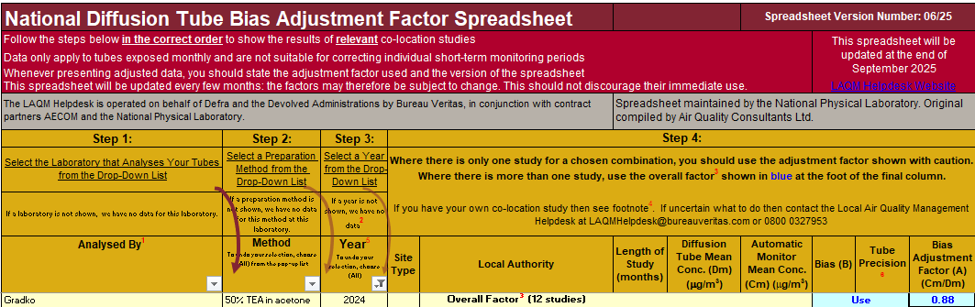
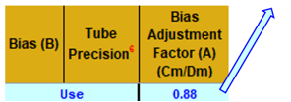
Table C.1 – Bias Adjustment Factor
Monitoring Year | Local or National | If National, Version of National Spreadsheet | Adjustment Factor
2024 | National | 04/25 | 0.88
2023 | National | 03/24 | 0.83
2022 | National | 03/23 | 0.82
2021 | National | 9/22 | 0.82
2020 | National | 06/21 | 0.83

NO₂ Fall-off with Distance from the Road
Wherever possible, monitoring locations are representative of exposure. However, where this is not possible, the NO₂ concentration at the nearest location relevant for exposure has been estimated using the Diffusion Tube Data Processing Tool/NO₂ fall-off with distance calculator via LAQM Support website. Where appropriate, non-automatic annual mean NO₂ concentrations corrected for distance are presented in Table B.1.
No diffusion tube NO₂ monitoring locations within Solihull MBC required distance correction during 2024.

QA/QC of Automatic Monitoring
No automatic monitoring carried out by Solihull MBC in 2024.

Appendix D: Map(s) of Monitoring Locations and AQMAs
Figure D.1a – Map of Non-Automatic Monitoring Sites
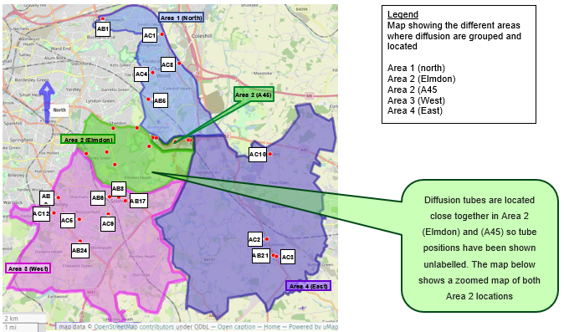
Figure D.2b – Map of Non-Automatic Monitoring Sites; Area 2 (Elmdon) and Area 2 (A45)

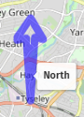


Appendix E: Summary of Air Quality Objectives in England
Table E.1 – Air Quality Objectives in England
Pollutant | Air Quality Objective: Concentration | Air Quality Objective: Measured as
Nitrogen Dioxide (NO₂) | 200µg/m³ not to be exceeded more than 18 times a year | 1-hour mean
Nitrogen Dioxide (NO₂) | 40µg/m³ | Annual mean
Particulate Matter (PM₁₀) | 50µg/m³, not to be exceeded more than 35 times a year | 24-hour mean
Particulate Matter (PM₁₀) | 40µg/m³ | Annual mean
Sulphur Dioxide (SO₂) | 350µg/m³, not to be exceeded more than 24 times a year | 1-hour mean
Sulphur Dioxide (SO₂) | 125µg/m³, not to be exceeded more than 3 times a year | 24-hour mean
Sulphur Dioxide (SO₂) | 266µg/m³, not to be exceeded more than 35 times a year | 15-minute mean

Glossary of Terms
Abbreviation | Description
AQAP | Air Quality Action Plan - A detailed description of measures, outcomes, achievement dates and implementation methods, showing how the local authority intends to achieve air quality limit values’
AQMA | Air Quality Management Area – An area where air pollutant concentrations exceed / are likely to exceed the relevant air quality objectives. AQMAs are declared for specific pollutants and objectives
ASR | Annual Status Report
Defra | Department for Environment, Food and Rural Affairs
DMRB | Design Manual for Roads and Bridges – Air quality screening tool produced by National Highways
LAQM | Local Air Quality Management
NO₂ | Nitrogen Dioxide
NO_{x} | Nitrogen Oxides
PM₁₀ | Airborne particulate matter with an aerodynamic diameter of 10µm or less
PM_{2.5} | Airborne particulate matter with an aerodynamic diameter of 2.5µm or less
QA/QC | Quality Assurance and Quality Control
SO₂ | Sulphur Dioxide

References
- Local Air Quality Management Technical Guidance LAQM.TG22. August 2022. Published by Defra in partnership with the Scottish Government, Welsh Assembly Government and Department of the Environment Northern Ireland.
- Local Air Quality Management Policy Guidance LAQM.PG22. August 2022. Published by Defra in partnership with the Scottish Government, Welsh Assembly Government and Department of the Environment Northern Ireland.
- Chemical hazards and poisons report: Issue 28. June 2022. Published by UK Health Security Agency
- Air Quality Strategy – Framework for Local Authority Delivery. August 2023. Published by Defra.

Defra. Air Quality Strategy – Framework for Local Authority Delivery, August 2023
The units are in microgrammes of pollutant per cubic metre of air (µg/m³).

