

2024 Air Quality Annual Status Report (ASR)

In fulfilment of Part IV of the Environment Act 1995 Local Air Quality Management, as amended by the Environment Act 2021

Date: June 2024

|  |  |
| --- | --- |
| Information | Waverley Borough Council Details |
| **Local Authority Officer** | Jeanette Guy |
| **Department** | Environmental and Regulatory Services |
| **Address** | Waverley Borough Council, The Burys, Godalming, Surrey, GU7 1HR |
| **Telephone** | 01483 523005 |
| **E-mail** | [Jeanette.guy@waverley.gov.uk](mailto:Jeanette.guy@waverley.gov.uk) |
| **Report Reference Number** | Waverley ASR 2024 (Issue 1) |
| **Date** | June 2024 |

# Executive Summary: Air Quality in Our Area

## Air Quality in Waverley Borough Council

Breathing in polluted air affects our health and costs the NHS and our society billions of pounds each year. Air pollution is recognised as a contributing factor in the onset of heart disease and cancer and can cause a range of health impacts, including effects on lung function, exacerbation of asthma, increases in hospital admissions and mortality. In the UK, it is estimated that the reduction in healthy life expectancy caused by air pollution is equivalent to 29,000 to 43,000 deaths a year[1].

Air pollution particularly affects the most vulnerable in society, children, the elderly, and those with existing heart and lung conditions. Additionally, people living in less affluent areas are most exposed to dangerous levels of air pollution[2].

Table ES 1 provides a brief explanation of the key pollutants relevant to Local Air Quality Management and the kind of activities they might arise from.

Table ES - Description of Key Pollutants

|  |  |
| --- | --- |
| Pollutant | Description |
| Nitrogen Dioxide (NO2) | Nitrogen dioxide is a gas which is generally emitted from high-temperature combustion processes such as road transport or energy generation. |
| Sulphur Dioxide (SO2) | Sulphur dioxide (SO2) is a corrosive gas which is predominantly produced from the combustion of coal or crude oil. |
| Particulate Matter  (PM10 and PM2.5) | Particulate matter is everything in the air that is not a gas.  Particles can come from natural sources such as pollen, as well as human made sources such as smoke from fires, emissions from industry and dust from tyres and brakes.  PM10 refers to particles under 10 micrometres. Fine particulate matter or PM2.5 are particles under 2.5 micrometres. |

Waverley is situated in the south-western corner of Surrey, the Borough is largely rural with four main populations centres: Farnham, Godalming, Haslemere and Cranleigh. Air quality within the Borough is generally good, but there are hotspots of pollution caused by elevated levels of nitrogen dioxide. Road traffic has been recognised as the major pollution source for nitrogen dioxide with the greatest effects in the largest population centres within the Borough.

Two main trunk roads cross Waverley; the A31 Guildford to Bere Regis (Dorset) and the A3 London to Portsmouth dual carriageways. The latter includes the Hindhead Tunnel which opened in August 2011 in order to relieve serious congestion on the A3 route in Hindhead.

Previous air quality assessments have concluded that concentrations of carbon monoxide, benzene, 1-3 butadiene, lead, sulphur dioxide (SO2) and particulates (PM10) are compliant with UK Air Quality Objectives (AQOs). However, concentrations of nitrogen dioxide (NO2) have been found to exceed the annual mean AQO at various locations within the Borough.

Waverley Borough Council (WBC) declared three Air Quality Management Areas (AQMAs) in 2005 in Farnham, Godalming and Hindhead. The 2005 Order was varied in 2007 when the Farnham AQMA was extended. The AQMAs were all directly attributed to exceedances of the annual mean AQO for NO2 due to traffic congestion. The AQMA in Hindhead was subsequently revoked in 2015 after completion of the Hindhead Tunnel project. Further information about the AQMAs in Waverley can be found at: <https://uk-air.defra.gov.uk/aqma/local-authorities?la_id=299>

Additionally, fine particulate pollution (PM2.5) is a concern across the Borough given health impacts, although there is no local AQO for PM2.5. Domestic sources make the largest contribution to primary local emissions. Other important sources include non-exhaust road traffic and the industry, agriculture and commercial sectors.

In 2023, most locations (50 out of 51 measuring NO2 by diffusion tube in both 2022 and 2023), the NO2 concentrations measured were lower than those measured in 2022. The only site which measured an increase in 2023 compared to 2022 was WBC45 (Windrush House Horsham Road) where the annual mean concentration increased from 21 µg m-3 to 21.2 µg m-3. As with 2022, the largest measured concentration occurred for WBC9 (29/30 The Borough) where the 2023 concentration was 32 µg m-3, although this was a decrease from 35.6 µg m-3 in 2022.

The NO2 annual mean concentration was below the 40 µg m-3 annual mean AQO within both AQMAs and all locations across the Borough.

In 2023, the annual mean NO2 concentrations measured by the automatic analysers in Farnham (South Street) and Godalming (Ockford Road 2) were 18 and 19 µg m-3 respectively, significantly below the annual mean objective concentration. This is a decrease from the 2022 annual mean NO2 concentrations which were 20 µg m-3 at both monitoring locations. At the national level, the annual mean concentration of NO2 at the roadside in 2023 were 21.8 µg m­­-3 which is their lowest point in the timeseries[3]. The annual means measured at Farnham and Godalming in 2023 are therefore below this concentration whilst they follow the same trend observed at the national level, decreasing from the 2022 measured concentrations. There were also no exceedances of the hourly NO2 mean objective at either site.

The PM10 annual mean concentration measured in Farnham in 2023 was 16 µg m-3, which is an increase from 14 µg m-3 in 2022, however this is significantly below the annual mean AQO of 40 µg m-3. The annual mean concentration in 2023 at Farnham is comparable to the national annual mean of 15.6 µg m-3 in 2023 for roadside sites[4]. There were also no exceedances of the short-term AQOs.

## Actions to Improve Air Quality

Whilst air quality has improved significantly in recent decades, there are some areas where local action is needed to protect people and the environment from the effects of air pollution.

The Environmental Improvement Plan[5] sets out actions that will drive continued improvements to air quality and to meet the new national interim and long-term targets for fine particulate matter (PM2.5), the pollutant of most harmful to human health. The Air Quality Strategy[6] provides more information on local authorities' responsibilities to work towards these new targets and reduce fine particulate matter in their areas.

The Road to Zero[7] details the Government’s approach to reduce exhaust emissions from road transport through a number of mechanisms, in balance with the needs of the local community. This is extremely important given that cars are the most popular mode of personal travel and the majority of AQMAs are designated due to elevated concentrations heavily influenced by transport emissions.

An updated [Air Quality Action Plan](https://www.waverley.gov.uk/Services/Environmental-concerns/Pollution-control/Air-quality/Air-Quality-Action-Plan-and-Clean-Air-Strategy) (AQAP) to reduce nitrogen dioxide in the Farnham and Godalming AQMAs was adopted in May 2023. We are working closely with Surrey County Council (SCC) and others, and plan to:

* Support the Town Centre changes within the Farnham Infrastructure Programme
* Support and implement the Farnham Town Centre Local Cycling and Walking Improvement Plan (LCWIP)
* Encourage Electric Vehicles in Farnham and Godalming through EV infrastructure improvements, including the uptake of EV taxis and buses.
* Provide a consistent process for air quality assessments for developments likely to impact on air quality, including committed development within and outside Waverley.

To complement the AQAP, and to consider measures more widely across Waverley, in May 2023, we adopted a [Clean Air Strategy (CAS)](https://www.waverley.gov.uk/Portals/0/Documents/services/environmental-concerns/pollution-control/air%20quality/FINAL%20CAS%20221130%20Clean%20Air%20Strategy%20Final.pdf?ver=mQNheRWzykuU641Hp6vjEQ%3d%3d) to reduce nitrogen dioxide and fine particulates across the Borough. In addition to our own commitments as a council, the strategy encourages collaboration and outlines actions which all of us can take. By developing a clean air strategy, the council seeks to: demonstrate leadership in improving air quality, work collaboratively with partners to improve air quality within the borough, and support and enable behaviour change to improve air quality directly.

WBC will continue to take steps towards implementing measures to improve air quality. We also work jointly with others through the Waverley Air Quality Steering Group, Farnham Infrastructure Board, Surrey Air Alliance (SAA), and internally within WBC. We encourage everyone to take responsibility for improving the quality of the air we breathe.

By acting together to reduce emissions of nitrogen dioxide and fine particulates we can improve air quality across the borough.

## Conclusions and Priorities

At the vast majority of monitoring sites, measured levels of NO2 across Waverley in 2023 were below those measured in 2022 with an average decrease across all sites of 10.5%. The highest annual mean concentration measured in Waverley was comfortably below the AQO.

Monitoring should continue to check annual mean NO2 levels against the AQO in the next few years and ensure the ongoing measures in the AQAP and CAS are achieving success. The need for the AQMA in Godalming and AQMA in Farnham should be reviewed.

Key completed measures in 2023 were:

* New [Air Quality Action Plan and Clean Air Strategy](https://www.waverley.gov.uk/Services/Environmental-concerns/Pollution-control/Air-quality/Air-Quality-Action-Plan-and-Clean-Air-Strategy) adopted in May 2023.
* Work undertaken in Farnham as part of the [Farnham Infrastructure Programme](https://www.surreycc.gov.uk/roads-and-transport/policies-plans-consultations/major-transport-projects/farnham-infrastructure-programme).
* Supported various programmes to improve provision of EVCPs in Waverley.
* A blue background with orange text

  Description automatically generatedWBC, in partnership with SCC (and through the Surrey Air Alliance (SAA) as a founder supporter), participated in the first Clean Air Night Campaign on Wednesday 24 January 2024, [Clean Air Night | Global Action Plan (actionforcleanair.org.uk)](https://www.actionforcleanair.org.uk/campaigns/clean-air-night).
* Work to progress the Defra funded project to provide low-cost trials of EV taxis to promote their uptake.
* Through the SAA we worked with Surrey Heartlands Integrated Care Board (ICB) to support the implementation of a paediatric toolkit for parents and schools, including promoting the Schools’ Air Quality Monitoring for Health and Education project, [SAMHE](https://samhe.org.uk/).
* Working with SCC and Town and Parish Councils, and local active travel groups, to develop [Local Cycle and Walking Infrastructure Plans (LCWIPs) for Farnham and Waverley](https://www.waverley.gov.uk/Services/Environmental-concerns/Sustainability-and-conservation/Active-travel-could-you-walk-or-cycle).
* Initiatives encouraging active travel in schools were taken forward by SCC working with the SAA, including Improving road safety outside schools, Promoting School Travel Plans through Modeshift Stars, Bikeability Training, Feet First Walking Training, School Crossing Patrols, Eco-Schools, and Lets Go Zero.
* In September 2023 [Surrey Connect, an on demand bus service, was launched in Farnham and Cranleigh](https://www.waverley.gov.uk/Council-updates/Read-our-latest-news/on-demand-bus-service-launches-in-farnham-and-cranleigh) to make it easier to access public transport in those areas.
* Actions contributed towards meeting the [Council’s Carbon Neutrality Action Plan](https://www.waverley.gov.uk/Portals/0/Documents/services/environmental-concerns/conservation-and-sustainability/Accessible%20PDF%20CNAP%202023%20update%20V4%20August%202023.pdf?ver=BdU1aZLJ6iTBCwH-9qgidg%3d%3d).

WBC priorities for 2024 are:

* Work with the Farnham Board to take actions forward to improve air quality in Farnham.
* Support ongoing projects to install EV charging points in Waverley.
* Work to take forward the Defra grant funded project across Surrey to provide low-cost trials of EV taxis to promote their uptake.
* Undertake work to investigate the feasibility of LEZs within Waverley, including completing ANPR surveys in Farnham and Godalming
* Through the SAA continue to work with Surrey Heartlands ICB to promote the parents and schools’ paediatric asthma toolkits, including supporting schools who have registered with SAMHE.
* Progress the LCWIPs for Farnham and Waverley and support ongoing work on the Guildford-Godalming Greenway and Godalming Greenway Gateway.
* Through the SAA work with SCC and schools on measures to encourage active travel and reduce air pollution.
* Through SCC and WBC’s Sustainability Team promote active travel and the uptake of public transport.
* Continue to implement actions presented in the 2023 AQAP and CAS.
* Continue to monitor air quality across Waverley and in the Farnham and Godalming AQMAs.
* Review the need for the Farnham AQMA and Godalming AQMA.
* Take actions contributing to towards meeting the Council’s Carbon Neutral Action Plan.

## Local Engagement and How to get Involved

WBC consulted stakeholders and the Public on an updated AQAP and Clean Air Strategy for Waverley in 2022 and early 2023.

We encourage everyone to take responsibility for improving the quality of the air we breathe. The Clean Air Strategy identified priority actions. In addition to our own commitments as a council there is a [template](https://view.officeapps.live.com/op/view.aspx?src=https%3A%2F%2Fwww.waverley.gov.uk%2FPortals%2F0%2FDocuments%2Fservices%2Fenvironmental-concerns%2Fpollution-control%2Fair%2520quality%2FTemplate%2520for%2520Actions.docx%3Fver%3DS0vU0UzgtG3Fs3UuLXQObw%253d%253d&wdOrigin=BROWSELINK) which could be used by organisations, or individuals, to adopt specific actions of their own. Examples of actions which could be taken are included within WBC’s commitments in Section 6 of the Clean Air Strategy. Other information on improving local air quality can be found on our website: [Waverley Borough Council - How you can help improve air quality](https://www.waverley.gov.uk/Services/Environmental-concerns/Pollution-control/Air-quality/How-you-can-help-improve-air-quality).

Information is also provided on Air Pollution Alerts, [Waverley Borough Council - air pollution alerts](https://www.waverley.gov.uk/Services/Environmental-concerns/Pollution-control/Air-quality/Air-pollution-alerts).

WBC works with others on the Farnham Board, and liaised with Town and Parish Councils, and other local stakeholder groups to consult with them about various neighbourhood plans and policies to protect air quality, and other local concerns.

WBC actively works with SCC and the SAA to help develop and take forward projects (liaising with the local stakeholders) on raising awareness about and actions to improve air quality, such as schools travel planning, EV taxi project and solid fuel burning.

## Local Responsibilities and Commitment

This ASR was prepared by the Regulatory Services of Waverley Borough Council with the support and agreement of the following officers and departments:

Environmental Health Manager (Environmental Protection)

Environmental Health Officer (Air Quality)

Team Leader Local Plans and Planning Policy

Sustainable Transport Policy Officer

Sustainability Projects Officer

Surrey Air Alliance (partners from other local authorities in Surrey including SCC’s Public Health, Transport, Greener Futures and Trading Standards)

This ASR has been approved by:

Assistant Director of Regulatory Services.

This ASR has not been signed off by a Director of Public Health. However, on behalf of the Surrey County Council Director of Public Health, the Public Health team work closely with Surrey Air Alliance including District and Borough Council partners responsible for submitting Annual Statement Reports (ASR) on air quality within their area; to develop initiatives, air quality action plans, and implement actions to improve air quality across the county of Surrey, through collaboration and consultation.

If you have any comments on this ASR, please send them to Environmental Health at:

Waverley Borough Council, Council Offices, The Burys, Godalming, Surrey, GU7 1HR

Telephone: 01483 523393

Email: Environmentalhealth@waverley.gov.uk

Table of Contents

Executive Summary: Air Quality in Our Area i

Air Quality in Waverley Borough Council i

Actions to Improve Air Quality iii

Conclusions and Priorities v

Local Engagement and How to get Involved vi

Local Responsibilities and Commitment vii

1 Local Air Quality Management 1

2 Actions to Improve Air Quality 2

2.1 Air Quality Management Areas 2

2.2 Progress and Impact of Measures to address Air Quality in Waverley Borough Council 4

2.3 PM2.5 – Local Authority Approach to Reducing Emissions and/or Concentrations 13

3 Air Quality Monitoring Data and Comparison with Air Quality Objectives and National Compliance 16

3.1 Summary of Monitoring Undertaken 16

3.1.1 Automatic Monitoring Sites 16

3.1.2 Non-Automatic Monitoring Sites 16

3.2 Individual Pollutants 17

3.2.1 Nitrogen Dioxide (NO2) 17

3.2.2 Particulate Matter (PM10) 19

3.2.3 Particulate Matter (PM2.5) 19

Appendix A: Monitoring Results 20

Appendix B: Full Monthly Diffusion Tube Results for 2023 38

Appendix C: Supporting Technical Information / Air Quality Monitoring Data QA/QC 41

New or Changed Sources Identified Within Waverley Borough Council During 2023 41

Additional Air Quality Works Undertaken by Waverley Borough Council During 2023 41

QA/QC of Diffusion Tube Monitoring 53

Diffusion Tube Annualisation 54

Diffusion Tube Bias Adjustment Factors 54

NO2 Fall-off with Distance from the Road 57

QA/QC of Automatic Monitoring 58

PM10 and PM2.5 Monitoring Adjustment 58

Automatic Monitoring Annualisation 58

NO2 Fall-off with Distance from the Road 58

Certificates of Calibration 59

Appendix D: Map(s) of Monitoring Locations and AQMAs 71

Appendix E: Summary of Air Quality Objectives in England 75

Glossary of Terms 76

References 77

Figures

Figure 2.1 – Fraction of total mortality attributable to particulate air pollution in Waverley (blue line) versus England as a whole (black line) 13

Figure A.1 – Trends in Annual Mean NO2 Concentrations (Automatic Monitoring) 27

Figure A.2 – Trends in Annual Mean NO2: AQMA1 Farnham (Diffusion Tubes) 28

Figure A.3 – Trends in Annual Mean NO2: AQMA2 Godalming (Diffusion Tubes) 29

Figure A.4 – Trends in Annual Mean NO2: Farnham outside AQMA (Diffusion Tubes) 30

Figure A.5 – Trends in Annual Mean NO2: Godalming outside AQMA (Diffusion Tubes) 31

Figure A.6 – Trends in Annual Mean NO2: Haslemere (Diffusion Tubes) 32

Figure A.7 – Trends in Annual Mean NO2: Remaining locations - mostly rural (Diffusion Tubes) 33

Figure C.1 – Local Diffusion Tube Precision Accuracy Bias Spreadsheet – Farnham 56

Figure C.2 – Local Diffusion Tube Precision Accuracy Bias Spreadsheet – Godalming 56

Figure C.3 – National Bias Adjustment Spreadsheets 57

Figure D.1 – Map of Non-Automatic Monitoring Sites 71

Figure D.2 – Map showing Farnham AQMA and location of automatic analyser (WA004) and diffusion tubes 72

Figure D.3 – Map showing Godalming AQMA and location of automatic analyser (WA001) and diffusion tubes 72

Figure D.4 – Map showing location of diffusion tubes in Farnham 73

Figure D.5 – Map showing location of diffusion tubes in Godalming and Farncombe 73

Figure D.6 – Map showing location of diffusion tubes in Haslemere 74

Figure D.7– Map showing location of diffusion tubes in Cranleigh 74

Tables

Table 2.1 – Declared Air Quality Management Areas 3

Table 2.2 – Progress on Measures to Improve Air Quality 11

Table A.1 – Details of Automatic Monitoring Sites 20

Table A.2 – Details of Non-Automatic Monitoring Sites 21

Table A.3 – Annual Mean NO2 Monitoring Results: Automatic Monitoring (µg/m3) 23

Table A.4 – Annual Mean NO2 Monitoring Results: Non-Automatic Monitoring (µg/m3) 24

Table A.5 – 1-Hour Mean NO2 Monitoring Results, Number of 1-Hour Means > 200µg/m3 34

Table A.6 – Annual Mean PM10 Monitoring Results (µg/m3) 35

Table A.7 – 24-Hour Mean PM10 Monitoring Results, Number of PM10 24-Hour Means > 50µg/m3 37

Table B.1 – NO2 2023 Diffusion Tube Results (µg/m3) 38

Table C.1 – Clean Air Strategy Actions with Updates to March 2024 42

Table C.2 – Bias Adjustment Factors for Previous Five Years 55

Table C.3 – Local Bias Adjustment Calculation 55

Table E.1 – Air Quality Objectives in England 75

# Local Air Quality Management

This report provides an overview of air quality in Waverley Brough Council during 2023. It fulfils the requirements of Local Air Quality Management (LAQM) as set out in Part IV of the Environment Act (1995), as amended by the Environment Act (2021), and the relevant Policy and Technical Guidance documents.

The LAQM process places an obligation on all local authorities to regularly review and assess air quality in their areas, and to determine whether or not the air quality objectives are likely to be achieved. Where an exceedance is considered likely the local authority must declare an Air Quality Management Area (AQMA) and prepare an Air Quality Action Plan (AQAP) setting out the measures it intends to put in place in order to achieve and maintain the objectives and the dates by which each measure will be carried out. This Annual Status Report (ASR) is an annual requirement showing the strategies employed by Waverley Brough Council to improve air quality and any progress that has been made.

The statutory air quality objectives applicable to LAQM in England are presented in Table E.1.

# Actions to Improve Air Quality

* 1. Air Quality Management Areas

Air Quality Management Areas (AQMAs) are declared when there is an exceedance or likely exceedance of an air quality objective. After declaration, the authority should prepare an Air Quality Action Plan (AQAP) within 18 months. The AQAP should specify how air quality targets will be achieved and maintained, and provide dates by which measures will be carried out.

A summary of AQMAs declared by Waverley Brough Council can be found in Table 2.1. The table presents a description of the two AQMAs that are currently designated within Waverley Brough Council. Appendix D: Map(s) of Monitoring Locations and AQMAs provides maps of AQMAs and also the air quality monitoring locations in relation to the AQMAs. The air quality objectives pertinent to the current AQMA designations are as follows:

* NO2 annual mean

Table 2.1 – Declared Air Quality Management Areas

| AQMA Name | Date of Declaration | Pollutants and Air Quality Objectives | One Line Description | Is air quality in the AQMA influenced by roads controlled by Highways England? | Level of Exceedance: Declaration | Level of Exceedance: Current Year | Number of Years Compliant with Air Quality Objective | Name and Date of AQAP Publication | Web Link to AQAP |
| --- | --- | --- | --- | --- | --- | --- | --- | --- | --- |
| Waverley AQMA No. 1 - Farnham | Declared 08/07/2005 (order amended 23/08/2007) | NO2 Annual Mean | An area encompassing parts Farnham town centre | No | Not known | 31.7 (WBC51) | 5 | Waverley Borough Council Air Quality Action Plan, May 2023 | [Waverley Borough Council - Air Quality Action Plan and Clean Air Strategy](https://www.waverley.gov.uk/Services/Environmental-concerns/Pollution-control/Air-quality/Air-Quality-Action-Plan-and-Clean-Air-Strategy) |
| Waverley AQMA No. 2 - Godalming | Declared 08/07/2005 (order amended 23/08/2007) | NO2 Annual Mean | An area encompassing parts of Ockford Road and Flambard Way in Godalming | No | Not known | 21.8 (WBC33) | 5 | Waverley Borough Council Air Quality Action Plan, May 2023 | [Waverley Borough Council - Air Quality Action Plan and Clean Air Strategy](https://www.waverley.gov.uk/Services/Environmental-concerns/Pollution-control/Air-quality/Air-Quality-Action-Plan-and-Clean-Air-Strategy) |

**Waverley Brough Council confirm the information on UK-Air regarding their AQMA(s) is up to date.**

**Waverley Brough Council confirm that all current AQAPs have been submitted to Defra.**

* 1. Progress and Impact of Measures to address Air Quality in Waverley Borough Council

Defra’s appraisal of last year’s ASR concluded:

*The report is well structured, detailed, and provides the information specified in the Guidance. The following comments are designed to help inform future reports:*

1. *The Council have robust QA/QC procedures, which were applied appropriately and accurately to the 2022 automatic and non-automatic monitoring data.*
2. *Thirty-six measures to improve air quality have been presented in the report, including traffic management measures (e.g., infrastructure to support the use of electric and hybrid vehicles, urban traffic control systems, etc.), promotion of travel alternatives and low emission transport. The progress of those measures has been well discussed.*
3. *The updated AQAP (2023-2028) has been published and the column “Name and Date of AQAP publication” on Table 2.1 needs to be updated.*
4. *All graphs and maps are well presented and are clear to read. The Council have also provided a detailed discussion of the trends.*
5. *The number of years compliant with the AQO needs to be included to Table 2.1.*
6. *Comments from last year’s ASR have been mentioned and addressed, which is welcomed.*
7. *The Council have discussed the health outcomes attributable to particulate air pollution. A line graph was also included showing the fraction of mortality in Waverley between 2018 and 2021, which is welcomed.*
8. *Actions to improve PM2.5 have not been discussed. It is correctly anticipated that most measures detailed in Table 2.2 are likely to result in an improvement of PM2.5. It is very encouraging that the Clean Air Strategy, adopted in March 2023, identifies priority actions to reduce PM and NO2 across Waverley. An update on the progress is expected in next year’s ASR.*
9. *Annual mean PM10 concentrations in Table A.6 (i.e., 16 µg/m3 and 14 µg/m3 for 2021 and 2022, respectively) are shown in bold. Only exceedances of the annual mean objective of 40 µg/m3 should be highlighted in bold.*
10. *Defra recommends that Directors of Public Health approve draft ASRs. Sign off is not a requirement, however collaboration and consultation with those who have responsibility for Public Health is expected to increase support for measures to improve air quality, with co-benefits for all. Please bear this in mind for the next annual reporting process.*
11. *On page 23, the ASR is called “2022 ASR” instead of “2023 ASR”.*
12. *WBC have applied a national bias adjustment factor of 0.76. A combined local bias adjustment factor of 0.71 was also calculated. WBC included a screenshot of the national bias adjustment spreadsheet, which is welcomed and it is encouraged that this continues with future ASRs.*
13. *It would be beneficial if the Council could provide additional information regarding the reasons behind choosing the new site location (WBC57).*

With regards to each of these points:

Point 1: We continued with the same QA/QC procedures in 2023 which are documented in this report.

Point 2: In 2023, we published an updated AQAP for both AQMA areas, along with a Clean Air Strategy for Waverley, which was agreed by Council in March 2023. The measures to improve air quality in Waverley AQMA areas, taken from the updated AQAP, are presented in the 2024 ASR. Wider actions to improve air quality across the entire borough are also presented in Appendix C.

Point 3: We have updated the column in Table 2.1 “Name and Date of AQAP Publication” to reflect the latest AQAP publication in May 2023.

Point 4: Graphs and analysis have been included in the 2024 ASR.

Point 5: We have updated Table 2.1 to include the number of known years compliant with the AQO.

Point 6: As with last year, we have mentioned and addressed the comments from the 2023 ASR.

Point 7: We have provided an updated graph in the 2024 ASR.

Point 8: We have provided an update on our progress in the 2024 ASR.

Point 9: Annual mean PM10 concentrations in 2023 were below the AQO and we have updated Table A.6 to ensure these results, along with those from 2021 and 2022, are not highlighted in bold.

Point 10: The Director of Public Health has not approved the draft ASR. We work closely with Public Health on the SAA, and we provide assurance on actions to improve air quality at Surrey Health Protection Board meetings. Public Health regularly engage with us on actions and are satisfied with progress. We work collaboratively with Public Health.

Point 11: We will ensure the 2024 ASR is correctly referenced throughout.

Point 12: We have included a screenshot of the 2023 local bias adjustment factor calculated using the Diffusion Tube Data Processing Tool v.4 2024 and presented in the 2024 ASR.

Point 13: As outlined on Page 31 of the 2023 ASR, the new site, WBC57 (5, Ewhurst Road), was introduced in 2022 to supplement the existing monitoring tube in Cranleigh High Street at a place of relevant public exposure.

Additionally, Defra made the following comments on the ASR 2023, and a priority before drafting the ASR 2025 will be to review the need for the AQMA in Farnham and the AQMA in Godalming.

*The revocation of an AQMA should be considered following three consecutive years of compliance with the relevant objective as evidenced through monitoring. Where there have been no exceedances for the past five years, local authorities must proceed with plans to revoke the AQMA. The LAQM Technical Guidance 2022 is clear in this respect:*

*"There should not be any declared AQMAs for which compliance with the relevant objective has been achieved for a consecutive five-year period." (Point 3.57, page 50).*

*Please be aware that unless a likely exceedance has been identified in the area, Defra will not appraise AQAPs for AQMAs that have been in compliance for five years. Local Authorities will instead be advised to revoke the AQMA.*

*AQMAs should identify areas where air quality objectives are not being met or are likely to be at risk of not meeting them. Keeping AQMAs in place longer than required risks diluting their meaning and impacting public trust in LAQM.*

*Local authorities that do not have an AQMA should continue to monitor for exceedances and should still have a local air quality strategy in place to ensure air quality remains a high-profile issue, thereby enabling a quick response should there be any deterioration in condition.*

Waverley Borough Council has taken forward a number of direct measures during the current reporting year of 2023 in pursuit of improving local air quality. Details of all measures completed, in progress or planned are set out in Table 2.2. Six measures are included within Table 2.2, with the type of measure and the progress Waverley Borough Council have made during the reporting year of 2023 presented. These measures, as outlined in the 2023 AQAP, target improving air quality in the Farnham and Godalming AQMAs. Additional actions outlined in the CAS and aimed at improving air quality across the whole of Waverley, can be found in Appendix C whilst some of the key measures are also highlighted below. Where there have been, or continue to be, barriers restricting the implementation of the measure, these are also presented within Table 2.2.

More detail on these measures can be found in their respective [Action Plans](https://www.waverley.gov.uk/Services/Environmental-concerns/Pollution-control/Air-quality/Air-Quality-Action-Plan-and-Clean-Air-Strategy) and [Clean Air Strategies](https://www.waverley.gov.uk/Services/Environmental-concerns/Pollution-control/Air-quality/Air-quality-reports).

Key completed measures are:

* An Updated [Air Quality Action Plan and Clean Air Strategy](https://www.waverley.gov.uk/Services/Environmental-concerns/Pollution-control/Air-quality/Air-Quality-Action-Plan-and-Clean-Air-Strategy) was adopted in May 2023
* Actions to take forward the Farnham Infrastructure Programme (FIP)/town centre changes. A [summary of the FIP actions](https://www.surreycc.gov.uk/roads-and-transport/policies-plans-consultations/major-transport-projects/farnham-infrastructure-programme#projects) is detailed on SCC’s website. Updates on progress are detailed in minutes of [FIP Board Meetings](https://mycouncil.surreycc.gov.uk/ieListMeetings.aspx?CId=828&Year=0), including applications for funding.
* Supported various programmes to improve the provision of EVCP’s in Waverley.
* Waverley Borough Council, as part of the SAA (a founder supporter) took part in Global Action Plan’s First Clean Air Night Campaign on Wednesday 24 January 2024.[Clean Air Night | Global Action Plan (actionforcleanair.org.uk)](https://url.uk.m.mimecastprotect.com/s/nv9PCWnD8I5jEJzh8ShWh?domain=actionforcleanair.org.uk). Additionally, in September 2023 a second consortium (including SCC and District and Borough Councils) application was submitted; led by Hertfordshire County Council (HCC), for DEFRA air quality grant funding to support Global Action Plan’s Clean Air Night campaign in January 2025. The submission followed the unsuccessful application in 2022, to support Global Action Plan’s Clean Air Night campaign in January 2024. In February 2024 DEFRA notified HCC that while the application scored higher than the previous application, the bid was unsuccessful on this occasion. The plan is to support the 2025 campaign; however, this is unlikely to be to the extent planned in the consortium grant bid.
* Work to progress the Defra funded project to provide low-cost trials of EV taxis to promote their uptake. Defra confirmed at the end of March 2023 they agreed the revised project. Unfortunately, the original grant to be provided by Surrey County Council’s (SCC) Greener Futures Team to help match fund the project was no longer available. Defra confirmed we could not use any grant funds awarded to pay SCC’s revenue costs. Fortunately, SCC’s Public Health Team secured a £25k Public Health grant to help provide match funding to take the project forward. However, the Greener Futures Team were not able to undertake the work needed to administer the project including drafting the required legal contracts and procurement work within this budget. Guildford Borough Council agreed to take on this work within the £25k budget which meant we had secured all the funding needed to take this project forward. The project team (which includes officers from Waverley) have drafted details of the contracts and procurement specifications needed. They are with Guildford Borough Council’s legal/procurement team to take forward. It is intended the grants will be awarded Autumn 2024 for completion of trials Autumn 2025.
* Working with Surrey Heartlands ICB, as part of the SAA, to support the implementation of the paediatric toolkit for parents and schools, [Asthma friendly school | Healthy Surrey](https://www.healthysurrey.org.uk/children-and-families/asthma-toolkit/asthma-friendly-school). As part of this work, we promoted the Schools’ Air Quality Monitoring for Health and Education project [SAMHE](https://samhe.org.uk/). We invited every school in A white square object on a desk

  Description automatically generatedWaverley to register as a SAMHE school and receive a free indoor air quality monitor linked to an interactive Web App, enabling teachers and pupils to view and investigate data on classroom air quality. This initiative was also promoted in SCC’s schools bulletin, which goes to all schools in Waverley. This is a citizen science project looking at how poor indoor air quality impacts on pupils’ health and attention levels. The [air quality monitor](https://www.airgradient.com/airgradient-one/) measures carbon dioxide (CO2), total volatile organic compounds (TVOCs), particulate matter (PM), temperature and relative humidity. The monitor sends this data to the SAMHE Web App via WiFi. Additionally, we offered support to schools in Waverley to get them online and using the air quality monitor. We were keen to find out how indoor is affected by outdoor air quality, however, only a few schools in Waverley have taken up this initiative.
* WBC have been working with SCC and Town and Parish Councils, and local active travel groups, to develop [Local Cycle and Walking Infrastructure Plans (LCWIPs) for Farnham and Waverley](https://www.waverley.gov.uk/Services/Environmental-concerns/Sustainability-and-conservation/Active-travel-could-you-walk-or-cycle). [Adoption of the Farnham and Waverley LCWIP](https://modgov.waverley.gov.uk/ieListDocuments.aspx?CId=132&MId=4507&Ver=4)s are a priority for the Council.
* Initiatives encouraging active travel in schools were taken forward by SCC working with the SAA, including Improving road safety outside schools, Promoting School Travel Plans through Modeshift Stars, Bikeability Training, Feet First Walking Training, School Crossing Patrols, Eco-Schools, and Lets Go Zero.
* In September 2023 [Surrey Connect, an on demand bus service, was launched in Farnham and Cranleigh](https://www.waverley.gov.uk/Council-updates/Read-our-latest-news/on-demand-bus-service-launches-in-farnham-and-cranleigh) to make it easier to access public transport in those areas.
* Actions contributed towards meeting the [Council’s Carbon Neutral Action Plan](https://www.waverley.gov.uk/Portals/0/Documents/services/environmental-concerns/conservation-and-sustainability/Accessible%20PDF%20CNAP%202023%20update%20V4%20August%202023.pdf?ver=BdU1aZLJ6iTBCwH-9qgidg%3d%3d).

Waverley Borough Council expects the following measures to be completed over the course of the next reporting year:

* Work with the Farnham Board to take actions forward to improve air quality in Farnham.
* Support ongoing projects to install EV charging points in Waverley.
* Work to take forward the Defra grant funded project across Surrey to provide low-cost trials of EV taxis to promote their uptake.
* Undertake work to investigate the feasibility of LEZs within Waverley, including completing ANPR surveys in Farnham and Godalming
* Through the SAA continue to work with Surrey Heartlands ICB to promote the parents and schools’ paediatric asthma toolkits, including supporting schools who have registered with SAMHE.
* Progress the LCWIPs for Farnham and Waverley and support ongoing work on the Guildford-Godalming Greenway and Godalming Greenway Gateway.
* Through the SAA work with SCC and schools on measures to encourage active travel and reduce air pollution.
* Through SCC and WBC’s Sustainability Team promote active travel and the uptake of public transport.

Waverley Borough Council’s priorities for the coming year are:

* Continue to implement measures set out in the 2023 AQAP and CAS.
* Continue to monitor air quality across Waverley and in the Farnham and Godalming AQMAs
* Review the need for the AQMA in Farnham and AQMA in Godalming.
* Continue to take actions contributing towards the Council’s Carbon Neutral Action Plan.
* Future reporting to incorporate a ’RAG’ rating of progress made in respect of specific elements of the AQAP and Clean Air Strategy following member input through the Executive Working Group on Climate Change.

Waverley Borough Council worked to implement these measures in partnership with the

following stakeholders during 2023:

* Surrey County Council (SCC)
* Farnham Town Council
* Godalming Town Council
* Surrey Air Alliance (SAA)

The principal challenges and barriers to implementation that Waverley Borough Council anticipates facing are:

* Resource issues with all organisations.
* Funding to undertake actions.
* Officer time for implementation of measures.

Progress on measures detailed in the AQAP and CAS has been slower than expected due to limited staff resources to be able to take actions forward.

Waverley Borough Council anticipates that the measures stated above and in Table 2.2 will continue to ensure compliance with the annual AQO for nitrogen dioxide in Waverley AQMA 1 – Farnham and Waverley AQMA 2 - Godalming.

Table 2.2 – Progress on Measures to Improve Air Quality

| Measure No. | Measure Title | Category | Classification | Year Measure Introduced in AQAP | Estimated / Actual Completion Date | Organisations Involved | Funding Source | Defra AQ Grant Funding | Funding Status | Estimated Cost of Measure | Measure Status | Reduction in Pollutant / Emission from Measure | Key Performance Indicator | Progress to Date | Comments / Barriers to Implementation |
| --- | --- | --- | --- | --- | --- | --- | --- | --- | --- | --- | --- | --- | --- | --- | --- |
| 1 | Farnham Infrastructure Programme: Town Centre Changes | Traffic Management | UTC, Congestion Management, Traffic reduction | 2023 | 2025 | Surrey County Council, Farnham Town Council, Waverley Borough Council | SCC and external funding pots | No | Not funded | Depends on which option is taken forward | Planning | Achievement/ maintenance of air quality objective compliance | Measured Concentration at Diffusion Tube Locations within AQMA | Consultation concluded October 2022, see FIP Board meeting minutes for updates. Made representations numbers of times for an AQA | Air Quality Assessment still to be undertaken. Agreement between different tiers of Government, multiple approval processes, Funding, Officer time for implementation. |
| 2 | Waverley Borough Council Clean Air Strategy | Policy Guidance and Development Control | Low Emissions Strategy | 2023 | 2028 | Waverley Borough Council with partners, SCC, Parish Councils, etc | Within existing budgets | Some projects may be eligible for funding | Partially Funded | £10k - 50k | Implementation | Aimed at emissions reductions across Waverley. Will tie in with targets announced by Defra | Achievement of targets to be announced by Defra. | Waverley CAS adopted May 2023. Updates on measures in CAS provided in Appendix | Resource issues with all organisations, as most of actions are not statutory |
| 3 | Encouragement of Electric Vehicles in Farnham and Godalming through EV infrastructure improvements, including the uptake of EV taxis and buses. | Promoting Low Emission Transport | Procuring alternative Refuelling infrastructure to promote Low Emission Vehicles, EV recharging, Gas fuel recharging | 2023 | Ongoing through period of AQAP | Surrey County Council, Farnham Town Council, Waverley Borough Council | SCC OLEV | No | Partially Funded | £100k - £500k | Implementation | Achievement/ maintenance of air quality objective compliance | Use of chargers, increase in proportion of EVs in the fleet in Farnham | **Farnham**  Public EV Charging in Riverside Car Park 3 x 6CPs, and Brightwells x 18CPs Ultra-rapid charges to be installed in Lower Hart Car Park and St James Car Park in 2024.  **Godalming**  Public EV Charging in Crown Court carpark x 2CPs, The Burys x 3CPs, Catteshall Lane x 6CPs and Station Rd Farncombe x 4CPs EV charge points to be installed in Croft Road Car Park in 2024.  **Uptake of EV Taxis** WBC drafted tender and contracts for EV taxi project, with GBC and SBC to take forward in consultation with WBC | Funding, officer time for implementation. |
| 4 | Farnham Infrastructure Programme: Implementing outcomes of ‘quick wins’ project | Freight and Delivery Management | Route Management Plans/ Strategic routing strategy for HGV's | 2022 | 2022 | Surrey County Council, Farnham Town Council, Waverley Borough Council | SCC | No | Funded | £10k - 50k | Completed | Achievement/ maintenance of air quality objective compliance | Measured Concentration at Diffusion Tube Locations within AQMA, increase in Active Travel | Completed | Current concerns are (a) enforcement and (b) whether such restrictions should and could be implemented elsewhere in the area |
| 5 | Consistent process for Air quality assessments for developments likely to impact on air quality, including committed development within and outside Waverley | Policy Guidance and Development Control | Air Quality Planning and Policy Guidance | Ongoing | Ongoing | WBC and neighbouring authorities | Within existing budgets | No | Not Funded | Not explicitly costed as mainly staff time | Currently air quality assessments are requested as well as mitigation where required. This measure will ensure consistency in the process. | Long term targets for reduction in emissions in line with Defra targets | Number of planning applications reviewed and commented on | Ongoing | The process of assessment will ensure that cumulative impacts are incorporated where possible. Collaborative working across boroughs will take applications in neighbouring authorities into account |
| 6 | Farnham Local Cycling and Walking Infrastructure Plan (LCWIP) | Promoting Travel Alternatives | Promotion of cycling, Promotion of walking | 2023 | 2033 | Surrey County Council, Farnham Town Council, Waverley Borough Council | DfT | No | Funded | Cost is dependant on what will be adopted | Planning | Achievement/ maintenance of air quality objective compliance | Increase in Active Travel, Measured Concentration at Diffusion Tube Locations within AQMA | Funding sources identified. Farnham (and broader Waverley) LCWIPs adopted 2024 | Dependent upon which schemes will be submitted by SCC as part of Active Travel England funding tranches |

* 1. PM2.5 – Local Authority Approach to Reducing Emissions and/or Concentrations

As detailed in Policy Guidance LAQM.PG22 (Chapter 8) and the Air Quality Strategy[8], local authorities are expected to work towards reducing emissions and/or concentrations of fine particulate matter (PM2.5)). There is clear evidence that PM2.5 (particulate matter smaller than 2.5 micrometres) has a significant impact on human health, including premature mortality, allergic reactions, and cardiovascular diseases.

The most recent available data from Public Health England’s Public Health Outcomes Framework[9] show that the fraction of total mortality which is attributable to particulate air pollution in Waverley Borough Council was 5.5% in 2022 and just below England as a whole (5.8%)

Figure 2. – Fraction of total mortality attributable to particulate air pollution in Waverley (blue line) versus England as a whole (black line)

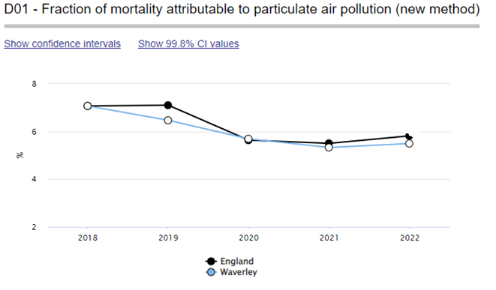

As highlighted in the 2023 AQAP and CAS, Waverley Borough Council is taking the following measures to address PM2.5:

* Avoid burning solid fuel and having bonfires.
* Raising public awareness of air quality issues and how to reduce effects, for example supporting events such as Clean Air Day and Clean Air Night, and promoting them to local communities through communication campaigns.
* Promote walking and cycling.

Waverley Borough Council also acknowledges Defra’s Environmental Targets for PM2.5[10]

* Annual Mean Concentration target – 10 µg m-3 to be achieved by 2040.
* Population Exposure Reduction Target – 35% reduction (on 2018 baseline) by 2040

The Government expects local authorities will need to take actions in support of the new targets.

A source apportionment study[11] carried out by CERC, on behalf of Waverley Borough Council showed that emissions from traffic (mostly non exhaust emissions), ‘other emissions’, and background sources, contributed 20 %, 10 % and 70 %, respectively, to the total PM2.5 concentration for a location in High Street, Godalming. This indicates that PM2.5 is dominated by sources outside the local authority area. The measures detailed above will inevitably help reduce emissions of PM2.5.

A Clean Air Strategy for Waverley was adopted in May 2023. It identified the origin of primary PM2.5 across Waverley: Domestic sources 50.8%, Industry / agriculture / commercial 38.8%, road transport (non-exhaust) 8.5%, and road transport (exhaust 1.8%). The strategy identifies priority actions to reduce particulates and nitrogen dioxide across Waverley. WBC have committed to taking actions and a template has been provided which can be used by organisations, or individuals to adopt specific actions of their own. WBC will report on progress in future ASRs.

Additionally, Waverley Borough Council, in partnership with SCC (and through the SAA), participated in the first Clean Air Night Campaign on Wednesday 24 January 2024. This raised public awareness about solid fuel burning, air quality impacts and promoting/enforcing changes to rules in supplying and buying solid fuel.

# Air Quality Monitoring Data and Comparison with Air Quality Objectives and National Compliance

This section sets out the monitoring undertaken within 2023 by Waverley Borough Council and how it compares with the relevant air quality objectives. In addition, monitoring results are presented for a five-year period between 2019 and 2023 to allow monitoring trends to be identified and discussed.

* 1. Summary of Monitoring Undertaken

### Automatic Monitoring Sites

Waverley Borough Council undertook automatic (continuous) monitoring at two sites during 2023. Table A.1 in Appendix A shows the details of the automatic monitoring sites. NB. Local authorities do not have to report annually on the following pollutants: 1,3 butadiene, benzene, carbon monoxide and lead, unless local circumstances indicate there is a problem. The [Air Quality England](https://www.airqualityengland.co.uk/local-authority/?la_id=379) page presents automatic monitoring results for Waverley Borough Council with automatic monitoring results also available through the [UK-Air website](https://uk-air.defra.gov.uk/interactive-map)[12]. For consistency with [Air Quality England](https://www.airqualityengland.co.uk/site/latest?site_id=WA001), the site code for Godalming Ockford Road 2 has been updated in the 2024 ASR to WA001, as shown in the first column of Table A.1. The site code in previous ASR’s is God 8. The site name, location, type and pollutants measured remain unchanged.

Maps showing the location of the monitoring sites are provided in [Appendix D](#_Appendix_E:_Map(s)). Further details on how the monitors are calibrated and how the data has been adjusted are included in Appendix C.

### Non-Automatic Monitoring Sites

Waverley Borough Council undertook non-automatic (i.e. passive) monitoring of NO2 at 51 sites during 2023. Table A.2 in Appendix A presents the details of the non-automatic sites.

Maps showing the location of the monitoring sites are provided in Appendix D. A web page showing the diffusion tubes locations are also available from the [Waverley Air Quality Web Site](https://www.waverley.gov.uk/Services/Environmental-concerns/Pollution-control/Air-quality/How-we-monitor-air-quality). Further details on Quality Assurance/Quality Control (QA/QC) for the diffusion tubes, including bias adjustments and any other adjustments applied (e.g. annualisation and/or distance correction), are included in Appendix C.

* 1. Individual Pollutants

The air quality monitoring results presented in this section are, where relevant, adjusted for bias, annualisation (where the annual mean data capture is below 75% and greater than 25%), and distance correction. Further details on adjustments are provided in Appendix C.

### Nitrogen Dioxide (NO2)

Table A.3 and Table A.4 in Appendix A compare the ratified and adjusted monitored NO2 annual mean concentrations for the past five years with the air quality objective of 40µg/m3. Note that the concentration data presented represents the concentration at the location of the monitoring site, following the application of bias adjustment and annualisation, as required (i.e. the values are exclusive of any consideration to fall-off with distance adjustment).

Figure A.1 presents NO2 annual mean concentrations for the automatic (continuous) monitoring sites between years 2019 and 2023 with the air quality objective of 40 µg m-3.

Figures A.2 to A.7 presents NO2 annual mean concentrations for all sites in Waverley between years 2019 to 2023 with the air quality objective of 40 µg m-3.

Figures A.2 and A.3 present the annual mean NO2 concentrations in the Farnham and Godalming AQMAs respectively, Figures A.4 and A.5 present the annual mean concentrations in Farnham and Godalming outside their respective AQMAs. Figures A.6 and A.7 present the annual mean NO2 concentrations in Haslemere and the locations outside Farnham, Godalming and Haslemere.

In 2023, the annual mean NO2 concentrations measured by the automatic (continuous) analysers in Farnham (South Street) and Godalming (Ockford Road 2) were 18 and 19 µg m-3 respectively, significantly below the annual objective concentration. There were also no exceedances of the hourly NO2 mean objective at either site.

In the Farnham AQMA, the largest annual mean NO2 concentration (32 µg m-3) measured was at site WBC9 (29/30 The Borough) but this site is not representative of relevant public exposure. The highest concentration at a location relevant for public exposure was measured (31.7 µg m-3) at WBC51 (25 The Borough (1st floor)), a decrease on the concentration measured in 2022 (34.4 µg m-3).

In Farnham the largest annual mean concentration (26 µg m-3) outside the AQMA was measured at WBC15b (4 – 5 Station Hill).

In the Godalming AQMA, the largest annual mean NO2 concentration (21.8 µg m-3) was measured at WBC33 (20 Ockford Road). This was a decrease of 2.2 µg m-3 compared to the annual mean measured in 2022 (24 µg m-3). Outside the AQMA the largest annual mean concentration in Godalming (29.4 µg m-3) was measured at site WBC31 (92 Ockford Road).

In Cranleigh, the largest annual mean concentration (22.5 µg m-3) was measured at WBC57 (5 Ewhurst Road). This site started in 2022 to supplement the existing monitoring tube in Cranleigh High Street, and the 2023 measured concentrations represents a decrease of 2.1 µg m-3 than that measured in 2022 (24.6 µg m-3).

In Haslemere, the largest annual mean concentration (25.7 µg m-3) was measured at WBC25b (66 Lower Street).

As with 2022, for the areas outside Farnham, Godalming and Haslemere, the largest (27.8 µg m‑3) annual mean concentration in 2023 was measured at WBC4c (Junction at Upper Hale).

The lowest annual mean measured concentration across all sites in 2023 (10.5 µg m‑3) was measured at WBC7 (4 Cherry Tree Close).

For diffusion tubes, the full 2023 dataset of monthly mean values is provided in Appendix B. Note that the concentration data presented in Table B.1 includes distance corrected values, only where relevant.

Table A.5 in Appendix A compares the ratified continuous monitored NO2 hourly mean concentrations for the past five years with the air quality objective of 200µg/m3, not to be exceeded more than 18 times per year. There were no exceedances of the 200 µg m-3 hourly value in 2023.

### Particulate Matter (PM10)

Table A.6 in Appendix A: Monitoring Results compares the ratified and adjusted monitored PM10 annual mean concentrations for the past three years at South Street with the air quality objective of 40µg/m3. PM10 annual mean concentration in 2023 was 16 µg m-3 which is a small increase from 14 µg m-3 in 2022, however this is still significantly below the annual objective concentration of 40 µg m-3.

Table A.7 in Appendix A compares the ratified continuous monitored PM10 daily mean concentrations for the past three years with the air quality objective of 50µg/m3, not to be exceeded more than 35 times per year. Figure A.8 presents PM10 annual mean concentrations for the automatic (continuous) monitoring site at Farnham (South Street) between years 2021 and 2023 with the air quality objective of 40 µg m-3.

There were no exceedances of the short-term air quality objectives.

### Particulate Matter (PM2.5)

As there is no PM2.5 monitoring in Waverley Borough Council, we have followed Defra’s technical guidance[13] to estimate PM2.5 concentration from the measured PM10 concentration. In accordance with the Technical Guidance (Defra, 2022, Box 7.7) a nationally derived PMCoarse concentration[14] of 5.9 µg m-3 was subtracted from the measured PM10 concentrations measured at South Street (15.7 µg m-3 to 1 decimal place) to provide PM2.5 concentration estimate of 9.8 µg m-3.

# Appendix A: Monitoring Results

Table A.1 – Details of Automatic Monitoring Sites

| Site ID | Site Name | Site Type | X OS Grid Ref (Easting) | Y OS Grid Ref (Northing) | Pollutants Monitored | In AQMA?  Which AQMA? | Monitoring Technique | Distance to Relevant Exposure (m) (1) | Distance to kerb of nearest road (m) (2) | Inlet Height (m) |
| --- | --- | --- | --- | --- | --- | --- | --- | --- | --- | --- |
| WA001 | Godalming Ockford Road | Roadside | 496711 | 143705 | NO2 | YES (AQMA 2) | Chemiluminescent | 8 | 2.5 | 1.7 |
| WA004 | South St, Farnham | Roadside | 484166 | 146862 | NO2; PM10 | YES (AQMA 1) | Chemiluminescent/BAM | 43.9 | 4.7 | 1.8 |

**Notes:**

(1) 0m if the monitoring site is at a location of exposure (e.g. installed on the façade of a residential property).

(2) N/A if not applicable

(3) Site ID Godalming Ockford Road updated to ‘WA001’ which provides consistency with the Air Quality England site code <https://www.airqualityengland.co.uk/site/latest?site_id=WA001> (listed as God 8 in previous ASR’s).

Table A.2 – Details of Non-Automatic Monitoring Sites

| Diffusion Tube ID | Site Name | Site Type | X OS Grid Ref (Easting) | Y OS Grid Ref (Northing) | Pollutants Monitored | In AQMA? Which AQMA? | Distance to Relevant Exposure (m) (1) | Distance to kerb of nearest road (m) (2) | Tube Co-located with a Continuous Analyser? | Tube Height (m) |
| --- | --- | --- | --- | --- | --- | --- | --- | --- | --- | --- |
| WBC1 | 53 Badshot Lea Road | Roadside | 486500 | 148692 | NO2 | NO | 0.0 | 1.4 | NO | 2.1 |
| WBC2 | 148 Farnborough Road | Roadside | 484793 | 149500 | NO2 | NO | 0.0 | 3.4 | NO | 2.0 |
| WBC3b | 103 Upper Hale | Roadside | 483909 | 149028 | NO2 | NO | 0.0 | 3.1 | NO | 1.7 |
| WBC4c | Upper Hale Crossroads | Roadside | 484959 | 148386 | NO2 | NO | 7.0 | 0.3 | NO | 2.0 |
| WBC5 | 10 Guildford Road | Roadside | 484809 | 147325 | NO2 | NO | 0.0 | 3.5 | NO | 2.2 |
| WBC6 | 6 St Marys Place | Roadside | 484465 | 147253 | NO2 | AQMA1 | 0.0 | 2.2 | NO | 2.1 |
| WBC7 | 4 Cherry Tree Close | Roadside | 484114 | 147065 | NO2 | AQMA1 | 0.0 | 6.3 | NO | 1.9 |
| WBC9 | 29/30 The Borough | Roadside | 484040 | 146912 | NO2 | AQMA1 | 0.0 | 1.0 | NO | 2.2 |
| WBC10 | 112 West Street | Roadside | 483841 | 146810 | NO2 | AQMA1 | 0.0 | 2.2 | NO | 2.1 |
| WBC11 | 77 West Street | Roadside | 483549 | 146673 | NO2 | NO | 0.0 | 1.6 | NO | 2.0 |
| WBC12 | 21 Downing Street | Roadside | 483951 | 146761 | NO2 | AQMA1 | 0.0 | 1.5 | NO | 2.1 |
| WBC13 | 8 Union Road | Roadside | 484184 | 146760 | NO2 | AQMA1 | 0.0 | 2.0 | NO | 2.1 |
| WBC14 | 7 Bridge Square | Roadside | 484130 | 146513 | NO2 | NO | 0.0 | 1.5 | NO | 2.1 |
| WBC15b | 4 – 5 Station Hill | Roadside | 484394 | 146609 | NO2 | NO | 0.0 | 1.7 | NO | 2.0 |
| WBC17 | Opp. Polycarps School Waverley Lane | Kerbside | 484735 | 146541 | NO2 | NO | 16.0 | 0.5 | NO | 1.9 |
| WBC19 | 11 Wrecclesham Road | Roadside | 482776 | 145674 | NO2 | NO | 0.0 | 3.0 | NO | 1.9 |
| WBC20 | 18 The Street | Kerbside | 482646 | 145087 | NO2 | NO | 0.0 | 0.8 | NO | 2.1 |
| WBC23 | 7 Exchange House | Roadside | 488776 | 135693 | NO2 | NO | 0.0 | 3.8 | NO | 2.1 |
| WBC24 | 54 Wey Hill | Roadside | 489244 | 132850 | NO2 | NO | 0.0 | 5.8 | NO | 2.1 |
| WBC25b | 66 Lower Street | Roadside | 490192 | 132908 | NO2 | NO | 0.0 | 3.3 | NO | 2.0 |
| WBC26 | 51 High Street | Kerbside | 490599 | 133101 | NO2 | NO | 0.0 | 0.7 | NO | 2.1 |
| WBC27 | 13 Petworth Road | Roadside | 490543 | 132754 | NO2 | NO | 0.0 | 2.6 | NO | 2.1 |
| WBC28 | Colporter Cottage A283 | Roadside | 496067 | 135318 | NO2 | NO | 0.0 | 1.0 | NO | 1.8 |
| WBC29 | Red Rose Cottage A283 | Roadside | 494751 | 139812 | NO2 | NO | 0.0 | 1.6 | NO | 2.2 |
| WBC30 | 4 Ridgeway Cottage Portsmouth Road | Roadside | 494448 | 142342 | NO2 | NO | 0.0 | 8.4 | NO | 2.2 |
| WBC31 | 92 Ockford Rd | Roadside | 496464 | 143458 | NO2 | NO | 0.0 | 4.0 | NO | 2.1 |
| WBC32 | 70 Ockford Road | Roadside | 496498 | 143508 | NO2 | AQMA2 | 0.0 | 7.0 | NO | 1.7 |
| WBC33 | 20 Ockford road | Roadside | 496639 | 143643 | NO2 | AQMA2 | 0.0 | 3.2 | NO | 2.0 |
| WBC34A, WBC34B, WBC34C | Co-located with WA001 automatic monitor (Flambard Way) | Roadside | 496711 | 143705 | NO2 | AQMA2 | 8.0 | 2.5 | YES | 1.7 |
| WBC35 | 20 Holloway Hill | Roadside | 496767 | 143659 | NO2 | NO | 0.0 | 5.2 | NO | 2.0 |
| WBC36 | Station Rd (Dominoes) | Roadside | 496777 | 143750 | NO2 | NO | 0.0 | 5.3 | YES | 2.2 |
| WBC37 | 12 Queen Street | Roadside | 497156 | 143745 | NO2 | NO | 0.0 | 6.5 | YES | 2.2 |
| WBC38 | Brighton Road | Roadside | 497390 | 143435 | NO2 | NO | 2.0 | 4.5 | YES | 1.9 |
| WBC39 | Edison House Flambard Way | Roadside | 497314 | 143854 | NO2 | NO | 0.0 | 3.8 | NO | 2.0 |
| WBC40 | 44 Bridge Street (Wey Gallery) | Roadside | 497234 | 143911 | NO2 | NO | 0.0 | 2.6 | NO | 2.1 |
| WBC41 | Major Minors Nursery Bridge Street | Roadside | 497412 | 144239 | NO2 | NO | 0.0 | 1.5 | NO | 1.9 |
| WBC43 | 5A Farncombe Street | Roadside | 497602 | 145017 | NO2 | NO | 0.0 | 6.0 | NO | 2.1 |
| WBC44 | 44 Meadrow | Roadside | 497801 | 144568 | NO2 | NO | 0.0 | 2.4 | NO | 2.0 |
| WBC45 | Windrush House Horsham Road | Roadside | 500898 | 144818 | NO2 | NO | 0.0 | 2.0 | NO | 2.0 |
| WBC46 | Cranleigh Bathrooms High Street | Roadside | 505795 | 139054 | NO2 | NO | 0.0 | 5.1 | NO | 1.9 |
| WBC47 | Carters Cottage Horsham Road | Roadside | 504045 | 135425 | NO2 | NO | 0.0 | 14.2 | NO | 2.0 |
| WBC48 | 45A Station Hill | Roadside | 484464 | 146584 | NO2 | NO | 0.0 | 2.6 | NO | 2.2 |
| WBC49 | Elmsleigh Dentist Station Hill (1st Floor) | Roadside | 484402 | 146606 | NO2 | NO | 0.0 | 1.5 | NO | 3.5 |
| WBC50b | 29/30 The Borough (1st Floor) | Roadside | 484034 | 146908 | NO2 | AQMA1 | 0.0 | 1.0 | NO | 4.0 |
| WBC51 | 25 The Borough (1st floor) | Roadside | 484066 | 146931 | NO2 | AQMA1 | 0.0 | 1.0 | NO | 3.0 |
| WBC52 | 2 Frensham Road | Roadside | 484379 | 145596 | NO2 | NO | 0.0 | 1.0 | NO | 1.0 |
| WBC53 | Waverley Lane nursery | Roadside | 484501 | 146552 | NO2 | NO | 5.0 | 0.3 | NO | 2.0 |
| WBC54 | The Wells, Lower Street | Roadside | 490271 | 132913 | NO2 | NO | 0.0 | 0.5 | NO | 2.0 |
| WBC55 | 86 Ockford Road | Roadside | 496476 | 143473 | NO2 | NO | 0.0 | 0.5 | NO | 1.0 |
| WBC56A, WBC56B, WBC56C | Co-located WA004 automatic monitor (South Street carpark) | Roadside | 484166 | 146862 | NO2 | AQMA1 | 43.9 | 4.7 | YES | 1.8 |
| WBC 57 | 5 Ewhurst Road | Roadside | 506112 | 139054 | NO2 | NO | 0 | 1 | NO | 2 |

**Notes:**

(1) 0m if the monitoring site is at a location of exposure (e.g. installed on the façade of a residential property).

(2) N/A if not applicable.

Table A.3 – Annual Mean NO2 Monitoring Results: Automatic Monitoring (µg/m3)

| Site ID | X OS Grid Ref (Easting) | Y OS Grid Ref (Northing) | Site Type | Valid Data Capture for Monitoring Period (%) (1) | Valid Data Capture 2023 (%) (2) | 2019 | 2020 | 2021 | 2022 | 2023 |
| --- | --- | --- | --- | --- | --- | --- | --- | --- | --- | --- |
| WA001 | 496711 | 143705 | Roadside | 97.93 | 97.93 | 24 | 17 | 18 | 20 | 19 |
| WA004 | 484166 | 146862 | Roadside | 98.23 | 98.23 |  |  | 21 | 20 | 18 |

**Annualisation has been conducted where data capture is <75% and >25% in line with LAQM.TG22.**

**Reported concentrations are those at the location of the monitoring site (annualised, as required), i.e. prior to any fall-off with distance correction.**

**Where exceedances of the NO2 annual mean objective occur at locations not representative of relevant exposure, the fall-off with distance concentration has been calculated and reported concentration provided in brackets for 2023.**

**Notes:**

The annual mean concentrations are presented as µg/m3.

Exceedances of the NO2 annual mean objective of 40µg/m3 are shown in **bold**.

All means have been “annualised” as per LAQM.TG22 if valid data capture for the full calendar year is less than 75%. See Appendix C for details.

Concentrations are those at the location of monitoring and not those following any fall-off with distance adjustment.

(1) Data capture for the monitoring period, in cases where monitoring was only carried out for part of the year.

(2) Data capture for the full calendar year (e.g. if monitoring was carried out for 6 months, the maximum data capture for the full calendar year is 50%).

Table A.4 – Annual Mean NO2 Monitoring Results: Non-Automatic Monitoring (µg/m3)

| Diffusion Tube ID | Site Name | X OS Grid Ref (Easting) | Y OS Grid Ref (Northing) | Site Type | Valid Data Capture for Monitoring Period (%) (1) | Valid Data Capture 2023 (%) (2) | 2019 | 2020 | 2021 | 2022 | 2023 |
| --- | --- | --- | --- | --- | --- | --- | --- | --- | --- | --- | --- |
| WBC1 | 53 Badshot Lea Road | 486500 | 148692 | Roadside | 92.3 | 92.3 | 21.6 | 19.5 | 20.9 | 19.5 | 17.7 |
| WBC2 | 148 Farnborough Road | 484793 | 149500 | Roadside | 100 | 100.0 | 25.3 | 21.5 | 20.2 | 20.5 | 17.7 |
| WBC3b | 103 Upper Hale | 483909 | 149028 | Roadside | 100 | 100.0 | 30.3 | 24.1 | 21.3 | 21.3 | 18.4 |
| WBC4c | Upper Hale Crossroads | 484959 | 148386 | Roadside | 100 | 100.0 |  | 31.3 | 35.1 | 31.6 | 27.8 |
| WBC5 | 10 Guildford Road | 484809 | 147325 | Roadside | 75 | 75.0 | 18.9 | 15.2 | 14.3 | 14.7 | 11.8 |
| WBC6 | 6 St Marys Place | 484465 | 147253 | Roadside | 100 | 100.0 | 30.1 | 22.3 | 23.3 | 23.1 | 20.0 |
| WBC7 | 4 Cherry Tree Close | 484114 | 147065 | Roadside | 100 | 100.0 | 16.4 | 14.0 | 12.6 | 12.9 | 10.5 |
| WBC9 | 29/30 The Borough | 484040 | 146912 | Roadside | 100 | 100.0 | **49.2** | 33.6 | 34.1 | 35.6 | 32.0 |
| WBC10 | 112 West Street | 483841 | 146810 | Roadside | 100 | 100.0 | 33.5 | 25.8 | 24.8 | 24.7 | 21.8 |
| WBC11 | 77 West Street | 483549 | 146673 | Roadside | 92.3 | 92.3 | 29.8 | 22.7 | 22.7 | 23.1 | 16.8 |
| WBC12 | 21 Downing Street | 483951 | 146761 | Roadside | 82.7 | 82.7 | 35.8 | 26.6 | 24.8 | 25.3 | 23.3 |
| WBC13 | 8 Union Road | 484184 | 146760 | Roadside | 100 | 100.0 | 34.7 | 27.5 | 26.8 | 26.8 | 24.9 |
| WBC14 | 7 Bridge Square | 484130 | 146513 | Roadside | 90.4 | 90.4 | 30.9 | 23.0 | 22.8 | 22.7 | 22.4 |
| WBC15 | 4 – 5 Station Hill | 484394 | 146609 | Roadside | 100 | 100.0 | 39.4 | 32.9 | 30.2 | 29.9 | 26.0 |
| WBC17 | Opp. Polycarps School Waverley Lane | 484735 | 146541 | Kerbside | 100 | 100.0 | 18.2 | 14.7 | 13.3 | 12.8 | 11.2 |
| WBC19 | 11 Wrecclesham Road | 482776 | 145674 | Roadside | 100 | 100.0 | 27.1 | 21.4 | 21.5 | 20.9 | 17.9 |
| WBC20 | 18 The Street | 482646 | 145087 | Kerbside | 100 | 100.0 | 34.0 | 27.8 | 27.3 | 26.7 | 22.7 |
| WBC23 | 7 Exchange House | 488776 | 135693 | Roadside | 100 | 100.0 | 29.9 | 22.3 | 23.9 | 22.4 | 19.5 |
| WBC24 | 54 Wey Hill | 489244 | 132850 | Roadside | 92.3 | 92.3 | 22.9 | 19.4 | 17.7 | 17.6 | 16.5 |
| WBC25b | 66 Lower Street | 490192 | 132908 | Roadside | 100 | 100.0 | 35.2 | 29.0 | 27.0 | 27.4 | 25.7 |
| WBC26 | 51 High Street | 490599 | 133101 | Kerbside | 100 | 100.0 | 26.7 | 23.5 | 22.3 | 22.7 | 19.2 |
| WBC27 | 13 Petworth Road | 490543 | 132754 | Roadside | 92.3 | 92.3 | 27.7 | 24.2 | 23.0 | 22.0 | 20.2 |
| WBC28 | Colporter Cottage A283 | 496067 | 135318 | Roadside | 100 | 100.0 | 21.4 | 18.7 | 17.8 | 17.3 | 15.0 |
| WBC29 | Red Rose Cottage A283 | 494751 | 139812 | Roadside | 92.3 | 92.3 | 31.8 | 27.2 | 28.0 | 24.8 | 21.1 |
| WBC30 | 4 Ridgeway Cottage Portsmouth Road | 494448 | 142342 | Roadside | 92.3 | 92.3 | 21.8 | 18.6 | 18.5 | 16.8 | 14.3 |
| WBC31 | 92 Ockford Rd | 496464 | 143458 | Roadside | 82.7 | 82.7 | **40.7** | 32.9 | 33.7 | 31.3 | 29.4 |
| WBC32 | 70 Ockford Road | 496498 | 143508 | Roadside | 100 | 100.0 | 27.7 | 23.9 | 20.6 | 21.4 | 18.5 |
| WBC33 | 20 Ockford road | 496639 | 143643 | Roadside | 84.6 | 84.6 | 33.5 | 26.5 | 24.9 | 24.0 | 21.8 |
| WBC34A, WBC34B, WBC34C | Co-located with WA001 automatic monitor (Flambard Way) | 496711 | 143705 | Roadside | 100 | 100.0 | 27.1 | 22.5 | 21.7 | 22.1 | 19.7 |
| WBC35 | 20 Holloway Hill | 496767 | 143659 | Roadside | 100 | 100.0 | 27.7 | 18.5 | 16.0 | 15.7 | 15.1 |
| WBC36 | Station Rd (Dominoes) | 496777 | 143750 | Roadside | 100 | 100.0 | 26.5 | 19.4 | 19.4 | 18.9 | 18.5 |
| WBC37 | 12 Queen Street | 497156 | 143745 | Roadside | 92.3 | 92.3 | 21.0 | 14.4 | 14.1 | 14.1 | 13.6 |
| WBC38 | Brighton Road | 497390 | 143435 | Roadside | 100 | 100.0 | 26.4 | 14.8 | 14.7 | 14.3 | 12.4 |
| WBC39 | Edison House Flambard Way | 497314 | 143854 | Roadside | 84.6 | 84.6 | 18.5 | 19.0 | 18.5 | 20.6 | 19.4 |
| WBC40 | 44 Bridge Street (Wey Gallery) | 497234 | 143911 | Roadside | 100 | 100.0 | 19.1 | 17.2 | 15.3 | 15.5 | 14.5 |
| WBC41 | Major Minors Nursery Bridge Street | 497412 | 144239 | Roadside | 100 | 100.0 | 24.5 | 24.1 | 26.4 | 22.1 | 20.3 |
| WBC43 | 5A Farncombe Street | 497602 | 145017 | Roadside | 90.4 | 90.4 | 19.4 | 16.9 | 16.1 | 15.2 | 13.4 |
| WBC44 | 44 Meadrow | 497801 | 144568 | Roadside | 100 | 100.0 | 29.9 | 27.0 | 28.0 | 24.7 | 22.1 |
| WBC45 | Windrush House Horsham Road | 500898 | 144818 | Roadside | 92.3 | 92.3 | 19.2 | 20.9 | 20.3 | 21.0 | 21.2 |
| WBC46 | Cranleigh Bathrooms High Street | 505795 | 139054 | Roadside | 100 | 100.0 | 34.2 | 22.4 | 21.2 | 19.9 | 19.0 |
| WBC47 | Carters Cottage Horsham Road | 504045 | 135425 | Roadside | 100 | 100.0 | 27.0 | 13.0 | 13.5 | 14.2 | 11.9 |
| WBC48 | 45A Station Hill | 484464 | 146584 | Roadside | 90.4 | 90.4 | 26.5 | 27.0 | 24.3 | 23.7 | 21.8 |
| WBC49 | Elmsleigh Dentist Station Hill (1st Floor) | 484402 | 146606 | Roadside | 92.3 | 92.3 | 16.2 | 28.2 | 26.4 | 25.4 | 22.7 |
| WBC50b | 29/30 The Borough (1st Floor) | 484034 | 146908 | Roadside | 100 | 100.0 | 31.8 | 27.1 | 28.2 | 26.9 | 25.3 |
| WBC51 | 25 The Borough (1st floor) | 484066 | 146931 | Roadside | 100 | 100.0 | 32.2 |  | 34.1 | 34.4 | 31.7 |
| WBC52 | 2 Frensham Road | 484379 | 145596 | Roadside | 100 | 100.0 | 35.9 | 16.1 | 18.2 | 16.6 | 14.6 |
| WBC53 | Waverley Lane nursery | 484501 | 146552 | Roadside | 100 | 100.0 |  | 18.2 | 19.9 | 16.8 | 14.3 |
| WBC54 | The Wells, Lower Street | 490271 | 132913 | Roadside | 100 | 100.0 |  | 24.2 | 23.2 | 21.8 | 20.5 |
| WBC55 | 86 Ockford Road | 496476 | 143473 | Roadside | 100 | 100.0 |  | 29.8 | 27.5 | 28.2 | 24.5 |
| WBC56A, WBC56B, WBC56C | Co-located WA0004 automatic monitor (South Street carpark) | 484166 | 146862 | Roadside | 100 | 100.0 |  |  | 21.2 | 20.9 | 18.7 |
| WBC 57 | 5 Ewhurst Road | 506112 | 139054 | Roadside | 84.6 | 84.6 |  |  |  | 24.6 | 22.5 |

**Annualisation has been conducted where data capture is <75% and >25% in line with LAQM.TG22**

**Diffusion tube data has been bias adjusted.**

**Reported concentrations are those at the location of the monitoring site (bias adjusted and annualised, as required), i.e. prior to any fall-off with distance correction.**

**Notes:**

The annual mean concentrations are presented as µg/m3.

Exceedances of the NO2 annual mean objective of 40µg/m3 are shown in **bold**.

NO2 annual means exceeding 60µg/m3, indicating a potential exceedance of the NO2 1-hour mean objective are shown in **bold and underlined**.

Means for diffusion tubes have been corrected for bias. All means have been “annualised” as per LAQM.TG22 if valid data capture for the full calendar year is less than 75%. See Appendix C for details.

Concentrations are those at the location of monitoring and not those following any fall-off with distance adjustment.

(1) Data capture for the monitoring period, in cases where monitoring was only carried out for part of the year.

(2) Data capture for the full calendar year (e.g. if monitoring was carried out for 6 months, the maximum data capture for the full calendar year is 50%).

Figure A. – Trends in Annual Mean NO2 Concentrations (Automatic Monitoring)

Figure A. – Trends in Annual Mean NO2: AQMA1 Farnham (Diffusion Tubes)

Figure A. – Trends in Annual Mean NO2: AQMA2 Godalming (Diffusion Tubes)

Figure A. – Trends in Annual Mean NO2: Farnham outside AQMA (Diffusion Tubes)

Figure A. – Trends in Annual Mean NO2: Godalming outside AQMA (Diffusion Tubes)

Figure A. – Trends in Annual Mean NO2: Haslemere (Diffusion Tubes)

Figure A. – Trends in Annual Mean NO2: Remaining locations - mostly rural (Diffusion Tubes)

Table A.5 – 1-Hour Mean NO2 Monitoring Results, Number of 1-Hour Means > 200µg/m3

| Site ID | X OS Grid Ref (Easting) | Y OS Grid Ref (Northing) | Site Type | Valid Data Capture for Monitoring Period (%) (1) | Valid Data Capture 2023 (%) (2) | 2019 | 2020 | 2021 | 2022 | 2023 |
| --- | --- | --- | --- | --- | --- | --- | --- | --- | --- | --- |
| WA001 | 496711 | 143705 | Roadside | 97.93 | 97.93 | 0 | 0 | 0 | 0 | 0 |
| WA004 | 484166 | 146862 | Roadside | 98.23 | 98.23 |  |  | 0 | 0 | 0 |

**Notes:**

Results are presented as the number of 1-hour periods where concentrations greater than 200µg/m3 have been recorded.

Exceedances of the NO2 1-hour mean objective (200µg/m3 not to be exceeded more than 18 times/year) are shown in **bold**.

If the period of valid data is less than 85%, the 99.8th percentile of 1-hour means is provided in brackets.

(1) Data capture for the monitoring period, in cases where monitoring was only carried out for part of the year.

(2) Data capture for the full calendar year (e.g. if monitoring was carried out for 6 months, the maximum data capture for the full calendar year is 50%).

Table A.6 – Annual Mean PM10 Monitoring Results (µg/m3)

| Site ID | X OS Grid Ref (Easting) | Y OS Grid Ref (Northing) | Site Type | Valid Data Capture for Monitoring Period (%) (1) | Valid Data Capture 2023 (%) (2) | 2019 | 2020 | 2021 | 2022 | 2023 |
| --- | --- | --- | --- | --- | --- | --- | --- | --- | --- | --- |
| WA004 | 484166 | 146862 | Roadside | 95.5 | 95.5 |  |  | 16 | 14 | 16 |

**Annualisation has been conducted where data capture is <75% and >25% in line with LAQM.TG22.**

**Notes:**

The annual mean concentrations are presented as µg/m3.

Exceedances of the PM10 annual mean objective of 40µg/m3 are shown in **bold**.

All means have been “annualised” as per LAQM.TG22 if valid data capture for the full calendar year is less than 75%. See Appendix C for details.

(1) Data capture for the monitoring period, in cases where monitoring was only carried out for part of the year.

(2) Data capture for the full calendar year (e.g. if monitoring was carried out for 6 months, the maximum data capture for the full calendar year is 50%).

Figure A.8 – Trends in Annual Mean PM10 Concentrations

Table A.7 – 24-Hour Mean PM10 Monitoring Results, Number of PM10 24-Hour Means > 50µg/m3

| Site ID | X OS Grid Ref (Easting) | Y OS Grid Ref (Northing) | Site Type | Valid Data Capture for Monitoring Period (%) (1) | Valid Data Capture 2023 (%) (2) | 2019 | 2020 | 2021 | 2022 | 2023 |
| --- | --- | --- | --- | --- | --- | --- | --- | --- | --- | --- |
| WA004 | 484166 | 146862 | Roadside | 95.5 | 95.5 |  |  | 0 | 0 | 0 |

**Notes:**

Results are presented as the number of 24-hour periods where daily mean concentrations greater than 50µg/m3 have been recorded.

Exceedances of the PM10 24-hour mean objective (50µg/m3 not to be exceeded more than 35 times/year) are shown in **bold**.

If the period of valid data is less than 85%, the 90.4th percentile of 24-hour means is provided in brackets.

(1) Data capture for the monitoring period, in cases where monitoring was only carried out for part of the year.

(2) Data capture for the full calendar year (e.g. if monitoring was carried out for 6 months, the maximum data capture for the full calendar year is 50%).

# Appendix B: Full Monthly Diffusion Tube Results for 2023

Table B.1 – NO2 2023 Diffusion Tube Results (µg/m3)

| DT ID | Site Name | X OS Grid Ref (Easting) | Y OS Grid Ref (Northing) | Jan | Feb | Mar | Apr | May | Jun | Jul | Aug | Sep | Oct | Nov | Dec | Annual Mean: Raw Data | Annual Mean: Annualised and Bias Adjusted 0.77 | Annual Mean: Distance Corrected to Nearest Exposure | Comment |
| --- | --- | --- | --- | --- | --- | --- | --- | --- | --- | --- | --- | --- | --- | --- | --- | --- | --- | --- | --- |
| WBC1 | 53 Badshot Lea Road | 486500 | 148692 | 29.7 | 29.9 | 25.8 |  | 24.8 | 23.7 | 15.1 | 15.1 | 27.5 | 24.7 | 20.6 | 16.4 | 23.0 | 17.7 | **-** |  |
| WBC2 | 148 Farnborough Road | 484793 | 149500 | 31.8 | 29.7 | 20.7 | 27.3 | 26.6 | 24.6 | 16.3 | 19.2 | 26.4 | 17.1 | 24.7 | 10.7 | 22.9 | 17.7 | **-** |  |
| WBC3b | 103 Upper Hale | 483909 | 149028 | 31.4 | 17.4 | 25.3 | 22.8 | 17.4 | 25.2 | 21.9 | 18.5 | 31.1 | 28.6 | 26.3 | 20.4 | 23.9 | 18.4 | **-** |  |
| WBC4c | Upper Hale Crossroads | 484959 | 148386 | 42.0 | 41.7 | 40.2 | 35.9 | 36.3 | 35.0 | 31.4 | 28.9 | 43.1 | 33.1 | 38.2 | 26.7 | 36.0 | 27.8 | **-** |  |
| WBC5 | 10 Guildford Road | 484809 | 147325 | 17.5 |  | 16.6 | 17.3 | 16.1 |  |  | 11.1 | 18.7 | 17.8 | 10.3 | 12.0 | 15.3 | 11.8 | **-** |  |
| WBC6 | 6 St Marys Place | 484465 | 147253 | 29.7 | 30.6 | 25.9 | 28.2 | 24.1 | 25.7 | 20.7 | 19.3 | 35.1 | 28.1 | 23.7 | 21.3 | 26.0 | 20.0 | **-** |  |
| WBC7 | 4 Cherry Tree Close | 484114 | 147065 | 18.4 | 17.3 | 14.6 | 13.1 | 11.3 | 11.2 | 8.6 | 10.5 | 17.2 | 16.6 | 12.6 | 11.9 | 13.6 | 10.5 | **-** |  |
| WBC9 | 29/30 The Borough | 484040 | 146912 | 48.1 | 43.3 | 47.2 | 47.0 | 40.5 | 39.0 | 32.5 | 37.7 | 48.4 | 45.2 | 39.4 | 29.7 | 41.5 | 32.0 | **-** |  |
| WBC10 | 112 West Street | 483841 | 146810 | 37.0 | 33.3 | 27.2 | 29.0 | 30.3 | 27.8 | 20.1 | 21.3 | 29.4 | 30.9 | 28.7 | 24.8 | 28.3 | 21.8 | **-** |  |
| WBC11 | 77 West Street | 483549 | 146673 | 27.7 |  | 17.1 | 19.0 | 22.6 | 23.6 | 15.4 | 18.8 | 28.0 | 26.1 | 21.1 | 20.5 | 21.8 | 16.8 | **-** |  |
| WBC12 | 21 Downing Street | 483951 | 146761 | 38.0 | 35.6 | 35.0 | 32.4 | 28.0 | 24.1 | 23.2 | 25.1 | 36.9 |  |  | 24.8 | 30.3 | 23.3 | **-** |  |
| WBC13 | 8 Union Road | 484184 | 146760 | 39.4 | 34.3 | 32.5 | 35.3 | 37.0 | 29.2 | 24.4 | 29.6 | 35.8 | 33.1 | 30.8 | 27.4 | 32.4 | 24.9 | **-** |  |
| WBC14 | 7 Bridge Square | 484130 | 146513 | 35.5 | 31.1 | 32.5 | 30.6 | 24.0 | 26.2 | 21.2 |  | 36.1 | 33.5 | 28.1 | 20.8 | 29.1 | 22.4 | **-** |  |
| WBC15 | 4 – 5 Station Hill | 484394 | 146609 | 40.6 | 21.6 | 34.1 | 40.3 | 43.0 | 43.6 | 24.4 | 29.1 | 32.8 | 30.2 | 37.8 | 27.1 | 33.7 | 26.0 | **-** |  |
| WBC17 | Opp. Polycarps School Waverley Lane | 484735 | 146541 | 21.9 | 19.2 | 14.7 | 13.9 | 13.1 | 12.0 | 9.3 | 9.5 | 16.8 | 14.7 | 17.1 | 11.8 | 14.5 | 11.2 | **-** |  |
| WBC19 | 11 Wrecclesham Road | 482776 | 145674 | 25.4 | 26.3 | 26.7 | 23.4 | 28.1 | 24.1 | 14.3 | 18.8 | 29.5 | 23.8 | 25.7 | 13.5 | 23.3 | 17.9 | **-** |  |
| WBC20 | 18 The Street | 482646 | 145087 | 38.9 | 36.0 | 27.9 | 30.4 | 32.9 | 24.4 | 22.1 | 25.9 | 35.9 | 31.7 | 26.9 | 20.6 | 29.5 | 22.7 | **-** |  |
| WBC23 | 7 Exchange House | 488776 | 135693 | 29.3 | 26.6 | 25.7 | 29.8 | 29.2 | 29.1 | 22.9 | 23.0 | 33.3 | 24.1 | 16.0 | 15.5 | 25.4 | 19.5 | **-** |  |
| WBC24 | 54 Wey Hill | 489244 | 132850 | 28.3 | 27.6 | 21.7 | 21.6 | 23.5 | 18.4 | 16.6 | 17.7 | 24.8 | 24.0 | 12.1 |  | 21.5 | 16.5 | **-** |  |
| WBC25b | 66 Lower Street | 490192 | 132908 | 35.5 | 39.6 | 35.5 | 34.0 | 24.5 | 33.6 | 32.3 | 28.8 | 39.3 | 38.1 | 32.1 | 26.5 | 33.3 | 25.7 | **-** |  |
| WBC26 | 51 High Street | 490599 | 133101 | 33.8 | 34.3 | 25.8 | 20.3 | 24.0 | 24.2 | 25.3 | 21.3 | 29.0 | 25.5 | 19.1 | 16.9 | 25.0 | 19.2 | **-** |  |
| WBC27 | 13 Petworth Road | 490543 | 132754 | 36.5 | 33.6 | 26.2 | 24.9 | 22.6 | 21.6 |  | 22.2 | 30.9 | 19.9 | 27.1 | 23.6 | 26.3 | 20.2 | **-** |  |
| WBC28 | Colporter Cottage A283 | 496067 | 135318 | 23.4 | 15.3 | 22.0 | 23.6 | 23.7 | 22.3 | 13.9 | 15.2 | 24.3 | 20.8 | 16.9 | 12.9 | 19.5 | 15.0 | **-** |  |
| WBC29 | Red Rose Cottage A283 | 494751 | 139812 | 38.2 |  | 28.5 | 28.0 | 25.8 | 22.5 | 23.8 | 22.8 | 29.2 | 29.0 | 30.9 | 23.0 | 27.4 | 21.1 | **-** |  |
| WBC30 | 4 Ridgeway Cottage Portsmouth Road | 494448 | 142342 | 18.8 |  | 22.7 | 21.1 | 21.0 | 19.1 | 14.1 | 15.7 | 21.2 | 13.1 | 21.1 | 16.9 | 18.6 | 14.3 | **-** |  |
| WBC31 | 92 Ockford Rd | 496464 | 143458 | 44.2 | 42.6 | 37.7 | 40.5 | 39.1 | 36.5 | 31.4 | 31.7 | 46.0 |  |  | 32.6 | 38.2 | 29.4 | **-** |  |
| WBC32 | 70 Ockford Road | 496498 | 143508 | 35.2 | 33.7 | 27.1 | 23.3 | 21.4 | 19.5 | 22.0 | 20.9 | 27.3 | 24.8 | 10.3 | 22.4 | 24.0 | 18.5 | **-** |  |
| WBC33 | 20 Ockford road | 496639 | 143643 | 40.2 | 31.9 | 31.8 | 29.6 | 29.0 | 25.4 | 19.1 | 17.6 | 31.5 |  | 27.4 |  | 28.4 | 21.8 | **-** |  |
| WBC34A | Co-located with WA001 automatic monitor (Flambard Way) | 496711 | 143705 | 39.6 |  | 25.1 | 22.5 | 23.3 | 20.8 | 16.9 | 17.5 | 28.9 | 27.8 | 25.4 | 22.8 | - | - | **-** | Triplicate Site with WBC34A, WBC34B and WBC34C - Annual data provided for WBC34C only |
| WBC34B | Co-located with WA001 automatic monitor (Flambard Way) | 496711 | 143705 | 38.3 | 33.8 | 25.9 | 23.0 | 23.9 | 18.0 | 17.3 | 18.2 | 29.2 | 28.7 | 25.4 | 24.9 | - | - | **-** | Triplicate Site with WBC34A, WBC34B and WBC34C - Annual data provided for WBC34C only |
| WBC34C | Co-located with WA001 automatic monitor (Flambard Way) | 496711 | 143705 | 38.0 | 34.1 | 26.3 | 23.8 | 24.7 | 19.7 | 17.3 | 18.6 | 27.5 | 27.5 | 30.3 | 20.1 | 25.5 | 19.7 | **-** | Triplicate Site with WBC34A, WBC34B and WBC34C – Annual data provided for WBC34C only |
| WBC35 | 20 Holloway Hill | 496767 | 143659 | 30.9 | 27.5 | 21.4 | 17.5 | 17.3 | 15.3 | 12.4 | 14.4 | 24.5 | 21.9 | 19.4 | 12.5 | 19.6 | 15.1 | **-** |  |
| WBC36 | Station Rd (Dominoes) | 496777 | 143750 | 32.6 | 32.9 | 25.1 | 23.6 | 23.0 | 21.2 | 14.8 | 16.9 | 27.2 | 26.3 | 26.4 | 18.0 | 24.0 | 18.5 | **-** |  |
| WBC37 | 12 Queen Street | 497156 | 143745 | 28.1 | 25.2 | 17.4 | 15.9 | 17.7 | 13.5 | 10.4 | 11.0 | 16.1 | 16.2 | 22.3 |  | 17.6 | 13.6 | **-** |  |
| WBC38 | Brighton Road | 497390 | 143435 | 22.5 | 17.5 | 17.2 | 15.6 | 14.7 | 11.5 | 11.4 | 10.9 | 17.4 | 17.0 | 20.3 | 16.6 | 16.1 | 12.4 | **-** |  |
| WBC39 | Edison House Flambard Way | 497314 | 143854 | 28.7 | 30.1 | 29.4 | 34.7 |  | 24.4 | 14.5 | 17.1 | 27.4 | 25.1 | 20.8 |  | 25.2 | 19.4 | **-** |  |
| WBC40 | 44 Bridge Street (Wey Gallery) | 497234 | 143911 | 29.2 | 25.3 | 19.2 | 16.3 | 19.3 | 16.2 | 13.1 | 11.2 | 18.5 | 19.7 | 22.2 | 15.7 | 18.8 | 14.5 | **-** |  |
| WBC41 | Major Minors Nursery Bridge Street | 497412 | 144239 | 31.2 | 35.0 | 30.8 | 29.7 | 30.6 | 26.7 | 15.9 | 19.1 | 29.3 | 28.9 | 22.9 | 16.0 | 26.3 | 20.3 | **-** |  |
| WBC43 | 5A Farncombe Street | 497602 | 145017 | 27.6 | 27.0 | 18.6 | 16.3 | 14.4 | 13.2 | 13.4 | 11.6 | 15.1 | 19.4 |  | 15.0 | 17.4 | 13.4 | **-** |  |
| WBC44 | 44 Meadrow | 497801 | 144568 | 41.9 | 31.3 | 34.6 | 25.0 | 25.1 | 23.4 | 24.1 | 21.8 | 31.2 | 31.3 | 31.0 | 24.0 | 28.7 | 22.1 | **-** |  |
| WBC45 | Windrush House Horsham Road | 500898 | 144818 | 35.1 | 59.5 | 27.6 | 24.1 |  | 22.0 | 18.5 | 20.3 | 27.7 | 27.2 | 23.7 | 17.1 | 27.5 | 21.2 | **-** |  |
| WBC46 | Cranleigh Bathrooms High Street | 505795 | 139054 | 36.9 | 25.2 | 24.5 | 21.9 | 18.6 | 17.1 | 21.1 | 20.2 | 37.6 | 26.4 | 26.2 | 20.6 | 24.7 | 19.0 | **-** |  |
| WBC47 | Carters Cottage Horsham Road | 504045 | 135425 | 17.6 | 15.5 | 13.7 | 16.0 | 17.6 | 15.3 | 9.2 | 14.4 | 19.4 | 19.4 | 16.7 | 10.5 | 15.4 | 11.9 | **-** |  |
| WBC48 | 45A Station Hill | 484464 | 146584 | 34.2 | 36.0 | 26.9 | 28.0 | 26.9 | 27.6 | 23.1 | 23.2 | 33.8 | 32.9 |  | 18.9 | 28.3 | 21.8 | **-** |  |
| WBC49 | Elmsleigh Dentist Station Hill (1st Floor) | 484402 | 146606 | 33.6 | 27.1 | 28.5 | 31.1 | 33.1 | 30.3 | 23.8 | 26.1 | 33.7 | 29.8 | 26.8 |  | 29.4 | 22.7 | **-** |  |
| WBC50b | 29/30 The Borough (1st Floor) | 484034 | 146908 | 38.7 | 30.1 | 36.2 | 21.5 | 35.8 | 33.9 | 27.8 | 28.9 | 39.7 | 39.2 | 34.3 | 28.6 | 32.9 | 25.3 | **-** |  |
| WBC51 | 25 The Borough (1st floor) | 484066 | 146931 | 43.9 | 48.1 | 43.0 | 43.3 | 36.2 | 35.7 | 37.4 | 35.2 | 51.2 | 47.8 | 40.4 | 32.4 | 41.2 | 31.7 | **-** |  |
| WBC52 | 2 Frensham Road | 484379 | 145596 | 28.3 | 22.9 | 18.2 | 20.7 | 23.0 | 18.4 | 10.5 | 13.9 | 21.0 | 17.0 | 20.8 | 13.2 | 19.0 | 14.6 | **-** |  |
| WBC53 | Waverley Lane nursery | 484501 | 146552 | 30.1 | 21.6 | 18.7 | 18.7 | 17.2 | 12.7 | 13.0 | 15.2 | 21.9 | 20.5 | 22.3 | 11.1 | 18.6 | 14.3 | **-** |  |
| WBC54 | The Wells, Lower Street | 490271 | 132913 | 35.7 | 21.3 | 27.5 | 25.1 | 24.4 | 22.7 | 16.2 | 20.3 | 31.9 | 35.3 | 33.1 | 26.3 | 26.7 | 20.5 | **-** |  |
| WBC55 | 86 Ockford Road | 496476 | 143473 | 35.7 | 40.6 | 35.5 | 34.1 | 33.1 | 28.0 | 25.9 | 26.7 | 37.2 | 29.4 | 31.1 | 24.4 | 31.8 | 24.5 | **-** |  |
| WBC56A | Co-located WA0004 automatic monitor (South Street carpark) | 484166 | 146862 | 32.8 | 28.7 | 25.5 | 22.8 | 24.1 | 20.4 | 16.3 | 15.6 | 28.3 | 26.2 | 27.6 | 21.4 | - | - | **-** | Triplicate Site with WBC56A, WBC56B and WBC56C - Annual data provided for WBC56C only |
| WBC56B | Co-located WA0004 automatic monitor (South Street carpark) | 484166 | 146862 | 34.5 |  | 25.8 | 23.8 | 20.4 | 20.8 | 17.2 | 18.0 | 27.1 | 24.8 | 26.7 | 23.6 | - | - | **-** | Triplicate Site with WBC56A, WBC56B and WBC56C - Annual data provided for WBC56C only |
| WBC56C | Co-located WA0004 automatic monitor (South Street carpark) | 484166 | 146862 | 31.1 | 26.9 | 25.3 | 23.7 | 23.4 |  | 18.3 | 18.2 | 29.3 | 24.4 | 28.7 | 23.4 | 24.3 | 18.7 | **-** | Triplicate Site with WBC56A, WBC56B and WBC56C - Annual data provided for WBC56C only |
| WBC 57 | 5 Ewhurst Road | 506112 | 139054 | 36.5 | 30.1 | 29.8 |  | 23.8 | 26.2 | 25.5 | 23.6 | 32.7 | 33.9 | 29.5 |  | 29.2 | 22.5 | **-** |  |

**All erroneous data has been removed from the NO2 diffusion tube dataset presented in Table B.1**

**Annualisation has been conducted where data capture is <75% and >25% in line with LAQM.TG22**

**Local bias adjustment factor used**

**National bias adjustment factor used**

**Where applicable, data has been distance corrected for relevant exposure in the final column**

**Waverley Borough Council confirm that all 2023 diffusion tube data has been uploaded to the Diffusion Tube Data Entry System**

**Notes:**

Exceedances of the NO2 annual mean objective of 40µg/m3 are shown in **bold**.

NO2 annual means exceeding 60µg/m3, indicating a potential exceedance of the NO2 1-hour mean objective are shown in **bold and underlined**.

See Appendix C for details on bias adjustment and annualisation.

# Appendix C: Supporting Technical Information / Air Quality Monitoring Data QA/QC

## New or Changed Sources Identified Within Waverley Borough Council During 2023

Waverley Borough Council has not identified any new sources relating to air quality within the reporting year of 2023. However, we continue to keep a watching brief on the following developments.

[Dunsfold Park Garden Village](https://www.waverley.gov.uk/Services/Planning-and-building/Strategic-and-Waverley-owned-developments/Dunsfold-Park-Garden-Village) – Planning consent was granted for 1800 new homes, new school, new community centre, expanded business park and supporting infrastructure. The consent is live but no development likely to impact on local air quality has taken place yet.

[Brightwell’s Yard](https://www.waverley.gov.uk/Services/Planning-and-building/Strategic-and-Waverley-owned-developments/Brightwells-Yard) – Development will make the area a hub for leisure and evening entertainment, with a cinema, restaurants, 25 retail units and 239 homes in the centre of Farnham. Parts of the development have been completed but construction activities continue. We will continue to monitor air quality in Farnham to check any impacts from this development.

[Farnham Infrastructure Programme (FIP)](https://www.surreycc.gov.uk/roads-and-transport/policies-plans-consultations/major-transport-projects/farnham-infrastructure-programme) – Please refer to Section 2.2 for information about this programme. Some actions have been completed and others will be taken forward. The FIP has committed to modelling air quality prior to making changes, and we will continue to monitor air quality in Farnham to check impacts of changes.

## Additional Air Quality Works Undertaken by Waverley Borough Council During 2023

In addition to the AQAP measures outlined in Table 2.2, Waverley Borough Council also outlined a number of actions aimed at improving air quality more widely across the Borough in the Clean Air Strategy published in May 2023. An update of these actions provided in March 2024 is provided in Table C.1.

Table C. – Clean Air Strategy Actions with Updates to March 2024

| **Priority Actions** | **Category** | **WBC Commitments Adopted May 2023** | | | | |
| --- | --- | --- | --- | --- | --- | --- |
| **Action** | **Who will deliver it?** | **Key Performance Measure** | **Timescale** | **Progress March 2024** |
| Leadership in Improving Air Quality | | | | | | |
| Reduce car journeys and commuting | Transport | L1. Reduce car journeys for commuting by Waverley staff by 60% consistent with the work done on the ‘Where Work Happens’ project by 2025 and promote low and zero emission transport including active transport | Organisational Development | Numbers of staff commuting. Numbers of staff using zero emission transport as reported in the Carbon Neutrality Action Plan | 2025 | 393 FTE employees deliver the Council’s core functions and services. An average of 125 staff now travel into the Burys each day. A reduction of journeys for commuting by Waverley staff by 69%. Home working supported through Hybrid working contracts.  Increase in use of electric and hybrid vehicles (both staff owned and council pool cars) reducing business mile emissions by 35% from the baseline figure. Salary sacrifice offered for bikes to work through Cyclescheme.co.uk |
| Increase numbers of low or zero emission vehicles | Transport | L2. Develop a plan to reduce emissions from travel by converting the WBC fleet to 100% zero emissions including contractor vehicles through the procurement process | Environmental Services | Proportion of WBC Fleet being zero emission as reported in the Carbon Neutrality Action Plan | 2025 onwards | Two fully electric Vauxhall Combo vans purchased by Environmental Services for environmental enforcement and monitoring staff use. |
| Increase numbers of low or zero emission vehicles | Transport | L3 We will continue to work with taxi drivers to reduce emissions from this sector. Subject to Defra approval this will entail delivering a Defra grant funded project across Surrey to engage with taxi drivers and increase the proportions of low and zero emission taxis, supported by the taxi licensing process | Regulatory Services | Proportion of licenses for low and zero emission taxis | End of 2024 | Gained Defra approval for a revised scheme. WBC drafted tender and contracts for EV taxi project, with GBC and SBC to take forward in consultation with WBC |
| Improve energy efficiency of buildings | Energy | L4 We will reduce NOx and PM emissions from council housing building stock, through the Asset Management Strategy, which will present a decarbonisation path for existing council housing stock | Organisational Development  Housing Services  Commercial Services,  Assets and Property | Energy use in council housing building stock as reported in the Carbon Neutrality Action Plan | Throughout the lifetime of this strategy | Asset Management Strategy proposal for the development of a Waverley Standard to incorporate Decent Homes Standard and Future Homes Standard.  Pilot project will include the installation of 30 Air Source Heat Pumps. Old boilers to be replaced with new hydrogen ready gas boilers. Investigate alternatives.  Action Plan to retrofit to net zero by 2030.  Further energy study to improve performance of housing assets.  EV chargers to be introduced to refurbishment projects. |
| Use renewable energy where possible | Energy | L5 We will support ongoing work within WBC regarding renewable energy generation projects and facilitating community power generation in the borough | Organisational Development | Renewable energy use within Waverley as reported in the Carbon Neutrality Action Plan | Throughout the lifetime of this strategy | Implementing solar PV on Leisure Centres.  Carrying out proposals for solar canopy over car park with feasibility studies for others in the borough.  Investigating the potential of solar PV installation on:   * Senior living schemes. * Pay and display machines in car parks. * Leased commercial sites. * Solar Farm |
| Encourage new developments to adopt best practice to improve air quality across Waverley | Strategies and Policy Guidance | L6 We will support the implementation of the Climate Change and Sustainability Supplementary Planning Document, including supporting approaches to reduce energy use in new developments and encouraging sustainable forms of transport will also reduce local air pollutant emissions | Planning Development  Organisational Development | Implementation of the SPD | End of 2024 | SPD adopted in 2022.  Strengthening the sustainability policies in the upgrade of Local Plan Part 1, particularly  Energy efficiency; renewable energy; sustainable transport; climate change risks and adaptation; land use change.  Reviewing transport assessment/travel plans for larger development applications. |
| Challenge business as usual for actions to improve air quality | Air Quality Evidence Base | L7 We will undertake further work to investigate the feasibility of Low Emission Zones within Waverley, and what form these could take (this is likely to entail a less formal approach than those implemented under the Clean Air Zone Framework, and may entail joint working more widely across Surrey) | Regulatory Services | Production of feasibility study into LEZs | 2023-2024 | Appointed contractor to undertake the study. ANPR surveys undertaken in Farnham and Godalming in March. |
| Work with the council to facilitate monitoring and modelling of air quality | Air Quality Evidence Base | L8 We will continue to deliver the statutory requirements of the LAQM process, including annual reporting to Defra, and air quality monitoring and modelling to provide the evidence base for those reports. This includes an update of the Air Quality Action Plan due in 2023 | Regulatory Services | Annual submission of Annual Status Report to Defra and Air Quality Action Plan | 2023 for AQAP, ongoing annual reporting | Ongoing.  Monitored air quality in WBC’s area last year.  ASR submitted to Defra at the end of September 2023. Approved in November 2023.  Growth bid for Surrey wide modelling to be submitted Autumn 2024. |
| Buy sustainably | Strategies and Policy Guidance | L9 We will ensure sustainable procurement practices throughout the council as part of the Council’s Procurement Strategy | Finance | Adoption of the WBC Sustainable Procurement Strategy | 2023 | Ongoing. |
| Avoid burning solid fuel and having bonfires | Energy | L10 We will consider with partner agencies, alternative ways to manage waste produced from land management, other than burning, where possible. | Environmental Services | Reduction in numbers of council bonfires | End of 2024 | Burning on WBC countryside land minimised and only when unavoidable due to ground conditions, access or other considerations. |
| Use renewable energy where possible | Energy | L11 We will not support commercial exploration or extraction of fossil fuels, which may in the future undergo combustion | Regeneration and Planning Policy |  | Throughout the lifetime of this strategy | Ongoing.  Council challenged the Loxley Well application process. |
| Reduce exposure to air pollutants | Planning and Infrastructure | L12 We will look for appropriate opportunities to implement green infrastructure either within new developments, or more widely such as at schools. | Environmental Services  Regeneration and Planning Policy | Implementation of green infrastructure | 2024-2027 | New leisure centre in Cranleigh to be built to Passivhaus standards, 60-70% reduction in carbon emissions against standard build.  Energy statement and SAP requirements through planning process.  Local Cycling and Walking Infrastructure Plans (LCWIPs) are referenced when development Transport Statements and Travel Plans are assessed |
| Work Collaboratively to improve Air Quality | | | | | |  |
| Support other organisations to improve air quality | Transport, Strategies and Policy Guidance | C1 We will work with Surrey County Council on delivering LTP4 to reduce the volume of traffic on our roads and encourage a radical transformation of transport infrastructure in favour of active transport. This will also include improvements to public transport, freight and delivery management and increase in low and zero emission vehicles, and park and ride facilities if appropriate, | Regeneration and Planning Policy | Work undertaken in support of LTP4 | Throughout the lifetime of this strategy | In September 2023 [Surrey Connect, an on demand bus service, was launched in Farnham and Cranleigh](https://www.waverley.gov.uk/Council-updates/Read-our-latest-news/on-demand-bus-service-launches-in-farnham-and-cranleigh) to make it easier to access public transport in those areas. |
| Support other organisations to improve air quality | Raise public awareness | C2 We will encourage collaborative working with Parish and Town Councils across Waverley to enable actions to be undertaken by residents in a coordinated way. | Regulatory Services | Measures committed to by Town and Parish Councils | Throughout the lifetime of this strategy | Publish a template for adoption of actions to improve air quality on WBC’s website. |
| Promote walking and cycling | Transport | C3 We will work with SCC to deliver a Greenway network, connecting the main centres across the borough. | Organisational Development | Delivery of the Greenway network | 2023-2025 | Godalming Greenway Gateway public consultation completed. Final route and design procurements agreed. CIL and UKSPF funding secured, and other funding opportunities identified.  WBC supported SCC on detailed design of Guildford Godalming Greenway, leading to SCC securing National Highways funding for Phase 1 construction.  MoU signed with SCC for design and costing of the Hale Trail Greenway in Farnham Park. |
| Support other organisations to improve air quality | Air Quality Evidence Base | C4 We will continue to work with the Surrey Air Alliance and identify opportunities for projects to either enhance the evidence base on which decisions are made, or implement measures to improve air quality. | Regulatory Services | Air quality projects implemented across Surrey | Throughout the lifetime of this strategy | Ongoing |
| Support other organisations to improve air quality | Public Health | C5 We will work collaboratively with SCC Public Health for example undertaking information dissemination on air quality through doctors’ surgeries. | Regulatory Services | Air Quality Projects delivered with Public Health | Throughout the lifetime of this strategy | Ongoing work with Surrey Heartlands on the asthma accredited schools’ scheme.  Promotion of SAHME to investigate indoor air quality in schools. Also supporting schools in WBC to get online and use the indoor monitor. |
| Encourage new developments to adopt best practice to improve air quality across Waverley | Planning and Infrastructure | C6 We will work across WBC to ensure air quality is fully considered within planning policy, and within planning applications, to ensure that air quality is maintained, and where possible improved. We will encourage best practice design measures through guidance provided to developers and will set appropriate planning conditions for mitigation where required | Regulatory Services  Regeneration and Planning Policy  Panning Development | Planning guidance for new developments and air quality | Throughout the lifetime of this strategy | Ongoing |
| Ensure that infrastructure is in place to reduce the need to travel | Planning and Infrastructure | C7 We will support extensive rollout of fibre broadband and 5G mobile coverage in order to reduce the need to travel | Regeneration and Planning Policy  Assets and Property | Proportion of borough covered by 5G | 2024-2027 | No update available. |
| Support the delivery of the Waverley Carbon Neutrality Action Plan | Transport, Energy, Planning and Infrastructure | C8 We will support work being undertaken on the Waverley carbon neutrality action plan, particularly in relation to active travel and energy generation | Organisational Development  Regulatory Services | Regular reports to the Carbon Emergency Board | Throughout the lifetime of this strategy | Climate Emergency Officers Group with established. Zurich producing CNAP Risk Register for WBC.  CNAP Reviewed annually and reported to Climate Change EWG and Executive  Top ten emitters identified and to be treated as priority projects |
| Increase numbers of low or zero emission vehicles | Transport | C9 Support the installation of on street EV chargers to encourage residents and taxi drivers to switch to electric vehicles in line with the WBC Electric Vehicle Strategy. | Organisational Development  Regulatory Services | Numbers of EV chargers in place | Throughout the lifetime of this strategy | Ultra-rapid charges to be installed in Lower Hart Car Park and St James car parks in Farnham and Croft Road car park in Godalming in 2024.  Working with SCC to install on-street EV chargers across Surrey.  Phase 2 – 32 EV chargers being installed at Brightwells, South Street Godalming, Chestnut Avenue, Station Lane, Croft Road, Queens Street, Haslemere Leisure Centre. Lower Hart to be installed in 2024.  Phase 3 rollout underway for other Waverley Car Parks.  Monitoring chargers in Burys to establish if more are needed to accommodate the increase in EV pool vehicles. |
| Influence others to improve air quality | Strategies and Policy Guidance | C10 We will work to influence national legislation by lobbying the national Government and responding to relevant consultations on air quality | Regulatory Services | Timely responses to consultations and surveys | Throughout the lifetime of this strategy | WBC is a consultee for Gatwick North and Future Airspace Strategy Implementation consultations. |
| Support and Enable Behaviour Change | | | | | | |
| Avoid burning solid fuel and having bonfires | Raise Public Awareness | B1 We will continue to work through the Surrey Air Alliance with SCC’s Trading Standards to develop a project to raise awareness about solid fuel burning air quality impacts and promoting/enforcing changes to rules in supplying/buying solid fuel | Regulatory Services  Communications and Customer Services | Implementation of a project about solid fuel burning | 2024 | The Surrey Air Alliance supported the first Clean Air Night Campaign on Wed 24 January 2024. They were an official supporter and SCC Public Health contributed to this campaign. WBC took part. |
| Avoid burning solid fuel and having bonfires | Raise Public Awareness | B2 We will continue to encourage people not to have bonfires. Longer term we will investigate bylaws for bonfires | Regulatory Services  Communications and Customer Services | Campaigns undertaken | Throughout the lifetime of this strategy | WBC do not encourage bonfires, as promoted on our website. |
| Raise awareness of air quality issues and how to reduce effects | Raise Public Awareness | B3 We will support events such as Clean Air Day and work to engage with local communities to raise awareness of measures they and individuals can take to reduce air pollution | Regulatory Services  Communications and Customer Services | Input into Clean Air Day | Throughout the lifetime of this strategy | WBC Comms campaign to support Clean Air Day last Thurs 20 June 2024. |
| Promote walking and cycling | Transport | B4 We will adopt Local Cycling and Walking Infrastructure Plans for Farnham and Waverley | Organisational Development | Adoption of LCWIPs | 2024-2026 | Funding sources identified. Farnham specific and broader Waverley LCWIPs to be adopted 2024.  Agreement to be reached with SCC on updated Farnham LCWIP to remove inconsistencies with the wider-Waverley LCWIP.  LCWIPs for Farnham and rest of Waverley are being taken through committee for adoption into planning policy in 24/25. |
| Raise awareness of air quality issues and how to reduce effects | Raise Public Awareness | B5 We will provide tailored, clear, accurate and consistent messages about the benefits of good air quality, utilising the Waverley Borough Council website as a platform to inform residents | Regulatory Services  Communications and Customer Services | Annual review of our air quality web pages with updates if needed | Throughout the lifetime of this strategy | Ongoing review of website to make sure it is up to date. |
| Raise awareness of air quality issues and how to reduce effects | Raise Public Awareness | B6 Carbon Neutrality Action Plan is setting up a Citizens Assembly to encourage public participation in shaping the climate emergency agenda – we will investigate the feasibility of using this mechanism to raise awareness on air quality. | Organisational Development  Regulatory Services  Communications and Customer Services | Use of Citizens Assembly for participation | 2023-2024 | Alternatives to traditional Citizen Assembly being considered, potential to use Commonplace platform. |
| Raise awareness of air quality issues and how to reduce effects | Raise Public Awareness, Transport | B7 We will work with SCC to tackle vehicle idling emissions at key locations such as on Station Hill in Farnham, other level crossings and outside schools | Regulatory Services | Anti-idling signs implemented | 2023-2024 | Proposal put forward for monitoring outside 4 schools, subject to funding. |
| Raise awareness of air quality issues and how to reduce effects | Raise Public Awareness, Public Health | B8 Through the SAA we will continue to work with Surrey Heartlands Clinical Commissioning Group to contribute to a project looking at links between paediatric asthma and AQMAs to help inform and take forward a paediatric asthma care bundle | Regulatory Services | Implementation of asthma care bundle | 2023-2024 | Work is ongoing, Surrey Heartlands have funding for this project to the end of the school year 2023/2024. |
| Raise awareness of air quality issues and how to reduce effects | Raise Public Awareness, Transport | B9 We will work with SCC to support the eco-school’s initiative (including promoting active travel, Mode Shift Stars, Bikeability training, walking training, and an understanding of impacts on air quality). | Regulatory Services | Number of schools signed up to the Eco-school’s initiative | 2023-2025 | Promotion of SAHME to investigate indoor air quality in schools. Also supporting schools in WBC to get online and use the indoor monitor. |
| Promote walking and cycling | Transport | B10 We will work with schools to identify and remove barriers to active travel | Regulatory Services | Levels of active travel within schools which have had interventions | 2024-2026 | Started a pilot project on provision of cycling and scooter storage at schools. |

## QA/QC of Diffusion Tube Monitoring

This section provides detail regarding aspects of non-automatic monitoring using diffusion tubes.

**Diffusion tube supplier**

Waverley Borough Council’s diffusion tubes are supplied and analysed by SOCOTEC Didcot utilising the 50% triethanolamine (TEA) in acetone preparation method.

SOCOTEC participate in the AIR-PT analysis scheme[15]. This is an independent analytical proficiency-testing scheme, operated by LGC Standards and supported by the Health and Safety Laboratory (HSL). Defra and the Devolved Administrations advise that diffusion tubes used for LAQM should be obtained from laboratories that have demonstrated satisfactory performance in the AIR NO2 PT scheme. For those reporting periods in 2023 for which SOCOTEC reported results, all results were considered satisfactory (based on z-scores less than or equal to 2). The laboratory performance for SOCOTEC from September 2021 to October 2023 is summarised here, [WASP – Annual Performance Criteria for NO2 Diffusion Tubes (defra.gov.uk)](https://laqm.defra.gov.uk/wp-content/uploads/2023/11/LAQM-NO2-Performance-data_Up-to-Oct-2023_V1_Final.pdf)

**Diffusion Tube Calendar**

The diffusion tube calendar used with Waverley is provided below. This did not deviate significantly from the 2023 Diffusion Tube Monitoring Calendar.

| **Month** | **Tube On** | **Tube Off** |
| --- | --- | --- |
| **Jan** | 04/01/2023 | 01/02/2023 |
| **Feb** | 01/02/2023 | 28/02/2023 |
| **Mar** | 28/02/2023 | 04/04/2023 |
| **Apr** | 04/04/2023 | 03/05/2023 |
| **May** | 03/05/2023 | 30/05/2023 |
| **Jun** | 30/05/2023 | 03/07/2023 |
| **Jul** | 03/07/2023 | 01/08/2023 |
| **Aug** | 01/08/2023 | 04/09/2023 |
| **Sep** | 04/09/2023 | 04/10/2023 |
| **Oct** | 04/10/2023 | 01/11/2023 |
| **Nov** | 01/11/2023 | 05/12/2023 |
| **Dec** | 05/12/2023 | 03/01/2024 |

### Diffusion Tube Annualisation

No sites required annualisation in 2023.

### Diffusion Tube Bias Adjustment Factors

The diffusion tube data presented within the 2024 ASR have been corrected for bias using an adjustment factor. Bias represents the overall tendency of the diffusion tubes to under or over-read relative to the reference chemiluminescence analyser. LAQM.TG22 provides guidance with regard to the application of a bias adjustment factor to correct diffusion tube monitoring. Triplicate co-location studies can be used to determine a local bias factor based on the comparison of diffusion tube results with data taken from NOx/NO2 continuous analysers. Alternatively, the national database of diffusion tube co-location surveys provides bias factors for the relevant laboratory and preparation method.

Waverley Borough Council have applied a national bias adjustment factor of 0.77 to the 2023 monitoring data. This provided a more conservative approach compared to the combined local factor (0.75). A summary of bias adjustment factors used by Waverley Borough Council over the past five years is presented in Table C.2.

Table C. – Bias Adjustment Factors for Previous Five Years

|  |  |  |  |
| --- | --- | --- | --- |
| Monitoring Year | Local or National | If National, Version of National Spreadsheet | Adjustment Factor |
| **2023** | National | 03/24 | 0.77 |
| **2022** | National | 03/23 | 0.76 |
| **2021** | National | 03/22 | 0.78 |
| **2020** | Local (Farnham) | - | 0.80 |
| **2019** | Local (Farnham) | - | 0.78 |

Table C. – Local Bias Adjustment Calculation

|  | Local Bias Adjustment Input 1  Farnham South Street | Local Bias Adjustment Input 2  Godalming |
| --- | --- | --- |
| **Periods used to calculate bias** | 12 | 12 |
| **Bias Factor A** | 0.76 (0.71 - 0.81) | 0.74 (0.69 - 0.78) |
| **Bias Factor B** | 32% (23% - 41%) | 36% (27% - 44%) |
| **Diffusion Tube Mean (µg m-3)** | 24.3 | 25.5 |
| **Mean CV (Precision)** | 4.5% | 4.1% |
| **Automatic Mean (µg m-3)** | 18.4 | 18.8 |
| **Data Capture** | 98% | 98% |
| **Adjusted Tube Mean (µg m-3)** | 18 (17 - 20) | 19 (18 - 20) |

Local bias adjustment factors of 0.76 and 0.74 were determined for Farnham South Street and Godalming Ockford Road 2 respectively using the Diffusion Tube Data Processing Tool v4.0. These factors are presented in Table C.3. Combining these according to LAQM.TG22 provides a combined local factor of 0.75. For completeness and to show full results, the calculation of a local bias adjustments for Farnham and Godalming was also carried out using the Diffusion Tube Precision Accuracy Bias Spreadsheet and these results are presented in Figures C.1 and Figure C.2 respectively.

Figure C. – Local Diffusion Tube Precision Accuracy Bias Spreadsheet – Farnham

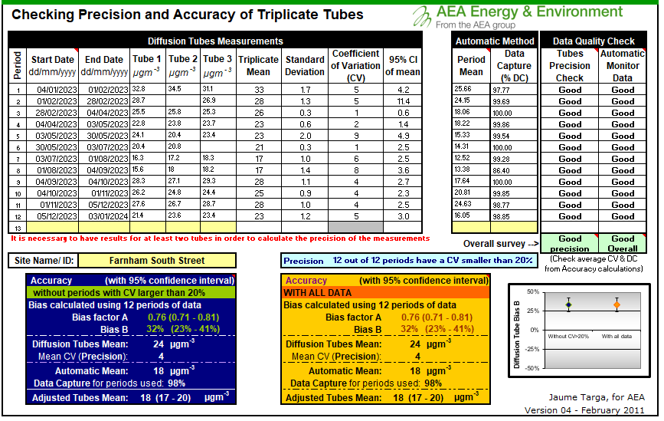

Figure C. – Local Diffusion Tube Precision Accuracy Bias Spreadsheet – Godalming

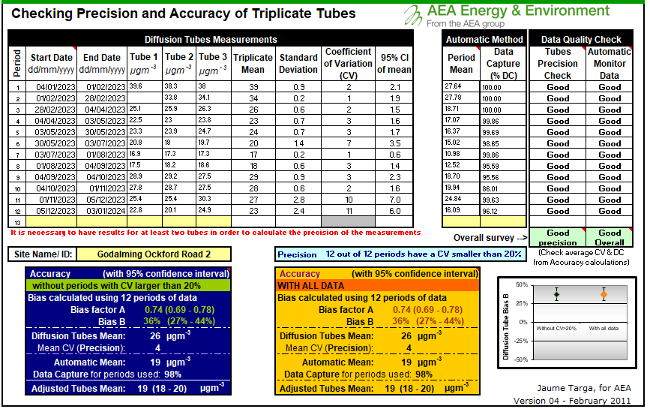

National bias adjustment

The national database of diffusion tube co-location surveys provides bias factors for the relevant laboratory and preparation method. A bias adjustment of 0.77 for the year 2023 (based on 28 studies) has been derived from the national bias adjustment spreadsheet (v03_24). A screenshot of the spreadsheet for SOCOTEC is shown in Figure C.3.

Figure C. – National Bias Adjustment Spreadsheets

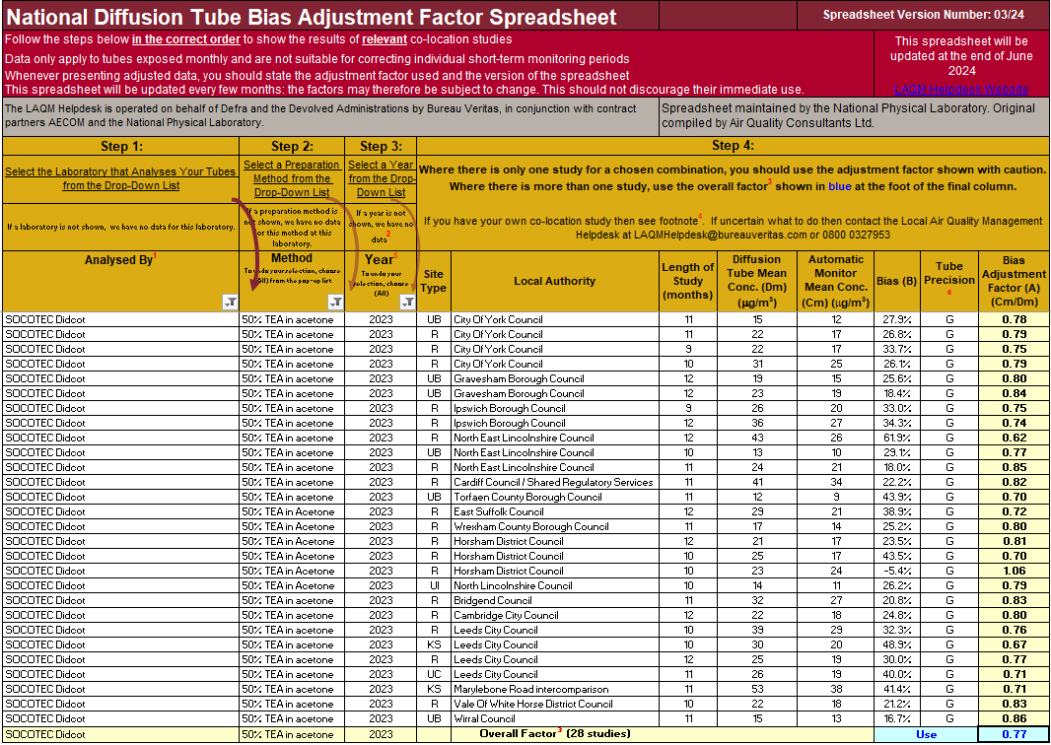

### NO2 Fall-off with Distance from the Road

Wherever possible, monitoring locations are representative of exposure. However, where this is not possible, the NO2 concentration at the nearest location relevant for exposure has been estimated using the Diffusion Tube Data Processing Tool/NO2 fall-off with distance calculator available on the LAQM Support website. Where appropriate, non-automatic annual mean NO2 concentrations corrected for distance are presented in Table B.1.

No diffusion tube NO2 monitoring locations within Waverley Borough Council required distance correction during 2023.

## QA/QC of Automatic Monitoring

Ricardo provides data management and local site operator (LSO) duties for the automatic monitoring sites within Waverley. The instrumentation is calibrated every four weeks and full site audits and services are carried out every six months. The calibration certificates are provided at the end of the Appendix. The QA/QC is accredited to ISO 17025. All data are ratified to all LAQM reporting requirements and the data provided in the 2024 are ratified. Live and historic data are available through [Air Quality England](https://www.airqualityengland.co.uk/local-authority/?la_id=379).

### PM10 and PM2.5 Monitoring Adjustment

PM10 is monitored using a Met One PM10 Unheated BAM 1020. A slope correction factor of 0.833 is applied to the data.

There is no PM2.5 monitoring within Waverley Borough Council although an estimation of PM2.5 derived from the measured PM10 concentrations at Farnham South Street is provided in section 3.2.3.

### Automatic Monitoring Annualisation

Annualisation was not required.

### NO2 Fall-off with Distance from the Road

Wherever possible, monitoring locations are representative of exposure. However, where this is not possible, the NO2 concentration at the nearest location relevant for exposure has been estimated using the NO2 fall-off with distance calculator available on the LAQM Support website. Where appropriate, automatic annual mean NO2 concentrations corrected for distance are presented in Table A.3.

No automatic NO2 monitoring locations within Waverley Borough Council required distance correction during 2022.

## Certificates of Calibration

Farnham, South Street (May 2023)

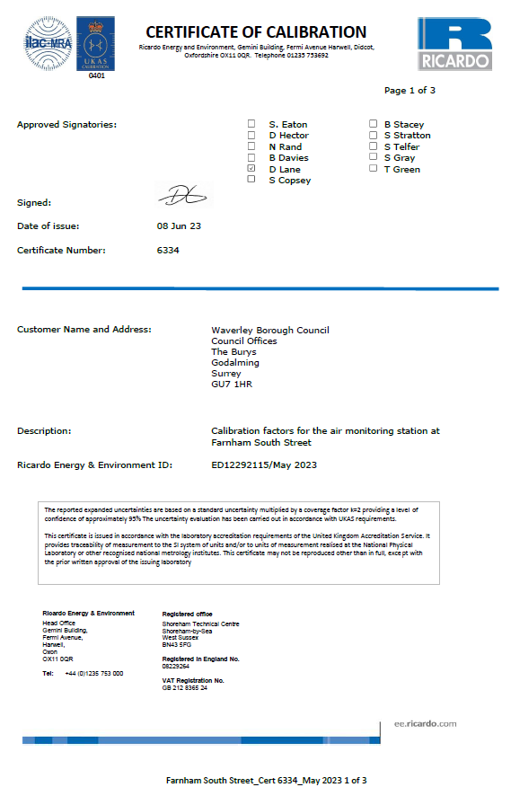

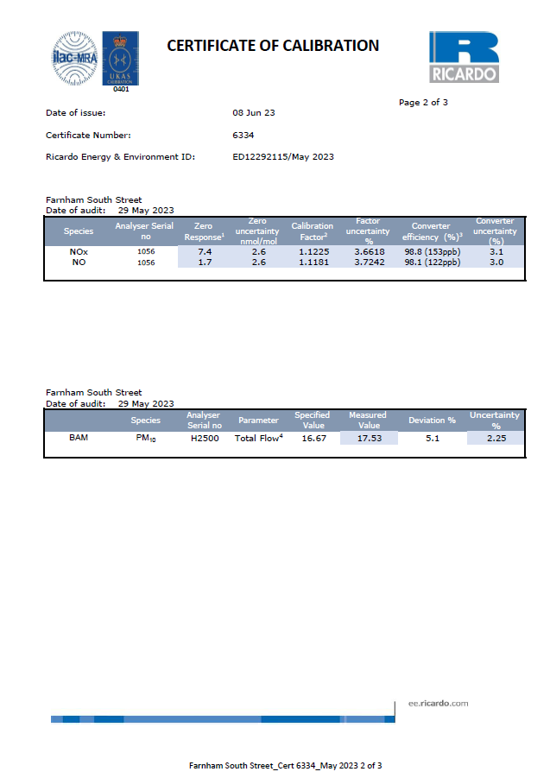

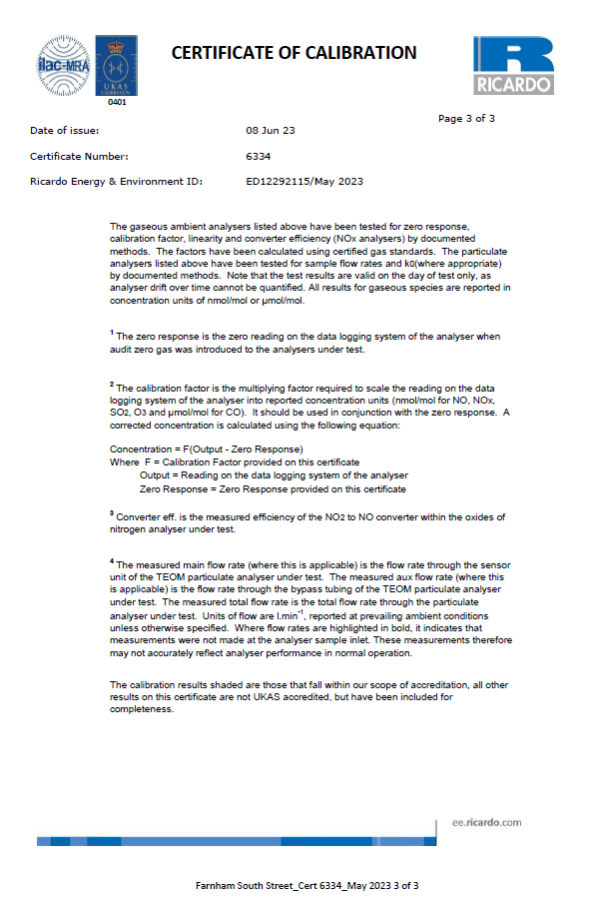

Farnham, South Street (November 2023)

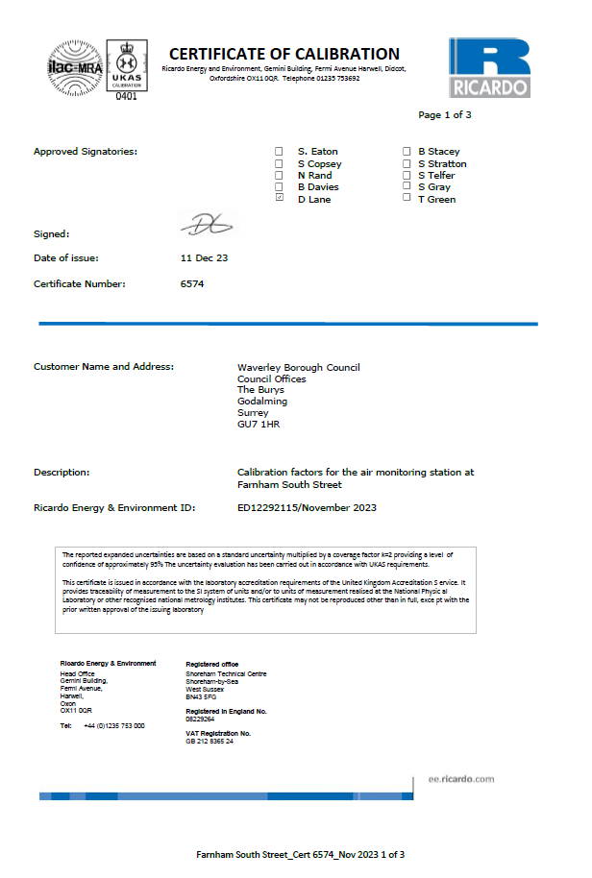

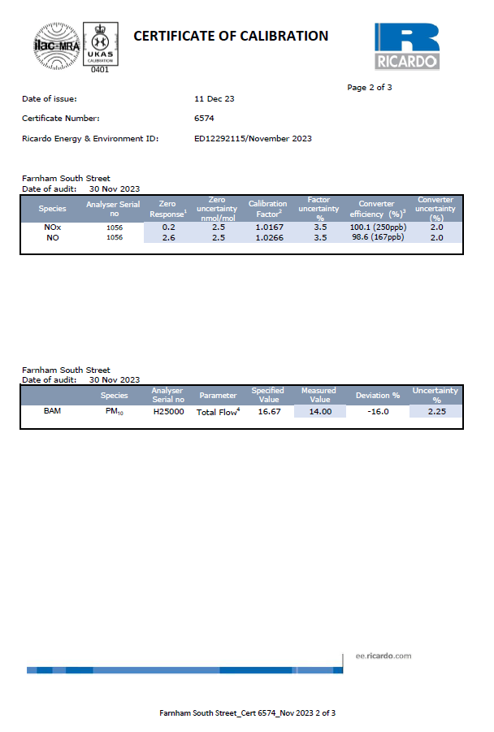

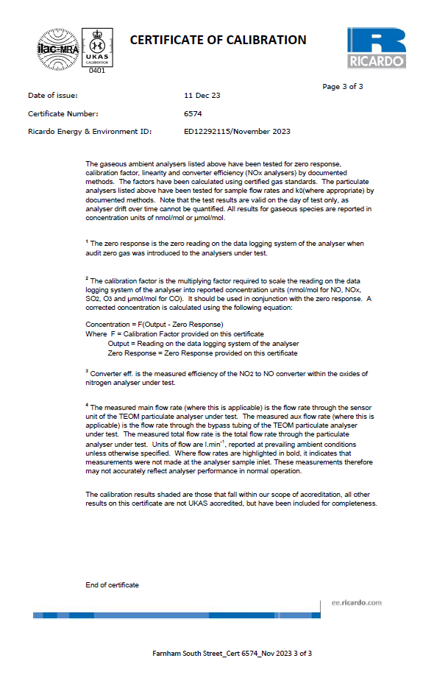

Godalming, Ockford Road 2 (May 2023)

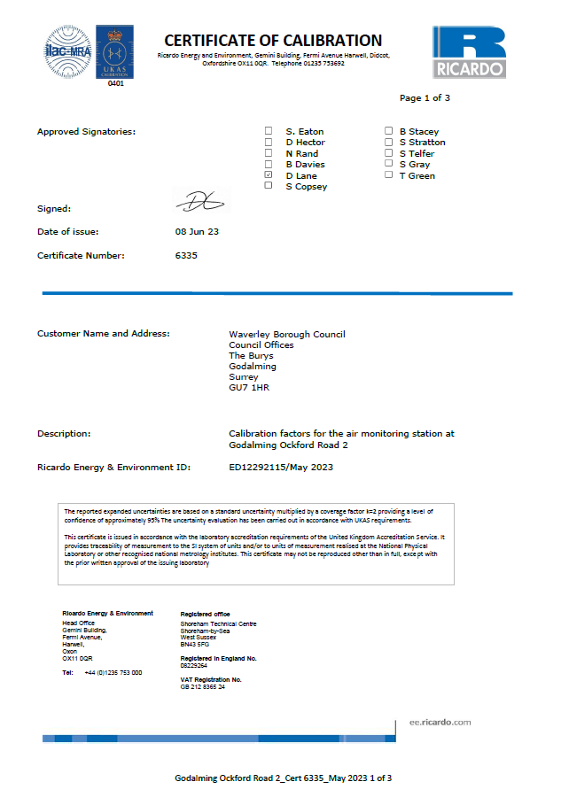

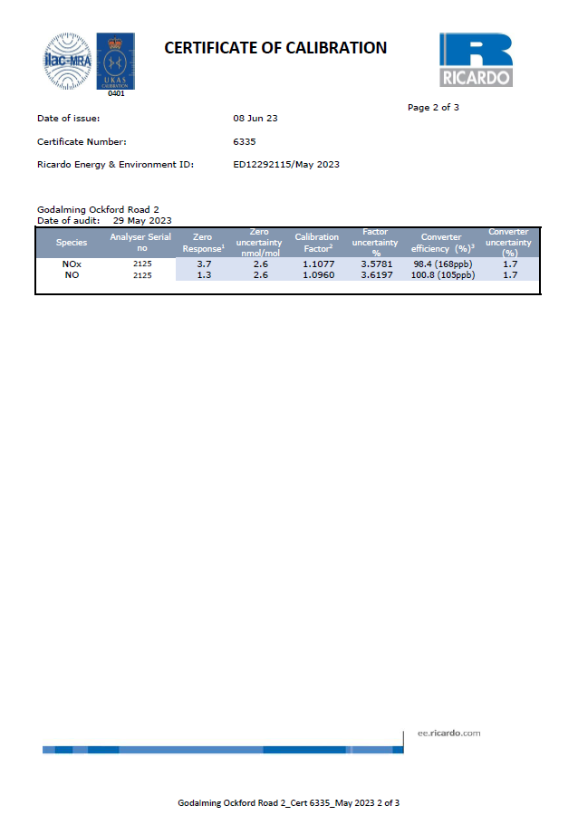

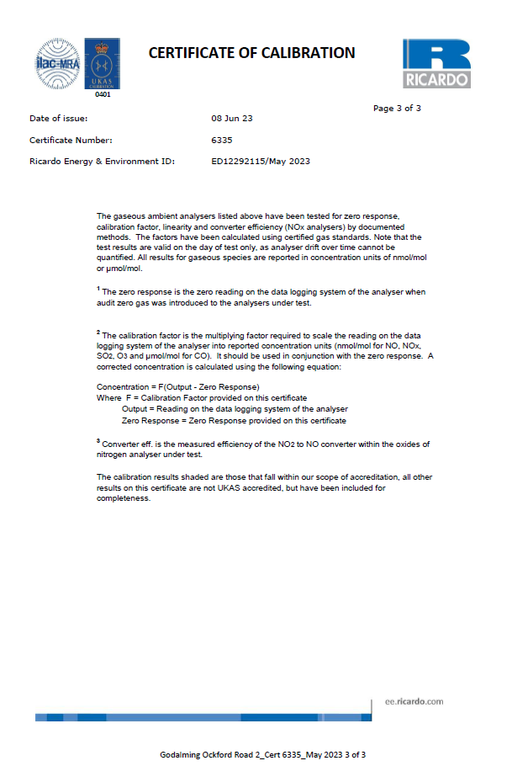

Godalming, Ockford Road 2 (November 2023)

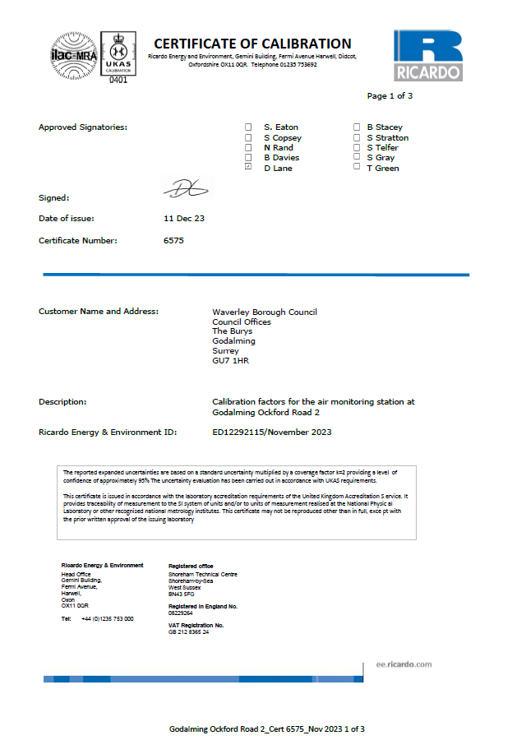

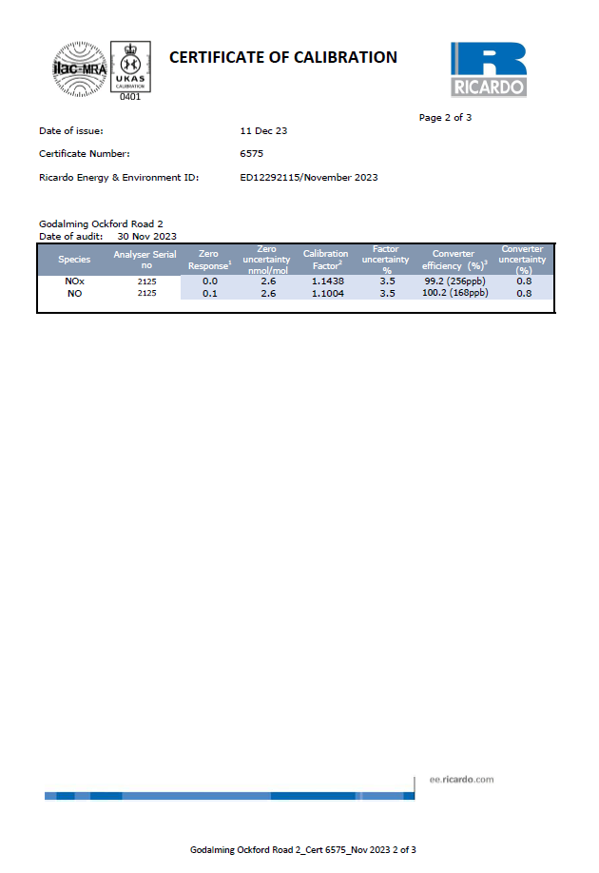

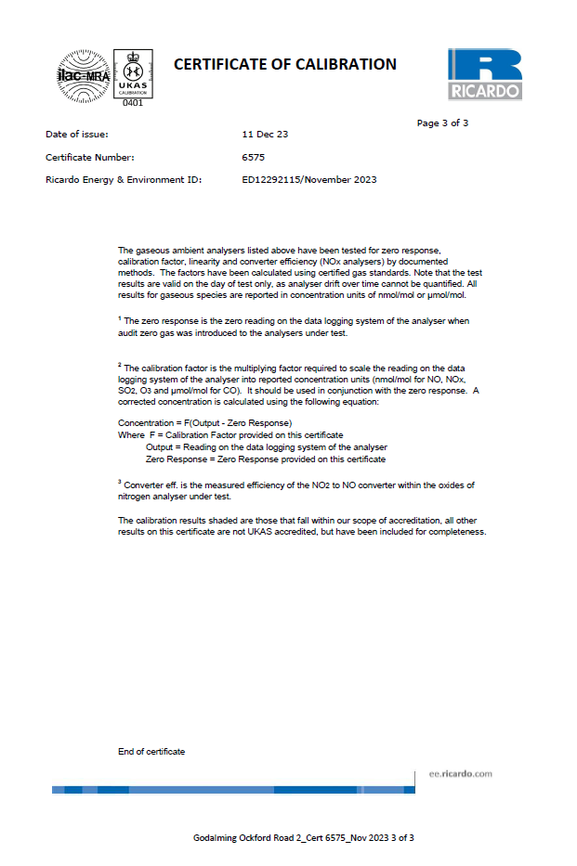

# Appendix D: Map(s) of Monitoring Locations and AQMAs

Figure D. – Map of Non-Automatic Monitoring Sites

|  |  |
| --- | --- |
|  |  |
| Figure D. – Map showing Farnham AQMA and location of automatic analyser (WA004) and diffusion tubes   | Figure D. – Map showing Godalming AQMA and location of automatic analyser (WA001) and diffusion tubes |

|  |  |  |
| --- | --- | --- |
| Figure D. – Map showing location of diffusion tubes in Farnham   | Figure D. – Map showing location of diffusion tubes in Godalming and Farncombe   | |
|  |  | |
| Figure D. – Map showing location of diffusion tubes in Haslemere   | | Figure D.– Map showing location of diffusion tubes in Cranleigh   |

# Appendix E: Summary of Air Quality Objectives in England

Table E.1 – Air Quality Objectives in England[16]

| Pollutant | Air Quality Objective: Concentration | Air Quality Objective: Measured as |
| --- | --- | --- |
| Nitrogen Dioxide (NO2) | 200µg/m3 not to be exceeded more than 18 times a year | 1-hour mean |
| Nitrogen Dioxide (NO2) | 40µg/m3 | Annual mean |
| Particulate Matter (PM10) | 50µg/m3, not to be exceeded more than 35 times a year | 24-hour mean |
| Particulate Matter (PM10) | 40µg/m3 | Annual mean |
| Sulphur Dioxide (SO2) | 350µg/m3, not to be exceeded more than 24 times a year | 1-hour mean |
| Sulphur Dioxide (SO2) | 125µg/m3, not to be exceeded more than 3 times a year | 24-hour mean |
| Sulphur Dioxide (SO2) | 266µg/m3, not to be exceeded more than 35 times a year | 15-minute mean |

# Glossary of Terms

| Abbreviation | Description |
| --- | --- |
| AQAP | Air Quality Action Plan - A detailed description of measures, outcomes, achievement dates and implementation methods, showing how the local authority intends to achieve air quality limit values’ |
| AQMA | Air Quality Management Area – An area where air pollutant concentrations exceed / are likely to exceed the relevant air quality objectives. AQMAs are declared for specific pollutants and objectives |
| ASR | Annual Status Report |
| CAS | Clean Air Strategy |
| Defra | Department for Environment, Food and Rural Affairs |
| DMRB | Design Manual for Roads and Bridges – Air quality screening tool produced by National Highways |
| EU | European Union |
| FDMS | Filter Dynamics Measurement System |
| LAQM | Local Air Quality Management |
| NO2 | Nitrogen Dioxide |
| NOx | Nitrogen Oxides |
| PM10 | Airborne particulate matter with an aerodynamic diameter of 10µm or less |
| PM2.5 | Airborne particulate matter with an aerodynamic diameter of 2.5µm or less |
| QA/QC | Quality Assurance and Quality Control |
| SO2 | Sulphur Dioxide |

# References

* Defra. National Statistics. Nitrogen Dioxide (NO2). <https://www.gov.uk/government/statistics/air-quality-statistics/ntrogen-dioxide>, accessed 10th May 2024
* Defra. National Statistics. Particulate matter (PM10/PM2.5) <https://www.gov.uk/government/statistics/air-quality-statistics/concentrations-of-particulate-matter-pm10-and-pm25#trends-in-concentrations-of-pm10-in-the-uk-1992-to-2023>, accessed 13th May 2024
* Local Air Quality Management Technical Guidance LAQM.TG22. August 2022. Published by Defra in partnership with the Scottish Government, Welsh Assembly Government and Department of the Environment Northern Ireland
* Local Air Quality Management Policy Guidance LAQM.PG22. August 2022. Published by Defra in partnership with the Scottish Government, Welsh Assembly Government and Department of the Environment Northern Ireland
* Chemical hazards and poisons report: Issue 28. June 2022. Published by UK Health Security Agency
* Air Quality Strategy – Framework for Local Authority Delivery. August 2023. Published by Defra
* Air Quality England, [Waverley Borough Council - Air Quality monitoring service (airqualityengland.co.uk)](https://www.airqualityengland.co.uk/local-authority/?la_id=379)
* Diffusion Tube Processing Tool. <https://laqm.defra.gov.uk/air-quality/air-quality-assessment/diffusion-tube-data-processing-tool/>
* National Bias Adjustment spreadsheet. <https://laqm.defra.gov.uk/air-quality/air-quality-assessment/national-bias/> (accessed 19th April 2024)
* [Public Health Outcomes Framework - Data - OHID (phe.org.uk)](https://fingertips.phe.org.uk/profile/public-health-outcomes-framework/data#page/4/gid/1000043/ati/501/iid/93861/age/230/sex/4/cat/-1/ctp/-1/yrr/1/cid/4/tbm/1/page-options/tre-do-0), accessed 19th April 2024
* Waverley Borough Council. Air Quality Action Plan 2023
* Waverley Borough Council. Clean Air Strategy 2023
* Waverley Borough Council. Annual Status Report 2019, 2020, 2021, 2022, 2023

1. UK Health Security Agency. Chemical Hazards and Poisons Report, Issue 28, 2022.
2. Defra. Air quality and social deprivation in the UK: an environmental inequalities analysis, 2006
3. Defra. National statistics. Nitrogen Dioxide (NO2), April 2024.
4. Defra. National statistics. Particulate Matter (PM10/PM2.5), April 2024.
5. Defra. Environmental Improvement Plan 2023, January 2023
6. Defra. Air Quality Strategy – Framework for Local Authority Delivery, August 2023
7. DfT. The Road to Zero: Next steps towards cleaner road transport and delivering our Industrial Strategy, July 2018
8. Defra. Air Quality Strategy – Framework for Local Authority Delivery, August 2023
9. [Public Health Outcomes Framework - Data - OHID (phe.org.uk)](https://fingertips.phe.org.uk/profile/public-health-outcomes-framework/data#page/4/gid/1000043/ati/501/iid/93861/age/230/sex/4/cat/-1/ctp/-1/yrr/1/cid/4/tbm/1/page-options/tre-do-0)

   Note, The method for calculating the fraction of mortality attributable to particulate air pollution was updated in 2022.
10. Air Quality Targets – Detailed Evidence Report, Defra May 2022
11. [Further_interpretation_of_air_quality_modelled_in_Waverley_from_CERC___March_2020.pdf](https://www.waverley.gov.uk/Portals/0/Documents/services/environmental-concerns/pollution-control/air%20quality/Further_interpretation_of_air_quality_modelled_in_Waverley_from_CERC___March_2020.pdf?ver=FuKDzFNczauvtnmwyM2DAw%3d%3d)
12. [Locally-managed automatic monitoring - Defra, UK](https://uk-air.defra.gov.uk/networks/network-info?view=nondefraaqmon)
13. <https://laqm.defra.gov.uk/wp-content/uploads/2022/08/LAQM-TG22-August-22-v1.0.pdf>
14. <https://laqm.defra.gov.uk/air-quality/air-quality-assessment/estimating-pm2-5-from-pm10-measurements/>
15. <https://laqm.defra.gov.uk/wp-content/uploads/2023/11/LAQM-NO2-Performance-data_Up-to-Oct-2023_V1_Final.pdf>
16. The units are in microgrammes of pollutant per cubic metre of air (µg/m3).