
Air Quality Action Plan (2024 – 2029)
for the district of East Hertfordshire
February 2024

Produced in partnership with Hertfordshire County Council and Bureau Veritas in fulfilment of Part IV of the Environment Act 1995
Local Air Quality Management
Information
Local Authority | East Herts Council
Department | Environmental Health  Housing and Health Service
Address | East Herts Council  Wallfields  Pegs Lane  Hertford  SG13 8EQ
Telephone | 01279 655261
E-mail | environmental.health@eastherts.gov.uk
Report Reference Number | Draft version: 05/03/2024
Date | January 2024

Executive Summary

The national context
Air pollution is bad for human health. Mounting scientific evidence shows the scale of the impact of poor ambient air quality on health.
In December 2020, the impact of air pollution was made evident in the most terrible of ways when the first case of air pollution being ruled as a medical cause of death was recorded in the coroner’s report relating to the tragic death of nine-year old Ella Kissi-Debrah[].
Part IV of the Environment Act 1995 (as Amended 2021) sets out national air quality objectives (AQO) which should be considered as the maximum levels of air pollution to which people should be exposed. These AQOs are:
- the annual average level of nitrogen dioxide (NO₂) in a location should be no higher than 40µg/m³, that is, 40 micrograms of NO₂ per cubic metre of air and
- the hourly average level of nitrogen dioxide (NO₂) in a location should be no higher than 200µg/m³.

Air quality in East Hertfordshire
Our analysis shows that:
- while the 200µg/m³ hourly mean average level of NO₂ is not breached in any location
- the 40µg/m³ annual mean average level of NO₂ is breached in three areas in Bishop’s Stortford, Hertford and Sawbridgeworth.
Resulting from these breaches, the council declared three Air Quality Management Areas (AQMAs):
- Bishop’s Stortford AQMA – An area encompassing several properties around the junction of Dunmow Road, Hockerill Street, London Road and Stansted Road in Bishop’s Stortford. Declared February 2007.
- Hertford AQMA – An area along Gascoyne Way, which passes through central Hertford and encompasses several residential and commercial properties. Declared May 2010.
- Sawbridgeworth AQMA – An area along London Road and Cambridge Road that encompasses several residential and commercial properties. Declared February 2014.
Air pollution in each of the three AQMAs is primarily the result of traffic.
Because we have declared AQMAs, we are required under the national legislation to produce this detailed action plan to tackle air pollution in each AQMA. This action plan is aimed at everyone who lives in, works in, visits or travels through East Hertfordshire. It will also be of particular interest to people who live in, walk through or drive through one of our three air quality management areas, as the interventions and initiatives within this action plan will help reduce the impact of air pollution on their health.

Who is exposed to air pollution in East Herts?
The analysis discussed in detail in this action plan shows that residents in the AQMAs are those most affected by air pollution. We recognise, however, that those walking, cycling and driving through the AQMAs will also experience poor air quality, though at levels below the nationally set maximum objectives for exposure.

Track record to date
This action plan builds on our good track record in tackling air pollution. For example, we have:
- trialled an e-car club, using Department for Environment, Food and Rural Affairs (DEFRA) funding, which served council staff in the day and the public outside of office hours with dedicated chargers in Hertford and Bishop’s Stortford. This pilot scheme has led to the establishment of a staff e-car club and private car rental companies in the area offering low emission vehicles for hire by the public
- published a Sustainability Supplementary Planning Document (SPD) with a specific air quality chapter applying strict air quality measures to all developments
- introduced the strictest emissions standards in Hertfordshire for the taxi vehicles we licence
- installed over 60 e-vehicle charging points to promote the switch to e-vehicles
- replaced our fleet of diesel vans with e-cars
- installed anti-idling signage in our own car parks and beyond.
In addition, together with our partners, principally Hertfordshire County Council, we have:
- introduced smart traffic light management at Hockerill junction in the Bishop’s Stortford Air Quality Management Area (AQMA) to promote traffic flow and minimise engine idling
- improved the lighting and visual appeal of pedestrian subways to counteract feelings of a lack of safety as a barrier to active travel
- annually promoted Clean Air Day
- supported the introduction of demand responsive bus services in the northern half of the district
- actively participated in initiatives organised through the Hertfordshire Climate Change and Sustainability Partnership (HCCSP), including leading on raising taxi emission standards across the county.
We have continued to facilitate behaviour change by:
- introducing and promoting an air alert notification scheme
- working with schools and businesses, using DEFRA funding, on active travel alternatives to daily commutes.

East Herts Air Quality Priorities
There is much still to do. We and our partners have reviewed the local evidence, the policies available and best practice to identify four key priorities for action:
- Priority 1: Reduce the impact of traffic levels and congestion on air quality
- Priority 2: Mitigate the impact of future growth on air quality
- Priority 3: Support residents’ make active travel choices
- Priority 4: Reduce East Herts Council’s own impact on air quality.
We have devised an action plan with a series of measures to tackle each of these priority areas.

Responsibilities and commitment
This Air Quality Action Plan (AQAP) was prepared by the Strategic Environmental Health team of East Herts Council with the support and agreement of colleagues from the following teams:
- East Herts Council
  - wider Environmental Health team
  - Sustainability
  - Planning
  - Economic Development
  - Taxi licensing
  - Parking
- Hertfordshire County Council
  - Transport Planning and Highways
  - Clean Air
- Bureau Veritas air quality consultants.
This AQAP has been approved by the Head of Housing and Health, the member of the council’s Senior Leadership Team with responsibility for both Environmental Health and Sustainability.
This AQAP <has/has not> been signed off by the Director of Public Health, Hertfordshire County Council.
<To be completed following the conclusion of the consultation>
This AQAP will be subject to regular review by the council’s Senior Leadership Team, the Executive Member for Environmental Sustainability and the council’s Overview and Scrutiny Committee. Progress each year will be reported in the Annual Status Reports (ASRs) produced by East Herts Council as part of our statutory Local Air Quality Management duties. The ASRs are available on our website: https://www.eastherts.gov.uk/environmental-health/air-quality
If you have any comments on this AQAP please submit these through the ‘Contact Environmental Health’ page on the East Herts website: https://www.eastherts.gov.uk/environmental-health/contact-environmental-health

Contents
1 Executive Summary i
2 The Importance of Tackling Air Pollution 6
3 The National Legislative Framework for Tackling Air Pollution 10
4 Exposure to Air Pollution in the Bishop’s Stortford AQMA 14
5 Exposure to Air Pollution in the Hertford AQMA 19
6 Exposure to Air Pollution in the Sawbridgeworth AQMA 25
7 Who is Exposed to Air Pollution in the AQMAs in East Hertfordshire? 30
8 Developing an Air Quality Action Plan for East Hertfordshire 34
9 Source Apportionment 41
10 Required Reduction in Emissions 49
11 Consultation 51
12 East Herts Air Quality Priorities 54
13 Air Quality Action Plan Measures 57
14 Illustration of Potential Impact of the AQAP 72
15 Cost / Benefit and Feasibility Analysis of Measures 80
Appendix A - Reasons for Not Pursuing Action Plan Measures 85
Appendix B - NO₂ Source Apportionment Calculations 88
Appendix C - Emission Reduction Calculations 89
Appendix D - Steering Group Attendees 90
Appendix E - Air Pollution Monitoring Results – Bishop’s Stortford 91
Appendix F - Air Pollution Monitoring Results - Hertford 92
Appendix G - Air Pollution Monitoring Results - Sawbridgeworth 93
Appendix H - Glossary of Terms 94
Appendix I - Action Plan presented in Defra format 95

The Importance of Tackling Air Pollution

Public health context
Put simply, air pollution is bad for human health. Mounting scientific evidence shows the scale of the impact of poor ambient air quality on health.
In December 2020, the impact of air pollution was made evident in the most terrible of ways when the first case of air pollution being ruled as a medical cause of death was recorded in the coroner’s report relating to the tragic death of nine-year old Ella Kissi-Debrah. In his report[], Philip Barlow, assistant coroner for the coroner area of Inner South London, stated:
Air pollution was a significant contributory factor to both the induction and exacerbations of [Ella’s] asthma. During the course of her illness between 2010 and 2013 she was exposed to levels of nitrogen dioxide and particulate matter in excess of World Health Organization Guidelines. The principal source of her exposure was traffic emissions.
During this period there was a recognized failure to reduce the level of nitrogen dioxide to within the limits set by EU and domestic law which possibly contributed to her death.
Poor air quality is a significant contributory factor to the loss of life, shortening lives by an average of six months.[] The Committee on the Medical Effects of Air Pollution (COMEAP)[] provides advice to Government on the setting of air quality standards and has increasingly sought to consolidate evidence on the health burden and impacts of various pollutants, both in single occurrence and pollutants in combination. The current range of estimate for annual mortality burden for air pollution in the UK is estimated to be between 28,000 – 36,000 deaths.
The Air Quality Indicator in the Public Health Outcomes Framework (England) provides further impetus to join up action between the various tiers of local government and different local authority services which can impact on the delivery of air quality improvements. The “Air Quality – A Briefing for Directors of Public Health”[] document published in March 2017 provides a one-stop guide to the latest evidence on air pollution, guiding local authorities to use existing tools to appraise the scale of the air pollution issue in its area. It also advises local authorities how to appropriately prioritise air quality alongside other public health priorities to ensure it is on the local agenda.
Besides NO₂, there is an increasing focus on fine particulate matter. PM_{2.5} is a pollutant of concern, this being particulate matter which is 2.5 microns or less in diameter. The AQMAs have not been declared for PM_{2.5} and the modelling (based on data collected from the continuous air quality monitor EH79) as part of the detailed assessment has shown predicted levels below the current annual mean objective of 20µg/m³.
National targets to further reduce PM_{2.5} have recently been introduced (see Section 3.1 for more details). During the lifetime of our air quality action plan, a national interim PM_{2.5} target of 12μg/m³ by January 2028 will come into effect. The council is closely monitoring the emergent national guidance on monitoring and reporting of this target. Of note, the current continuous air quality monitor in Hertford and the three additional continuous air quality monitors to be installed in each of the three AQMAs will enable the council to monitor PM_{2.5} levels.
The Public Health Outcomes Framework data tool compiled by UK Health Security Agency (formally Public Health England) quantifies the mortality burden of PM_{2.5} within England on a county and local authority basis. The 2021 fraction of mortality attributable to PM_{2.5} pollution, that is, the percentage of total deaths as a result of pollution, in East Herts was 5.8%, which is above the national average of 5.5%, and higher than the regional average (East of England) of 5.5%[]. It should be noted that this figure only accounts for one pollutant (PM_{2.5}), for which stronger scientific evidence on links with mortality exist, and not NO₂, for which the AQMA is declared.
Furthermore, following a review of research into the mortality burden associated with the air pollution mixture rather than single pollutants acting independently, the Committee on the Medical Effects of Air Pollutants (COMEAP) are reviewing the legitimacy of linking deaths to one specific pollutant.
Further information about the health effects associated with poor air quality can be found on UKHSA link to the Global Action Plan website – www.cleanairhub.org.uk/home

Local understanding of air pollution’s impact on health
The focus on tackling air pollution and improving health outcomes is clear at both the Hertfordshire County Council (HCC) and East Herts Council tiers. Of note, HCC’s Air Quality Strategy (2019)[] sets out the following strategic objectives for dealing with air quality issues:
- to gain a stronger understanding of the air quality issues within Hertfordshire
- to ensure that air quality is an integral part of everything that we do
- to develop a productive relationship with partners, in particular the District and Borough Councils, to achieve positive air quality outcomes
- to create clear leadership on air quality
- to establish a coherent workstream on air quality, including clarification on roles and responsibilities.
East Herts Council’s Health and Wellbeing Strategy 2019-2023[] sets out the key priorities that affect people’s health and wellbeing and includes facilitating ‘residents living active and healthy lives’ which clearly resonates with the push to reduce air pollution.

Working with local partners
To enable this action plan, the council is keen for both member and officer-led forums to be formed with representatives from East Herts Council and Hertfordshire County Council, co-opting people as appropriate. The purpose of the forums would be to help overcome any obstacles and monitor progress on the AQAP.
The council will also look to engage with local members of parliament (MPs) to discuss changes at a national level which would also benefit the air quality in East Hertfordshire.

The National Legislative Framework for Tackling Air Pollution

National legislation: NO₂
Part IV of the Environment Act 1995 (as amended 2021) sets out national air quality objectives (AQO) which should be considered as the maximum levels of air pollution to which people should be exposed. These AQOs are:
- the annual average level of nitrogen dioxide (NO₂) in a location should be no higher than 40µg/m³, that is, 40 micrograms of NO₂ per cubic metre of air and
- the hourly average level of nitrogen dioxide (NO₂) in a location should be no higher than 200µg/m³.
Relevant regulations made under the Environment Act 1995 and guidance in the Local Air Quality Management Technical Guidance 2022 require that where at least one these AQOs are consistently breached, the local authority (that is, the district council in an area such as East Hertfordshire with both a district and county council) should declare an Air Quality Management Area (AQMA).

National legislation: PM2.5
With regard to particulate matter (specifically PM_{2.5}), unlike when considering NO₂, the government has only recently set national objectives. These objectives have been set within the Environmental Targets (fine particulate matter) (England) Regulations 2023, brought in under Environment Act 2021. The two objectives, both to be met by 2040, are:
- annual mean concentrations of to be 10 µg/m³ or lower
- population exposure to PM_{2.5} to be reduced by 35% compared with 2018 levels.
The two targets are designed to work together to drive actions that both reduce concentrations where it is highest and reduce the pollution that everyone in the country experiences.
During the lifetime of our air quality action plan, a national interim PM_{2.5} target of 12μg/m³ by January 2028 will come into effect. It is, therefore, to be anticipated that the government will update its Local Air Quality Management Technical Guidance in due course to provide guidance to local authorities on how to monitor, report and seek to reduce PM_{2.5} levels in line with these new national objectives.
The council is prepared to act on the emerging guidance. Of note, the current continuous air quality monitor in Hertford and the three additional continuous air quality monitors to be installed in each of the three AQMAs will enable the council to monitor PM_{2.5} levels so as to determine where to focus our interventions. Monitoring the emergent national guidance on reporting and reducing PM_{2.5} levels so as to determine interventions is included in the detailed action plan in Section 13.

National legislation: zero emission vehicle mandate
The Government’s zero emission vehicle (ZEV) mandate[] sets out the percentage of new zero emission cars manufacturers will be required to produce each year. This requires 80% of new cars and 70% of new vans sold in the country to be zero emission by 2030, increasing to 100% by 2035.
Over time this move will help reduce pollution from NO_{x}, however it will not address the pollution from particulate matter.

East Herts Council’s requirements under the national legislation
Unfortunately, the council’s monitoring shows that there are three areas within the district where the level of air pollution is too high. Our analysis, reported in this action plan, shows that:
- while the 200µg/m³ hourly mean average level of NO₂ is not breached in any location
- the 40µg/m³ annual mean average level of NO₂ is breached in three areas in Bishop’s Stortford, Hertford and Sawbridgeworth.
We have thus declared the following Air Quality Management Areas:
- Bishop’s Stortford AQMA – An area encompassing several properties around the junction of Dunmow Road, Hockerill Street, London Road and Stansted Road in Bishop’s Stortford. Declared February 2007. Figure 1 shows the location covered by the AQMA.
Data showing the air quality in this AQMA from when it was first declared in 2007 to 2022 can be found in Appendix E.
While the pollution levels show a pattern of rises and falls, the levels in 2022 are in fact very similar to those when the AQMA was first declared in 2007.
- Hertford AQMA – An area along Gascoyne Way, which passes through central Hertford and encompasses several residential and commercial properties. Declared May 2010. Figure 3 shows the location covered by the AQMA.
Data showing the air quality in this AQMA from when it was first declared in 2010 to 2022 can be found in Appendix F.
While the pollution levels have dropped in recent years, the levels in 2022 have started to indicate an increase again in pollution levels post the COVID-19 pandemic.
- Sawbridgeworth AQMA – An area along London Road and Cambridge Road that encompasses several residential and commercial properties. Declared February 2014. Figure 5 shows the location covered by the AQMA.
Data showing the air quality in this AQMA from when it was first declared in 2014 to 2022 can be found in Appendix G.
While the pollution levels have dropped in recent years in this AQMA, the levels in 2022 have started to indicate a slight increase in pollution levels.
Because we have declared AQMAs, we are required under the national legislation to produce this detailed action plan to tackle air pollution in each AQMA.
This report explains in detail what we know about the locations and sources of air pollution in East Hertfordshire and thus what we and our partners will do between 2024 and 2029 to reduce air pollution.
It has been developed in recognition of the legal requirement on the council to work towards Air Quality Strategy (AQS) objectives under Part IV of the Environment Act 1995 (as Amended 2021) and relevant regulations made under that part and to meet the requirements of the Local Air Quality Management (LAQM) statutory process.
This plan will be reviewed regularly, at least every five years, and progress on measures set out within this plan will be reported annually within East Herts Council’s air quality Annual Status Report (ASR).
This document has been written to be as easy to read and understand as possible by everyone with an interest in seeing air pollution reduced in the district while providing DEFRA with the required level of technical data to assure them that the council and its partners have thoroughly analysed the local situation and devised effective interventions in response.

Revocation of an Air Quality Management Area
Revoking an AQMA, that is, declaring that the air pollution has been sufficiently reduced to be below the national air quality objectives, is not something to be done lightly.
As noted above, each of the AQMAs in East Hertfordshire have been declared because of breaches of the 40µg/m³ annual mean average level of NO_{2.} The monitoring is based the use of diffusion tubes in which case the national guidance, contained in the LAQM Technical Guidance 2022, requires at least three continuous years of readings at 10% below this level to revoke the AQMA applies. This means all recording locations in the AQMA would need to show NO₂ levels of no more than 36µg/m³ for three years running, with the readings during the COVID-19 pandemic not applying as the impacts of the lockdowns will have led to unrepresentative levels.

Exposure to Air Pollution in the Bishop’s Stortford AQMA
This chapter of the report provides details of exposure to air pollution in the Bishop’s Stortford Air Quality Management Area (AQMA).
Figure 1 shows the location of the council’s air quality monitoring stations in and adjacent to the Bishop’s Stortford AQMA which is centred on Hockerill junction.

Figure 1 – Bishop’s Stortford AQMA and air quality monitoring locations
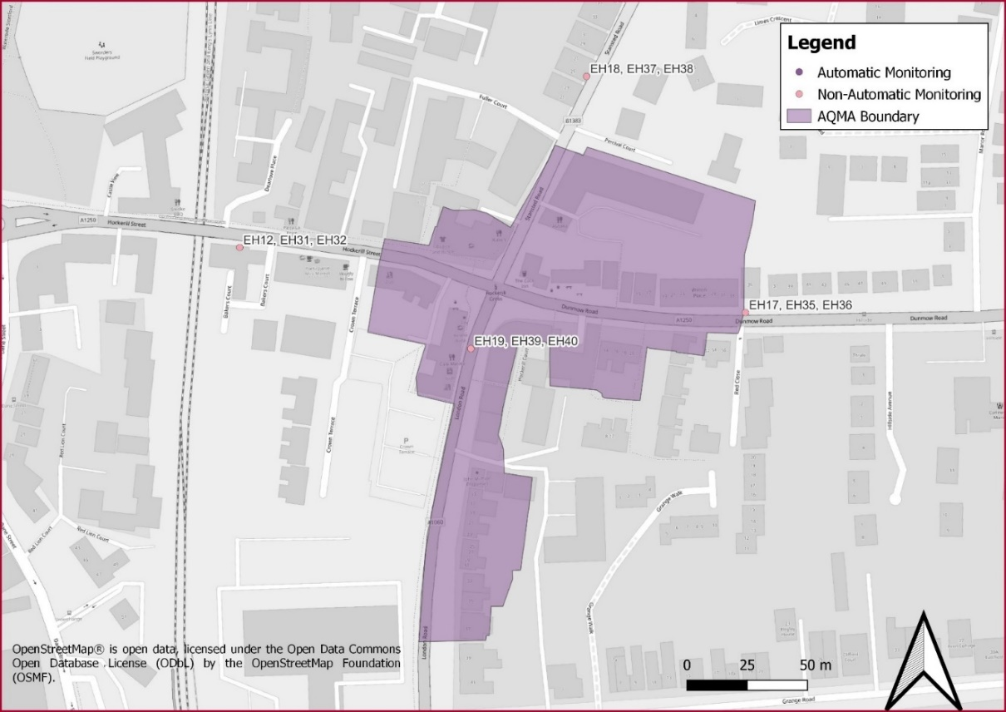

Analysis of the annual mean average NO₂ concentration in the Bishop’s Stortford AQMA
Table 1 gives the readings at the monitoring locations in Bishop’s Stortford over the last five years. It can be seen that by 2022, two of the four roads at Hockerill junction are below the annual average of no more than 40µg/m³. Can the AQMA be revoked? No, as a consistent pattern of three years’ readings at or below 36µg/m³ is not shown. Of note, the three years of low readings in Stanstead Road must be treated with caution as the 2020/21 and 2021/22 levels will have been impacted by the COVID-19 pandemic and lockdowns.
Table 1 gives annual mean average levels as the ‘raw data’ and as ‘bias adjusted’ figures. The latter figures are the raw numbers with a DEFRA formula applied to take account of the precise location of the monitoring in relation to residents and thus purport to give a better measure of how the residents in the area would be likely to experience the pollution. Both figures have been included for completeness.

Table 1 – LAQM diffusion tube monitoring – Bishop’s Stortford AQMA
Site ID | Site location | Within Bishop’s Stortford AQMA | Bias adjusted annual mean concentration (µg/m³)  [Annual Mean NO₂ Concentration] (µg/m³)  Figures in bold = level above the national objective of 40 µg/m³
 |  |  | 2018 | 2019[] | 2020 | 2021 | 2022
EH12 EH31 EH32 | Hockerill Street | Yes | 35.4  [43.6] | 43.8  [42.9] | 34.5  [33.4] | 33.4  [34.8] | 38.9  [36.1]
EH17 EH35 EH36 | Dunmow Road | Yes | 51.4  [63.2] | 59.5  [58.3] | 46.9  [48.5] | 47.3  [49.3] | 48.8  [45.2]
EH18 EH37 EH38 | Stansted Road | No | 30.9  [38.0] | 36.1  [35.4] | 30.8  [29.8] | 30.7  [31.9] | 33.1  [30.6]
EH19 EH39 EH40 | London Road | No | 52.0  [64.0] | 59.1  [57.9] | 48.9  [47.4] | 48.3  [50.3] | 50.0  [46.3]

Analysis of the hourly mean average NO₂ concentration in the Bishop’s Stortford AQMA
At present, we do not have data from a continuous air quality monitor in the Bishop’s Stortford AQMA and so we use the guidance published by DEFRA to calculate whether the hourly mean average for NO₂ of 200μg/m³ objective has or is likely to have been exceeded.
DEFRA’s Local Air Quality Management Technical Guidance (TG22)[] states that the hourly mean average of NO₂ of 200μg/m³ objective is only likely to be exceeded where the annual mean average concentrations are 60μg/m³ or more. As the data in Table 1 reports levels below 60μg/m³ we can deduce that the hourly 200μg/m³ level is likely not to have been exceeded in the last five years.

Heat map showing NO₂ concentrations in the Bishop’s Stortford AQMA
The ‘heat map’ in Figure 2 shows the modelled air pollution levels in the Bishop’s Stortford AQMA based on the readings from the various monitoring stations. The map uses DEFRA’s standard scale, represented as yellow, orange and red, to indicate the severity of the NO₂ levels in each location.
The map illustrates that exceedances of the annual mean NO₂ concentration are primarily due to vehicle congestion at the Hockerill junction. This is exacerbated at this location by the “road canyon” effects of the surrounding streets due to narrow roads and buildings on either side of the roads. As can thus be anticipated, the modelling used for the heat maps illustrates that concentrations of air pollution in the AQMAs are highest in the centre of the main roads, with levels of pollution falling as one moves away from each road.

Figure 2 - Bishop’s Stortford AQMA modelled pollutant concentrations (based on data from 2019)
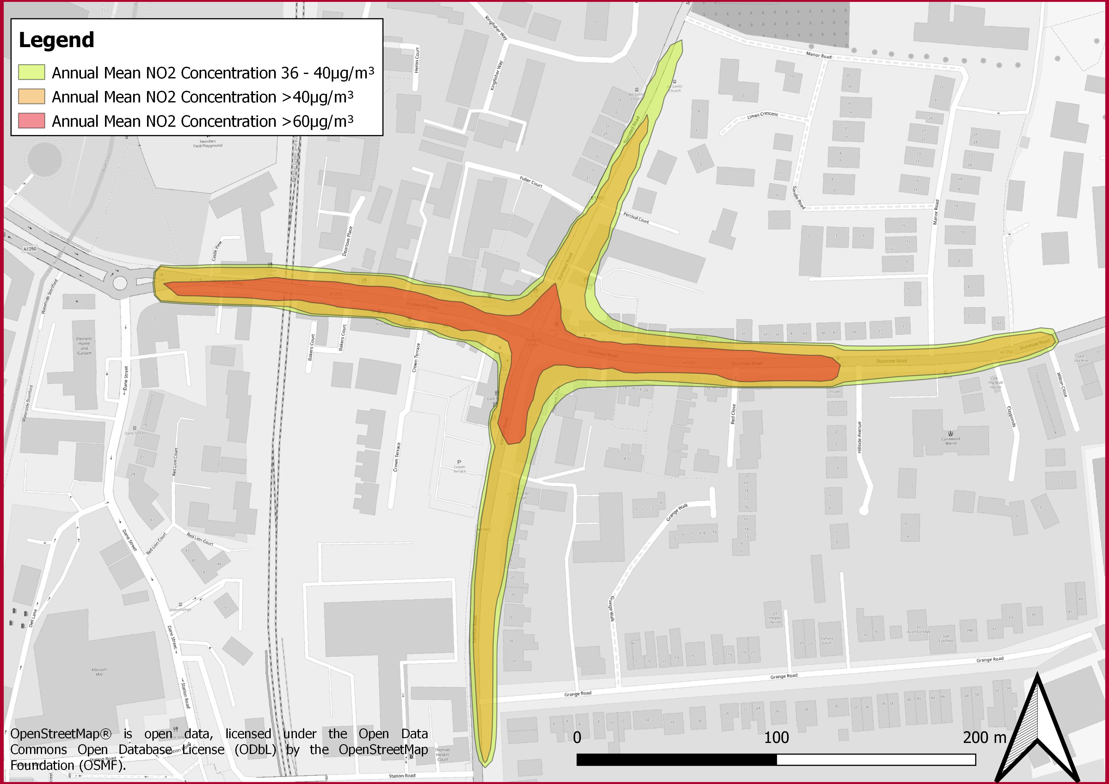

Exposure to Air Pollution in the Hertford AQMA
This chapter of the report provides details of exposure to air pollution in the Hertford Air Quality Management Area (AQMA).
Figure 3 shows the location of the council’s air quality monitoring stations in and adjacent to the Hertford AQMA which is centred on Gascoyne Way.

Figure 3 - Hertford AQMA and air quality monitoring locations
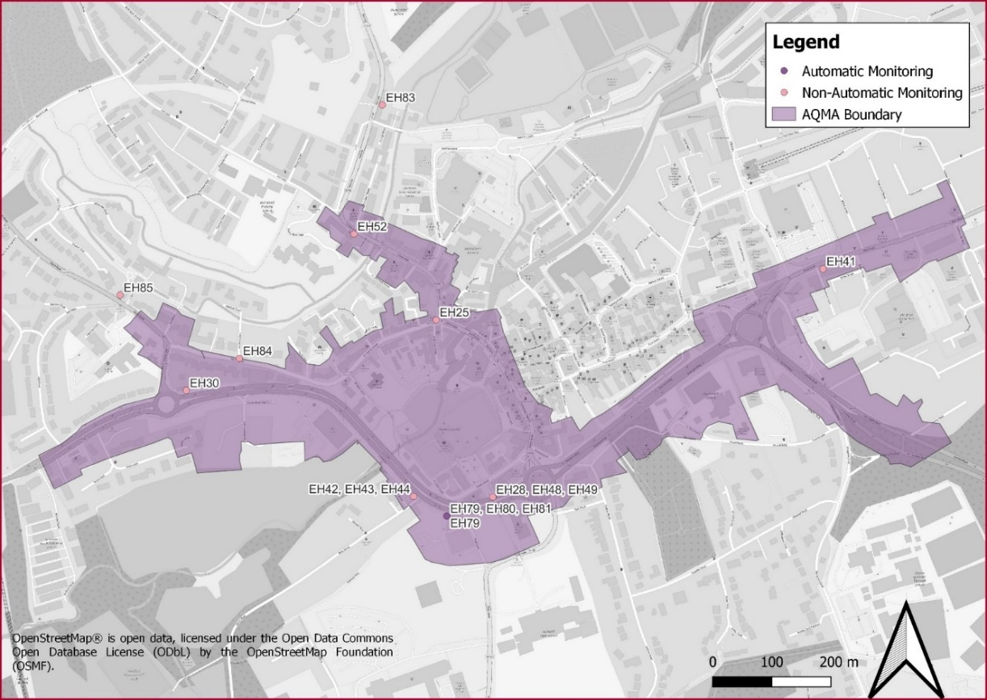

Analysis of the annual mean average NO₂ concentration in the Hertford AQMA
From the data in Table 2, we can see that by 2022 all five monitoring locations are below the annual mean air quality objective (AQO) for NO₂ of 40µg/m³.
As discussed earlier in this report, to revoke an AQMA, the annual mean air quality objective for NO₂ must be at least 10% lower than the exceedance value of 40µg/m³ or, put another way, the readings must not be above 36µg/m³, for at least three years. Because of the unreliability of the data collected during the COVID-19 pandemic (2020 and 2021), we do not have three consecutive years’ worth of data to support revoking this AQMA at the present time.
Table 2 gives annual mean average levels as the ‘raw data’ and as ‘bias adjusted’ figures. The latter figures are the raw numbers with a DEFRA formula applied to take account of the precise location of the monitoring in relation to residents and thus purport to give a better measure of how the residents in the area would be likely to experience the pollution. Both figures have been included for completeness.

Table 2 – LAQM diffusion tube monitoring – Hertford AQMA
Site ID | Site location | Within Hertford AQMA | Bias adjusted annual mean concentration (µg/m³)  [Annual Mean NO₂ Concentration] (µg/m³)  Figures in bold = level above the national objective of 40 µg/m³
 |  |  | 2018 | 2019[] | 2020 | 2021 | 2022
EH25 | Old Cross | Yes | 35.1  [43.2] | 41.8  [41.0] | 33.1  [32.1] | 32.3  [33.7] | 32.0  [29.7]
EH28 EH48 EH49 | Castle Street | Yes | 28.4  [35.0] | 34.7  [34.0] | 28.0  [27.2] | 28.1  [29.3] | 31.8  [29.4]
EH42 EH43 EH44 | West Street  (co-located with EH29) | Yes | 32.9  [40.5] | 40.6  [41.4] | 31.8  [30.9] | 32.1  [33.5] | 36.8  [34.1]
EH79 EH80 EH81 | Gascoyne Way | Yes | 31.8  [39.2] | 32.0  [31.4] | 25.6  [24.9] | 26.1  [27.2] | 28.9  [26.7]
EH30 | Downey Cottage, Hertingfordbury Road | Yes | 29.9  [36.8] | 37.3  [36.5] | 31.3  [30.3] | 30.0  [31.3] | 33.3  [30.8]

Analysis of the hourly mean average NO₂ concentration in the Hertford AQMA
Hertford is the only AQMA which currently has a continuous air quality monitoring station. The monitor is located on Gascoyne Way, within the Hertford AQMA, and monitors NO₂ and PM_{2.5} via a chemiluminescent and BAM analyser. This can be used to assess performance against the annual mean average objective of 200µg/m³.
Details of the continuous air quality monitor are provided in Table 3. The location of the monitoring site within the AQMA is shown in Figure 3.

Table 3 – Automatic monitor (Hertford)
Site ID | Site Location | Site Type | OS Grid Ref  (E, N) | In AQMA | Pollutants Monitored | Inlet Height (m)
EH79 | Gascoyne Way | Roadside | 532464, 212338 | Yes | NO₂ and PM_{2.5} | 1.5

The monitoring results for the annual mean NO₂ concentration are presented in Table 4. It can be seen that there have been no recorded exceedances of 60μg/m³, we can therefore deduce that the hourly 200μg/m³ level is likely not to have been exceeded in the last five years.

Table 4 – Automatic monitor EH79: NO₂ annual mean concentrations
Site ID | NO₂ Annual Mean Concentration (µg/m³)
 | 2018 | 2019 | 2020 | 2021 | 2022
EH79 | 32.2 | 33.0 | 20.0 | 26.0 | 28.9

Table 5 confirms that the 200µg/m³ NO₂ exposure to air pollution objective has not been breached during any single hourly reading.

Table 5 – Automatic monitor EH79: Number of NO₂ hourly means exceedances
Site ID | Hourly Means in Excess of the 1-hour Objective (200 µg/m³)
 | 2018 | 2019 | 2020 | 2021 | 2022
EH79 | 0 | 0 | 0 | 0 | 0

Heat map showing NO₂ concentrations in the Hertford AQMA
The ‘heat map’ in Figure 4 shows the modelled air pollution levels in the Hertford AQMA based on the readings from the various monitoring stations. The map uses DEFRA’s standard scale, represented as yellow, orange and red, to indicate the severity of the NO₂ levels in each location.
The map illustrates that annual mean NO₂ concentrations are highest in the centre of the main roads, notably Gascoyne Way and London Road. The levels of pollution fall as one moves away from each road. This illustrates that traffic is the primary cause of air pollution in the AQMA.

Figure 4 - Hertford AQMA modelled pollutant concentrations (based on data from 2019)
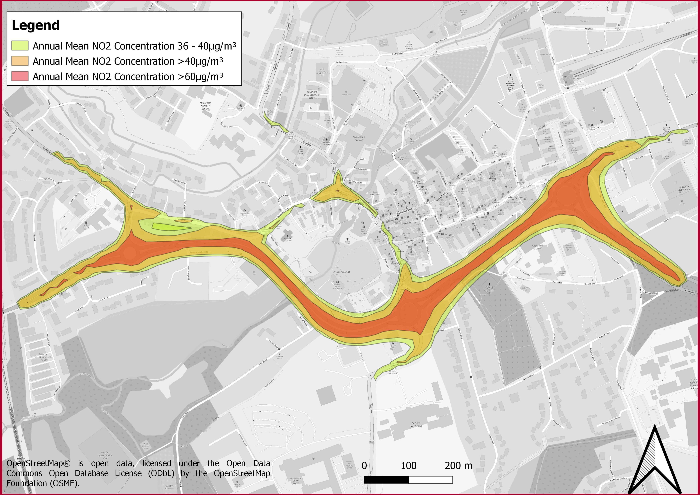

Exposure to Air Pollution in the Sawbridgeworth AQMA
This chapter of the report provides details of exposure to air pollution in the Sawbridgeworth Air Quality Management Area (AQMA).
Figure 5 shows the location of the council’s air quality monitoring stations in the Sawbridgeworth AQMA which is centred on the London Road/Cambridge Road corridor through the town.

Figure 5 - Sawbridgeworth AQMA and air quality monitoring locations
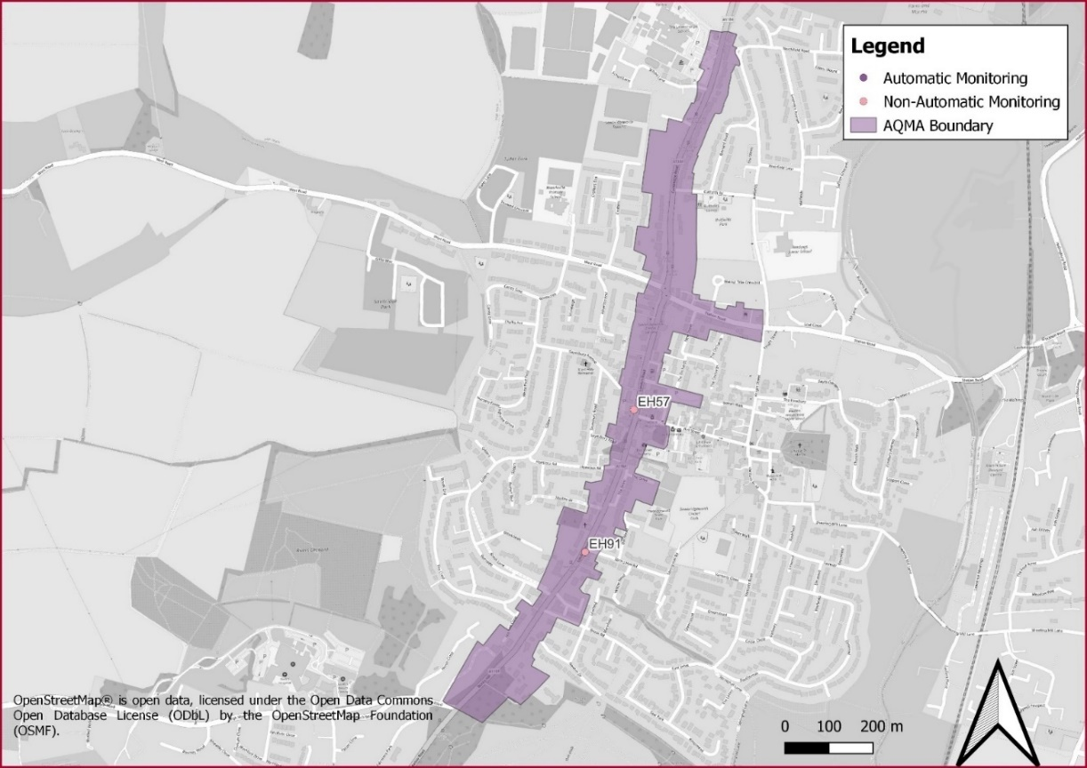

Analysis of the annual mean average NO₂ concentration in the Sawbridgeworth AQMA
From the data in Table 6, we can see that one of the monitoring locations is below the annual mean air quality objective (AQO) for NO₂ of 40µg/m³, and one exceeds it based on the bias adjusted concentration.
As discussed earlier in this report, to revoke an AQMA, the annual mean air quality objective for NO₂ must be at least 10% lower than the exceedance value of 40µg/m³ or, put another way, the readings must not be above 36µg/m³, for at least three years. Notwithstanding the unrepresentative nature of the data collected during the COVID-19 pandemic (2020 and 2021), the threshold for revocation clearly has not yet been met.
Table 6 gives annual mean average levels as the ‘raw data’ and as ‘bias adjusted’ figures. The latter figures are the raw numbers with a DEFRA formula applied to take account of the precise location of the monitoring in relation to residents and thus purport to give a better measure of how the residents in the area would be likely to experience the pollution. Both figures have been included for completeness.

Table 6 – LAQM diffusion tube monitoring – Sawbridgeworth AQMA
Site ID | Site location | Within Sawbrid-geworth AQMA | Bias adjusted annual mean concentration (µg/m³)  [Annual Mean NO₂ Concentration] (µg/m³)  Figures in bold = level above the national objective of 40 µg/m³
 |  |  | 2018 | 2019[] | 2020 | 2021 | 2022
EH57 | Bell Street at crossing | Yes | 41.5  [51.0] | 50.4  [49.5] | 40.5  [39.3] | 40.9  [42.6] | 42.9  [39.8]
EH91 | 14 London Road | Yes | 36.7  [43.3] | 39.5  [38.7] | 32.7  [31.7] | 33.6  [33.6] | 37.3  [34.5]

Analysis of the hourly mean average NO₂ concentration in the Sawbridgeworth AQMA
At present, we do not have data from a continuous air quality monitor in the Sawbridgeworth AQMA and so we use the guidance published by DEFRA to calculate whether the hourly mean average for NO₂ of 200μg/m³ objective has or is likely to be exceeded.
DEFRA’s Local Air Quality Management Technical Guidance (TG22)[] states that the hourly mean average of NO₂ of 200μg/m³ objective is only likely to be exceeded where the annual mean average concentrations are 60μg/m³ or more. As the data in Table 6 shows levels below 60μg/m³ we can deduce that the hourly 200μg/m³ level has not been exceeded in the last five years.

Heat map showing NO₂ concentrations in the Sawbridgeworth AQMA
The ‘heat map’ in Figure 6 shows the modelled air pollution levels in the Sawbridgeworth AQMA based on the readings from the various monitoring stations. The map uses DEFRA’s standard scale, represented as yellow, orange and red, to indicate the severity of the NO₂ levels in each location.
The map illustrates that annual mean NO₂ concentrations are highest at the junction of London Road and Bell Street and the dual roundabouts linking Cambridge Road, Station Road, London Road and West Road. The levels of pollution fall as one moves away from these two traffic junctions. This illustrates that traffic is the primary cause of air pollution in the AQMA.

Figure 6 - Sawbridgeworth AQMA modelled pollutant concentrations (based on data from 2019)
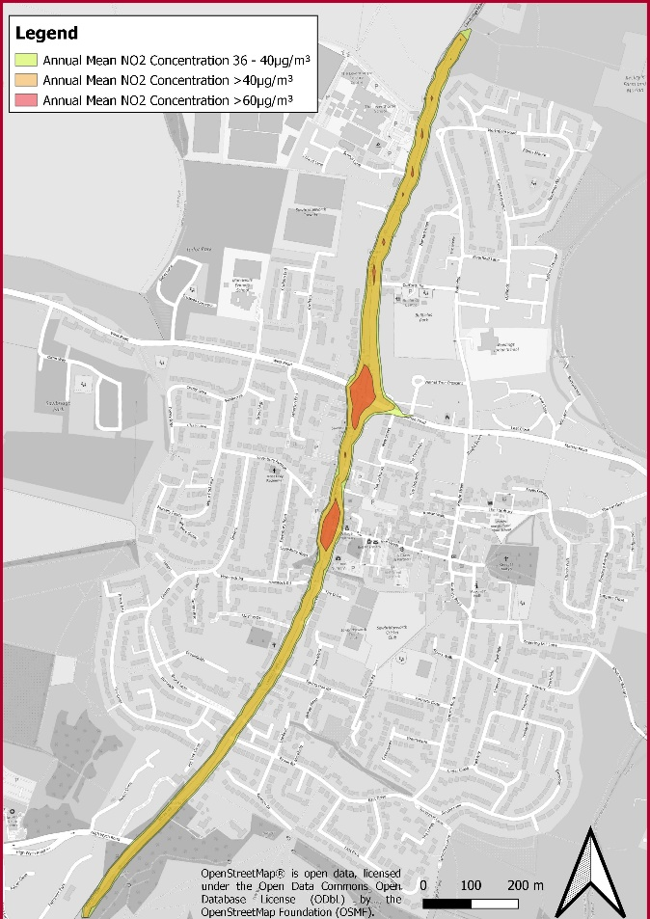

Who is Exposed to Air Pollution in the AQMAs in East Hertfordshire?
Those living in an AQMA, as well as those walking, cycling or driving through one will be exposed to some extent to air pollution. That said, as discussed in the preceding chapters, it is only the annual mean NO₂ concentration of 40μg/m³ which is exceeded and thus only those living in the AQMA who will be impacted according to the DEFRA guidance. That is not to say that those walking, cycling or driving through an AQMA will not experience poor air quality, however, none are likely to walk, cycle or drive through for a continuous hour and even if they did, the 200μg/m³ hourly exposure level has not been exceeded in any of the three AQMAs.

Residents
To understand the extent of the population of East Hertfordshire who reside in an AQMA and are exposed to poor air quality, a review of the estimated population of each AQMA has been undertaken (see Table 7). This has been completed using the Office for National Statistics ‘Lower Super Output Area’ (LSOA) information[]. Information from the Indices of Multiple Deprivation (IMD)[] are also included.
The scores for the IMD are based on deciles of multiple factors of deprivation. The larger the score, the more deprived the area, on a scale of 1 to 10.

Table 7 - Population Exposure within East Herts AQMAs
AQMA | Estimated population in AQMA | Average IMD score  (1 being the most disadvantaged, 10 being the least) | Median age
Bishop’s Stortford | 71 | 9 | 35
Hertford | 2,128 | 9 | 41
Sawbridgeworth | 428 | 9 | 47

As shown, the Hertford AQMA has the greatest population.
All AQMAs are in the 9th decile (out of 10), indicating that none of the three AQMAs are in areas of deprivation. This makes the AQMAs in East Hertfordshire different from some other ones, particularly those in more urban and metropolitan areas, where living in an area of poor air quality is correlated more closely with deprivation.
The median ages for the district of East Hertfordshire and England are 43 years and 42 years respectively. The 71 people estimated to be living in the Bishop’s Stortford AQMA have a younger average age than the East Hertfordshire population, with those living in the Hertford AQMA being slightly younger and Sawbridgeworth AQMA being older than the both the district-wide and national average ages. The younger average among the, albeit low, population in the Bishop’s Stortford AQMAs suggests there may be young residents who are particularly susceptible to the adverse effects of air pollution. This further serves to emphasise the need for action.

Walkers and cyclists
For those who walk or cycle through an AQMA, when reading this AQAP, the measure likely to be of most interest is the hourly mean objective for Nitrogen Dioxide of no more than 200µg/m³. This is because this is the nationally set upper level of pollution for someone to experience continuously for a whole hour.
As air pollution in East Hertfordshire stems from traffic, it is to be expected that higher concentrations will be experienced by someone walking or cycling through an AQMA than someone living in one because they will be nearer to the source of the emissions, that is, the vehicles driving along the roads.
At the same time, it is important to note that the measure relates to an hourly mean average of 200µg/m³ rather than a very short exposure to this level although, of course, the council recognises that ideally no-one would be exposed to air pollution at all.
As discussed in earlier chapters, modelling in Bishop’s Stortford and Sawbridgeworth and the continuous monitor in Hertford indicate no location within any of the AQMAs ever demonstrates a whole hour’s worth of air pollution above 200µg/m³, although data from continuous air quality monitors will show the fluctuating level of NO₂ at the monitoring station.
At present there is only one continuous monitoring station in the district. This is located in the Hertford AQMA. The findings from this monitoring station for January to October 2023 are shown in Figure 7 below. There are ‘spikes’ where for short bursts of time air pollution exceeds 200µg/m³. See section 9.1 for information about the relationship between NO_{x} and NO₂.

Figure 7 - Hertford AQMA NO_{x} as NO₂ Levels for 2023
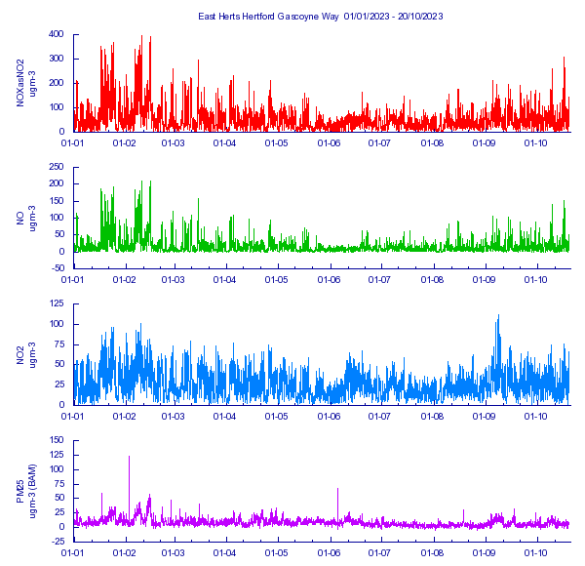
Those walking or cycling through the Hertford AQMA, or considering doing so, may wish the check the real time information which is available online via the council’s air quality webpage: https://www.eastherts.gov.uk/environmental-health/air-quality
In 2024, continuous air quality monitoring stations will be added to each of the three AQMAs.

Drivers
As the heat maps included in earlier chapters have clearly shown, air pollution in East Herts’ AQMAs is the result of traffic. While much of the national debate and discussion in this AQAP sees drivers of fossil-fuelled vehicles as the polluters, those same drivers, and indeed drivers of electric vehicles, will experience a degree of air pollution within their vehicles (however powered) as they drive through an AQMA.
There are no national objectives relating to pollution levels within vehicles but just as for those walking or cycling in an AQMA, the real time data, as exemplified in Figure 7 above, is likely to be of interest to drivers.

Developing an Air Quality Action Plan for East Hertfordshire
The preceding chapters have explained that:
- air pollution is detrimental to health
- nationally set maximum levels for annual average air pollution have been exceeded in three AQMAs
- traffic is the primary cause of air pollution in the three AQMAs
- while those living within the district’s AQMAs are the most exposed to pollution, those walking, cycling or driving through the AQMAs will also experience poor air quality.
This chapter will now cover the council’s examination of the work to date, policies, evidence and best practice which can be drawn upon to effectively tackle the district’s air pollution.

Track record to date
This action plan will need to build on our track record to date. For example, we have:
- trialled an e-car club, using Department for Environment, Food and Rural Affairs (DEFRA) funding, which served council staff in the day and the public outside of office hours with dedicated charges in Hertford and Bishop’s Stortford. This pilot has led to the establishment of a staff e-car club and private car rental companies in the area offering low emission vehicles for hire by the public
- published a sustainability Supplementary Planning Document (SPD) with a specific air quality chapter applying strict air quality measures to all developments
- introduced the strictest emissions standards in Hertfordshire for the taxi vehicles we licence
- installed over 60 e-vehicle charging points to promote the switch to e-vehicles
- replaced our fleet of diesel vans with e-cars
- installed anti-idling signage in our own car parks and beyond.
In addition, together with our partners, principally Hertfordshire County Council, we have:
- introduced smart traffic light management at Hockerill junction in the Bishop’s Stortford Air Quality Management Area (AQMA) to promote traffic flow and minimise idling
- improved the lighting and visual appeal of pedestrian subways to counteract feelings of a lack of safety as a barrier to active travel
- annually promoted Clean Air Day
- supported the introduction of demand responsive bus services in the northern half of the district.
We have continued to facilitate behaviour change by:
- introducing and promoting an air alert notification scheme
- working with schools and businesses, using DEFRA funding, on active travel alternatives to daily commutes.
The evidence discussed in earlier chapters demonstrates that despite all the efforts and interventions described above there is still more to do. It is thus incumbent on East Herts Council to work with its partners to marshal all the available information, best practice or policy levers to tackle the unacceptable levels of air pollution.

Planning and Policy Context

Clean Air Strategy 2019
The Government’s Clean Air Strategy[] sets out the case for action at a national level, identifying a number of sources of air pollution within the UK including road transportation (relevant in terms of the AQMAs currently present within East Hertfordshire). It also sets out the actions required to reduce the impact upon air quality from these sources. It has been developed in conjunction with three other UK Government Strategies; the Industrial Strategy, the Clean Growth Strategy, and the 25 Year Environment Plan.

Air Quality Strategy 2023
In April 2023, the government’s new Air Quality Strategy was published[], which supersedes the Air Quality Strategy (2008).
The strategy plans to set out a framework to enable local authorities to deliver for their communities and contribute to the governments long term air quality goals, this includes the new targets for PM_{2.5}.
The Air Quality Strategy is designed for local authorities in England with the focus on three main pollutants, PM_{2.5}, NO_{x} and NH₃.
The Air Quality Strategy seeks to implement the focus on air quality being a public health issue, with Directors of Public Health being involved and collaboration with plans and strategies with other departments and strategies such as climate change.

UK Plan for Tackling Roadside Nitrogen Dioxide Concentrations
Published in July 2017, the UK Plan for Tackling Roadside Nitrogen Dioxide Concentrations (Detailed Plan)[] is the UK government’s plan for bringing concentrations of NO₂ within statutory limits within the shortest possible time. It identifies that the most immediate air quality challenge within the UK is tackling the issue of NO₂ concentrations close to roads, especially within towns and cities.
The plan identifies the local authorities that were required to complete feasibility studies to define NO₂ concentrations on road links which were identified by the national Pollutant Climate Mapping (PCM) model as exceeding the NO₂ annual mean AQS objective. East Herts Council was not one of the authorities identified. That said, the UK Plan details a range of possible solutions to reduce NO_{x} emissions from vehicles and therefore lower NO₂ concentrations which the council has been mindful of when devising this plan. The actions detailed within the UK Plan include:
- implementation of Clean Air Zones (CAZs)
- new real world driving emissions requirements for light passenger and commercial vehicles
- additional funding to accelerate the uptake of low emissions buses and also for the retrofitting of older buses
- additional funding to accelerate the uptake of hydrogen vehicles and associated infrastructure
- new mandatory emissions standards for non-road mobile machinery
- local cycling and walking investment plans.

East Herts District Plan (the Local Plan)
The council adopted its Local Plan, known locally as the District Plan, on the 23 October 2018[]. The District Plan sets out the planning framework for the district for the period of 2011-2033 and prioritises the delivery of sustainable development.
Specific Air Quality policies are included within the plan, notably:
Policy EQ4 Air Quality
I. The effect of development upon air quality is a material consideration. All applications should take account of the Council’s Air Quality Planning Guidance Document, which details when an air quality assessment is required.
II. All development should take account of the Council’s latest Air Quality Action Plan, local Air Quality Strategies, Local Transport Plans, as well as national air quality guidance.
III. All developments should include measures to minimise air quality impact at the design stage and should incorporate best practice in the design, construction and operation of all developments.
IV. Where development (on its own or cumulatively) will have a negative impact on local air quality during either construction or operation, mitigation measures will be sought that will remove overriding impacts, such as an air quality neutral or negative development. Evidence of mitigation measures will be required upfront.
V. Where on-site mitigation is not sufficient, appropriate off-site mitigation measures may be required. Where adequate mitigation cannot be provided, development will not normally be permitted.
VI. Developments must not:
- lead to a breach or worsening of a breach of UK or EU limit values;
- lead to a breach or worsening of a breach of an Air Quality objective or cause the declaration of an Air Quality Management Area or;
- prejudice the implementation of any Air Quality Action Plan or local air quality strategy

East Herts Sustainability Planning Guidance
East Herts Council have developed a Sustainability Supplementary Planning Document (SPD)[]. This planning guidance document has been prepared to support East Herts Council’s Air Quality Development Management Policy within its District Plan. The aim is to facilitate sustainable development by helping to achieve the best possible public health protection outcomes, in relation to air quality.
The objectives defined to help achieve this aim are to:
- identify the district-specific air pollution issues
- identify the tools to control air pollution that are available to this local authority under the planning regime
- provide clarity and consistency to developers, planners and local communities by confirming:
      - how the council will assess planning applications in relation to air quality
      - the mitigation and monitoring of air quality impacts via planning conditions and the use of tools such as Section 106 agreements
      - the circumstances where an air quality assessment will be required for a proposed development
      - the requirements of an air quality assessment
- contribute to the improvement of air quality in the district, in particular in Air Quality Management Areas
- be compatible with existing East Herts Council policies
- complement and add important local context to the National Planning Practice Guidance
- direct developers to detailed guidelines for undertaking an emissions assessment in line with that from the Low Emission Partnership.
- use the Damage Cost Approach for applications
- promote Air Quality Neutral Assessments.

East Herts Climate Change Strategy
In 2022, following East Herts Council’s climate change declaration in July 2019, the council introduced its first Climate Change Strategy. The strategy lays out how the council, residents, business and other partners can all pull together and help each other make signiﬁcant and long-lasting improvements to the sustainability of our precious environment.
Another key aspect of the strategy was the inclusion of the council’s route map to net-zero carbon by 2030.
Since this time, the council has accelerated its efforts to tackle climate change by:
- declaring a Climate Emergency in July 2023
- bringing forward to 2027 the deadline for minimising its own carbon footprint and putting in place robust offsetting plans and
- devoting over £500,000 from its share of the UK Shared Prosperity Fund to environmental sustainability measures.
The Climate Change Strategy and this air quality action plan share a number of priorities, goal and actions, for example, the promotion of e-vehicles, anti-idling measures and the focus of enabling people to making lasting behavioural changes.

Hertfordshire’s Local Transport Plan 2018-2031
The Local Transport Plan 2018 – 2031, developed by Hertfordshire County Council, sets out how transport can help deliver a positive future vision for Hertfordshire by having a major input into wider policies such as economic growth, meeting housing needs, improving public health and reducing environmental damage whilst also providing for safe and efficient travel[]. As part of this there are two specific policies relating to Air Quality as set out below:
Policy 19: Emissions reduction
The county council will reduce levels of harmful emissions by:
a) Promoting a change in people’s travel behaviour to encourage a modal shift in journeys from cars to walking, cycling and passenger transport.
b) Addressing any barriers to and supporting the uptake of ULEVs in the county, particularly where this can positively affect areas with identified poor air quality.
c) Reducing emissions from its operations.
Policy 20: Air Quality
The county council will seek to reduce the impact of poor Air Quality on human health, by:
a) Investigating the use of Clean Air Zones.
b) Working with district/borough councils to monitor and assess air pollution levels and working in partnership with them to deliver any declared AQMA joint action plans.
c) Implementing, monitoring and reviewing the county council’s Air Quality Strategic Plan.

Local cycling and walking infrastructure plans
Local Cycling and Walking Infrastructure Plans (LCWIPs) are a 10-year strategic approach to cycling and walking improvements. They form part of the Government’s strategy to increase the number of trips made on foot or by cycle. The LCWIP for East Herts Council was still in development at the time of devising the Air Quality Action Plan.

Source Apportionment

How was the source apportionment work undertaken?
The AQAP measures presented in this report are intended to be targeted towards the predominant sources of emissions within East Hertfordshire. To assist in this, a source apportionment exercise was carried out for East Herts Council by Bureau Veritas based on a 2019 baseline year. Importantly, this is a pre-COVID-19 dataset which the council believes best reflects the local situation without the unprecedented events of the pandemic, notably the lockdowns, which are likely to have skewed more recent readings. Full details are provided within the technical report found on our website[] including a breakdown of polluting vehicles and pollution from background sources.
The source apportionment exercise used 12-months traffic data from traffic flow cameras around the AQMAs to match against vehicle classifications held by the DVLA. The calculations were undertaken using an air dispersion model to assess the overall emissions profiles of vehicles moving through each AQMA. It should be noted that emission sources of NO₂ are dominated by a combination of direct NO₂ (f-NO₂) and oxides of nitrogen (NOx), the latter of which is chemically unstable and rapidly oxidised upon release to form NO₂. Reducing levels of NO_{x} emissions therefore reduces levels of NO₂.
“f-NO₂” factors are developed from real world testing of vehicles, thereby measuring what vehicles actually emit rather than emissions measured in a laboratory. These values are used in dispersion modelling to make it more accurate.

Bishop’s Stortford AQMA
The NO₂ source apportionment exercise has been completed at the maximum receptor reading location in line with the guidance contained within the Local Air Quality Management Technical Guidance (TG22). A summary of this information can be found in Appendix B.
Using the calculations in Table 24 (in Appendix B), the NO₂ apportionment for vehicles is set out below in Table 8. These apportionments are based on the total actual vehicle movement through the AQMA and represent the total impact of each class of vehicle, not each individual vehicle. Therefore, Table 8 is not showing that ‘petrol LGVs’ are less polluting than ‘plug-in hybrid petrol cars’, it is instead saying that during the monitoring period the impact of petrol LGV vehicles on the NO₂ level was less than the plug-in hybrid petrol cars, which is most likely a result of fewer, if any, petrol LGVs passing through the AQMA during this time.

Table 8 - NO₂ Source apportionment from vehicles at max receptor in Bishop’s Stortford AQMA
Vehicle | NO₂ Contribution (µg/m³)
Diesel Cars | 24.61
Diesel light goods vehicles (LGV) | 8.40
Rigid heavy goods vehicles (HGV) | 4.26
Petrol Cars | 3.92
Articulated HGV | 1.66
Buses | 1.56
Full Hybrid Diesel Cars | 0.14
Motorcycle | 0.03
Plug-in Hybrid Petrol Cars | 0.01
Petrol LGV | 0.00
Full Hybrid Petrol Cars | 0.00
Electric Cars | 0.00

The source apportionment exercise demonstrates a ranking of contributing vehicle classes with diesel cars being the main contributors to total road NO₂ concentrations across the Bishop’s Stortford AQMA, followed by diesel LGVs, rigid HGVs and petrol cars.
Overall, the volume of traffic, “street canyon” effects and congestion in the AQMA are considered to be the key contributors to elevated levels of NO₂ annual mean concentrations within the AQMA. The location within the AQMA where particularly elevated levels of NO₂ are observed is the main junction of A1060 London Road, A1250 Hockerill Road, B1383 Stansted Road and A1250 Dunmow Road.
This is explored in detail in the Bureau Veritas source apportionment report found on our website[]. A summary is shown below in Figure 8.

Figure 8 - Source apportionment in Bishop’s Stortford AQMA, show as an average percentage of NO₂
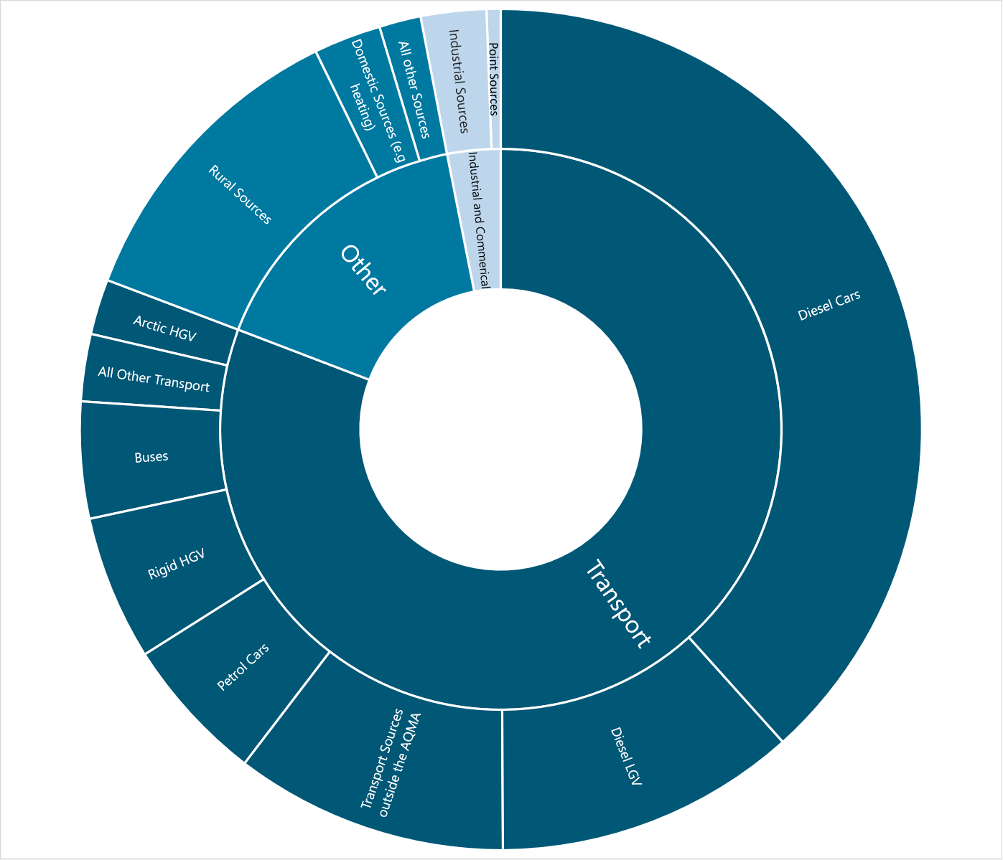

Notes on chart
- ‘All other transport’ includes emissions from Motorcycles, Petrol LGVs, Full Hybrid Petrol Cars, Plug-in Hybrid Petrol Cars, Full Hybrid Diesel Cars, EV Cars, Aircraft and Rail.
- ‘Transport sources outside the AQMA’ relates to pollution migrating into the AQMA from adjacent roads.

Hertford AQMA
The NO₂ source apportionment exercise has been completed at the maximum receptor reading location in line with the guidance contained within Local Air Quality Management Technical Guidance (TG22). A summary of this information can be found in Appendix B.
Using the calculations in Table 24 (in Appendix B), the NO₂ apportionment for vehicles is set out below in Table 9. These apportionments are based on the total actual vehicle movement through the AQMA and represent the total impact of each class of vehicle, not each individual vehicle. Therefore, Table 9 is not showing that ‘petrol LGVs’ are less polluting than ‘plug-in hybrid petrol cars’, it is instead saying that during the monitoring period the impact of petrol LGVs on the NO₂ level was less than the plug-in hybrid petrol cars, which is most likely a result of fewer, if any, petrol LGVs passing through the AQMA during this time.

Table 9 - NO₂ Source Apportionment from Vehicles at Max Receptor in Hertford AQMA
Vehicle | NO₂ Contribution (µg/m³)
Diesel Cars | 20.98
Rigid HGV | 4.52
Diesel LGV | 3.70
Petrol Cars | 3.19
Articulated HGV | 1.75
Buses | 1.03
Full Hybrid Diesel Cars | 0.11
Full Hybrid Petrol Cars | 0.05
Motorcycle | 0.02
Plug-in Hybrid Petrol Cars | 0.01
Petrol LGV | 0.00
Electric Cars | 0.00

The source apportionment exercise demonstrates a ranking of contributing vehicle classes with diesel cars being the main contributors to total road NO₂ concentrations across the Hertford AQMA, followed by diesel LGVs, rigid HGVs and petrol cars.
Overall, the volume of traffic and congestion on the main roads such as Gascoyne Way are considered to be the key contributors to elevated levels of NO₂ annual mean concentrations within the AQMA.
This is explored in detail in the Bureau Veritas source apportionment report found on our website[]. A summary is shown below in Figure 9.

Figure 9 - Average NO₂ % Source Apportionment in Hertford AQMA
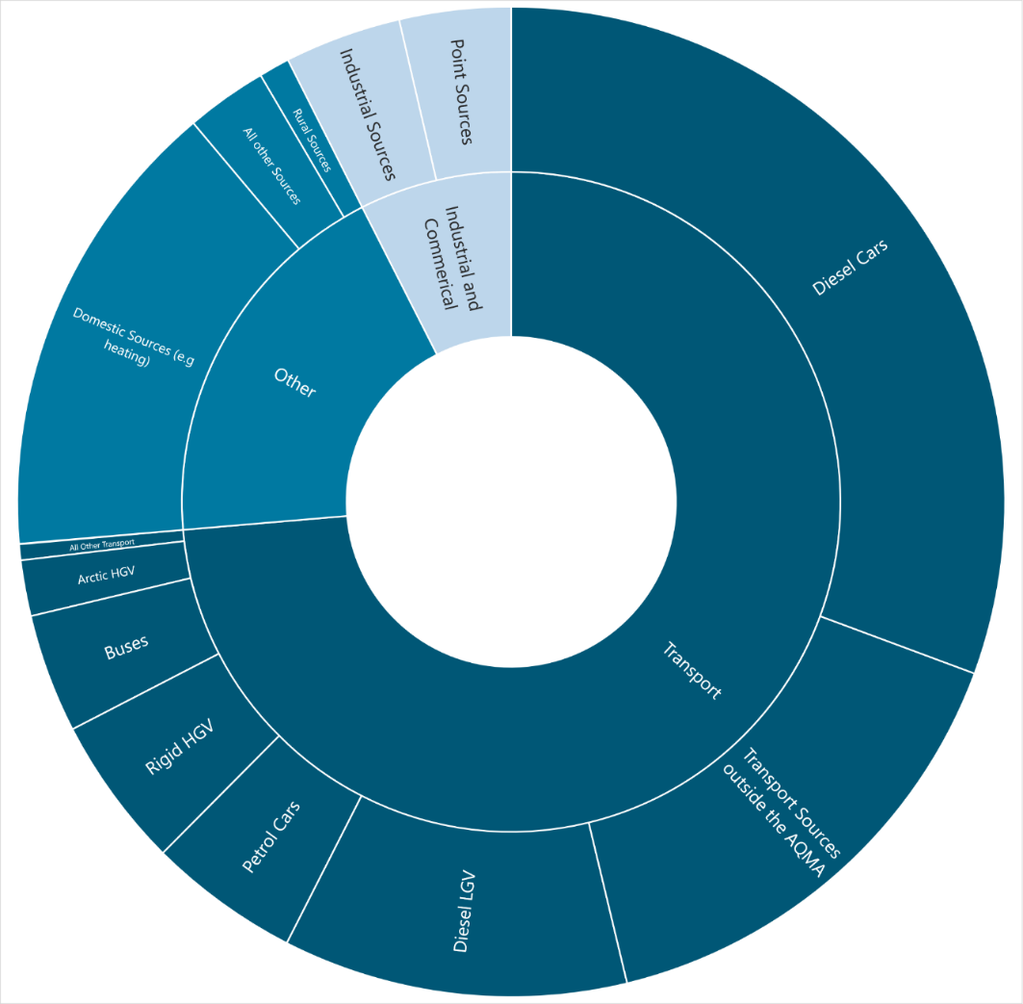

Notes on chart
- ‘All other transport’ includes emissions from Motorcycles, Petrol LGVs, Full Hybrid Petrol Cars, Plug-in Hybrid Petrol Cars, Full Hybrid Diesel Cars, EV Cars, Aircraft and Rail.
- ‘Transport sources outside the AQMA’ relates to pollution migrating into the AQMA from adjacent roads.

Sawbridgeworth AQMA
The NO₂ source apportionment exercise has been completed at the maximum receptor reading location in line with the guidance contained within Local Air Quality Management Technical Guidance (TG22). A summary of this information can be found in Appendix B.
Using the calculations in Table 24 (in Appendix B), the NO₂ apportionment for vehicles is set out below in Table 10. These apportionments are based on the total actual vehicle movement through the AQMA and represent the total impact of each class of vehicle, not each individual vehicle. Therefore, Table 10 is not showing that ‘petrol LGVs’ produce the same level of pollution as ‘plug-in hybrid petrol cars’, it is instead saying that during the monitoring period the impact of petrol LGVs on the NO₂ level was the same as plug-in hybrid petrol cars.

Table 10 - NO₂ Source Apportionment from Vehicles at Max Receptor in Sawbridgeworth AQMA
Vehicle | NO₂ Contribution (µg/m³)
Diesel Cars | 21.79
Diesel LGV | 10.56
Buses | 3.66
Rigid HGV | 3.48
Petrol Cars | 3.30
Articulated HGV | 1.35
Full Hybrid Diesel Cars | 0.12
Full Hybrid Petrol Cars | 0.05
Motorcycle | 0.04
Petrol LGV | 0.01
Plug-in Hybrid Petrol Cars | 0.01
Electric Cars | 0.00

The source apportionment exercise demonstrates a ranking of contributing vehicle classes with diesel cars being the main contributors to total road NO₂ concentrations across the Sawbridgeworth AQMA, followed by diesel LGVs, buses, rigid HGVs and petrol cars.
Overall, this suggests the volume of traffic and congestion at the main junctions along London Road are the key contributors to elevated levels of NO₂ annual mean concentrations within the AQMA.
This is explored in detail in the Bureau Veritas source apportionment report found on our website[]. A summary is shown below in Figure 10.

Figure 10 - Average NO₂ % Source Apportionment in Sawbridgeworth AQMA
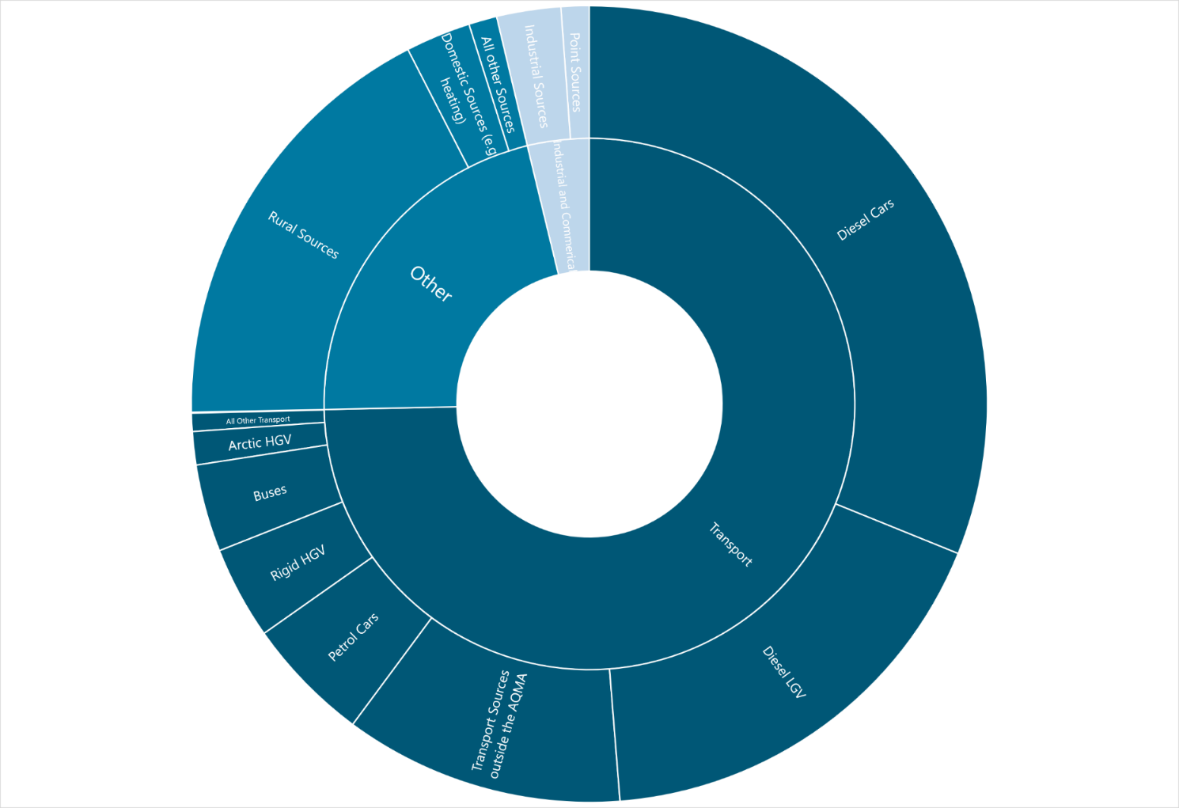

Notes on chart
- ‘All other transport’ includes emissions from Motorcycles, Petrol LGVs, Full Hybrid Petrol Cars, Plug-in Hybrid Petrol Cars, Full Hybrid Diesel Cars, EV Cars, Aircraft and Rail
- ‘Transport sources outside the AQMA’ relates to pollution migrating into the AQMA from adjacent roads.

Required Reduction in Emissions

Emissions reduction calculations
Any area will experience air pollution from a variety of local and more remote, background sources. For each AQMA in East Hertfordshire, the evidence reported in this action plan, shows that it is traffic emissions within the AQMAs that are the primary source of air pollution.
The council and partners need to target interventions that are likely to have the largest impact on reducing air pollution within each AQMA and so the primary source of pollution, that is traffic emissions, needs to be addressed. These will have some, though limited, impact on reducing the background sources of pollution outside of the AQMA, thus, interventions within the AQMA will need to have a proportionally greater impact on reducing the emissions arising within the AQMA as, unfortunately, the AQMA is still likely to suffer from pollution sources beyond its boundaries.
Based on their analysis of the 2019 emissions data in the three AQMAs, Bureau Veritas have calculated the required reduction in NO_{x} emissions, that is, various nitrogen oxides, from traffic within the AQMAs on the basis of pollution outside of the AQMAs remaining at consistent levels. This analysis also takes account of the way in which NO_{x} breaks down into the polluting NO₂ and so gives the NO_{x} percentage reduction needed for NO₂ concentrations to fall below the AQO of 40µg/m³. The findings are as follows:
- 45.6% reduction in road NO_{x} is required to meet the AQO for annual mean NO₂ at the worst-case receptor in the Bishop’s Stortford AQMA
- 33.7% reduction in road NO_{x} is required to meet the AQO for annual mean NO₂ at the worst-case receptor in the Hertford AQMA
- 40.6% reduction in road NO_{x} is required to meet the AQO for annual mean NO₂ at the worst-case receptor in the Sawbridgeworth AQMA.
Table 25, found in Appendix C, contains a summary of the values used to calculate the required reduction in emissions listed above, with full details of the required reductions and methodology contained within the Technical Report found on our website[].
It is worth noting that the council and its partners will aim to take as broad a range of actions as possible to reduce air pollution in the AQMAs and so the full percentage reduction in road NO_{x} is unlikely to be necessary because our proposed interventions should reduce pollution in other ways too – see Chapter 13 for more details of this.

Consultation

Consultation and Stakeholder Engagement
In developing our updated AQAP, we have worked with other local authorities, expert agencies, businesses and the local community to identify actions likely to have a positive impact. Schedule 11 of the Environment Act 1995 requires local authorities to consult the bodies listed in Table 11. To help encourage engagement at a local level, we have undertaken the following stakeholder engagement:
- publishing the consultation on our website and social media channels
- advising local climate groups of the consultation.

Table 11‒ Consultation Undertaken
Consultee | Yes/No
The Secretary of State | Yes
The Environment Agency | Yes
DEFRA / LAQM | Yes
Julie Marson MP for Hertford and Stortford | Yes
Sir Oliver Heald MP for North East Hertfordshire | Yes
Hertfordshire County Council (Public Health / Highways) | Yes
All neighbouring local authorities | Yes
Hertfordshire police | Yes
UK Health Security Agency | Yes
Hertfordshire Local Enterprise Partnership | Yes
Federation of Small Businesses | Yes
Licensed hackney carriage and private hire operators | Yes
Commercial bus operators | Yes

Steering Group
A steering group was established as part of the AQAP development process to drive forward the development of the new AQAP. The core aim of the steering group has been to identify measures for inclusion within the AQAP that would be effective both in terms of reducing NO₂ concentrations and feasible in terms of implementation and delivery.
The steering group is composed mainly of officers from East Herts Council, from those services with an interest or potential impact on air quality and who may have an influence on the action measures being considered.
The officers have provided and continue to provide guidance in their respective areas of expertise to ensure selection and continual evaluation of the most appropriate measures.
A first steering group meeting took place in February 2023. The steering group included officers from the local authority from: Environmental Health, Sustainability and Climate Change, Planning, Licensing, Parking, Economic Development, Transport and Highways.
Having members within the steering group from different areas and departments allows a collaborative approach to improving air quality and provides a wider scope of measures that can be implemented.
The steering groups set out an ambitious approach to tackling air quality within the wider district. While the technical aspects of this AQAP have focussed on concentrations within the declared AQMA, the wider ambitions are included as part of the measures for reducing pollutant concentrations across the whole district.
It is the aim for this steering group to continue to communicate at regular intervals following the adoption of the AQAP. This is essential to provide progress reports on individual actions in relation to the AQAP measures, discuss any key lessons learnt from the continual implementation of the measures and to continue to discuss any new ideas in terms of future measures and actions within the AQMAs.

East Herts Air Quality Priorities
In devising our air quality priorities, we have drawn upon:
- the empirical air pollution findings from our AQMAs
- the detailed source apportionment modelling
- our review of the wider public health, planning and climate change contexts and
- the professional views and experience of our steering group.
Our four priorities, presented below, focus on the key issues we need to tackle to improve air quality across our AQMAs and, indeed, beyond.

Priority 1: Reduce the impact of traffic levels and congestion on air quality
The main source of air pollution leading to the declaration of the AQMAs is road transport emissions. Therefore, reducing transport emissions is the key priority. Our approach focuses on factors where East Herts Council has direct control (for example, planning and procurement of outsourced functions) and measures that can be implemented via a partnership with Hertfordshire County Council (HCC) or others, with the necessary monitoring arrangements put in place, for example sustainable travel plans for businesses and schools that need to be checked to see if they are working.
As the roads contributing to pollutant concentrations which result in exceedance of the annual average NO₂ objective are not managed by National Highways, this Relevant Public Authority has not been engaged with for the purpose of preparing this AQAP.
Across the council and its partners, there are already multiple efforts in place to improve uptake in cleaner vehicles. This includes provision of additional electrical vehicle charging, incentives for taxis to use electric or Euro VI vehicles and improvements in technology in buses used within the district.

Priority 2: Mitigate the impact of future growth on air quality
Construction and demolition activities can have a significant impact on local air quality. These impacts can be minimised by using the planning system to ensure best practice techniques are employed on all sites.
New or refurbished buildings have the potential to add to emissions from domestic heating and cooling. These impacts can be addressed directly through emissions limits or indirectly by reducing the energy demand in new buildings.
New residents will need to travel for work and leisure. The impact of this can be addressed by measures to encourage walking and cycling or by working with Hertfordshire County Council (HCC) to further improve public transport provision.
An increased provision of services to meet extra demand such as refuse collections will create additional emissions. Negative impacts can be reduced by designing new developments with due consideration to operational efficiency and ensuring only the cleanest vehicles are used.
New roads have the potential to increase pollutant concentrations unless they are well designed and well placed. East Herts Council will work closely with HCC to ensure that necessary infrastructure improvements minimise any detrimental effects on air quality.
East Herts Council’s District Plan and its associated policies set out the considerations that will be applied by the council to all development proposals. The council will work with developers and partner organisations to ensure the delivery of infrastructure, services and community facilities necessary to develop and maintain sustainable communities. This will not only apply to air quality but all relevant environmental aspects. Further Section 106 agreements will be sought to secure funding for future mitigation measures as appropriate where development will increase pollutant concentrations.
The review of the council’s District Plan, which will take place within the lifetime of this AQAP, will provide a crucial means for continued and expanded efforts to mitigate the impact of development on air quality.
Existing strategies and policies adopted by East Herts Council and HCC are key mechanisms for reducing emissions across the district. Transport is the main source of NO_{x} emissions, and therefore NO₂ concentrations, within the AQMAs. For effective reductions in NO_{x} emissions, in addition to the implementation of the measures outlined within the AQAP, future revisions of the council’s and Hertfordshire County Council’s Transport Plans, Freight Strategies, Climate Change Strategies, Cycle Strategies and the like should all be completed with potential air quality impacts taken into account.

Priority 3: Support residents to make active travel choices
One of the most effective ways to achieve a reduction in vehicle numbers is to change the attitudes and behaviour of the population towards travel. East Herts Council and partners will encourage and facilitate these changes through implementing a suite of interventions that have been informed by insights into the key factors affecting travel behaviour. Measures will include education and awareness raising alongside schemes which incentivise change.
Reducing the need to travel by car promotes neighbourhoods which are not so dominated by cars, which in turn provide good quality outdoor spaces, encourage residents to be more active and enable benefits for mental health and wellbeing. Indeed, measures to encourage active travel such as walking and cycling can support residents to achieve and maintain an active lifestyle, which has additional health benefits beyond those achieved through improving air quality.
Ensuring that outdoor spaces are protected from pollution sources not only makes them more pleasant to use but reduces residents’ exposure.
Improving air quality to protect public health requires a wide-reaching perspective which is not specific to the AQMAs but instead aims to have a broader impact across the district.

Priority 4: Reduce East Herts Council’s own impact on air quality
We have already replaced all our diesel vans with electric vehicles. We will continue to extend the use of these vehicles beyond the services making most use of them, notably our environmental services team, by promoting the vehicles for use as a staff car club to reduce officers using their own fossil-fuelled vehicles when on council business.
We will also continue to take steps towards greening the fleets of our contractors, notably our waste management and ground maintenance contractors. Procurement processes are key to this next step and we know that seeking higher environmental standards from council suppliers and contractors would accelerate moves to replacement of fossil-fuelled vehicles across the whole district.

Air Quality Action Plan Measures
Table 12, Table 13, Table 14 and Table 15 list the measures East Herts Council and its partners will take as part of this AQAP. They contain:
- a list of the actions that form part of the plan
- expected benefit in terms of pollutant emission and/or concentration reductions – listed in more detail in Table 16 and Table 17
- the estimated cost of implementing each action
- the responsible individual, team and/or organisation who will lead on delivery of the action.
Future ASRs will provide regular annual updates on implementation of these measures.

Air Quality Action Plan Measures

Table 12 - Priority 1: Reduce the impact of traffic levels and congestion on air quality
No. | Action | Benefits | Costs  Low < £10k  Medium £10 to £50k  High > £50k | Responsible Agency
1.1 | Continued expansion of EV infrastructure  - Expanding the current electric charging points for electric vehicles on council owned land.  - Explore possibility of on street lamppost chargers on residential streets.  - Continued efforts to provide information and support to enable residents to make informed choices as to when and if to switch to an e-vehicle. | - Increased provision of charging points encouraging EV uptake. Leads to direct reduction in NO₂ emissions. | Medium – based on commercial contract | East Herts Council & Hertfordshire County Council
1.2 | Explore emissions-based parking charges  - In council owned car parks.  - For council issued parking permits. | - Further incentives to encourage EV uptake. Leads to direct reduction in NO₂ emissions. | Medium | East Herts Council
1.3 | Explore Last Mile Delivery possibilities within the district  - By replacing diesel delivery vehicles with ultra-low emission electric vehicles or zero-emission bicycles/e-cargo bikes (operating from depots).  - Through the introduction of pick-up/drop-off points, meaning companies can distribute a large number of parcels to fewer locations. | - Reduction in delivery vehicle emissions and numbers also reducing congestion. | High | East Herts Council & Hertfordshire County Council
1.4 | Installation of additional anti-idling signage  - Previous campaigns saw anti idling signage and messaging which was promoted in local businesses and council car parks.  - We plan to roll out the message wider and to create more permanent signs around schools and other public spaces. | - Less idling increased awareness. Leads to direct reduction in NO₂ emissions. | Low | East Herts Council & Hertfordshire County Council
1.5 | Continued promotion of our four key air quality campaigns  - Air Quality Alert System – a free to use, health based digital notification system which notifies users of days when air quality is poor in their area to help them make more informed choices about their activities that day.  - Electric vehicle uptake – continued promotion to increase e-vehicle uptake.  - Herts liftshare scheme – a free to use liftshare scheme matching users and locations to reduce lone journeys.  - Clean Air Day – national air quality campaign to highlight the effects of air pollution and positive ways in which we can all make a difference.  - Install at least one real-time air quality sensor in the Bishop’s Stortford and Sawbridgeworth AQMAs and another on in the Hertford AQMAs  - Explore ways to make the real-time air quality date more accessible and visible  - Work with residents and community groups on priorities for air quality campaigns and seek external funding for this wherever possible. | - Improved health outcomes for vulnerable residents.  - Increased awareness of air pollution.  - Increased uptake of electric vehicles.  - Reduction in lone journeys and vehicles.  - All lead to direct reduction in NO₂ emissions. | Medium | East Herts Council & Hertfordshire County Council
1.6 | Review the effectiveness of travel plans for schools and businesses  - Review the travel plans produced for local schools and businesses to establish their effectiveness on reducing pollution in the AQMA. | - Understand the effectiveness of travel plans.  - Work to improve the implementation and effectiveness of travel plans. | Low | East Herts Council & Hertfordshire County Council
1.7 | Investigate the possible pros and cons of new options being adopted by other local authorities, such as road pricing and ultra-low emission zones (ULEZ) in the AQMAs  - Understand the relevance, benefits and costs of road pricing / ULEZ within the context of East Herts’ AQMAs.  - Involve residents, community groups and statutory stakeholders in better understanding the possible pros and cons of new approaches such as road pricing / ULEZ as part of the council’s overall aim to engage everyone in the shared endeavour to reduce air pollution. | - Reduce traffic in congested areas. | High – if road pricing or ULEZs introduced | East Herts Council & Hertfordshire County Council
1.8 | Hertfordshire County Council, East Herts Council and other stakeholders to maintain dialogue about any emerging operational and/or technical means of minimising congestion.  - Wherever possible, minimise congestion due to planned roadworks.  - Encourage vehicular journeys which cannot reasonably be replaced by active travel alternatives to avoid the AQMAs.  - Explore the co-benefits to air quality of 20mph zones and other safe system approaches to road safety. | - Reduce traffic in congested areas. | Low | East Herts Council & Hertfordshire County Council
1.9 | Monitor and act upon emerging guidance on the new national PM_{2.5} objectives.  - Use and report on data from the existing and new continuous air quality monitors in each AQMA.  - With partners, identify potential actions required to address any PM_{2.5} levels in excess of national objectives. | - Reduce air pollution due to PM_{2.5}. | Low | East Herts Council & Hertfordshire County Council

Table 13 - Priority 2: Mitigate the impact of future growth on air quality
No. | Action | Benefits | Costs  Low < £10k  Medium £10 to £50k  High > £50k | Responsible Agency
2.1 | Hertfordshire Essex Rapid Transit (HERT)/ The A414 Corridor Strategy  - The HERT will deliver a step-change in the passenger transport network through an accessible, reliable and affordable east-west transit system which connects people easily to where they live, work and visit which could reduce private vehicle use in, most notably, the Hertford AQMA. | - Increased provision of public transport, reduction in overall vehicle numbers.  - Leads to direct reduction in NO₂ emissions. | High | Hertfordshire County Council
2.2 | Continued adherence to our sustainability SPD and air quality neutral policies  - Using the upcoming district plan review to strengthen the planning policy in relation to air quality. | - Reduction in building emissions and construction emissions. | Low | East Herts Council
2.3 | Create a sustainable design and construction code of practice (CCOP) | - Reduction in construction emissions. | Low | East Herts Council

Table 14 - Priority 3: Support residents’ make active travel choices
No. | Action | Benefits | Costs  Low < £10k  Medium £10 to £50k  High > £50k | Responsible Agency
3.1 | Support expansion of Herts Lynx on demand public transport scheme  - Increased coverage and provision of the transport leading to increased use of this form of public transport, reduction in private lone journeys from rural areas of the district through the AQMAs. | - Reduction in vehicles and emissions in the AQMAs. | High | Hertfordshire County Council & Department for Transport
3.2 | Investigate potential implementation of ‘footstreets’ in central Hertford  - Footstreets minimise the volume and impact of cars within certain areas making them more attractive and safer places for people to walk. | - Increasing active travel.  - Reducing vehicle numbers and therefore emissions. | Medium | East Herts Council & Hertfordshire County Council
3.3 | Develop personalised travel planning for residents  - Highlighting the public transport options within their area. | - Increased public transport use, reducing private vehicle numbers and emissions in AQMAs. | Medium | East Herts Council & Hertfordshire County Council
3.4 | Active Travel Campaign working with schools and businesses  - Continuation of the council’s active travel campaign which has so far reached 11 schools. | - Increased awareness of air pollution sources and outcomes. Increased active travel and public transport uptake. | Medium | East Herts Council
3.5 | Local Cycling and Walking Infrastructure Plan (LCWIP)  - Projects to improve the commuter infrastructure for non-motorised users between residential areas and towns.  - Promotion to encourage use. | - Increased uptake of active travel due to increased provision and links. Reducing car usage. | Medium | Hertfordshire County Council
3.6 | Exploration of increased on street town centre cycle parking  - Explore the feasibility of installing secure bicycle storage at key areas in East Hertfordshire. | - Increased uptake of active travel, reducing private car usage. | Medium | East Herts Council & Hertfordshire County Council
3.7 | Creation of an East Herts standalone air quality website  - Provide annual updates on the council’s website on progress against the action plan. | - Increased awareness, access to information and resources. | Medium | East Herts Council

Table 15 - Priority 4: Reduce East Herts Council’s own impact on air quality
No. | Action | Benefits | Costs  Low < £10k  Medium £10 to £50k  High > £50k | Responsible Agency
4.1 | New council procurement rules  - Consolidate and reduce deliveries to council buildings.  - Promote e-vehicles through East Herts Council waste management contract. | - Reduced vehicles driving through AQMA to council offices.  - Reduction in vehicle emissions throughout district from council procured vehicles. | Low | East Herts Council
4.2 | Create East Herts Council workplace travel plan for staff  - Continuing facilitating home working arrangements.  - Promotion of car share schemes, public transport opportunities and council’s cycling facilities. | - Reduced car journeys, increased uptake in active travel. | Low | East Herts Council
4.3 | Work with colleagues in Trading Standards to ensure the Domestic Solid Fuels Regulations are complied with  - Help with promotion and messaging. | - Reduced emissions. | Low | East Herts Council
4.4 | Explore the benefits to air pollution of introducing/expanding smoke control areas in East Hertfordshire.  - Establish the extend of pollution in East Hertfordshire from domestic wood burners. | - Reduced emissions. | Low | East Herts Council

Illustration of Potential Impact of the AQAP

Estimated potential impact
The measures set out in the tables in Chapter 13 present an ambitious programme of interventions by the council and its partners. Ultimately, however, the impact of the measures will depend on the extent to which they lead to behaviour change by those living or working in the district or just passing through. Quantifying the impact, in terms of NO₂ reduction, of the proposed measures is thus very difficult and susceptible to spurious precision, that is, figures which would be hard to justify given the inevitable uncertainty about how people will react in the real world.
While eager to avoid misleading predictions, we have nevertheless attempted to estimate the impact of each proposed measure based on background work by Bureau Veritas and council officers’ professional judgement. The illustrations are presented as ranges of NO₂ reductions to avoid the spurious precision discussed above while justifying a fair degree of confidence in the likely efficacy of the proposed measures.
Table 16 below gives the estimated potential reductions in NO₂ for proposed interventions.
Table 17 below gives the estimated potential reductions in NO₂ for measures that the council proposes to explore in order to determine whether to implementation them.
A summary consideration of the measures not included as part of this action plan is contained in Appendix A.

Table 16 - Estimated impact of proposed interventions
No. | Measure to be taken | Assumptions for Quantification | Estimated potential reduction in NO₂
 |  |  | Bishop's Stortford | Hertford | Sawbridge-worth
1.1 | Continued expansion of EV infrastructure. | Additional 60 EV cars across all AQMAs. Expected 0.006% reduction in road emissions per EV rather than combustion engine vehicle using latest Emissions Factors Toolkit. Additional 60 EVs would therefore result in around a 0.36% reduction in emissions. Effectiveness of measure in isolation is likely to be negligible, but it will help to push the drive towards normalising EV use. | 0.5µg/m³ to 1µg/m³ | 0.5µg/m³ to 1µg/m³ | 0.5µg/m³ to 1µg/m³
1.4 | Install additional anti-idling guidance /advisory signage. | Not possible to quantify given the existing amount of idling is not known for comparison. Reduction based on conservative professional judgement. | Up to 0.5µg/m³ | Up to 0.5µg/m³ | Up to 0.5µg/m³
1.5 | Continued promotion of our four key air quality campaigns. | Will promote behavioural change but not considered possible to quantify. Reduction based on professional judgement. | 0.5µg/m³ to 1µg/m³ | 0.5µg/m³ to 1µg/m³ | 0.5µg/m³ to 1µg/m³
1.8 | Hertfordshire County Council, East Herts Council and other stakeholders to maintain dialogue about any emerging operational and/or technical means of minimising congestion. | Not considered to be quantifiable. Reduction based on professional judgement. | Up to 0.5µg/m³ | Up to 0.5µg/m³ | Up to 0.5µg/m³
2.1 | Hertfordshire Essex Rapid Transit (HERT)/ The A414 Corridor Strategy. | It is anticipated that a detailed Air Quality assessment will be completed for this scheme, which will set out the expected changes in pollutant concentrations. However, no assessment is yet available. |  | 2µg/m³ to 3µg/m³
2.2 | Continued adherence to our Sustainability SPD and air quality neutral policies. | Not considered to be quantifiable. Reduction based on professional judgement. | Up to 0.5µg/m³ | Up to 0.5µg/m³ | Up to 0.5µg/m³
2.3 | Create a sustainable design and construction code of practice (CCOP). | Not considered to be quantifiable. Reduction based on professional judgement. | Up to 0.5µg/m³ | Up to 0.5µg/m³ | Up to 0.5µg/m³
3.1 | Support expansion of Herts Lynx on demand public transport scheme. | Current usage rates applied to an expanded service. | Up to 0.5µg/m³ | Up to 0.5µg/m³ | Up to 0.5µg/m³
3.3 | Develop personalised travel planning for residents. | Insufficient detail to quantify this measure. Reduction based on professional judgement. | Up to 0.5µg/m³ | Up to 0.5µg/m³ | Up to 0.5µg/m³
3.4 | Active Travel Campaign working with schools and businesses. | Unknown effectiveness at this stage. Reduction based on professional judgement. | Up to 0.5µg/m³ | Up to 0.5µg/m³ | Up to 0.5µg/m³
3.5 | Local Cycling and Walking Infrastructure Plan (LCWIP). | Potential for 5% fewer single occupancy vehicle trips due to shift to active travel based on case studies[] | Up to 0.5µg/m³ | Up to 0.5µg/m³ | Up to 0.5µg/m³
3.7 | Creation of an East Herts standalone air quality website. | Unknown effectiveness at this stage. Reduction based on professional judgement. | Up to 0.5µg/m³ | Up to 0.5µg/m³ | Up to 0.5µg/m³
4.1 | New council procurement rules. | Unknown effectiveness at this stage. Reduction based on professional judgement. | Up to 0.5µg/m³ | Up to 0.5µg/m³ | Up to 0.5µg/m³
4.2 | Create East Herts Council workplace travel plan for staff. | Unknown effectiveness at this stage. Reduction based on professional judgement. | Up to 0.5µg/m³ | Up to 0.5µg/m³ | Up to 0.5µg/m³
4.3 | Work with colleagues in Trading Standards to ensure the Domestic Solid Fuels Regulations are complied with. | Unknown effectiveness at this stage. Reduction based on professional judgement. | Up to 0.5µg/m³ | Up to 0.5µg/m³ | Up to 0.5µg/m³
Combined estimated potential reduction in NO₂ |  |  | 1 to 8 µg/m³ | 3 to 11µg/m³ | 1 to 8µg/m³

Table 17 considers the potential measures that will be explored during the lifetime of this AQAP. For each exploratory measure, an estimated potential impact, based on background work by Bureau Veritas and the professional judgement of council officers, is given should the potential measure to be explored then be implemented.

Table 17 - Quantification of measure to be explored
No. | Exploratory measure | Assumptions for Quantification | Assumed Reduction in AQMA
 |  |  | Bishop's Stortford | Hertford | Sawbridge-worth
1.2 | Explore emissions-based parking charges. | Would promote behavioural change but not considered possible to quantify. Reduction based on professional judgement. | 0.5µg/m³ to 1µg/m³ | 0.5µg/m³ to 1µg/m³ | 0.5µg/m³ to 1µg/m³
1.3 | Explore Last Mile Delivery possibilities within the district. | Change in fleet/trips not yet known as not possible to quantify measures. Reduction based on professional judgement. | 0.5µg/m³ to 1µg/m³ | 0.5µg/m³ to 1µg/m³ | 0.5µg/m³ to 1µg/m³
1.6 | Review the effectiveness of travel plans for schools and businesses. | Assumption based on increased adoption of plans triggered by the review process. Reduction based on professional judgement. | Up to 0.5µg/m³ | Up to 0.5µg/m³ | Up to 0.5µg/m³
1.7 | Investigate the possible pros and cons of new options being adopted by other local authorities, such as road pricing and ultra-low emission zones (ULEZ) in the AQMAs. | Would promote behavioural change but not considered possible to quantify with any accuracy especially as AQMA-only measures could see a reduction in the AQMA but increases elsewhere due to displacement of traffic. Prudent estimate used. | 1µg/m³ to 2µg/m³ | 1µg/m³ to 2µg/m³ | 1µg/m³ to 2µg/m³
1.9 | Monitor and act upon emerging guidance on the new national PM_{2.5} objectives. | Would reduce pollution from PM_{2.5} which could be alongside NO₂ reductions, though PM_{2.5} would not of themselves bring about NO₂ reductions. | 0µg/m³ | 0µg/m³ | 0µg/m³
3.2 | Investigate potential implementation of footstreets in central Hertford. | In planning stage, insufficient detail to attempt quantification. Reduction based on professional judgement. | 0.5µg/m³ to 1µg/m³ | 0.5µg/m³ to 1µg/m³ | 0.5µg/m³ to 1µg/m³
3.6 | Exploration of increased on street town centre cycle storage / parking. | Unknown effectiveness at this stage. Reduction based on professional judgement. | Up to 0.5µg/m³ | Up to 0.5µg/m³ | Up to 0.5µg/m³
4.4 | Explore the benefits to air pollution of introducing/ expanding smoke control areas in East Hertfordshire. | Unknown effectiveness at this stage. Reduction based on professional judgement. | Up to 0.5µg/m³ | Up to 0.5µg/m³ | Up to 0.5µg/m³
Combined estimated potential reduction in NO₂ |  |  | 2.5 to 6.5µg/m³ | 2.5 to 6.5µg/m³ | 2.5 to 6.5µg/m³

Illustration of potential cumulative impact of measures in the AQMAs
As noted above, assessing the extent to which individual interventions made by the council and its partners will lead to behaviour change and thus reductions in NO₂ is fraught with difficulty. It follows that seeking to estimate the cumulative impact will be extremely difficult. This difficulty is compounded by:
- some measures acting in combination may lead to a higher reduction to that estimated for each measure alone. For example, a measure to increase public transport when acting in combination with more cycling resulting from, say, more secure storage and dedicated cycle lanes may together make walking, as an alternative to driving, through the AQMA more pleasant thus the two individual measures could have an additive impact leading to greater reductions than the sum of the estimated reduction of each measure
- nationally, drivers of cars and commercial vehicles are switching to less polluting vehicles, it is thus to be expected that pollution from vehicles based on their fuel alone will begin to decrease, or at least arrest rises in, air pollution in the AQMAs over the lifetime of this AQAP. For all the reasons discussed above, precise estimates for this are difficult to make.

Table 18 - Illustration of the cumulative impact of measures in this AQMA
 | Bishop’s Stortford AQMA | Hertford AQMA | Sawbridge- worth AQMA
National annual mean average NO₂ exposure objective | 40µg/m³ | 40µg/m³ | 40µg/m³
Consistent level required to revoke AQMA | 36µg/m³ | 36µg/m³ | 36µg/m³
Highest annual bias-adjusted level of NO₂ in 2022 | 50.0µg/m³ | 36.8µg/m³ | 42.9µg/m³
NO₂ level based on estimated cumulative impact of measures to be taken (in Table 16) | 42.0µg/m³ to 49.0µg/m³ | 25.8µg/m³ to 33.8µg/m³ | 34.9µg/m³ to 41.9µg/m³
NO₂ level based on estimated cumulative impact of measures to be taken (in Table 16) and implementation of measures to be explored (in Table 17) | 36.0µg/m³ to 47.0µg/m³ | 19.8µg/m³ to 31.8µg/m³ | 28.9µg/m³ to 39.9µg/m³

Table 18 indicates that:
- in the Hertford AQMA, the measures to be taken over the lifetime of this action plan are likely to act together to bring air pollution below the 36µg/m³ threshold for revoking the AQMA
- in Sawbridgeworth, if the upper estimates of pollution reduction from all the proposed measures (as listed in Table 16) were met, then it would appear possible to achieve pollution levels below the 36µg/m³ threshold for revoking the AQMA over the lifetime of this action plan. Lower reductions stemming from the proposed measures would not, however, lead to meeting this threshold. The ongoing switch away from fossil-fuelled vehicles could assist in meeting the threshold. If this impact is insufficient to achieve the lower levels then the council and its partners would need to consider the case for implementing some of the exploratory measures listed in Table 17
- the situation in Bishop’s Stortford is more complicated; just the measures to be taken as listed in Table 16 would not be sufficient to bring air pollution below the 36µg/m³ threshold for revoking the AQMA. In this AQMA, it is suggested that the impact of the switch away from fossil-fuelled vehicles is very closely monitored on a regular basis and that, should this not assist sufficiently in bringing air pollution down below the threshold for revocation of the AQMA, the council, its partners and those living and working in the district will consider the case for implementing some of the exploratory measures listed in Table 17.

Cost / Benefit and Feasibility Analysis of Measures
Given the pressures on the capacity and resources of the council and its partners, it is important to determine how best to prioritise our efforts. This chapter uses the cost/benefit and feasibility rating scores developed by Bureau Veritas to rank the different measures in the action plans in Chapter 13.

Methodology
The low-medium-high estimated cost ratings in the action plan tables have been combined with the estimated impact of the measure on pollutant concentrations as listed in Table 16 in line with the scoring matrix in Table 19 provided by Bureau Veritas.

Table 19 - Cost Benefit Scoring Matrix
 |  | Benefit: Estimated Reduction in Pollutant Concentrations (as listed in Table 16 and Table 17)
 |  | (1)  <0.5µg/m³ | (2)  0.5-1 µg/m³ | (3)  1-2 µg/m³ | (4)  2-3 µg/m³ | (5)  3-4 µg/m³ | (6)  4-5 µg/m³ | (7)  >5µg/m³
Cost (as listed in the tables in Chapter 12) | (1) < £10k | 6 | 8 | 10 | 12 | 14 | 16 | 18
 | (2) £10k - £50k | 5 | 6 | 8 | 10 | 12 | 14 | 16
 | (3) £50k + | 4 | 5 | 6 | 8 | 10 | 12 | 14

The resulting scores are then multiplied by the feasibility assessment ratings listed in Table 20.

Table 20 - Feasibility Scores
Feasibility Score | Score
Measure has already been started and just requires progressing | 4
Very easy to implement, and political good will towards this, sufficient resources | 3
Possible to implement but may require some learning/campaigning, moderately time intensive | 2
Difficult to implement, time and resource intensive | 1

This methodology gives the overall combined cost/benefit and feasibility rating.
Table 21 lists all the measures to be taken (as listed in Table 16) in order of descending overall combined cost/benefit and feasibility score.

Table 21 – Cost, Benefit and Feasibility Analysis of proposed interventions
No. | Measure | Cost / Benefit  Score  (Table 19) | Feasibility Score  (Table 20) | Overall Score  (Cost / Benefit Score * Feasibility Score)
1.1 | Continued expansion of EV infrastructure | 6 | 4 | 24
3.5 | Local Cycling and Walking Infrastructure Plan (LCWIP) | 5 | 4 | 20
1.4 | Install additional anti-idling guidance /advisory signage | 6 | 3 | 18
4.2 | Create East Herts Council workplace travel plan for staff | 6 | 3 | 18
4.1 | New council procurement rules | 6 | 3 | 18
1.5 | Continued promotion of our four key air quality campaigns | 6 | 3 | 18
2.2 | Continued adherence to our Sustainability SPD and air quality neutral policies | 6 | 3 | 18
3.3 | Develop personalised travel planning for residents | 6 | 3 | 18
3.7 | Creation of an East Herts standalone air quality website | 5 | 3 | 15
4.3 | Work with colleagues in Trading Standards to ensure the Domestic Solid Fuels Regulations are complied with | 6 | 2 | 12
2.3 | Create a sustainable design and construction code of practice (CCOP). | 6 | 2 | 12
1.8 | Hertfordshire County Council, East Herts Council and other stakeholders to maintain dialogue about any emerging operational and/or technical means of minimising congestion. | 6 | 2 | 12
3.4 | Active Travel Campaign working with schools and businesses | 5 | 2 | 10
2.1 | Hertfordshire Essex Rapid Transit (HERT)/ The A414 Corridor Strategy | 8 | 1 | 8
3.1 | Support expansion of Herts Lynx on demand public transport scheme | 4 | 2 | 8

Table 22 lists the cost/benefit and feasibility of actions arising from the exploratory measures should it be decided to implement the actions in order of descending overall combined cost/benefit and feasibility score.

Table 22 – Cost, Benefit and Feasibility Analysis of measures to be explored
No. | Measure to be taken | Cost / Benefit  Score  (Table 19) | Feasibility Score  (Table 20) | Overall Score  Cost / Benefit (Score * Feasibility Score)
3.2 | Investigate potential implementation of footstreets in central Hertford | 6 | 2 | 12
1.6 | Review of travel plans | 6 | 2 | 12
1.2 | Explore emissions-based parking charges | 6 | 2 | 12
1.9 | Monitor and act upon emerging guidance on the new national PM_{2.5} objectives | 6 | 2 | 12
4.4 | Explore the benefits to air pollution of introducing/ expanding smoke control areas in East Hertfordshire. | 6 | 2 | 12
3.6 | Exploration of increased on street town centre cycle storage / parking | 5 | 2 | 10
1.7 | Investigate the possible pros and cons of new options being adopted by other local authorities, such as road pricing and ultra-low emission zones (ULEZ) in the AQMAs | 6  note: the cost to implement this measure would be far higher than the £50k lower threshold of the highest cost score rating available. Also, the reduction in NO₂ could be higher than the prudent assumption in Table 17. Therefore, this score would require recalibration during any investigation of the pros and cons this possible measure | 1 | 6
1.3 | Explore Last Mile Delivery possibilities within the district | 5 | 1 | 5

- Reasons for Not Pursuing Action Plan Measures

Table 23 ‒ Measures considered and not pursued and the reasons for that decision
Action Category | Action Description | Reason action is not being pursued (including Stakeholder views)
Traffic Management | Junction Improvements at Sawbridgeworth Junction | One measure to help alleviate the congestion issues observed in the Sawbridgeworth AQMA at the double mini roundabout could be to determine if improvements to the junction can be made to help alleviate congestion on the four roads. A traffic light system could help to ensure that traffic on the main part of the road (London Road to Cambridge Road) would be better flowing, whilst also providing a potential safer junction for both pedestrians as well as cyclists.  This measure has already been subject to examination, and it has been determined that there are no viable improvements to the junction based on its current capacity.
Traffic Management | Junction Improvements at Hockerill Junction | Similar to the above measure on the improvements at the Sawbridgeworth Junction, the Hockerill Junction which is currently a 4-way traffic light system results in congestions on each arm of the junction. However, this in combination with the narrow streets and proximity to buildings on either sites makes any additional measures other than an improved traffic light system, which has already been implemented, an non-viable solution.
Green Walls | Install a green wall on the Gascoyne Way multistorey car park or elsewhere within the AQMAs | This intervention has been considered in the past and not pursued. DEFRA’s UK-Air website which states the following with regards to quantifying the effect of vegetation on NO₂ concentrations:  For nitrogen dioxide (NO₂), vegetation is, generally speaking, of little benefit; it is not a very efficient sink. The deposition occurs in daytime, and primarily in the warmer months, when NO₂ is less of a problem. Vegetation is a very poor sink for nitric oxide (NO) and soil is a source of NO, at least partially offsetting any potential benefit of uptake by vegetation.
Planting Trees | Use tree planting to reduce air pollution | DEFRA’s UK-Air website indicates the relatively low benefit of tree planting with regard to reducing the effect of vegetation on NO₂ concentrations:  Locally (tens to hundreds of square metres) tree planting may enhance or reduce dispersion; this redistributes pollution but does not remove it. Where vegetation acts as a barrier close to a source, concentrations immediately behind the barrier owing to that source are reduced typically by a factor of about 2 relative to those which would occur without the barrier, whereas on the source side of the barrier concentrations are increased.  Tree planting may also exacerbate the build-up of pollution within street canyons by reducing air-flow. The use of trees to improve air quality is not without negative impacts as some tree species are important sources of biogenic volatile organic compounds (BVOCs), notably isoprene. BVOCs can enhance the formation of pollutants including PM and ozone.
Stopping further housing development | Reduce air pollution by dramatically reducing / halting new housing developments | The council is required by law to make provision for new housing development to meet local need. If the council were to seek to reduce development to significantly below local need levels as informed by nationally set methodologies, developers would in all probability apply to the national Planning Inspectorate to review the decision. The Planning Inspectorate would form a view based on the level of local need and could overturn the council’s decision. It is in the local interest for the council to set planning targets and policies and designate sites so as to exert maximum control over the numbers, type, location, environmental sustainability and other standards of new housing.

- NO₂ Source Apportionment Calculations
The µg/m³ concentrations in Table 24 have been used by Bureau Veritas to undertake the source apportionment work for the council. Their full report can be found on our website:
https://www.eastherts.gov.uk/environmental-health/air-quality

Table 24 - NO₂ Source Apportionment Calculations
Calculation | Concentration (µg/m³)
 | Bishop’s Stortford  AQMA | Hertford  AQMA | Sawbridgeworth  AQMA
Total Background NO₂  [TB-NO₂] | 13.50 | 15.06 | 11.50
Total Background NO_{x}  [TB-NO_{x}] | 18.28 | 20.68 | 15.29
Regional Background NO_{X}  [RB-NO_{x}] | 7.17 | 7.31 | 7.34
Local Background NO_{X}  [LB-NO_{x}] | 11.10 | 13.37 | 7.95
Regional Background NO₂  [RB-NO₂] | 5.30 | 5.32 | 5.52
Local Background NO₂  [LB-NO₂] | 8.20 | 9.74 | 5.98
Total Max Modelled NO₂  [T-NO₂] | 58.10 | 50.44 | 59.70
Local NO₂ Contribution  [L-NO₂] | 44.60 | 35.38 | 44.38

- Emission Reduction Calculations
The µg/m³ concentrations in Table 25 have been used by Bureau Veritas to calculate the needed reduction in NOx in order for the air quality to meet the hourly AQO. Their full report can be found on our website:
https://www.eastherts.gov.uk/environmental-health/air-quality

Table 25 – Required Reduction in NO_{x} emissions to meet AQO for Annual Mean Bias-Adjusted NO₂ (based on 2019 figures unless otherwise stated) –
Metric | Value (µg/m³)
 | Bishop’s Stortford  AQMA | Hertford  AQMA | Sawbridgeworth  AQMA
- Worst-Case Relevant Exposure NO₂ Concentration | 58.1 | 50.4 | 59.7
- Equivalent NO_{x} Concentration | 108.8 | 96.9 | 112.8
- Background NO_{x} | 18.3 | 20.7 | 15.3
- Background NO₂ | 13.5 | 15.1 | 11.5
- Road NO_{x} – Current | 98.9 | 76.2 | 97.5
- Road NO_{x} – Required to achieve NO₂ concentration of 39.9µg/m³ | 53.8 | 50.5 | 57.9
- Required Road NO_{x} Reduction | 45.1 | 25.7 | 39.6
Required % Reduction  figure in row (g) as a % of the figure in row (e) | 45.6% | 33.7% | 40.6%
µg/m³ reduction from worst exposure to 10% below the national objective of 40µg/m³ that is, 36µg/m³ (data from Table 18)
reduction from worst exposure in 2019 | 22.1 | 14.6 | 19.9
reduction from worst exposure in 2022 | 14.0 | 0.8 | 6.9

- Steering Group Attendees
Invitees | From
Claire Spendley | Environmental Health
Linda Meehan | Sustainability and Climate Change
Laura Guy | Sustainability and Planning
Brad Wheeler | Taxi Licensing
Dominique Kingsbury | Car Parking
Chris Smith | Economic Development
Tina Gigg | Local Transport Plan, Hertfordshire County Council
Anushia Vettivelu | Transport/Highways
Daniel Clampin | Bureau Veritas
Viral Patel | Bureau Veritas

- Air Pollution Monitoring Results – Bishop’s Stortford
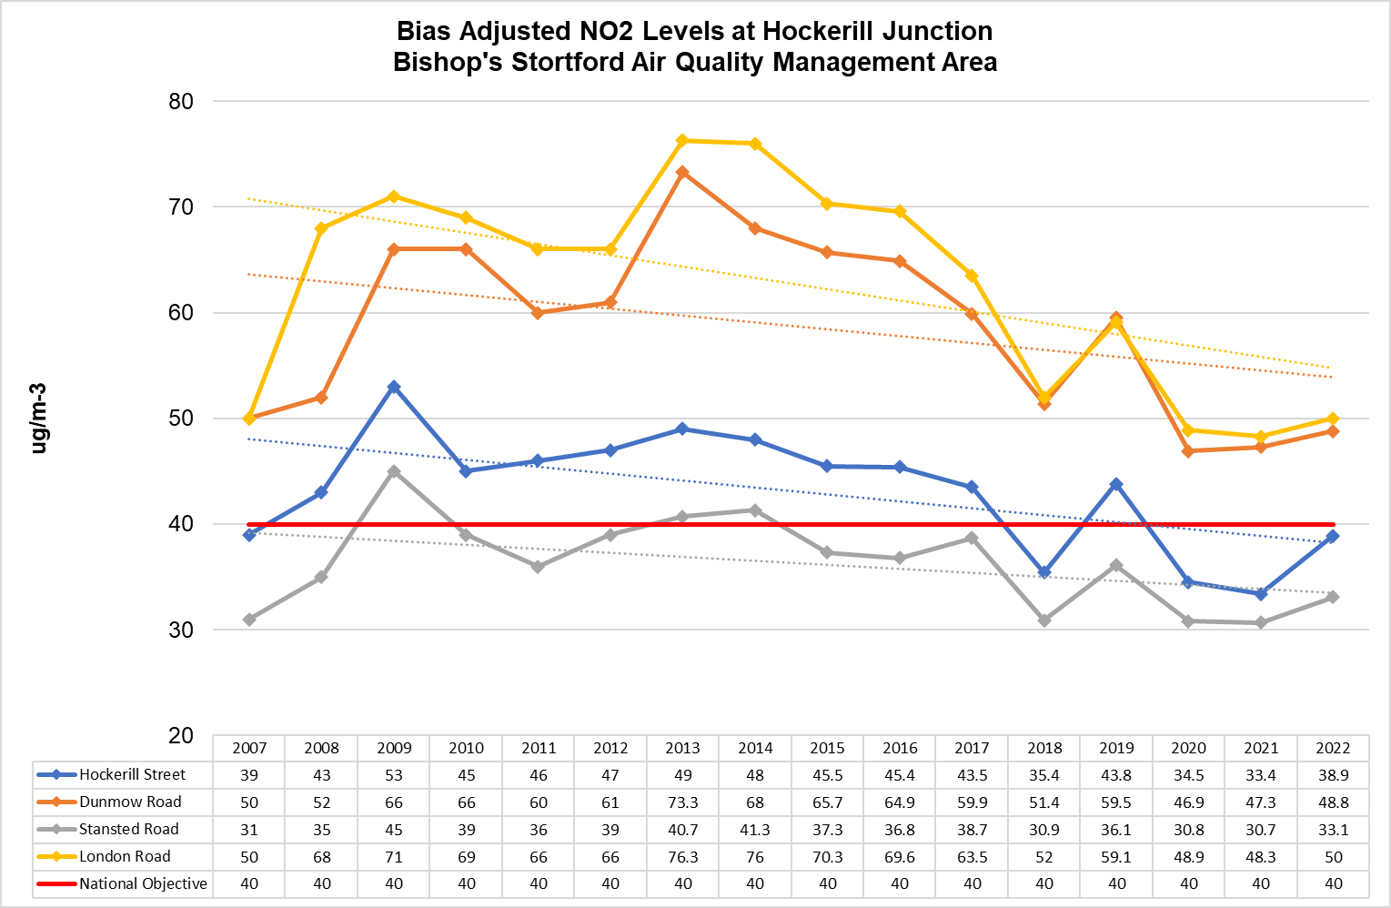

- Air Pollution Monitoring Results - Hertford
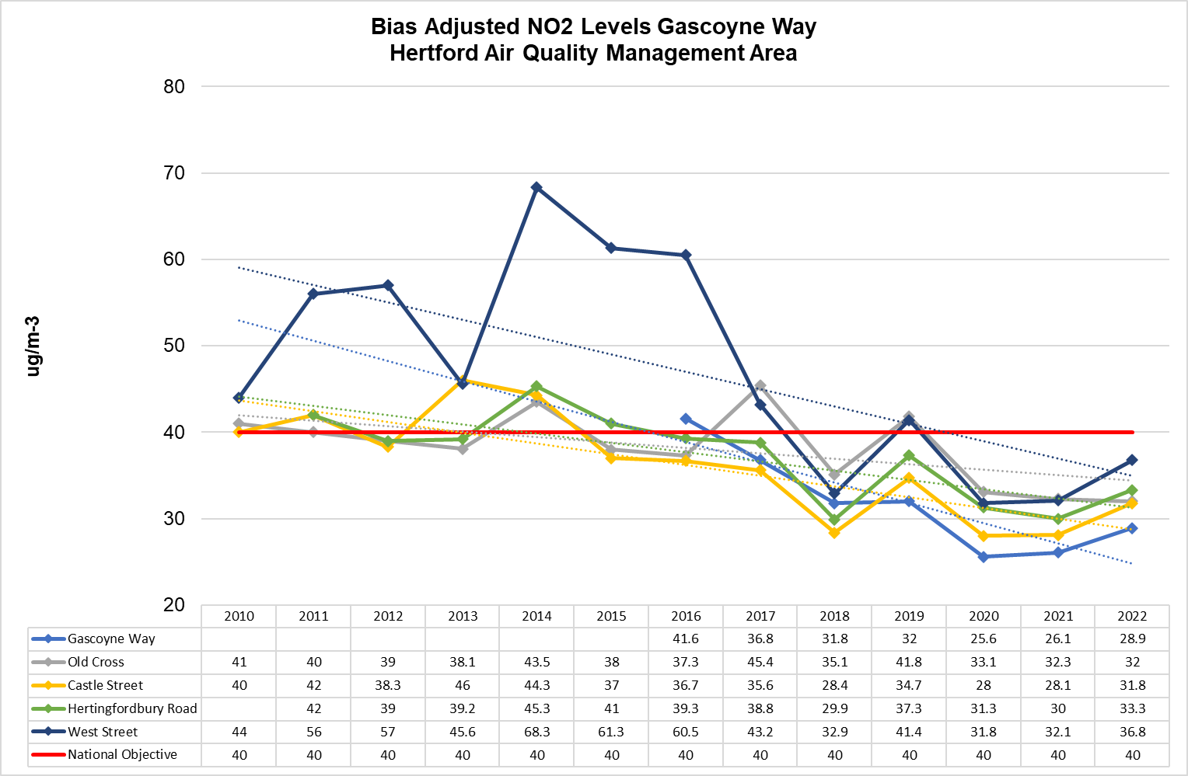

- Air Pollution Monitoring Results - Sawbridgeworth
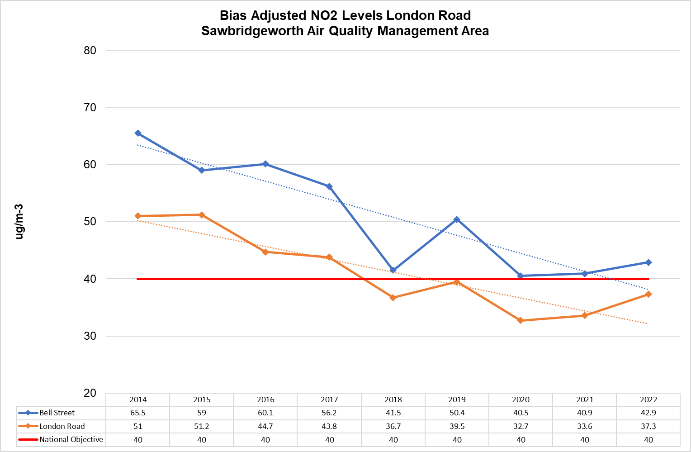

- Glossary of Terms
Abbreviation | Description
AQAP | Air Quality Action Plan - A detailed description of measures, outcomes, achievement dates and implementation methods, showing how the local authority intends to achieve air quality limit values’
AQMA | Air Quality Management Area – An area where air pollutant concentrations exceed / are likely to exceed the relevant air quality objectives. AQMAs are declared for specific pollutants and objectives
AQO | Air Quality Objective
AQS | Air Quality Strategy
ASR | Air Quality Annual Status Report
DEFRA | Department for Environment, Food and Rural Affairs
EHDC | East Hertfordshire District Council
EU | European Union
EV | Electric Vehicle
LAQM | Local Air Quality Management
NO₂ | Nitrogen Dioxide
NO_{x} | Nitrogen Oxides
PM_{2.5} | Airborne particulate matter with an aerodynamic diameter of 2.5µm or less
PM₁₀ | Airborne particulate matter with an aerodynamic diameter of 10µm (micrometres or microns) or less

- Action Plan presented in Defra format
Priority 1: Reduce the impact of traffic levels and congestion on air quality
Measure No. | Measure | Category | Classification | Estimated Year Measure to be Introduced | Estimated / Actual Completion Year | Organis- ations Involved | Funding Source | DEFRA AQ Grant Funding | Funding Status | Estimated Cost of Measure | Measure Status | Target Reduction in Pollutant / Emission from Measure (per AQMA) | Key Perform- ance Indicator | Progress to Date | Comments / Potential Barriers to Implementation
1.1 | Continued expansion of EV infrastructure | Promoting Low Emission Transport | Procuring alternative Refuelling infrastructure to promote Low Emission Vehicles, EV recharging, gas fuel recharge | 2024 | 2027 | East Herts Council | Private market / East Herts Council/LEVI scheme | No | Funding through contract and potentially LEVI contribution | £10k-£50k | Implementation | 0.5µg/m³ to 1µg/m³ | Additional EV charging points | Tendering exercise complete | Adverse market conditions
1.2 | Explore emissions based parking charges | Promoting Low Emission Transport | Other | 2024 | 2027 | East Herts Council | East Herts Council | No | Not funded | £10k-£50k | Implementation and publicity | 0.5µg/m³ to 1µg/m³ | Reduced traffic volumes | Not yet started | Potential lack of political and/or public support
1.3 | Explore Last Mile Delivery possibilities in the district | Freight and Delivery Management | Freight Partnerships for city centre deliveries | To be confirmed (TBC) | TBC | East Herts Council | East Herts Council | No | Not funded | > £50k | Planning | 0.5µg/m³ to 1µg/m³ | Implementation of last mile delivery. Additional delivery lockers etc | including AQ hub lockers in certain areas to avoid individual LGV delivery movements | This measure specifically targets LGVs which are identified through the Source Apportionment to be the greatest contributor to NOx Emissions
1.4 | Install additional anti-idling signage | Public Information | Other | TBC | 2027 | East Herts Council & Hertfordshire County Council | East Herts Council | No | Not funded | < £10k | Implementation | Up to 0.5µg/m³ | Installation of signage | Council has already installed signs in some car parks | Support in place
1.5 | Continued promotion of our four key air campaigns | Promoting Travel Alternatives | Promotion of walking, promotion of cycling | 2024 | Ongoing | East Herts Council & Hertfordshire County Council | East Herts Council / HCC | No | Part funded | £10k-£50k | Implementation and publicity | 0.5µg/m³ to 1µg/m³ | Participation and awareness & increase d sign up of air alert scheme | Delivered each year  Ongoing use of air alert scheme | Budget constraints
1.6 | Review effectiveness of travels plans for schools and businesses | Promoting Travel Alternatives | Other | TBC | 2027 | East Herts Council & Hertfordshire County Council | East Herts Council & Hertfordshire County Council | No | Funded | < £10k | Implemented | Up to 0.5µg/m³ | Plans in place and being followed | Ongoing | Budget constraints
1.7 | Investigate the possible pros and cons of new options being adopted by other local authorities, such as road pricing and ultra-low emission zones (ULEZ) in the AQMAs | Promoting Low Emission Transport | Low Emission Vehicles, EV recharging, gas fuel recharge | TBC | 2029 | East Herts Council & Hertfordshire County Council | East Herts Council & Hertfordshire County Council | No | Funded | > £50k if adopted | Planning | 1µg/m³ to 2µg/m³ | Decision made on ULEZ / road pricing | Not yet started | Objections to even investigating the idea
1.8 | Hertfordshire County Council, East Herts Council and other stakeholders to maintain dialogue about any emerging operational and/or technical means of minimising congestion | Traffic Management | Other | 2024 | Ongoing | East Herts Council & Hertfordshire County Council | East Herts Council & Hertfordshire County Council | No | Not funded | < £10k | Planning | Up to 0.5µg/m³ | Implementation of any identified measaures | Not started | Budget constraints
1.9 | Monitor and act upon emerging guidance on the new national PM_{2.5} objectives | Policy Guidance and Development Control | Air Quality Planning and Policy Guidance | 2024 | Ongoing | East Herts Council & Hertfordshire County Council | East Herts Council & Hertfordshire County Council | No | Funded | < £10k | Planning | 0µg/m³ | Implementation of any identified measaures | Not started | Budget constraints
Priority 2: Mitigate the impact of future growth on air quality
Measure No. | Measure | Category | Classification | Estimated Year Measure to be Introduced | Estimated / Actual Completion Year | Organis- ations Involved | Funding Source | DEFRA AQ Grant Funding | Funding Status | Estimated Cost of Measure | Measure Status | Target Reduction in Pollutant / Emission from Measure (per AQMA) | Key Perform-ance Indicator | Progress to Date | Comments / Potential Barriers to Implementation
2.1 | Hertfordshire Essex Rapid Transit (HERT)/ The A414 Corridor Strategy | Traffic Management | Other | TBC | Ongoing | HCC | HCC | No | Fully funded | > £50k | Implementation | 2µg/m³ to 3µg/m³ note: only applies to Hertford AQMA | Ongoing implementation | Early options and business case completed
2.2 | Continued adherence to our Sustainability SPD and air quality neutral policies | Policy Guidance and Development Control | Air Quality Planning and Policy Guidance | Ongoing | Ongoing | East Herts Council | East Herts Council | No | Fully funded | < £10k | Implementation | Up to 0.5µg/m³ | Reviewed through planning process | Sustainability SPD in place | SPD and District Plan significantly more stringent on requiring consideration of air quality in all planning apps
2.3 | Create a sustainable design and construction code of practice (CCOP). | Policy Guidance and Development Control | Other | Review due to start in 2024 | TBC | East Herts Council | East Herts Council and gov funding | No | Not funded | < £10k | Planning | Up to 0.5µg/m³ | Creation of CCOP | Not yet started | Lack of resources or political will

Priority 3: Support residents’ make active travel choices
Measure No. | Measure | Category | Classification | Estimated Year Measure to be Introduced | Estimated / Actual Completion Year | Organis- ations Involved | Funding Source | DEFRA AQ Grant Funding | Funding Status | Estimated Cost of Measure | Measure Status | Target Reduction in Pollutant / Emission from Measure (per AQMA) | Key Perform-ance Indicator | Progress to Date | Comments / Potential Barriers to Implementation
3.1 | Support expansion of Herts Lynx on demand public transport scheme | Transport Planning and Infrastructure | Other | 2024 | Ongoing | HCC | DfT / HCC | No | DfT funding being sought | > £50k | Implementation | Up to 0.5µg/m³ | Usage numbers | Scheme in place | Availability fo government funding is crucial
3.2 | Investigate potential implementation of footstreets in central Hertford | Promoting Travel Alternatives | Promotion of Walking | TBC | 2029 | East Herts Council/Herts County Council | East Herts Council/Herts County Council | No | Not funded | £10k - £50k | Planning | 0.5µg/m³ to 1µg/m³ |  |  | Initial stages of viability
3.3 | Develop personalised travel planning for residents | Promoting Travel Alternatives | Personalised Travel Planning | 2024 | Ongoing | Herts County Council | Herts County Council | No | TBC | £10k - £50k | Implementation | Up to 0.5µg/m³ | Development of travel plans | A Bishop's Stortford Town wide travel plan (including Personalised Travel Planning) is being developed
3.4 | Active Travel Campaign working with schools and businesses | Promoting Travel Alternatives | Intensive active travel campaign & infrastructure | 2024 | Ongoing (subject to funds) | East Herts Council | East Herts Council | No | Not funded | £10k - £50k | Planning | Up to 0.5µg/m³ | Greater Foot Traffic | Plans to be developed
3.5 | Local Cycling and Walking Infrastructure Plan (LCWIP) | Promoting Travel Alternatives | Promotion of cycling | 2024 | 2025 | Herts County Council | Herts County Council | No | Fully Funded | £10k - £50k | Implementation | Up to 0.5µg/m³ | Securing funds to improve commuter options | Plans are underway for works to begin and funding has been secured for the works. | Work to deliver a continuous shared-use cycling and pedestrian path along the eastern side of London Road and Station Road in Buntingford is progressing well. Works are on track to complete in Summer 2023 before the Buntingford First School opens in September.
3.6 | Exploration of increased on street town centre cycle parking | Promoting Travel Alternatives | Other | 2024 | TBC | HCC | HCC | No | Not funded | £10k - £50k | planning | Up to 0.5µg/m³ | Storage in place | None | funding
3.7 | Creation of an East Herts standalone air quality website | Promoting Travel Alternatives | Other | 2024 | 2026 | East Herts Council | East Herts Council | No | Not funded | £10k - £50k | Planning | Up to 0.5µg/m³ | Website in place | None | funding

Priority 4: Reduce East Herts Council’s own impact on air quality
Measure No. | Measure | Category | Classification | Estimated Year Measure to be Introduced | Estimated / Actual Completion Year | Organis-ations Involved | Funding Source | DEFRA AQ Grant Funding | Funding Status | Estimated Cost of Measure | Measure Status | Target Reduction in Pollutant / Emission from Measure (AQMA) | Key Perform-ance Indicator | Progress to Date | Comments / Potential Barriers to Implementation
4.1 | New council procurement rules | Promoting Low Emission Transport | Public Vehicle Procurement - Prioritising uptake of low emission vehicles | 2025 | 2025 | East Herts Council (and North Herts Council as part of waste management consortium) | East Herts Council | No | Fully funded | < £10k | Implementation | Up to 0.5µg/m³ | % of waste management mileage via e-vehicles | Discussion with tenderers has commenced | New council procurement rules to consolidate and reduce deliveries to council buildings.  Ultimate value of the final tenders
4.2 | Create East Herts Council workplace travel plans for staff | Promoting Travel Alternatives | Other | 2024 | Ongoing | East Herts Council | East Herts Council | No | Unfunded | < £10k | Amended travel patterns | Up to 0.5µg/m³ | Reduced mileage | Work not yet started | Lack of political appetite / resources
4.3 | Work with colleagues in HCC Trading Standards to ensure the Domestic Solid Fuels Regulations are complied with | Policy Guidance and Development Control | Other | 2024 | Ongoing | East Herts Council / HCC | East Herts Council / HCC | No | Unfunded | < £10k | Publicity and enforcement | Up to 0.5µg/m³ | Adherence to regulations | Work not yet started
4.4 | Explore the benefits to air pollution of introducing/ expanding smoke control areas in East Hertfordshire. | Policy Guidance and Development Control | Other | TBC | 2029 | East Herts Council | East Herts Council | No | Unfunded | <£10k | Publicity and enforcement | Up to 0.5µg/m³ | Adherence to regulations | Work not yet started

https://www.judiciary.uk/prevention-of-future-death-reports/ella-kissi-debrah/
https://www.judiciary.uk/wp-content/uploads/2021/04/Ella-Kissi-Debrah-2021-0113-1.pdf
https://assets.publishing.service.gov.uk/media/5a7e2f4640f0b62302689b57/COMEAP _mortality_effects_of_long_term_exposure.pdf
https://www.gov.uk/government/collections/comeap-reports
https://laqm.defra.gov.uk/assets/63091defraairqualityguide9web.pdf
https://fingertips.phe.org.uk/search/pollution#page/1/gid/1/pat/6/ati/401/are/E07000242/iid/ 30101/age/230/sex/4/cat/-1/ctp/-1/yrr/1/cid/4/tbm/1
https://www.hertfordshire.gov.uk/media-library/documents/about-the-council/data-and-information/public-health/air-quality-strategy.pdf
https://eastherts.fra1.digitaloceanspaces.com/s3fs-public/2019-10/Health%20and%20WellbeingStrategy%202019%20-%202023.pdf
https://www.gov.uk/government/consultations/a-zero-emission-vehicle-zev-mandate-and-co2-emissions-regulation-for-new-cars-and-vans-in-the-uk/outcome/zero-emission-vehicle-zev-mandate-consultation-summary-of-responses-and-joint-government-response
Year of readings used for source apportionment.
https://laqm.defra.gov.uk/wp-content/uploads/2022/08/LAQM-TG22-August-22-v1.0.pdf
Year of readings used for source apportionment.
Year of readings used for source apportionment.
https://laqm.defra.gov.uk/wp-content/uploads/2022/08/LAQM-TG22-August-22-v1.0.pdf
https://www.data.gov.uk/dataset/3f6c84f1-9da1-4ee0-82a7-50086a775e22/lower-layer-super-output-areas-2021-boundaries-ew-bgc
https://data.england.nhs.uk/ncdr/data_element/indices-of-multiple-deprivation-imd-decile/
https://www.gov.uk/government/publications/clean-air-strategy-2019
https://www.gov.uk/government/publications/the-air-quality-strategy-for-england/air-quality-strategy-framework-for-local-authority-delivery
https://www.gov.uk/government/publications/air-quality-plan-for-nitrogen-dioxide-no2-in-uk-2017
https://cdn-eastherts.onwebcurl.com/s3fs-public/documents/District_Plan_Publish_web_view.pdf
https://cdn-eastherts.onwebcurl.com/s3fs-public/2021-03/Sustainability%20SPD.pdf
https://www.hertfordshire.gov.uk/media-library/documents/about-the-council/consultations/ltp4-local-transport-plan-4-complete.pdf
https://www.eastherts.gov.uk/environmental-health/air-quality
https://www.eastherts.gov.uk/environmental-health/air-quality
https://www.eastherts.gov.uk/environmental-health/air-quality
https://www.eastherts.gov.uk/environmental-health/air-quality
https://www.eastherts.gov.uk/environmental-health/air-quality
https://www.theguardian.com/environment/bike-blog/2017/dec/01/bike-lanes-dont-clog-up-our-roads-they-keep-london-moving

