[Insert Local Authority Logo Here]
INSTRUCTIONS
This is the Annual Progress Report (APR) for submission to the Welsh Government by 30th September of each calendar year.
PLEASE NOTE:
There is a mandatory requirement for local authorities to submit their NO₂ diffusion tube data to the LAQM Portal via the Diffusion Tube Data Entry System (DTDES) upload facility. This submission should be completed once all monitoring data for 2023 has been processed. The Diffusion Tube Data Processing Tool has been developed to assist local authorities in processing NO₂ diffusion tube monitoring data. It provides an output table which can be directly uploaded via the DTDES. If not using the processing tool, a template for submitting the data is available from the LAQM website.
- LAQM Portal
- Diffusion Tube Data Processing Tool
Local authorities are required to submit the Excel file with all relevant tables completed via the LAQM Portal, in addition to a MS Word or PDF copy of the completed APR.
It is advised that local authorities complete the Excel based tables first, before then copying the relevant completed tables in to the Word APR template, as any inconsistencies between data tables may result in the submission being rejected. If particular tables are not relevant to the local authority, the reasons as to why should be indicated via the drop-down menus at the top of each Table tab.
Blue boxes provide instructions and/or further information to help local authorities complete the report. These boxes should be deleted before submitting the report.
Where a conglomerate of authorities work together on air quality control, it is permissible to submit a single APR on behalf of all the authorities.
Red text indicates where the local authority needs to fill in information. Once the required information has been completed the font colour should be amended to match that of the body text.
You can insert your own cover page design of your choice, this may include a title, subtitle, picture, Local Authority’s own logo and consultant logo (if applicable)
Delete this box when the document is finished.
<LA Name> 2024 Air Quality Progress Report
In fulfilment of Part IV of the Environment Act 1995, as amended by the Environment Act 2021
Local Air Quality Management
Date: (Month, Year)
ACCESSIBILTY INSTRUCTIONS
This 2024 reporting template has been developed to comply with the Accessibility Regulations (2018). Instructions are provided throughout the template as a steer to ensuring that the completed APR remains compliant with Accessibility Regulations, with the key points to adhere to summarised as follows:
- Make hyperlinks accessible - the text used for hyperlinks should describe where people will go if they click that link
- Follow the template heading styles - important to define the content hierarchy and use the correct heading style at the right time
- Avoid using ‘tab’ or ‘enter’ to create spaces between text/sections, utilise page/section breaks
- Use the tables within the template. If any additional tables are required, ensure these are formatted correctly and a summary of the table is provided within the accompanying text (N.B. alt text added to tables does not save if the document is converted to a pdf):
  - Ensure the top row is selected as the ‘header row’
  - Avoid the use of merged or split cells
  - The table should read logically from left to right and top to bottom
- When inserting trend graphs/charts ensure that colour combinations relevant to colour blindness are avoided
- Add alt text to charts or pictures inserted within the report that do not have a corresponding summary written directly above or below the chart
- Text should be aligned to the left and not justified
If saving the document as a PDF it is recommended that the ‘Create bookmarks using’ option with the sub-option of ‘Headings’ is selected. Although not an explicit requirement in terms of accessibility, this will ensure your document is easy to read and navigate.
Further guidance in terms of publishing accessible documents can be found through the following on the .gov.wales website. If the APR is to be published on your authority website, it is recommended that the APR is checked by your content team to ensure compliance.
Delete this box when the document is finished

Information | <Local Authority Name> Details
Local Authority Officer | Enter Name(s) Here
Department | Enter Department Name
Address | Enter Address
Telephone | Enter Telephone
E-mail | Enter Email Address
Report Reference Number | Enter Report Reference
Date | Enter Date of Report

Please update the header information on this page
Section 2 (new monitoring data) and Section 3 (new local developments) must be completed by all Local Authorities using this template. Progress Reports are required to provide this information.
It is also recommended, if these are relevant to your Local Authority, that you include the information covered within Section 4 of this template, on:
- Local / Regional air quality strategy
- Planning applications that may be relevant to air quality
- Air quality planning policies
- Local transport plans and strategies
- Climate Change Strategies (optional)
If you have an Action Plan, it is recommended that you incorporate your Action Plan Progress Report into this Progress Report. Section 1 of the template is provided for this.
Not all Local Authorities will need to complete Section 4. Any sections not used should be completely deleted. (The section numbering will of course change accordingly).
This report should be completed in full consideration of requirement set out in the Local Air Quality Management Technical Guidance (TG22).
The following list is provided to assist local authorities in understanding the most frequent issues noted by the Welsh Government during the APR appraisal process:
- Outdated national bias adjustment factor used – if a national factor is to be used please ensure the relevant factor from the most up to date version of the National Bias Adjustment Factor Spreadsheet is adopted.
- Incorrect methodology used to complete annualisation – the Diffusion Tube Data Processing Tool can be used to complete annualisation to minimise the likelihood of processing errors and can export files suitable for upload to the LAQM Portal.
- Erroneous monthly diffusion tube data included within annual mean calculations - data should be removed as per Chapter 7: NO_{X} and NO₂ Monitoring, NO₂ by Diffusion Tubes of Technical Guidance LAQM.TG22
- Distance correction - should only be completed for monitoring sites where the concentration is greater than 36µg/m³ and the receptor is not located at a point of relevant exposure.
- Insufficient detail provided regarding the progress of action plan measures - insufficient detail provided within Table 1.2
- Monitoring and AQMA maps - these should be clear and accurate
Adequately addressing the above points will minimise the likelihood of your report being rejected at the appraisal stage.
Delete this box when the document is finished.

Executive Summary: Air Quality in Our Area
Please summarise for the general public the main findings and conclusions of the report here. This may include:
- Key news/headlines about how you’ve been working to improve air quality in your area.
- Current challenges/priorities for addressing air quality in your area - a brief summary of the main air quality issues in your local area. If there are no air quality issues in your area, please provide a statement to this effect and say how you are working to keep levels of pollution as low as reasonably practicable.
- What are the observed trends shown by the latest monitoring data (e.g. are levels going up or down?)
- Include a brief summary of core actions (and in particular success stories or lessons learnt) to target sources of pollution in your area over the past year, indicate any quantitative improvements from actions taken (if known). If your authority has no AQMAs or action plans and is not undertaking any other air quality related activities, please provide a statement to this effect.
- How the public is or can get involved – e.g. walking, not driving; anti-idling, car sharing, activities in schools, etc. Include a brief statement on how the public can obtain further information on air quality within your local authority area.
- Engaging pictures of air quality initiatives in your area, if possible.
This section is especially designed to inform those living and working in your area about the state of local air quality and is intended to be understood by those not familiar with LAQM. This section should especially avoid the use of technical terms.
The remainder of the document should also be made as reader friendly as possible but the template assumes that some people may not read beyond this section of the document.
These blue instruction boxes are used throughout this template to provide guidance on completing the Progress Report. Please delete them before submitting the report.
Delete this box when the document is finished.

Air Quality in <Local Authority Name>
Include a brief summary of the main air quality issues in your local area – what are the main pollutants of concern, what are the observed trends shown by the latest monitoring data (e.g. are levels going up or down?), where are the current AQMAs or hotspots (including a link to your AQMA webpage, any new major sources of emissions. Include the introduction of any new AQMAs, Action Plans or strategies. Briefly explain how your local authority works to manage local air quality and how you work with your partners e.g. County Council, Natural Resource Wales.

Actions to Improve Air Quality
Include a brief summary of core actions (and in particular success stories or lessons learned) to target sources of pollution in your area over the past year, indicate any quantitative improvements from actions taken (if known).
If your authority has no AQMAs or action plans and is not undertaking any other air quality related activities, please provide a statement to this effect.

Local Priorities and Challenges
Include here a brief summary of what the priorities are for the local authority in addressing air quality for the coming year and briefly set out any challenges.
If your authority has no specific priorities or challenges for the coming year beyond the statutory monitoring and reporting requirements, please provide a statement to this effect.

How to Get Involved
Include a brief statement on how the public can obtain further information on air quality within your local authority area.

Table of Contents
Update Table on Completion of Report
Select some text below> right click > update field>Update Entire Table
DELETE THIS INSTRUCTION BOX BEFORE SUBMITTING THE REPORT.
Executive Summary: Air Quality in Our Area i
Air Quality in <Local Authority Name> ii
Actions to Improve Air Quality ii
Local Priorities and Challenges ii
How to Get Involved ii
1 Actions to Improve Air Quality 1
1.1 Previous Work in Relation to Air Quality 1
1.2 Air Quality Management Areas 1
1.3 Implementation of Action Plans 4
2 Air Quality Monitoring Data and Comparison with Air Quality Objectives 10
2.1 Summary of Monitoring Undertaken in 2023 10
2.1.1 Automatic Monitoring Sites 10
2.1.2 Non-Automating Monitoring Sites 11
2.2 2023 Air Quality Monitoring Results 18
2.3 Comparison of 2023 Monitoring Results with Previous Years and the Air Quality Objectives 33
2.3.1 Nitrogen Dioxide (NO₂) 34
2.3.2 Particulate Matter (PM₁₀) 36
2.3.3 Particulate Matter (PM_{2.5}) 36
2.3.4 Other Pollutants Monitored (optional) 37
2.4 Summary of Compliance with AQS Objectives as of 2023 37
3 New Local Developments 39
3.1 Road Traffic Sources (and Other Transport) 39
3.2 Industrial / Fugitive or Uncontrolled Sources / Commercial Sources 39
3.3 Other Sources 41
3.4 Bonfires / Incidents 41
3.5 Firework Displays 41
3.6 Domestic Wood Burners 41
4 Policies and Strategies Affecting Airborne Pollution 43
4.1 Local / Regional Air Quality Strategy 43
4.2 Air Quality Planning Policies 44
4.3 Local Transport Plans and Strategies 44
4.4 Active Travel Plans and Strategies 44
4.5 Local Authorities Well-being Objectives 44
4.6 Green Infrastructure Plans and Strategies 45
4.7 Climate Change Strategies 45
5 Conclusion and Proposed Actions 46
5.1 Conclusions from New Monitoring Data 46
5.2 Conclusions relating to New Local Developments 46
5.3 Other Conclusions 46
5.4 Proposed Actions 47
References 48
Appendices 49
Appendix A: Quality Assurance / Quality Control (QA/QC) Data 50
Appendix B: A Summary of Local Air Quality Management 52
5.5 Purpose of an Annual Progress Report 52
5.6 Air Quality Objectives 52
Appendix C: Air Quality Monitoring Data QA/QC 54
5.7 QA/QC of Diffusion Tube Monitoring 54
Diffusion Tube Annualisation 55
Diffusion Tube Bias Adjustment Factors 55
NO₂ Fall-off with Distance from the Road 56
5.8 QA/QC of Automatic Monitoring 57
PM₁₀ and PM_{2.5} Monitoring Adjustment 57
Automatic Monitoring Annualisation 57
NO₂ Fall-off with Distance from the Road 58
Appendix D: AQMA Boundary Maps 63
Glossary of Terms 64

Tables
Please insert a list of Tables here.
Insert list on Completion of Report
Select References tab Insert Table of Figures Select ‘….’ Tab leader Select ‘Table’ Caption Label
Delete this box after you have inserted the table
Figures
Please insert a list of Figures here.
Insert list on Completion of Report
Select References tab Insert Table of Figures Select ‘….’ Tab leader Select ‘Figure’ Caption Label
Delete this box after you have inserted the table

Actions to Improve Air Quality

Previous Work in Relation to Air Quality
Please outline the conclusions of previous local action in relation to air quality.
To include:
- All stages completed
- Exceedances identified/predicted
- Areas affected
- AQMAs declared (together with maps) or amended, clearly stating which pollutant(s) and objective(s) they cover
- Any locations where exceedances of objective concentrations have previously been identified but reports have judged that no AQMA is necessary
- AQMAs that have been revoked
- Any on-going assessments that have not yet been reported
It may be helpful to include a table of previous reports, dates they were produced and brief outcomes.
Delete this box when the document is finished.
Provide details here.

Air Quality Management Areas
Air Quality Management Areas (AQMAs) are declared when air quality is close to or above an acceptable level of pollution (known as the air quality objective (Please see Appendix A)). After declaring an AQMA the authority must prepare an Air Quality Action Plan (AQAP) within 18 months setting out measures it intends to put in place to improve air quality to at least the air quality objectives, if not even better. AQMA(s) are seen by local authorities as the focal points to channel resources into the most pressing areas of pollution as a priority.
Amend the following as necessary:
A summary of AQMAs declared by <Local Authority Name> can be found in Table 1.1. Further information related to declared or revoked AQMAs, including maps of AQMA boundaries are available online at <insert link to local authority’s AQMA webpage.
Or:
<Local Authority Name> currently does not have any AQMAs. <insert reference to air quality strategy or similar document>
Add text if necessary: We propose to declare a new AQMA in <x> area (see monitoring section). We propose to amend <AQMA Name> (see monitoring section). We propose to revoke <AQMA Name> (see monitoring section).

<DELETE IF NOT REQUIRED>
Table 1.1 – Declared Air Quality Management Areas
AQMA | Relevant Air Quality Objective(s) | Comments on Air Quality Trend | City / Town<Delete column if not relevant> | Description | Action Plan
AQMA Name 1 | - NO₂ annual mean  - PM₁₀ 24-hour mean | There has been no discernible improvement in air quality in the AQMA for the last 3 years. | Name | An area encompassing a number of properties at the junction of road 1 and road 2. | Name and Link to Action Plan
AQMA Name 2 | NO₂ annual mean | This year’s monitoring results indicate a significant improvement in air quality compared to previous years. | Name | Residential properties along road name 1. The AQMA was further extended in April 2013 to include road name 2. | Name and Link to Action Plan
AQMA boundary maps within <Local Authority Name> can be viewed at <Link to relevant GIS website link> and are included in Appendix D.

Implementation of Action Plans
Inclusion of this section is now mandatory where local authorities have published an AQAP. As required, you may also produce additional action plan progress reports separately.
Please refer to Chapter 3 of LAQM.TG22 for further information.
Links should be provided to existing Action Plans.
It would be helpful if you could provide this information in the form of a large table in the format of the blank table (Table 1.2) that is provided below, with an example in the first row (shaded). However, this can be supplemented and amended at the Local Authority’s discretion.
Please delete the whole section if not used and delete this box when the document is finished.
<Local Authority Name> has taken forward a number of measures during <XXXX> in pursuit of improving local air quality. Details of all measures completed, in progress or planned are set out in Table 1.2. More detail on these measures can be found in the Air Quality Action Plan relating to any designated AQMAs.
Air Quality Action Plans are continuously reviewed and updated whenever deemed necessary, but no less frequently than once every five years. Such updates are completed in close consultation with local communities.
Key measures completed in 2023 are: <set out bullet of main measures below and any key outcomes from these – keep text brief>.
<Local Authority Name> expects the following measures to be completed over the course of the next reporting year: <set out measures and brief explanation of expected impact of these measures>.

INSTRUCTIONS
Please fill in Table 1.2 (Progress on Measures to Improve Air Quality) below to reflect each measure implemented.
Measures should be ordered in terms of their expected efficacy, i.e. the most effective measure first, least effective measure last.
For the Lead organisation and funding source column, please indicate the organisations or departments involved with the measure, including any information on collaboration, and the source of the funding supporting the measure.
For the KPI column, please also indicate (if relevant) if these have been met to date.
The “EU Category” and “EU Classification” columns should be populated based on the following options, to be consistent with the National Air Quality Plans:
EU Measure Category | EU Measure Classification
Alternatives to private vehicle use | Bus based Park & Ride
 | Car & lift sharing schemes
 | Car Clubs
 | Rail based Park & Ride
 | Other
Environmental Permits | Introduction/increase of environment charges through permit systems and economic instruments
 | Introduction/increase of environmental funding through permit systems and economic instruments
 | Large Combustion Plant Permits and National Plans going beyond BAT
 | Measures to reduce pollution through IPPC Permits going beyond BAT
 | Other measure through permit systems and economic instruments
 | Tradable permit system through permit systems and economic instruments
 | Other
Freight and Delivery Management | Delivery and Service plans
 | Freight Consolidation Centre
 | Freight Partnerships for city centre deliveries
 | Quiet & out of hours delivery
 | Route Management Plans/ Strategic routing strategy for HGV's
 | Other
Policy Guidance and Development Control | Air Quality Planning and Policy Guidance
 | Low Emissions Strategy
 | Other policy
 | Regional Groups Co-ordinating programmes to develop Area wide Strategies to reduce emissions and improve air quality
 | Sustainable Procurement Guidance
Promoting Low Emission Plant | Emission control equipment for small and medium sized stationary combustion sources / replacement of combustion sources
 | Low Emission Fuels for stationary and mobile sources in Public Procurement
 | Other measure for low emission fuels for stationary and mobile sources
 | Public Procurement of stationary combustion sources
 | Regulations for fuel quality for low emission fuels for stationary and mobile sources
 | Shift to installations using low emission fuels for stationary and mobile sources
 | Other Policy
Promoting Low Emission Transport | Company Vehicle Procurement -Prioritising uptake of low emission vehicles
 | Low Emission Zone (LEZ)
 | Priority parking for LEV's
 | Procuring alternative Refuelling infrastructure to promote Low Emission Vehicles, EV recharging, Gas fuel recharging
 | Public Vehicle Procurement -Prioritising uptake of low emission vehicles
 | Taxi emission incentives
 | Taxi Licensing conditions
 | Other
Promoting Travel Alternatives | Encourage / Facilitate home-working
 | Intensive active travel campaign & infrastructure
 | Personalised Travel Planning
 | Promote use of rail and inland waterways
 | Promotion of cycling
 | Promotion of walking
 | School Travel Plans
 | Workplace Travel Planning
 | Other
Public Information | Via leaflets
 | Via other mechanisms
 | Via radio
 | Via television
 | Via the Internet
 | Other
Traffic Management | Anti-idling enforcement
 | Emission based parking or permit charges
 | Reduction of speed limits, 20mph zones
 | Road User Charging (RUC)/ Congestion charging
 | Strategic highway improvements, Re-prioritising road space away from cars, including Access management, Selective vehicle priority, bus priority, high vehicle occupancy lane
 | Testing Vehicle Emissions
 | UTC, Congestion management, traffic reduction
 | Workplace Parking Levy, Parking Enforcement on highway
 | Other
Transport Planning and Infrastructure | Bus route improvements
 | Cycle network
 | Public cycle hire scheme
 | Public transport improvements-interchanges stations and services
 | Other
Vehicle Fleet Efficiency | Driver training and ECO driving aids
 | Fleet efficiency and recognition schemes
 | Promoting Low Emission Public Transport
 | Testing Vehicle Emissions
 | Vehicle Retrofitting programmes
 | Other
Delete this box when the document is finished.
Table 1.2 – Progress on Measures to Improve Air Quality
No. | Measure | Focus | Lead Authority | Planning Phase | Implementation Phase | Indicator | Target Annual Emission Reduction in the AQMA | Progress to Date | Progress in Last 12 Months | Estimated Completion Date | Comments Relating to Emission Reductions
1 | Manage bus emissions | Reduce unit emissions in the AQMA using Bus Quality Partnership Agreements (BQPA) | County Council | 2013 | 2014-15 | Elimination of Euro I and II buses by 2016 – | 2%* Extremely hard if not impossible to prove. | Failure to reach a BQPA meant the authority applied for a Traffic Regulation Control (TRC) | The TRC was adopted with the condition of having no Euro I and Euro II buses passing through the AQMA from 2014 onwards | 2016 | Elimination of remaining few Euro I and II buses still estimated to deliver a 2% reduction in annual emissions.
2
3
4
5

Any additional supporting information on the measures within Table 1.2 and progress towards their completion should be provided here.

Air Quality Monitoring Data and Comparison with Air Quality Objectives

Summary of Monitoring Undertaken in 2023

Automatic Monitoring Sites
Please provide details of automatic monitoring carried out in the year covered by this report. Table 2.1 below provides the recommended format for a table of site details. Include in this section:
- A map showing the location of your monitoring sites. If applicable, AQMAs should also be included
- Details of any sites that started up, or closed down, since the previous report, with reasons
Please provide, for each monitoring site, a unique identifier (Site ID), which should be used in all relevant tables and maps. For example, CM1, CM2… could be used for continuous monitoring sites, and DT1, DT2… for diffusion tube sites. Alternatively, the following IDs could also be used:
- AN1, AN2… for Automatic NO₂
- PN1, PN2… for Passive NO₂
- APM1, APM2… for Automatic PM₁₀
- AS1, AS2… for Automatic SO₂
- …
Descriptions of monitoring site classifications can be found in Table 7.7 of LAQM.TG22. The term ‘worst-case’ exposure is used to represent those places where concentrations are expected to be the highest, and where the public may be exposed over the relevant averaging period of the objectives.
Details of QA/QC should be included within Appendix C:
- Frequency of routine calibrations and periodic site audits
- Who carries these out? (LA or contractor)
- Data validation and ratification procedures
- Monitoring period, if not full calendar year
- Clearly labelled maps of all monitoring locations (monitoring site labels should match those in tables)
In the case of PM₁₀ monitoring, provide the equipment type and details of any adjustments applied to the data, e.g. correction factors applied to BAM data or use of VCM to correct TEOM data. (You can find out more about the VCM model here).
Delete this box when the document is finished.
This section sets out what monitoring has taken place and how results compare with the objectives.
<Local Authority Name> undertook automatic (continuous) monitoring at <X> sites during 2023. Table 2.1 presents the details of the sites. National monitoring results are available at <please insert link>.
Maps showing the location of the monitoring sites are provided in <Figure 2.1 / or link>. Further details on how the monitors are calibrated and how the data has been adjusted are included in Appendix C.

Non-Automating Monitoring Sites
Please provide details of non-automatic monitoring. This will most commonly be NO₂ diffusion tubes but could also include benzene diffusion tubes.
Table 2.2 below provides the recommended format for a table of site details.
Maps showing locations of monitoring sites (if applicable) should be included (see Figure 2.2) with the site ID clearly identified. In case the maps show many monitoring sites, it may be useful to provide several maps at various zoom levels to allow for clear identification of each monitoring site. If there are AQMAs in place for the relevant pollutants, these should also be included on any maps.
Details of QA/QC for diffusion tubes should be included within Appendix C, this should include:
- Laboratory supplying and analysing the tubes
- Preparation method used
- Confirmation that the laboratory follows the procedures set out in the Practical Guidance
- Results of laboratory precision and AIR-PT proficiency testing scheme referenced within Chapter 7 of LAQM.TG22
- Whether the Local Authority has compared the diffusion tubes with the reference method in a co-location study (details of this can be included as a sub-section or appendix)
- The bias adjustment factor being applied to the annual means from the diffusion tubes
- Where this came from – i.e. local co-location, LAQM Support website
The national bias adjustment factors are available from the National Bias Adjustment Factor Spreadsheet and the questionnaire for adding your own co-location study to the database is also available via the LAQM Website.
Local authorities are encouraged to share co-location information with other authorities. Please complete and return the co-location questionnaire to ensure your monitoring data is considered for inclusion in the database of bias adjustment factors provided by the LAQM Helpdesk. This should be done as soon as possible to ensure the database is updated in advance of report submission.
Information on QA/QC for diffusion tubes can be found on the LAQM website.
The term ‘worst-case’ exposure is used to represent those places where concentrations are expected to be the highest, and where the public may be exposed over the relevant averaging period of the objectives.
Delete this box when the document is finished.
<Local Authority Name> undertook non- automatic (passive) monitoring of NO₂ at <X> sites during 2023. Table 2.2 presents the details of the sites.
Maps showing the location of the monitoring sites are provided in <Figure 2.2 / or link>. Further details on Quality Assurance/Quality Control (QA/QC) and bias adjustment for the diffusion tubes are included in Appendix C.

Table 2.1 – Details of Automatic Monitoring Sites
Site ID | Site Name | Site Type | Associated with (Named) AQMA? | X OS Grid Reference | Y OS Grid Reference | Pollutants Monitored | Monitoring Technique | Inlet Height (m) | Distance from monitor to nearest relevant exposure (m) ⁽¹⁾ | Distance from Kerb to Nearest Relevant Exposure (m) | Distance from Kerb to Monitor (m)
AN1 | Smith Street | Urban background | Smith Street AQMA | 332395 | 433175 | PM₁₀ | FDMS | 2.0 | 2.5 | 1 | 3.5
Notes:
(1) 0m indicates that the sited monitor represents exposure and as such no distance calculation is required.

Figure 2.1 – Map(s) of Automatic Monitoring Sites (if applicable) [Link to Welsh Air Quality Forum (WAQF) Website GIS]
INSTRUCTIONS
Please include here one or more clear map(s) that show the location of all automatic monitoring sites ensuring that monitoring positions are clearly labelled using the Site IDs and the mapped coordinates correspond to those presented in Table 2.1.
As for all charts within the annual report, alt text should be added to comply with accessibility regulations.
Delete this box when the document is finished

Table 2.2 – Details of Non-Automatic Monitoring Sites
INSTRUCTIONS
To help with consistency of approach to processing diffusion tube monitoring data a specific Diffusion Tube Data Processing Tool has been developed. It is recommended that this tool is used to process all diffusion tube data.
The tool is available for download from the LAQM website. Any questions relating to the use of the tool should be directed to the LAQM Helpdesk.
The tab ‘Table 2.2’ from the Diffusion Tube Data Processing Tool aligns with the diffusion tube data reporting requirements of Table 2.2; therefore the data can be easily copied. If the Diffusion Tube Data Processing Tool has not been utilised, please copy across from any alternative calculation spreadsheet or populate manually.
Delete this box when the document is finished

Diffusion Tube ID | Site Name | Site Type | X OS Grid Ref (Easting) | Y OS Grid Ref (Northing) | Pollutants Monitored | In AQMA? Which AQMA? | Distance to Relevant Exposure (m) ⁽¹⁾ | Distance to kerb of nearest road (m) ⁽²⁾ | Tube Co-located with a Continuous Analyser? | Tube Height (m)
<DT1> | <Name 1> | <Roadside> | <666555> | <333444> | <NO₂> | <YES/NO  AQMA 1> | <2.5> | <1> | <No> | <2>
<DT2> | <Name 2> | <Urban Background> | <777444> | <333555> | <NO₂> | <YES/NO  AQMA 2> | <25> | <N/A> | <No> | <1.8>

Notes:
(1) 0m indicates that the sited monitor represents exposure and as such no distance calculation is required.
(2) N/A if not applicable.
Figure 2.2 – Map(s) of Non-Automatic Monitoring Sites (if applicable)
INSTRUCTIONS
Please include here one or more clear map(s) that show the location of all monitoring sites in relation to any AQMA(s) and, if appropriate, the local authority boundary, ensuring that monitoring positions are clearly labelled using the Site IDs and the mapped coordinates correspond to those presented in Table 2.2.
As for all charts within the annual report, alt text should be added to comply with accessibility regulations.
Delete this box when the document is finished

2023 Air Quality Monitoring Results
Table 2.3 – Annual Mean NO₂ Monitoring Results: Automatic Monitoring (µg/m³)
Site ID | Site Type | Monitoring Type | Valid Data Capture for Monitoring Period (%) ⁽¹⁾ | Valid Data Capture 2023 (%) ⁽²⁾ | 2019 | 2020 | 2021 | 2022 | 2023
AN1 | Urban background | Automatic | 95.8 | 95.8 | 35.6 | 38.3 | 40.9 | 45.6 | 36.5
Notes:
Exceedances of the NO₂ annual mean objective of 40µg/m³ are shown in bold.
NO₂ annual means exceeding 60µg/m³, indicating a potential exceedance of the NO₂ 1-hour mean objective are shown in bold and underlined.
Means for diffusion tubes have been corrected for bias. All means have been “annualised” as per LAQM.TG22 if valid data capture for the full calendar year is less than 75%. See Appendix C for details.
(1) Data capture for the monitoring period, in cases where monitoring was only carried out for part of the year.
(2) Data capture for the full calendar year (e.g. if monitoring was carried out for 6 months, the maximum data capture for the full calendar year is 50%).

Table 2.4 – Annual Mean NO₂ Monitoring Results: Non-Automatic Monitoring (µg/m³)
INSTRUCTIONS
Populate Table 2.4 with all diffusion tube (non-automatic) annual mean NO₂ monitoring results over the past five years.
To help with consistency of approach to processing diffusion tube monitoring data a specific Diffusion Tube Data Processing Tool has been developed which should be used to process all diffusion tube data. The tool has been developed to calculate annual mean concentrations for the diffusion tube monthly data entered and amalgamates the following individual LAQM processing tools:
- Annualisation tool;
- Precision and accuracy tool – calculation of local bias; and
- NO₂ fall off with distance calculator.
In regard to diffusion tube data to include within the APR, the data for following tables can be output from the relevant tabs tool in the same format as within the APR:
- Table 2.2 – Tab: Table 2.2
- Table 2.4 – Tab: Table 2.4
- Table A.1 – Tab: Table A.1
- Table C.2 – Tab: Annualisation Summary
- Table C.1 – Tab: Step 3 - Bias Adjustment
- Table C.4 – Tab: Step 4 - Fall off with Distance
Any questions relating to the use of the tool should be directed to the LAQM Helpdesk.
Note, there is a requirement for local authorities to submit their NO₂ diffusion tube data to the LAQM Portal via the DTDES upload facility. The Diffusion Tube Data Processing Tool has been developed to assist local authorities in processing NO₂ diffusion tube monitoring data. It provides an output table which can be directly uploaded via the DTDES.
Any questions relating to the use of any LAQM tool should be directed to the LAQM Helpdesk. Guidance presented in Chapter 7: NO_{X} and NO₂ Monitoring of the Technical Guidance LAQM.TG22 should be followed for the calculation of annual mean concentrations, both automatic and using diffusion tubes.
Concentrations should be annualised (where required) and bias adjusted, but NOT distance corrected.
Concentrations should be presented within Table 2.4, and throughout the report to one decimal place (1 dp).
Any exceedances of the NO₂ annual mean objective of 40µg/m³ should be presented in BOLD.
Any NO₂ annual means that exceed 60µg/m³, indicating a potential exceedance of the NO₂ 1-hour mean objective are shown in BOLD and UNDERLINED.
When completing the Data Capture values the following should be adhered to:
- Valid data capture for monitoring period – This should be the data capture for the period within the calendar year for which monitoring was undertaken. In certain cases, monitoring may only have been undertaken for part of the year, e.g. monitoring that began in January and ran until June (six months) before finishing - if results were returned for all six months this would equate to 100% data capture.
- Valid data capture 2023 – This is the data capture based upon the calendar year. For the example given above this would result in a 50% data capture within 2023.
Delete this box when the document is finished

Diffusion Tube ID | X OS Grid Ref (Easting) | Y OS Grid Ref (Northing) | Site Type | Valid Data Capture for Monitoring Period (%) (1) | Valid Data Capture 2022 (%) (2) | 2019 | 2020 | 2021 | 2022 | 2023
<DT1> | <666555> | <333444> | <Roadside> | <100 > | <75 > | <15.5> | <18.8> | <19.9> | <20.5> | <20.5>
<DT2> | <777444> | <333555> | <Urban Background> | <100> | <100> | <15.5> | <18.8> | <19.9> | <20.5> | <20.5>

<CLICK HERE THEN PASTE COMPLETED DATA ROWS FROM LAQM DATA PROCESSING TOOL (IF UTILISED)>
☐ Annualisation has been conducted where data capture is <75% and >25% in line with LAQM.TG22 (confirm by selecting in box).
☐ Diffusion tube data has been bias adjusted (confirm by selecting in box).
☐ Reported concentrations are those at the location of the monitoring site (bias adjusted and annualised, as required), i.e. prior to any fall-off with distance correction (confirm by selecting in box).
Notes:
The annual mean concentrations are presented as µg/m³.
Exceedances of the NO₂ annual mean objective of 40µg/m³ are shown in bold.
NO₂ annual means exceeding 60µg/m³, indicating a potential exceedance of the NO₂ 1-hour mean objective are shown in bold and underlined.
Means for diffusion tubes have been corrected for bias. All means have been “annualised” as per LAQM.TG22 if valid data capture for the full calendar year is less than 75%. See Appendix C for details.
Concentrations are those at the location of monitoring and not those following any fall-off with distance adjustment.
(1) Data capture for the monitoring period, in cases where monitoring was only carried out for part of the year.
(2) Data capture for the full calendar year (e.g. if monitoring was carried out for 6 months, the maximum data capture for the full calendar year is 50%).

Figure 2.3 – Trends in Annual Mean NO₂ Concentrations
INSTRUCTIONS
An Example Trend Chart is presented below. Trend charts should be inserted for results for all pollutants monitored and all relevant air quality objectives.
It is recommended that, where AQMA(s) are present, separate charts are provided for each AQMA.
Sites outside of AQMAs are also to be shown. It is preferable that these are presented by grouped geographical areas.
To comply with Accessibility Regulations, each chart must have a summary note attached to them using the alt-text function. To add alt text right click on an image and select Edit Alt Text… and insert a brief description of the chart, e.g. Figure A.1 presents NO₂ annual mean concentrations for sites DT1 to DT10 between years 2019 to 2023. There are no exceedances of the annual mean objective in 2023 and there is a general trend of reduction experienced across the sites.
The presentation of trend charts should take account of readers who are colour blind, with suitable colour-blind friendly pallets chosen. The following colour combinations should be avoided:
- green/red
- green/brown
- blue/purple
- green/blue
- light green/yellow
- blue/grey
- green/grey
- green/black
- red/amber/green
The website ColorBrewer provides colour-blind safe information regarding palettes, and allows the definition of a 5-class palette that would be applicable to a trend chart with five years of monitoring data.
All subsequent trend charts included in the APR should follow the instructions as presented above.
Delete this box when the document is finished
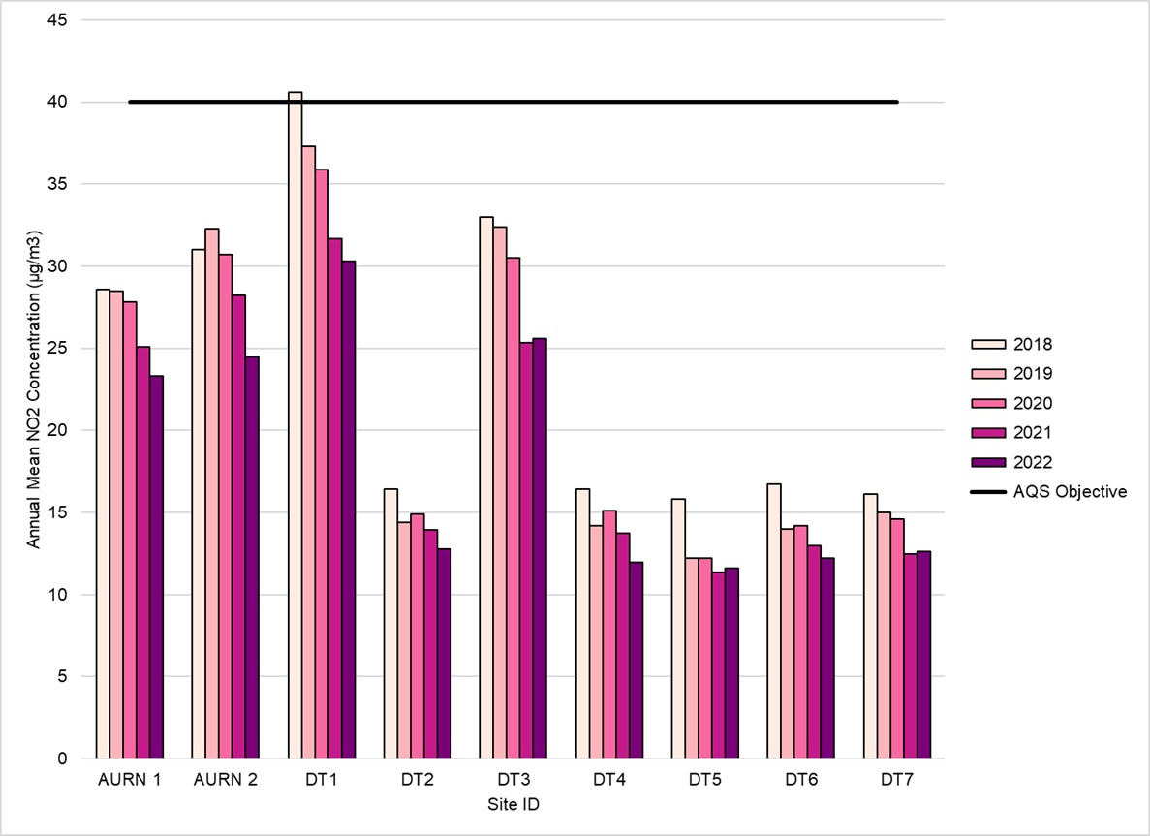
<Delete if not required>

Table 2.5 – 1-Hour Mean NO₂ Monitoring Results, Number of 1-Hour Means > 200µg/m³
Site ID | Site Type | Monitoring Type | Valid Data Capture for Monitoring Period (%) ⁽¹⁾ | Valid Data Capture 2023 (%) ⁽²⁾ | 2019 | 2020 | 2021 | 2022 | 2023
AN1 | Urban background | Automatic | 95.8 | 95.8 | 15 | 10 | 19 | 17 | 5
Notes:
Exceedances of the NO₂ 1-hour mean objective (200µg/m³ not to be exceeded more than 18 times/year) are shown in bold.
If the period of valid data is less than 85%, the 99.8th percentile of 1-hour means is provided in brackets.
(1) Data capture for the monitoring period, in cases where monitoring was only carried out for part of the year.
(2) Data capture for the full calendar year (e.g. if monitoring was carried out for 6 months, the maximum data capture for the full calendar year is 50%).

Figure 2.4 – Trends in Number of NO₂ 1-Hour Means > 200µg/m³
<Delete if not required>
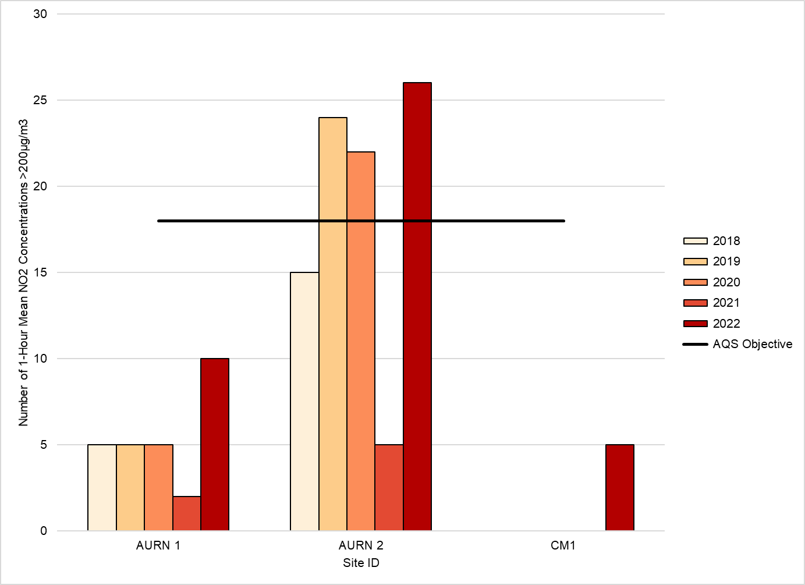

Table 2.6 – Annual Mean PM₁₀ Monitoring Results (µg/m³)
Site ID | Site Type | Valid Data Capture for Monitoring Period (%) ⁽¹⁾ | Valid Data Capture 2023 (%) ⁽²⁾ | 2019 | 2020 | 2021 | 2022 | 2023
AP1 | Roadside | 80 | 80 | 45.5 | 43.9 | 38.6 | 35.7 | 37.4
Notes:
Exceedances of the PM₁₀ annual mean objective of 40µg/m³ are shown in bold.
All means have been “annualised” as per LAQM.TG22 if valid data capture for the full calendar year is less than 75%. See Appendix C for details.
(1) Data capture for the monitoring period, in cases where monitoring was only carried out for part of the year.
(2) Data capture for the full calendar year (e.g. if monitoring was carried out for 6 months, the maximum data capture for the full calendar year is 50%).

Figure 2.5 – Trends in Annual Mean PM₁₀ Concentrations
<Delete if not required>
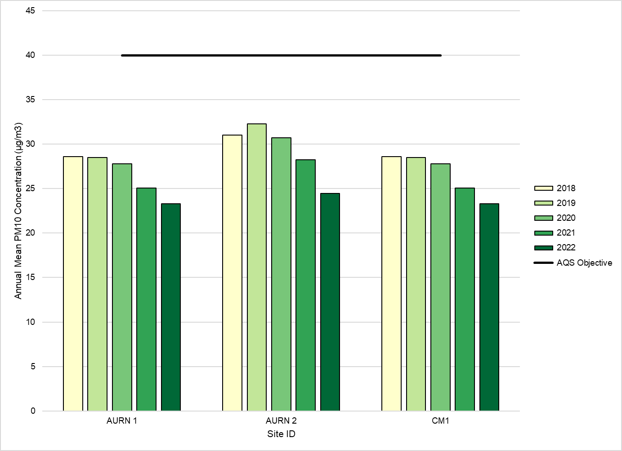

Table 2.7 – 24-Hour Mean PM₁₀ Monitoring Results, Number of PM₁₀ 24-Hour Means > 50µg/m³
Site ID | Site Type | Valid Data Capture for Monitoring Period (%) ⁽¹⁾ | Valid Data Capture 2023 (%) ⁽²⁾ | 2019 | 2020 | 2021 | 2022 | 2023
AP1 | Roadside | 80 | 80 | 20 | 36 | 25 | 15 | 10 (185)
Notes:
Exceedances of the PM₁₀ 24-hour mean objective (50µg/m³ not to be exceeded more than 35 times/year) are shown in bold.
If the period of valid data is less than 85%, the 90.4th percentile of 24-hour means is provided in brackets.
(1) Data capture for the monitoring period, in cases where monitoring was only carried out for part of the year.
(2) Data capture for the full calendar year (e.g. if monitoring was carried out for 6 months, the maximum data capture for the full calendar year is 50%).

Figure 2.6 – Trends in Number of 24-Hour Mean PM₁₀ Results > 50µg/m³
<Delete if not required>
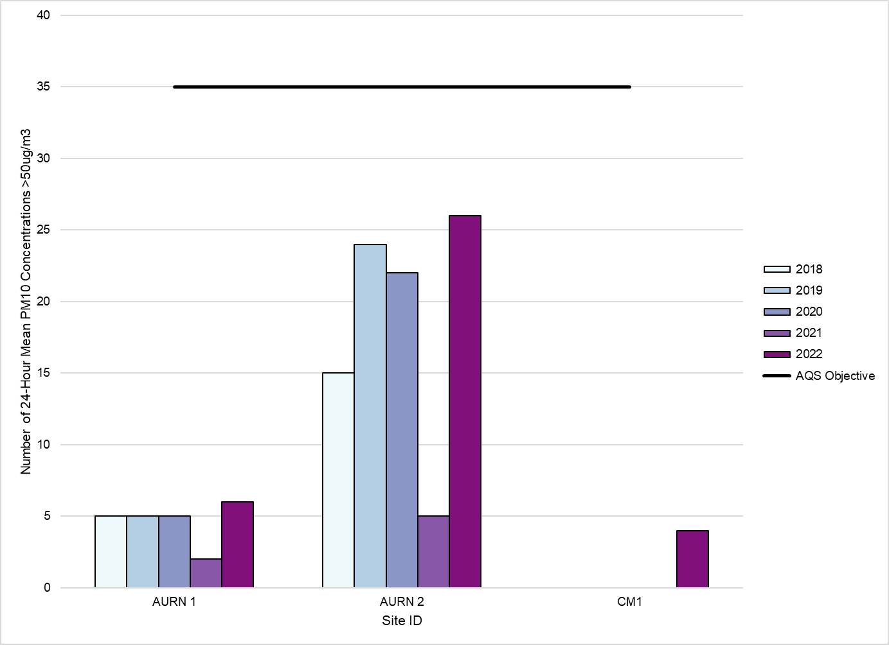

Table 2.8 – PM_{2.5} Monitoring Results (µg/m³)
Site ID | Site Type | Valid Data Capture for Monitoring Period (%) ⁽¹⁾ | Valid Data Capture 2023 (%) ⁽²⁾ | 2019 | 2020 | 2021 | 2022 | 2023
AP1 | Roadside | 85 | 85 | 10.5 | 15.3 | 12.2 | 16.8 | 18.4
Notes:
All means have been “annualised” as per LAQM.TG22 if valid data capture for the full calendar year is less than 75%. See Appendix C for details.
(1) Data capture for the monitoring period, in cases where monitoring was only carried out for part of the year.
(2) Data capture for the full calendar year (e.g. if monitoring was carried out for 6 months, the maximum data capture for the full calendar year is 50%).

Figure 2.7 – Trends in Annual Mean PM_{2.5} Concentrations
<Delete if not required>
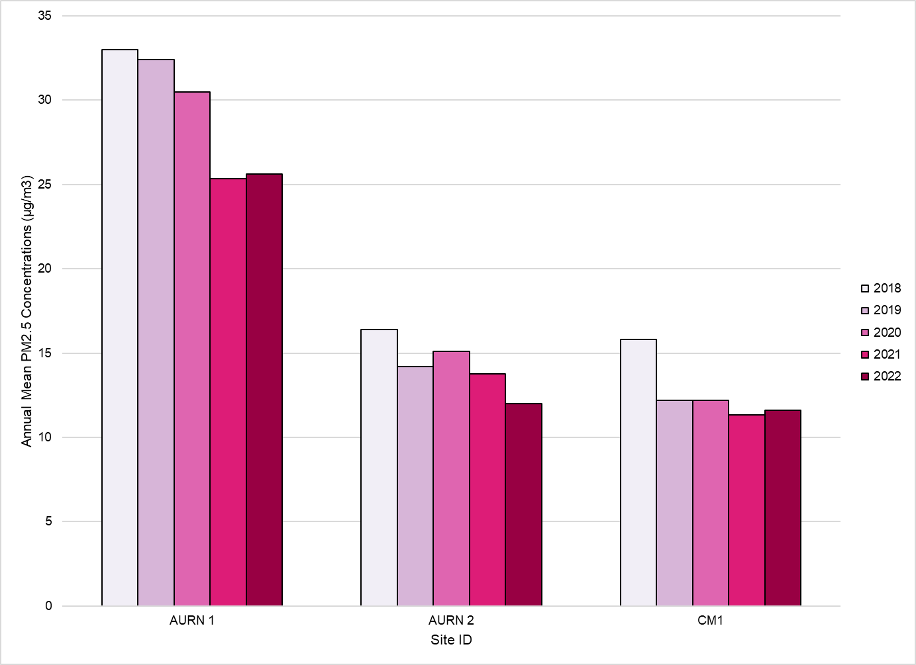

Comparison of 2023 Monitoring Results with Previous Years and the Air Quality Objectives
This section can be divided by pollutant. Tables of key statistics for each pollutant monitored should be provided above in Section 2.2.
Separate tables should be used for automatic and non-automatic (e.g. diffusion tube) results.
For each monitoring site the key statistics should include:
- Data capture as a % of the calendar year
- Data capture as a % of the monitoring period if monitoring was not carried out for the full year. (If monitoring was carried out for less than the full calendar year, the monitoring period should be clearly stated)
- Key statistics, e.g. annual mean
- All statistics relevant to Air Quality Strategy (AQS) objectives, e.g. number of 1-hour mean NO₂ concentrations >200µg/m³, annual mean PM₁₀, etc
- Where the period of valid data is less than 85% of a full year, include relevant percentile alternatives (e.g. the 99.8th percentile of hourly means rather than the number of hours >200µg/m³)
Identify any sites where monitoring was not carried out for a full calendar year. In these cases, please state:
- What part of the year was it carried out for?
- What was the data capture for the monitoring period?
- What was the data capture for the calendar year? (e.g. if full data capture was achieved, but monitoring was only carried out for six months, the data capture for the year would be 50%)
Where data capture is less than 75% of a full calendar year (i.e. less than 9 months for NO₂ diffusion tubes), the mean should be “annualised” – i.e. adjusted using the methodology demonstrated within Chapter 7 of LAQM.TG22 - before being compared to annual mean objectives. Please make it clear where this has been done, and provide further details in Appendix A if necessary.
Text should highlight which sites have exceeded the relevant AQS Objective, and which have not. Mention any cases that are borderline (For example, sites above 36µg/m³ for NO₂ and PM₁₀ annual mean).
If any exceedances are identified, are they within an existing AQMA or not? And do they represent relevant exposure?
The Local Authority should include any trend data from previous years, showing any increasing or decreasing trends (five years data is usually considered the minimum necessary to identify a significant trend). Data presented in this form is more accessible to members of the public. Any apparent trends in this data should be discussed.
Delete this box when the document is finished.
Start writing here…

Nitrogen Dioxide (NO₂)
Recommended formats for results tables, for both automatic and non-automatic sites are given below. These should answer the following questions:
- Is the measured annual mean concentration at any site greater than 40µg/m³? Exceedances of the 40µg/m³ annual mean NO₂ objective should be highlighted in bold.
- Have any sites recorded more than 18 1-hour means above 200µg/m³, or (if the period of valid data is less than 85% of a full year) does the 99.8th percentile of 1-hour mean concentrations exceed 200µg/m³? Cases where there are more than the permitted 18 exceedances of the 200μg/m³ 1-hour mean NO₂ objective, or where the 99.8th percentile exceeds 200µg/m³ should be highlighted in bold.
Automatic Monitoring:
- Where the period of valid data is less than 85% of a full year, please include the 99.8th percentile in brackets after the number of exceedances.
Diffusion Tube Data:
- For diffusion tubes, the annual means should be bias-adjusted, with the bias adjustment factors used for each year included e.g. as a footnote.
- Please indicate where a result is the mean of multiple tube exposure (e.g. triplicate tubes).
- Please include the full dataset (monthly mean values) as an appendix.
- Exceedances of 60µg/m³ should be highlighted, as these indicate a risk that the 1-hour objective may also be exceeded.
In both cases, where data capture is less than 75% of a full calendar year, the mean should be “annualised” – i.e. adjusted using the methodology demonstrated within Chapter 7 of LAQM.TG22 - before being compared to annual mean objectives. Please make it clear where this has been done, and provide further details in Appendix A if necessary.
In both cases, comment on whether there are exceedances of the air quality objectives for NO₂ and whether they occur within or outside AQMAs.
In both cases, discuss whether the monitoring site locations are representative of relevant public exposure. If a concentration is above or within 10% of the annual mean air quality objective for NO₂ but was measured at a monitoring site which is not representative of public exposure, please use the procedure specified in Chapter 7: Fall-off in NO₂ Concentrations with Distance from the Road of the Technical Guidance LAQM.TG22LAQM.TG16 to estimate the concentration at the nearest receptor, and discuss these results.
To help with consistency of approach to processing diffusion tube monitoring data a specific Diffusion Tube Data Processing Tool has been developed which should be used to process all diffusion tube data. The tool has been developed to calculate annual mean concentrations for the diffusion tube monthly data entered and amalgamates the following individual LAQM processing tools:
- Annualisation tool;
- Precision and accuracy tool – calculation of local bias; and
- NO₂ fall off with distance calculator.
Where possible, previous year’s statistics should be included for comparison, although this is not a requirement. If you have at least five years’ valid data, you may wish to include a graph in as Figure 2.3 to illustrate trends.
Delete this box when the document is finished.
Start writing here…

Particulate Matter (PM₁₀)
Comment on whether there are exceedances of the air quality objectives for PM₁₀ and whether they occur within or outside AQMAs.
Also flag if there are concentrations above the air quality objectives for PM₁₀ measured at monitoring sites which are not representative of public exposure
Monitoring data should be included in Table 2.6 and Table 2.7. These should answer the following questions:
- Is the annual mean concentration greater than 40µg/m³, or
- Are there more than 35 daily mean exceedances of 50µg/m³, or does the 90.4th percentile of daily mean concentrations exceed 50µg/m³?
You should state whether the information led to the declaration of an AQMA, including the main points/trends coming out of the data – e.g. where are the exceedances or areas of concern?
If you don’t monitor PM₁₀, please provide a statement to this effect.
Delete this box when the document is finished.
Start writing here…

Particulate Matter (PM_{2.5})
Monitoring data should be included in Table 2.8.
Flag if concentrations of PM_{2.5} are measured at monitoring sites which are not representative of public exposure.
Whilst there are no PM_{2.5} objectives included in regulations for the purpose of LAQM in Wales, consideration may be given as to whether monitored PM_{2.5} annual mean concentrations exceed either the 20µg/m³ EU Limit Value or the 10µg/m³ WHO Guideline.
If you don’t currently monitor PM_{2.5} but have plans to do so in the future, please set out the details here.
If you don’t currently monitor PM_{2.5} and have no plans to do so in the future, please provide a statement to this effect.
Delete this box when the document is finished.
Start writing here…

Other Pollutants Monitored (optional)
Add as many sub-sections as required. Delete if no other pollutants are monitored.
Available reporting data for SO₂, Lead, Benzene etc. may be included here but are no longer a mandatory reporting requirement.
If you carry out monitoring for pollutants not covered by the LAQM regulations (for example ozone, PAH,) you may report it here.
Local authorities may also include information on dust deposition, radiation monitoring, and odour complaints (especially where these are relevant to sources identified in this report).
Delete this box when the document is finished.
Start writing here…

Summary of Compliance with AQS Objectives as of 2023
The boxes below summarise the Local Authority area’s compliance (or otherwise) with the AQS Objectives.
Delete this box when the document is finished.
PLEASE SELECT THE STATEMENTS THAT ARE APPLICABLE FROM THE FOLLOWING OPTIONS and DELETE THE ONES THAT DO NOT APPLY:
<LA Name> has examined the results from monitoring in the <borough> <district>. Concentrations are all below the Objectives, therefore no further action is required.
<LA Name> has examined the results from monitoring in the <borough> <district>. Concentrations in some areas have been found to be close to the Objectives, therefore further investigation is required before deciding on whether action is necessary.
<LA Name> has examined the results from monitoring in the <borough> <district>.
Concentrations within the [Named] AQMA[s] still exceed the <objective> for <pollutant>. Therefore, these AQMA[s] should remain.
<LA Name> has measured concentrations of <pollutant> above the <annual> <1-hour> <24-hour> <15-minute> mean objective at relevant locations <outside of the AQMA(s)>, and will need to undertake further investigation, for <description of area(s) to be assessed>.
<LA Name> Intends to <Declare> / <Amend> an AQMA for <description of area(s)> due to the proven exceedance of <pollutant>.
<LA Name> Intends to Revoke the <Named> AQMA for <Lack of Exceedance of Pollutant>.

New Local Developments
This section should deal with any changes in the Local Authority area that may affect air quality. It is only necessary to consider locations which have not been assessed during the earlier rounds or where there has been a change or new development.
If an air quality assessment has been carried out (e.g. as part of an Environmental Statement) for a new development, please summarise the outcome, and provide a reference to the assessment.
Delete this box when the document is finished.
Start writing here…

Road Traffic Sources (and Other Transport)
Please identify any of the following which are new since the last Assessment:
- Narrow congested streets with residential properties close to the kerb.
- Busy streets where people may spend one hour or more close to traffic.
- Roads with a high flow of buses and/or HGVs.
- Junctions.
- New roads constructed or proposed since the last Assessment.
- Roads with significantly changed traffic flows.
- Bus or coach stations.
- Airports / diesel or steam trains / ports & Shipping
- Major roadworks / disruptions
IF THERE HAVE BEEN NONE PLEASE STATE.
Delete this box when the document is finished.
Start writing your supporting text on new/newly identified road traffic sources here…

Industrial / Fugitive or Uncontrolled Sources / Commercial Sources
Please identify any of the following which are new since the last Assessment:
- Industrial installations: new or proposed installations for which an air quality assessment has been carried out.
- Industrial installations: existing installations where emissions have increased substantially or new relevant exposure has been introduced.
- Industrial installations: new or significantly changed installations with no previous air quality assessment.
- Major fuel storage depots storing petrol.
- Petrol stations.
- Poultry farms.
If there are none of the above, state this explicitly in the report.
Please identify any of the following potential sources of fugitive or uncontrolled particulate matter, which are new since the last Assessment:
- Landfill sites.
- Quarries.
- Unmade haulage roads on industrial sites.
- Waste transfer stations, etc.
- Other potential sources of fugitive particulate matter emissions.
If there are none of the above, please state this explicitly in the report.
Please identify any of the following which are new since the last Assessment:
- Biomass combustion plant – individual installations.
- Areas where the combined impact of several biomass combustion sources may be relevant.
- Areas where domestic solid fuel burning may be relevant.
- Combined Heat and Power (CHP) plant.
IF THERE HAVE BEEN NONE PLEASE STATE.
Delete this box when the document is finished
Start writing here…

Other Sources

Bonfires / Incidents

Firework Displays

Domestic Wood Burners
Beyond road traffic sources - Bonfires, pollution incidents, firework displays, and domestic wood burners can all contribute to air pollution. As a tool to evidence future policy, it is useful to record trends in these emission sources. For example, has there been a significant pollution incident, has this been reflected in the air quality monitoring?
Has there been a large firework display that has resulted in high air pollution? Has there been a significant increase in the number of enquires / complaints about wood burners?
IF THERE HAVE BEEN NONE PLEASE STATE.
Delete this box when the document is finished.
Start writing here…
<LA Name> confirms that there are no new or newly identified local developments which may have an impact on air quality within the Local Authority area.
<LA Name> confirms that all the following have been considered:
- Road traffic sources
- Other transport sources
- Industrial sources
- Commercial and domestic sources
- New developments with fugitive or uncontrolled sources.
Delete statements if not applicable. Otherwise add local authority name, amend the text as appropriate and leave sentence in the report. This sentence is only provided for guidance and can be adapted if necessary.
<LA Name> has identified the following new or previously unidentified local developments which may impact on air quality in the Local Authority area.
< List them here>
These will be taken into consideration in the next Annual Progress Report.
(Keep if appropriate) <LA Name> has identified the following new or previously unidentified local development, for which available information clearly suggests that there is a risk of exceeding <objective> <pollutant>.
< description of development here>
Therefore <LA Name> will need further consider the implications to local air quality arising from the development.
Delete statements if not applicable. Otherwise add local authority name, amend the text as appropriate and leave sentence in the report. This sentence is only provided for guidance and can be adapted if necessary.

Policies and Strategies Affecting Airborne Pollution
The 2017 Statutory policy guidance requires local authorities to set out in an annual progress report what policies they have in place to reduce overall levels of NO₂, Particulate Matter and Environmental noise pollution for the population as a whole.
This should include, but is not limited to, the following (where appropriate):
- Local/regional air quality strategies
- Planning policies
- Transport Plans and strategies
- Active Travel Plans and Strategies
- Green Infrastructure Plans and Strategies
- Well-being Objectives
In the absence of any of these strategies please mark as non-applicable.
Please delete the whole section if not used and delete this box when the document is finished.

Local / Regional Air Quality Strategy
Please refer to Chapter 3 in LAQM.TG22 for further information.
The relevant Policy Guidance documents required that from 2023, all Local Authorities who have not had to designate an AQMA are required to draw up a Local Air Quality Strategy.
Progress Reports provide an opportunity to report on the development of the strategy, or, if the strategy is already in place, to report on progress towards implementation of the measures it may contain. The following questions may usefully be addressed:
- Progress towards development of the strategy
- If it is already completed, progress towards its implementation?
- Ease of access to the strategy (is it available through local libraries or on the authority’s website)?
- When will it next be reviewed?
Please delete the whole section if not used and delete this box when the document is finished.
Start writing here…

Air Quality Planning Policies
Please refer to Chapter 3 of LAQM.TG22 for further information.
This section can reference Local Plans and Supplementary Guidance documentation.
Please delete the whole section if not used and delete this box when the document is finished.
Start writing here…

Local Transport Plans and Strategies
Please refer to Chapter 3 of LAQM.TG22 for further information.
Please delete the whole section if not used and delete this box when the document is finished.
Start writing here…

Active Travel Plans and Strategies
Start writing here…

Local Authorities Well-being Objectives
Outline if and how airborne pollution figures in your well-being objectives.
The Well-being of Future Generations (Wales) Act 2015 (Assessments of Local Well-being) Regulations 2017 require Public Services Boards, when preparing an assessment of local well-being under section 37 of the Act to take into account the most recent review of air quality for their local authority area carried out under section 82 of the Environment Act 1995 (“the 1995 Act”) and the most recent strategic noise maps made under Chapter 2 of the Environmental Noise (Wales) Regulations 2006 (“the 2006 Regulations”) and adopted by the Welsh Ministers.
Delete this box when the document is finished.
Start writing here…

Green Infrastructure Plans and Strategies
Start writing here…

Climate Change Strategies
Inclusion of this section is optional. It is recommended that you summarise details of any Climate Change Strategies here if applicable.
Please delete the whole section if not used and delete this box when the document is finished.
Start writing here…

Conclusion and Proposed Actions

Conclusions from New Monitoring Data
For example, exceedances identified, within and outside of existing AQMAs. Cases where exceedances were previously suspected but monitoring has confirmed that the AQS Objective is met. Significant trends.
Has monitoring identified any potential or actual exceedances at relevant locations outside existing AQMAs?
Are all monitoring results within AQMAs below the air quality objective, such that it may be appropriate to revoke the AQMA? If so, is further investiagtion required?
Delete this box when the document is finished.
Start writing here…

Conclusions relating to New Local Developments
Summary of new local developments that will require more detailed consideration in the next Annual Progress Report.
In particular, do any of these give rise to the need for further investigation? If so, early engagement with local communties is essential.
Delete this box when the document is finished.
Start writing here…

Other Conclusions
Any conclusions drawn from consideration (if applicable) of:
- Implementation of Air Quality Action Plans
- Additional monitoring (of parameters not covered by regulations)
- Local air quality strategy
- Planning applications not yet approved
- Local Transport Plan
- Relevant updates of planning policies that relate to air quality.
Delete this box when the document is finished.
Start writing here…

Proposed Actions
- Has the new monitoring data identified the need to declare an AQMA or further assessment/investigation for any pollutant? If so, which pollutant(s) and objectives, and where? If not, state explicitly that this is the case.
- Has the new monitoring data identified any need for additional monitoring, or changes to the existing monitoring programme (e.g. re-location of sites)?
- Are changes required to any existing AQMAs – for example should their boundaries be changed or can they be revoked? If so, it will be necessary to undertake further investigation/monitoring and consultation with the local community.
- Details of proposed dates of completion of any other outstanding LAQM Tasks such AQMA declarations.
- What is your next course of action?
Delete this box when the document is finished.
Start writing here…

References
Please provide a list of all documents referred to in the report.
Delete this box when the document is finished.
Start writing here…

Appendices
Appendix A: Monthly Diffusion Tube Monitoring Results
Appendix B: A Summary of Local Air Quality Management
Appendix C: Air Quality Monitoring Data QA/QC
Appendix D: AQMA Boundary Maps
Appendix E: …
Appendices may include maps, tables, lists of processes etc. Include as many as necessary.
Delete this box when the document is finished.

Appendix A: Quality Assurance / Quality Control (QA/QC) Data
Table A.1 – Full Monthly Diffusion Tube Results for 2023 (µg/m³)
INSTRUCTIONS
Please fill in Table A.1 with details of NO₂ diffusion tube monitoring results.
It is recommended that the Diffusion Tube Data Processing Tool is used to process all diffusion tube data. The tab Annual Results Summary from the Diffusion Tube Data Processing Tool aligns with the diffusion tube data requirements of Table B.1 therefore the data can be easily copied. If the tool has not been utilised, please copy across from any working spreadsheet or populate manually.
This table should contain:
- Full month by month raw data (state if different exposure periods from the suggested calendar available via the LAQM website
- The raw data annual mean
- The bias adjusted annual mean – This should also be an annualised annual mean if data capture is below 75% but greater than 25%.
- The distance corrected annual mean – If the location is not relevant to public exposure and the concentration is greater than 36µg/m³. If the monitoring location is relevant to annual mean public exposure, please leave the final column blank or add a dash (-).
The following erroneous data should have been excluded when processing the monthly diffusion tube data for the monitoring year, therefore should not be included within Table A.1
- Results that have been identified as contaminated during analysis, e.g. insect(s) or dirt contained within the tube
- Extreme low or high concentrations as detailed within Chapter 7: NO_{X} and NO₂ Monitoring of the Technical Guidance LAQM.TG22
- Results from tubes that have been exposed past the laboratory’s use by date
Ensure the Diffusion Tube (DT) IDs and Coordinates match those provided in Table 2.2.
Please delete this box when the document is finished

DT ID | X OS Grid Ref (Easting) | Y OS Grid Ref (Northing) | Jan | Feb | Mar | Apr | May | Jun | Jul | Aug | Sep | Oct | Nov | Dec | Annual Mean: Raw Data | Annual Mean: Annualised and Bias Adjusted | Annual Mean: Distance Corrected to Nearest Exposure | Comment
<DT1> | <666555> | <333444> | <36.0> | <42.1> | <-> | <-> | <59.1> | <52.9> | <-> | <47.0> | <55.0> | <38.4> | <45.2> | <46.8> | <46.9> | <44.9> | <25.9>
<DT2> | <777444> | <333555> | <35.7> | <23.3> | <19.7> | <17.1> | <18.2> | <19.5> | <25.7> | <17.0> | <27.0> | <19.0> | <33.0> | <27.6> | <23.6> | <21.6> | <->

<CLICK HERE THEN PASTE COMPLETED DATA ROWS FROM LAQM DATA PROCESSING TOOL (IF UTILISED)>
☐ All erroneous data has been removed from the NO₂ diffusion tube dataset presented in Table A.1 (confirm by selecting in box).
☐ Annualisation has been conducted where data capture is <75% and >25% in line with LAQM.TG22 (confirm by selecting in box).
☐ Local bias adjustment factor used (confirm by selecting in box).
☐ National bias adjustment factor used (confirm by selecting in box).
☐ Where applicable, data has been distance corrected for relevant exposure in the final column (confirm by selecting in box).
☐ <Local Authority> confirm that all 2023 diffusion tube data has been uploaded to the Diffusion Tube Data Entry System (confirm by selecting in box).
Notes:
Exceedances of the NO₂ annual mean objective of 40µg/m³ are shown in bold.
NO₂ annual means exceeding 60µg/m³, indicating a potential exceedance of the NO₂ 1-hour mean objective are shown in bold and underlined.
See Appendix C for details on bias adjustment and annualisation.

Appendix B: A Summary of Local Air Quality Management

Purpose of an Annual Progress Report
This report fulfils the requirements of the Local Air Quality Management (LAQM) process as set out in the Environment Act 1995, as amended by the Environment Act 2021, and associated government guidance. The LAQM process places an obligation on all local authorities to regularly review and assess air quality in their areas and to determine whether or not the air quality objectives are being achieved. Where exceedances occur, or are likely to occur, the local authority must then declare an Air Quality Management Area (AQMA) and prepare an Air Quality Action Plan (AQAP) within 18 months of declaration setting out the measures it intends to put in place in pursuit of the objectives. Action plans must then be reviewed and updated no later than every five years; or if a local authority considers there is a need for further or different measures to be taken in order to achieve air quality standards; or if significant changes to sources occur within your local area.
For Local Authorities in Wales, an Annual Progress Report replaces all other formal reporting requirements and have a very clear purpose of updating the general public on air quality, including what ongoing actions are being taken locally to improve it if necessary.

Air Quality Objectives
The air quality objectives applicable to LAQM in Wales are set out in the Air Quality (Wales) Regulations 2000, No. 1940 (Wales 138), Air Quality (Amendment) (Wales) Regulations 2002, No 3182 (Wales 298), and are shown in Table B.1.
The table shows the objectives in units of microgrammes per cubic metre µg/m³ (milligrammes per cubic metre, mg/m³ for carbon monoxide) with the number of exceedances in each year that are permitted (where applicable).

Table B.1 – Air Quality Objectives Included in Regulations for the Purpose of LAQM in Wales
Pollutant | Air Quality Objective: Concentration | Air Quality Objective: Measured as | Date to be achieved by
Nitrogen Dioxide (NO₂) | 200µg/m³ not to be exceeded more than 18 times a year | 1-hour mean | 31.12.2005
Nitrogen Dioxide (NO₂) | 40µg/m³ | Annual mean | 31.12.2005
Particulate Matter (PM₁₀) | 50µg/m³, not to be exceeded more than 35 times a year | 24-hour mean | 31.12.2010
Particulate Matter (PM₁₀) | 40µg/m³ | Annual mean | 31.12.2010
Sulphur dioxide (SO₂) | 350µg/m³, not to be exceeded more than 24 times a year | 1-hour mean | 31.12.2004
Sulphur dioxide (SO₂) | 125µg/m³, not to be exceeded more than 3 times a year | 24-hour mean | 31.12.2004
Sulphur dioxide (SO₂) | 266µg/m³, not to be exceeded more than 35 times a year | 15-minute mean | 31.12.2005
Benzene | 16.25µg/m³ | Running annual mean | 31.12.2003
Benzene | 5µg/m³ | Annual mean | 31 12 2010
1,3 Butadiene | 2.25µg/m³ | Running annual mean | 31.12.2003
Carbon Monoxide | 10.0mg/m³ | Maximum Daily Running 8-Hour mean | 31.12.2003
Lead | 0.25µg/m³ | Annual Mean | 31.12.2008

Appendix C: Air Quality Monitoring Data QA/QC
INSTRUCTIONS
Please include information relating to the QA/QC on monitoring data, including bias adjustments, annualisation and fall-off with distance correction, as appropriate:
- Discussion and justification on the choice of bias adjustment factor applied for diffusion tubes (i.e. local vs national), with reference to previous years’ choices of bias factors, giving due consideration to the discussion in Chapter 7 of Technical Guidance LAQM.TG22.
- Discussion on the annualisation process, which is provided in Chapter 7 of Technical Guidance LAQM.TG22.
- Details of distance correction using the diffusion tube data processing/ NO₂ fall off with distance calculator as discussed in Chapter 7 of Technical Guidance LAQM.TG22. Distance correction is an important point to consider if your monitoring sites are not representative of public exposure, e.g. if located at roadside or kerbside, but with façades of nearest properties set back further from the road.
- Please include calculations within the tables provided as found within the relevant LAQM tools; particularly regarding bias adjustments, annualisation and fall-off with distance correction, where appropriate.
Failure to provide clear and auditable details is likely to result in the rejection of the report.
Delete this box when the document is finished

QA/QC of Diffusion Tube Monitoring
Within this section provide details relating to the following aspects of non-automatic (i.e. passive) monitoring using diffusion tubes:
- The supplier used for diffusion tubes within 2023 and the method of preparation, e.g. 20% TEA in water;
- Information on the diffusion tube supplier; any accreditation held, analysis procedure followed, participation in analysis schemes (e.g. AIR-PT) and most recent results, inclusion in the annual field inter-comparison exercise and associated result;
- If the diffusion tube supplier has been changed part way through the year (if so provide the previous two points for both suppliers);
- State whether or not the monitoring has been completed in adherence with the 2023 Diffusion Tube Monitoring Calendar, providing commentary of any divergences as necessary.
The additional subsections should be used to provide QA/QC details of the data processing methodologies applied to diffusion tube monitoring data, specifically in relation to annualisation, bias adjustment and fall-off-with-distance calculations.
If you do not undertake diffusion tube monitoring, please delete this section.

Diffusion Tube Annualisation
If annualisation was required for any non-automatic monitoring sites, the sites requiring annualisation should be clearly defined along with details of the calculation method undertaken provided in Table C.2. Annualisation is required for any site with data capture less than 75% but greater than 25%.
Or:
All diffusion tube monitoring locations within <Local Authority Name> recorded data capture of 75% therefore it was not required to annualise any monitoring data. In addition, any sites with a data capture below 25% do not require annualisation.

Diffusion Tube Bias Adjustment Factors
<Local Authority Name> have applied a <national/local> bias adjustment factor of <insert factor> to the <Year> monitoring data. A summary of bias adjustment factors used by <Local Authority Name> over the past five years is presented in Table C.1.
Provide discussion in relation to the bias adjustment factor chosen, a national factor or a local factor.
- If a national factor has been used, please state as per Table C.1 which version of the national spreadsheet the factor has been taken from and also the number of studies applicable to the factor.
- If a local factor has been used, please advise at which site(s) the co-location study has been completed at and present the details in Table C.2.
- If more than one co-location study has been utilised to derive a local factor, please provide the calculations that have been completed within the body of text. These should be completed in line with guidance provided within LAQM.TG22 Chapter 7: NO_{X} and NO₂ Monitoring, NO₂ by Diffusion Tubes.
Table C.1 – Bias Adjustment Factor
INSTRUCTIONS
Please complete the following table detailing the bias adjustment factors used to adjust the diffusion tube monitoring data. If a national factor has been used, please detail the version of the National Bias Adjustment Factor Spreadsheet that has been used (detailed in the top-right corner of each revision of the spreadsheet). If a local factor has been derived, please leave this column blank or insert a dash (-).
Delete this box when the document is finished

Year | Local or National | If National, Version of National Spreadsheet | Adjustment Factor
2023 | Local | - | 0.88
2022 | National | 03/23 | 1.01
2021 | National | 09/22 | 1.05
2020 | National | 06/21 | 1.07
2019 | National | 09/20 | 1.08

NO₂ Fall-off with Distance from the Road
If fall-off-with-distance calculations were required for any non-automatic monitoring sites, a summary of the sites should be provided here and the output data from the LAQM NO₂ fall-off with distance calculator, or output from the Diffusion Tube Data Processing Tool should be presented in Table C.4. Distance correction should be considered at any monitoring site where the annual mean concentration is greater than 36µg/m³ and the monitoring site is not located at a point of relevant exposure (taking the limitations of the calculator into account).
Or:
No diffusion tube NO₂ monitoring locations within <Local Authority Name> required distance correction during <Year>.

QA/QC of Automatic Monitoring
Within this section details relating to the following should be included:
- Who completes the data management and Local Site Operator (LSO) duties for any automatic monitoring sites within the authority;
- Details on the frequency of calibrations, audit/servicing;
- Ratification process, and if the monitoring data presented within the APR is provisional or ratified;
- If live/historic data is available through a website.

PM₁₀ and PM_{2.5} Monitoring Adjustment
If PM₁₀/PM_{2.5} monitoring is completed within your authority, where applicable please detail any correction factors applied to the data before it is published (e.g. using the Volatile Correction Model (VCM) or a specific correction factor). Correction factors as detailed within LAQM.TG22 Chapter 7: Particulate Matter Monitoring.
Or:
The type of <PM₁₀/PM_{2.5}> monitor(s) utilised within <Local Authority Name> do not required the application of a correction factor.
Please delete this section if no PM₁₀/PM_{2.5} monitoring is completed within your authority.

Automatic Monitoring Annualisation
If annualisation was required for any automatic monitoring sites a summary of the sites should be provided here and the annualisation data should be presented in Table C.2. Annualisation is required for any site with data capture less than 75% but greater than 25%.
Or:
All automatic monitoring locations within <Local Authority Name> recorded data capture of greater than 75% therefore it was not required to annualise any monitoring data. In addition, any sites with a data capture below 25% do not require annualisation.
Please delete this section if no automatic monitoring is completed within your authority.

NO₂ Fall-off with Distance from the Road
If fall-off-with-distance calculations were required for automatic monitoring sites, a summary of the sites should be provided here and the output data from the LAQM NO₂ fall-off with distance calculator should be presented in Table C.4. Distance correction should be considered at any monitoring site where the annual mean concentration is greater than 36µg/m³ and the monitoring site is not located at a point of relevant exposure (taking the limitations of the calculator into account).
Or:
No automatic NO₂ monitoring locations within <Local Authority Name> required distance correction during <Year>.
INSTRUCTIONS
The structure of the following QA/QC tables are consistent with those output by the Diffusion Tube Data Processing Tool. It is therefore recommended that this tool is used to aid transparency of calculations and associated QA/QC pertaining to the processing of diffusion tube data.
However, it is acknowledged that not all local authorities will initially use the processing tool due to having many years of experience in processing the data within their authority using existing LAQM tools and methods. This also includes automatic monitoring data, for which the Diffusion Tube Data Processing Tool does not currently support. Therefore, in these instances please align these tables to present equivalent details, text and/or tabulated data, to support any calculations completed.
If you have any queries relating to the data that you should present, please contact the LAQM Helpdesk.
Delete this box when the document is finished

Table C.2 – Annualisation Summary (concentrations presented in µg/m³)
INSTRUCTIONS
Both automatic and non-automatic annualisation results should be included within Table C.2.
For diffusion tube annualisation the Annualisation Tool or the Diffusion Tube Data Processing Tool can be used to complete annualisation. Either tool should be used to ensure the correct methodology for annualisation is utilised. Table C.2 has the same structure as the Annualisation Summary tab within both tools, therefore the required data can easily be copied.
If a LAQM tool has not been used for diffusion tube annualisation, please enter the relevant data into the table below or replace this table with one presenting the relevant details for annualisation.
Currently there is no LAQM tool to process annualisation for automatic monitoring, therefore guidance as per Chapter 7: NO_{X} and NO₂ Monitoring of the Technical Guidance LAQM.TG22 should be followed and the results presented within Table C.2.
If less than four background sites have been used to annualise, the relevant boxes can be left blank or a dash added (-). Any relevant comments should be added within the Comments column.
This table should be deleted if annualisation has not been required at any site.
Delete this box when the document is finished

Site ID | Annualisation Factor Site 1 Name | Annualisation Factor Site 2 Name | Annualisation Factor Site 3 Name | Annualisation Factor Site 4 Name | Average Annualisation Factor | Raw Data Annual Mean | Annualised Annual Mean | Comments
DT1
DT2

Table C.3 – Local Bias Adjustment Calculations
INSTRUCTIONS
Please complete Table C.3 if a local bias adjustment factor has been calculated.
For the calculation of a local bias adjustment factor the Diffusion Tube Precision Accuracy Bias Spreadsheet or the Diffusion Tube Data Processing Tool can be used to complete the calculations. Either tool should be used to ensure the correct methodology for bias calculation is utilised. Table C.3 has the same structure as the Local Bias Adjustment Outputs tab within the LAQM Diffusion Tube Data Processing Tool, therefore the required data can be easily copied. If the Diffusion Tube Precision Accuracy Bias Spreadsheet has been utilised, please enter the relevant data into Table C.3. Alternatively, replace this table with one presenting the equivalent data of the local bias calculation and consider adding a screenshot of the completed Prevision & Accuracy tab for clarity.
If a local factor from more than one local co-location study has been calculated without utilising the Diffusion Tube Data Processing Tool, guidance to average the bias B values as per Chapter 7: NO_{X} and NO₂ Monitoring of the Technical Guidance LAQM.TG22 should be followed.
The table has been set up to take account of a maximum of five local co-location studies. If less than five sites have been utilised the relevant boxes can be left blank or a dash added (-). If more than five sites have been utilised, please add any additional columns to the table.
This table should be deleted if a local bias adjustment factor has not been calculated.
Delete this box when the document is finished

 | Local Bias Adjustment Input 1 | Local Bias Adjustment Input 2 | Local Bias Adjustment Input 3 | Local Bias Adjustment Input 4 | Local Bias Adjustment Input 5
Periods used to calculate bias | 12
Bias Factor A | 1.13 (1.06 – 1.21)
Bias Factor B | -12% (-17% - -6%)
Diffusion Tube Mean (µg/m³) | 30.9
Mean CV (Precision) | 0.0%
Automatic Mean (µg/m³) | 35.0
Data Capture | 100%
Adjusted Tube Mean (µg/m³) | 35 (33 – 37)
Notes:
A single local bias adjustment factor has been used to bias adjust the 2023 diffusion tube results.
Or:
A combined local bias adjustment factor of <enter combined factor> has been used to bias adjust the 2023 diffusion tube results.

Table C.4 – NO₂ Fall off With Distance Calculations (concentrations presented in µg/m³)
INSTRUCTIONS
Both automatic and non-automatic distance corrected results can be included within Table C.4.
For distance correction of NO₂ monitoring, the NO₂ Fall-Off with Distance Calculator or the Diffusion Tube Data Processing Tool can be used to complete the calculations. Either tool should be used to ensure the correct methodology for NO₂ concentration fall off is utilised. Table C.4 has the same structure as the output tabs as follows, therefore the required data can easily be copied:
- NO₂ Fall-Off with Distance Calculator – Calculator - Multiple Tubes
- Diffusion Tube Data Processing Tool – Step 4 - Fall off with Distance
The Limitations / Important Notes tab within the calculator should be referred to, in order to ensure only relevant sites are included within the calculator. Please ensure the correct distances are utilised within the calculator:
Any comments output from the calculator should be added within the Comments column.
This table should be deleted if distance correction has not been completed at any site.
Delete this box when the document is finished

Site ID | Distance (m): Monitoring Site to Kerb | Distance (m): Receptor to Kerb | Monitored Concentration (Annualised and Bias Adjusted | Background Concentration | Concentration Predicted at Receptor | Comments
DT1
DT2

Appendix D: AQMA Boundary Maps
Figure D.1 –
<Please include AQMA boundary maps within this appendix – for consistency it is recommend these are taken from the Air Quality in Wales website.>

Glossary of Terms
Please add a description of any abbreviation included in the APR – An example is provided below.
Abbreviation | Description
AQAP | Air Quality Action Plan - A detailed description of measures, outcomes, achievement dates and implementation methods, showing how the LA intends to achieve air quality limit values’
AQMA | Air Quality Management Area – An area where air pollutant concentrations exceed / are likely to exceed the relevant air quality objectives. AQMAs are declared for specific pollutants and objectives
APR | Air quality Annual Progress Report
AURN | Automatic Urban and Rural Network (UK air quality monitoring network)
Defra | Department for Environment, Food and Rural Affairs
DMRB | Design Manual for Roads and Bridges – Air quality screening tool produced by Highways England
FDMS | Filter Dynamics Measurement System
LAQM | Local Air Quality Management
NO₂ | Nitrogen Dioxide
NO_{X} | Nitrogen Oxides
PM₁₀ | Airborne particulate matter with an aerodynamic diameter of 10µm (micrometres or microns) or less
PM_{2.5} | Airborne particulate matter with an aerodynamic diameter of 2.5µm or less
QA/QC | Quality Assurance and Quality Control
SO₂ | Sulphur Dioxide

