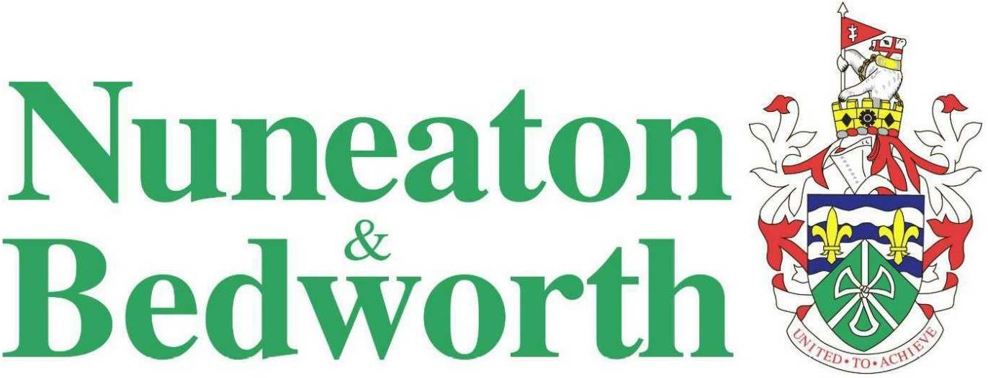

Nuneaton and Bedworth Borough Council
Air Quality Action Plan

In fulfilment of Part IV of the
Environment Act 1995
Local Air Quality Management

April 2022

Local Authority Officer | Environmental Protection Team
Department | Planning and Regulation
Address | Nuneaton and Bedworth Borough Council  Town Hall, Coton Road  Nuneaton  CV11 5AA
Telephone | 024 7637 6376
E-mail | env.health@nuneatonandbedworth.gov.uk
Report Reference number | J4425/1/D1
Date | April 2022
Report prepared by | Dr Clare Beattie  

Executive Summary
This Air Quality Action Plan (AQAP) has been produced as part of our statutory duties required by the Local Air Quality Management framework. It outlines the action we will take to improve air quality in Nuneaton and Bedworth over the next few years until the nitrogen dioxide air quality objective is achieved.
This action plan replaces the previous action plan which ran from 2011. Projects delivered through the past action plan include:
- more effective use of the planning system to ensure air quality is fully considered, including the successful adoption of a Supplementary Planning Document on air quality;
- working closely with Warwickshire County Council on traffic measures within Nuneaton;
- ensuring that the Transforming Nuneaton project delivers improvements that will assist with congestion and therefore improve emissions;
- delivering Electric Vehicle infrastructure;
- delivering energy efficiency measures; and
- continuing with the statutory LAQM process of monitoring, reporting and implementing the Action Plan.
This collaborative working continues into this Action Plan update.
Over the time period since the publication of the first AQAP, air quality has improved in Nuneaton and Bedworth. However pollutant concentrations remain above the objective within the Midland Road/ Corporation Street AQMA, although exceedances are restricted to the section of Midland Road between Manor Court Road and Stanley Road. Using the factors for adjusting roadside nitrogen dioxide concentrations to future years supplied by Defra, and 2019 concentrations, the objective should be achieved on Midland Road in 2021. Although it is acknowledged that these adjustments should be used with some caution, particularly in light of trends in Nuneaton and Bedworth not reducing as has been seen elsewhere in the UK, it is judged likely that the objective will be achieved in the next few years as less polluting vehicles increase within the fleet. Therefore, the Action Plan, in order to be proportionate, focusses on actions which can be implemented within the next few years, with costs that are proportionate to the level of exceedance.
Air pollution is associated with a number of adverse health impacts. It is recognised as a contributing factor in the onset of heart disease and cancer. Additionally, air pollution particularly affects the most vulnerable in society: children and older people, and those with heart and lung conditions. There is also often a strong correlation with equalities issues because areas with poor air quality are also often the less affluent areas,.
The annual health cost to society of the impacts of particulate matter alone in the UK is estimated to be around £16 billion. Nuneaton and Bedworth Borough Council (NBBC) is committed to reducing the exposure of people in the borough to poor air quality in order to improve health.
Actions have been developed that both address the nitrogen dioxide air quality objective exceedance along Midland Road in Nuneaton, but also to address more strategic issues to try and reduce emissions of both nitrogen dioxide and PM_{2.5} across the borough in order to improve health in a more equitable way. The measures can be considered under five broad topics:
- Support and Collaborate with Warwickshire County Council on Traffic Management Measures Directly Impacting Midland Road;
- Promotion of Behaviour Change away from Single Occupancy Private Vehicle Use;
- Promotion of the Use of Alternatively Fuelled Vehicles;
- Developing Policies to Support Better Air Quality; and
- Controlling Domestic Emissions.
Our priorities are to ensure that the air quality objectives are met along Midland Road in Nuneaton, largely through traffic management measures as well as encouragement of alternatively fuelled vehicles (in particular electric cars and buses). Secondly, the plan aims to reduce emissions more generally across the borough through collaborative working with other policy areas such as County transport, public health, planning and work underway to tackle the Climate Emergency declared in Nuneaton and Bedworth. We will ensure that air quality is considered within transport schemes, the Borough Plan and within other policy areas which are looking to reduce vehicle use, either by encouraging active travel, by reducing travel demand, encouraging freight onto different modes, or increasing the use of non-diesel and petrol vehicles. By taking this more strategic approach, air quality and the associated health outcomes should improve more generally across the district.
In this AQAP we outline how we plan to effectively tackle air quality issues within our control. However, we recognise that there are a large number of air quality policy areas that are outside of our influence (such as vehicle emissions standards agreed in Europe), but for which we may have useful evidence, and so we will continue to work with regional and central government on policies and issues beyond NBBC’s direct influence.

Responsibilities and Commitment
This AQAP was prepared by the Environmental Health Department of NBBC, with the assistance of Air Quality Consultants Ltd, with the support and agreement of the following officers and departments:
- Team Leader Transport Planning, Transport and Highways, Warwickshire County Council;
- Senior Transport Planner, Transport Planning, Warwickshire County Council;
- Head of Planning, Nuneaton and Bedworth Borough Council;
- Consultant in Public Health, Warwickshire County Council; and
- Fleet Manager, Nuneaton and Bedworth Borough Council
This AQAP will be subject to an annual review and appraisal of progress. Progress each year will be reported in the Annual Status Reports (ASRs) produced by Nuneaton and Bedworth Borough Council, as part of our statutory Local Air Quality Management duties.
If you have any comments on this AQAP please send them to the Environmental Protection Team at:
Planning and Regulation
Nuneaton and Bedworth Borough Council
Town Hall, Coton Road
Nuneaton
CV11 5AA
Telephone: 024 7637 6376
Email: env.health@nuneatonandbedworth.gov.uk
Table of Contents
Executive Summary i
Responsibilities and Commitment iii
1 Introduction 1
2 Summary of Current Air Quality in Nuneaton and Bedworth 2
2.1 Leicester Road Gyratory AQMA 3
2.2 Midland Road/ Corporation Street AQMA 5
3 Nuneaton and Bedworth’s Air Quality Priorities 8
3.1 Public Health Context 8
3.2 Planning and Policy Context 9
3.2.1 Local Transport Plan 9
3.2.2 Transforming Nuneaton 11
3.2.3 Town Investment Plan 12
3.2.4 Local Planning Policies 12
3.2.5 Air Quality Action Plan 14
3.2.6 Climate Change 15
3.3 Source Apportionment 16
3.4 Required Reduction in Emissions 18
3.4.1 When will the objective be achieved? 18
3.5 Key Priorities 18
4 Development and Implementation of Nuneaton and Bedworth’s AQAP 20
4.1 Consultation and Stakeholder Engagement 20
4.2 Steering Group 20
5 AQAP Measures 22
Appendix A: Response to Consultation 34
Appendix B: Reasons for Not Pursuing Action Plan Measures 35
Glossary of Terms 36

List of Tables
Table 1: Summary of Nitrogen Dioxide (NO₂) Monitoring (2014-2019) in Leicester Road Gyratory AQMA (µg/m³) 5
Table 2: Summary of Nitrogen Dioxide (NO₂) Monitoring (2013-2019) in the Midland Road/Corporation Street AQMA (µg/m³)ª 7
Table 3: Percentage Decrease in Road NOx required to Meet Annual Mean NO₂ Objective at Local Monitoring Sites (µg/m³) in 2019 18
Table 4: Consultation Undertaken 20
Table 5: Current Measures in Nuneaton and Bedworth 22
Table 6: Air Quality Action Plan Measures 32

List of Figures
Figure 1: Nuneaton and Bedworth Monitoring Locations 2
Figure 2: Nuneaton and Bedworth Air Quality Managements Areas (AQMAs) 3
Figure 3: Monitoring sites within the Leicester Road Gyratory AQMA 4
Figure 4: Annual Mean Nitrogen Dioxide Concentrations in Leicester Road Gyratory AQMA (µg/m³) 4
Figure 5: Midland Road/Corporation Street AQMA and Nearby Monitoring Sites 6
Figure 6: Annual Mean Nitrogen Dioxide Concentrations in the Midland Road/Corporation Street AQMA (µg/m³) 6
Figure 7: Percentage Contributions of Different Sources to Total Predicted NOx Road Emissions in 2019 on Midland Road 17

Introduction
This report outlines the actions that Nuneaton and Bedworth Borough Council will deliver between 2022 and 2027 in order to reduce concentrations of air pollutants and exposure to air pollution; thereby positively impacting on the health and quality of life of residents and visitors to Nuneaton and Bedworth.
It has been developed in recognition of the legal requirement on the local authority to work towards Air Quality Strategy (AQS) objectives under Part IV of the Environment Act 1995 and relevant regulations made under that part and to meet the requirements of the Local Air Quality Management (LAQM) statutory process.
This Plan will be reviewed every five years at the latest and progress on measures set out within this Plan will be reported on annually within NBBC’s air quality ASR.

Summary of Current Air Quality in Nuneaton and Bedworth
NBBC carries out monitoring of nitrogen dioxide concentrations using a network of diffusion tubes, and previously at one automatic analyser. All of the monitoring sites are shown in Figure 1. The Council has declared two Air Quality Management Areas (AQMAs), both within Nuneaton, for exceedances of the annual mean nitrogen dioxide objective (see Figure 2).
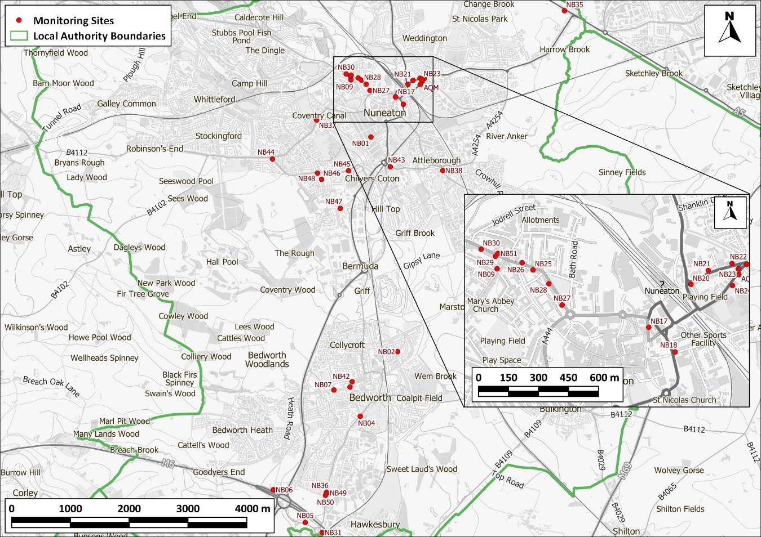
Figure 1: Nuneaton and Bedworth Monitoring Locations
Contains Ordnance Survey data © Crown copyright and database right 2021. Ordnance Survey licence number 100046099. Additional data sourced from third parties, including public sector information licensed under the Open Government Licence v1.0.
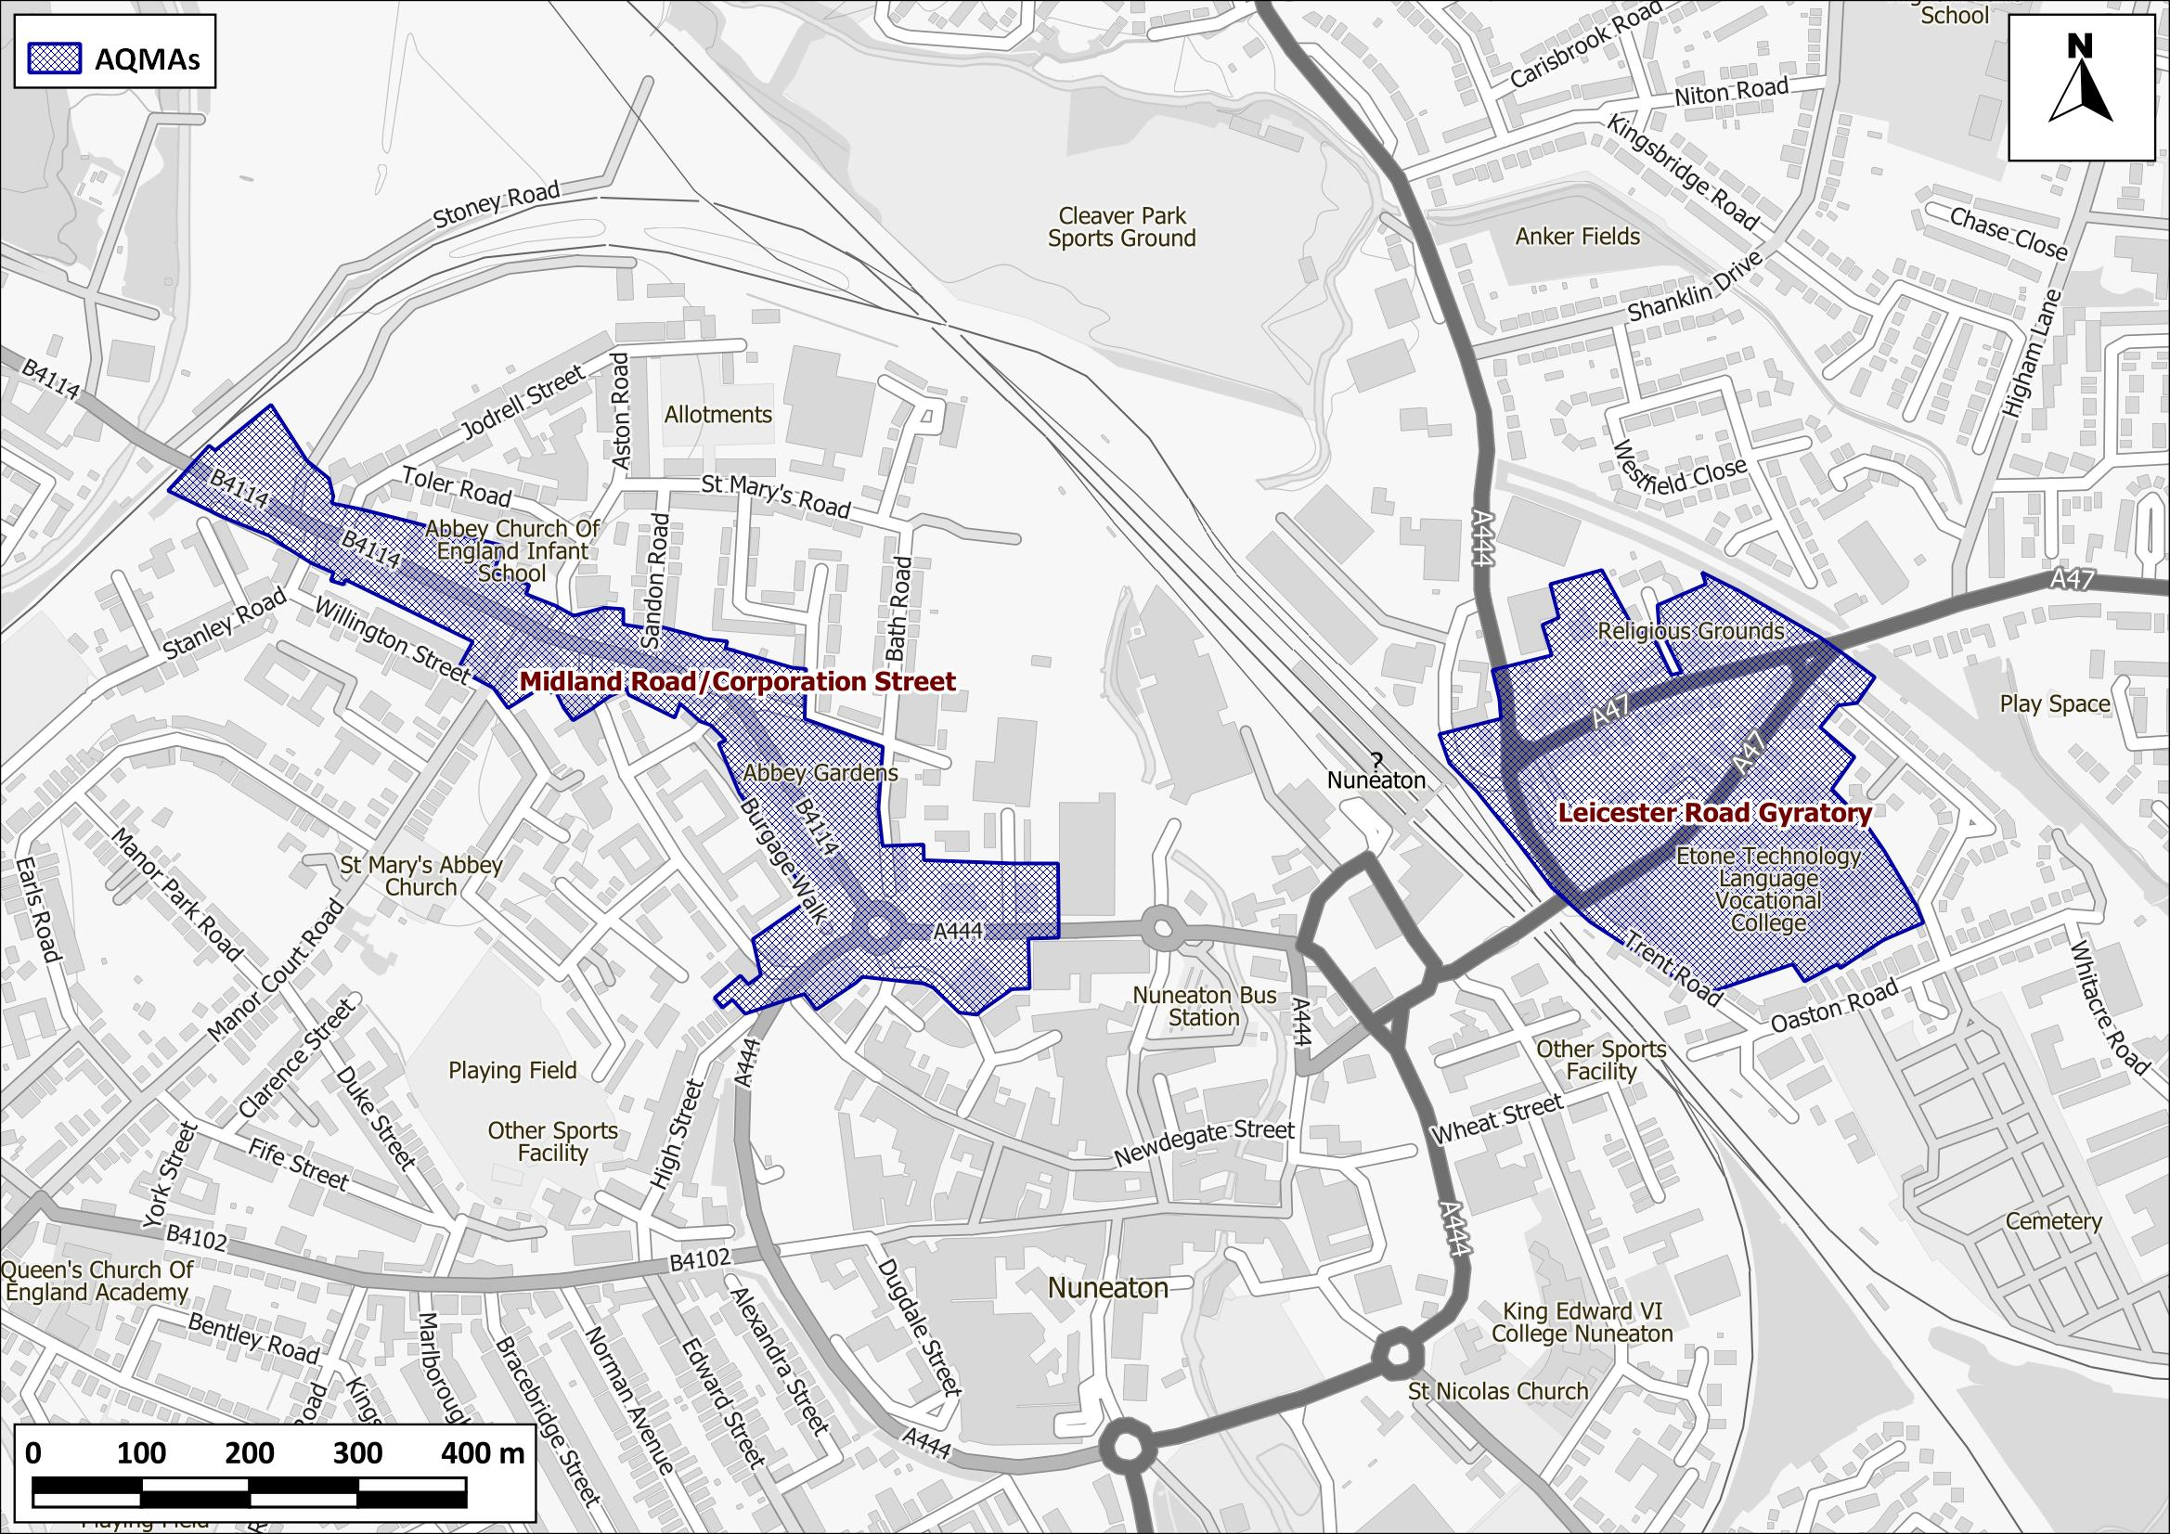
Figure 2: Nuneaton and Bedworth Air Quality Managements Areas (AQMAs)
Contains Ordnance Survey data © Crown copyright and database right 2021. Ordnance Survey licence number 100046099. Additional data sourced from third parties, including public sector information licensed under the Open Government Licence v1.0.
The following section presents monitoring data for each of the AQMAs and provides recommendations for NBBC in relation to the AQMAs, for progressing with the LAQM process.

Leicester Road Gyratory AQMA
Monitoring is carried out using diffusion tubes at seven locations within the Leicester Road AQMA (AQM, NB15, NB20, NB21, NB22, NB23 and NB24), as seen in Figure 3. As shown in Figure 4 and Table 1, concentrations at all monitoring sites within the Leicester Road Gyratory AQMA have been consistently below the objective since 2014, with concentrations below 35 µg/m³ at all sites between 2014 and 2019. Whilst the data would justify revocation of the AQMA, concern regarding extensive future development to the north of Nuneaton means that the AQMA will retained for the time being for the purposes of continued monitoring and observation.
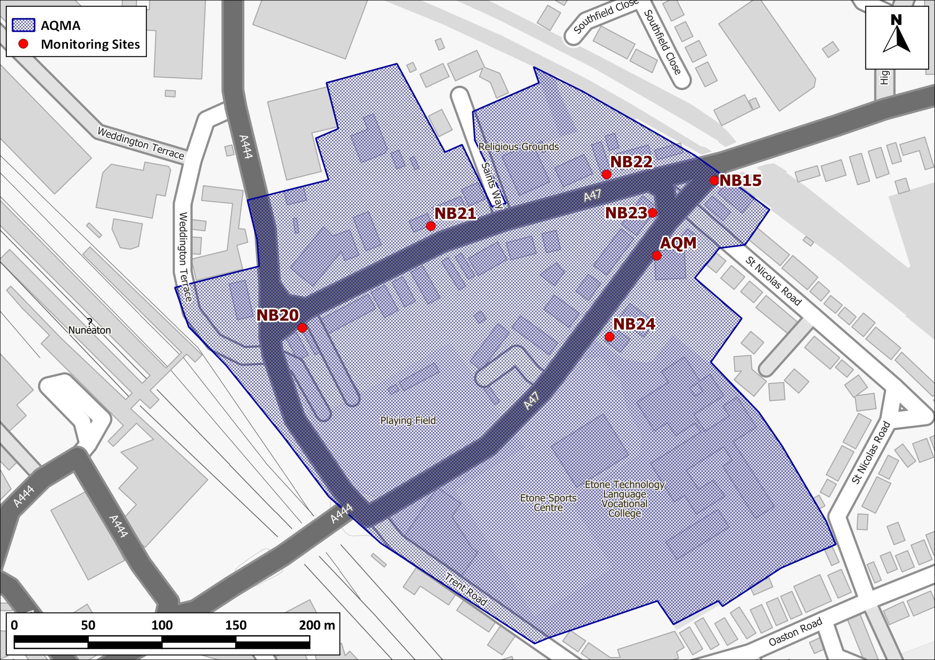
Figure 3: Monitoring sites within the Leicester Road Gyratory AQMA
Contains Ordnance Survey data © Crown copyright and database right 2021. Ordnance Survey licence number 100046099. Additional data sourced from third parties, including public sector information licensed under the Open Government Licence v1.0.
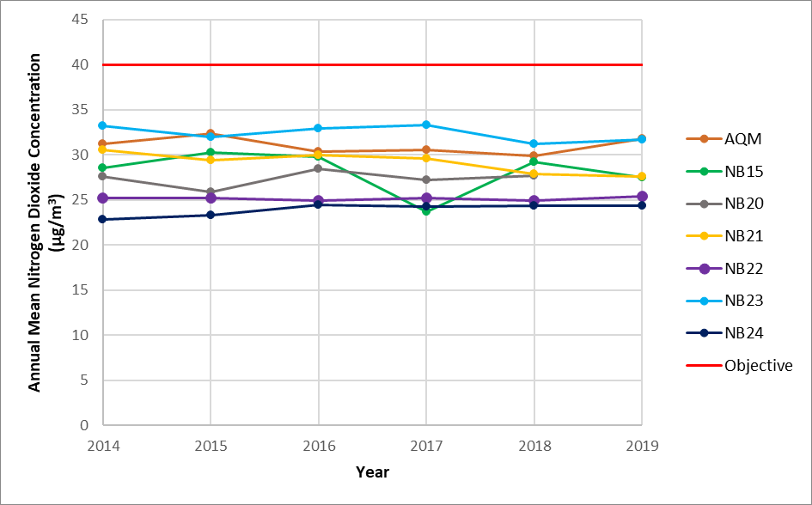
Figure 4: Annual Mean Nitrogen Dioxide Concentrations in Leicester Road Gyratory AQMA (µg/m³)

Table 1: Summary of Nitrogen Dioxide (NO₂) Monitoring (2014-2019) in Leicester Road Gyratory AQMA (µg/m³)
Site No | Location | 2014 | 2015 | 2016 | 2017 | 2018 | 2019
AQM ª | AQM Leicester Road | 31.2 | 32.4 | 30.4 | 30.6 | 29.9 | 31.8
NB15 | Bridge Grove, Leicester Road | 28.6 | 30.3 | 29.8 | 23.7 | 29.2 | 27.5
NB20 | 17 Old Hinckley Road | 27.6 | 25.9 | 28.5 | 27.2 | 27.7 | -
NB21 | 36 Old Hinckley Road | 30.6 | 29.4 | 30.0 | 29.6 | 27.9 | 27.6
NB22 | 58 Old Hinckley Road | 25.2 | 25.2 | 24.9 | 25.2 | 24.9 | 25.4
NB23 | 46 Leicester Road | 33.2 | 32.0 | 32.9 | 33.3 | 31.2 | 31.7
NB24 | 31 Leicester Road | 22.8 | 23.3 | 24.5 | 24.3 | 24.4 | 24.4
Objective |  | 40

ª Average of duplicate diffusion tubes.

Midland Road/ Corporation Street AQMA
Monitoring is carried out using diffusion tubes at eight locations within the Midland Road/ Corporation Street AQMA (NB09, NB25, NB26, NB27, NB28, NB29, NB30 and NB51), as seen in Figure 5. As shown in Figure 6 and Table 2, concentrations at most of the monitoring sites within the Midland Road/ Corporation Street AQMA have been consistently below the objective since 2014, with the exception of sites NB29 and NB30. Concentrations were below the objective in 2017 at site NB30, however were above the objective in all other years between 2014 and 2019 and at site NB29 concentrations were above the objective in all years. Diffusion tube sites NB29 and NB30 are located on the façade of terraced houses, close to the carriageway. It is recommended that, as pollutant concentrations remain above the objective within the AQMA, this AQMA is maintained, although exceedances are restricted to the section of Midland Road between Manor Court Road and Stanley Road. The Action Plan has been reviewed and updated for this AQMA.
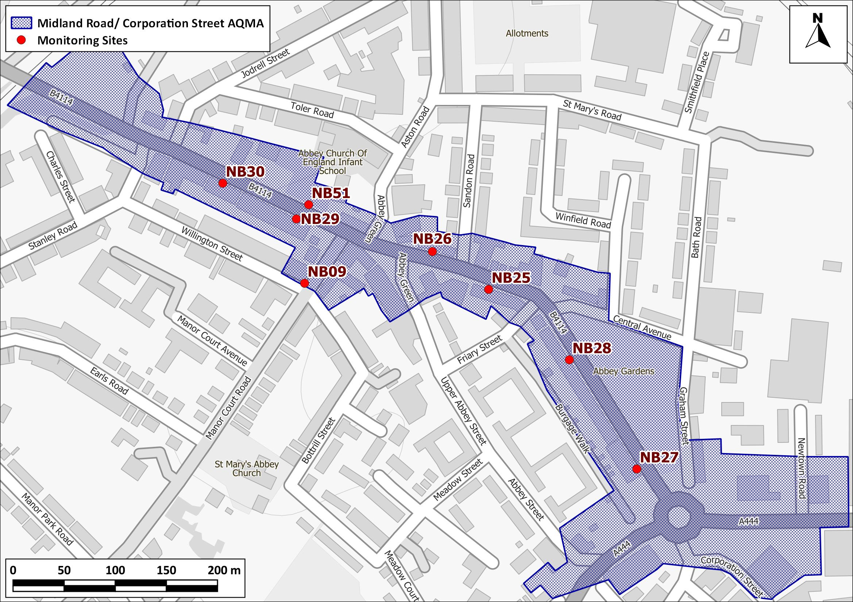
Figure 5: Midland Road/Corporation Street AQMA and Nearby Monitoring Sites
Contains Ordnance Survey data © Crown copyright and database right 2021. Ordnance Survey licence number 100046099. Additional data sourced from third parties, including public sector information licensed under the Open Government Licence v1.0.
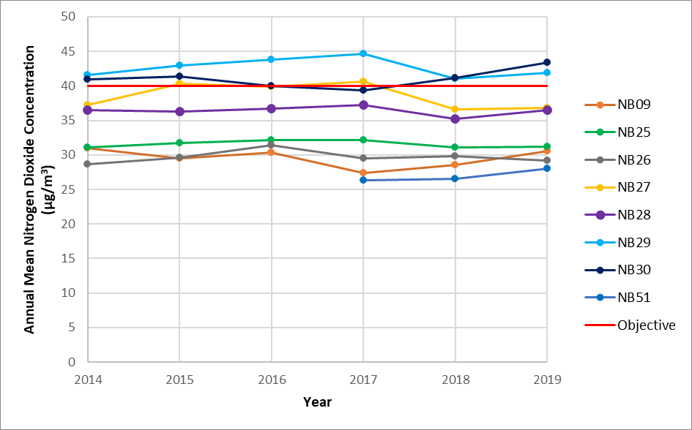
Figure 6: Annual Mean Nitrogen Dioxide Concentrations in the Midland Road/Corporation Street AQMA (µg/m³)
Table 2: Summary of Nitrogen Dioxide (NO₂) Monitoring (2013-2019) in the Midland Road/Corporation Street AQMA (µg/m³)ª
Site No | Location | 2014 | 2015 | 2016 | 2017 | 2018 | 2019
NB09 | Manor Court Road | 31.0 | 29.5 | 30.3 | 27.4 | 28.5 | 30.6
NB25 | 25 Central Avenue | 31.1 | 31.7 | 32.2 | 32.1 | 31.1 | 31.2
NB26 | 26 Central Avenue | 28.7 | 29.6 | 31.4 | 29.5 | 29.8 | 29.2
NB27 | 90 Corporation Street | 37.2 | 40.3 | 39.9 | 40.6 | 36.6 | 36.8
NB28 | 138 Corporation Street | 36.5 | 36.3 | 36.7 | 37.2 | 35.2 | 36.5
NB29 | 16 Midland Road | 41.6 | 43 | 43.8 | 44.6 | 41.0 | 41.9
NB30 | 50/52 Midland Road | 40.9 | 41.4 | 40.0 | 39.3 | 41.1 | 43.4
NB51 | Abbey Green School | - | - | - | 26.3 | 26.5 | 28
Objective |  | 40

ª Exceedances of the objective are shown in bold.
Concentrations in both AQMAs have remained fairly stable between 2014 and 2019, even though some reductions in roadside concentrations would be expected, particularly since 2016.

More recent data, from 2020 onwards, was notably affected by the Covid-19 pandemic. As such this action plan is driven by pre-pandemic nitrogen dioxide concentrations. However 2020 data can be found in the Annual Status Report (ASR) 2021 and shows that there were no exceedances in either AQMA, or elsewhere in the borough. Appendix F of the ASR provides specific commentary on the impacts of Covid-19.
The 2021 ASR is available at;
https://www.nuneatonandbedworth.gov.uk/downloads/file/4646/nuneaton_and_bedworth_air_qulity_annual_status_report_2021

Nuneaton and Bedworth’s Air Quality Priorities

Public Health Context
Air pollution is a major public health risk ranking alongside cancer, heart disease and obesity. A review by the World Health Organisation concluded that long-term exposure to air pollution reduces life expectancy by increasing the incidence of lung, heart and circulatory conditions. The Department of Health and Social Care’s advisory Committee on the Medical Effects of Air Pollutants (COMEAP) has estimated that long-term exposure to man-made air pollution in the UK has an annual impact on shortening lifespans, equivalent to 28,000 to 36,000 deaths (COMEAP, 2018). Poor air quality can affect health at all stages of life. Those most affected are the young and old. In the womb, maternal exposure to air pollution can result in low birth weight, premature birth, stillbirth or organ damage. In children, there is evidence of reduced lung capacity, while impacts in adulthood can include diabetes, heart disease and stroke. In old age, a lifetime of exposure to air pollution can result in reduced life-expectancy and reduced wellbeing at end of life. There is also emerging evidence for a link between air pollution and an acceleration of the decline in cognitive function (Defra, 2019).
COMEAPs current work programme of topis can be found at;
https://assets.publishing.service.gov.uk/government/uploads/system/uploads/attachment_data/file/976297/COMEAP_working_programme_May_2020_onwards.pdf

Poor air quality disproportionately affects the poorest and most vulnerable in our communities including children. Public health not only aims to improve health, but also reduce health inequalities by using an evidence-based approach to make recommendations on the delivery of health and wellbeing services. As such, this Action Plan will support work underway within the public health arena.
The Warwickshire Joint Strategic Needs Assessment (JSNA) seeks to analyse current and future wellbeing needs of the local population. Prior to 2017, thematic needs assessments were carried out. Between 2017 and 2020 a new, place-based approach to the JSNA was taken. From January 2021 a new work programme of thematic needs assessments will commence, including air quality. The place-based assessment for Nuneaton central identified from the evidence available, four key themes:
1. Deprivation (including home ownership, child poverty, financial inclusion) and regeneration (planning and transport)
2. Mental health and wellbeing
3. Children and young people
4. Living with long term conditions – including CVD and COPD
All of these themes have a link with air quality and the report includes a recommendation to ‘continue to monitor air quality in the area and review measures to reduce emissions from road traffic’.
Future projects delivered under the JSNA will be implemented through the Warwickshire and Coventry Air Quality Alliance, which is led by the public health team. The alliance aspires to undertake more work in relation to behaviour change to active travel (particularly around schools) and undertake personalised travel planning on a county-wide basis. Projects such as these will require additional resource at both county and borough level. A previous project was undertaken using personal air quality monitors in order to assess travel behaviours and promote air quality awareness. Although the project was small scale, some change in behaviour was attained at a personal level, illustrating that given enough resources to apply the principles more widely, personal travel planning projects can be effective.

Planning and Policy Context

Local Transport Plan
The Warwickshire Local Transport Plan 2011-2026 (Warwickshire County Council, 2011) was adopted in April 2011, and sets out the Council’s Transport Strategy, which will provide the framework for how the transport network will be maintained and improved across Warwickshire over the fifteen year period. The Plan references an Air Quality Strategy, that focuses on air quality issues within Warwickshire, of which the objectives are:
“To address air quality issues that have, or will arise, due to transport-related issues;
To inform and complement the County Council’s wider policies on transport contained in the LTP;
To take a proactive, rather than a reactive approach, to dealing with future air quality issues and taking measures to minimise them before they occur;
To create a realistic, deliverable Action Plan with schemes and initiatives for improving air quality related to transport issues within the County; and
To integrate the Strategy fully within the Local Transport Plan, complementing the schemes and objectives contained in other parts of the document”
The Plan also includes three policies relating to air quality:
- Policy AQA2, ‘Improving poor air quality through partnership working’, which states that “Within 18 months of the declaration of an Air Quality Management Area, the County Council will assist the relevant District/Borough Council in drawing up an Air Quality Action Plan, and provide support in its implementation…”;
- Policy AQA3, ‘Maintaining areas of good air quality’, which states that “The County Council will seek to maintain good air quality in areas without existing air quality problems. A proactive approach will be undertaken with the five District/Borough Councils in Warwickshire to monitor and address emerging air quality problems in the County, in order to ensure the potential AQMAs are tackled prior to any formal declaration…”; and
- Policy AQA5, ‘Integration of air quality and transport planning’, which states that “Through the planning process, the County Council and the five Warwickshire District/Borough Councils will take into account known and emerging air quality issues to ensure that new development:
- Does not exacerbate an existing air quality problem, or trigger the declaration of a new Air Quality Management Area;
- Is well served by public transport, walking and cycling facilities; and
- Is supported by measures such as Travel Plans to ensure that sustainable travel patterns are maintained”
Although there is not a statutory requirement, Warwickshire County Council have identified the need to undertake a widescale review of the Local Transport Plan to take account of several new and emerging issues at local, regional and national levels. These include the reorganisation of the County Council and the new organisational priorities that have emerged from that process, the County’s declaration of a climate emergency, the inception of the West Midlands Combined Authority (including Transport for West Midlands), national efforts to achieve net zero carbon emissions by 2050 with numerous impacts on transport, and the response to COVID-19. A consultation regarding the new LTP is being undertaken in the first quarter of 2021.

Transforming Nuneaton
Warwickshire County Council (WCC) and Nuneaton and Bedworth Borough Council (NBBC) are working together to deliver the transformation of Nuneaton town centre, by implementing mixed-use regeneration for boosting economic growth. The Transforming Nuneaton programme is a strategic package of projects, with the overall aspiration of the Transport and Access element being the delivery of a fully integrated transport system for Nuneaton town centre including a new transport hub at the train station, improved pedestrian, bus and cycle access into the town centre, improved services and supporting public realm to support the delivery of creating gateway points. To assist in the delivery of this aspiration the draft Nuneaton Town Centre Transport Strategy has been developed to provide a comprehensive, evidence-based approach to improved highway and sustainable transport infrastructure in the town. It provides the context for the delivery of any transport related project in the town. It will tie into LTP3, the Borough Plan and Town Centre Area Action Plan and identifies short, medium and long term aspirations. The Transforming Nuneaton programme also includes creating new and improved heavy rail links to enhance connectivity in the North/South corridor (NUCKLE - Nuneaton, Coventry, Kenilworth, and Leamington). This includes direct links to Birmingham, London, Manchester and Leicester. These changes are likely to have a positive impact both on the area of exceedance in Midland Road, and more widely across Nuneaton.

Town Investment Plan
A Town Investment Plan (TIP) for Nuneaton, which has successfully received £23.2 million funding from Government in March 2021, sets out 12 projects that aim to bring social and economic benefits to the town and help it grow and develop in the future. Public consultation was instrumental in formulating the projects, which fit in with the key areas of local transport, digital connectivity, urban regeneration, arts, culture and heritage, and skills, education and enterprise.

Local Planning Policies
The NBBC Borough Plan 2011-2031 (Nuneaton and Bedworth Borough Council, 2019) was adopted in June 2019, and within this there are two policies which refer to air quality:
- Policy HS2, ‘Strategic accessibility and sustainable transport’, which states that “…Where a development is likely to have transport implications, planning applications are required to clearly demonstrate how the following issues are addressed: (…)
3. The impact of air quality and measures proposed to ensure impact is not exacerbated. The council would support measures such as the provision and integration of infrastructure which may help to deal with the issues of air quality, such as electric vehicle charging points.”
- Policy BE3, ‘Sustainable design and construction’, which states that “… Major development proposals must provide a statement with their application showing how their proposal will: (…)
6. Minimise the potential for pollution of air…and in particular not contribute to unacceptable levels of air pollution”.
Since the publication of the Borough Plan, the Council has adopted a Supplementary Planning Document (SPD) on Air Quality, which is designed to support measures to mitigate against and improve air quality impacts on new developments. The Document’s objectives are:
- “to improve the consideration of air quality and health impacts in the planning process, in line with national / local policy and practice;
- to help ensure consistency in the approach to dealing with air quality and planning in the Borough;
- to highlight the existing policy framework and emphases the importance of air quality as a material planning consideration;
- to identify the circumstances where detailed assessments and/or low emission strategies will be required as part of planning applications;
- to provide guidance on measures that can be implemented to mitigate the potentially harmful impacts on new developments on air quality;
- to promote the identification of suitable mitigation on major schemes through pre-application discussions;
- to provide guidance on the use of planning conditions and Section 106 obligations to improve air quality; and
- to encourage co-benefits of reducing carbon and noise emissions”.
The guidance provides a consistent approach for the assessment of potential air quality impacts from development-generated transport emissions, emissions during the construction phase, and a common framework to mitigate those impacts.
The guidance follows a staged process to determine the level of assessment required:
- Stage 1: Determining the development classification as minor, medium or major
- Stage 2: Determining whether the development requires an air quality assessment and/or a pollutant emission cost assessment (damage costs); and
- Stage 3: Determining the level of mitigation required.
Conditions are used to ensure that the SPD is delivered in full.
The Borough Plan includes a target to deliver 14,000 new dwellings in the borough by 2031 and the impacts of this development on air quality have been assessed as part of the evidence base for the Borough Plan. This assessment has shown that the proposals will result in mostly negligible changes in concentrations of nitrogen dioxide, PM₁₀ and PM_{2.5} across the borough, including at town centre locations and within the AQMAs in Nuneaton. No exceedances of the air quality objectives are predicted for 2030. With the proposed updated Borough Plan, there will be good air quality conditions within Nuneaton and Bedworth in 2030, with pollutant concentrations well below the air quality objectives. Most of allocated sites which may impact on Nuneaton’s AQMAs already have permission, but not all are built out yet.
The Council has consulted on a Town Centres Area Action Plan (TCAAP) Issues and Options document. The Council is working towards producing a 'Publication' document for consultation in May 2021. The TCAAP will set out a vision for each of the town centres (Nuneaton and Bedworth), the objectives by which to achieve this vision and provide a realistic and viable plan for the implementation and monitoring of the TCAAP objectives and proposals.
Other SPD’s which may positively influence air quality include the Health Impact Assessment SPD which provides the framework for assessing health impacts from all new major developments proposals in the Borough. The Open Space and Green Infrastructure SPD provides additional guidance in relation to open space, parks and play provision, ecology/biodiversity, trees, allotments, and green corridors.

Air Quality Action Plan
The Council developed an Air Quality Action Plan, adopted in 2011, which aimed to promote joint working with relevant stakeholders, such as the County Council and other relevant organisations, to deliver viable measures that work towards achieving the air quality objectives within the AQMAs. There are a number of collaborative measures including actions which aim to:
- Identify and bring forward traffic management improvements in Nuneaton Town Centre,
- Increase uptake and implementation of School and Workplace Travel Plans (including in the Council),
- Include planning policies within the Borough Plan that seek to improve air quality, sustainable transport links and secure Travel Plan agreements.
- Identify as part of the Borough Plan Infrastructure Delivery Plan specific infrastructure required within the AQMAs or that could relieve the AQMAs. These can then be prioritised alongside the Borough’s other infrastructure demands for external funding and developer contributions/CIL.
- Encourage developers to take part in preapplication discussions to ensure air quality is considered when formulating a planning application.
- Continue to work with WCC and other partners to deliver improvements in emissions where practicable.
- Continue to work with Public Health, WCC and the Warwickshire District Authorities on air quality and travel awareness campaigns to raise the profile of air quality in the Borough and Countywide.
The Action Plan is incorporated into the Warwickshire Local Transport Plan LTP. The wide range of collaborative measures are built on in this updated Air Quality Action Plan.

Climate Change
NBBC declared a Climate Emergency in 2019, following which the council set up a working group to seek ways of making NBBC’s activities carbon neutral by 2030. The issue of climate change is central to the Borough Plan, with its importance recognised within the Plan as it is a key objective (Objective 8 - paragraph 4.9) which states: “To address climate change and encourage sustainability in all new development”.
In particular:
a) Avoid where possible sites that are at risk of flooding now or in the future.
b) Utilising appropriate sustainable urban drainage systems for flood or surface water attenuation and using water sustainably.
c) Protect and enhance the Borough’s ecological network, in particular priority habitats and species and minimising impacts on biodiversity.
d) Maximise energy efficiency and the use of renewable energy, particularly those with greatest potential in the Borough. For example, combined heat and power district energy, biomass energy, ground source heat pumps, solar photovoltaics and solar thermal, along with any future renewable or low carbon technology that may become more suitable for the Borough during the plan period.
e) Ensure development makes links to cycling and walking networks to encourage green travel.”
The issue of climate change is addressed in a multitude of policies. It is specifically addressed in Policy NE4 where it states, “New development proposals must account for climate change in their plans to ensure that the site will be “safe” over its lifetime.” However, it is also covered in other policies for example, in the strategic housing policies there are requirements relating to the network of green infrastructure within the Borough.
There is a Warwickshire County partnership group (at officer level), and a political working group at borough level which help steer this work.

Source Apportionment
The AQAP measures presented in this report are intended to be targeted towards the predominant sources of emissions within NBBC’s area.
In order to develop appropriate measures to improve air quality along Midland Road and inform the action plan, it is useful to identify the sources contributing to the objective exceedances within the area of exceedance.
Air pollution can be quantified in terms of emissions (the amount of pollutants released into the atmosphere from a source) or the concentration of pollutants in a location (air quality). The source apportionment presented in this section uses emissions. Emissions are related to concentrations, but not in a linear way, due to the effects of meteorology and atmospheric chemistry. Whilst it is exposure to elevated concentrations which cause the health effects, measures to reduce emissions will minimise these effects and are hence a useful approximation.
Source apportioned NOx emissions have been calculated taking account of the different proportions of emissions emitted by different vehicle types on the section of Midland Road between Manor Court Road and Stanley Road, where the objective continues to be exceeded. The different proportions have been calculated using the Emission Factor Toolkit (EFT version 10.1 available at https://laqm.defra.gov.uk/review-and-assessment/tools/emissions-factors-toolkit.html ). Traffic data provided by Warwickshire County Council which split vehicles into cars, LGVs, buses, rigid HGVs, articulated HGVs and motorcycles has been used. Splits between diesel and petrol cars utilises the national splits available in the EFT.
The following categories have therefore been included in the source apportionment:
- Petrol Cars;
- Diesel Cars;
- Diesel LGVs;
- Buses and Coaches;
- Rigid Heavy Goods Vehicles (HGVs); and
- Articulated HGVs.
Petrol LGVs and motorcycles were also included in source apportionment calculations, however emissions from these sources make up <0.2 % of emissions and have not been considered further.
Figure 7 shows the percentage contributions of each vehicle type to total predicted NOx emissions from the road. The largest proportion and nearly half of the road NOx emissions is contributed by diesel cars (46%), followed by diesel LGVs (18%), and buses/coaches (13%).
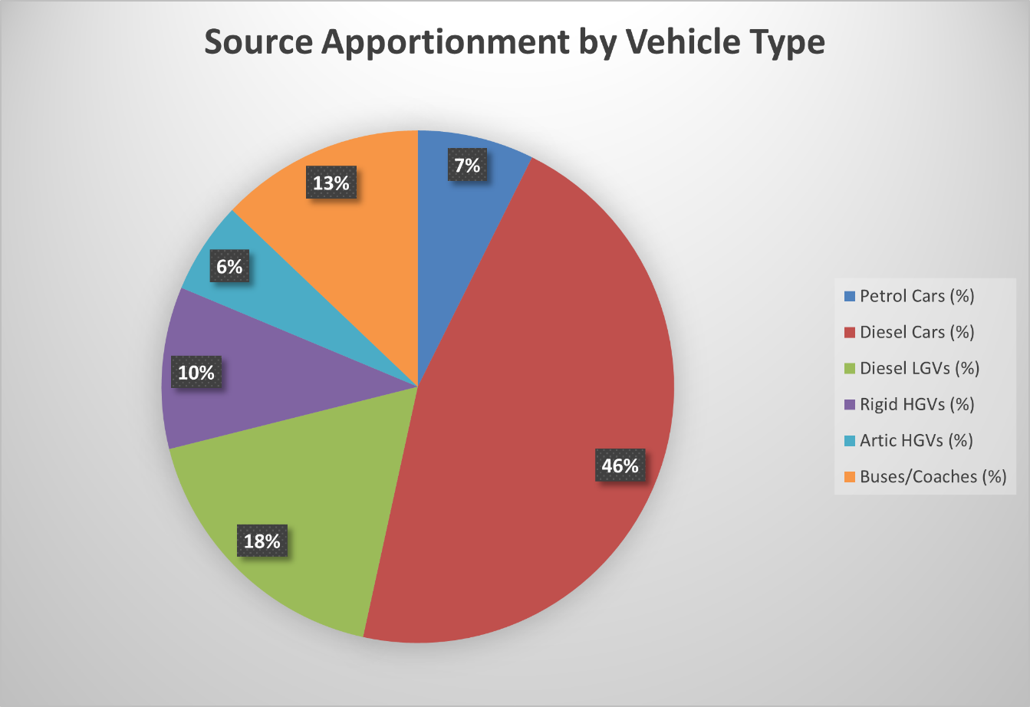
Figure 7: Percentage Contributions of Different Sources to Total Predicted NOx Road Emissions in 2019 on Midland Road

Required Reduction in Emissions
The improvement in road NOx emissions in order to meet the objective at monitoring sites NB29 and NB30, where measured concentrations exceeded the objective in 2019, is shown in Table 3. An 8.9% decrease in emissions is required to meet the objective at monitoring site NB29 and a 16% decrease in emissions is required at monitoring site NB30.
Table 3: Percentage Decrease in Road NOx required to Meet Annual Mean NO₂ Objective at Local Monitoring Sites (µg/m³) in 2019
Receptor | Annual Mean Contribution (µg/m³) |  |  |  | % Decrease in Road NOx to Meet Objective
 | Measured NO₂ | Background NOx | Background NO₂ | Road NOx | % Decrease in Road NOx to Meet Objective
NB29 | 41.9 | 23.6 | 15.9 | 53.5 | 8.9
NB30 | 43.4 | 23.6 | 15.9 | 57.0 | 16.0
Concentration required to meet the Objective | 40 | - | - | 49.2 | -

When will the objective be achieved?
Using the factors for adjusting roadside nitrogen dioxide concentrations to future years supplied by defra (https://laqm.defra.gov.uk/tools-monitoring-data/roadside-no2-projection-factor.html), concentrations at NB30 (43.4 µg/m³ in 2019) should achieve the objective in 2021 (projected concentration = 43.4 X 0.8864 = 38.5 µg/m³). These adjustments should be used with some caution, particularly in light of trends in Nuneaton and Bedworth not reducing as has been seen elsewhere in the UK (see https://www.aqconsultants.co.uk/news/january-2020/nox-trends-in-the-uk-2013-to-2019 for details), but nonetheless, it is likely that the objective will be achieved in the next few years as less polluting vehicles increase within the fleet. Therefore, the Action Plan, in order to be proportionate, focusses on actions which can be implemented within the next few years.

Key Priorities
Based on the evidence provided above, the key priorities are:
- To reduce nitrogen dioxide concentrations in Midland Road, Nuneaton in order to achieve the air quality objective at this location. This will be achieved through both traffic management measures at this location and various supporting transport measures, including those to increase the proportion of electric vehicles in the fleet (both in relation to buses and private cars);
- To ensure that more strategic measures to reduce emissions of air pollutants (nitrogen dioxide and PM_{2.5}) are in place to ensure wider benefits to health across the population. This will be achieved through ongoing collaborative work with Warwickshire County Council on transport, planning colleagues to ensure that the planning system fully considers air quality implications of development, public health staff and climate change colleagues.

Development and Implementation of Nuneaton and Bedworth’s AQAP

Consultation and Stakeholder Engagement
In developing/updating this updated AQAP, we have worked with other local authorities, agencies, and the local community to improve local air quality. Schedule 11 of the Environment Act 1995 requires local authorities to consult the bodies listed in Table 4. The consultation will be undertaken by making the report available on the Council website, and publicising through social media as well as direct contact with neighbouring authorities, Warwickshire County Council and Defra. Prior to consultation, the Action Plan will be taken to the Overview and Scrutiny Panel and then cabinet for approval. Following consultation, the report will go back to cabinet for adoption.
The response to our consultation stakeholder engagement is given in Appendix A.
Table 4: Consultation Undertaken
Yes/No | Consultee
Yes | the Secretary of State
Yes | the Environment Agency
Yes | the highways authority
Yes | all neighbouring local authorities
Yes | other public authorities as appropriate, such as Public Health officials
Yes | bodies representing local business interests and other organisations as appropriate

Steering Group
A Steering Group was set up in order to take this Action Plan revision forward. Up to the publication of the consultation draft, two Steering Group meetings have been held (9th February and 5th March 2021). In addition, separate meetings were held with the fleet manager of Nuneaton and Bedworth Borough Council and Warwickshire Consultant in Public Health, who were unable to make the meetings. The meetings have involved setting out the background to the air quality issue in Nuneaton and Bedworth, the process of the Action Plan, recent work undertaken on air quality (review of air quality delivery and the AQMAs) and gaining input and insight into existing and future policy measures within Nuneaton and Bedworth and how these may assist in the implementation of measures within this Plan (and vice versa). Some discussions around evaluation of the measures included were also held. Warwickshire County Council, as Highways Authority are key to the implementation of the transport measures within the plan, and their input is paramount to the success of this plan. Planning and climate change colleagues, within Nuneaton and Bedworth have also been invaluable in the drafting of the plan. The Consultant in Public Health, Warwickshire has also been engaged with separately to the main meetings and will continue to be involved through the Warwickshire and Coventry Air Quality Alliance. The Transforming Nuneaton team have also been consulted with. The Steering Group will continue to be fully involved, and consulted on as the process continues, through comment on this draft report, and following a wider consultation.
Following adoption of the plan the steering group will meet at least every 12 months to discuss actions for the coming year and review the previous year’s activity.

AQAP Measures
The following groups of measures, as outlined by Defra and categorised for reporting to the EU, have been considered. A brief overview of current practice is included in Table 5.
Table 5: Current Measures in Nuneaton and Bedworth
EU Measure Category | Current practice
Alternatives to Private Vehicle Use | The overall aspiration of the Transport and Access element of Transforming Nuneaton programme is the delivery of a fully integrated transport system for Nuneaton town centre including a new transport hub at the train station, improved pedestrian, bus and cycle access into the town centre, improved services and supporting public realm to support the delivery of gateway points in order to provide more effective alternatives to private vehicle use.
Environmental Permits | Work to ensure that all industrial installations are permitted and visits etc. are up to date. Not likely to be a significant issue in Nuneaton.
Freight and Delivery Management | The Transforming Nuneaton programme includes creating new and improved heavy rail links to enhance connectivity in the North/South corridor (NUCKLE - Nuneaton, Coventry, Kenilworth, and Leamington) to reduce freight on the roads.
Policy Guidance and Development Control | A comprehensive Supplementary Planning Document on air quality is in place and planning applications are assessed in terms of their impact on air quality, with planning conditions used to ensure that the SPD is fully implemented.
Promoting Low Emission Plant | NBBC recognises that although this Action Plan is focussing on transport, other sectors such as domestic and small plant should also be considered. This is already being considered within the planning process for new development (and within the SPD on air quality), and through actions to achieve carbon neutrality.
Promoting Low Emission Transport | NBBC is investing in EV infrastructure as part of the Council’s zero carbon ambition. This is being undertaken both for cars (through infrastructure in council car parks) and for buses (Coventry’s all electric bus city bid will have some positive impacts for Nuneaton). The implementation of EV infrastructure will continue.
Promoting Travel Alternatives | A number of cycle schemes are currently being delivered including the Nuneaton to Bedworth, Bedworth to Coventry and A47 Long Shoot cycle routes creating new high quality, safe, segregated cycle track. Also a number of projects have been undertaken to encourage more walking. A Local Cycling and Walking Infrastructure Plan currently being developed.
Public Information | Public information on air quality is being delivered through the Council website.
Traffic Management | A number of traffic management schemes have been tested in Nuneaton, specifically on Midland Road, for example the rephasing of traffic lights. Through the Transforming Nuneaton programme, junction improvements, including those which should reduce congestion on Midland Road are currently in the planning phase.
Transport Planning and Infrastructure | Wider transport planning schemes and infrastructure are largely being delivered through the Warwickshire LTP, which is currently being reviewed.
Vehicle Fleet Efficiency | Fleet efficiency measures prioritised through encouraging an increase in Electric Vehicle ownership (by providing effective EV infrastructure).
The following measures are for inclusion in this Action Plan. They are described below under five broad topics. Where possible, costs have been included in the text (using the banding system used to report costs within the ASR reporting structure), and a summary is provided in Table 6, which summarises the measures and implementation and contains:
- a list of the actions that form part of the plan
- the responsible individual and departments/organisations who will deliver this action
- expected benefit in terms of pollutant emission and/or concentration reduction
- the timescale for implementation
- how progress will be monitored
NB: Please see future ASRs for regular annual updates on implementation of these measures
Action 1: Support and Collaborate with Warwickshire County Council on Traffic Management Measures Directly Impacting Midland Road
As part of the Transforming Nuneaton programme, a series of highway improvements are planned which, together, will; assist development to support the wider Transforming Nuneaton Programme, help improve air quality in existing Air Quality Management Areas (AQMA’s), enhance existing cycling infrastructure along with creating new infrastructure therefore encouraging more sustainable travel, and relieve existing localised pinch points and congestion.
The ring road highway programme includes junction reconfiguration and key improvements at 3 major junctions on the ring road to accommodate growth (housing and employment) outlined in the Borough Plan (as identified within the Strategic Transport Assessment carried out as part of the Borough Plan) and minor upgrades to existing junctions to support these. The issues at Midland Rd are in part related to the performance of Corporation St roundabout and Newton Rd. In October 2020, Warwickshire County Council approved capital investment of £21.7m towards the delivery of these upgrades to the ring road; this has enabled the work to progress on detailed design of these schemes including a key upgrade to the A444 / Corporation Street / Powell Way junction which is key to reducing queues on Corporation Street and Midland Road and improving facilities for cyclists and pedestrians. Also included within this scheme is a new four arm signalised junction at the A444 / Abbey Street junction, to provide bus access into the town centre. This scheme, which is yet to be implemented, should provide improvements in concentrations on Midland Road.
Other schemes which are currently under consideration directly in relation to air quality, include repositioning the bus stops on Midland Road (which are currently opposite each other) to alleviate congestion, particularly when there are buses at both stops.
A further scheme for consideration includes holding inbound traffic on Tuttle Hill (by phasing the traffic lights with the junction on Midland Road to ensure queuing happens at Tuttle Hill where the very few receptors are further from the carriageway, rather than on Midland Road as currently). Both of these suggested schemes are being investigated by Warwickshire County Council and will be reported on in annual updates.
Funding Sources: developer contributions, Transforming Nuneaton project.
Cost: >£10 million (including existing programme)
Action 2: Promote Behaviour Change away from Single Occupancy Private Vehicle Use
When considering solutions to reduce the environmental impacts of transport, it is important to first establish what drives transport demand. Access to efficient public transport will be of high importance in reducing demand for cars, including the provision of buses and bus priority measures in urban areas. Achieving change in travel mode choice to active travel can be an effective strategy to manage transport demand and so reduce NOx emissions. Changes in travel mode may come about through incentivisation, public engagement or a regulatory scheme. Measures to provide information on alternative ways of travelling or encouraging lift sharing can be implemented relatively quickly compared to provision of transport infrastructure or the development and introduction of cleaner vehicles, and in many cases can be a more cost-effective approach.
WCC has a number of strategies aimed at promoting active travel (cycling and walking) and public transport which are largely being implemented through the LTP. WCC is currently developing a Local Cycling and Walking Infrastructure Plan (LCWIP), which will set out a long term, prioritised and costed programme of cycling infrastructure improvements for Warwickshire. This will be completed later in 2022. Within the Transforming Nuneaton programme, improved walking and cycling facilities in and around the town centre will be provided, supporting active travel and all junction upgrades will include upgrades for pedestrians and cyclists. In addition, there will be new public realm works, uplifting the local landscape and improving people’s perceptions of the area, which may also encourage active travel. The Nuneaton Town Investment Plan will also complement the public realm works and encourage further active travel.
A number of cycling schemes in NBBC have already been allocated funding including the Nuneaton to Bedworth, Bedworth to Coventry and A47 Long Shoot cycle routes. WCC are actively working on delivery of these schemes to support the development of walking and cycling in and around Nuneaton. The Nuneaton and Bedworth Cycling Connection scheme will create approximately 4kms of new cycling route on the Nuneaton - Bedworth - Coventry corridor, providing safe and attractive cycling access to major employment sites, supporting planned housing growth. The area currently has no continuous direct cycling link between Nuneaton and Coventry, recognised as one of the main barriers to cycling. The A47 Long Shoot Cycle Route will create approximately 1.4 kms of new high quality, safe, segregated cycle track on the A47 Long Shoot as part of a strategic cycle route connecting Nuneaton to Hinckley. The scheme will encourage and enable a shift from car-based travel to cycling for local journeys, providing the necessary sustainable transport links to the town centre and rail station to support Transforming Nuneaton and the significant residential expansion in north-east Nuneaton.
There is currently no cycle infrastructure on Midland Road, which is recognised as an issue to be addressed through the LCWIP.
With regard to travel plans, WCC is actively working in this area through the safer travel team (who work with both schools and key employment sites). Two travel plan officers have been employed to take this work forward, in order to assist with behavioural change to both active modes and public transport. Use of public transport has been particularly reduced due to the Covid pandemic and the travel plan work will assist in the recovery.
WCC is also providing bikeability courses (a national programme to increase skills and confidence for cyclists delivered at different levels) to both schools and adults, with further cycle training planned.
In relation to public transport, the creation of a new gateway entrance point at Nuneaton train station will lay the foundations for further work at the station to create an integrated transport hub (bus, cycling, pedestrian and rail). Work is also taking place to look at creating a northern access point for rail and bus users thereby removing the need for them to travel over the Leicester Road bridge onto the ring road. Funding strategies are yet to be developed for these projects, which will be part of the second phase of Transforming Nuneaton. An initial feasibility report has been completed to assess the existing station access based on passenger growth, and consider the feasibility of a new second access. This will now be used to move forward with key stakeholders on the proposal, funding options and delivery methods.
There are also rail improvements between Coventry and Nuneaton with a half hourly service in place. A station at Bermuda Park, Nuneaton was opened in 2016, and a new through service added between Nuneaton and Leamington, which although currently suspended due to the Covid pandemic, will also be a half hourly service by 2023.
WCC have been working with bus operators to build the Warwickshire Bus Service Improvement Plan, this is in line with the Bus Back Better: National Bus Strategy for England (​except London) was published by the ​Government in March 2021. This sets out the vision for the future and through this process WCC will bid for funding for a range of measures which are designed to make bus travel more attractive. Measures could include bus priority (including traffic management measures), provision of lower emission vehicles, improved bus information, and enhanced Ticketing.

There is a county wide platform for carsharing, and once restrictions due to Covid have reduced, this will be more widely publicised to make further reductions in single occupancy car use.
All of the specific measures which are included under the promotion of behaviour change to active modes of travel and public transport will also have a beneficial impact on climate change gas emissions, enabling co-benefits across Nuneaton and Bedworth.
Funding Source: WCC
Cost: >£10 million for all aspects of the measure
Action 3: Promote the use of Alternatively Fuelled Vehicles
The primary objective of promoting a switch to low emission vehicles is the reduction of carbon and local pollutant emissions from transport. However, this measure does not have the additional benefits such as congestion reduction, or increased levels of physical activity that are generated by measures to encourage active travel modes. Provision of suitable infrastructure to support low emission vehicles is critical to their introduction. For commercial vehicle operators, the financial case for investing in electric vehicles is strongly dependent on ensuring high vehicle usage.
Lower emissions from diesel HGV’s or buses can also be realised through vehicle retrofit, which usually consists of the installation of an on-board device that allows vehicles to comply with more stringent standards by reducing the emission of pollutants through technical measures. Retrofit measures are usually either Exhaust Gas Recirculation (EGR) or Selective Catalytic Reduction and urea technology (SCR).
In relation to smaller vehicles, the priority will be a switch to electric, which is being taken forward in a number of ways. Electric vehicle (EV) charging infrastructure will be required at destinations (for example, town centres), residential locations for those without off-street parking and at rapid charging hub facilities. Where possible, the private sector will be used to install and maintain charging facilities, but there is a role for local authorities to ensure equitable distribution. WCC commissioned Cenex to assess demand for charging infrastructure to support EV take up. In Nuneaton and Bedworth the study concluded that a further 197 charging points (x150 7kW, x39 22kW and x8 50kW+) were required by 2025 to meet projected future demand in EV uptake. These figures assume an element of charging will occur at home. Increasing the number of charge points in Nuneaton is likely to be one of the most effective measures to stimulate EV uptake by private and business car owners. The provision of charge points will overcome two significant barriers to EV adoption; actual and perceived lack of charge points. There are many user groups including; householders who do not have off-street parking, EV drivers who cover relatively high mileages, and commercial vehicle fleets, which cannot do all their charging at drivers’ homes or depots and therefore require additional charge point infrastructure.
Over £1m OLEV funding has been secured to deliver approximately 180 charging points across Warwickshire in 2021/22, which will predominantly be provided in Council off-street car parks, with some located on street in town centres and smaller market towns. The OLEV funding will provide 8 charging points in the NBBC owned car parks at the Pingles Leisure Centre in Nuneaton, and Bedworth Leisure Centre, within 2020/21. In addition, the Towns Fund means that £250k of funds have been approved to install 10 twin headed fast charging points as well as a rapid charging point in Nuneaton which will facilitate faster charging and could be used for e-taxis in the future.
In relation to public transport, Coventry is likely to become one of the first all-electric bus cities after a funding announcement from DfT. As there are cross boundary services between Coventry and Nuneaton, this will have a positive influence in emissions in Nuneaton, and the wider Borough. There is also a £1.3 million capital investment fund to deliver electric bus charging across Warwickshire including in Nuneaton town centre. These schemes are likely to be delivered in 2024/5.
In relation to taxi licenses, applications for replacement of all existing vehicle licences, for vehicles older than 8 years (for purpose-built hackney carriages) and 5 years (for all other vehicles) will be treated on their individual merits but must be in ‘exceptional condition’ to be licensed. Vehicles that are emission standard Euro 6, Euro 5, or which are an Ultra-Low Emission Vehicle (ULEV) or have been converted to those standards will be licenced without any mileage criteria, provided they comply with all other licensing conditions and are as per manufacturer’s specification in relation to emissions. For older vehicles, new and replacement vehicles which are Euro 4 or below will only be licensed if the mileage is below certain mileage criteria.
With regards to the Nuneaton and Bedworth Council fleet, work has been undertaken looking at vehicle replacement with electric/ hybrids and the infrastructure required for current use of the vehicles. It has been estimated that 50% of the current housing fleet could not at this time be replaced by electric. The council is currently making decisions about the strategy to be applied in relation to EVs in the fleet, and in order to take this forward a finance review has been procured to review EV availability and costs.
The promotion of alternatively fuelled vehicles across the vehicle fleet will also have a beneficial effect on climate change gas emissions, enabling co-benefits across Nuneaton and Bedworth.
Funding Sources and Partners: DfT, Office for Low Emission Vehicles (OLEV), Energy Savings Trust (EST), Warwickshire County Council
Cost: >£1-10 million
Action 4: Develop Policies to Support Better Air Quality
There are a number of policies already in place which will help support air quality, which have been outlined in section 3. Most of these polices cannot be quantified in terms of the impact on pollutant concentrations at specific locations (which is the aim of this Action Plan), but they will lead to an overall reduction in emissions across Nuneaton and Bedworth, which in turn will reduce concentrations of NO₂, PM₁₀ and PM_{2.5} thereby improving health.
In relation to the planning process, the appropriate regulatory framework is in place to guide new and existing developments to minimise emissions. All new developments are required to implement or support actions that make a positive contribution to improving air quality, for example by reducing travel demand and opening up possibilities for increasing cycling and walking. Air quality assessments for applications are undertaken where air quality is of specific concern. NBBC has adopted a Supplementary Planning Document (SPD) to ensure that air quality is considered fully and consistently within the development control process, that developers know what is required of them, and that mitigation, proportionate to the impacts of the development is routinely implemented. The SPD includes that NBBC will seek Section 106 Agreements (S106) under the Town and Country Planning Act 1990, and other relevant obligations with developers to secure mitigation, including off-set, on larger schemes (‘Medium’ and ‘Major’), where appropriate, to make the scheme acceptable. The SPD covers both construction and operational phases and includes emissions standards relating to heating and power, as well as criteria for assessments for traffic generation.
In order to support the SPD on air quality, a workshop will be undertaken with planning officers (development management and strategic planning) to increase collective knowledge of the air quality process and discuss how the process of assessing air quality within the planning process is undertaken in practice.
Any actions being implemented to achieve the aim of the Council being carbon neutral by 2030 will also be supported, either in relation to transport, including EV infrastructure implementation, projects to increase the use of renewable energy within homes and council buildings and projects to increase levels of active travel.
NBBC is currently working closely with Warwickshire Public Health colleagues, mainly through the Warwickshire and Coventry Air Quality Alliance. Although public health priorities have been redirected to the Covid 19 pandemic in 2020, there are aspirations to work more closely with schools on air quality (which may have been made easier by ongoing work at schools in relation to the pandemic) and wider work in relation to travel planning. Within the timeframe of this Action Plan there are likely to be future opportunities for specific projects, for example with schools, or potentially for monitoring, which NBBC can input. These opportunities will be identified through the Air Quality Alliance and resourced, where possible, using external funding.
Funding Source: Mainly from existing budgets at both Borough and County level. Planning system generates funding, which could be used for measures within this Action Plan.
Cost: <£10K unless significant projects are progressed.
Action 5: Control Domestic Emissions
Open fires and wood-burning stoves have risen in popularity over recent years. They are now an additional form of heating for many households in both urban and rural areas; for a minority they may be the sole heat source. In addition, there has been a growth of biomass boilers for home heating. This increase in burning solid fuels in our homes is having an impact on our air quality and now makes up the single largest contributor to UK wide Particulate Matter emissions at 38%. This compares with industrial combustion (16%) and road transport (12%). What people burn and the appliance they use will have a significant impact on emissions. A recent report by King’s College London, measuring local concentrations, found that wood burning accounts for up to 31% of the urban derived PM_{2.5} in London. Not all forms of domestic burning are equally polluting. The appliance (for example, stove or fireplace), how well it is used and maintained, and what fuels are burnt in it, all make a big difference to how much pollution is produced. Significant air quality benefits can be realised through a new efficient appliance as compared with an old stove or open fire. There are simple steps that households can take to limit emissions both indoors and out. Using cleaner fuels, in a cleaner appliance which is installed by a competent person, knowing how to operate it efficiently, and ensuring that chimneys are regularly swept, will all reduce emissions. However, a reduction in solid fuel burning towards non-polluting renewable sources of heat and power, will also reduce the overall emissions of this sector. NBBC are currently offering grants for Insultation of homes through the Green Homes Grant Scheme to increase energy rating of homes with EPC rating of E, F or G which should reduce fuel use in relation to heating.
The UK Air Quality Strategy provides a number of actions around solid fuel burning, including encouraging the uptake of cleaner stoves, working with business and industry to support educational schemes, taking forward potential measures to control the supply of the most polluting domestic fuels – including a ban on house coal, and restricting the sulphur content of smokeless fuels to 2% and prohibiting the sale of wet wood. NBBC will support work being undertaken by the UK Government in reducing emissions from this source, and where necessary undertake local information campaigns to support the national message.
Funding Source: NBBC
Cost: <£10K unless a significant project on solid fuel burning is progressed.

Table 6: Air Quality Action Plan Measures
Measure No. | Measure | EU Category | EU Classification | Lead Authority | Planning Phase | Implementation Phase | Key Performance Indicator | Target Pollution Reduction in the AQMA | Progress to Date | Estimated Completion Date | Comments
1 | Support and Collaborate with Warwickshire County Council on Traffic Management Measures Directly Impacting Midland Road | Traffic Management | Strategic Highway Improvements | WCC and NBBC | 2021 | 2021 onwards | Traffic flows on Midland Road, Nuneaton, and resulting nitrogen dioxide concentrations | Reductions large enough to achieve the annual mean NO₂ at all relevant monitoring locations | Some on going traffic management projects, eg rephasing of traffic lights | 2023 | Upgrades to the Ring Road are high cost, costs for any other traffic management measures are unknown at this stage, being dependant on initial investigation
2 | Promote Behaviour Change away from Single Occupancy Private Vehicle Use | Promoting Travel Alternatives | Encourage/ facilitate home working, active travel campaign & infrastructure, Personalised Travel Planning, Promotion of Cycling, Promotion of Walking, School Travel Plans, Workplace Travel Planning | NBBC and WCC | Ongoing | Ongoing and 2022 onwards | Monitoring strategy for LTP | n/a – strategic measure which will also assist in achievement of air quality objective in AQMA | Ongoing work with schools and businesses, and travel plans through planning system. Local Cycling and Walking Infrastructure plan being drafted | Ongoing for the measure as a whole, late 2022 for WCC Local Cycling and Walking Infrastructure Plan | A number of initiatives across the borough to encourage walking and cycling, but at the moment none on Midland Road. Not costed specifically as wider measures to reduce emissions.
3 | Promote the use of Alternatively Fuelled Vehicles | Promoting Low Emission Transport | Priority Parking for LEVs, procuring alternative refuelling infrastructure to promote Low Emission Vehicles, EV recharging, Gas fuel recharging, taxi emission incentives, taxi licensing conditions | WCC and NBBC | Ongoing | Ongoing and 2021 onwards | Proportion of alternatively fuelled vehicles in the fleet on Warwickshire’s roads | n/a – strategic measure which will also assist in achievement of air quality objective in AQMA | EV charging points increasing in NBBC as funding will allow | Ongoing with aim to become carbon neutral by 2030 | EV charging infrastructure to be implemented over next few years in line with Carbon Reduction Strategy. High cost, but grants and private sector funding available and will be actively targeted.
4 | Develop Policies to Support Better Air Quality | Policy Guidance and Development Control | Air Quality Planning and Policy Guidance, Low emission strategy, other policy, regional groups | NBBC | Ongoing | Ongoing and 2021 onwards | n/a as no specific projects identified as yet | n/a – strategic measure which will also assist in achievement of air quality objective in AQMA | Air Quality SPD adopted and being implemented. Working closely with Warwickshire Public Health, mainly through the Warwickshire and Coventry Air Quality Alliance | n/a – ongoing collaborative working | Non statutory function will require additional resources to implement. No specific budget for this work as ongoing collaborative work.
5 | Control Domestic Emissions | Promoting Low Emission Plant | Regulations for fuel quality for stationary and mobile sources | NBBC | 2021 | 2022 | Level of solid fuel burning | n/a – strategic measure which will also assist in achievement of air quality objective in AQMA | Insultation of homes through Green Homes Grant Scheme to increase energy rating of homes with EPC rating of E, F or G | n/a | Very difficult to quantify any change without detailed survey work. Cost of measure already within existing budgets.

Appendix A: Response to Consultation
Table A.1 ‒ Summary of Responses to Consultation and Stakeholder Engagement on the AQAP
Consultee | Category | Response
Warwickshire County Council | Statutory | Overall supportive of the action plan. Some suggestions around better wording and emphasis on transport elements. Some technical corrections. (Recommendations generally included in final plan).
Environment Agency | Statutory | No Response
Highways England | Statutory | No Response
Council Members | Public | 1 Response, Critical of action plan for not ‘going far enough to address air quality issues.
Defra | Statutory | The action plan appraisal element was undertaken, and plan accepted. Some recommendations were made for inclusion in the final plan (recommendations taken forward where appropriate),
Neighbouring Local Authorities | Statutory | Response from Hinckley and Bosworth BC only – supportive of the action plan with no further comment.
General Public | Public | 6 responses - All raised concern or are opposed to the revocation of AQMA 1 (AQMA 1 revocation not taken forward to final action plan).  2 of the 6 more widely critical of the action plan for ‘not going far enough’.
Coventry and Warwickshire Chamber of Commerce | Statutory | No response
Public Health Warwickshire | Statutory | Supportive of the action plan. Suggested inserting link to most recent Committee on the Medical Effects of Air Pollutants (COMEAP) work programme and noting current studies are looking at the emerging relationship between air pollution and COVID-19 (recommendation included in final plan).

Appendix B: Reasons for Not Pursuing Action Plan Measures
Table B.1 ‒ Action Plan Measures Not Pursued and the Reasons for that Decision
Action category | Action description | Reason action is not being pursued (including Stakeholder views)
Not in EU list | Move sensitive receptors away from area of exceedance (ie compulsory purchase properties on Midland Road in exceedance area) | This is not considered feasible and would be disproportionately expensive compared to the extent of the air quality exceedance (which may be resolved prior to being able to implement this). Also does not reduce pollution itself.
Not in EU list | Move carriageway away from receptors on Midland Road (increase width of the footway and widen carriageway on opposite side of the road, requiring land acquisition). | This is not considered feasible and would be disproportionately expensive compared to the extent of the air quality exceedance (which may be resolved prior to being able to implement this). Also does not reduce pollution itself.
Promoting Low Emission Transport | Low Emission Zone/ Clean Air Zone | Disproportionate cost to size of exceedance.
Traffic Management | Road User Charging/ Workplace Parking Levy | Disproportionate cost to size of exceedance. Not targeted at roads which are an issue. Could make town unattractive to developers/ workers and shoppers.
Not in EU list | Planting of trees | Very difficult to implement on Midland Road and unclear what air quality benefit would be. Could be used as a more strategic measure to offset carbon emissions (and wider air quality emissions), making sure trees are species which have been shown to reduce air pollutants.

Glossary of Terms

Abbreviation | Description
AQAP | Air Quality Action Plan - A detailed description of measures, outcomes, achievement dates and implementation methods, showing how the local authority intends to achieve air quality objectives
AQC | Air Quality Consultants Ltd
AQMA | Air Quality Management Area – An area where air pollutant concentrations exceed / are likely to exceed the relevant air quality objectives. AQMAs are declared for specific pollutants and objectives
AQS | Air Quality Strategy
ASR | Air quality Annual Status Report
COMEAP | Committee on the Medical Effects of Air Pollution
Defra | Department for Environment, Food and Rural Affairs
DfT | Department for Transport
EFT | Emission Factor Toolkit
EGR | Exhaust Gas Recirculation
EST | Energy Savings Trust
EU | European Union
EV | Electric Vehicle
HGV | Heavy Goods Vehicle
JSNA | Joint Strategic Needs Assessment
LAQM | Local Air Quality Management
LCWIP | Local Cycling and Walking Infrastructure Plan
LGV | Light Goods Vehicle
LTP | Local Transport Plan
NBBC | Nuneaton and Bedworth Borough Council
NO₂ | Nitrogen Dioxide
NO_{x} | Nitrogen Oxides
NRMM | Non Road Mobile Machinery
NUCKLE | Coventry to Nuneaton rail upgrade, is known locally as NUCKLE
OLEV | Office for Low Emission Vehicles
PM₁₀ | Airborne particulate matter with an aerodynamic diameter of 10µm (micrometres or microns) or less
PM_{2.5} | Airborne particulate matter with an aerodynamic diameter of 2.5µm or less
SCR | Selective Catalytic Reduction
SPD | Supplementary Planning Document
TCAAP | Town Centres Area Action Plan
TIP | Town Investment Plan
WCC | Warwickshire County Council

Environmental equity, air quality, socioeconomic status and respiratory health, 2010
Air quality and social deprivation in the UK: an environmental inequalities analysis, 2006
Defra. Abatement cost guidance for valuing changes in air quality, May 2013
See https://www.aqconsultants.co.uk/news/january-2020/nox-trends-in-the-uk-2013-to-2019
Available at https://www.warwickshire.gov.uk/joint-strategic-needs-assessments-1/jsna-place-based-approach/2?documentId=743&categoryId=20158
Available at https://www.nuneatonandbedworth.gov.uk/download/downloads/id/2545/nbbc55_-_air_quality_assessment_for_borough_plan_march_2018.pdf
Clean Air Strategy 2019 https://www.gov.uk/government/publications/clean-air-strategy-2019
Font, Fuller et al, ‘Airborne particles from wood-burning in UK cities’ (2017), https://uk-air.defra.gov. uk/assets/documents/reports/cat05/1801301017_KCL_WoodBurningReport_2017_FINAL.pdf

