

Elmbridge Borough Council
Air Quality Action Plan

In fulfilment of Part IV of the
Environment Act 1995
Local Air Quality Management

2021 - 2026



Local Authority Officer | Paul Leadbeater
Department | Environmental Services
Address | Elmbridge Borough Council  Council Offices  High Street  Esher  KT10 9SD
Telephone | 01372 474750
E-mail | envhealth@elmbridge.gov.uk
Report Reference number | Stantec47763/AQAP2020
Date | 2021

Executive Summary

Introduction
Air pollution is associated with a number of adverse health impacts. It is recognised as a contributing factor in the onset of heart disease and cancer. Air pollution particularly affects the most vulnerable in society: children and older people, and those with heart and lung conditions. There is also often a strong correlation with equality issues because areas with poor air quality are also often the less affluent areas.
This report outlines the actions that Elmbridge Borough Council (‘the Council’) will deliver between 2021 and 2026 in order to reduce levels of air pollutants and exposure to air pollution; thereby positively impacting on the health and quality of life of residents and visitors to the Borough. It has been developed in recognition of the legal requirement on the local authority to work towards Air Quality Strategy (AQS) objectives under Part IV of the Environment Act 1995 and relevant regulations made under that part and to meet the requirements of the Local Air Quality Management (LAQM) statutory process.
In 2021 the Council has 6 Air Quality Management Areas (AQMAs) which have all been declared due to exceedances of the legal objective for annual mean nitrogen dioxide (NO₂). The main priority of this Air Quality Action Plan (AQAP) is working to reduce these exceedances. The full details of the AQMAs, NO₂ monitoring locations and results are reported annually in the Council’s Air Quality Annual Status Reports (ASRs).
This AQAP will be reviewed every five years at the latest and progress on measures set out within this AQAP will be reported on annually within the ASRs.
Community wellbeing and supporting communities to become healthier is a priority of the Council. In working towards improving air quality across the Borough, this AQAP upholds the Council priority in supporting communities to become healthier by reducing exposure to poor air quality.
We have developed actions within this AQAP that can be considered under five broad topics. These are summarised in the following sections.

Reducing Emissions from Transport
The greatest contributor to air pollution from within the Borough is road transport and all exceedances of legal air quality objectives within the Borough occur along main roads and within town centres. Reducing pollutant emissions from road transport is therefore vital to improving air quality in the Borough. AQAP measures within this theme focus on encouraging use of alternative transport modes through the improvement of pedestrian and cycling infrastructure, provision of electric vehicle charging infrastructure and reducing emissions from the Council’s vehicle fleet. A key action within this theme will be the development and implementation of a Local Cycling and Walking Infrastructure Plan (LCWIP) for Elmbridge which will identify where cycling and walking improvements are needed most and will set out a delivery plan for these improvements.
The Council will also work with Surrey County Council (SCC) to deliver wider strategies, such as the Surrey Climate Change Strategy and Low Emission Transport Strategy. These strategies include a range of actions which will be beneficial for air quality across Elmbridge.

Buildings and New Development
New development should be sustainable and aim to improve air quality where possible. The theme ‘buildings and new development’ encompasses AQAP measures that will ensure air quality is a consideration for new development, as well measures to reduce pollutant emissions from existing buildings. A key action for the Council will be to embed air quality within the emerging Local Plan, through specific air quality policies and guidance.

Monitoring
Monitoring is essential for identifying where air quality issues occur and measuring the impact of measures aimed at improving air quality. Measures within this theme focus on ensuring effective monitoring is undertaken within the Borough for these purposes. Whilst levels of particulates do not exceed legal limits in Elmbridge, this pollutant is associated with a wide range of adverse health effects. A key action under this theme is the Council’s commitment to install a Particulate Matter (PM) monitor to establish a baseline for levels of this pollutant in the Borough, and to monitor progress in reducing PM levels.

Raising Awareness
Awareness-raising is important for informing and educating the public about air quality issues, so that decisions can be made regarding certain behaviours (for example, whether to drive or walk to work). In recent years, the Council has delivered a successful awareness-raising programme at schools across Elmbridge which involved a range of activities such as theatre performances, cycle training, anti-idling campaigns and air quality monitoring workshops. The Council will continue to work with the Surrey Air Alliance (SAA) to deliver the Schools Air Quality Programme and this is a key measure of the raising awareness theme. The Council will also continue to promote the AirAlert service and utilise their website to provide the latest air quality information to the public.

Lobbying and Partnership Working
Air pollution is a transboundary issue and therefore partnership working across local authorities is essential for tackling poor air quality.
A large proportion of air pollution in Elmbridge comes from outside the Borough, particularly PM_{2.5}. The World Health Organisation (WHO) sets out more stringent target levels for PM_{2.5} than the legal air quality objectives in the UK, and the Council has ambitiously committed to achieving the WHO level by 2030. This can only be achieved through partnership working with the Surrey Authorities to drive down levels of PM_{2.5} across the County. In September 2021 the WHO introduced even more stringent Guideline Values for particulates, the AQAP target will remain at the former Guideline Value of 10 µg/m³ for PM_{2.5}.
The Council will remain an active member of the SAA which facilitates partnership working across Surrey Authorities, as well as working with SCC to ensure air quality is considered appropriately in emerging county-wide strategies such as the draft Local Transport Plan 4.

Table of Contents
Executive Summary i
Introduction i
Reducing Emissions from Transport ii
Buildings and New Development ii
Monitoring ii
Raising Awareness iii
Lobbying and Partnership Working iii
1 Air Quality in Elmbridge 1
1.1 AQMAs 1
1.2 Air Quality Monitoring 2
1.3 Air Quality Modelling 4
2 Elmbridge’s Air Quality Priorities 5
3 AQAP Measures 6
Appendix A: Glossary of Terms 19
Appendix B: Impacts of COVID-19 on Air Quality 20
Appendix C: Public Health Context 22
Appendix D: Planning and Policies Context 24
D.1 Elmbridge Borough Council Policies 24
D.2 Regional Overarching Policies and Plans 27
D.3 Surrey County Council Overarching Policies 28
Appendix E: Source Apportionment 31
E.1 Summary 31
E.2 Walton-on-Thames 32
E.3 Weybridge High Street 33
E.4 Hampton Court 33
E.5 Hinchley Wood 33
E.6 Esher High Street 33
E.7 Walton Road, Molesey 34
Appendix F: Required Reduction in Emissions 45
Appendix G: Estimated Reduction in Emissions 46
G.1 Estimated Future Emissions by Vehicle Type 46
G.2 Estimated Future Emission Reductions in the AQMAs 47
G.3 Indicative Estimated Emission Reductions from AQAP Measures 50
Appendix H: Consultation 51
H.1 Consultation Undertaken 51
H.2 Steering Group 52
H.3 Consultation Response 53
Appendix I: Cost Benefit Analysis 54
I.1 Effectiveness of Measures 54
I.2 Estimated Cost of Measures 54
I.3 Cost-Benefit Analysis 55
I.4 Wider Benefits of Measures 56

List of Tables
Table 1.1: Required Reductions in NO₂ Concentrations 2
Table 3.1: Elmbridge Borough Council AQAP Measures 7
Table 3.2: Surrey County Council AQAP Measures 15
Table B. 1: Percentage Reduction in Annual Mean NO₂ (µg/m³) between 2019 and 2020 in the AQMAs 21
Table E. 1: Source Apportionment Locations 32
Table E. 2: NOx Source Apportionment (%) by Source Sector 35
Table E. 3: NOx Source Apportionment (%) by Road Vehicle Type 36
Table E. 4: PM_{2.5} Source Apportionment (%) by Source Sector 37
Table E. 5: PM_{2.5} Source Apportionment (%) of Vehicle Exhaust Emissions by Vehicle Type 38
Table E. 6: PM_{2.5} Source Apportionment (%) of Vehicle Non-Exhaust Emissions by Source Type 39
Table F. 1: Required Reductions in Road NOx Emissions 45
Table G. 1:Department for Transport Traffic Data 49
Table G. 2: Estimated Reductions in Road NOx Emissions 50
Table H. 1: Consultation Undertaken 51
Table I. 1: Cost-benefit Analysis of AQAP Measures 55

Air Quality in Elmbridge

AQMAs
The Council has six AQMAs that have been declared due to exceedances of the legal objective for annual mean nitrogen dioxide (NO₂). The AQMAs are as follows and their locations are shown in Figure 1.1:
- Walton-on-Thames High Street;
- Weybridge High Street;
- Hampton Court, Molesey;
- Hinchley Wood;
- Esher High Street;
- Walton Road, Molesey.
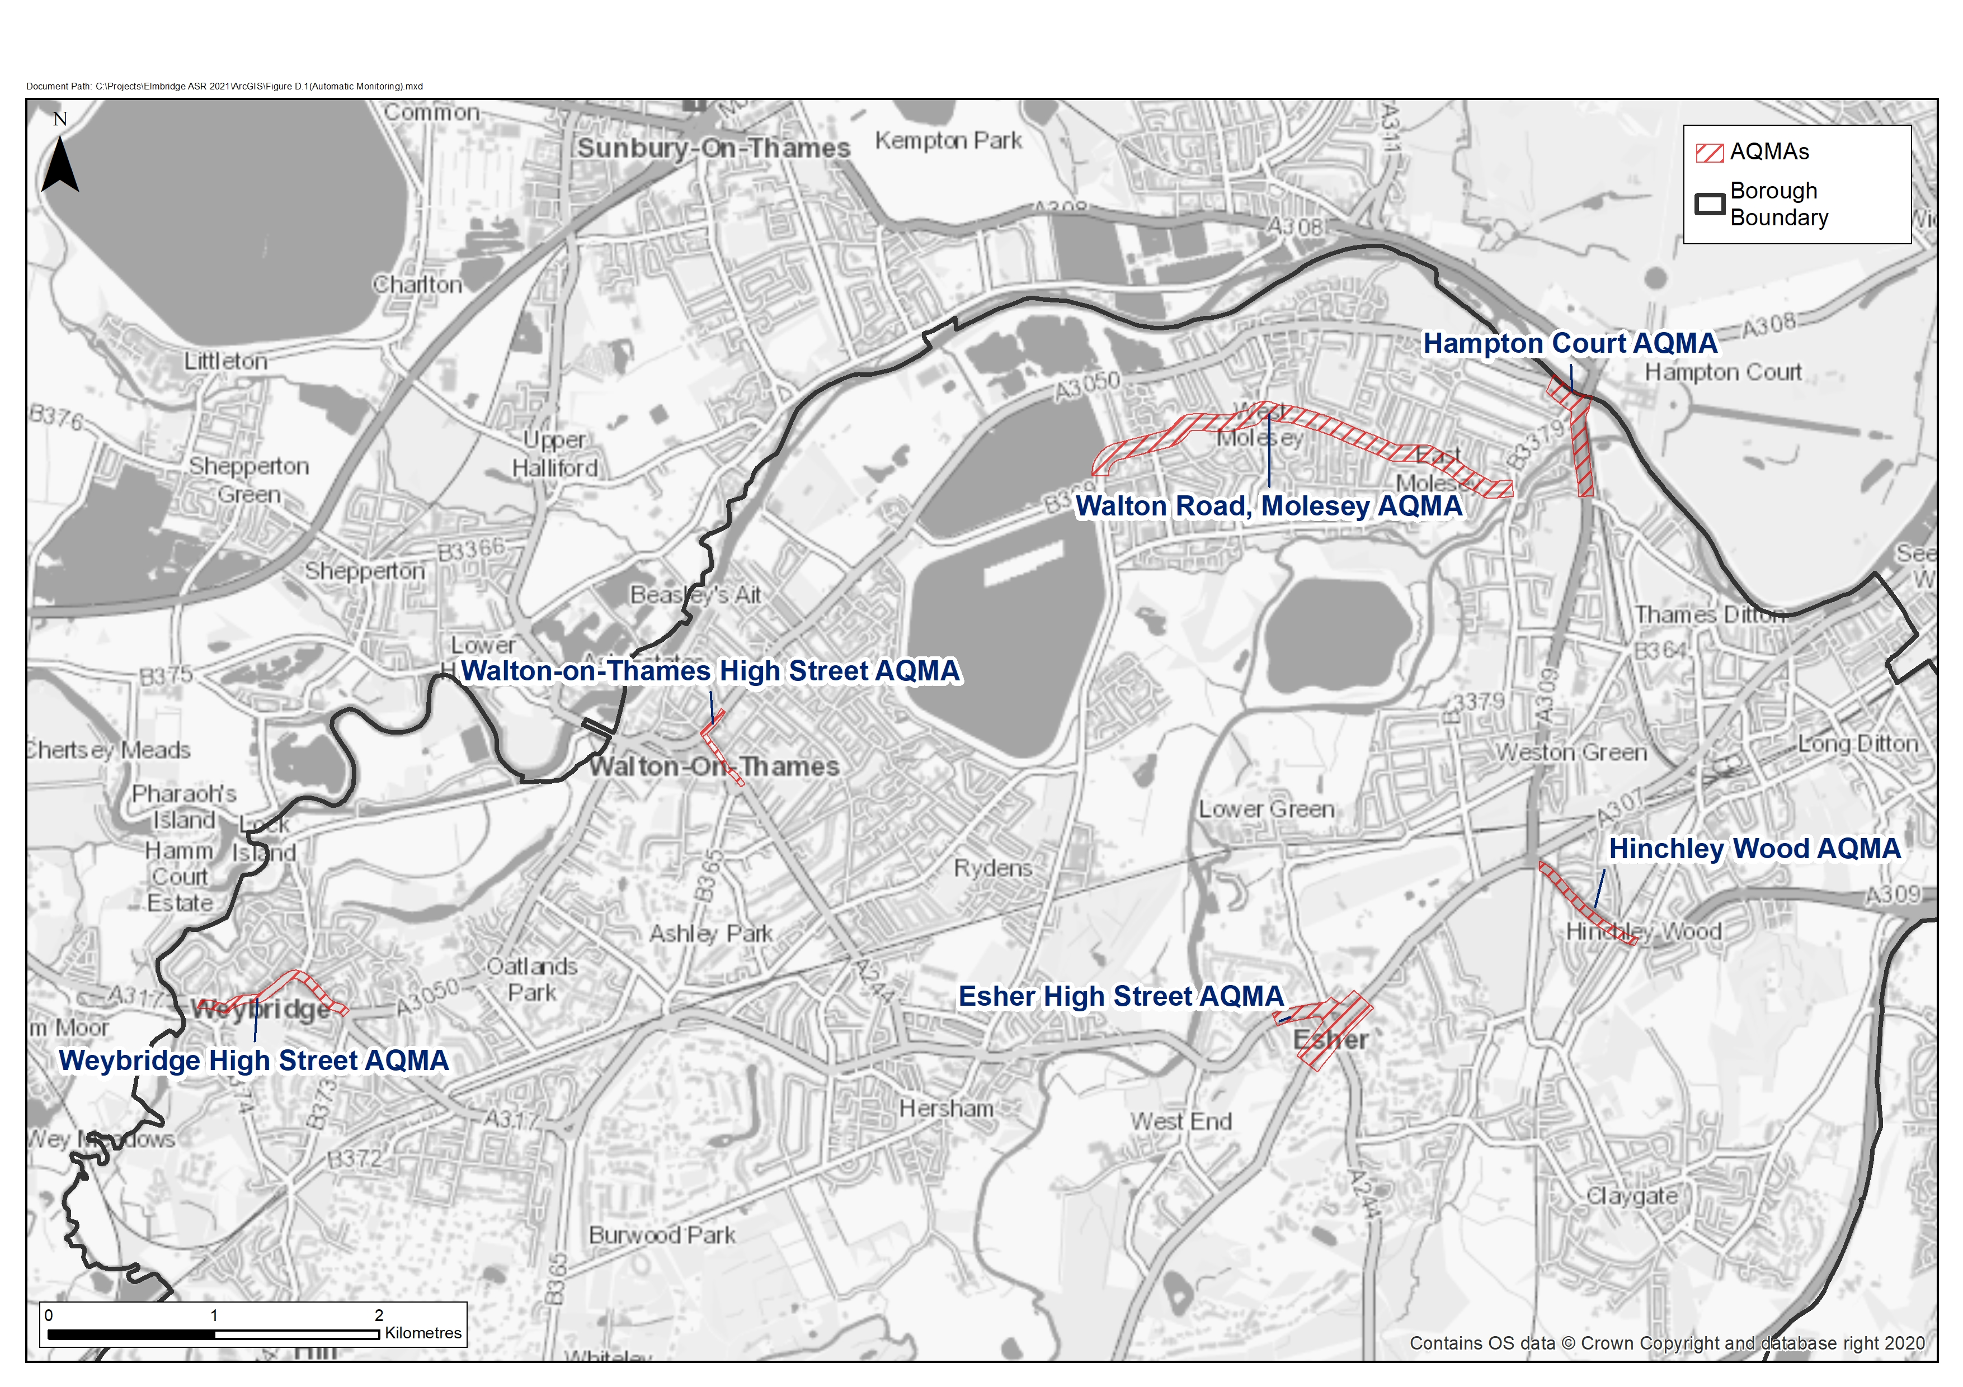
Figure 1.1: AQMAs in Elmbridge Borough

Air Quality Monitoring
The Council works to understand local air quality in the Borough through an appropriate monitoring network for NO₂ that includes passive diffusion tubes and two roadside monitoring stations. A particulate monitoring station is planned for 2022.

Details of monitoring locations and monitoring data for Elmbridge are provided in the Council’s Air Quality Annual Status Reports at: https://www.elmbridge.gov.uk/pollution/local-air-quality/

In 2019, monitoring in the Borough showed that there are still breaches of the legal objective for annual mean NO₂ within three of the Council’s six existing AQMAs (Esher High Street, Weybridge High Street and Hampton Court). Within the remaining AQMAs, levels of NO₂ were close to exceeding the objective (i.e. within 10%). Table 1.1 below shows the reduction in NO₂ required in each of the AQMAs. Although the legal objective is 40 µg/m³ for annual mean NO₂, the target value used in these calculations is 36 µg/m³. This is to take into account the requirement for NO₂ levels to be at least 10% below the legal objective for revocation of the AQMA to be considered.
Table 1.1: Required Reductions in NO₂ Concentrations
Location | 2019 Measured Annual Mean NO₂ Level (µg/m³) | Reduction Required in NO₂ (µg/m³)
Esher High Street | 46ª | -10
Weybridge High Street | 45.6^{b} | -9.6
Hampton Court | 41^{c} | -5
Walton-on-Thames High Street | 39.2^{d} | -3.2
Walton Road, Molesey | 39.4e | -3.4
Hinchley Wood | 37.4^{f} | -1.4
a) Measured at Esher 7
b) Measured at Weybridge 7
c) Measured at Hampton Court Parade automatic monitor
d) Measured at Walton 10
e) Measured at Molesey 8
f) Measured at Hinchley Wood 1

In 2020, lockdown restrictions due to the COVID-19 had a significant impact on road traffic volumes, and subsequent air pollution levels. Despite the reductions seen in pollution levels in Elmbridge’s AQMAs during 2020, further action is still required as there is uncertainty surrounding future trends in air quality following the return of traffic flows to pre-pandemic levels. Further discussion regarding the impacts of the COVID-19 pandemic on air quality in Elmbridge is provided in Appendix B.
Whilst levels of Particulate Matter (PM) do not exceed legal objectives in Elmbridge, particulates are associated with adverse health effects. Associations between health effects and long-term exposure to PM_{2.5} are particularly strong, as particles of this size can enter the blood stream and are linked to a range of health effects including cardiovascular and respiratory illness.
The World Health Organisation (WHO) has set Guideline Values for PM which are more stringent than current legal objectives and the Council is committed to protecting the health of the Borough’s population and achieving the WHO Guideline Value for PM_{2.5} across the Borough by 2030 as part of this Air Quality Action Plan (AQAP). In September 2021 the WHO introduced even more stringent Guideline Values for particulates, the AQAP target will remain at the former Guideline Value of 10 µg/m³ for PM_{2.5}. The DEFRA background maps provide estimated background levels of PM_{2.5} across Elmbridge in future years. In 2030, the latest background maps indicate that predicted annual mean background levels of PM_{2.5} will range between 8.5 – 10.7 µg/m³. Therefore, it is considered more appropriate and realistic for Elmbridge Borough Council to commit to achieving the former annual mean WHO Guideline Value of 10 µg/m³ for PM_{2.5}, rather than the revised Guideline Value of 5 µg/m³, by 2030.
The proposed Environment Bill 2019 – 2021 also introduces a duty on the government to set new long-term targets for PM_{2.5} by October 2022. A key action under this AQAP will be to install a particulate (PM₁₀ and PM_{2.5}) monitor to establish a baseline for levels of this pollutant in the Borough, and to monitor progress in reducing particulate levels.

Air Quality Modelling
Air dispersion modelling is a technique used to simulate how air pollution moves through the atmosphere. Surrey-wide dispersion modelling, carried out by Cambridge Environmental Research Consultants (CERC), establishes a clear baseline of key air pollutants across Elmbridge and the wider-Surrey area. The contour maps of predicted levels of pollutants across Elmbridge show the clear relationship between busy roads and high pollutant levels, as illustrated in Figure 1.2. It should be noted that the contour maps show predicted pollutant levels, which take into account a degree of uncertainty and there are therefore likely to be some discrepancies between the predicted and measured pollutant levels in the Borough. The interactive contour maps of modelled pollutant levels are hosted on the Surrey County Council (SCC) website and can be viewed in detail at:
https://surreycc.maps.arcgis.com/apps/webappviewer/index.html?id=43910ffb100248ed972115b7a9b49d20.
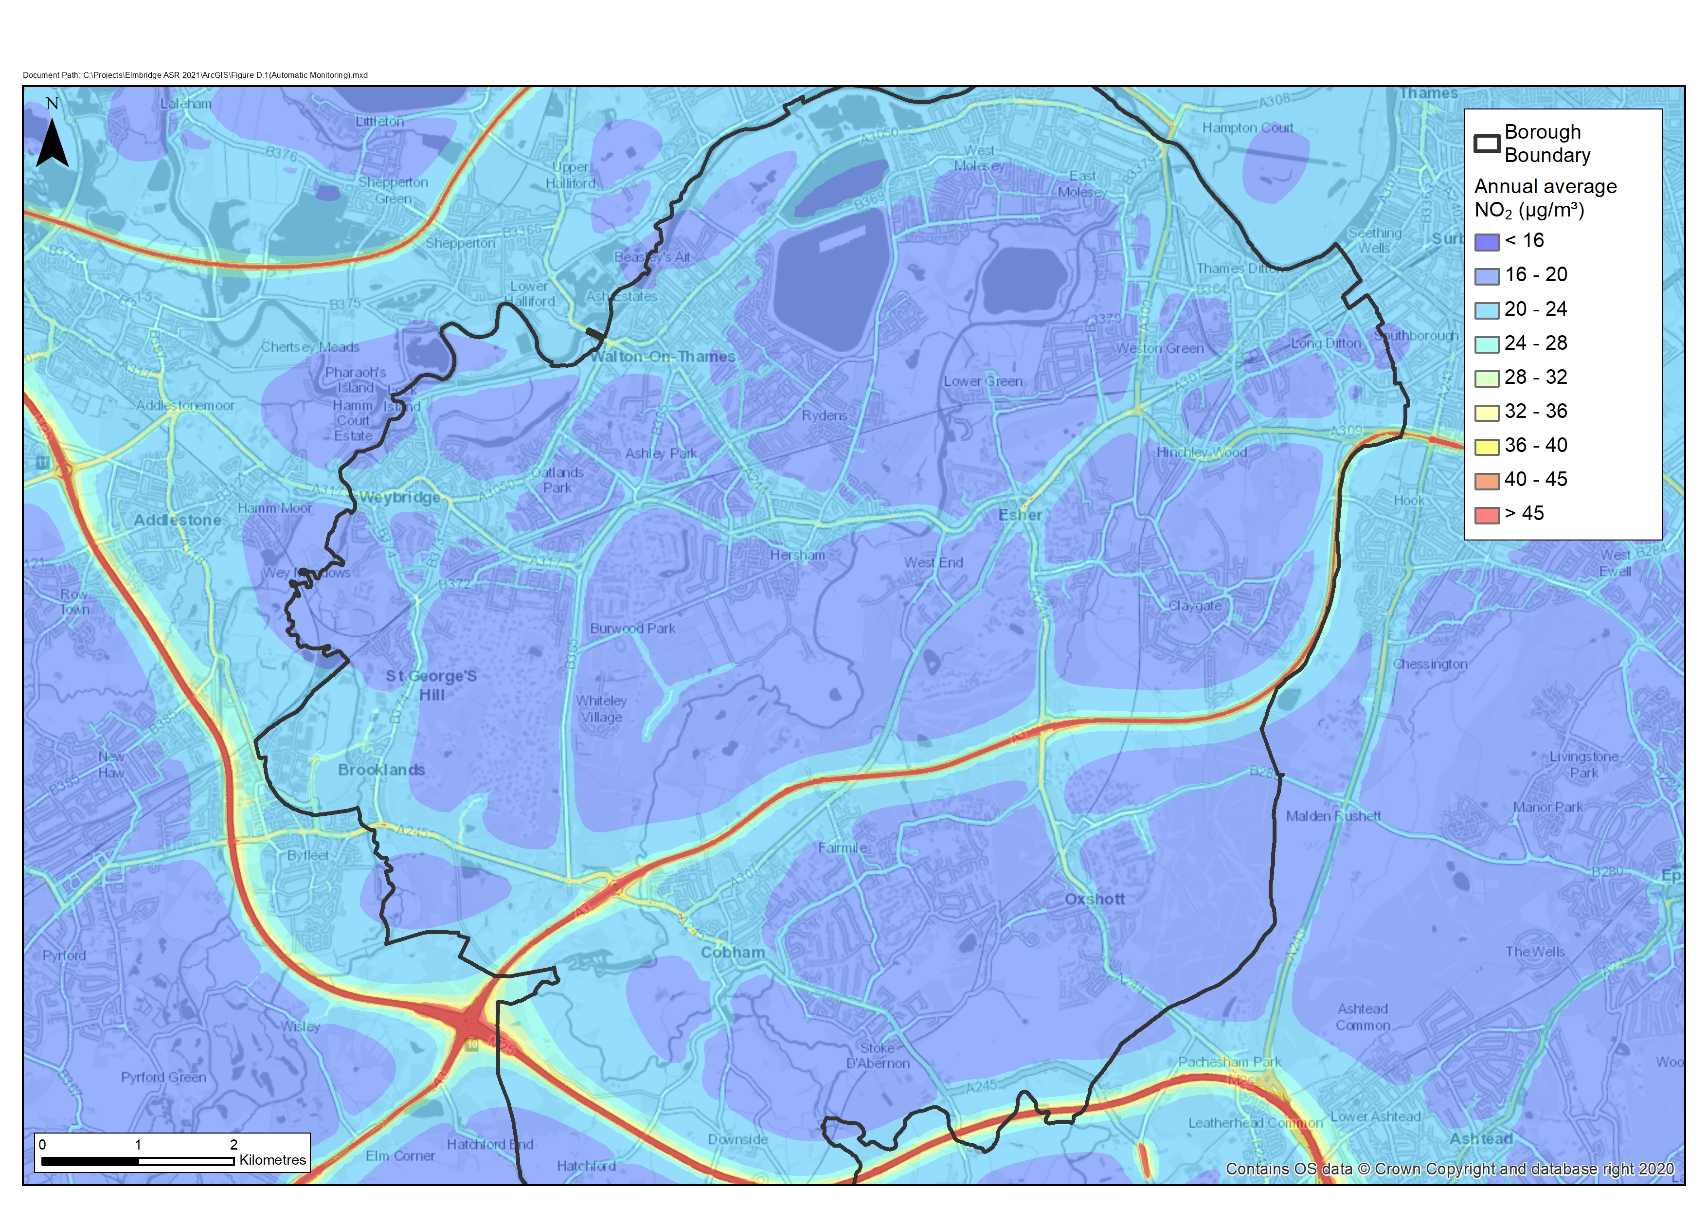
Figure 1.2: Modelled Annual Mean NO₂ Concentrations across Elmbridge in 2017

Elmbridge’s Air Quality Priorities

The following key priorities have been developed taking into account the following:
- the public health context (Appendix C);
- the planning and policy context (Appendix D);
- the sources of pollution in Elmbridge (Appendix E);
- the reduction in emissions required to achieve the legal objectives (Appendix F); and
- estimated reductions in emissions from various AQAP measures (Appendix G).
The AQAP priorities for delivering compliance within the AQMAs, and improving air quality across the Borough are:


- Priority 1 – reducing NO₂ levels with the boroughs AQMAs to below the objective in the shortest time practicable.
- Priority 2 - targeting PM_{2.5} through a range of interventions with the aim of reaching the World Health Organisations former recommended level of 10 µg/m³ by 2030 within the Borough.
- Priority 3 – modal shift to more sustainable transport.
- Priority 4 – ensuring air quality continues to be a priority within the Council’s policies and those of SCC and assist in delivering the projects and actions.
- Priority 5 – partnership working as part of the Surrey Air Alliance (SAA) to improve Surrey’s air quality.

AQAP Measures

Table 3.2 and Table 3.3 provide the AQAP measures with the aim of improving air quality in Elmbridge and achieving the Councils’ Air Quality Priorities. They contain:
- a list of the actions that form part of the Plan;
- the responsible individual and departments/organisations who will deliver this action;
- a cost-benefit rating for each action based upon the cost-benefit analysis provided in Appendix I;
- the timescale for implementation; and
- how progress will be monitored.

Elmbridge Borough Council-led actions are detailed in Table 3.2, whilst Table 3.3 outlines Surrey County Council-led actions. The AQAP measures are categorised into the under the following five themes:
- reducing emissions from transport;
- reducing emissions from buildings and new development;
- monitoring;
- raising awareness; and
- lobbying and partnership working.

In developing this AQAP, we have worked with other local authorities, agencies, businesses, and the local community to improve local air quality. Appendix H provides details of the consultation undertaken and responses considered in the development of this AQAP.
Table 3.2: Elmbridge Borough Council AQAP Measures
Measure No. | Measure | Category | Classification | Lead Authority | Planning Phase | Implementation Phase | Key Performance Indicator | Effectiveness Rating | Cost Benefit Rating | Progress to Date | Estimated Completion Date | Comments
Reducing Emissions from Transport
EBC-1 | Use of, and exploration of possibilities for increasing use of, Council electric vehicles for journeys within the Borough and supporting electric vehicle use by Council contractors | Promoting Low Emission Transport | Public Vehicle Procurement – prioritising uptake of low emission vehicles | EBC | - | Each new vehicle purchased by EBC will be considered to be low emission / electric | Usage of >1900 miles/month to be cost effective | Very small | Medium | Jan to Dec 2019 usage 16,497 miles (1,375 average miles per month).  Parking enforcement contractor moved to green fleet. | Review  2025 | The Carbon Management and Reduction Plan includes actions that will assist in the implementation of this measure including:  - Review of the Council’s internal purchases, working towards the ambition of an ultra-low carbon fleet.  - Replace and review existing electric vehicle fleet and increase number of electric pool cars.  The full Carbon Management and Reduction Plan can be viewed at: https://www.elmbridge.gov.uk/pollution/climate-change/
EBC-2 | Increasing the number of electric vehicles charging points in Council car parks | Promoting Low Emission Transport | Procuring alternative refuelling infrastructure to promote Low Emission Vehicles, EV recharging, gas fuel recharging | EBC | - | Phase 1 – main town centre car parks to be equipped with fast charging points | No. of charging points installed | Small | Medium | As part of an upgrade to council car parks, the charger at Holly Hedge Car Park in Cobham was replaced with four fast charging points and Esher Civic Centre and Churchfield Weybridge car parks to be completed by end 2022. | 2022 | A requirement for all developments to implement electric vehicle charging points to be included in the emerging Local Plan.  The Council adopted the Parking Supplementary Planning Document in July 2020. The document includes standards that new developments are expected to meet in relation to electric vehicle charging infrastructure.  The Parking SPD is available at: https://www.elmbridge.gov.uk/planning/local-plan/strategic-planning/supplementary-planning-documents/
EBC-3 | Use of a tiered fee structure for taxi licensing to benefit operators with lower emission vehicles | Promoting Low Emission Transport | Taxi emission incentives | EBC | - | - | Percentage/ type diesel vehicles remaining | Small | High | New EBC Taxi and Private Hire Licensing Policy adopted in September 2020. | 2026 | The EBC Taxi and Private Hire Licensing Policy 2020 – 2025 includes a commitment to phase out use of all diesel-fuelled vehicles and petrol-fuelled vehicles that do not meet the latest Euro standard. From September 2020, new licences will not be issued for diesel-fuelled vehicles or petrol-fuelled vehicles that do not meet the latest Euro standard.  Furthermore, if a licence holder wishes to replace their vehicle, the replacement vehicle must meet a higher Euro emission standard that the existing vehicle.  The Taxi and Private Hire Licensing Policy is available at:  https://www.elmbridge.gov.uk/licensing/policies-and-information-for-passengers/  Also see SCC-3 Table 3.2, SAA DEFRA grant from Taxi project
EBC-4 | Reducing Council staff and fleet transport emissions as part of the Council’s Carbon Reduction Strategy | Promoting Travel Alternatives | Workplace Travel Planning | EBC | - | 2020 - 2030 Phased in Carbon Management and Reduction Plan. | Latest carbon reduction action plan updates. | Very small | Medium | Initial assessment of emissions completed. | 2030 | The Carbon Management and Reduction Plan (CRMP) includes actions that will assist in the implementation of this measure including:  - Review of the Council’s internal purchases, working towards the ambition of an ultra-low carbon fleet.  - Replace and review existing electric vehicle fleet and increase number of electric pool cars.  The full Carbon Management and Reduction Plan can be viewed at: https://www.elmbridge.gov.uk/pollution/climate-change/
EBC-5 | Investigate options for a pilot cargo bike scheme for local businesses | Promoting Travel Alternatives | Promotion of cycling | EBC | 2021-2022 | 2022-23 | - | Very small | Medium | - | - | High streets are where the Boroughs AQMAs are located. Exploring alternate delivery options for high street businesses could help reduce emissions within AQMAs. SCC to implement measure through the Local Transport Plan 4 (LTP4).
Building and New Development
EBC-6 | Work towards fulfilling the Council’s pledge to be carbon neutral by 2030 | Promoting Travel Alternatives | Other | EBC | - | Ongoing. 2020- 2030 phased in Carbon Management and Reduction Plan. | - | Small | Medium | Key priority in the Council’s Service and Delivery Plan for 2020/2021.  Carbon Management and Reduction Plan adopted. | 2030 | The Carbon Management and Reduction Plan contains actions aimed at fulfilling the Council’s Carbon neutral pledge. Such actions that will also be beneficial to air quality include:  - Seeking strategic direction on enabling remote working for Council staff.  - Replacement of gas-fired boilers with electric or other state-of-the-art technologies at the Civic Centre.  - Planning for future replacement of gas-fired boilers at community centres.  The full Carbon Management and Reduction Plan can be viewed at: https://www.elmbridge.gov.uk/pollution/climate-change/  The emerging Local Plan will also seek to encourage more sustainable development through the implementation of policies regarding energy usage etc.
EBC-7 | Embed air quality in the Local Plan | Policy Guidance and Development Control | Air Quality Planning and Policy Guidance | EBC | 2021 | 2022/23 | Adoption of an Air Quality within Design and a renewables focused SPD. | Medium | High | - | 2023 | The emerging Local Plan will seek to encourage more sustainable development through the implementation of policies regarding matters such as energy usage, sustainable transport modes and electric vehicle charging requirements, etc.  Specific guidance relating to air quality is to be covered in two SPD’s, focused on design and renewables. Consideration will be given to a separate SPD on air quality if required. These will incorporate air quality positive principles.  The latest information regarding the emerging Local Plan can be found at: https://www.elmbridge.gov.uk/planning/local-plan/
EBC-8 | Indoor air quality to be considered as part of the planning process for new development in the AQMAs | Policy Guidance and Development Control | Air Quality Planning and Policy Guidance | EBC | 2020-2021 | Ongoing | Number of planning applications in AQMA with indoor air quality considered | Small | High | - | 2021-2026 | Housing within existing high streets is on the increase. The six AQMA’s are all high street locations. While indoor air quality is not the primary focus of an AQAP it is included as an action on the grounds of public health.  Consideration will be given to inclusion within an SPD on air quality.
EBC-9 | Investigate including Air Quality Positive principles in a Design and Renewables SPD | Policy Guidance and Development Control | Air Quality Planning and Policy Guidance | EBC | 2021-2022 | 2022-23 | Number of planning applications considered to be air quality positive | Small | High | - | 2023 | Details on how this can be achieved to be provided within SPD’s covering design and renewables. Also, a separate SPD on air quality if required.  The Publication London Plan (December 2020), which is intended to be published in 2021, requires large-scale developments to consider how air quality can be improved across the area through an Air Quality Positive approach.  The Air Quality Positive approach requires new development proposals to consider ways in which the development could maximise benefits to local air quality, as well as what measures and design features that will be put in place to reduce exposure to air pollution.
EBC-10 | Encouraging residents to refrain from garden bonfires | Public Information | Via the internet | EBC | - | Ongoing | Reduction in the number of “bonfire” complaints received | Very small | Medium |  | 2026 | Use of the Council’s website and social media to promote changes in behaviour to move away from burning.
EBC-11 | Promoting approved wood-burning stoves and burning of approved products and encouraging recycling of waste | Promoting Low Emission Plant | Shift to installations using low emission fuels for stationary and mobile sources | EBC | - | 2022 | - | Very small | Medium | Animation video on wood burning stoves produced with the SAA. | Video launched for Clean Air Day Nov 2020.  Ongoing promotion  Animation to be updated 2022 | Wood burning stove animation video.  SAA plan on update to animation following new guidance.
Monitoring
EBC-12 | Ensure appropriate and effective monitoring is undertaken across Elmbridge to meet statutory review and assessment duties | Other | Other | EBC | - | 2021-26 | Production of Air Quality Annual Status Report | Small | High | Annual reports produced. | 2021 ASR submitted June 2021 | The Council seeks to maintain and run and efficient monitoring network. That includes monitoring for nitrogen dioxide via passive diffusion tubes and two monitoring stations.
EBC-13 | Installation of a PM_{2.5} monitor in Elmbridge | Other | Other | EBC | 2020-2021 | 2022 | Installation of a PM_{2.5} monitoring site | Small | Medium | Application submitted for CIL funds. | 2022 | A Community Infrastructure Levy (CIL) bid was submitted in March 2021 for a roadside particulate monitor.  The Councils Cabinet meeting on 7 July 2021 approved the CIL funding. The project has started with a planned completion in 2022.
EBC-14 | CERC Surrey-wide air quality modelling update | Other | Other | EBC (in partnership with the SAA) | 2022-2023 | 2024 | Air quality modelling undertaken | Small | Medium | - | 2024 | To undertake updated borough modelling in 2024.
EBC-15 | Review of diffusion tube locations across the Borough following CERC modelling update | Other | Other | EBC | 2024 | 2025 | Report on diffusion tube location review produced | Small | High | - | 2025 | Once updated borough modelling has been undertaken, a further review of diffusion tube locations will be carried out.
EBC-16 | Monitor impact of London Low Emission Zones in Elmbridge AQMAs | Other | Other | EBC | - | 2020 Onwards | Results of traffic surveys and reported in air quality annual status reports | Small | High | SAA to monitor the situation | 2026 | Potential for negative impacts in Esher and Hampton Court with traffic rerouting around LEZ. Identification of any issues will allow further actions to be targeted in these areas.
Raising Awareness
EBC-17 | Continuation of the Schools Air Quality Programme | Public Information | Via other mechanisms | EBC (in partnership with the SAA) | - | Ongoing | No. children reached by promotional / engagement activities | Very small | Medium | - | 2026 | SCC and the SAA continue to support the role out of a school’s programme including Golden and Green Boot Challenges.  September 2021 – new online teaching package on air quality available to all schools in Surrey.
EBC-18 | Use of the EBC website to promote public awareness of the Elmbridge AQMAs and air quality in general | Public Information | Via the internet | EBC | - | Ongoing | Latest ASR available on website | Very small | Medium | - | Ongoing | The Council’s website publishes the ASRs back to 2017, provides a link to the CERC modelling map, plus links to both real time monitors along with a range of advice https://www.elmbridge.gov.uk/pollution/local-air-quality/
EBC-19 | Continue to promote the AirAlert service | Public Information | Via other mechanisms | EBC | - | Ongoing | Number of residents subscribed in Elmbridge | Very small | Medium | 282 subscriptions  October 2021 | Ongoing | Elmbridge continues to have the highest number of subscriptions within Surrey as of October 2021.  AirAlert to be promoted via social media and website.
EBC-20 | Clean Air Day Activities | Public Information | Via other mechanisms | EBC | 2020 | Ongoing annual project | - | Very small | Medium | - | 2026, next CAD 2022 | Support the annual Clean Air Day (CAD)
EBC-21 | Raise awareness of indoor air pollution through the EBC website and social media | Public Information | Via the internet and social media | EBC | - | Ongoing | Information available on website | Very small | Medium | - | 2021 and Ongoing | Consideration is also given to planning applications for residential development with AQMA’s and the likely impacts on indoor air quality
Lobbying and Partnership Working
EBC-22 | Remain an active member of the Surrey Air Alliance and contributors to Work Plan | Policy Guidance and Development Control | Regional groups co-ordinating programmes to develop area-wide strategies to reduce emission and improve air quality | EBC | - | Ongoing | Adoption of Work Plan | Small | High | Constitution adopted and workplan produced. Regular meetings held. | Ongoing | The SAA facilitates Surrey Authorities, and SCC working together to improve air quality in Surrey.  Examples of large projects include CERC County wide modelling project, DEFRA grant for school’s project and the recent DEFRA grant for Electric Taxi fleet trial see measure SCC 3 in Table 3.2.
EBC-23 | Work with the Surrey Authorities to achieve WHO Guideline Values for PM₁₀ and PM_{2.5} in the Elmbridge Borough by 2030 and any further UK Government targets introduced. | Policy Guidance and Development Control | Regional groups co-ordinating programmes to develop area-wide strategies to reduce emission and improve air quality | EBC (in Partnership with Surrey Authorities) | - | Ongoing | Achievement of WHO Guideline Values across Elmbridge | Small | High | - | 2030 | Various measures within the AQAP will assist in quantifying particulate levels within the Borough and seek to reduce PM levels within a local authority sphere of control.

Table 3.3: Surrey County Council AQAP Measures
Measure No. | Measure | Category | Classification | Lead Authority | Planning Phase | Implementation Phase | Key Performance Indicator | Effectiveness Rating | Cost Benefit Rating | Progress to Date | Estimated Completion Date | Comments
Reducing Emissions from Transport
SCC-1 | Supporting Transport for South East | Policy Guidance and Development Control | Other policy | SCC | - | Ongoing | - | Large | Medium | Transport Strategy adopted in Summer 2020. | Ongoing Implementation | Elmbridge is located within two of the five study areas (the inner orbital and southwest radial). The outcome of these studies will form the basis of the Transport for South East Strategic Investment Plan for new transport schemes, initiatives, and policies. The Strategic Investment Plan is expected to be published in 2022.  Further information on Transport for South East can be found at: https://transportforthesoutheast.org.uk/
SCC-2 | Implementation of the Low Emission Transport Strategy for Surrey | Policy Guidance and Development Control | Low Emission Strategy | SCC | - | Ongoing | Suite of indicators associated with quantum and distribution of air pollution, travel behaviour and delivery of infrastructure for low emission transport options | Large | Medium | Strategy in use | Ongoing Implementation | The Strategy is backed by £49 million of county council funding and will see the introduction of up to 80 ultra-low or zero-emission buses and 50 community transport minibuses by 2025 with the aim that all buses across the county will be ultra-low or zero-emission by 2030.  The full Low Emission Transport Strategy for Surrey can be viewed at: https://www.surreycc.gov.uk/roads-and-transport/policies-plans-consultations/transport-plan/surrey-transport-plan-strategies/low-emissions-transport-strategy
SCC-3 | Support an electric vehicle strategy for Surrey | Policy Guidance and Development Control | Low Emission Strategy | SCC | - | Ongoing | - | Medium | Medium | Electric Vehicle Strategy produced and adopted by Elmbridge Borough Council | Ongoing Implementation  As of June 2021, project in initial stages with a plan to implement Autumn/Winter 2021 | SCC electric vehicle charging infrastructure pilot underway. The pilot is trialling fast chargers in urban and residential streets in Guildford, Woking, Spelthorne and Waverley. The findings of the pilot will be used to develop EV charging design and policy guidelines. A report on lessons learned will be prepared to inform the delivery of a county-wide roll-out of EV charging infrastructure.  The SAA has also submitted a grant application to DEFRA for an electric taxi fleet trial including telemetric devices in vehicles.  In March 2021 the project was awarded £256,868 from the DEFRA Air Quality Grant Fund.  The Electric Vehicle Charging Strategy is available at: https://www.surreycc.gov.uk/roads-and-transport/policies-plans-consultations/transport-plan/surrey-transport-plan-strategies/electric-vehicle-strategy
SCC-4 | Implementation of the Climate Change Strategy for Surrey | Policy Guidance and Development Control | Other policy | SCC | - | Ongoing | Implementation of Strategy | Medium | Medium | Strategy in use | Ongoing Implementation | The Strategy has been considered by 11 Districts and Boroughs.  The Strategy includes measures that will be beneficial for air quality. Air quality-related actions are provided in the section ‘Transport and Air Quality’ of the Strategy which can be viewed at: https://www.surreycc.gov.uk/people-and-community/climate-change/what-are-we-doing/climate-change-strategy/surreys-climate-change-strategy-2020
SCC-5 | Development and implementation of a Local Cycling and Walking Infrastructure Plan (LCWIP) for Elmbridge Borough | Promoting Travel Alternative | Intensive active travel campaign and infrastructure | SCC | 2021 | 2022 | Completion and adoption of the LCWIP | Small | Medium | - | 2022-2032 - implementation of the LCWIP would be ongoing over next 10 years.  2021 - policy completed  2021 -2022 - identify locations and corridors that need improvement.  2022-2023 -  feasibility and business cases for projects.  2023-2024 - target for first projects to be delivered.  2025 - delivery programme continues. | The LCWIP is a ten-year programme and would include the following:  - Identification of where good walking and cycling facilities would be most beneficial.  - Identify what improvements are required at these locations.  Plan how these improvements can be delivered, and which prioritise first.
SCC-6 | Alteration of existing signalised pedestrian crossings on the High Street, Weybridge to reduce congestion | Traffic Management | Other | SCC | 2020-2021 | - | - | Small | Medium | Study on going to determine feasibility | Medium term | Still at feasibility stage. Work brief was issued to SCC’s Professional Services Highway Partner in August 2021, awaiting work programme.
SCC-7 | Improvements to the Hampton Court Roundabout/ junction to reduce congestion | Traffic Management | Other | SCC |  | - | - | Small | Medium | The Planning application was refused. | - | An agreed scheme as part of a development proposal. Could be implemented either as part of development or a standalone scheme. The planning application was refused (July 2021).  Applicant may submit an appeal.
SCC-8 | Installation of additional pedestrian facilities on Esher High Street | Promoting Travel Alternatives | Promotion of walking | SCC | 2020-2021 | - | - | Small | Medium | Feasibility study in progress | Medium term | Feasibility study remains in progress. Following a recent LSWIP workshop, feedback received noted this location is a core walking area and needs a broader consideration of the local aspirations and the competing place vs. movement functions of the road. Significant improvements to achieve the ‘place’ objective and improve pedestrian facilities would likely require a reduction in capacity
Lobbying and Partnership Working
SCC-9 | Working with SCC to ensure that Air Quality is appropriately considered within the Local Transport Plan 4 (LTP4) | Policy Guidance and Development Control | Regional groups co-ordinating programmes to develop area-wide strategies to reduce emission and improve air quality | SCC | 2020 | 2022 | - | Small | Medium | - | Ongoing | By the end of 2020 visions, objectives and core principles to be developed. LTP development to be started in 2021. Adoption anticipated by early 2022.

Appendix A: Glossary of Terms
Abbreviation | Description
AQAP | Air Quality Action Plan - A detailed description of measures, outcomes, achievement dates and implementation methods, showing how the local authority intends to achieve air quality limit values’
AQMA | Air Quality Management Area – An area where air pollutant concentrations exceed / are likely to exceed the relevant air quality objectives. AQMAs are declared for specific pollutants and objectives
AQS | Air Quality Strategy
ASR | Air quality Annual Status Report
CERC | Cambridge Environmental Research Consultants
DEFRA | Department for Environment, Food and Rural Affairs
COMEAP | Committee on the Medical Effects of Air Pollution
DfT | Department for Transport
EBC | Elmbridge Borough Council
EFT | Emission Factor Toolkit
EU | European Union
HDV | Heavy Duty Vehicles (vehicles >3.5 tonnes + buses)
HGV | Heavy Goods Vehicle (vehicles >3.5 tonnes)
LAQM | Local Air Quality Management
LGV | Light Goods Vehicle
NO₂ | Nitrogen Dioxide
NO_{x} | Nitrogen Oxides
PM₁₀ | Airborne particulate matter with an aerodynamic diameter of 10µm (micrometres or microns) or less
PM_{2.5} | Airborne particulate matter with an aerodynamic diameter of 2.5µm or less
SCC | Surrey County Council
WHO | World Health Organisation

Appendix B: Impacts of COVID-19 on Air Quality
COVID-19 has had a significant impact on society. Inevitably, COVID-19 has also had an impact on the environment, with implications to air quality at local, regional and national scales.
On 23rd March 2020, the UK Government released official guidance advising all members of public to stay at home, with work-related travel only permitted when absolutely necessary. During this initial national lockdown (and to a lesser extent, other national and regional lockdowns that followed), marked reductions in vehicle traffic were observed; Department for Transport (DfT) data suggests reductions in vehicle traffic of up to 70% were experienced across the UK by mid-April, relative to pre COVID-19 levels.
This reduction in travel in turn gave rise to a change of air pollutant emissions associated with road traffic, i.e. nitrous oxides (NOx), and exhaust and non-exhaust particulates. The Air Quality Expert Group (AQEG) has estimated that during the initial lockdown period in 2020, within urbanised areas of the UK reductions in NO₂ annual mean concentrations were between 20 and 30% relative to pre-pandemic levels, which represents an absolute reduction of between 10 to 20 µg/m³ if expressed relative to annual mean averages. During this period, changes in PM_{2.5} concentrations were less marked than those of NO₂. PM_{2.5} concentrations are affected by both local sources and the transport of pollution from wider regions, often from well beyond the UK. Through analysis of Automatic Urban and Rural Network (AURN) monitoring data for 2018-2020, AQEG have detailed that PM_{2.5} concentrations during the initial lockdown period are of the order 2 to 5 µg/m³ lower relative to those that would be expected under business-as-usual conditions.
In Elmbridge, a decrease in annual mean NO₂ concentrations was experienced at all monitoring sites across Elmbridge in 2020 when compared to 2019. There were no exceedances of the annual mean NO₂ objective within any of Elmbridge’s six AQMAs in 2020. The percentage reductions within each AQMA are shown in Table B. 1.
Table B. 1: Percentage Reduction in Annual Mean NO₂ (µg/m³) between 2019 and 2020 in the AQMAs
AQMA | Reduction in Annual Mean NO₂ (%)
Esher High Street | 29% - 48%
Hampton Court | 25% - 37%
Walton Road, Molesey | 30% - 34%
Walton-on-Thames High Street | 24% - 46%
Weybridge High Street | 16% - 46%
Hinchley Wood | 26% - 39%

Despite the reductions seen in annual mean NO₂ concentrations in Elmbridge’s AQMAs, further action is still required as there is uncertainty surrounding future trends in air quality following the return of traffic flows to pre-pandemic levels.

Appendix C: Public Health Context

Air pollution is associated with a number of adverse health impacts. In its most recent report, the Committee on the Medical Effects of Air Pollutants (COMEAP) advised that the range of estimates of the annual mortality burden of human-made air pollution in the UK is estimated as an effect equivalent to 28,000 to 36,000 deaths. Additionally, air pollution particularly affects the most vulnerable in society: children and older people, and those with heart and lung conditions. There is also often a strong correlation with equalities issues, because areas with poor air quality are also often the less affluent areas.
The AQS objectives, upon which the declaration of an AQMA is based, are pollutant concentrations recorded over a given time period (e.g. the annual mean NO₂ objective of 40 µg/m³) and are designed for the protection of human health, including sensitive groups of people. Whilst the AQS objectives do not include PM_{2.5,} the 2019 Clean Air Strategy includes a commitment to set a “new, ambitious, long-term target to reduce people's exposure to PM_{2.5}” which the proposed Environment Bill 2019-2021 commits the Secretary of State to setting. Two PM_{2.5} targets to be set under the Environment Bill are currently under consideration: an annual mean PM_{2.5} concentration target; and an exposure reduction target. The Environment Bill introduces a duty on the government to set these targets by October 2022.
The AQMAs in Elmbridge have all been declared due to exceedances of the annual mean NO₂ objective and there are no declared AQMAs for particulates (PM₁₀ or PM_{2.5}) in the Borough. However, there is now a large body of evidence linking particulates to health effects at levels still found in the Borough. Associations are particularly strong for long-term exposure to PM_{2.5}, as the particles are known to enter the blood stream and are linked to a range of health effects including cardiovascular and respiratory illness. The total cost due of PM_{2.5} in the UK in relation to the NHS and social care in 2017 was estimated to be £41 million, and this is estimated to rise to £1.5 billion in 2025. The World Health Organisation (WHO) has set Guideline Values for particulates which are more stringent than the AQS objectives and the Council is committed to protecting the health of the Borough’s population and achieving the WHO Guideline Values across the Borough by 2030.
In September 2021 the WHO introduced even more stringent Guideline Values for particulates, the AQAP target will remain at the former Guideline Value of 10 µg/m³ for PM_{2.5}. The DEFRA background maps provide estimated background levels of PM_{2.5} across Elmbridge in future years. In 2030, the latest background maps indicate that predicted annual mean background levels of PM_{2.5} will range between 8.5 – 10.7 µg/m³. Therefore, it is considered more appropriate and realistic for Elmbridge Borough Council to commit to achieving the former annual mean WHO Guideline Value of 10 µg/m³ for PM_{2.5}, rather than the revised Guideline Value of 5 µg/m³, by 2030.
A priority of the Council Plan 2020/2021 focuses on Community Wellbeing and supporting communities to become healthier. To meet this priority, the Council supports the Surrey Health and Wellbeing Strategy. The Health and Wellbeing Strategy sets out SCC’s priorities for improving health and wellbeing across the population in Surrey, including environmental factors that impact people’s health and wellbeing, such as air quality. In working towards improving air quality across the Borough to below the AQS objective and WHO guideline values, this AQAP upholds the Council priority in supporting communities to become healthier by reducing exposure to poor air quality.

Appendix D: Planning and Policies Context

D.1 Elmbridge Borough Council Policies
Council Plan 2020/2021
Air quality and a healthy environment is important to the Council and measures to improve air quality also feature in our Council Plan 2020/2021Error: Reference source not found. In our five-year vision, we aim to be “a responsive and effective Council, protecting and promoting interests of residents and businesses and safeguarding our environment, while maintaining a community for all”. A number of priorities have been defined by the Council to support this vision, including a priority to respond to the Climate Change Emergency and a commitment to becoming a carbon neutral organisation by 2030. Council actions under the climate change priority that are expected to be beneficial for air quality include the installation of more electric car charging points in the Borough and refreshing the AQAP.
Core Strategy
The Core Strategy is the principal planning document that sets out the vision, spatial strategy and core policies that are used for shaping future development in the Borough up to 2026. Policies relevant to the AQAP are summarised below:
- Policy CS1 – Spatial Strategy requires new development to “be delivered in accordance with a clear spatial strategy which provides the most sustainable way to accommodate growth”.
- Policy CS25 – Travel and Accessibility. Through this policy, the Council will promote improvements to sustainable travel, and accessibility to services, through a variety of measures including:
- “directing new development with a high number of trips to previously developed land in sustainble locations”.
- “applying maximum parking standards to all uses”.
- “requiring a transport assessment and travel plan for all major development proposals in order to promote the delivery and use of sustainble transport”.
- “mitigate the detrimental environmental effects caused by transport…support will be given to schemes that help to meet the commitments contained in the Elmbridge Air Quality Strategy.”
In July 2020, the Council adopted the Parking Supplementary Planning Document to provide further detail to support the implementation of Core Strategy Policy CS25. The document includes standards that new developments are expected to meet in relation to electric vehicle charging infrastructure, car club and cycle parking provision.
Development Management Plan
The Development Management Plan (DMP) contains detailed policies that all planning applications in the Borough are assessed against. The DMP contains Policy DM5 – Pollution which states:
“Air Quality
Within designated Air Quality Management Areas, the Council will promote measures to improve air quality and will expect development proposals to avoid introducing additional sources of air pollution. For proposals falling within an Air Quality Management Area and/or where the Council considers that air quality objectives are likely to be prejudiced, applicants will be expected to submit a detailed specialist report which sets out the impact that the proposed development would have upon air quality. Planning permission will not be granted for proposals where there is significant adverse impact upon the status of the Air Quality Management Area or where air quality may have a harmful effect on the health of future occupiers of the development, taking into account their sensitivity to pollutants, unless the harm can be suitably mitigated.”
Emerging Local Plan
EBC is currently preparing a new local plan which will shape how Elmbridge is developed in the future. Once adopted the new local plan will replace the Core Strategy 2011 and Development Management Plan 2015. The new Local Plan will play a central role in addressing the climate emergency by setting out a development strategy and policies that seek to reduce carbon dioxide emissions and support the transition to a low carbon future. As well as delivering improvements to green and blue infrastructure, flood risk, air quality, recycling and waste management. The Plan will form the basis on which planning applications in the Borough will be determined.
Design and Renewables Focused Supplementary Planning Documents (SPDs)
EBC has committed to preparing two SPDs that will provide detailed guidance on the implementation of policies set out in the Local Plan. This includes detailed guidance for dealing with air quality and will be aimed at those involved in the submission and determination of planning applications where air quality needs to be addressed.
Carbon Management and Reduction Plan 2020 - 2030
The Carbon Management and Reduction Plan was approved by EBC in September 2020. The Plan outlines an ambitious ten-year action plan of projects and activities in order for EBC to become a carbon neutral organisation by 2030.
Elmbridge Borough Council Taxi and Private Hire Licensing Policy
In July 2020, the Council adopted a new Taxi and Private Hire Licensing Policy 2020 – 2025 which came into force on 1st September 2020. The new policy recognises the need to ensure the health and wellbeing of residents and aims to improve local air quality by encouraging the use of low and ultra-low emissions taxi and private hire vehicles such as electric, hybrid or liquified petroleum gas (LPG). From 1st September 2020 the Council will not issue new licences for diesel vehicles and all new petrol vehicles must meet the latest Euro emissions standards. By 1st January 2026 the Council will phase out the use of all diesel vehicles and petrol vehicles that do not meet the latest Euro emissions standard.

D.2 Regional Overarching Policies and Plans
Transport for the South East was established in 2017 to determine what transport infrastructure is needed to boost the region’s economy. The partnership is made up of sixteen local authorities, five local enterprise partnerships plus representatives of district and borough authorities, and protected landscapes and national delivery agencies.
The role of Transport for the South East is to add strategic value by making sure that funding and strategy decisions about transport in the South East are informed by local knowledge and priorities. At the heart of this is the transport strategy, which was published in Summer 2020 and sets out the partnership’s shared vision for a better connected, more prosperous, and more sustainable South East by 2050.
To turn the vision into reality, work is taking place with key partners and stakeholders across the region to determine what the South East’s priority transport schemes, initiatives and policies should be. This is being undertaken through a series of area studies (five in total).
Each study will investigate the issues, challenges and opportunities identified in the transport strategy in more detail and, ultimately, identify a shortlist of interventions to make life better for people, for businesses and for the environment. The outcomes of these studies will form the basis of the strategic investment plan – a blueprint for investment which Transport for the South East want to deliver with government and national bodies like Network Rail and Highways England.
Elmbridge is located in two study areas:
- The inner orbital
- Southwest radial
The inner orbital area encompasses the strategic cross-regional routes around the southern outskirts of London. It includes the M25 London Orbital motorway, which is the busiest and most congested highway corridor in the South East area. It also includes the roads that serve Heathrow Airport, the Medway Ports, and Thamesport. Further information on Transport for South East can be accessed through the following link:
https://transportforthesoutheast.org.uk/our-work/transport-strategy/

D.3 Surrey County Council Overarching Policies
Surrey’s Climate Change Strategy
Surrey’s Climate Change Strategy provides a joint framework for collaborative action on climate change across Surrey’s local authorities and other partners. The strategic priorities and accompanying actions will deliver against Surrey’s emissions-based reduction targets. Section 1.2 of the Strategy is focused specifically on transport and air quality, with an ambition to “deliver and promote an integrated, accessible, affordable and reliable public and active (walking or cycling) transport system across the County, thereby reducing journeys and improving local air quality for improved health and wellbeing of our residents”. The following strategic priorities relating to transport and air quality are included in the Strategy:
- Strategic Priority 1 – “Prioritise investment in place-based development that creates well-connected communities close to high quality places, spaces and services to reduce the number and length of car journeys for all residents.”
- Strategic Priority 2 – “Invest in initiatives and infrastructure to increase the uptake of walking cycling and public transport, alongside schemes to reduce reliance on the car e.g. ultra-low emission zones, pedestrianisation and car-free zones.”
- Strategic Priority 3 – “Invest in and support the development of the infrastructure required to support the move to zero emission vehicles for journeys that cannot be made on foots, by bicycle or public transport.”
Surrey Local Transport Plan 3
The Surrey Local Transport Plan 3 (LTP3) is a statutory plan required by the Local Transport Act 2008 and Transport Act 2000. The vision of the plan is to “help people meet their transport and travel needs effectively, reliably, safely and sustainably within Surrey; in order to promote economy, protect and enhance the environment and improve quality of life”.
A number of transport strategies form part of the Surrey Transport Plan including a Low Emission Transport Strategy. The Low Emission Transport Strategy aims “to reduce polluting emissions from road transport across the county which are harmful to health and the environment, and work with partners to achieve legal compliance with air quality locally.” A range of activities to deliver the Low Emissions Strategy are described and funding opportunities identified.
Surrey Local Transport Plan 4
SCC is currently preparing a new Local Transport Plan (LTP4) which is expected to be adopted late 2021 to early 2022. The LTP4 will be a more holistic policy than previous Transport Plans and will see air quality having a higher profile.
Other Surrey County Council Policies
Other SCC policies with an impact on air quality include:
- Surrey’s 2050 Place Ambition
- Health and Wellbeing StrategyError: Reference source not found
- Physical Activity Strategy (2015-2020) – includes measures to promote and encourage walking and cycling.
- Rethinking Transport Programme – The programme has been setup to understand the current transport challenges in Surrey and look at how the relationship with transport and travel can be changed through imagining a future transport system. A number of pilot projects are planned to be delivered from 2020. The three identified core ambitions for Rethinking Transport include:
- take journeys off the road;
- improve air quality; and
- increase independence via access to sustainable modes of transport.
- Surrey Cycling Strategy (2014) – identifies issues and priorities for improvement for cyclists. The Elmbridge Cycle Plan sets out the practical local implementation of the Cycling Strategy.
- Local Cycling and Walking Infrastructure Plans (LCWIPs) – these are currently being developed for local authorities across Surrey, including Elmbridge. The LCWIPs are being developed in accordance with Government best practice guidance and will consider what improvements to both walking and cycling would be most useful and where improvements should be targeted.

Appendix E: Source Apportionment

E.1 Summary
The measures presented in this AQAP are intended to be targeted towards the predominant sources of emissions within the Council’s area. Pollution in Elmbridge comes from a variety of sources. In order to evaluate the impact of pollution sources in the Borough, a source apportionment modelling exercise was carried out by CERC, on behalf of the Council, to determine the sources of NOx and particulate pollution across Elmbridge.
The source apportionment exercise has been carried out for NOx rather than NO_{2.} This is because the contribution to different sources to the total NO₂ concentrations cannot be quantified due to the non-linearity nature of chemical reactions which take place in the atmosphere. The contribution of different sources to the total NO₂ concentrations will be related to the contribution of each source to the total NOx concentrations and the proportion of NOx emissions emitted as NO₂.
A proportion of pollution comes from outside of Elmbridge and is transported into the Borough by wind. These sources of pollution are reference to as ‘background’ sources. Across all of the six AQMAs, the greatest proportion of particulate matter pollution (PM_{2.5}) comes from background sources (ranging between 68 - 79%). The greatest proportion to NOx also comes from background sources in the Molesey and Hinchley Wood AQMAs, and for the remaining AQMAs, background sources are the second greatest contributor to NOx pollution.
Road sources contribute 23 - 70% of NOx in the AQMAs, and 2 - 17% of PM_{2.5}. ‘Other’ sources contribute the third highest amount to NOx and PM_{2.5} in all the AQMAs, whilst large industrial sources contribute the smallest amount.
Across all six AQMAs, vehicle exhaust emissions contribute approximately 20 – 25% to PM_{2.5} concentrations, whilst non-exhaust emissions (emissions from the breaking up of surfaces such as brake-wear, tyre-wear and road-wear) contribute approximately 75 – 80%. Tyre-wear emissions make up the largest proportion of non-exhaust PM_{2.5} emissions (around 40%), followed by brake-wear (around 32%) and road-wear (around 26%).
A summary of the locations within Elmbridge’s AQMAs at which source apportionment has been assessed is provided in Table E. 1.

Table E. 1: Source Apportionment Locations
Source Apportionment Receptor Location | AQMA
Hampton Court AQ Monitoring Station | Hampton Court
Walton Road, Molesey | Walton Road, Molesey
Walton Road, Molesey | Walton Road, Molesey
Kingston By-pass, Hinchley Wood | Hinchley Wood
Manor Road North, Hinchley Wood | Hinchley Wood
The Bear, Esher High Street, Esher | Esher High Street
Church Street, Walton-on-Thames | Walton-on-Thames High Street
High Street, Walton-on-Thames | Walton-on-Thames High Street
Church Street, Weybridge | Weybridge High Street
Weybridge High Street AQ Monitoring Station 1 | Weybridge High Street

The greatest contributors to NOx and PM_{2.5} for exhaust emissions by vehicle type within each AQMA are summarised in the following section and shown in Figure E.2 and Figure E.4. Table E. 2 - Table E. 1 provide the complete source apportionment details for NOx and PM_{2.5} for the six AQMAs.

E.2 Walton-on-Thames
By vehicle type, diesel cars are the greatest contributor to NOx on Church Street (44%), within the Walton-on-Thames AQMA. On the High Street, NOx emissions from light goods vehicles (LGVs) make up the largest proportion (36%) of NOx, with diesel cars also contributing a similar amount (34%). Of the six AQMAs in Elmbridge, the Walton-on-Thames AQMA has the highest NOx contribution from buses and coaches (11% on the High Street).
Diesel cars are also the greatest contributor to PM_{2.5} (50% on Church Street and 37% on the High Street), followed by LGVs (24% on Church Street and 32% on the High Street).

E.3 Weybridge High Street
Diesel cars and LGVs contribute a similar proportion to the NOx emissions in the Weybridge AQMA. On Church Street, diesel car emissions contribute 42% to NOx concentrations, whilst LGVs contribute 34%. At the Weybridge High Street automatic monitoring station, diesel cars contribute 41% and LGVs contribute 36% to NOx emissions.
Diesel cars are also the greatest contributor to PM_{2.5} (48% on Church Street and 47% on the High Street), followed by LGVs (28% on Church Street and 29% on the High Street). HGVs contribute around approximately 10% to PM_{2.5} concentrations on both the High Street and Church Street.

E.4 Hampton Court
Diesel cars are the greatest contributor to NOx concentrations (41%), followed by LGVs (27%) in the Hampton Court AQMA. Of the six AQMAs in Elmbridge, the Hampton Court AQMA has the second highest NOx contribution from buses and coaches (8%). HGVs contribute approximately 15%.
Diesel cars are also the greatest contributor to PM2_{.5} (45%), followed by LGVs (25%) HGVs contribute approximately 12% to PM_{2.5} concentrations, whilst buses and coaches contribute 10%.

E.5 Hinchley Wood
Diesel cars are the greatest contributor to NOx (41%) within the Hinchley Wood AQMA. LGVs also contribute to a large proportion of NOx emissions (36%). HGVs contribute approximately 12%, whilst buses and coaches contribute the smallest proportion to NOx from road transport (approximately 2%).
Diesel cars are also the greatest contributor to PM_{2.5} (47%), followed by LGVs (31%) HGVs contribute approximately 12% to PM_{2.5} concentrations, whilst buses and coaches contribute approximately 3%.

E.6 Esher High Street
Diesel cars are the greatest contributor to NOx within the AQMA (44%), whilst LGVs contribute the second highest proportion (30%). HGVs contribute approximately 13%, whilst buses and coaches contribute the smallest proportion of NOx from road transport (approximately 3%).
Diesel cars are also the greatest contributor to PM_{2.5} (49%) from road transport exhaust emissions, followed by LGVs (27%). HGVs contribute approximately 12% to PM_{2.5} concentrations, whilst buses and coaches contribute approximately 5%.

E.7 Walton Road, Molesey
LGVs are the greatest contributor to NOx within the AQMA (40% - 39%), followed by diesel cars (29% - 32%) within the Molesey AQMA. However, the source contribution from HGVs is the highest within Elmbridge’s six AQMAs (15% and 17%).
LGVs and diesel cars contribute similar amounts to PM_{2.5} (between 33% and 36%). HGVs contribute between 14% to 17% to PM_{2.5} concentrations, whilst buses and coaches contribute approximately 7% to 14%.
Table E. 2: NOx Source Apportionment (%) by Source Sector
AQMA | Location | NOx Source Apportionment by Source Sector (%)
AQMA | Location | Road Sources | Otherª Sources | Background Sources | Large Industrial Sources
Hampton Court | Hampton Court AQ Monitoring Station | 63.3 | 11.4 | 24.5 | 0.7
Molesey | Walton Rd, Molesey | 32.0 | 19.2 | 47.4 | 1.4
Molesey | Walton Rd, Molesey | 22.7 | 21.8 | 54.0 | 1.5
Hinchley Wood | Kingston By-pass, Hinchley Wood | 32.1 | 16.7 | 49.9 | 1.2
Hinchley Wood | Manor Rd North, Hinchley Wood | 32.2 | 15.9 | 50.7 | 1.2
Esher | The Bear, High St, Esher | 42.4 | 13.7 | 42.8 | 1.0
Walton-on-Thames | Church St, Walton-on-Thames | 51.3 | 13.8 | 33.9 | 0.9
Walton-on-Thames | High St, Walton-on-Thames | 34.8 | 17.9 | 46.1 | 1.2
Weybridge | Church St, Weybridge | 70.4 | 7.1 | 21.9 | 0.6
Weybridge | Weybridge High St AQ Monitoring Station 1 | 54.3 | 11.5 | 33.4 | 0.9
ª Other sources include: 1) combustion in commercial, institution and agricultural sectors, 2) combustion in industry, 3) combustion in energy production and transfer, 4) production processes, 5) extraction and distribution of fossil fuels, 6) solvent use, 7) other transport and machinery, waste treatment and disposal, 8) agricultural, forests and land use change, 9) other sources and sinks.
Table E. 3: NOx Source Apportionment (%) by Road Vehicle Type
AQMA | Location | NOx Source Apportionment by Road Vehicle Typeª (%)
AQMA | Location | Petrol Cars and Motorcycles | Diesel Cars | Light Goods Vehicles | Buses and Coaches | Heavy Goods Vehicles
Hampton Court | Hampton Court AQ Monitoring Station | 9.0 | 41.3 | 27.1 | 8.0 | 14.6
Molesey | Walton Rd, Molesey | 6.3 | 29.1 | 39.8 | 9.6 | 15.2
Molesey | Walton Rd, Molesey | 6.8 | 31.7 | 39.0 | 5.0 | 17.5
Hinchley Wood | Kingston By-pass, Hinchley Wood | 9.3 | 41.1 | 35.9 | 1.7 | 12.0
Hinchley Wood | Manor Rd North, Hinchley Wood | 9.2 | 40.7 | 36.0 | 2.2 | 11.9
Esher | The Bear, High St, Esher | 9.6 | 44.0 | 30.2 | 3.4 | 12.9
Walton-on-Thames | Church St, Walton-on-Thames | 9.7 | 44.0 | 29.3 | 2.9 | 14.1
Walton-on-Thames | High St, Walton-on-Thames | 7.2 | 33.5 | 36.4 | 10.8 | 12.0
Weybridge | Church St, Weybridge | 9.2 | 41.6 | 33.8 | 4.4 | 11.0
Weybridge | Weybridge High St AQ Monitoring Station 1 | 9.1 | 40.5 | 35.7 | 3.7 | 11.0
ª NOx source apportionment for road vehicle type is expressed as a percentage of the total NOx from road sources.

Table E. 4: PM_{2.5} Source Apportionment (%) by Source Sector
AQMA | Location | PM_{2.5} Source Apportionment by Source Sector (%)
AQMA | Location | Road Sources | Otherª Sources | Background Sources | Large Industrial Sources
Hampton Court | Hampton Court AQ Monitoring Station | 12.8 | 15.4 | 71.5 | 0.3
Molesey | Walton Rd, Molesey | 3.8 | 20.1 | 75.8 | 0.3
Molesey | Walton Rd, Molesey | 2.5 | 18.9 | 78.3 | 0.3
Hinchley Wood | Kingston By-pass, Hinchley Wood | 4.3 | 17.0 | 78.4 | 0.2
Hinchley Wood | Manor Rd North, Hinchley Wood | 4.2 | 17.1 | 78.5 | 0.2
Esher | The Bear, High St, Esher | 6.1 | 15.0 | 78.7 | 0.2
Walton-on-Thames | Church St, Walton-on-Thames | 8.6 | 20.0 | 71.1 | 0.2
Walton-on-Thames | High St, Walton-on-Thames | 4.2 | 20.5 | 75.1 | 0.2
Weybridge | Church St, Weybridge | 17.3 | 14.3 | 68.3 | 0.2
Weybridge | Weybridge High St AQ Monitoring Station 1 | 9.8 | 16.5 | 73.4 | 0.2

ª Other sources include: 1) combustion in commercial, institution and agricultural sectors, 2) combustion in industry, 3) combustion in energy production and transfer, 4) production processes, 5) extraction and distribution of fossil fuels, 6) solvent use, 7) other transport and machinery, waste treatment and disposal,
8) agricultural, forests and land use change, 9) other sources and sinks.

Table E. 5: PM_{2.5} Source Apportionment (%) of Vehicle Exhaust Emissions by Vehicle Type
AQMA | Location | Exhaust Emissions – Road VehicleTypeª (%) |  |  |  |  | Non-Exhaust Emissions Type ^{b} (%)
AQMA | Location | Petrol Cars and Motorcycles | Diesel Cars | Light Goods Vehicles | Buses and Coaches | Heavy Goods Vehicles | Brake-wear | Tyre-wear | Road-wear
Hampton Court | Hampton Court AQ Monitoring Station | 7.9 | 44.7 | 25.5 | 10.3 | 11.6 | 32.6 | 40.7 | 26.7
Molesey | Walton Rd, Molesey | 5.0 | 33.3 | 32.8 | 14.5 | 14.4 | 33.1 | 40.4 | 26.6
Molesey | Walton Rd, Molesey | 5.5 | 36.3 | 34.1 | 7.4 | 16.7 | 32.8 | 40.7 | 26.5
Hinchley Wood | Kingston By-pass, Hinchley Wood | 7.7 | 47.0 | 30.8 | 2.6 | 11.9 | 32.5 | 41.1 | 26.4
Hinchley Wood | Manor Rd North, Hinchley Wood | 7.7 | 46.4 | 31.0 | 3.2 | 11.7 | 32.5 | 41.1 | 26.4
Esher | The Bear, High St, Esher | 7.8 | 49.2 | 26.6 | 4.8 | 11.6 | 32.4 | 40.9 | 26.6
Walton-on-Thames | Church St, Walton-on-Thames | 8.3 | 50.0 | 24.7 | 4.3 | 12.8 | 32.4 | 40.9 | 26.7
Walton-on-Thames | High St, Walton-on-Thames | 5.5 | 37.0 | 31.7 | 14.8 | 10.9 | 32.8 | 40.6 | 26.5
Weybridge | Church St, Weybridge | 7.9 | 47.7 | 28.0 | 6.5 | 10.0 | 32.6 | 41.1 | 26.3
Weybridge | Weybridge High St AQ Monitoring Station 1 | 8.0 | 46.8 | 28.8 | 5.7 | 10.6 | 32.6 | 41.1 | 26.3
ª PM_{2.5} source apportionment for exhaust emissions by road vehicle type is expressed as a percentage of the total exhaust emissions for road sources.
Table E. 6: PM_{2.5} Source Apportionment (%) of Vehicle Non-Exhaust Emissions by Source Type
AQMA | Location | Non-Exhaust Emissions Type ª (%)
AQMA | Location | Brake-wear | Tyre-wear | Road-wear
Hampton Court | Hampton Court AQ Monitoring Station | 32.6 | 40.7 | 26.7
Molesey | Walton Rd, Molesey | 33.1 | 40.4 | 26.6
Molesey | Walton Rd, Molesey | 32.8 | 40.7 | 26.5
Hinchley Wood | Kingston By-pass, Hinchley Wood | 32.5 | 41.1 | 26.4
Hinchley Wood | Manor Rd North, Hinchley Wood | 32.5 | 41.1 | 26.4
Esher | The Bear, High St, Esher | 32.4 | 40.9 | 26.6
Walton-on-Thames | Church St, Walton-on-Thames | 32.4 | 40.9 | 26.7
Walton-on-Thames | High St, Walton-on-Thames | 32.8 | 40.6 | 26.5
Weybridge | Church St, Weybridge | 32.6 | 41.1 | 26.3
Weybridge | Weybridge High St AQ Monitoring Station 1 | 32.6 | 41.1 | 26.3
ª PM_{2.5} source apportionment for non-exhaust emissions type is expressed as a percentage of the total non-exhaust emissions.
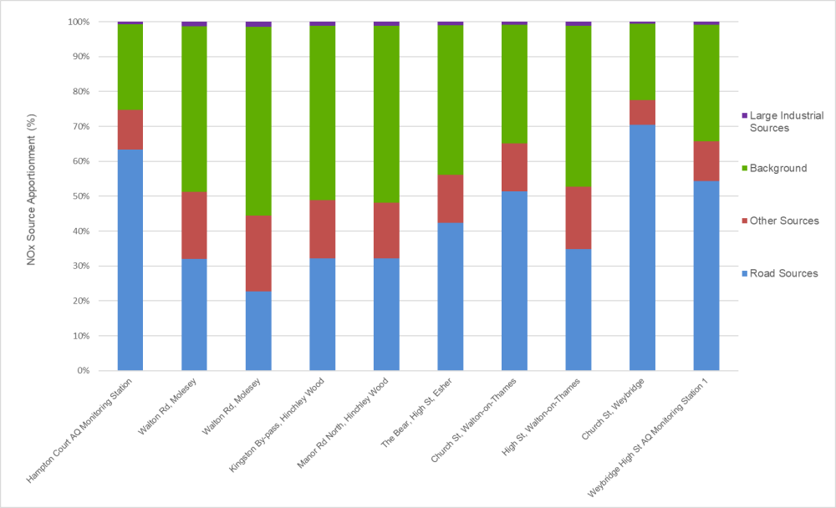
Figure E.1: NOx Source Apportionment in Elmbridge AQMAs by Sector
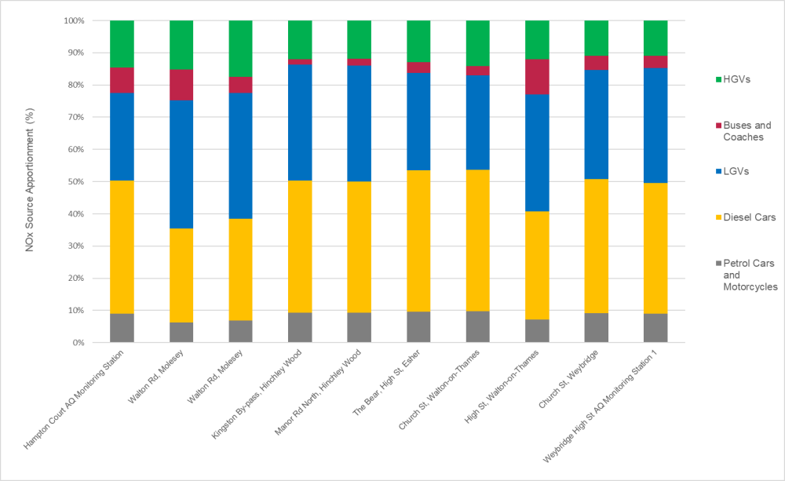

Figure E.2: NOx source apportionment in Elmbridge AQMAs by Road Vehicle Type
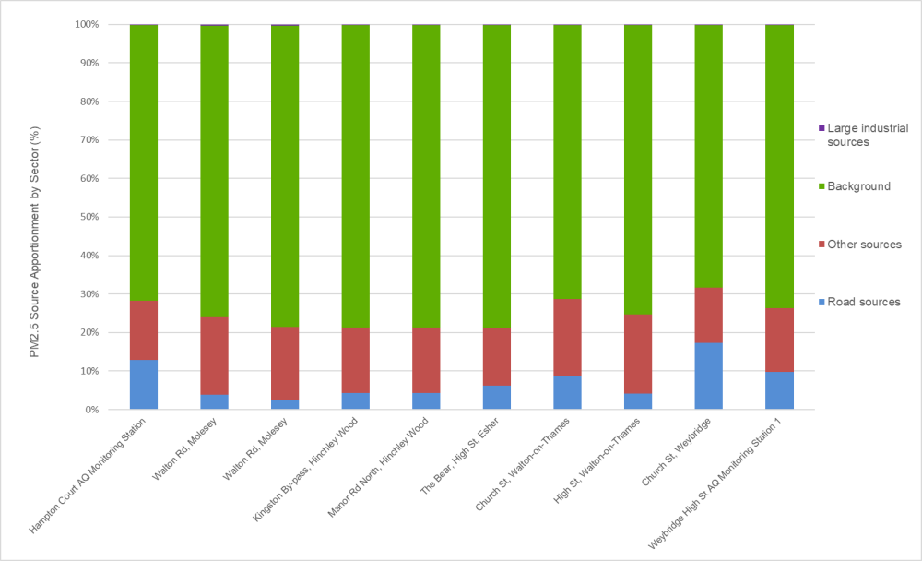

Figure E.3: PM_{2.5} Source Apportionment in Elmbridge AQMAs by Sector
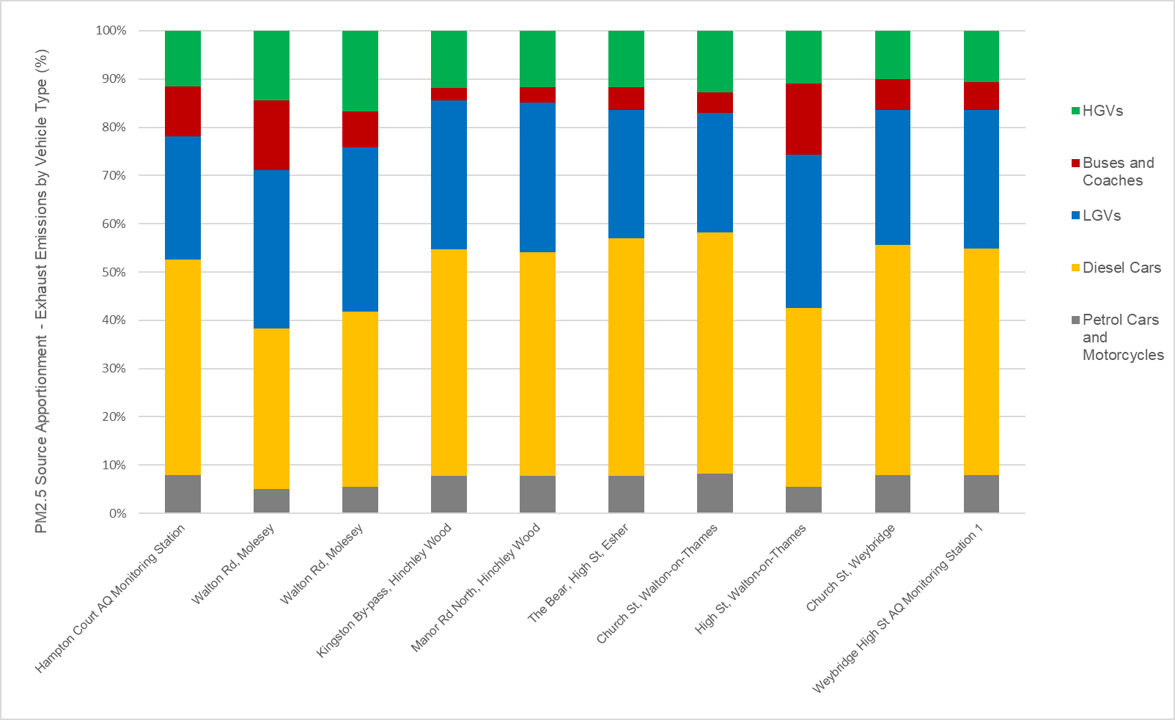

Figure E.4: PM_{2.5} Source Apportionment in Elmbridge AQMAs by Road Vehicle Type
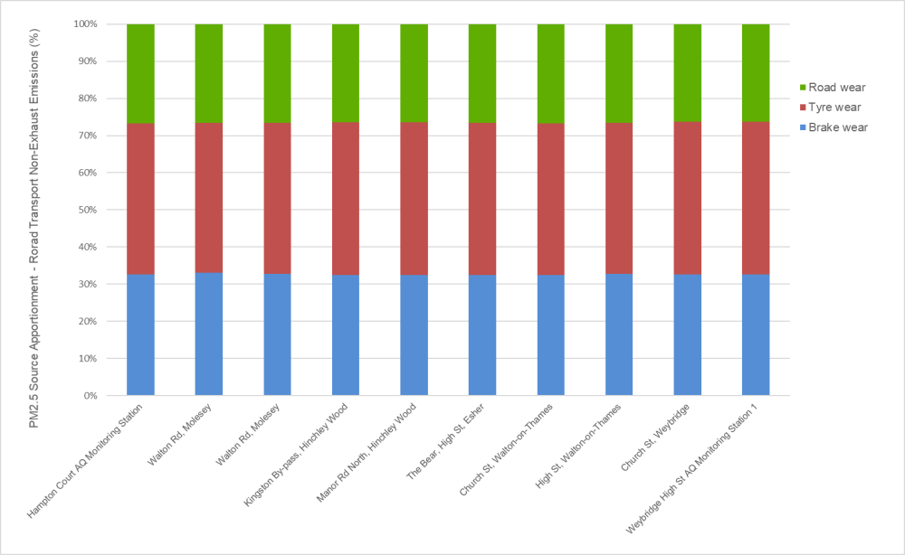
Figure E.5: PM_{2.5} Source Apportionment of Non- Exhaust Emissions in Elmbridge AQMAs

Appendix F: Required Reduction in Emissions

Table F. 1 shows the reduction in NO₂ concentrations and road NO_{x} emissions required in the Council’s AQMAs based on 2019 measured values. The required reduction in emissions has been calculated in accordance with Chapter 7 (Box 7.6) of the LAQM Technical Guidance 2016 (LAQM TG.16) using DEFRA’s latest NOx to NO₂ Calculator Tool v8.1. The target value used in these calculations is 36 µg/m³ to take into account the requirement for concentrations to be at least 10% below the objective for revocation of the AQMA to be considered on the basis of monitoring data alone.
Table F. 1: Required Reductions in Road NOx Emissions
Location | NO₂ Concentrations (µg/m³) |  | Road NOx Emissions (%)
Location | 2019 Measured Concentration | Reduction Required | Reduction Required
Esher High Street | 46ª | -10 | 36.9
Weybridge High Street | 45.6^{b} | -9.6 | 36.3
Hampton Court | 41^{c} | -5 | 24.4
Walton-on-Thames High Street | 39.2^{d} | -3.2 | 15.0
Walton Road, Molesey | 39.4e | -3.4 | 16.6
Hinchley Wood | 37.4^{f} | -1.4 | 7.5
a) Measured at Esher 7
b) Measured at Weybridge 7
c) Measured at Hampton Court Parade automatic monitor
d) Measured at Walton 10
e) Measured at Molesey 8
f) Measured at Hinchley Wood 1

Appendix G: Estimated Reduction in Emissions

G.1 Estimated Future Emissions by Vehicle Type
In order to gain further understanding of the types of AQAP measures that would be the most beneficial in terms of improving air quality within the AQMAs, the Emission Factor Toolkit (EFT) v10.1 has been used to provide an indication of expected NOx emission reductions between 2020 - 2025 by vehicle type. The EFT utilises NOx emission factors taken from the European Environment Agency COPERT 5.3 emission tool. The EFT provides pollutant emission rates for 2018 through to 2030 and takes into consideration the following information available from the National Atmospheric Emissions Inventory (NAEI):
- fleet composition data for motorways, urban and rural roads in London and rest of the UK;
- fleet composition based on European emission standards from pre-Euro I to Euro 6(a-d)/VI;
- scaling factors reflecting improvements in the quality of fuel and some degree of retrofitting; and
- technology conversions in the national fleet.
Emissions have been calculated for a hypothetical road with a traffic flow of 31,000 vehicles (either 100% cars, LGVs, HGVs and buses and coaches) to determine which vehicle type is expected to result in the greatest emission reductions in the future, without the implementation of any specific AQAP measures. Figure G.1 presents the results of the analysis of future emission reductions by vehicle type.
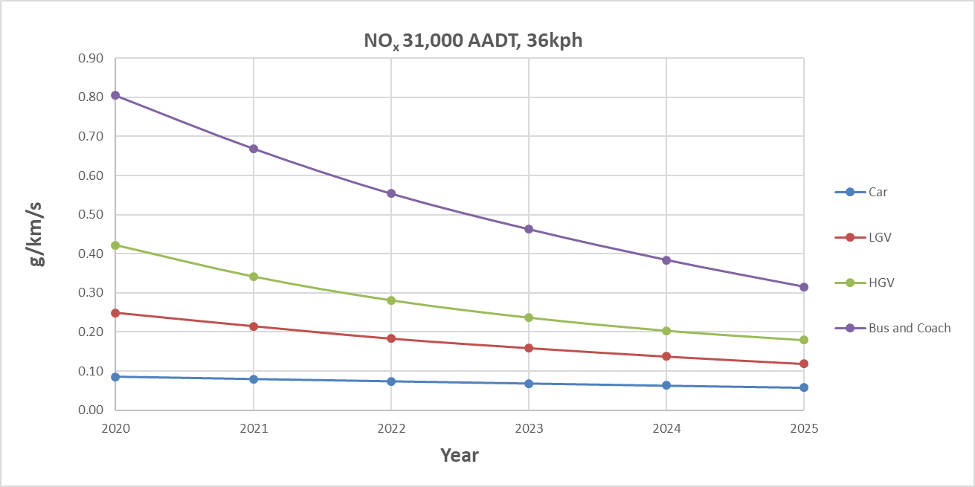
Figure G.1 – Estimated NOx Emission Reductions by Vehicle Type without AQAP Measures

Figure G.1 shows that buses and coaches are expected to have the greatest emission reductions between 2020 – 2025, without the implementation of specific AQAP measures. However, emissions from buses and coaches are still estimated to be approximately 8x higher than those from cars in 2025. Cars are expected to have the smallest reduction in emissions between 2020 – 2025 without the implementation of AQAP measures. It should be noted that the EFT does not take into account any effects of COVID-19 upon vehicle fleet changes and there are likely to be impacts on vehicle replacement rates for some years to come.

G.2 Estimated Future Emission Reductions in the AQMAs
In order to understand the future reduction in emissions within the AQMAs in a ‘business as usual’ scenario (i.e. without any AQAP measures), the EFT v10.1 has been used to calculate road NOx emissions up to 2025 within the three AQMAs where exceedances of the annual mean NO₂ objective are still present (Weybridge, Esher and Hampton Court). Publicly available traffic data for roads within the AQMAs have been obtained from the Department for Transport (DfT) and are provided in Table G. 1. The latest available (2019) annual average daily traffic (AADT) data has been factored to each of the corresponding future emission years to account for growth in traffic flows in the future. The National Trip End Model has been used via the TEMPro software to obtain the growth factors for each year (see Table G. 1 for further details). It has been assumed that the heavy-duty vehicle (HDV) split remains constant in future years. The traffic data has been inputted into the EFT to calculate road vehicle NOx emissions rates for 2019 - 2025, for an urban road type, at the speed limit on the road within the AQMAs.
Figure G.2 shows that the emission outputs from the EFT demonstrate a predicted decrease in NOx emissions between 2019 – 2025 of approximately 40% in Weybridge, Esher and Hampton Court AQMAs. Taking into consideration the emissions reductions required in the AQMAs (Appendix F), Figure G.2 therefore suggests that the emissions reductions required could possibly be achieved by 2025 without the implementation of AQAP measures. However, it is recognised that AQAP measures are required in order to reduce NO₂ concentrations within the AQMAs in the shortest time possible in order to protect human health. It should also be noted that the analysis of future emission trends is based upon national fleet assumptions in the EFT, which may not be completely reflective of each area where the vehicle fleet composition may be different and may also change in a different way to the national fleet in the future.
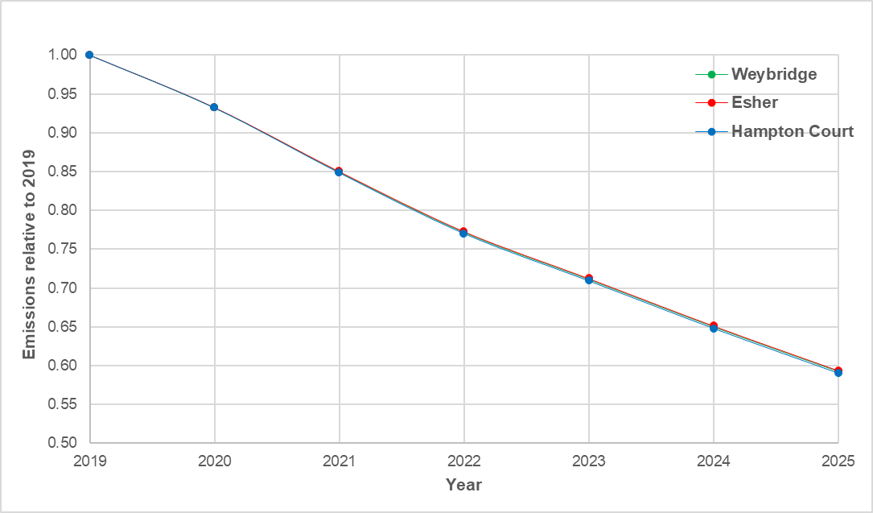
Figure G.2 – Estimated Future Road NOx Emission Reductions without AQAP Measures

Table G. 1:Department for Transport Traffic Data
Year | TEMPro Growth Factor (Elmbridge – All Roads) | Weybridge - Monument Green (DFT Count Point |  | Hampton Court – A309 |  | Esher – High Street |  | Hinchley Wood – Kingston Bypass |  | Molesey – Walton Road |  | Walton-on-Thames – A3050
Year | TEMPro Growth Factor (Elmbridge – All Roads) | Total AADT | %HDV | Total AADT | %HDV | Total AADT | %HDV | Total AADT | %HDV | Total AADT | %HDV | Total AADT | %HDV
2019 | - | 15732 | 2.01 | 21651 | 2.36 | 28151 | 1.89 | 28114 | 1.85 | 13822 | 2.56 | 14249 | 2.71
2020 | 1.0107 | 15900 | 2.01 | 21883 | 2.36 | 28452 | 1.89 | - | - | - | - | - | -
2021 | 1.022 | 16078 | 2.01 | 22127 | 2.36 | 28770 | 1.89 | - | - | - | - | - | -
2022 | 1.0346 | 16276 | 2.01 | 22400 | 2.36 | 29125 | 1.89 | - | - | - | - | - | -
2023 | 1.0549 | 16596 | 2.01 | 22840 | 2.36 | 29696 | 1.89 | - | - | - | - | - | -
2024 | 1.0697 | 16829 | 2.01 | 23160 | 2.36 | 30113 | 1.89 | - | - | - | - | - | -
2025 | 1.0846 | 17063 | 2.01 | 23483 | 2.36 | 30533 | 1.89 | - | - | - | - | - | -

G.3 Indicative Estimated Emission Reductions from AQAP Measures
The measures contained within this AQAP are largely centred around reducing vehicle emissions and encouraging sustainable travel modes to reduce the number of vehicles on the roads. An exercise has been undertaken to quantify the estimated emission reductions that could be expected as a result of the implementation of a range of AQAP measures. The Emission Factor Toolkit (EFT) V10.1 and publicly available traffic data from the DfT have been used to calculate estimated road vehicle NOx emissions in the AQMAs in 2019. Road NOx emission reductions in various scenarios representing different AQAP measures have then been calculated by altering the fleet composition in the EFT. These scenarios have then been compared against the baseline road NOx emissions in order to obtain an estimated percentage reduction. These calculations are only intended to provide an indication of NOx emission reductions associated with AQAP measures and the assumptions applied may not be representative in every situation.
Table G. 2: Estimated Reductions in Road NOx Emissions
Scenario | Estimated Road NOx Reduction (%)
Scenario | Walton-on-Thames | Weybridge High Street | Hampton Court | Esher High Street | Walton Road Molesey | Hinchley Wood
Reduce number of cars by  5% | 3.9 | 4.1 | 3.9 | 4.1 | 3.8 | 4.0
Reduce number of cars by 10% | 7.8 | 8.1 | 7.8 | 8.2 | 7.6 | 8.0
Reduce number of cars by 25% | 19.6 | 20.3 | 19.4 | 20.4 | 18.9 | 20.0
Change all HGVs to Euro VI | 8.0 | 4.3 | 6.4 | 4.8 | 4.8 | 5.2
Change all Buses to Euro VI | 3.5 | 6.1 | 2.1 | 4.1 | 8.7 | 1.5
% Reduction Required | 16.6 | 36.3 | 24.4 | 36.9 | 15 | 7.5

Appendix H: Consultation

H.1 Consultation Undertaken
In updating this AQAP, we have worked with other local authorities, agencies, businesses, and the local community to improve local air quality. Schedule 11 of the Environment Act 1995 requires local authorities to consult the bodies listed in Table H. 1. In addition, we have undertaken the following stakeholder engagement:
- EBC’s website – dedicated online consultation form on all the AQAP actions;
- promoting the AQAP consultation via Clear Channel advertisement screens at bus stops and high street locations;
- consultation email to business groups, trading associations, businesses improvement districts businesses and high street leads;
- inclusion of a link to the AQAP consultation in Council email footers; and
- consultation promoted via social media.
Table H. 1: Consultation Undertaken
Yes/No | Consultee
No | the Secretary of State
Yes | the Environment Agency
Yes | the highways authority
Yes | all neighbouring local authorities
Yes | other public authorities as appropriate, such as Public Health officials (SCC Public Health Team)
Yes | bodies representing local business interests and other organisations as appropriate

H.2 Steering Group
The Council established an Air Quality Action Plan Steering Group in August 2020 with the purpose of overseeing the formulation of the Plan by identifying new policies or actions that could positively affect air quality, as well as assisting with the implementation of the AQAP. The Steering Group includes the following stakeholders:
- Elmbridge Borough Council’s Environmental Services Team, Organisational Development and Planning Team’s
- Surrey County Council – Public Health Team
- Surrey County Council Highways
- Surrey Air Alliance (SAA) representatives
- Reigate and Banstead Borough Council
- Woking Borough Council
- Waverley Borough Council
- Guildford Borough Council
- Spelthorne Borough Council
- Runnymede Borough Council
- Mole Valley District Council
- Surrey Heath Borough Council
Two Steering Group Workshops were held in August 2020 to review and assess the viability of AQAP measures. A separate meeting was held with the Public Health Team at SCC to accommodate COVID-19 response demands. The Steering Group were kept informed throughout the consultation process.

H.3 Consultation Response
The Draft AQAP was released for public consultation from 10th March to 5th May 2021. During this time, the document was available on the Council website with an accompanying questionnaire. The consultation was advertised on the Council website, in Council staff email footers, via Clear Channel advertising screens at bus stops and high street locations, and on social media. A consultation email was also sent to business groups, trading associations, business improvement district businesses and high street leads encouraging them to take part in the consultation. A total of 85 questionnaire responses were received, in addition to a number of written responses. The consultation responses have been discussed with the Council’s Portfolio Holder for the Environment and have been considered in this AQAP.
DEFRA’s first appraisal review of the Draft AQAP submitted in March 2021, at the start of the eight-week public consultation, concluded that the AQAP was considered acceptable. Comments on the Draft AQAP were provided by DEFRA in their appraisal, and these have been incorporated into this version of the AQAP.
Since DEFRA’s review, further comments have been received from Cabinet Members following a Cabinet Meeting in July 2021. The latest version of the Draft AQAP has been revised to take into account Cabinet Members comments. The AQAP was approved by Cabinet on 17 November 2021.

Appendix I: Cost Benefit Analysis

The Council is required to assess the impacts and costs of proposed actions in improving air quality. The process for undertaking this cost-benefit analysis of the proposed AQAP measures is outlined in the following.

I.1 Effectiveness of Measures
It is not practicable to provide estimates of the effectiveness of measures detailed in Table 3.2 and Table 3.3 in terms of the reduction in pollutant concentration, as many measures are indirect measures, such as monitoring and studies, aimed at enabling the development of measures which will directly result in pollutant reductions. Therefore, the approach taken has been used to rate measures in terms of how favourable they are towards facilitating future air quality improvements or reducing exposure within the AQMAs. For example, BW-28 requires the Council to work with local businesses to investigate options to reduce vehicle emissions from deliveries. Whilst this measure will not necessarily lead to a direct reduction in pollutant concentrations itself, it will assist with the development of measures that can have a direct impact.
The effectiveness of each measure in relation to the potential indirect beneficial air quality impact has been rated large, moderate, small, very small or negligible.

I.2 Estimated Cost of Measures
The cost of each measure has been estimated and measures have been categorised into the following cost categories:
- Negligible/ No cost
- >£1k
- £1k - £10k
- £10k - £100k
- £100k – £1 million
- £1 million - £10 million
- >£10 million

I.3 Cost-Benefit Analysis
The cost-benefit of each measure has then been assessed considering its effectiveness and cost using the matrix below.
Cost Benefit | Negligible | Very Small | Small | Moderate | Large
Negligible/no cost | Medium | Medium | High | High | High
<£1k | Low | Medium | High | High | High
£1k- £10k | Low | Medium | High | High | High
£10k - £100k | Low | Medium | Medium | High | High
£100k - £1 million | Low | Low | Medium | Medium | High
£1 million - £10 million | Low | Low | Low | Medium | Medium
>£10 million | Low | Low | Low | Low | Medium

Table I. 1 shows the effectiveness rating, estimated cost and cost-benefit rating for each of the measures included in Table 3.2 and Table 3.3. Table I. 1 shows that the cost-benefit rating for all measures is medium or high.
Table I. 1: Cost-benefit Analysis of AQAP Measures
Measure Number | Effectiveness Rating | Cost | Cost-Benefit Rating
SCC-1 | Large | £1 million - £10 million | Medium
SCC-2 | Large | £1 million - £10 million | Medium
SCC-3 | Medium | £100k - £1 million | Medium
SCC-4 | Medium | £1 million - £10 million | Medium
SCC-5 | Small | £10k - £100k | Medium
SCC-6 | Small | £1k - £10k | High
SCC-7 | Small | £10k - £100k | Medium
SCC-8 | Small | £10k - £100k | Medium
SCC-9 | Small | £10k - £100k | Medium
EBC-1 | Very small | £10k - £100k | Medium
EBC-2 | Small | £10k - £100k | Medium
EBC-3 | Small | Negligible/no cost | High
EBC-4 | Very small | £10k - £100k | Medium
EBC-5 | Very small | £1k - £10k | Medium
EBC-6 | Small | £10k - £100k | Medium
EBC-7 | Medium | £1k - £10k | High
EBC-8 | Small | £1k - £10k | High
EBC-9 | Small | £1k - £10k | High
EBC-10 | Very small | £1k - £10k | Medium
EBC-11 | Very small | £1k - £10k | Medium
EBC-12 | Small | £1k - £10k | High
EBC-13 | Small | £10k - £100k | Medium
EBC-14 | Small | £10k - £100k | Medium
EBC-15 | Small | £1k – £10k | High
EBC-16 | Small | £1k - £10k | High
EBC-17 | Very small | £1k - £10k | Medium
EBC-18 | Very small | £1k - £10k | Medium
EBC-19 | Very small | £1k - £10k | Medium
EBC-20 | Very small | £1k - £10k | Medium
EBC-21 | Very small | £1k - £10k | Medium
EBC-22 | Small | £1k - £10k | High
EBC-23 | Small | £1k - £10k | High

I.4 Wider Benefits of Measures
Whilst a cost-benefit analysis has been undertaken in relation to the effectiveness of measures in improving air quality and reducing exposure, it should be recognised that many measures have wider social, economic and environmental benefits.
Several of the AQAP measures are designed to encourage the use of sustainable transport modes such as walking and cycling. These measures include the implementation of the Low Emission Transport Strategy for Surrey (SCC-2), development and implementation of a LCWIP for Elmbridge (SCC-5), piloting a cargo-bike scheme for local businesses (EBC-5), and installation of pedestrian facilities on Esher High Street (SCC-9). These measures are beneficial for climate change as they have potential to reduce the amount of green-house gas (GHG) emissions from vehicles, whilst also having wider social benefits, particularly in relation to wellbeing by encouraging the use of active travel modes.
The economic benefits of a number of measures are also apparent. The installation of pedestrian facilities on Esher High Street (SCC-9) has the potential to make the area more attractive for local businesses and their customers. Similarly, customers may wish to use businesses who support environmental initiatives, therefore measures such piloting a cargo-bike scheme for local businesses (EBC-5) may also have economic benefits for businesses in relation to increased customer numbers as well as cost-savings from reduced vehicle costs.

Barnes et al. Emissions vs exposure: Increasing injustice from road traffic-related air pollution in the United Kingdom. August 2019.
Council Plan 2020/2021
The SAA is formed of officer representatives from all eleven District and Borough Councils, and SCC Highways and Public Health services.
https://airalert.info/Surrey/Default.aspx
DEFRA. Policy Paper 10 March 2020: Air Quality Factsheet (Part 4). Updated 21 October 2020.
Prime Minister’s Office, COVID-19 briefing on the 31st of May 2020
Air Quality Expert Group, Estimation of changes in air pollution emissions, concentrations and exposure during the COVID-19 outbreak in the UK, June 2020
COMEAP. Associations of long-term average concentration of nitrogen oxide with mortality, 2018.
Barnes et al., 2019. Emissions vs exposure: Increasing injustice from road traffic-related air pollution in the United Kingdom.
DEFRA. Clean Air Strategy. 2019.
DEFRA. Policy Paper 10 March 2020: Air Quality Factsheet (Part 4). Updated 21 October 2020.
DEFRA. Assessing progress towards WHO guideline levels of PM_{2.5} in the UK. July 2019.
Public Health England. Estimation of costs to the NHS and social care due to the health impacts of air pollution: summary report. May 2018.
Council Plan 2020/2021
Healthy Surrey. Surrey Health and Wellbeing Strategy. February 2020.
Elmbridge Borough Council. Elmbridge Core Strategy. July 2011.
Elmbridge Borough Council (2020). Parking Supplementary Planning Document. July 2020.
Elmbridge Borough Council. Elmbridge Local Plan Development Management Plan. April 2015.
Elmbridge Borough Council (2020). Carbon Management and Reduction Plan. Available at: https://www.elmbridge.gov.uk/pollution/climate-change-and-sustainability/
Elmbridge Borough Council (2020). Taxi and Private Hire Licensing Policy 2020-2025. Available at: https://www.elmbridge.gov.uk/licensing/policies-and-information-for-passengers/
Surrey County Council. Surrey’s Climate Change Strategy. 2020.
Surrey County Council. Surrey Local Transport Plan 3. April 2018.
Surrey County Council. Surrey Low Emission Transport Strategy.
Surrey County Council. Surrey’s 2050 Place Ambition – our approach to place leadership and good growth. July 2019.
Healthy Surrey. Surrey’s Physical Activity Strategy 2015-2020. 2015.
Surrey County Council. Rethinking Transport Programme Summary. December 2019.
Surrey County Council (2014). Surrey Cycling Strategy.
Elmbridge Borough Council (2016). Elmbridge Cycling Plan. Available at: https://www.surreycc.gov.uk/roads-and-transport/cycling-and-walking/plans/elmbridge
Department for Transport (2017). Local Cycling and Walking Plans Technical Guidance for Local Authorities. April 2017.
NOx is a mix of NO₂ and nitric oxide (NO). NO can react with oxygen to produce more NO₂.
Other sources include the following: 1) combustion in commercial, institution and agricultural sectors, 2) combustion in industry, 3) combustion in energy production and transfer, 4) production processes, 5) extraction and distribution of fossil fuels, 6) solvent use, 7) other transport and machinery, waste treatment and disposal, 8) agricultural, forests and land use change, 9) other sources and sinks.
PM_{2.5} source apportionment for exhaust emissions by road vehicle type is expressed as a percentage of the total exhaust emissions for road sources.
PM_{2.5} source apportionment for non-exhaust emissions type is expressed as a percentage of the total non-exhaust emissions.

