INSTRUCTIONS – PLEASE READ
This is the Annual Status Report (ASR) for submission to Defra by 30 June of each calendar year.
This template is divided into two main sections. The first, entitled “Overview of Air Quality in Our Area” provides a public-facing summary and should contain a brief overview of the state of local air quality. The rest of the document should contain the detailed technical information supporting the conclusions presented in this summary.
Whilst use of this template is mandatory, this approach does not preclude the flexibility to provide detailed or extra analysis where this has taken place. For instance, appendices may be adjoined to the ASR.
PLEASE NOTE:
There is a mandatory requirement for local authorities to submit their NO₂ diffusion tube data to the LAQM Portal via the Diffusion Tube Data Entry System (DTDES) upload facility. This submission should be completed once all monitoring data for 2022 has been processed. The Diffusion Tube Data Processing Tool has been developed to assist local authorities in processing NO₂ diffusion tube monitoring data. It provides an output table which can be directly uploaded via the DTDES. If not using the processing tool, a template for submitting the data is available from the LAQM website.
- LAQM Portal
- Diffusion Tube Data Processing Tool
To avoid duplication of works, there is no longer a requirement to submit electronic copies of ASR tables A.2, A.4 and B.1 relating to diffusion tubes as part of the separate ASR Excel template data return. This data will be accessible to Defra through the LAQM Portal. Note, there is still a requirement to submit all other data tables electronically as part of the separate ASR Excel template data return.
Local authorities are required to submit the Excel file with all relevant tables completed via the LAQM Portal, in addition to a MS Word or PDF copy of the completed ASR.
It is advised that local authorities complete the Excel based tables first, before then copying the relevant completed tables in to the Word ASR template, as any inconsistencies between data tables may result in the submission being rejected. If particular tables are not relevant to the local authority, the reasons as to why should be indicated via the drop-down menus at the top of each Table tab.
Where a conglomerate of authorities work together on air quality management, it is permissible to submit a single ASR on behalf of all the authorities, subject to Defra notification and approval.
Blue boxes provide instructions and/or further information to help local authorities complete the report. These boxes should be deleted before submitting the report.
<Text in angle brackets> indicates an example or where the local authority needs to fill in information. Once the required information has been completed the font colour should be amended to match that of the body text.
Delete this box when the document is finished
<Insert Local Authority Logo Here>
2023 Air Quality Annual Status Report (ASR)
In fulfilment of Part IV of the Environment Act 1995 Local Air Quality Management, as amended by the Environment Act 2021
Date: <June, 2023>
ACCESSIBILTY INSTRUCTIONS
This 2023 reporting template has been developed to comply with the Accessibility Regulations (2018). Instructions are provided throughout the template as a steer to ensuring that the completed ASR remains compliant with Accessibility Regulations, with the key points to adhere to summarised as follows:
- Make hyperlinks accessible - the text used for hyperlinks should describe where people will go if they click that link
- Follow the template heading styles - important to define the content hierarchy and use the correct heading style at the right time
- Avoid using ‘tab’ or ‘enter’ to create spaces between text/sections, utilise page/section breaks
- Use the tables within the template. If any additional tables are required, ensure these are formatted correctly and a summary of the table is provided within the accompanying text (N.B. alt text added to tables does not save if the document is converted to a pdf):
  - Ensure the top row is selected as the ‘header row’
  - Avoid the use of merged or split cells
  - The table should read logically from left to right and top to bottom
- When inserting trend graphs/charts ensure that colour combinations relevant to colour blindness are avoided
- Add alt text to charts or pictures inserted within the report that do not have a corresponding summary written directly above or below the chart
- Text should be aligned to the left and not justified
If saving the document as a PDF it is recommended that the ‘Create bookmarks using’ option with the sub-option of ‘Headings’ is selected. Although not an explicit requirement in terms of accessibility, this will ensure your document is easy to read and navigate.
Further guidance in terms of publishing accessible documents can be found through the following on the .gov.uk website. If the ASR is to be published on your authority website, it is recommended that the ASR is checked by your content team to ensure compliance.
Delete this box when the document is finished

Information | <Local Authority Name> Details
Local Authority Officer | <Enter Name(s) Here>
Department | <Enter Department Name>
Address | <Enter Address>
Telephone | <Enter Telephone>
E-mail | <Enter Email Address>
Report Reference Number | <Enter Report Reference>
Date | <Enter Date of Report>

INSTRUCTIONS
Please update the header information on this page.
The following list is provided to assist local authorities in understanding the most frequent issues noted by Defra during the ASR appraisal process:
- Outdated national bias adjustment factor used – if a national factor is to be used please ensure the relevant factor from the most up to date version of the National Bias Adjustment Factor Spreadsheet is adopted.
- Incorrect methodology used to complete annualisation – the Diffusion Tube Data Processing Tool can be used to complete annualisation to minimise the likelihood of processing errors and can export files suitable for upload to the LAQM Portal. The Annualisation Tool is also still available.
- Erroneous monthly diffusion tube data included within annual mean calculations - data should be removed as per Chapter 7: NO_{x} and NO₂ Monitoring, NO₂ by Diffusion Tubes of Technical Guidance LAQM.TG22
- Distance correction - should only be completed for monitoring sites where the concentration is greater than 36µg/m³ and the receptor is not located at a point of relevant exposure
- Insufficient detail provided regarding the progress of action plan measures - insufficient detail provided within Table 2.2
- Monitoring and AQMA maps - these should be clear and accurate
Adequately addressing the above points will minimise the likelihood of your report being rejected at the appraisal stage.
Delete this box when the document is finished

Executive Summary: Air Quality in Our Area
INSTRUCTIONS
Please summarise the main findings and conclusions of the report here. This should include (but is not limited to, as could include other information you consider important):
- Key news/headlines about how you’ve improved air quality in your area
- Current challenges/priorities for addressing air quality in your area
- How the public is or can get involved – e.g. walk, don’t drive; anti-idling, car sharing etc.
- 1-2 pictures of air quality initiatives in your area, if possible
This section is designed to inform those living and working in your area about the state of local air quality. It is intended to be understood by those not familiar with the technical details of LAQM. Local authorities are (as a minimum) mandated to make this section available on their website to help promote air quality locally.
This summary should also briefly outline progress on the actions that you and others, including the public, are taking or should take to improve air quality and associated health impacts. This is an opportunity to indicate whether any changes are required to your Action Plans.
Any supplementary information related to air quality that the public may find useful can also be included here.
Delete this box when the document is finished

Air Quality in <Local Authority Name>
Air pollution is associated with a number of adverse health impacts. It is recognised as a contributing factor in the onset of heart disease and cancer. Additionally, air pollution particularly affects the most vulnerable in society: children, the elderly, and those with existing heart and lung conditions. There is also often a strong correlation with equalities issues because areas with poor air quality are also often less affluent areas,.
The mortality burden of air pollution within the UK is equivalent to 29,000 to 43,000 deaths at typical ages, with a total estimated healthcare cost to the NHS and social care of £157 million in 2017.
INSTRUCTIONS
Include a brief summary of the main air quality issues in your local area – what are the main pollutants of concern, what are the observed trends shown by the latest monitoring data (e.g. are levels going up or down?) and are these in line with national trends, where are the current AQMAs or hotspots (including a link to your AQMA webpage), any new major sources of emissions. Include the introduction of any new AQMAs, Action Plans or strategies. Briefly explain how your local authority works to manage local air quality and how you work with your partners, e.g. County Council, Public Health, Environment Agency.
Delete this box when the document is finished

Actions to Improve Air Quality
Whilst air quality has improved significantly in recent decades, there are some areas where local action is needed to protect people and the environment from the effects of air pollution.
The Environmental Improvement Plan sets out actions that will drive continued improvements to air quality and to meet the new national interim and long-term PM_{2.5} targets. The National Air Quality Strategy, due to be published in 2023, will provide more information on local authorities' responsibilities to work towards these new targets and reduce PM_{2.5} in their areas. The Road to Zero details the approach to reduce exhaust emissions from road transport through a number of mechanisms; this is extremely important given that the majority of Air Quality Management Areas (AQMAs) are designated due to elevated concentrations heavily influenced by transport emissions.
INSTRUCTIONS
Include a brief summary of core actions (and in particular good practice examples, success stories or lessons learned) to target sources of pollution within your area over the past reporting year. Has the implementation of measures or any recent actions resulted in a change in monitoring concentrations? Detail which partnership organisations you are collaborating with to achieve delivery of actions. Indicate any quantitative improvements from actions taken (if known) and include a summary of progress on any grant funded projects.
Delete this box when the document is finished

Conclusions and Priorities
INSTRUCTIONS
Summarise the conclusions from this year’s ASR, and the main actions to be taken moving forward. This can include, but is not limited to, discussion of the following:
- Were exceedances identified, within and outside of existing AQMAs?
- What were the significant trends?
- Are all monitoring results within existing AQMAs below the air quality objective, such that it may be appropriate to revoke the AQMA?
- Are there any monitoring results in excess of the air quality objectives outside of any existing AQMAs, therefore leading to either an AQMA amendment or the designation of a new AQMA?
- Are there any new developments that will have an impact on air quality moving forward?
Is there a need to update the Air Quality Action Plan? It should be made clear what the priorities are for the local authority in addressing air quality for the coming year and briefly set out any challenges anticipated.
Delete this box when the document is finished

Local Engagement and How to get Involved
INSTRUCTIONS
Include text that addresses how the local authority has engaged with decision makers and the public and what the current level of interest and understanding is. Also include a brief note on how the public can help improve air quality in your area, any action groups, and where they can obtain further information.
Delete this box when the document is finished

Local Responsibilities and Commitment
This ASR was prepared by the <Environmental Health Department> of <Local Authority Name> Council with the support and agreement of the following officers and departments:
<List officers/departments involved in the preparation of the ASR>
This ASR has been approved by:
<Details of high level Council members who have approved the ASR (This could also include support from County Councils or from National Highways where appropriate) e.g. Head of Transport Planning, Head of Public Health, with e-signature>.
<Amend as appropriate> This ASR <has/has not> been signed off by a Director of Public Health.
If you have any comments on this ASR please send them to <report author> at:
<Address>
<Telephone>
<Email>

Table of Contents
INSTRUCTIONS
This is the start of main body of the ASR, which should contain all the detailed technical information.
Please:
- Update Table of Contents, List of Tables and List of Figures on completion of report (select within text below> right click > update field>Update Entire Table)
- Include hyperlinks in the PDF version
Delete this box when the document is finished
Executive Summary: Air Quality in Our Area i
Air Quality in <Local Authority Name> i
Actions to Improve Air Quality ii
Conclusions and Priorities iii
Local Engagement and How to get Involved iv
Local Responsibilities and Commitment iv
1 Local Air Quality Management 1
2 Actions to Improve Air Quality 2
2.1 Air Quality Management Areas 3
2.2 Progress and Impact of Measures to address Air Quality in <Local Authority Name> 8
2.3 PM_{2.5} – Local Authority Approach to Reducing Emissions and/or Concentrations 13
3 Air Quality Monitoring Data and Comparison with Air Quality Objectives and National Compliance 15
3.1 Summary of Monitoring Undertaken 16
3.1.1 Automatic Monitoring Sites 16
3.1.2 Non-Automatic Monitoring Sites 16
3.2 Individual Pollutants 17
3.2.1 Nitrogen Dioxide (NO₂) 17
3.2.2 Particulate Matter (PM₁₀) 20
3.2.3 Particulate Matter (PM_{2.5}) 21
3.2.4 Sulphur Dioxide (SO₂) 22
Appendix A: Monitoring Results 24
Appendix B: Full Monthly Diffusion Tube Results for 2022 48
Appendix C: Supporting Technical Information / Air Quality Monitoring Data QA/QC 50
New or Changed Sources Identified Within <Local Authority Name> During <Year> 51
Additional Air Quality Works Undertaken by <Local Authority Name> During <Year> 51
QA/QC of Diffusion Tube Monitoring 52
Diffusion Tube Annualisation 53
Diffusion Tube Bias Adjustment Factors 54
NO₂ Fall-off with Distance from the Road 57
QA/QC of Automatic Monitoring 58
PM₁₀ and PM_{2.5} Monitoring Adjustment 59
Automatic Monitoring Annualisation 59
NO₂ Fall-off with Distance from the Road 60
Appendix D: Map(s) of Monitoring Locations and AQMAs 61
Appendix E: Summary of Air Quality Objectives in England 63
Glossary of Terms 64
References 65

Figures
Figure A.1 – Trends in Annual Mean NO₂ Concentrations 31
Figure A.2 – Trends in Number of NO₂ 1-Hour Means > 200µg/m³ 36
Figure A.3 – Trends in Annual Mean PM₁₀ Concentrations 39
Figure A.4 – Trends in Number of 24-Hour Mean PM₁₀ Results > 50µg/m³ 42
Figure A.5 – Trends in Annual Mean PM_{2.5} Concentrations 45
Figure D.1 – Map of Non-Automatic Monitoring Site 61
Tables
Table 2.1 – Declared Air Quality Management Areas 5
Table 2.2 – Progress on Measures to Improve Air Quality 10

Table A.1 – Details of Automatic Monitoring Sites 24
Table A.2 – Details of Non-Automatic Monitoring Sites 25
Table A.3 – Annual Mean NO₂ Monitoring Results: Automatic Monitoring (µg/m³) 26
Table A.4 – Annual Mean NO₂ Monitoring Results: Non-Automatic Monitoring (µg/m³) 28
Table A.5 – 1-Hour Mean NO₂ Monitoring Results, Number of 1-Hour Means > 200µg/m³ 34
Table A.6 – Annual Mean PM₁₀ Monitoring Results (µg/m³) 37
Table A.7 – 24-Hour Mean PM₁₀ Monitoring Results, Number of PM₁₀ 24-Hour Means > 50µg/m³ 40
Table A.8 – Annual Mean PM_{2.5} Monitoring Results (µg/m³) 43
Table A.9 – SO₂ 2022 Monitoring Results, Number of Relevant Instances 46
Table B.1 – NO₂ 2022 Diffusion Tube Results (µg/m³) 48
Table C.1 – Annualisation Summary (concentrations presented in µg/m³) 53
Table C.2 – Bias Adjustment Factor 55
Table C.3 – Local Bias Adjustment Calculation 55
Table C.4 – NO₂ Fall off With Distance Calculations (concentrations presented in µg/m³) 57
Table E.1 – Air Quality Objectives in England 63

Local Air Quality Management
INSTRUCTIONS
The following section is a summary of the LAQM regime in England. Please update your Local Authority’s name and the year as appropriate.
Delete this box when the document is finished
This report provides an overview of air quality in <Local Authority Name> during <year>. It fulfils the requirements of Local Air Quality Management (LAQM) as set out in Part IV of the Environment Act (1995), as amended by the Environment Act (2021), and the relevant Policy and Technical Guidance documents.
The LAQM process places an obligation on all local authorities to regularly review and assess air quality in their areas, and to determine whether or not the air quality objectives are likely to be achieved. Where an exceedance is considered likely the local authority must declare an Air Quality Management Area (AQMA) and prepare an Air Quality Action Plan (AQAP) setting out the measures it intends to put in place in order to achieve and maintain the objectives and the dates by which each measure will be carried out. This Annual Status Report (ASR) is an annual requirement showing the strategies employed by <Local Authority Name> to improve air quality and any progress that has been made.
The statutory air quality objectives applicable to LAQM in England are presented in Table E.1.

Actions to Improve Air Quality
INSTRUCTIONS
This section provides information relating to AQMAs (Section 2.1), and actions to improve air quality in these areas/in general (Sections 2.2 and 2.3).
Details and maps of AQMAs should be available on UK Air.
Please make sure you review the maps and associated information on the website and ensure these are accurate and up-to-date. If the AQMA maps should need updating, please submit the required changes via the LAQM Portal. For declarations and amendments, an up-to-date shapefile of the AQMA(s) will be required as part of the submission.
Please fill out Table 2.1 with additional information pertaining to each AQMA in your area and ensure the table is summarised within the text.
An additional map including all monitoring locations relative to these AQMA(s) must also be included in Appendix D, so that monitoring results within each AQMA can be easily identified. Even if no AQMA has been declared, a map of monitoring locations should be included in Appendix D.
If one or more AQMAs have been declared and an AQAP has been published, please provide in Section 2.2 details on progress made to implement each of the AQAP measures. Please also indicate when any relevant AQAPs were developed and/or most recently updated in Table 2.1. Where an AQAP is in development, please indicate if this is currently within its draft or final stage, providing an anticipated publication date.
If no AQMA is declared, an Air Quality Strategy should be prepared. You should provide details within the free text and provide link(s) to the relevant document(s).
If action on air quality is being addressed through other plans, e.g. through the development and implementation of Local NO₂ Plans, Local Transport Plans or climate change strategies, please indicate here with links and any progress.
If any information does not fit within Table 2.2, please provide further information below the table including:
- Key actions completed, in progress or planned since last year, and outcomes in terms of benefits for air quality
- Any difficulties encountered / why measures have not been progressed, and if measures have slipped, how this will be addressed
- Forecast progress up to next year’s ASR
- An indication of main funding sources for the measures, e.g. if the local authority has acquired a Defra Air Quality Grant
Local authorities in England no longer have a mandatory requirement to report on 1,3-Butadiene, Benzene, Carbon Monoxide and Lead, but if you have decided to report on these pollutants then state clearly which pollutant(s) and why.
In Section 2.2, please also indicate what conclusions have been brought forward from last year’s appraisal and actioned in this ASR.
In Section 2.3, local authorities are now asked to work towards reducing levels of PM_{2.5} (fine particulates). You should use this section to briefly set out how your authority has decided to do this, why and what measures are being taken – further information is provided in LAQM policy and technical guidance.
Delete this box when the document is finished

Air Quality Management Areas
Air Quality Management Areas (AQMAs) are declared when there is an exceedance or likely exceedance of an air quality objective. After declaration, the authority should prepare an Air Quality Action Plan (AQAP) within 18 months. The AQAP should specify how air quality targets will be achieved and maintained, and provide dates by which measures will be carried out.
<Amend the following as necessary:>
A summary of AQMAs declared by <Local Authority Name> can be found in Table 2.1. The table presents a description of the <number of designated AQMAs> AQMA(s) that is/are currently designated within <Local Authority Name>. Appendix D: Map(s) of Monitoring Locations and AQMAs provides maps of AQMA(s) and also the air quality monitoring locations in relation to the AQMA(s). The air quality objectives pertinent to the current AQMA designation(s) are as follows:
- <NO₂ annual mean;>
- <PM₁₀ 24-hour mean; >
- <…>
<Or: >
<Local Authority Name> currently does not have any declared AQMAs. A local Air Quality Strategy is <in place / under development> to prevent and reduce polluting activities. <The Local Air Quality Strategy is available at …(insert webpage and link if it is in place)>
<Add text if necessary:> We propose to declare a new AQMA in <x> area due to exceedances of the <NO₂ annual mean/PM₁₀ 24-hour mean/…> air quality objective(s) (see <monitoring/additional information> section).
<Add text if necessary: > We propose to amend <AQMA Name> (see <monitoring/additional> section).
<Add text if necessary: > We propose to revoke <AQMA Name> (see <monitoring/additional> section).

Table 2.1 – Declared Air Quality Management Areas
INSTRUCTIONS
Please fill in Table 2.1 as per the following:
- AQMA Name = Official declared name of AQMA.
- Date of Declaration = The date of the original declaration, and of any subsequent amendments. Revoked AQMAs do not require inclusion within Table 2.1, however they may be discussed within Section 2.1.
- Pollutants and Air Quality Objectives = The pollutant for which the AQMA is declared, and the objective for that pollutant against which it is declared. If an AQMA is declared for multiple pollutants and/or objectives, please include details of each pollutant/objective on a new row.
- One Line Description = A brief description of the characteristics and location of the AQMA.
- Is air quality within the AQMA influenced by National Highways roads? = Yes/No. This may include emissions from Motorways, Urban Expressways, Dual carriageways, major trunk roads.
- Level of Exceedance = Highest pollutant concentration and/or number of exceedances at point of relevant exposure, i.e. following NO₂ fall off with distance correction (if applicable). The units presented should be relevant to the AQMA designation, i.e. for an AQMA designated for 1-hour the units should be hours (x hours were concentrations exceeded 200µg/m³):
  - At Declaration – Monitored/modelled information that led to a declaration.
  - Now – Latest Monitored/modelled information of current situation in AQMA for that pollutant.
- Number of Years Compliant with Air Quality Objective = Where relevant, provide details of the number of consecutive years that the relevant Air Quality Objective has been achieved within the AQMA. If an AQMA is declared for multiple pollutants and/or objectives, please include details for each pollutant/objective on a new row. As stated in the Technical Guidance LAQM.TG22, the revocation of an AQMA should be considered following three consecutive years of compliance with the relevant objective, as evidenced through monitoring and/or modelling. As such, there should not be any declared AQMAs for which compliance with the relevant objective has been achieved for a consecutive five-year period.
- Name of AQAP and Date of Designation = Name/Title of action plan and the date it was published.
- Web Link to AQAP = Where relevant, include a link to where the public can attain this plan. Ensure this hyperlink is completed to meet accessibility standards.
Delete this box when the document is finished

AQMA Name | Date of Declaration | Pollutants and Air Quality Objectives | One Line Description | Is air quality in the AQMA influenced by roads controlled by Highways England? | Level of Exceedance: Declaration | Level of Exceedance: Current Year | Number of Years Compliant with Air Quality Objective | Name and Date of AQAP Publication | Web Link to AQAP
AQMA Name 1 | Declared <Date>, Amended <Date> | Select | E.g. An area encompassing a number of properties at the junction of road 1 and road 2. | YES/NO | 41 | 40 | 2 years | E.g. AQAP for AQMA 1, May 2010 | Visit the AQAP for AQMA Name 1
AQMA Name 1 | Declared <Date>, Amended <Date> | Select | E.g. An area encompassing a number of properties at the junction of road 1 and road 2. | YES/NO | 55 | 59 | Not compliant | E.g. AQAP for AQMA 2, May 2015 | Visit the AQAP for AQMA Name 2
AQMA Name 2 | Declared <Date>, Amended <Date> | Select | E.g. An area encompassing residential properties near <industrial facility>. The AQMA was further extended in April 2013 to include residential properties along road name 2. | YES/NO | 28 | 21 | 1 year | E.g. AQAP for AQMA 3, May 2020 | Visit the AQAP for AQMA Name 3
<CLICK HERE THEN PASTE COMPLETED DATA ROWS FROM ASR EXCEL TEMPLATE>
☐ <Local Authority> confirm the information on UK-Air regarding their AQMA(s) is up to date (confirm by selecting in box).
☐ <Local Authority> confirm that all current AQAPs have been submitted to Defra (confirm by selecting in box).

Progress and Impact of Measures to address Air Quality in <Local Authority Name>
Defra’s appraisal of last year’s ASR concluded <Insert main comments from previous appraisal and indicate how these have been addressed this year. This can be inserted as a bullet point list with responses detailed>.
<Local Authority Name> has taken forward a number of direct measures during the current reporting year of <Year> in pursuit of improving local air quality. Details of all measures completed, in progress or planned are set out in Table 2.2. <xx> measures are included within Table 2.2, with the type of measure and the progress <Local Authority Name> have made during the reporting year of <Year> presented. Where there have been, or continue to be, barriers restricting the implementation of the measure, these are also presented within Table 2.2.
More detail on these measures can be found in their respective Action Plans <insert names of other plans or strategies if appropriate>. Key completed measures are: <set out bullet of main measures below and any key outcomes from these – keep text brief>.
<Amend as appropriate: >
<Local Authority Name> expects the following measures to be completed over the course of the next reporting year: <set out measures and brief explanation of expected impact of these measures>. <Local Authority Name>’s priorities for the coming year are <set out briefly with explanation>.
<Local Authority Name> worked to implement these measures in partnership with the following stakeholders during 2022:
- <E.g., Neighbouring local authorities; >
- <E.g., National Highways>
- <etc>
The principal challenges and barriers to implementation that <Local Authority Name> anticipates facing are <set out briefly with explanation>.
Progress on the following measures has been slower than expected due to: <insert explanation>.
<Delete as appropriate: >
<Local Authority Name> anticipates that the measures stated above and in Table 2.2 will achieve compliance in <AQMA Name(s)>.
Whilst the measures stated above and in Table 2.2 will help to contribute towards compliance, <Local Authority Name> anticipates that further additional measures not yet prescribed will be required in subsequent years to achieve compliance and enable the revocation of <AQMA Name(s)>.

Table 2.2 – Progress on Measures to Improve Air Quality
INSTRUCTIONS
Under the Environment Act 1995, as amended by the Environment Act 2021, action plans must now set out the particular measures local authorities will take to secure the achievement, and maintenance, of air quality standards and objectives, and must specify a date by which each measure will be carried out. Once action plans have been updated as such, Table 2.2 in the ASR should be completed in full using this information and then updated annually thereafter to report on developments, progress and barriers for each measure. Local authorities that do not have an AQMA, and therefore are not required to produce action plans, should complete Table 2.2 providing as much information as possible on measures to improve air quality.
Please fill in Table 2.2 (Progress on Measures to Improve Air Quality) below to reflect each measure implemented as per the following:
- Measure = Detail the name of the measure
- Category = Select the Measure Category from the available options (detailed below)
- Classification = Select the Measure Classification from the available options (detailed below)
- Year Measure Introduced in AQAP = Input the year the measure was initially developed, select between 2010 - 2023
- Estimated / Actual Completion Date = Input the date by which the measure will be carried out, select between 2015 – 2040.
- Organisation(s) Involved = List the organisations that are involved with the delivery of the measure, e.g. Local Authority/County Council/AQ Alliance/Community Group/Private Company
- Funding Source = Detail where the funding for the measure is to/has been sourced from
- Defra AQ Grant Funding = Has funding from the Defra AQ Grant been secured for the measure, Yes/No
- Funding Status = Select from Funded/Not Funded/Partially Funded
- Estimated Cost of Measure = Select from < £10k/£10k - £50k/£50k - £100k/£100k - £500k/£500k - £1m/£1m - £10m/ > £10m
- Measure Status = Select from Aborted/Planning/Implementation/Completed
- Reduction in Pollutant / Emission from Measure = Provide an estimate in terms of concentration or emission reduction that is predicted to occur due to the measure being implemented. This can also relate to the area where the measure is designed to impact upon, e.g. significantly reduce the levels of Heavy Good Vehicles
- Key Performance Indicator = Detail how the success of the measure is to be constantly presented and reviewed
- Progress to Date = Provide a summary of the progress for implementing the measure
- Barriers to Implementation = Provide details of any barriers that have been experienced during the implementation of the measure
The expected efficacy of measures should be clearly provided. This may be presented either by listing measures in rank order (i.e. the most effective measure first, least effective measure last) or through the adoption of a colour-coded approach (e.g. measures highlighted green most effective, red least effective, etc).
An ASR Excel template is provided to assist in the production of this table and must be electronically submitted as part of the ASR submission process.
The “Measure Category” and “Measure Classification” columns should be populated based on the following options, to be consistent with the National Air Quality Plans:
Measure Category | Measure Classification
Alternatives to private vehicle use | Bus based Park & Ride
 | Car & lift sharing schemes
 | Car Clubs
 | Rail based Park & Ride
 | Other
Environmental Permits | Introduction/increase of environment charges through permit systems and economic instruments
 | Introduction/increase of environmental funding through permit systems and economic instruments
 | Large Combustion Plant Permits and National Plans going beyond BAT
 | Measures to reduce pollution through IPPC Permits going beyond BAT
 | Other measure through permit systems and economic instruments
 | Tradable permit system through permit systems and economic instruments
 | Other
Freight and Delivery Management | Delivery and Service plans
 | Freight Consolidation Centre
 | Freight Partnerships for city centre deliveries
 | Quiet & out of hours delivery
 | Route Management Plans/ Strategic routing strategy for HGV's
 | Other
Policy Guidance and Development Control | Air Quality Planning and Policy Guidance
 | Low Emissions Strategy
 | Other policy
 | Regional Groups Co-ordinating programmes to develop Area wide Strategies to reduce emissions and improve air quality
 | Sustainable Procurement Guidance
Promoting Low Emission Plant | Emission control equipment for small and medium sized stationary combustion sources / replacement of combustion sources
 | Low Emission Fuels for stationary and mobile sources in Public Procurement
 | Other measure for low emission fuels for stationary and mobile sources
 | Public Procurement of stationary combustion sources
 | Regulations for fuel quality for low emission fuels for stationary and mobile sources
 | Shift to installations using low emission fuels for stationary and mobile sources
 | Other Policy
Promoting Low Emission Transport | Company Vehicle Procurement -Prioritising uptake of low emission vehicles
 | Low Emission Zone (LEZ)
 | Priority parking for LEVs
 | Procuring alternative Refuelling infrastructure to promote Low Emission Vehicles, EV recharging, Gas fuel recharging
 | Public Vehicle Procurement -Prioritising uptake of low emission vehicles
 | Taxi emission incentives
 | Taxi Licensing conditions
 | Other
Promoting Travel Alternatives | Encourage / Facilitate home-working
 | Intensive active travel campaign & infrastructure
 | Personalised Travel Planning
 | Promote use of rail and inland waterways
 | Promotion of cycling
 | Promotion of walking
 | School Travel Plans
 | Workplace Travel Planning
 | Other
Public Information | Via leaflets
 | Via other mechanisms
 | Via radio
 | Via television
 | Via the Internet
 | Other
Traffic Management | Anti-idling enforcement
 | Emission based parking or permit charges
 | Reduction of speed limits, 20mph zones
 | Road User Charging (RUC)/ Congestion charging
 | Strategic highway improvements, Re-prioritising road space away from cars, including Access management, Selective vehicle priority, bus priority, high vehicle occupancy lane
 | Testing Vehicle Emissions
 | UTC, Congestion management, traffic reduction
 | Workplace Parking Levy, Parking Enforcement on highway
 | Other
Transport Planning and Infrastructure | Bus route improvements
 | Cycle network
 | Public cycle hire scheme
 | Public transport improvements-interchanges stations and services
 | Other
Vehicle Fleet Efficiency | Driver training and ECO driving aids
 | Fleet efficiency and recognition schemes
 | Promoting Low Emission Public Transport
 | Testing Vehicle Emissions
 | Vehicle Retrofitting programmes
 | Other
Delete this box when the document is finished

Measure No. | Measure | Category | Classification | Year Measure Introduced in AQAP | Estimated / Actual Completion Date | Organisations Involved | Funding Source | Defra AQ Grant Funding | Funding Status | Estimated Cost of Measure | Measure Status | Reduction in Pollutant / Emission from Measure | Key Performance Indicator | Progress to Date | Comments / Barriers to Implementation
<1> | <Title> | <Select from the available categories> | <Select from the available classifications> | <2019> | <2019> | <Local Authority Environmental Health, Local Authority Transport Dept, . > | <Developers & highway infrastructure funding> | <No> | <Fully funded> | <£100k - £500k> | <Implemented> | <2%> | <% of x.. > | < E.g., a technical working group was established to develop and implement XXX Local Plan including Environmental Health, Planning and Transport Planning, National Highways. > | <Lengthy Timescale>
<2> | <Title> | <Select from the available categories> | <Select from the available classifications> | <-> | <2022> | <Local Authority Environmental Health, Local Authority Transport Dept. > | <Defra and LA> | <Yes> | <Partially funded> | <£15000 - £20000> | <Planning> | <0.2µg/m3> | <# of y.. > | < E.g., Phase 1 of the busway expansion is complete. Phase 2 expansion of the network is ongoing> | <Funding>
<3> | <Title> | <Select from the available categories> | <Select from the available classifications> | <-> | <-> | <Local Authority Environmental Health, Local Authority Transport Dept. > | <N/A> | <No> | <-> | <> £1m> | <Discontinued> | <Reduced vehicle emissions> | <Measured Concentration at z…> | <Implementation on-going: XXX report has been produced and sent to the committee; XXX objectives have been achieved; XXX actions/ measures are still ongoing> | <First phase successful, second phase on-going>
<CLICK HERE THEN PASTE COMPLETED DATA ROWS FROM ASR EXCEL TEMPLATE>

PM_{2.5} – Local Authority Approach to Reducing Emissions and/or Concentrations
INSTRUCTIONS
Briefly set out how you have chosen to interpret the requirement to work towards reducing PM_{2.5} in your local area as set out in LAQM Policy Guidance and why. This can include information regarding any smoke control areas in your local area, and measures being implemented within these.
Please then set down any measures that you are taking or planning and whether they have links to the Public Health Outcomes Framework. This information is accessible through the Public Health Outcomes Framework.
Further guidance is available under the PM_{2.5} and Action Planning section of Technical Guidance LAQM.TG22 (Chapter 2).
In the absence of PM_{2.5} monitoring, and where a local authority carries out PM₁₀ monitoring, it is recommended to consult Chapter 7: Estimating PM_{2.5} from PM₁₀ measurements of Technical Guidance LAQM.TG22 in order to include an estimate of PM_{2.5} concentrations.
In the absence of PM_{2.5} monitoring and where a local authority does not undertake PM₁₀ monitoring, the current Defra background mapping resource should be used to provide maximum background annual mean PM_{2.5} concentrations within the Local Authority.
Delete this box when the document is finished
As detailed in Policy Guidance LAQM.PG22 (Chapter 8), local authorities are expected to work towards reducing emissions and/or concentrations of PM_{2.5} (particulate matter with an aerodynamic diameter of 2.5µm or less). There is clear evidence that PM_{2.5} has a significant impact on human health, including premature mortality, allergic reactions, and cardiovascular diseases.
<Local Authority Name> is taking the following measures to address PM_{2.5}: <insert text – include whether new or existing measures (please refer to specific number of measures in the Progress Report on Action Plans in the section above) that may also be addressing other pollutants as well and any partnership working. Can also include information regarding Smoke Control Areas.>

Air Quality Monitoring Data and Comparison with Air Quality Objectives and National Compliance
INSTRUCTIONS
Please include a brief summary of monitoring data in this section, with an explanation of any changes in the past 12 months and if those changes have led to the declaration of an AQMA, a decision to amend or revoke an AQMA, or informed an appropriate local strategy.
Also include the level of exceedance in comparison with national objectives. The tabular details should be supplied in an Appendix and/or link. In addition, local authorities should consider adding a graph to demonstrate historic trends in the monitoring data.
To improve transparency, local authorities with AQMAs may wish to consider aligning the presentation of monitoring information in this section with the individual AQMAs.
If changes have led to a decision to declare an AQMA, please indicate the details of the declaration and the timescales (taking into account LAQM Guidance). Any additional evidence supporting the declaration should be provided in Appendix C.
If any change to your monitoring strategy has been made during the past 12 months or is planned, briefly set out here and explain why.
Please ensure that at least one clearly labelled map of all monitoring locations within any AQMA (showing the AQMA boundary), is included in Appendix D with monitoring site IDs consistent with those provided in the relevant tables in Appendix A Table A.1 Table A.3 and should be populated to include the details of all automatic (continuous) monitoring only. Table A.2 and Table A.4 should be populated to include the details of all non-automatic monitoring only.
Local automatic (continuous) monitoring site data is now available from Defra’s UK-Air website for most local authorities. More information on the available data and how to add your automatic monitoring data is available on UK Air.
Delete this box when the document is finished
This section sets out the monitoring undertaken within <Year> by <Local Authority Name> and how it compares with the relevant air quality objectives. In addition, monitoring results are presented for a five-year period between 2018 and 2022 to allow monitoring trends to be identified and discussed.

Summary of Monitoring Undertaken

Automatic Monitoring Sites
<Local Authority Name> undertook automatic (continuous) monitoring at <X> sites during <year>. Table A.1 in Appendix A shows the details of the automatic monitoring sites. NB. Local authorities do not have to report annually on the following pollutants: 1,3 butadiene, benzene, carbon monoxide and lead, unless local circumstances indicate there is a problem. The <please insert hyperlink> page presents automatic monitoring results for <Local Authority Name>, with automatic monitoring results also available through the UK-Air website .
Maps showing the location of the monitoring sites are provided in Appendix D. Further details on how the monitors are calibrated and how the data has been adjusted are included in Appendix C.

Non-Automatic Monitoring Sites
<Local Authority Name> undertook non- automatic (i.e. passive) monitoring of NO₂ at <X> sites during <Year>. Table A.2 in Appendix A presents the details of the non-automatic sites.
Maps showing the location of the monitoring sites are provided in <Appendix D/or external; link>. Further details on Quality Assurance/Quality Control (QA/QC) for the diffusion tubes, including bias adjustments and any other adjustments applied (e.g. annualisation and/or distance correction), are included in Appendix C.

Individual Pollutants
INSTRUCTIONS
It is recommended to include trend data over a five-year period, showing any increasing or decreasing trends (five years data is usually considered the minimum necessary to identify a significant trend). Trend graph figure captions for each pollutant have been included. Any apparent trends in this data should be discussed. When trends/results are presented in a graph, please indicate clearly in the graph the relevant objectives for that pollutant so that conclusions can be drawn easily by members of the public. Charts should be presented using a colour-blind friendly palette and Alt text would need to be added to each chart to ensure compliance with Accessibility Regulations.
Delete this box when the document is finished
The air quality monitoring results presented in this section are, where relevant, adjusted for bias, annualisation (where the annual mean data capture is below 75% and greater than 25%), and distance correction. Further details on adjustments are provided in Appendix C.

Nitrogen Dioxide (NO₂)
INSTRUCTIONS
Comment on whether there are exceedances of the air quality objectives for NO₂ and whether they occur within or outside AQMAs.
Guidance presented in Chapter 7: NO_{x} and NO₂ Monitoring, NO₂ by Diffusion Tubes of the Technical Guidance LAQM.TG22 should be followed for the calculation of both annual mean concentration and 1-hour concentrations.
If a concentration is above or within 10% of the annual mean air quality objective for NO₂ but was measured at a monitoring site which is not representative of public exposure, please use the procedure specified in Chapter 7: Fall-off in NO₂ Concentrations with Distance from the Road of the Technical Guidance LAQM.TG22LAQM.TG16 to estimate the concentration at the nearest receptor, and discuss these results.
To help with consistency of approach to processing diffusion tube monitoring data a specific Diffusion Tube Data Processing Tool has been developed which should be used to process all diffusion tube data. The tool has been developed to calculate annual mean concentrations for the diffusion tube monthly data entered and amalgamates the following individual LAQM processing tools:
- Annualisation tool;
- Precision and accuracy tool – calculation of local bias; and
- NO₂ fall off with distance calculator.
In regard to diffusion tube data to include within the ASR, the data for following tables can be output from the relevant tabs tool in the same format as within the ASR:
- Table A.2 – Tab: Table A.2
- Table A.4 – Tab: Table A.4
- Table B.1 – Tab: Annual Results Summary
- Table C.2 – Tab: Annualisation Summary
- Table C.3 – Tab: Step 3 - Bias Adjustment
- Table C.4 – Tab: Step 4 - Fall off with Distance
Any questions relating to the use of the tool should be directed to the LAQM Helpdesk.
Note, there is a requirement for local authorities to submit their NO₂ diffusion tube data to the LAQM Portal via the DTDES upload facility. The Diffusion Tube Data Processing Tool has been developed to assist local authorities in processing NO₂ diffusion tube monitoring data. It provides an output table which can be directly uploaded via the DTDES.
Any questions relating to the use of any LAQM tool should be directed to the LAQM Helpdesk.
Table A.3 should be populated to include all relevant automatic monitoring (continuous) data. Table A.4 in Appendix A, and Table B.1 of Appendix B: Full Monthly Diffusion Tube Results for should be populated to include all relevant non-automatic monitoring data.
Please provide coordinates in OSGB36 National Grid Eastings and Northings format, e.g. 123456, 123456. Please ensure the Site IDs and Coordinates match those provided in Table A.1 and Table A.2.
State clearly that all monitoring data presented has been properly ratified and corrected for bias where applicable. This should also include consideration and discussion of relevance to fall-off with distance correction that has been completed to the nearest receptor, if required. Note, distance corrected concentration data should be included in Table B.1 only.
Note, the concentration values entered in Table A.3, Table A.4 and illustrated in Figure A.1 should be those at the location of the monitoring site (bias adjusted and annualised, as required), not those following any fall-off with distance correction.
Comment on whether the information led to the declaration, amendment or revocation of an AQMA, including the main points/trends coming out of the data – e.g. where are the exceedances, areas of concern or areas where concentrations have decreased.
Please ensure that results are labelled so that it is possible to link monitoring locations relative to each AQMA in clearly labelled maps in Appendix D.
Delete this box when the document is finished
Table A.3 and Table A.4 in Appendix A compare the ratified and adjusted monitored NO₂ annual mean concentrations for the past five years with the air quality objective of 40µg/m³. Note that the concentration data presented represents the concentration at the location of the monitoring site, following the application of bias adjustment and annualisation, as required (i.e. the values are exclusive of any consideration to fall-off with distance adjustment).
For diffusion tubes, the full <most recent year of data> dataset of monthly mean values is provided in Appendix B. Note that the concentration data presented in Table B.1 includes distance corrected values, only where relevant.
Table A.5 in Appendix A compares the ratified continuous monitored NO₂ hourly mean concentrations for the past five years with the air quality objective of 200µg/m³, not to be exceeded more than 18 times per year.
INSTRUCTIONS
Briefly describe any exceedances of the air quality objectives here, relating to both annual mean and 1-hour (where applicable) objectives. Detail where monitored exceedances are located - are these within a current AQMA, close to an AQMA boundary or located away from any current AQMA(s). What are the conclusions of the monitoring following the most recent results - will there be any changes to existing AQMAs or the declaration of a new AQMA? Are there any proposed changes to the monitoring network?
Where relevant, consider annual means greater than 60µg/m³, which indicates that an exceedance of the 1-hour mean objective is also likely at these sites.
Delete this box when the document is finished

Particulate Matter (PM₁₀)
INSTRUCTIONS
If PM₁₀ monitoring is available, then provide tables of results.
Guidance presented in Chapter 7: Particulate Matter Monitoring of the Technical Guidance LAQM.TG22 should be followed for the calculation of both annual mean concentration and 24-hour mean concentrations.
Comment on whether there are exceedances of the air quality objectives for PM₁₀ and whether they occur within or outside AQMAs.
Also flag if there are concentrations above the air quality objectives for PM₁₀ measured at monitoring sites which are not representative of public exposure.
Monitoring data should be included in Table A.6 and Table A.7 in Appendix A.
Please provide coordinates in OSGB36 National Grid Eastings and Northings format, e.g. 123456, 123456. Ensure the Site IDs and Coordinates match those provided in Table A.1.
Comment on whether the information led to the declaration, amendment or revocation of an AQMA, including the main points/trends coming out of the data – e.g. where are the exceedances, areas of concern, or areas where concentrations have decreased.
State clearly that all monitoring data presented has been properly ratified.
If your authority does not monitor PM₁₀, please delete this section.
Delete this box when the document is finished
Table A.6 in Appendix A: Monitoring Results compares the ratified and adjusted monitored PM₁₀ annual mean concentrations for the past five years with the air quality objective of 40µg/m³.
Table A.7 in Appendix A compares the ratified continuous monitored PM₁₀ daily mean concentrations for the past five years with the air quality objective of 50µg/m³, not to be exceeded more than 35 times per year.
INSTRUCTIONS
Briefly describe any exceedances of the air quality objectives here, relating to both annual mean and 24-hour (where applicable) objectives. Detail where monitored exceedances are located - are these within a current AQMA, close to an AQMA boundary or located away from any current AQMA(s). What are the conclusions of the monitoring following the most recent results - will there be any changes to existing AQMAs or the declaration of a new AQMA? Are there any proposed changes to the monitoring network?
Delete this box when the document is finished

Particulate Matter (PM_{2.5})
INSTRUCTIONS
PM_{2.5} is the pollutant which has the biggest impact on public health and on which the Public Health Outcomes Framework (PHOF) indicator is based. Therefore, although not covered by the LAQM regulations, if you carry out monitoring of PM_{2.5} please report details here.
In the absence of PM_{2.5} monitoring, and where a local authority carries out PM₁₀ monitoring, it is recommended to consult Chapter 7: Estimating PM_{2.5} from PM₁₀ Measurements of Technical Guidance LAQM.TG22 in order to include an estimate of PM_{2.5} concentrations.
Monitoring data should be included in Table A.8 in Appendix A.
Please provide coordinates in OSGB36 National Grid Eastings and Northings format, e.g. 123456, 123456. Ensure the Site IDs and Coordinates match those provided in Table A.1.
State clearly that all monitoring data presented has been properly ratified.
If you use other methods to evaluate local PM₂._{5,} rather than local monitoring, please delete this section.
Delete this box when the document is finished
Table A.8 in Appendix A presents the ratified and adjusted monitored PM_{2.5} annual mean concentrations for the past five years.
<Briefly describe the concentration results here.>

Sulphur Dioxide (SO₂)
INSTRUCTIONS
If SO₂ monitoring is undertaken then provide a table of results.
Comment on whether there are exceedances of the air quality objectives for SO₂ and whether they occur within or outside AQMAs.
Flag if there are concentrations above the air quality objectives for SO₂ measured at monitoring sites which are not representative of public exposure.
Monitoring data should be included in Table A.9 in Appendix A.
Please provide coordinates in OSGB36 National Grid Eastings and Northings format, e.g. 123456, 123456. Ensure the Site IDs and Coordinates match those provided in Table A.1.
Comment on whether the information led to the declaration, amendment or revocation of an AQMA, including the main points/trends coming out of the data – e.g. where are the exceedances, areas of concern or areas where concentrations have decreased.
State clearly that all monitoring data presented has been properly ratified.
If you don’t monitor SO₂, please delete this section.
Delete this box when the document is finished
Table A.9 in Appendix A compares the ratified continuous monitored SO₂ concentrations for <Year> with the air quality objectives for SO₂.
INSTRUCTIONS
Briefly describe any exceedances of the air quality objectives here, relating to the 24-hour, 1-hour and 15-minute (where applicable) objectives. Detail where any monitored exceedances are located - are these within a current AQMA, close to an AQMA boundary or located away from any current AQMA(s). What are the conclusions of the monitoring following the most recent results - will there be any changes to existing AQMAs or the declaration of a new AQMA? Are there any proposed changes to the monitoring network?
Delete this box when the document is finished

Appendix A: Monitoring Results
Table A.1 – Details of Automatic Monitoring Sites
Site ID | Site Name | Site Type | X OS Grid Ref (Easting) | Y OS Grid Ref (Northing) | Pollutants Monitored | In AQMA?  Which AQMA? | Monitoring Technique | Distance to Relevant Exposure (m) ⁽¹⁾ | Distance to kerb of nearest road (m) ⁽²⁾ | Inlet Height (m)
<CM1> | <Name 1> | <Roadside> | <666555> | <333444> | <NO₂, PM₁₀> | <YES/NO  AQMA 1> | <Chemiluminescent; FDMS> | <2.5> | <1> | <2>
<CM2> | <Name 2> | <Urban Background> | <777444> | <333555> | <NO₂> | <YES/NO  AQMA 2> | <Chemiluminescent> | <25> | <N/A> | <1.8>
<CLICK HERE THEN PASTE COMPLETED DATA ROWS FROM ASR EXCEL TEMPLATE>
Notes:
(1) 0m if the monitoring site is at a location of exposure (e.g. installed on the façade of a residential property).
(2) N/A if not applicable

Table A.2 – Details of Non-Automatic Monitoring Sites
INSTRUCTIONS
To help with consistency of approach to processing diffusion tube monitoring data a specific Diffusion Tube Data Processing Tool has been developed. It is recommended that this tool is used to process all diffusion tube data.
The tool is available for download from the LAQM website. Any questions relating to the use of the tool should be directed to the LAQM Helpdesk.
The tab Table A.2 from the Diffusion Tube Data Processing Tool aligns with the diffusion tube data reporting requirements of Table A.2; therefore the data can be easily copied. If the Diffusion Tube Data Processing Tool has not been utilised, please copy across from any alternative calculation spreadsheet or populate manually.
Delete this box when the document is finished

Diffusion Tube ID | Site Name | Site Type | X OS Grid Ref (Easting) | Y OS Grid Ref (Northing) | Pollutants Monitored | In AQMA? Which AQMA? | Distance to Relevant Exposure (m) ⁽¹⁾ | Distance to kerb of nearest road (m) ⁽²⁾ | Tube Co-located with a Continuous Analyser? | Tube Height (m)
<DT1> | <Name 1> | <Roadside> | <666555> | <333444> | <NO₂> | <YES/NO  AQMA 1> | <2.5> | <1> | <No> | <2>
<DT2> | <Name 2> | <Urban Background> | <777444> | <333555> | <NO₂> | <YES/NO  AQMA 2> | <25> | <N/A> | <No> | <1.8>
<CLICK HERE THEN PASTE COMPLETED DATA ROWS FROM LAQM DATA PROCESSING TOOL (IF UTILISED)>
Notes:
(1) 0m if the monitoring site is at a location of exposure (e.g. installed on the façade of a residential property).
(2) N/A if not applicable.
Table A.3 – Annual Mean NO₂ Monitoring Results: Automatic Monitoring (µg/m³)
INSTRUCTIONS
Populate Table A.3 with all automatic annual mean NO₂ monitoring results over the past five years.
If there are no automatic NO₂ monitors in operation within your local authority, please delete this table.
Guidance presented in Chapter 7: NO_{x} and NO₂ Monitoring of the Technical Guidance LAQM.TG22 should be followed for the calculation of annual mean concentrations.
Concentrations should be annualised (where required) and bias adjusted, but NOT distance corrected.
Concentrations should be presented within Table A.3, and throughout the report to one decimal place (1 dp).
Any exceedances of the NO₂ annual mean objective of 40µg/m³ should be presented in BOLD.
When completing the Data Capture values the following should be adhered to:
- Valid data capture for monitoring period – This should be the data capture for the period within the calendar year for which monitoring was undertaken. In certain cases, monitoring may only have been undertaken for part of the year, e.g. monitoring that began in January and ran until June (six months) before finishing - if results were returned for all six months this would equate to 100% data capture.
- Valid data capture 2022 – This is the data capture based upon the calendar year. For the example given above this would result in a 50% data capture within 2022.
Delete this box when the document is finished

Site ID | X OS Grid Ref (Easting) | Y OS Grid Ref (Northing) | Site Type | Valid Data Capture for Monitoring Period (%) ⁽¹⁾ | Valid Data Capture 2022 (%) ⁽²⁾ | 2018 | 2019 | 2020 | 2021 | 2022
<CM1> | <666555> | <333444> | <Roadside> | <98> | <98> | <15.5> | <18.8> | <19.9> | <20.5> | <18.5>
<CM2> | <777444> | <333555> | <Urban Background> | <89> | <89> | <15.5> | <18.8> | <19.9> | <20.5> | <18.5>
<CLICK HERE THEN PASTE COMPLETED DATA ROWS FROM ASR EXCEL TEMPLATE>
☐ Annualisation has been conducted where data capture is <75% and >25% in line with LAQM.TG22 (confirm by selecting in box).
☐ Reported concentrations are those at the location of the monitoring site (annualised, as required), i.e. prior to any fall-off with distance correction (confirm by selecting in box).
Notes:
The annual mean concentrations are presented as µg/m³.
Exceedances of the NO₂ annual mean objective of 40µg/m³ are shown in bold.
All means have been “annualised” as per LAQM.TG22 if valid data capture for the full calendar year is less than 75%. See Appendix C for details.
Concentrations are those at the location of monitoring and not those following any fall-off with distance adjustment.
(1) Data capture for the monitoring period, in cases where monitoring was only carried out for part of the year.
(2) Data capture for the full calendar year (e.g. if monitoring was carried out for 6 months, the maximum data capture for the full calendar year is 50%).

Table A.4 – Annual Mean NO₂ Monitoring Results: Non-Automatic Monitoring (µg/m³)
INSTRUCTIONS
Populate Table A.4 with all diffusion tube (non-automatic) annual mean NO₂ monitoring results over the past five years.
It is recommended that the Diffusion Tube Data Processing Tool is used to process all diffusion tube data, the tool is available for download from the LAQM website. The tab Table A.4 from the Diffusion Tube Data Processing Tool aligns with the diffusion tube data requirements of Table A.4 therefore the data can be easily copied. If the tool has not been utilised, please copy across from any working spreadsheet or populate manually.
Guidance presented in Chapter 7: NO_{x} and NO₂ Monitoring of the Technical Guidance LAQM.TG22 should be followed for the calculation of annual mean concentrations, both automatic and using diffusion tubes.
Concentrations should be annualised (where required) and bias adjusted, but NOT distance corrected.
Concentrations should be presented within Table A.4, and throughout the report to one decimal place (1 dp).
Any exceedances of the NO₂ annual mean objective of 40µg/m³ should be presented in BOLD.
Any NO₂ annual means that exceed 60µg/m³, indicating a potential exceedance of the NO₂ 1-hour mean objective are shown in BOLD and UNDERLINED.
When completing the Data Capture values the following should be adhered to:
- Valid data capture for monitoring period – This should be the data capture for the period within the calendar year for which monitoring was undertaken. In certain cases, monitoring may only have been undertaken for part of the year, e.g. monitoring that began in January and ran until June (six months) before finishing - if results were returned for all six months this would equate to 100% data capture.
- Valid data capture 2022 – This is the data capture based upon the calendar year. For the example given above this would result in a 50% data capture within 2022.
Delete this box when the document is finished

Diffusion Tube ID | X OS Grid Ref (Easting) | Y OS Grid Ref (Northing) | Site Type | Valid Data Capture for Monitoring Period (%) ⁽¹⁾ | Valid Data Capture 2022 (%) ⁽²⁾ | 2018 | 2019 | 2020 | 2021 | 2022
<DT1> | <666555> | <333444> | <Roadside> | <100 > | <75 > | <15.5> | <18.8> | <19.9> | <20.5> | <45.2>
<DT2> | <777444> | <333555> | <Urban Background> | <100> | <100> | <15.5> | <18.8> | <19.9> | <20.5> | <65.5>
<CLICK HERE THEN PASTE COMPLETED DATA ROWS FROM LAQM DATA PROCESSING TOOL (IF UTILISED)>
☐ Annualisation has been conducted where data capture is <75% and >25% in line with LAQM.TG22 (confirm by selecting in box).
☐ Diffusion tube data has been bias adjusted (confirm by selecting in box).
☐ Reported concentrations are those at the location of the monitoring site (bias adjusted and annualised, as required), i.e. prior to any fall-off with distance correction (confirm by selecting in box).
Notes:
The annual mean concentrations are presented as µg/m³.
Exceedances of the NO₂ annual mean objective of 40µg/m³ are shown in bold.
NO₂ annual means exceeding 60µg/m³, indicating a potential exceedance of the NO₂ 1-hour mean objective are shown in bold and underlined.
Means for diffusion tubes have been corrected for bias. All means have been “annualised” as per LAQM.TG22 if valid data capture for the full calendar year is less than 75%. See Appendix C for details.
Concentrations are those at the location of monitoring and not those following any fall-off with distance adjustment.
(1) Data capture for the monitoring period, in cases where monitoring was only carried out for part of the year.
(2) Data capture for the full calendar year (e.g. if monitoring was carried out for 6 months, the maximum data capture for the full calendar year is 50%).

Figure A.1 – Trends in Annual Mean NO₂ Concentrations
INSTRUCTIONS
An Example Trend Chart is presented below. Trend charts should be inserted for results for all pollutants monitored and all relevant air quality objectives.
It is recommended that where AQMA(s) are present, separate charts are provided for each AQMA.
Sites outside of AQMAs are also to be shown. It is preferable that these are presented by grouped geographical areas.
The concentrations presented should be those presented in Table A.3 and Table A.4, annualised and bias adjusted where required, but NOT distance corrected.
To comply with Accessibility Regulations each chart must have a summary note attached to them using the alt-text function. To add alt text right click on an image and select Edit Alt Text… and insert a brief description of the chart, e.g. Figure A.1 presents NO₂ annual mean concentrations for sites DT1 to DT10 between years 2018 to 2022. There are no exceedances of the annual mean objective in 2022 and there is a general trend of reduction experienced across the sites.
The presentation of trend charts should take account of readers who are colour blind, with suitable colour-blind friendly pallets chosen. The following colour combinations should be avoided:
- green/red
- green/brown
- blue/purple
- green/blue
- light green/yellow
- blue/grey
- green/grey
- green/black
- red/amber/green
The website ColorBrewer provides colour-blind safe information regarding palettes, and allows the definition of a 5-class palette that would be applicable to a trend chart with five years of monitoring data.
All subsequent trend charts included in the ASR should follow the instructions as presented above.
Delete this box when the document is finished
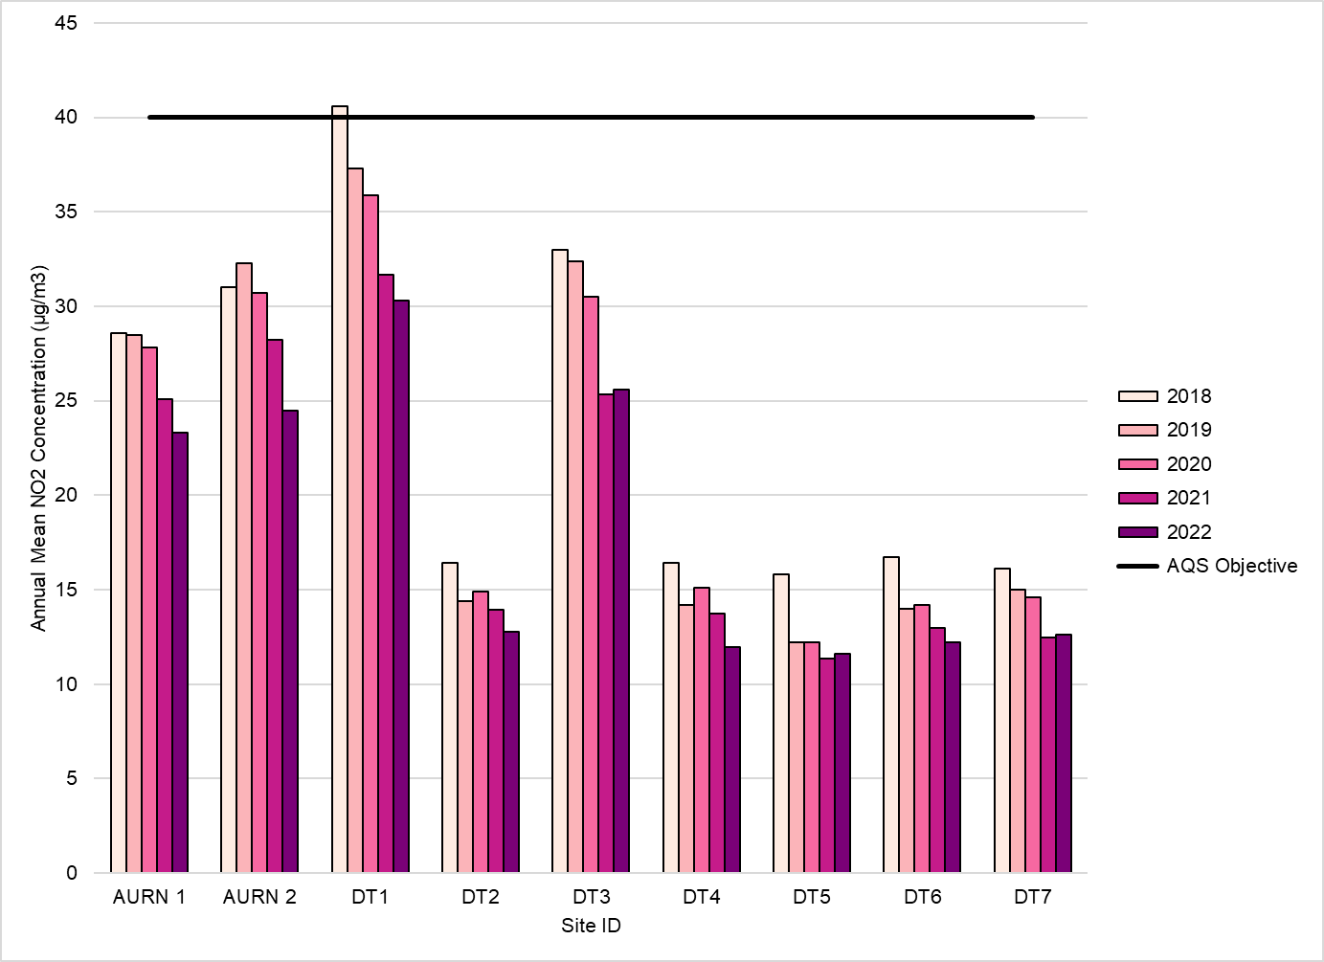

Table A.5 – 1-Hour Mean NO₂ Monitoring Results, Number of 1-Hour Means > 200µg/m³
INSTRUCTIONS
Populate Table A.5 with all relevant 1-hour mean NO₂ automatic monitoring completed over the past five years.
Guidance presented in Chapter 7: NO_{x} and NO₂ Monitoring of the Technical Guidance LAQM.TG22 should be followed for the calculation of 1-hour mean concentrations.
The number of 1-hour periods with concentrations greater than 200µg/m³ should be presented as whole numbers, aside from any percentile values that should be presented to 1 dp.
Exceedances of the NO₂ 1-hour mean objective (200µg/m³ not to be exceeded more than 18 times/year) are shown in BOLD. Any values presented within Table A.5 that are equal to or above 19 should therefore be shown in BOLD.
When completing the Data Capture values the following should be adhered to:
- Valid data capture for monitoring period – This should be the data capture for the period within the calendar year for which monitoring was undertaken. In certain cases, monitoring may only have been undertaken for part of the year, e.g. monitoring that began in January and ran until June (six months) before finishing - if results were returned for all six months this would equate to 100% data capture.
- Valid data capture 2022 – This is the data capture based upon the calendar year. For the example given above this would result in a 50% data capture within 2022.
If the VALID DATA Capture 2022 is less than 85%, the 99.8th percentile of 1-hour means should be presented in brackets. This can be calculated following the procedure as detailed in Chapter 7: NO_{x} and NO₂ Monitoring of the Technical Guidance LAQM.TG22.
Delete this box when the document is finished
Site ID | X OS Grid Ref (Easting) | Y OS Grid Ref (Northing) | Site Type | Valid Data Capture for Monitoring Period (%) ⁽¹⁾ | Valid Data Capture 2022 (%) ⁽²⁾ | 2018 | 2019 | 2020 | 2021 | 2022
<CM1> | <666555> | <333444> | <Roadside> | <100> | <50> | <19> | <11> | <18> | <19> | <30>
<CM2> | <777444> | <333555> | <Urban Background> | <65> | <65> | <-> | <-> | <15 (185) > | <25> | <16 (275) >
<CLICK HERE THEN PASTE COMPLETED DATA ROWS FROM ASR EXCEL TEMPLATE>
Notes:
Results are presented as the number of 1-hour periods where concentrations greater than 200µg/m³ have been recorded.
Exceedances of the NO₂ 1-hour mean objective (200µg/m³ not to be exceeded more than 18 times/year) are shown in bold.
If the period of valid data is less than 85%, the 99.8th percentile of 1-hour means is provided in brackets.
(1) Data capture for the monitoring period, in cases where monitoring was only carried out for part of the year.
(2) Data capture for the full calendar year (e.g. if monitoring was carried out for 6 months, the maximum data capture for the full calendar year is 50%).

Figure A.2 – Trends in Number of NO₂ 1-Hour Means > 200µg/m³
< Example Trend Chart illustrated below. Delete section if not required>
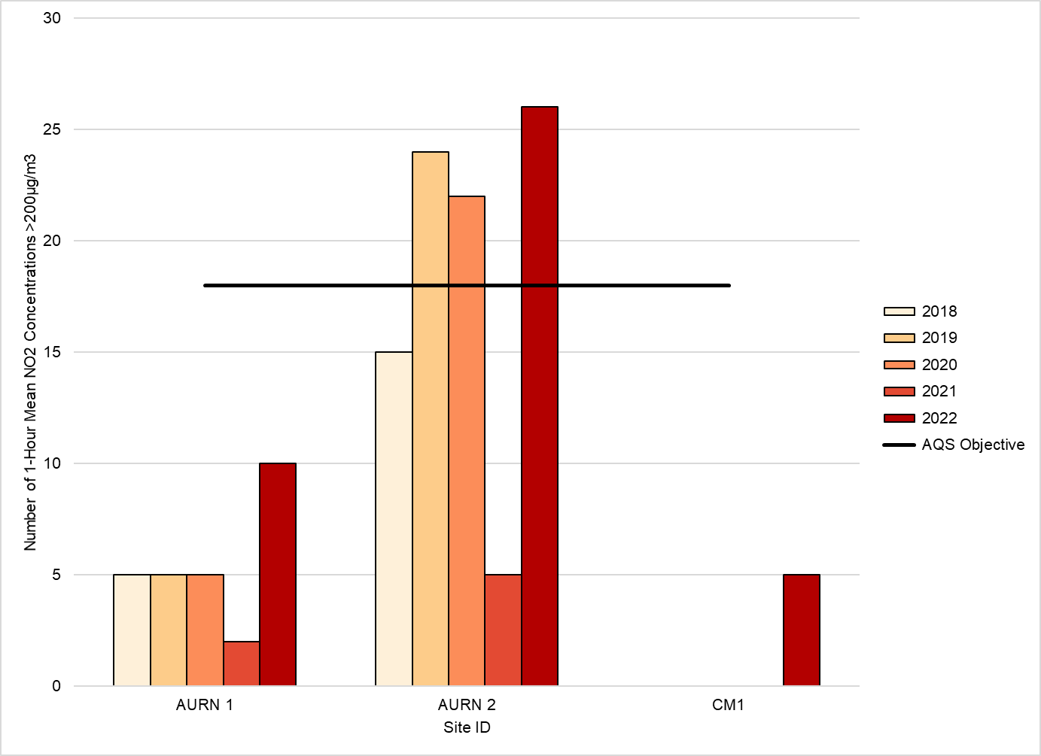
Table A.6 – Annual Mean PM₁₀ Monitoring Results (µg/m³)
INSTRUCTIONS
Populate Table A.6 with all automatic annual mean PM₁₀ monitoring results for the past five years.
Guidance presented in Chapter 7: Particulate Matter Monitoring of the Technical Guidance LAQM.TG22 should be followed for the calculation of the annual mean; for both PM₁₀ and PM_{2.5,} the annual mean can be calculated by averaging all of the valid 1-hour mean data values for the calendar year.
Concentrations should be annualised (where required).
Concentrations should be presented within Table A.6, and throughout the report to one decimal place (1 dp).
Any exceedances of the PM₁₀ annual mean objective of 40µg/m³ should be presented in BOLD.
When completing the Data Capture values the following should be adhered to:
- Valid data capture for monitoring period – This should be the data capture for the period within the calendar year for which monitoring was undertaken. In certain cases, monitoring may only have been undertaken for part of the year, e.g. monitoring that began in January and ran until June (six months) before finishing - if results were returned for all six months this would equate to 100% data capture.
- Valid data capture 2022 – This is the data capture based upon the calendar year. For the example given above this would result in a 50% data capture within 2022.
Delete this box when the document is finished
Site ID | X OS Grid Ref (Easting) | Y OS Grid Ref (Northing) | Site Type | Valid Data Capture for Monitoring Period (%) ⁽¹⁾ | Valid Data Capture 2022 (%) ⁽²⁾ | 2018 | 2019 | 2020 | 2021 | 2022
<CM1> | <666555> | <333444> | <Roadside> | <100> | <80> | <61.0> | <48.1> | <44.1> | <43.2> | <41.4>
<CM2> | <777444> | <333555> | <Urban Background> | <65> | <65> | <27.0> | <28.2> | <31.5> | <27.8> | <30.5>
<CLICK HERE THEN PASTE COMPLETED DATA ROWS FROM ASR EXCEL TEMPLATE>
☐ Annualisation has been conducted where data capture is <75% and >25% in line with LAQM.TG22 (confirm by selecting in box).
Notes:
The annual mean concentrations are presented as µg/m³.
Exceedances of the PM₁₀ annual mean objective of 40µg/m³ are shown in bold.
All means have been “annualised” as per LAQM.TG22 if valid data capture for the full calendar year is less than 75%. See Appendix C for details.
(1) Data capture for the monitoring period, in cases where monitoring was only carried out for part of the year.
(2) Data capture for the full calendar year (e.g. if monitoring was carried out for 6 months, the maximum data capture for the full calendar year is 50%).

Figure A.3 – Trends in Annual Mean PM₁₀ Concentrations
< Example Trend Chart illustrated below. Delete section if not required>
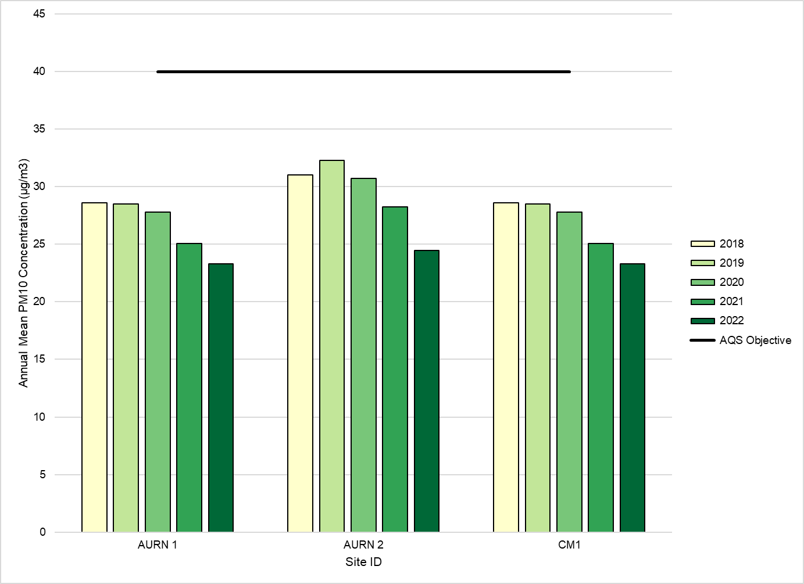
Table A.7 – 24-Hour Mean PM₁₀ Monitoring Results, Number of PM₁₀ 24-Hour Means > 50µg/m³
INSTRUCTIONS
Populate Table A.7 with all relevant 24-hour mean PM₁₀ automatic monitoring completed for the past five years.
Guidance presented in Chapter 7: Particulate Matter Monitoring of the Technical Guidance LAQM.TG22 should be followed for the calculation of 24-hour period means.
The number of 24-hour periods greater than 50µg/m³ should be presented as whole numbers, aside from any percentile values that should be presented to 1 dp.
Exceedances of the PM₁₀ 24-hour mean objective (50µg/m³ not to be exceeded more than 35 times/year) are shown in BOLD. Any values presented within Table A.7 equal to or above 36 should therefore be shown in BOLD.
When completing the Data Capture values the following should be adhered to:
- Valid data capture for monitoring period – This should be the data capture for the period within the calendar year for which monitoring was undertaken. In certain cases, monitoring may only have been undertaken for part of the year, e.g. monitoring that began in January and ran until June (six months) before finishing - if results were returned for all six months this would equate to 100% data capture.
- Valid data capture 2022 – This is the data capture based upon the calendar year. For the example given above this would result in a 50% data capture within 2022.
If the VALID DATA Capture 2022 is less than 85%, the 90.4th percentile of 1-hour means should be presented in brackets. This can be calculated following the procedure as detailed in Chapter 7: Particulate Matter Monitoring of the Technical Guidance LAQM.TG22.
Delete this box when the document is finished
Site ID | X OS Grid Ref (Easting) | Y OS Grid Ref (Northing) | Site Type | Valid Data Capture for Monitoring Period (%) ⁽¹⁾ | Valid Data Capture 2022 (%) ⁽²⁾ | 2018 | 2019 | 2020 | 2021 | 2022
<CM1> | <666555> | <333444> | <Roadside> | <100> | <80> | <42> | <36> | <35> | <34> | <30>
<CM2> | <777444> | <333555> | <Urban Background> | <65> | <65> | <-> | <-> | <28 (52) > | <38> | <28 (30) >
<CLICK HERE THEN PASTE COMPLETED DATA ROWS FROM ASR EXCEL TEMPLATE>
Notes:
Results are presented as the number of 24-hour periods where daily mean concentrations greater than 50µg/m³ have been recorded.
Exceedances of the PM₁₀ 24-hour mean objective (50µg/m³ not to be exceeded more than 35 times/year) are shown in bold.
If the period of valid data is less than 85%, the 90.4th percentile of 24-hour means is provided in brackets.
(1) Data capture for the monitoring period, in cases where monitoring was only carried out for part of the year.
(2) Data capture for the full calendar year (e.g. if monitoring was carried out for 6 months, the maximum data capture for the full calendar year is 50%).

Figure A.4 – Trends in Number of 24-Hour Mean PM₁₀ Results > 50µg/m³
<Example Trend Chart illustrated below. Delete section if not required>
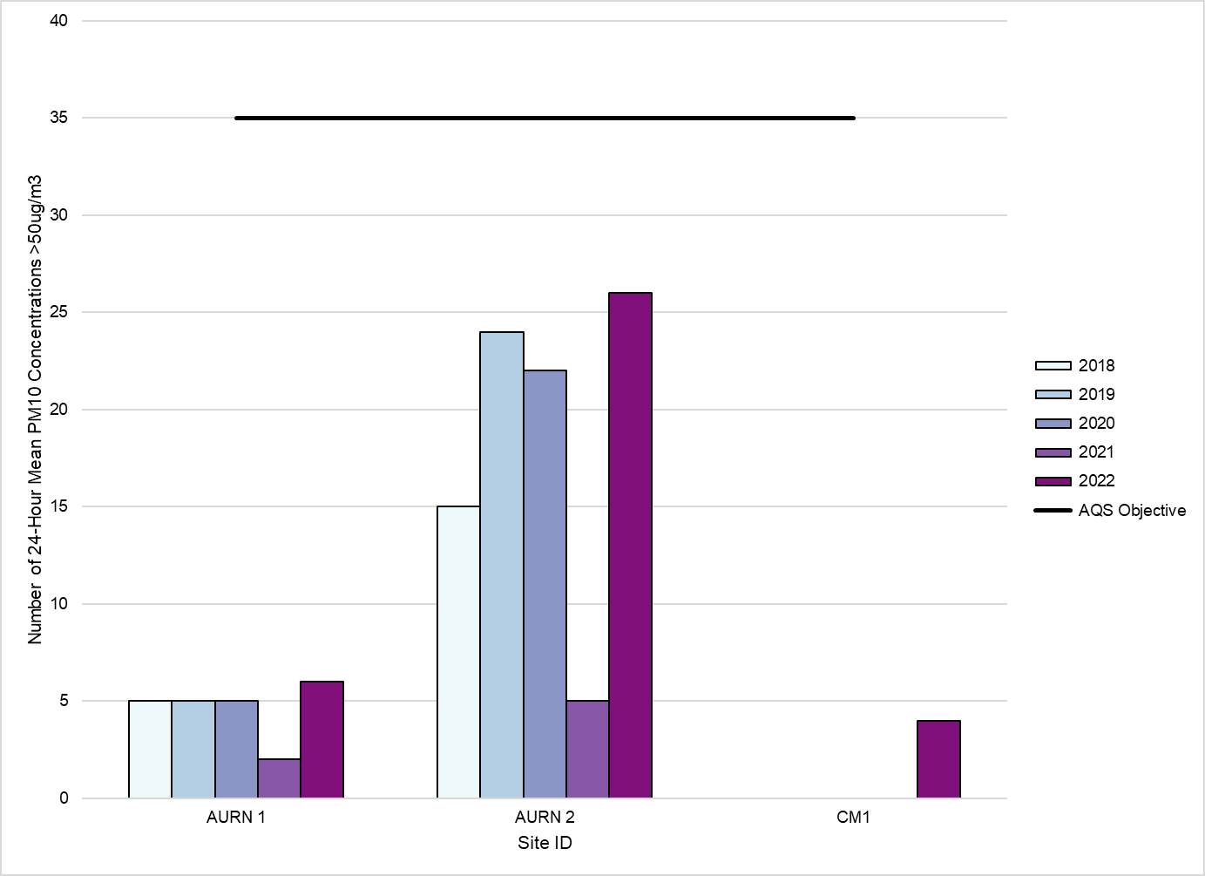
Table A.8 – Annual Mean PM_{2.5} Monitoring Results (µg/m³)
INSTRUCTIONS
Populate Table A.8 with all automatic annual mean PM_{2.5} monitoring results for the past five years.
Guidance presented in Chapter 7: Particulate Matter Monitoring of the Technical Guidance LAQM.TG22 should be followed for the calculation of the annual mean; for both PM₁₀ and PM_{2.5,} the annual mean can be calculated by averaging all of the valid 1-hour mean data values for the calendar year.
Concentrations should be annualised (where required).
Concentrations should be presented within Table A.8, and throughout the report to one decimal place (1 dp).
When completing the Data Capture values the following should be adhered to:
- Valid data capture for monitoring period – This should be the data capture for the period within the calendar year for which monitoring was undertaken. In certain cases, monitoring may only have been undertaken for part of the year, e.g. monitoring that began in January and ran until June (six months) before finishing - if results were returned for all six months this would equate to 100% data capture.
- Valid data capture 2022 – This is the data capture based upon the calendar year. For the example given above this would result in a 50% data capture within 2022.
Delete this box when the document is finished

Site ID | X OS Grid Ref (Easting) | Y OS Grid Ref (Northing) | Site Type | Valid Data Capture for Monitoring Period (%) ⁽¹⁾ | Valid Data Capture 2022 (%) ⁽²⁾ | 2018 | 2019 | 2020 | 2021 | 2022
<CM1> | <666555> | <333444> | <Roadside> | <100> | <80>
<CM2> | <777444> | <333555> | <Urban Background> | <65> | <65>
<CLICK HERE THEN PASTE COMPLETED DATA ROWS FROM ASR EXCEL TEMPLATE>
☐ Annualisation has been conducted where data capture is <75% and >25% in line with LAQM.TG22 (confirm by selecting in box).
Notes:
The annual mean concentrations are presented as µg/m³.
All means have been “annualised” as per LAQM.TG22 if valid data capture for the full calendar year is less than 75%. See Appendix C for details.
(1) Data capture for the monitoring period, in cases where monitoring was only carried out for part of the year.
(2) Data capture for the full calendar year (e.g. if monitoring was carried out for 6 months, the maximum data capture for the full calendar year is 50%).

Figure A.5 – Trends in Annual Mean PM_{2.5} Concentrations
<Example Trend Chart provided below. Delete section if not required>
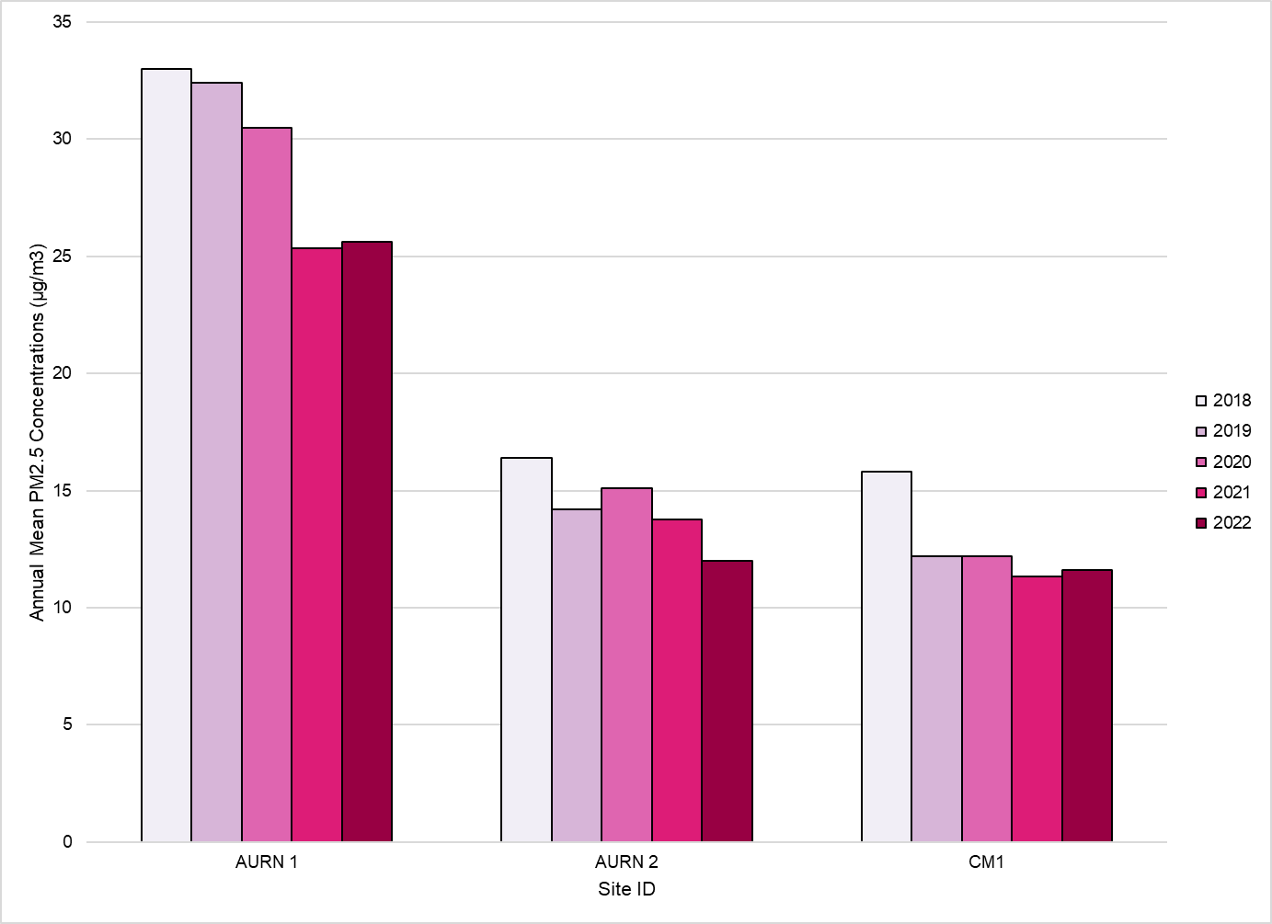
Table A.9 – SO₂ 2022 Monitoring Results, Number of Relevant Instances
INSTRUCTIONS
Populate Table A.9 with all relevant SO₂ automatic monitoring completed within 2022.
Guidance presented in Chapter 7: SO₂ Monitoring of the Technical Guidance LAQM.TG22 should be followed for the calculation of concentrations for the relevant averaging period.
The number of periods greater than the relevant objectives should be presented as whole numbers, aside from any percentile values that should be presented to 1 dp.
Exceedances of any of the objectives should be shown in BOLD. The relevant objectives are as follows:
- 15-minute, 266µg/m³, 35 permitted exceedances per year
- 1-hour, 350µg/m³, 24 permitted exceedances per year
- 24-hour, 150µg/m³, 3 permitted exceedances per year
When completing the Data Capture values the following should be adhered to:
- Valid data capture for monitoring period – This should be the data capture for the period within the calendar year for which monitoring was undertaken. In certain cases, monitoring may only have been undertaken for part of the year, e.g. monitoring that began in January and ran until June (six months) before finishing - if results were returned for all six months this would equate to 100% data capture.
- Valid data capture 2022 – This is the data capture based upon the calendar year. For the example given above this would result in a 50% data capture within 2022.
If the period of VALID DATA is less than 85%, the relevant percentile calculation should be presented in brackets. The relevant percentiles for SO₂ objectives are as follows:
- 15-minute, 99.9th percentile
- 1-hour, 99.7th percentile
- 24-hour, 33.2nd percentile
These can be calculated following the procedure as detailed in Chapter 7: SO₂ Monitoring of the Technical Guidance LAQM.TG22.
Delete this box when the document is finished

Site ID | X OS Grid Ref (Easting) | Y OS Grid Ref (Northing) | Site Type | Valid Data Capture for Monitoring Period (%) ⁽¹⁾ | Valid Data Capture 2022 (%) ⁽²⁾ | Number of 15-minute Means > 266µg/m³ | Number of 1-hour Means > 350µg/m³ | Number of 24-hour Means > 125µg/m³
<CM1> | <666555> | <333444> | <Roadside> | <100> | <80> | <4> | <1> | <0>
<CM2> | <777444> | <333555> | <Urban Background> | <65> | <65> | <1> | <0> | <0>
Notes:
Results are presented as the number of instances where monitored concentrations are greater than the objective concentration.
Exceedances of the SO₂ objectives are shown in bold (15-min mean = 35 allowed a year, 1-hour mean = 24 allowed a year, 24-hour mean = 3 allowed a year).
If the period of valid data is less than 85%, the relevant percentiles are provided in brackets.
(1) Data capture for the monitoring period, in cases where monitoring was only carried out for part of the year.
(2) Data capture for the full calendar year (e.g. if monitoring was carried out for 6 months, the maximum data capture for the full calendar year is 50%).

Appendix B: Full Monthly Diffusion Tube Results for 2022
Table B.1 – NO₂ 2022 Diffusion Tube Results (µg/m³)
INSTRUCTIONS
Please fill in Table B.1 with details of NO₂ diffusion tube monitoring results.
It is recommended that the Diffusion Tube Data Processing Tool is used to process all diffusion tube data. The tab Annual Results Summary from the Diffusion Tube Data Processing Tool aligns with the diffusion tube data requirements of Table B.1 therefore the data can be easily copied. If the tool has not been utilised, please copy across from any working spreadsheet or populate manually.
This table should contain:
- Full month by month raw data (state if different exposure periods from the suggested calendar available via the LAQM website
- The raw data annual mean
- The bias adjusted annual mean – This should also be an annualised annual mean if data capture is below 75% but greater than 25%.
- The distance corrected annual mean – If the location is not relevant to public exposure and the concentration is greater than 36µg/m³. If the monitoring location is relevant to annual mean public exposure, please leave the final column blank or add a dash (-).
The following erroneous data should have been excluded when processing the monthly diffusion tube data for the monitoring year, therefore should not be included within Table B.1:
- Results that have been identified as contaminated during analysis, e.g. insect(s) or dirt contained within the tube
- Extreme low or high concentrations as detailed within Chapter 7: NO_{x} and NO₂ Monitoring of the Technical Guidance LAQM.TG22
- Results from tubes that have been exposed past the laboratory’s use by date
Ensure the Diffusion Tube (DT) IDs and Coordinates match those provided in Table A.2.
Please delete this box when the document is finished

DT ID | X OS Grid Ref (Easting) | Y OS Grid Ref (Northing) | Jan | Feb | Mar | Apr | May | Jun | Jul | Aug | Sep | Oct | Nov | Dec | Annual Mean: Raw Data | Annual Mean: Annualised and Bias Adjusted  <(x.x)> | Annual Mean: Distance Corrected to Nearest Exposure | Comment
<DT1> | <666555> | <333444> | <36.0> | <42.1> | <-> | <-> | <59.1> | <52.9> | <-> | <47.0> | <55.0> | <38.4> | <45.2> | <46.8> | <46.9> | <44.9> | <25.9>
<DT2> | <777444> | <333555> | <35.7> | <23.3> | <19.7> | <17.1> | <18.2> | <19.5> | <25.7> | <17.0> | <27.0> | <19.0> | <33.0> | <27.6> | <23.6> | <21.6> | <->
<CLICK HERE THEN PASTE COMPLETED DATA ROWS FROM LAQM DATA PROCESSING TOOL (IF UTILISED)>
☐ All erroneous data has been removed from the NO₂ diffusion tube dataset presented in Table B.1 (confirm by selecting in box).
☐ Annualisation has been conducted where data capture is <75% and >25% in line with LAQM.TG22 (confirm by selecting in box).
☐ Local bias adjustment factor used (confirm by selecting in box).
☐ National bias adjustment factor used (confirm by selecting in box).
☐ Where applicable, data has been distance corrected for relevant exposure in the final column (confirm by selecting in box).
☐ <Local Authority> confirm that all 2022 diffusion tube data has been uploaded to the Diffusion Tube Data Entry System (confirm by selecting in box).
Notes:
Exceedances of the NO₂ annual mean objective of 40µg/m³ are shown in bold.
NO₂ annual means exceeding 60µg/m³, indicating a potential exceedance of the NO₂ 1-hour mean objective are shown in bold and underlined.
See Appendix C for details on bias adjustment and annualisation.

Appendix C: Supporting Technical Information / Air Quality Monitoring Data QA/QC
INSTRUCTIONS
Please include here any additional information required to support the ASR. Subheadings have been provided as prompts for which information may be required. This may include:
- Indication, if necessary, of any significant changes to sources, and therefore any screening assessment of identified new or changed sources of pollution based on LAQM screening tools, etc (see Chapter 7: Screening Tools and Methodology in Technical Guidance LAQM.TG22). Outline whether this has resulted / will result in any change to monitoring or an AQMA declaration.
- A summary of any additional studies/evidence for support of action plan measures, detailed dispersion modelling of emissions, or results of monitoring campaigns carried out to determine whether an AQMA needs to be declared, amended or revoked. Any additional studies should be included as a further Appendix to the annual report.
- QA/QC on monitoring data, including bias adjustments, annualisation and fall-off with distance correction, as appropriate:
  - Discussion and justification on the choice of bias adjustment factor applied for diffusion tubes (i.e. local vs national), with reference to previous years’ choices of bias factors, giving due consideration to the discussion in Chapter 7 of Technical Guidance LAQM.TG22.
  - Discussion on the annualisation process, which is provided in Chapter 7 of Technical Guidance LAQM.TG22.
  - Details of distance correction using the diffusion tube data processing/ NO₂ fall off with distance calculator as discussed in Chapter 7 of Technical Guidance LAQM.TG22. Distance correction is an important point to consider if your monitoring sites are not representative of public exposure, e.g. if located at roadside or kerbside, but with façades of nearest properties set back further from the road.
- Please include calculations within the tables provided as found within the relevant LAQM tools; particularly regarding bias adjustments, annualisation and fall-off with distance correction, where appropriate. Failure to provide clear and auditable details is likely to result in the rejection of the report.
Delete this box when the document is finished

New or Changed Sources Identified Within <Local Authority Name> During <Year>
INSTRUCTIONS
Detail any new sources within your authority that have been identified with a potential to impact air quality. This may include sources that are operational, have planning permission granted or have been identified at an earlier stage of the planning process. Sources may include additional road traffic, static or standby plant, biomass or industrial processes, etc.
Or:
<Local Authority Name> has not identified any new sources relating to air quality within the reporting year of <Year>.
Delete this box when the document is finished

Additional Air Quality Works Undertaken by <Local Authority Name> During <Year>
INSTRUCTIONS
Provide a summary of any supporting evidence or additional studies that has been completed during the reporting year relating to the development of action plan measures or the declaration, amendment or revocation of an AQMA. If an additional study has been completed, please provide the report as an additional appendix.
Or:
<Local Authority Name> has not completed any additional works within the reporting year of <Year>.
Delete this box when the document is finished

QA/QC of Diffusion Tube Monitoring
INSTRUCTIONS
Within this section provide details relating to the following aspects of non-automatic (i.e. passive) monitoring using diffusion tubes:
- The supplier used for diffusion tubes within 2022 and the method of preparation, e.g. 20% TEA in water;
- Information on the diffusion tube supplier; any accreditation held, analysis procedure followed, participation in analysis schemes (e.g. AIR-PT) and most recent results, inclusion in the annual field inter-comparison exercise and associated result;
- If the diffusion tube supplier has been changed part way through the year (if so provide the previous two points for both suppliers);
- State whether or not the monitoring has been completed in adherence with the 2022 Diffusion Tube Monitoring Calendar, providing commentary of any divergences as necessary.
The additional subsections should be used to provide QA/QC details of the data processing methodologies applied to diffusion tube monitoring data, specifically in relation to annualisation, bias adjustment and fall-off-with-distance calculations.
If you do not undertake diffusion tube monitoring, please delete this section.
Delete this box when the document is finished

Diffusion Tube Annualisation
INSTRUCTIONS
If annualisation was required for any non-automatic monitoring sites, the sites requiring annualisation should be clearly defined along with details of the calculation method undertaken provided in Table C.1. Annualisation is required for any site with data capture less than 75% but greater than 25%.
Or:
All diffusion tube monitoring locations within <Local Authority Name> recorded data capture of 75% therefore it was not required to annualise any monitoring data. In addition, any sites with a data capture below 25% do not require annualisation.
Delete this box when the document is finished
Table C.1 – Annualisation Summary (concentrations presented in µg/m³)
INSTRUCTIONS
Both automatic and non-automatic annualisation results should be included within Table C.1.
For diffusion tube annualisation the Annualisation Tool or the Diffusion Tube Data Processing Tool can be used to complete annualisation. Either tool should be used to ensure the correct methodology for annualisation is utilised. Table C.1 has the same structure as the Annualisation Summary tab within both tools, therefore the required data can easily be copied.
If a LAQM tool has not been used for diffusion tube annualisation, please enter the relevant data into the table below or replace this table with one presenting the relevant details for annualisation.
Currently there is no LAQM tool to process annualisation for automatic monitoring, therefore guidance as per Chapter 7: NO_{x} and NO₂ Monitoring of the Technical Guidance LAQM.TG22 should be followed and the results presented within Table C.1.
If less than four background sites have been used to annualise, the relevant boxes can be left blank or a dash added (-). Any relevant comments should be added within the Comments column.
This table should be deleted if annualisation has not been required at any site.
Delete this box when the document is finished

Site ID | Annualisation Factor <Site 1 Name> | Annualisation Factor <Site 2 Name> | Annualisation Factor <Site 3 Name> | Annualisation Factor <Site 4 Name> | Average Annualisation Factor | Raw Data Annual Mean | Annualised Annual Mean
<DT1>
<DT2>

Diffusion Tube Bias Adjustment Factors
The diffusion tube data presented within the <Year> ASR have been corrected for bias using an adjustment factor. Bias represents the overall tendency of the diffusion tubes to under or over-read relative to the reference chemiluminescence analyser. LAQM.TG22 provides guidance with regard to the application of a bias adjustment factor to correct diffusion tube monitoring. Triplicate co-location studies can be used to determine a local bias factor based on the comparison of diffusion tube results with data taken from NO_{x}/NO₂ continuous analysers. Alternatively, the national database of diffusion tube co-location surveys provides bias factors for the relevant laboratory and preparation method.
<Local Authority Name> have applied a <national/local> bias adjustment factor of <insert factor> to the <Year> monitoring data. A summary of bias adjustment factors used by <Local Authority Name> over the past five years is presented in Table C.2.
INSTRUCTIONS
Provide discussion in relation to the bias adjustment factor chosen; a national factor or a local factor.
- If a national factor has been used, please state as per Table C.2 which version of the national spreadsheet the factor has been taken from and also the number of studies applicable to the factor.
- If a local factor has been used, please advise at which site(s) the co-location study has been completed at and present the details in Table C.3.
- If more than one co-location study has been utilised to derive a local factor, please provide the calculations that have been completed within the body of text. These should be completed in line with guidance provided within LAQM.TG22 Chapter 7: NO_{x} and NO₂ Monitoring, NO₂ by Diffusion Tubes.
Delete this box when the document is finished
Table C.2 – Bias Adjustment Factor
INSTRUCTIONS
Please complete the following table detailing the bias adjustment factors used to adjust the data presented in Table A.4 and Table B.1. If a national factor has been used, please detail the version of the National Bias Adjustment Factor Spreadsheet that has been used (detailed in the top-right corner of each revision of the spreadsheet). If a local factor has been derived, please leave this column blank or insert a dash (-).
Delete this box when the document is finished

Monitoring Year | Local or National | If National, Version of National Spreadsheet | Adjustment Factor
2022 | <Local> | <-> | <0.88>
2021 | <National> | <09/19> | <1.01>
2020 | <National> | <06/18> | <1.05>
2019 | <National> | <09/17> | <1.07>
2018 | <National> | <06/16> | <1.08>
Table C.3 – Local Bias Adjustment Calculation
INSTRUCTIONS
Please complete
Table C.3 if a local bias adjustment factor has been calculated.
For the calculation of a local bias adjustment factor the Diffusion Tube Precision Accuracy Bias Spreadsheet or the Diffusion Tube Data Processing Tool can be used to complete the calculations. Either tool should be used to ensure the correct methodology for bias calculation is utilised. Table C.3 has the same structure as the Local Bias Adjustment Outputs tab within the LAQM Diffusion Tube Data Processing Tool, therefore the required data can be easily copied. If the Diffusion Tube Precision Accuracy Bias Spreadsheet has been utilised, please enter the relevant data into Table C.3. Alternatively, replace this table with one presenting the equivalent data of the local bias calculation and consider adding a screenshot of the completed Precision & Accuracy tab for clarity.
If a local factor from more than one local co-location study has been calculated without utilising the Diffusion Tube Data Processing Tool, guidance to average the bias B values as per Chapter 7: NO_{x} and NO₂ Monitoring of the Technical Guidance LAQM.TG22 should be followed.
The table has been set up to take account of a maximum of five local co-location studies. If less than five sites have been utilised the relevant boxes can be left blank or a dash added (-). If more than five sites have been utilised, please add any additional columns to the table.
This table should be deleted if a local bias adjustment factor has not been calculated.
Delete this box when the document is finished

 | Local Bias Adjustment Input 1 | Local Bias Adjustment Input 2 | Local Bias Adjustment Input 3 | Local Bias Adjustment Input 4 | Local Bias Adjustment Input 5
Periods used to calculate bias | 12
Bias Factor A | 1.13 (1.06 – 1.21)
Bias Factor B | -12% (-17% - -6%)
Diffusion Tube Mean (µg/m³) | 30.9
Mean CV (Precision) | 0.0%
Automatic Mean (µg/m³) | 35.0
Data Capture | 100%
Adjusted Tube Mean (µg/m³) | 35 (33 – 37)
Notes:
A single local bias adjustment factor has been used to bias adjust the 2022 diffusion tube results.
Or:
A combined local bias adjustment factor of <enter combined factor> has been used to bias adjust the 2022 diffusion tube results.

NO₂ Fall-off with Distance from the Road
Wherever possible, monitoring locations are representative of exposure. However, where this is not possible, the NO₂ concentration at the nearest location relevant for exposure has been estimated using the Diffusion Tube Data Processing Tool/NO₂ fall-off with distance calculator available on the LAQM Support website. Where appropriate, non-automatic annual mean NO₂ concentrations corrected for distance are presented in Table B.1.
INSTRUCTIONS
If fall-off-with-distance calculations were required for any non-automatic monitoring sites, a summary of the sites should be provided here and the output data from the LAQM NO₂ fall-off with distance calculator, or output from the Diffusion Tube Data Processing Tool should be presented in Table C.4. Distance correction should be considered at any monitoring site where the annual mean concentration is greater than 36µg/m³ and the monitoring site is not located at a point of relevant exposure (taking the limitations of the calculator into account).
Or:
No diffusion tube NO₂ monitoring locations within <Local Authority Name> required distance correction during <Year>.
Delete this box when the document is finished
Table C.4 – NO₂ Fall off With Distance Calculations (concentrations presented in µg/m³)
INSTRUCTIONS
Both automatic and non-automatic distance corrected results should be included within Table C.4.
For distance correction of NO₂ monitoring the NO₂ Fall-Off with Distance Calculator or the Diffusion Tube Data Processing Tool can be used to complete the calculations. Either tool should be used to ensure the correct methodology for NO₂ concentration fall off is utilised. Table C.4 has the same structure as the output tabs as follows, therefore the required data can easily be copied:
- NO₂ Fall-Off with Distance Calculator – Calculator - Multiple Tubes
- Diffusion Tube Data Processing Tool – Step 4 - Fall off with Distance
The Limitations / Important Notes tab within the calculator should be referred to ensure only relevant sites are included within the calculator.
Please ensure the correct distances are utilised within the calculator:
- The distance from monitoring site to kerb is presented within Table A.1 and Table A.2 (Distance to kerb of nearest road)
- The distance from receptor to kerb is the sum of Distance to kerb of nearest road and Distance to Relevant Exposure from Table A.1 and/or Table A.2
Any comments output from the calculator should be added within the Comments column.
This table should be deleted if distance correction has not been completed at any site.
Delete this box when the document is finished

Site ID | Distance (m): Monitoring Site to Kerb | Distance (m): Receptor to Kerb | Monitored Concentration (Annualised and Bias Adjusted | Background Concentration | Concentration Predicted at Receptor | Comments
<DT1>
<DT2>

QA/QC of Automatic Monitoring
INSTRUCTIONS
Within this section details relating to the following should be included:
- Who completes the data management and Local Site Operator (LSO) duties for any automatic monitoring sites within the authority;
- Details on the frequency of calibrations, audit/servicing;
- Ratification process, and if the monitoring data presented within the ASR is provisional or ratified;
- If live/historic data is available through a website.
Delete this box when the document is finished

PM₁₀ and PM_{2.5} Monitoring Adjustment
INSTRUCTIONS
If PM₁₀/PM_{2.5} monitoring is completed within your authority, where applicable please detail any correction factors applied to the data before it is published (e.g. using the Volatile Correction Model (VCM) or a specific correction factor). Correction factors as detailed within LAQM.TG22 Chapter 7: Particulate Matter Monitoring.
Or:
The type of <PM₁₀/PM_{2.5}> monitor(s) utilised within <Local Authority Name> do not required the application of a correction factor.
Please delete this section if no PM₁₀/PM_{2.5} monitoring is not completed within your authority.
Delete this box when the document is finished

Automatic Monitoring Annualisation
INSTRUCTIONS
If annualisation was required for any automatic monitoring sites a summary of the sites should be provided here and the annualisation data should be presented in Table C.1. Annualisation is required for any site with data capture less than 75% but greater than 25%.
Or:
All automatic monitoring locations within <Local Authority Name> recorded data capture of greater than 75% therefore it was not required to annualise any monitoring data. In addition, any sites with a data capture below 25% do not require annualisation.
Please delete this section if no automatic monitoring is completed within your authority.
Delete this box when the document is finished

NO₂ Fall-off with Distance from the Road
Wherever possible, monitoring locations are representative of exposure. However, where this is not possible, the NO₂ concentration at the nearest location relevant for exposure has been estimated using the NO₂ fall-off with distance calculator available on the LAQM Support website. Where appropriate, non-automatic annual mean NO₂ concentrations corrected for distance are presented in Table B.1.
INSTRUCTIONS
If fall-off-with-distance calculations were required for automatic monitoring sites, a summary of the sites should be provided here and the output data from the LAQM NO₂ fall-off with distance calculator should be presented in Table C.4. Distance correction should be considered at any monitoring site where the annual mean concentration is greater than 36µg/m³ and the monitoring site is not located at a point of relevant exposure (taking the limitations of the calculator into account).>
Or:
No automatic NO₂ monitoring locations within <Local Authority Name> required distance correction during <Year>.
The structure of the above and following QA/QC tables are consistent with those output by the Diffusion Tube Data Processing Tool. It is therefore recommended that this tool is used to aid transparency of calculations and associated QA/QC pertaining to the processing of diffusion tube data.
However, it is acknowledged that not all local authorities will initially use the processing tool due to having many years of experience in processing the data within their authority using existing LAQM tools and methods. This also includes automatic monitoring data, for which the Diffusion Tube Data Processing Tool does not currently support. Therefore, in these instances please align these tables to present equivalent details, text and/or tabulated data, to support any calculations completed.
If you have any queries relating to the data that you should present, please contact the LAQM Helpdesk.
Delete this box when the document is finished

Appendix D: Map(s) of Monitoring Locations and AQMAs
INSTRUCTIONS
Please include here one or more clear map(s) that show the location of all monitoring sites in relation to any AQMA(s) and, if appropriate, the local authority boundary, ensuring that monitoring positions are clearly labelled using the Site IDs and the mapped coordinates correspond to those presented in Table A.1 and in Table A.2 of Appendix A.
As for all charts within the annual report alt text should be added to comply with accessibility regulations.
Delete this box when the document is finished
Figure D.1 – Map of Non-Automatic Monitoring Site
<Add required maps here. Example map template provided below>
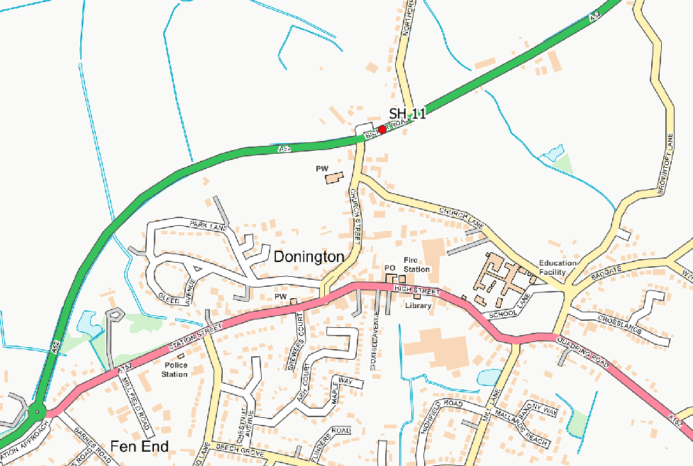

Appendix E: Summary of Air Quality Objectives in England
Table E.1 – Air Quality Objectives in England
Pollutant | Air Quality Objective: Concentration | Air Quality Objective: Measured as
Nitrogen Dioxide (NO₂) | 200µg/m³ not to be exceeded more than 18 times a year | 1-hour mean
Nitrogen Dioxide (NO₂) | 40µg/m³ | Annual mean
Particulate Matter (PM₁₀) | 50µg/m³, not to be exceeded more than 35 times a year | 24-hour mean
Particulate Matter (PM₁₀) | 40µg/m³ | Annual mean
Sulphur Dioxide (SO₂) | 350µg/m³, not to be exceeded more than 24 times a year | 1-hour mean
Sulphur Dioxide (SO₂) | 125µg/m³, not to be exceeded more than 3 times a year | 24-hour mean
Sulphur Dioxide (SO₂) | 266µg/m³, not to be exceeded more than 35 times a year | 15-minute mean

Glossary of Terms
Abbreviation | Description
AQAP | Air Quality Action Plan - A detailed description of measures, outcomes, achievement dates and implementation methods, showing how the local authority intends to achieve air quality limit values’
AQMA | Air Quality Management Area – An area where air pollutant concentrations exceed / are likely to exceed the relevant air quality objectives. AQMAs are declared for specific pollutants and objectives
ASR | Annual Status Report
Defra | Department for Environment, Food and Rural Affairs
DMRB | Design Manual for Roads and Bridges – Air quality screening tool produced by National Highways
EU | European Union
FDMS | Filter Dynamics Measurement System
LAQM | Local Air Quality Management
NO₂ | Nitrogen Dioxide
NO_{x} | Nitrogen Oxides
PM₁₀ | Airborne particulate matter with an aerodynamic diameter of 10µm or less
PM_{2.5} | Airborne particulate matter with an aerodynamic diameter of 2.5µm or less
QA/QC | Quality Assurance and Quality Control
SO₂ | Sulphur Dioxide

References
- Local Air Quality Management Technical Guidance LAQM.TG22. August 2022. Published by Defra in partnership with the Scottish Government, Welsh Assembly Government and Department of the Environment Northern Ireland.
- Local Air Quality Management Policy Guidance LAQM.PG22. August 2022. Published by Defra in partnership with the Scottish Government, Welsh Assembly Government and Department of the Environment Northern Ireland.
<Add additional references here>

Public Health England. Air Quality: A Briefing for Directors of Public Health, 2017
Defra. Air quality and social deprivation in the UK: an environmental inequalities analysis, 2006
Defra. Air quality appraisal: damage cost guidance, January 2023
Public Health England. Estimation of costs to the NHS and social care due to the health impacts of air pollution: summary report, May 2018
Defra. Environmental Improvement Plan 2023, January 2023
DfT. The Road to Zero: Next steps towards cleaner road transport and delivering our Industrial Strategy, July 2018
The units are in microgrammes of pollutant per cubic metre of air (µg/m³).

