2019 Air Quality Annual Status Report (ASR)

In fulfilment of Part IV of the
Environment Act 1995
Local Air Quality Management

June, 2019

Local Authority Officer | John Warren
Department | Environmental Health
Address | Civic Centre, Stone Cross, Northallerton, North Yorkshire, DL6 2UU
Telephone | 01609 767093
E-mail | ehts@hambleton.gov.uk
Report Reference number | HDC/ASR/2019
Date | 7th June 2019

Executive Summary: Air Quality in Our Area

Air Quality in Hambleton
Hambleton is located in the county of North Yorkshire and is one of the largest local authorities by land area covering 1,310 square kilometres (506 square miles). Hambleton is predominantly rural in nature although there are several thriving market towns which form the main centres of population.
Immediately to the north of the district are the built up areas of Darlington, Stockton and Middlesbrough and the highly industrialised Tees Valley. To the south is the City of York, the eastern boundary extends into the North York Moors National Park, and to the west is Swaledale, Wensleydale and the Pennines.
The district topography is mostly low lying and incorporates the River Swale catchment area, Vale of York and the Vale of Mowbray. The main areas of high ground lie to the east of the district where the North York Moors National Park, incorporating the Cleveland Hills and Hambleton Hills (from which the authority takes its name), is located.
Air pollution is associated with a number of adverse health impacts. It is recognised as a contributing factor in the onset of heart disease and cancer. Additionally, air pollution particularly affects the most vulnerable in society: children and older people, and those with heart and lung conditions. There is also often a strong correlation with equalities issues, because areas with poor air quality are also often the less affluent areas,.
The annual health cost to society of the impacts of particulate matter alone in the UK is estimated to be around £16 billion.
The major source of air pollution within Hambleton is from road transport, both NO₂ and PM₁₀. The A1(M) and A19 run north/south through the district but they do not impact on the major population centres. However, there are several other 'A' and 'B' class roads that run through the towns, villages and rural areas and these can generate substantial traffic flows which lead to localised congestion.
The council helps to manage air quality by monitoring at numerous locations across the district, reporting results to Defra and feeding information to North Yorkshire County Council (NYCC) to assist in their transport planning work.
Concentrations of NO₂ are lower at all monitoring locations in 2018 compared to 2017. This is primarily due to meteorological conditions as the background monitoring locations that are not affected by changes in traffic flows have also shown a reduction in pollution concentrations. Other reasons for the reduction include a reduced bias adjustment factor for 2018 data and the application of distance correction factors to the data. The long term trend at the automatic monitoring station shows an overall reduction in pollution concentrations of approximately 28% since 2002. Other monitoring sites where diffusion tubes are located show a reduction of between 13 and 48%.
The Bedale AQMA declared in November 2017 remains in place despite the 2018 dataset showing the annual mean concentration to be more than 10% below the annual mean objective. The reduction in the annual mean concentration inside and outside the AQMA demonstrates that the redirection of traffic onto the Bedale, Aiskew and Leeming Bar bypass has eased congestion and reduced pollution levels.
The council prepared and submitted to Defra in October 2018 an Air Quality Action Plan (AQAP). The AQAP sets out the measures the council intends taking to reduce pollution levels in the AQMA. Defra accepted the AQAP in January 2019 and the council is continuing to monitoring pollution concentrations in the AQMA as recommended by Defra.
The council relocated 14 diffusion tube monitoring sites from existing surveys and created a new survey in Northallerton which started in January 2018. The aim of the new survey is to assess pollution levels on the A684 Stokesley Road and the surrounding areas near to the North Northallerton development scheme. No exceedances of the NO₂ annual mean objective have been identified at these monitoring sites.
The council also started monitoring at five locations near to the former HM Prison in Northallerton town centre in November 2018. This was to assess the impact of the redevelopment of this site. The 2018 monitoring results for these new sites are presented in Appendix A.
At the end of December 2018, the council’s air quality monitoring station closed. The site had been running since 2002 and collected automatic monitoring data for inclusion in annual reports each year to the present. The site also allowed the council to generate its own bias adjustment factor using a triplicate diffusion tube survey to compare monitoring results against those of the automatic analyser. Next year the council will need to use a national adjustment factor generated at comparison sites using the same analysis laboratory and tube preparation method. Due to current financial constraints, the council does not intend re-starting the station, although in the future if a need can be identified and funding obtained then a new station may be possible.

Actions to Improve Air Quality
The council's main action to improve air quality involves monitoring at 43 sites across the district. Monitoring has been carried out in Hambleton since 1993 and the information gathered is provided to the North Yorkshire County Council (NYCC) transport planning team. Monitoring results from 2018 show a reduction in pollution levels across all the monitoring locations in the district. This is likely due to changes in meteorological conditions, bias adjustment factor and the application of distance correction factors to the 2018 dataset. Monitoring will continue through 2019 and the council has started monitoring at new locations in January 2019. The results of the monitoring will be presented in the 2020 annual status report.
Recommendations to amend the council's local plan and taxi licensing policy have also been made to help improve air quality. The outcome of these recommendations will be provided in further detail in the 2020 annual status report

Conclusions and Priorities
The council has not identified any exceedances of the nitrogen dioxide annual mean at any of the 43 monitoring locations across the district and therefore no new AQMAs are required to be declared.
The Bedale AQMA has shown a reduction in pollution levels so that the nitrogen dioxide annual mean is now more than 10% below the air quality objective. This is attributed to the Bedale Aiskew and Leeming Bar bypass which opened in August 2016. The opening of the bypass has increased traffic volumes in Bedale by 9% but this has not caused an increase in NO2 concentrations in the AQMA and it has not caused any areas of congestion. Monitoring will continue through 2019 and 2020 in order to provide additional data on which to base any decision to revoke the AQMA in the future.
The long term monitoring trend at the automatic monitoring station shows that since 2002, there has been a 28% reduction in pollution concentrations. Other sites across the district show reductions of 13 to 48% in nitrogen dioxide annual mean concentrations. The council started new monitoring at 19 sites in Northallerton in 2018 and the results are presented in Appendix A.
Four additional sites were started in January 2019 and the results of these will be presented in the 2020 annual status report.
The council closed the air quality monitoring station at the end of December 2018 due to financial constraints. The station had been in continuous operation since 2002 and provided automatic monitoring results for inclusion in air quality reports for 16 years. It will not be possible to generate a locally derived bias adjustment factor in future so a national factor will be used instead. The council does not have any immediate plans to replace the station.
Major developments that are likely to affect air quality in the district include the Sowerby Gateway Development, North Northallerton Development and the redevelopment of the former HM Prison site in Northallerton. The creation of a new junction on the A168 near the Sowerby Gateway scheme is now complete opened on 3rd June 2018. This will improve vehicular access to the north and help to reduce congestion in Thirsk town centre.
Hambleton District Council's priorities for the coming year are:
- Continue monitoring programme across the district, particularly in and around the Bedale AQMA, Northallerton and Thirsk town centres.
- Identify future monitoring locations in areas with frequent congestion and where new development is taking place.
- Update air quality information in Local Plan and development of a Supplementary Planning Document for air quality.
- Recommendation to improve air quality by taxi licensing conditions.
Challenges faced in addressing these priorities are primarily financial due to reduced local authority funding, increasing costs of monitoring and diminishing resources. Other challenges include identifying pollution and traffic congestion hotspots and working with developers to ensure air quality is properly considered.

Local Engagement and How to get Involved
There are currently no council run schemes to specifically help improve air quality in the district, however the council does encourage active travel such as walking and cycling as part of 'Healthier Lifestyles', which includes promoting information via the website on finding local cycling or walking groups and links to external websites, such as North Yorkshire Sport (www.northyorkshiresport.co.uk). The council also promotes links to external organisations such as Government and DVLA websites for reporting smoky lorries or buses in an attempt to improve air quality by local engagement.

Table of Contents
Executive Summary: Air Quality in Our Area i
Air Quality in Hambleton i
Actions to Improve Air Quality iii
Conclusions and Priorities iii
Local Engagement and How to get Involved v
1 Local Air Quality Management 1
2 Actions to Improve Air Quality 2
2.1 Air Quality Management Areas 2
2.2 Progress and Impact of Measures to address Air Quality in Hambleton 4
2.3 PM_{2.5} – Local Authority Approach to Reducing Emissions and/or Concentrations 10
3 Air Quality Monitoring Data and Comparison with Air Quality Objectives and National Compliance 12
3.1 Summary of Monitoring Undertaken 12
3.1.1 Automatic Monitoring Sites 12
3.1.2 Non-Automatic Monitoring Sites 12
3.2 Individual Pollutants 13
3.2.1 Nitrogen Dioxide (NO₂) 13
3.2.2 Particulate Matter (PM₁₀) 20
Appendix A: Monitoring Results 21
Appendix B: Full Monthly Diffusion Tube Results for 2018 30
Appendix C: Supporting Technical Information / Air Quality Monitoring Data QA/QC 33
Appendix D: Map(s) of Monitoring Locations and AQMAs 40
Appendix E: Summary of Air Quality Objectives in England 48
Glossary of Terms 49
References 51
List of Tables
Table 2.1 Declared Air Quality Management Areas 3
Table 2.2 Progress on Measures to Improve Air Quality 8
Table A.1 Details of Automatic Monitoring Sites 21
Table A.2 Details of Non-Automatic Monitoring Sites 22
Table A.3 Annual Mean NO₂ Monitoring Results 25
Table A.4 1-Hour Mean NO₂ Monitoring Results 29
Table B.1 NO₂ Monthly Diffusion Tube Results - 2018 30
Table E.1 Air Quality Objectives in England 48

List of Figures

Figure 3.1 Automatic analyser nitrogen dioxide trend 2002 to 2018 16
Figure 3.2 Nitrogen dioxide annual means 1993 to 2018 non bias corrected 16
Figure 3.3 Nitrogen dioxide annual means 2002 to 2018 (bias corrected and from 2016 distance corrected) 17
Figure A.1 Trends in Annual Mean NO₂ Concentrations 28
Figure D.1 Map of Automatic Monitoring Site 40
Figure D.2 District Survey Monitoring Sites 41
Figure D.3 Northallerton Survey Monitoring Sites 42
Figure D.4 Friarage Street Survey Monitoring Sites 43
Figure D.5 Co-Location Survey Monitoring Site 44
Figure D.6 Bedale Survey Monitoring Sites 44
Figure D.7 Bedale Air Quality Management Area 45
Figure D.8 Thirsk Survey Monitoring Sites 46
Figure D.9 East Road Survey Monitoring Sites 47

Local Air Quality Management
This report provides an overview of air quality in Hambleton district during 2018. It fulfils the requirements of Local Air Quality Management (LAQM) as set out in Part IV of the Environment Act (1995) and the relevant Policy and Technical Guidance documents.
The LAQM process places an obligation on all local authorities to regularly review and assess air quality in their areas, and to determine whether or not the air quality objectives are likely to be achieved. Where an exceedance is considered likely the local authority must declare an Air Quality Management Area (AQMA) and prepare an Air Quality Action Plan (AQAP) setting out the measures it intends to put in place in pursuit of the objectives. This Annual Status Report (ASR) is an annual requirement showing the strategies employed by Hambleton District Council to improve air quality and any progress that has been made.
The statutory air quality objectives applicable to LAQM in England can be found in Appendix E.

Actions to Improve Air Quality

Air Quality Management Areas
Air Quality Management Areas (AQMAs) are declared when there is an exceedance or likely exceedance of an air quality objective. After declaration, the authority must prepare an Air Quality Action Plan (AQAP) within 12-18 months setting out measures it intends to put in place in pursuit of compliance with the objectives.
A summary of AQMAs declared by Hambleton District Council can be found in Table 2.1. Further information related to declared or revoked AQMAs, including maps of AQMA boundaries are available online at https://uk-air.defra.gov.uk/aqma/list?la=H&country=all&pollutant=all – see full list at https://uk-air.defra.gov.uk/aqma/list. A map showing the location of the AQMA in relation to air quality monitoring locations in Hambleton district is provided in Appendix D.

Table 2.1 Declared Air Quality Management Areas

AQMA Name | Date of Declaration | Pollutants and Air Quality Objectives | City / Town | One Line Description | Is air quality in the AQMA influenced by roads controlled by Highways England? | Level of Exceedance (maximum monitored/modelled concentration at a location of relevant exposure) |  |  |  | Action Plan
 |  |  |  |  |  | At Declaration |  | Now |  | Name | Date of Publication | Link
The Hambleton District Council (Bedale) Air Quality Management Order | Declared 01/11/17 | NO₂ Annual Mean | Bedale | An area encompassing a number of properties at the junction of Bridge Street and Market Place. | NO | 50.2 | µg/m3 | 32.8 | µg/m3 | Bedale Air Quality Management Area Air Quality Action Plan | 22 October 2018 | www.hambleton.gov.uk

☒ Hambleton District Council confirms the information on UK-Air regarding their AQMA(s) is up to date (confirm by selecting in box)

Progress and Impact of Measures to address Air Quality in Hambleton
Defra’s appraisal of last year’s ASR concluded that the report is well structured, detailed, and provides the information specified in the Guidance, using the latest template. Defra’s comments included:
- 2017 monitoring results demonstrate one minor exceedance of the annual mean NO₂ objective at site HDC33, following corrections for bias and distance.
The council has continued to monitor at this location and the results for 2018 do not show an exceedance of the annual mean NO₂ objective.
- QA/QC procedures have been applied correctly and in full for local bias adjustment and distance. Annualisation is not required for any site. No details of distance corrections have been provided. Full details of distance corrections including example calculations should be presented in Appendix C in future reporting.
The council applied distance correction to the bias adjusted annual mean results at all diffusion tube locations. These results were presented in Table B.1 in Appendix B. The distance correction values were determined using the LAQM NO₂ Fall-Off with Distance Calculator (V4.1) which does not show the formula used in the calculations, so example calculations were unable to be presented.
- Compliance has been achieved within the newly declared AQMA, with the highest measured annual mean NO₂ concentration being 37.7 µg/m³. This appears to demonstrate the successful impact of the Bedale Aiskew and Leeming Bar bypass on reducing emissions within the AQMA.
Monitoring has continued at this location and the results for 2018 show further reductions in the NO2 annual mean objective, thereby providing further evidence of the successful impact of the bypass on reducing emissions within the AQMA.
- Current concentrations within the AQMA are still within 10% of the annual mean objective. The AQMA should be considered for revocation following three consecutive years of concentrations measured more than 10% below the objective level (36 µg/m³). Authority should continue to monitor within the AQMA, and keeping it under review, ensuring that monitoring is being carried out at the worst-case locations of relevant exposure in the area.
Monitoring results for 2018 show that the measured concentrations within the AQMA are now more than 10% below the objective level. The council proposes to continue monitoring over the next few years to ensure the reductions are sustainable.
- The measured exceedance at site HDC33 is minor, and is not demonstrated at the other diffusion tubes in proximity to HDC33. If the site continues to demonstrate an exceedance of the annual mean NO₂ objective for the next three years, the Local Authority should consider undertaking a Detailed Assessment and proceeding to declare an AQMA.
The council has continued to monitor at this location and the results for 2018 do not show an exceedance of the annual mean objective.
- An AQAP is required for the recently declared Bedale AQMA. The Council are reminded that an AQAP should be prepared within 12 months following the declaration of an AQMA.
The council submitted an AQAP on 22nd October 2018 and received Defra’s acceptance and appraisal report on 25th January 2019.
- The AQAP should be developed in accordance with specifications outlined in the Technical Guidance TG(16), and a draft should be submitted to Defra as part of the consultation process.
The AQAP was developed in accordance with the Technical Guidance TG(16) and submitted to Defra on 22nd October 2018.
- New AQAP measures should specifically target improvement in pollution hotspots, and achieving stable compliance below 36 µg/m³ in the AQMA. It is expected that Table 2.2 be completed in full after the AQAP has been adopted, including dates for planning, implementation and estimated/actual completion, in addition to realistic KPIs and estimated pollution reduction.
Table 2.2 has been completed in full following adoption of the AQAP.
- The impact of the Sowerby Gateway development is already being seen with increased vehicles passing through Thirsk and increased congestion on the A61 at Westgate, Castlegate and Market Place. Development of a new junction on the A168 has commenced to alleviate traffic pressure through Thirsk. Additionally, a new road link between the A168 and A684 is planned to accompany the North Northallerton development, and provide alternative access for vehicles to reduce congestion in the town centre. Additional diffusion tube monitoring has been planned for locations in the vicinity of the HM Prison redevelopment.
The council is proactive in monitoring pollution concentrations in areas of major development, new roads and junctions and will continue to report the results in Annual Status Reports each year.
- The Local Authority is therefore taking an active approach mitigate and/or monitor these developments as they progress. This is encouraging to see, and the Local Authority should continue to provide updates on these development schemes and any impact on local air quality in future ASR reports.
The council is proactive in monitoring pollution concentrations in areas of major development, new roads and junctions and will continue to report the results in Annual Status Reports each year.
- The Local Authority have introduced eight new monitoring sites in 2017, and have relocated 14 sites at the start of January 2018 to the A684 Stokesley Road and the Surrounding areas near to the North Northallerton development scheme.
The results of the monitoring started in January 2018 are presented in the 2019 Annual Status Report.
- There appears to be a mistake in Table A.2 as 2017 concentrations for new sites HDC31-38 have also been entered into the 2016 column.
Table A.2 does not contain a column with 2016 or 2017 concentrations – this appears to be a mistake as this information is contained in Table A.3. Table A.3 does not show data for sites HDC31-38 in the 2016 year column.
- In general the report is very good, concise and provides a good level of detail and discussion of monitoring results and updates of air quality management in the District.
The council welcomes these positive comments.
Hambleton District Council has taken forward a number of direct measures during the current reporting year of 2019 in pursuit of improving local air quality. Details of all measures completed, in progress or planned are set out in Table 2.2.
Hambleton District Council’s priorities for the coming year are:
- Continue monitoring programme across the district, particularly in and around the Bedale AQMA, Northallerton development schemes and Thirsk A168 junction improvement works.
- Continue to identify future monitoring locations in areas with frequent congestion and where new development is taking place.
- Development of a Supplementary Planning Document for air quality.
- Make recommendations to improve air quality by taxi licensing conditions.
The principal challenges and barriers to implementation that Hambleton District Council anticipates facing include reliance on traffic improvement schemes to help reduce air pollution in the Bedale AQMA and Thirsk A168 junction improvement works and recommendations for new taxi licensing conditions due to possible objections from operators on economic grounds.
Hambleton District Council anticipates that the measures stated above and in Table 2.2 will achieve compliance in the Bedale AQMA.

Table 2.2 Progress on Measures to Improve Air Quality

Measure No. | Measure | EU Category | EU Classification | Organisations involved and Funding Source | Planning Phase | Implementation Phase | Key Performance Indicator | Reduction in Pollutant / Emission from Measure | Progress to Date | Estimated / Actual Completion Date | Comments / Barriers to implementation
1 | Bedale Aiskew Leeming Bar bypass scheme | Traffic Management | Strategic highway improvements | North Yorkshire County Council | Pre 2015 | 2015/16 | Measured NO₂ concentration at diffusion tube site HDC29 in Bedale AQMA | Reduced vehicle emissions to below 10% of the NO₂ annual mean objective (36µg/m3) | Monitoring results from 2018 indicate the bias adjusted annual mean is below 36µg/m3. | Bypass completed in 2016, measured NO₂ concentration estimated completion by end of 2020/21 | Monitoring to continue to assess whether reduction is sustainable.
2 | A168 Thirsk junction improvement scheme | Traffic Management | Strategic highway improvements | North Yorkshire County Council | Pre 2018 | 2018 to 2019 | Measured NO₂ concentration at diffusion tube sites HDC33, HDC34 and HDC35 in Thirsk | Predicted reduction vehicle emissions to below 10% of the NO₂ annual mean objective (36µg/m3) | Monitoring results from 2018 indicate the bias adjusted annual mean is 39.4µg/m3. | Junction opened 4th June 2019, expected reduction in NO₂ concentration estimated completion by end of 2020/21 | Monitoring to continue to assess whether predicted reduction is achieved.
3 | Hambleton District Council Local Development Framework | Policy Guidance and Development Control | Other policy | Hambleton District Council, internal budget | N/A | 2007 - 2026 | N/A | N/A | N/A | N/A | The strategic objectives of the Core Strategy relevant to air quality include ensuring that all development is sustainable, reducing the need for travel and encouraging the use of sustainable forms of transport such as public transport, walking and cycling, reducing the adverse impact of society on the environment (eg reducing pollution) and responding to the implications of climate change. http://www.hambleton.gov.uk/info/20039/planning/283/adopted_local_development_framework
4 | Local Transport Plan 4 (LTP4) | Policy Guidance and Development Control | Other policy | North Yorkshire County Council, internal budget | N/A | 2016 - 2045 | N/A | N/A | N/A | N/A | Objectives include Environment and Climate Change – managing the adverse impact of transport on the environment and Healthier Travel – promoting healthier travel opportunities known as 'active travel'. http://www.northyorks.gov.uk/article/30583/Local-transport-plan-four-LTP4
5 | Taxi licensing conditions to reduce vehicle emissions | Promoting Low Emission Transport | Taxi Licensing conditions | Hambleton District Council | N/A | 2019/20 | N/A | N/A | Proposed changes to the revised Hackney Carriage and Private Hire Licensing Policy were put before the Licensing Committee on 27/09/2018 but were not approved. The committee recommended further amendments are considered prior to re-submitting to the committee.  A revised policy is currently being prepared and is expected to be presented to the committee later in 2019. | End of 2019/20 | Potential barriers include opposition from taxi drivers and councillors
6 | Provision of Air Quality Information | Public Information | Via the Internet | Hambleton District Council, internal budget | N/A | N/A | N/A | N/A | N/A | N/A | http://hambleton.gov.uk/info/20329/air_quality/228/air_quality
7 | Signposting information on walking groups | Public Information | Via the Internet | Hambleton District Council, internal budget | N/A | N/A | N/A | N/A | N/A | N/A | http://hambleton.gov.uk/info/20064/sport_and_physical_activity/326/walking
8 | Signposting information on cycling groups and routes | Public Information | Via the Internet | Hambleton District Council, internal budget | N/A | N/A | N/A | N/A | N/A | N/A | http://hambleton.gov.uk/info/20064/sport_and_physical_activity/3/cycling_and_routes

PM_{2.5} – Local Authority Approach to Reducing Emissions and/or Concentrations
As detailed in Policy Guidance LAQM.PG16 (Chapter 7), local authorities are expected to work towards reducing emissions and/or concentrations of PM_{2.5} (particulate matter with an aerodynamic diameter of 2.5µm or less). There is clear evidence that PM_{2.5} has a significant impact on human health, including premature mortality, allergic reactions, and cardiovascular diseases.
Hambleton District Council is taking the following measures, as outlined in the technical guidance LAQM.TG16, in order to work towards reducing emissions of PM_{2.5}, and these include:
• National PM_{2.5} modelling;
• Public Health Indicators for PM_{2.5}.
National PM_{2.5} Modelling
Defra maintains national background maps for various pollutants, including PM_{2.5}, which are provided for each 1km x 1km grid square across the UK. For Hambleton, the PM_{2.5} concentrations, based on estimated maps for 2017, are generally low and vary from 5.88µg/m³ to 9.04µg/m³. The lowest concentrations are found in rural, moorland and other upland areas away from primary sources, whereas the highest concentrations are located near to industrial sites, main arterial road networks such as the A1M and A168/A19 and also when the grid square coincides with the main East Coast railway or other roads, as these reflect a primary source of PM_{2.5} from industrial or transport emissions.
Public Health Indicators for PM_{2.5}
The Public Health Outcomes Framework (PHOF), a Department of Health data tool for England intended to focus public health action on increasing health life expectancy and reducing differences in life expectancy between communities, uses indicators to assess improvements. Due to the significant impact that poor air quality can have on health, the PHOF includes an indicator relating to PM_{2.5}. The indicator is PHOF Indicator 3.1 Health Protection (Fraction of all-cause adult mortality attributable to anthropogenic particulate air pollution, measured as fine particulate matter PM_{2.5}).
Estimates of mortality in England (2017 data) range from 2.5% (Isles of Scilly) to 7.1% (City of London). In Hambleton, the indicator value is 3.9%, which is 0.1% lower than reported in the 2018 ASR. The value for the whole of the Yorkshire and the Humber region is 4.8 and for the whole of England the value is 5.1.
Hambleton intends working more closely with public health on schemes involving reducing emissions, such as through active travel, which will help tackle PM_{2.5} levels as well as having wider public health benefits such as increased physical activity and reducing excess weight.

Air Quality Monitoring Data and Comparison with Air Quality Objectives and National Compliance

Summary of Monitoring Undertaken

Automatic Monitoring Sites
This section sets out what monitoring has taken place and how it compares with objectives.
Hambleton District Council undertook automatic (continuous) monitoring at 1 site during 2018. Table A.1 in Appendix A shows the site details. NB. Local authorities do not have to report annually on the following pollutants: 1,3 butadiene, benzene, carbon monoxide and lead, unless local circumstances indicate there is a problem. National monitoring results are available at https://uk-air.defra.gov.uk .
Further details on how the monitors are calibrated and how the data has been adjusted are included in Appendix C. Maps showing the location of the monitoring sites are provided in Appendix D.
The automatic monitoring site is representative of relevant public exposure because it is 8m from the road whereas the facades of residential dwellings adjacent to the monitoring site are within 10m of the road. The monitoring site is essentially a worst case scenario at this location.
Due to financial reasons the monitoring station closed at the end of 2018 and therefore no further monitoring has taken place.

Non-Automatic Monitoring Sites
Hambleton District Council undertook non-automatic (passive) monitoring of NO₂ at 43 sites during 2018. Five of these sites HDC53 to HDC 57 only started in November 2018 and therefore only have 2 months of data to report. Table A.2 in Appendix A shows the details of the sites.
Further details on Quality Assurance/Quality Control (QA/QC) for the diffusion tubes, including bias adjustments and any other adjustments applied (e.g. “annualisation” and/or distance correction), are included in Appendix C.
Maps showing the location of the monitoring sites are provided in Appendix D.
The non-automatic monitoring sites are mostly representative of relevant human exposure however there are some exceptions:
Friarage Street Survey – all tubes are at the facades of buildings however there is relevant exposure as one residential apartment in the roof space of The Tithe public house. The rest of the buildings are all commercial properties (shops). This has been reported in previous Review & Assessments and the advice received from Defra was to continue monitoring in case the building use changed to residential in the future.

Individual Pollutants
The air quality monitoring results presented in this section are, where relevant, adjusted for bias, “annualisation” and distance correction. Further details on adjustments are provided in Appendix C.
The monitoring sites HDC53 to HDC57 only have 2 months of data to report for 2018. Advice received from the LAQM helpdesk stated:
“As per Defra's TG(16) (Point 7.124), in order for annualisation to be completed, there must be at least 3 months of monitoring data available. Therefore, in relation to your 2019 ASR, we'd recommend you provide the monthly values for November and December 2018 in Table B.1, however provide no resultant annual mean value for the Site in the specified column and within Table 3.1.
In Table 3.1, the period data capture will be 100% for the five sites (i.e. full data capture for the monitoring period), however the 2018 data capture percentage will be 16.6% to reflect two months out of twelve.
We'd recommend you make reference to the deployment of these five sites throughout the report, and then technically state within Appendix C that in-line with TG(16) annualisation wasn't performed at these five sites due to the data capture for 2018 being less than 25%.”
Hambleton District Council therefore has not carried out annualisation on the results for monitoring sites HDC53 to HDC57. The monthly values are presented in Table B.1 and no annual mean has been provided. Data capture is presented at the rates shown above. Appendix C contains further reference to TG(16) annualisation method not applying to these sites due to the data capture being less than 25%.

Nitrogen Dioxide (NO₂)
Hambleton District Council confirms that all data has been ratified and corrected for bias and distance corrected where applicable.
Table A.3 in Appendix A compares the ratified and adjusted monitored NO₂ annual mean concentrations for the past 5 years with the air quality objective of 40µg/m³. Hambleton District Council confirms there are no exceedances of the nitrogen dioxide annual mean air quality objective in 2018.
Table A.4 in Appendix A compares the ratified continuous monitored NO₂ hourly mean concentrations for the past 5 years with the air quality objective of 200µg/m³, not to be exceeded more than 18 times per year. Hambleton District Council confirms there are no exceedances of the nitrogen dioxide hourly air quality objective in 2018.
For diffusion tubes, the full 2018 dataset of monthly mean values is provided in Appendix B. Hambleton District Council confirms there are no monitoring locations that show an exceedance of the air quality objective of 40µg/m³ in 2018.
Air Quality Management Area
Hambleton District Council declared its first AQMA on 1st November 2017. The AQMA, called "The Hambleton District Council (Bedale) Air Quality Management Order 2017", is shown in Appendix C and the area designated as an AQMA is shown in Appendix D.
The council's annual status report of 2016 reported an annual mean of 50.2µg/m³ for 2015 data and, following advice received from Defra, resulted in the declaration of the AQMA.
The Air Quality Action Plan (AQAP) submitted to Defra in support of the AQMA declaration specified that the main mechanism for reducting pollution levels in the AQMA was reliance on the Bedale Aiskew and Leeming Bar bypass scheme. In August 2016, the bypass opened diverting traffic away from the former A684 corridor passing through these towns. The reduction in traffic volumes in Bedale town centre has produced a corresponding reduction in monitored NO₂ concentrations at the sites in and around the AQMA.
NYCC commissioned Jacobs Consultancy Ltd to produce a report to compare the impacts on traffic one year after the bypass opened. The report dated 11 June 2018 identified changes in two-way traffic at several traffic count points in the vicinity of the bypass and surounding areas.

The following observations from the report have been made regarding the traffic flows in the Bedale, Aiskew and Leeming Bar areas one year after the bypass opened:
- Over 7,000 vehicles per day use the majority of the new bypass. 11,000 vehicles per day use the central section of the bypass, however, a significant proportion of this traffic is likely to be from the A1 heading to Exelby Services adjacent to the bypass, accessed via the Leases Road roundabout.
- Traffic volumes through the centre of Bedale (site 1) have increased by 9%. This is likely due to traffic entering Bedale from the B6268 to the west, and the B6285 to the south, rerouting through to the north of Bedale to access the new bypass.
- There has been a reduction in traffic of approximately 45% through Aiskew.
- A reduction in traffic in the region of 47% has been observed in Leeming Bar.
Although the traffic volumes in Bedale have increased by 9%, the monitoring site HDC30 has not shown a corresponding increase in NO2 conentrations and there has not been any reported congestion as a result of this increase.
The annual status report of 2017 reported an annual mean of 41.1µg/m³ for 2016 data which represents a reduction of 18% on 2015 data prior to the bypass opening. The annual status report of 2018 reported an annual mean of 37.7µg/m³ for the 2017 data (bias corrected and distance adjusted) which is a further 8% reduction on the previous year and 25% from before the bypass opened.
The annual mean for 2018 data is 32.8µg/m³ (bias adjusted and distance corrected) which is even lower than the average for 2017. This is a strong indication that the Bedale bypass scheme is having a positive effect on helping to lower NO₂ concentrations in the AQMA and surrounding area. The council intends continuing the monitoring throughout 2019 and 2020 to provide data to help support any future revocation of the AQMA.
Trends in NO₂ Concentrations
The results shown in Figures 3.1, 3.2 and 3.3 suggest that there is a long term reduction in NO₂ concentrations at the monitoring sites around the district.

Figure 3.1 Automatic analyser nitrogen dioxide trend 2002 to 2018

Figure 3.2 Nitrogen dioxide annual means 1993 to 2018 non bias corrected

Figure 3.3 Nitrogen dioxide annual means 2002 to 2018 (bias corrected and from 2016 distance corrected)
The diffusion tube monitoring across the district has seen long term reductions of between 13% and 48% with an average reduction of 36% since 2002.
The 2018 dataset shows a reduction in annual mean at all monitoring sites compared to the 2017 data. Because background sites are located in areas that are not influenced by traffic emissions, this decrease is therefore likely to be due to meteorological conditions.
The application of distance correction calculations to the dataset may also have had an influence as has the lower bias adjustment factor of 0.83. The diffusion tube data in Figures 3.2 and 3.3 highlight the changes in annual mean concentrations.
The automatic monitoring site in Northallerton has seen a reduction of 28% since 2002 when concentrations were measured at 25µg/m³, despite the fluctuating concentrations from year to year. These fluctuations can be influenced by vehicle numbers and type, engine and exhaust technologies and also meteorological conditions.

New/Changed Monitoring Sites
At the start of 2018, the council commenced monitoring at 14 new locations in Northallerton to provide a baseline of pollution concentrations prior to a major development scheme in the north of Northallerton. All of the monitoring locations are roadside sites and are situated close to the façade of residential receptors. The new sites are reference HDC39 to HDC52 and the results are presented in Table A.3 of Appendix A.
In November 2018, the council also started monitoring at five locations (HDC53 to HDC57) in Northallerton to assess the impact of the former HM Prison development. In line with TG16, due to less than 25% data collection achieved annualisation of the results has not been carried out and and annual average has not been calculated. The site information and monitoring data is presented in Tables A.2 and A.3 in Appendix A.
At the end of 2018, the council decided to cease monitoring at the following locations:
- A19 Jeater Houses;
- Triplicate Survey at the automatic station in Northallerton.
Jeater Houses ceased because of a change in ownership of land where monitoring took place did not allow continued monitoring. A replacement site could not be established and therefore the resources for this monitoring site were utilised at an alternative location.
When the council’s automatic station closed at the end of December 2018, the triplicate survey located at the station was no longer required and therefore the resources for this monitoring site were utilised at alternative locations.
The new monitoring locations started in 2019 are:
- New site on Newton Road in Great Ayton following concerns from local residents about air quality.
- Three new sites on Thirsk Road in Northallerton to assess concentrations at residential properties near a busy road and roundabout.
The results from these new monitoring locations will be presented in the 2020 annual status report.

New Developments Affecting Air Quality
There are three major development schemes currently underway in Hambleton:
- Sowerby Gateway, Thirsk;
- North Northallerton
- Former HM Prison Northallerton
The Sowerby Gateway development was granted planning permission in 2011 and when completed in 2025 will comprise 925 residential dwellings, retail units, restuarants, a community centre, sports facilities and a school. The impact of increased numbers of vehicles passing through Thirsk is already being seen with increased congestion on the A61 at Westgate, Castlegate and Market Place. A contributing factor to the increased traffic in Thirsk is the lack of a north-bound access onto the A168/A19 dual carriageway. At present, traffic from the south and west of Thirsk can only access the southbound carriageway so any traffic wishing to go north has to go through Thirsk town centre. However, in February 2018 a new £6.5 million junction on the A168, part of the infrastructure required as part of the planning permission for the Sowerby Gateway development, was started. The junction was expected to open in May 2018 however due to electricity issues the junction officialy opened overnight on 3rd June 2019. Monitoring in Thirsk town centre will continue to assess the impact of the new junction and details will be presented in next year’s annual status report.
The North Northallerton development scheme involves the building of approximately 1000 residential dwellings, commercial premises, recreation facilities and a new link road connecting the A168 and A684 at the north of the town. The link road is designed to reduce traffic congestion in Northallerton when the railway level crossing at Low Gates on the A168 is closed. When the crossing is closed traffic backs up into the town centre which then becomes gridlocked. The link road is designed to provide an alternative access for vehicles to reduce the need to enter the town centre. The diffusion tube monitoring on the A684 which started in January 2018 is designed to assess the impact the development and new link road have on pollution concentrations in the town. Housing development is continuing and the eastern section of the new link road was opened in early 2019. The main part of the link road is scheduled for completion at the end of 2019/early 2020 as it crosses a major railway line and there are limitations on when works over the line can be carried out.
The former HM Prison in Northallerton town centre is being redeveloped into a mixed use development featuring retail and leisure facilities including a supermarket, smaller retail units, office space, cinema, restaurants, heritage centre and public events square. The £16 million scheme will provide an extension to the main retail area around the High Street, with new car parking and pedestrian links across the A684 East Road. Additional diffusion tube monitoring has commenced in November 2018 to assess the impact of this development and will continue until after the scheme has been completed in a number of years time.
Other Areas of Concern
There are no other areas of concern at present that could affect, or be affected by, air quality however this situation will be keep under review.

Particulate Matter (PM₁₀)
Hambleton District Council monitored PM₁₀ using an automatic analyser (Tapered Element Oscillating Microbalance, TEOM, from 2002 to 2016. In February 2016 the TEOM developed a fault which proved uneconomical to repair and therefore the council decided to cease monitoring PM₁₀. As a consequence of this decision, no further monitoring of PM₁₀ has taken place and no further data is available, however the 2015 ASR reported the PM₁₀ objective had not been exceeded and was unlikely to be exceeded in the future.

Appendix A: Monitoring Results
Table A.1 Details of Automatic Monitoring Sites
Site ID | Site Name | Site Type | X OS Grid Ref | Y OS Grid Ref | Pollutants Monitored | In AQMA? | Monitoring Technique | Distance to Relevant Exposure (m) ⁽¹⁾ | Distance to kerb of nearest road (m) ⁽²⁾ | Inlet Height (m)
HDC-AQS | 50 South Parade, Northallerton | Roadside | 436584 | 493323 | NO2 | N | Chemiluminescent | 23 | 7.5 | 3m

Notes:
(1) 0m if the monitoring site is at a location of exposure (e.g. installed on the façade of a residential property).
(2) N/A if not applicable.

Table A.2 Details of Non-Automatic Monitoring Sites
Site ID | Site Name | Site Type | X OS Grid Ref | Y OS Grid Ref | Pollutants Monitored | In AQMA? | Distance to Relevant Exposure (m) ⁽¹⁾ | Distance to kerb of nearest road (m) ⁽²⁾ | Tube collocated with a Continuous Analyser? | Height (m)
HDC2 | Northallerton 4 | Suburban | 435858 | 492676 | NO2 | NO | 7 | 3 | NO | 3
HDC3 | Northallerton 5 | Suburban | 437714 | 493626 | NO2 | NO | 6 | 1.5 | NO | 3
HDC4 | Northallerton 6 South Parade | Roadside | 436558 | 493326 | NO2 | NO | 0 | 3 | NO | 3
HDC5 | Thirsk 1 | Suburban | 442384 | 481510 | NO2 | NO | 7.5 | 1.5 | NO | 3
HDC6 | Easingwold 1 | Suburban | 453011 | 469267 | NO2 | NO | 6 | 2 | NO | 3
HDC7 | Bedale 1 | Suburban | 427096 | 487894 | NO2 | NO | 10 | 2.5 | NO | 3
HDC8 | Great Ayton 1 | Suburban | 456243 | 510859 | NO2 | NO | 4 | 2 | NO | 3
HDC10 | Aiskew | Roadside | 427530 | 488821 | NO2 | NO | 1 | 2.5 | NO | 3.5
HDC11 | Jeater Houses (A19) | Roadside | 443676 | 494884 | NO2 | NO | 6.5 | 11 | NO | 2
HDC12 | Masons Arms | Roadside | 436885 | 494104 | NO2 | NO | 4.5 | 2 | NO | 3
HDC13 | Hunt and Wrigley | Roadside | 436877 | 494087 | NO2 | NO | 16 | 4 | NO | 3
HDC14 | Grande | Roadside | 436886 | 494091 | NO2 | NO | 16 | 4 | NO | 2.5
HDC15 | The Tithe | Roadside | 436933 | 494101 | NO2 | NO | 4 | 5.5 | NO | 3
HDC16 | Quattro Ragazzi | Roadside | 436950 | 494105 | NO2 | NO | 4 | 5 | NO | 3
HDC17 | Odana | Roadside | 436963 | 494107 | NO2 | NO | 5 | 4.5 | NO | 3
HDC25 | Air Quality Station | Roadside | 436585 | 493324 | NO2 | NO | 3 | 8 | YES | 3
HDC26 | Air Quality Station | Roadside | 436585 | 493323 | NO2 | NO | 3 | 8 | YES | 3
HDC27 | Air Quality Station | Roadside | 436584 | 493323 | NO2 | NO | 3 | 8 | YES | 3
HDC28 | Bedale Bridge Street | Roadside | 426733 | 488169 | NO2 | NO | 1 | 1.5 | NO | 3
HDC29 | Bedale White Bear Hotel | Roadside | 426698 | 488143 | NO2 | YES | 0 | 1.5 | NO | 3.5
HDC30 | Bedale Commerce House | Roadside | 426681 | 488132 | NO2 | NO | 18 | 4.5 | NO | 3
HDC33 | Thirsk 11 Westgate | Roadside | 442783 | 481896 | NO2 | NO | 0 | 1 | NO | 3
HDC34 | Thirsk 27 Westgate | Kerbside | 442815 | 481915 | NO2 | NO | 2 | 0.5 | NO | 3
HDC35 | Thirsk 2 Castlegate | Roadside | 442871 | 481943 | NO2 | NO | 1 | 3 | NO | 3
HDC39 | Northallerton A684 S1 | Roadside | 437109 | 494970 | NO2 | NO | 13.7 | 2.7 | NO | 3
HDC40 | Northallerton A684 S2 | Roadside | 437083 | 494958 | NO2 | NO | 13 | 1.8 | NO | 3
HDC41 | Northallerton A684 S3 | Roadside | 436988 | 494596 | NO2 | NO | 8.7 | 1.6 | NO | 3
HDC42 | Northallerton A684 S4 | Roadside | 436999 | 494584 | NO2 | NO | 7.8 | 3 | NO | 3
HDC43 | Northallerton A684 S5 | Roadside | 436995 | 494515 | NO2 | NO | 8.8 | 3.6 | NO | 3
HDC44 | Northallerton A684 S6 | Roadside | 436973 | 494436 | NO2 | NO | 7 | 3 | NO | 3
HDC45 | Northallerton A684 S7 | Roadside | 436975 | 494395 | NO2 | NO | 8 | 2.8 | NO | 3
HDC46 | Northallerton A684 S8 | Roadside | 436934 | 494296 | NO2 | NO | 5.5 | 2.7 | NO | 3
HDC47 | Northallerton A684 S9 | Roadside | 436923 | 494220 | NO2 | NO | 2.5 | 2.6 | NO | 3
HDC48 | Northallerton Quaker Lane S10 | Roadside | 436973 | 494519 | NO2 | NO | 11.4 | 1.7 | NO | 3
HDC49 | Northallerton Quaker Lane S11 | Roadside | 436907 | 494500 | NO2 | NO | 6.5 | 1.6 | NO | 3
HDC50 | Northallerton Quaker Lane S12 | Roadside | 436717 | 494395 | NO2 | NO | 5 | 1.8 | NO | 3
HDC51 | Northallerton Quaker Lane S13 | Roadside | 436691 | 494388 | NO2 | NO | 2.3 | 0.2 | NO | 3
HDC52 | Northallerton Quaker Lane S14 | Roadside | 436680 | 494362 | NO2 | NO | 0 | 2 | NO | 3
HDC53 | S1 York Vale House | Roadside | 437037 | 493967 | NO2 | NO | 4.7 | 2.5 | NO | 3
HDC54 | S2 17 East Road | Roadside | 437046 | 493802 | NO2 | NO | 8 | 2 | NO | 3
HDC55 | S3 5 Crosby Road | Roadside | 437121 | 493879 | NO2 | NO | 1.8 | 1.8 | NO | 3
HDC56 | S4 9 Crosby Road | Roadside | 437140 | 493852 | NO2 | NO | 2.1 | 1.4 | NO | 3
HDC57 | S5 16 Crosby Road | Roadside | 437176 | 493762 | NO2 | NO | 2.4 | 1.7 | NO | 3

Notes:
(1) 0m if the monitoring site is at a location of exposure (e.g. installed on/adjacent to the façade of a residential property).
(2) N/A if not applicable.

Table A.3 Annual Mean NO₂ Monitoring Results
Site ID | Site Type | Monitoring Type | Valid Data Capture for Monitoring Period (%) ⁽¹⁾ | Valid Data Capture 2018 (%) ⁽²⁾ | NO₂ Annual Mean Concentration (µg/m³) ⁽³⁾
 |  |  |  |  | 2014 | 2015 | 2016 | 2017 | 2018
HDC-AQS | Roadside | Automatic | 96.9 | 96.9 | 20 | 19 | 19.6 | 20.0 | 18
HDC2 | Suburban | Diffusion Tube | 100 | 100 | 14.4 | 11.7 | 11.5 | 14.1 | 12.8
HDC3 | Suburban | Diffusion Tube | 100 | 100 | 12.9 | 11.5 | 11.3 | 13.2 | 12.2
HDC4 | Roadside | Diffusion Tube | 100 | 100 | 33.4 | 30.3 | 32 | 34.2 | 30.1
HDC5 | Suburban | Diffusion Tube | 100 | 100 | 14.7 | 12.9 | 11.6 | 14.9 | 12.9
HDC6 | Suburban | Diffusion Tube | 100 | 100 | 13.4 | 11.5 | 10.4 | 13.2 | 12.0
HDC7 | Suburban | Diffusion Tube | 91.7 | 91.7 | 11.2 | 8.7 | 8.9 | 10.3 | 10.3
HDC8 | Suburban | Diffusion Tube | 100 | 100 | 11.1 | 9.9 | 9.3 | 10.9 | 9.8
HDC10 | Roadside | Diffusion Tube | 100 | 100 | 21.9 | 20.6 | 18 | 15.6 | 14.6
HDC11 | Roadside | Diffusion Tube | 83.3 | 83.3 | 30.2 | 27.4 | 30.2 | 28.4 | 19.7
HDC12 | Roadside | Diffusion Tube | 100 | 100 | 31.2 | 31.8 | 26 | 33.2 | 29.2
HDC13 | Roadside | Diffusion Tube | 100 | 100 | 38.6 | 37.6 | 28.3 | 41.5 | 35.3
HDC14 | Roadside | Diffusion Tube | 100 | 100 | 39.4 | 38 | 27.6 | 41.3 | 33.5
HDC15 | Roadside | Diffusion Tube | 100 | 100 | 36.7 | 33.7 | 27.7 | 36.6 | 29.2
HDC16 | Roadside | Diffusion Tube | 100 | 100 | 36.3 | 31.8 | 26 | 35.6 | 28.8
HDC17 | Roadside | Diffusion Tube | 100 | 100 | 30.9 | 28 | 22.8 | 30.4 | 27.7
HDC25 | Roadside | Diffusion Tube | 100 | 100 | 20.1 | 19.4 | 16.9 | 20.5 | 17.5
HDC26 | Roadside | Diffusion Tube | 100 | 100 | 20 | 21.5 | 16.6 | 19.7 | 17.9
HDC27 | Roadside | Diffusion Tube | 100 | 100 | 19.9 | 19 | 16.8 | 19.7 | 18.0
HDC28 | Roadside | Diffusion Tube | 91.7 | 91.7 | 39.7 | 34.2 | 25.6 | 26.3 | 23.4
HDC29 | Roadside | Diffusion Tube | 100 | 100 | 55.6 | 50.2 | 41.1 | 38.6 | 33.5
HDC30 | Roadside | Diffusion Tube | 100 | 100 | 35.1 | 33.3 | 22.5 | 32.6 | 28.1
HDC33 | Roadside | Diffusion Tube | 100 | 100 | / | / | / | 40.1 | 34.1
HDC34 | Kerbside | Diffusion Tube | 100 | 100 | / | / | / | 46.1 | 39.4
HDC35 | Roadside | Diffusion Tube | 100 | 100 | / | / | / | 35.5 | 30.2
HDC39 | Roadside | Diffusion Tube | 91.7 | 91.7 | / | / | / | / | 18.2
HDC40 | Roadside | Diffusion Tube | 100 | 100 | / | / | / | / | 26.6
HDC41 | Roadside | Diffusion Tube | 100 | 100 | / | / | / | / | 32.7
HDC42 | Roadside | Diffusion Tube | 91.7 | 91.7 | / | / | / | / | 26.7
HDC43 | Roadside | Diffusion Tube | 100 | 100 | / | / | / | / | 32.7
HDC44 | Roadside | Diffusion Tube | 100 | 100 | / | / | / | / | 28.2
HDC45 | Roadside | Diffusion Tube | 100 | 100 | / | / | / | / | 26.1
HDC46 | Roadside | Diffusion Tube | 100 | 100 | / | / | / | / | 30.5
HDC47 | Roadside | Diffusion Tube | 100 | 100 | / | / | / | / | 27.6
HDC48 | Roadside | Diffusion Tube | 100 | 100 | / | / | / | / | 25.2
HDC49 | Roadside | Diffusion Tube | 91.7 | 91.7 | / | / | / | / | 20.1
HDC50 | Roadside | Diffusion Tube | 100 | 100 | / | / | / | / | 25.7
HDC51 | Roadside | Diffusion Tube | 100 | 100 | / | / | / | / | 24.0
HDC52 | Roadside | Diffusion Tube | 100 | 100 | / | / | / | / | 24.7
HDC53 | Roadside | Diffusion Tube | 100 | 16.6 | / | / | / | / | /
HDC54 | Roadside | Diffusion Tube | 100 | 16.6 | / | / | / | / | /
HDC55 | Roadside | Diffusion Tube | 100 | 16.6 | / | / | / | / | /
HDC56 | Roadside | Diffusion Tube | 100 | 16.6 | / | / | / | / | /
HDC57 | Roadside | Diffusion Tube | 100 | 16.6 | / | / | / | / | /
☒ Diffusion tube data has been bias corrected (confirm by selecting in box)
☐ Annualisation has been conducted where data capture is <75% (confirm by selecting in box)
Notes:
Exceedances of the NO₂ annual mean objective of 40µg/m³ are shown in bold.
NO₂ annual means exceeding 60µg/m³, indicating a potential exceedance of the NO₂ 1-hour mean objective are shown in bold and underlined.
(1) Data capture for the monitoring period, in cases where monitoring was only carried out for part of the year.
(2) Data capture for the full calendar year (e.g. if monitoring was carried out for 6 months, the maximum data capture for the full calendar year is 50%).
(3) Means for diffusion tubes have been corrected for bias. All means have been “annualised” as per Boxes 7.9 and 7.10 in LAQM.TG16 if valid data capture for the full calendar year is less than 75%. See Appendix C for details.

Figure A.1 Trends in Annual Mean NO₂ Concentrations

Table A.4 1-Hour Mean NO₂ Monitoring Results
Site ID | Site Type | Monitoring Type | Valid Data Capture for Monitoring Period (%) ⁽¹⁾ | Valid Data Capture 2018 (%) ⁽²⁾ | NO₂ 1-Hour Means > 200µg/m³ ⁽³⁾
 |  |  |  |  | 2014 | 2015 | 2016 | 2017 | 2018
HDC-AQS | Roadside | Automatic | 96.9 | 96.9 | 0 | 0 | 0 | 0 | 0

Notes:
Exceedances of the NO₂ 1-hour mean objective (200µg/m³ not to be exceeded more than 18 times/year) are shown in bold.
(1) Data capture for the monitoring period, in cases where monitoring was only carried out for part of the year.
(2) Data capture for the full calendar year (e.g. if monitoring was carried out for 6 months, the maximum data capture for the full calendar year is 50%).
(3) If the period of valid data is less than 85%, the 99.8th percentile of 1-hour means is provided in brackets.

Appendix B: Full Monthly Diffusion Tube Results for 2018
Table B.1 NO₂ Monthly Diffusion Tube Results - 2018
Site ID | NO₂ Mean Concentrations (µg/m³)
 | Jan | Feb | Mar | Apr | May | Jun | Jul | Aug | Sep | Oct | Nov | Dec | Annual Mean
 |  |  |  |  |  |  |  |  |  |  |  |  | Raw Data | Bias Adjusted (0.83) and Annualised ⁽¹⁾ | Distance Corrected to Nearest Exposure ⁽²⁾
HDC2 | 18.7 | 15.4 | 19.0 | 14.9 | 12.2 | 9.6 | 10.5 | 9.8 | 11.5 | 18.1 | 23.7 | 21.7 | 15.4 | 12.8 | 10.9
HDC3 | 20.8 | 18.8 | 16.9 | 11.5 | 10.5 | 9.1 | 8.6 | 9.1 | 11.7 | 16.6 | 21.7 | 20.4 | 14.6 | 12.2 | 11.0
HDC4 | 41.5 | 39.8 | 42.6 | 31.2 | 32.8 | 32 | 32.6 | 31.1 | 32.4 | 38 | 39 | 42.5 | 36.3 | 30.1 | 29.3
HDC5 | 19.4 | 18.6 | 20.1 | 12.5 | 9.8 | 9.1 | 9.4 | 8.8 | 15 | 15.3 | 30.8 | 17.1 | 15.5 | 12.9 | 11.1
HDC6 | 13.9 | 14.6 | 18.6 | 11.5 | 8.7 | 7.7 | 9.9 | 9.8 | 12.9 | 16.6 | 25.8 | 23.2 | 14.4 | 12.0 | 10.3
HDC7 | 14 | 16.1 | 14.6 | 11.2 | 9 | 6.7 | 7.3 | 7.5 | 8.8 | / | 23.1 | 18.1 | 12.4 | 10.3 | 8.4
HDC8 | 13.5 | 11.9 | 14.3 | 10.3 | 9.4 | 8.2 | 7.2 | 7.9 | 10.5 | 13.6 | 17 | 17.2 | 11.8 | 9.8 | 9.0
HDC10 | 21.8 | 21.3 | 20 | 11.3 | 13.9 | 14.2 | 12.5 | 10.2 | 13.6 | 19.4 | 28.7 | 24 | 17.6 | 14.6 | 13.9
HDC11 | 28.4 | 25.6 | 29.4 | 23.4 | 19.4 | 18 | 22.2 | 19.8 | 20.6 | 31 | / | / | 23.8 | 19.7 | 23.7
HDC12 | 35.4 | 41.3 | 40.1 | 30.8 | 37.3 | 33.2 | 33.1 | 27.1 | 31.5 | 34.4 | 38.6 | 39.8 | 35.2 | 29.2 | 23.8
HDC13 | 48.9 | 46 | 49.3 | 41 | 35.6 | 29.7 | 39 | 33.6 | 35 | 39.8 | 55.1 | 56.9 | 42.5 | 35.3 | 27.5
HDC14 | 37.6 | 48.7 | 40.3 | 42.8 | 35.1 | 28 | 38 | 35.2 | 35.7 | 36.6 | 54.6 | 51.5 | 40.3 | 33.5 | 26.2
HDC15 | 27.5 | 40.9 | 45.9 | 36.8 | 32.5 | 26 | 33 | 29.3 | 31.1 | 32.5 | 42.5 | 43.9 | 35.2 | 29.2 | 25.9
HDC16 | 40.5 | 37.9 | 39.1 | 35.1 | 32.8 | 26.2 | 30.1 | 29.2 | 29.2 | 33.1 | 40.7 | 41.9 | 34.7 | 28.8 | 25.5
HDC17 | 37.9 | 36.3 | 38.4 | 30.6 | 27.8 | 26.4 | 27.1 | 25.9 | 29.6 | 33.6 | 42.5 | 44.6 | 33.4 | 27.7 | 23.8
HDC25 | 27 | 23.4 | 20.8 | 17.4 | 18.6 | 18.3 | 16.3 | 18.3 | 19.8 | 23.1 | 24.8 | 25.2 | 21.1 | 17.5 | 16.7
HDC26 | 26.5 | 23.3 | 23.4 | 18.3 | 17.4 | 18.3 | 16 | 19.5 | 17.6 | 25.1 | 27.3 | 26.4 | 21.6 | 17.9 | 17.0
HDC27 | 27.2 | 23.5 | 20.4 | 18.5 | 18.8 | 18.6 | 18.9 | 18 | 20.2 | 24.5 | 27.7 | 24.4 | 21.7 | 18.0 | 17.1
HDC28 | 28.8 | 31.2 | 31.9 | 31.2 | / | 21.4 | 23.8 | 20.7 | 24.1 | 24.1 | 38.6 | 33.7 | 28.1 | 23.4 | 21.5
HDC29 | 46.3 | 49.4 | 49.8 | 43.2 | 31.6 | 31 | 32.8 | 30.7 | 36.7 | 35.6 | 48.3 | 49.1 | 40.4 | 33.5 | 32.8
HDC30 | 39.8 | 36.1 | 40.8 | 35.6 | 29.7 | 26.5 | 27.2 | 24.1 | 33 | 31 | 42.4 | 39.4 | 33.8 | 28.1 | 21.2
HDC33 | 41.5 | 35 | 45.1 | 39.2 | 47.6 | 39.9 | 42.7 | 35 | 38.5 | 45.4 | 47.2 | 36.5 | 41.1 | 34.1 | 34.1
HDC34 | 51.1 | 55.4 | 49.4 | 44.3 | 43 | 40.4 | 47.5 | 38.2 | 48.8 | 51.2 | 51.6 | 48.4 | 47.4 | 39.4 | 29.5
HDC35 | 35.2 | 43.3 | 43.4 | 38.1 | 31.3 | 34.5 | 33.6 | 27.3 | 30.9 | 37.3 | 49.4 | 31.9 | 36.4 | 30.2 | 28.6
HDC39 | 30.2 | 20.7 | 24.9 | 18.7 | / | 18.9 | 17.3 | 15.7 | 17.1 | 24.9 | 27 | 26.3 | 22.0 | 18.2 | 16.0
HDC40 | 31.5 | 35.5 | 32 | 26.1 | 26.5 | 25 | 28.8 | 26.9 | 29.1 | 40.1 | 40.2 | 43.3 | 32.1 | 26.6 | 20.5
HDC41 | 49.7 | 46.8 | 46.5 | 35.8 | 36.3 | 32.6 | 32.3 | 26.8 | 32.4 | 40.9 | 51.6 | 41.4 | 39.4 | 32.7 | 27.1
HDC42 | 41.7 | 37 | 36.5 | 32 | / | 23.4 | 28.1 | 22.4 | 26.6 | 34.4 | 36.3 | 36.1 | 32.2 | 26.7 | 24.9
HDC43 | 52.2 | 44 | 45.5 | 38.4 | / | 33.4 | 29 | 27.7 | 32.4 | 40.2 | 47.8 | 42.7 | 39.4 | 32.7 | 29.2
HDC44 | 39.3 | 32.7 | 38.5 | 34.2 | 30.2 | 24.3 | 27.6 | 25.2 | 31.5 | 37 | 43 | 44.6 | 34.0 | 28.2 | 26.5
HDC45 | 37.8 | 36.5 | 38.3 | 30 | 28.4 | 28.8 | 25.8 | 22.3 | 24.4 | 32.5 | 35.2 | 36.7 | 31.4 | 26.1 | 23.7
HDC46 | 39.6 | 38.4 | 41.7 | 35.6 | 34 | 27.9 | 33 | 28.8 | 31.9 | 37.3 | 44.7 | 47.9 | 36.7 | 30.5 | 29.0
HDC47 | 43.8 | 34 | 40.8 | 32 | 31.3 | 28.1 | 27.9 | 23.1 | 26.6 | 35.5 | 44.6 | 31 | 33.2 | 27.6 | 29.2
HDC48 | 35.3 | 32.6 | 34.3 | 30.5 | 32.5 | 25.7 | 24.4 | 20.1 | 22.4 | 30.4 | 39.4 | 37.2 | 30.4 | 25.2 | 21.2
HDC49 | 32.1 | 28 | 28.8 | 20.8 | 19 | 16 | / | 17 | 17.5 | 24.5 | 34.9 | 27.5 | 24.2 | 20.1 | 18.9
HDC50 | 51.1 | 25.5 | 33.3 | 26.5 | 20.2 | 17.8 | 23.1 | 22.4 | 26.1 | 30.3 | 49.3 | 45.9 | 31.0 | 25.7 | 24.8
HDC51 | 34.2 | 32.8 | 36.5 | 26 | 27.8 | 24 | 23.1 | 19.4 | 23.2 | 30.3 | 37.8 | 31.5 | 28.9 | 24.0 | 22.8
HDC52 | 32.5 | 34.7 | 35.1 | 29 | 22.9 | 20.2 | 24.7 | 23.5 | 25.3 | 30.6 | 41.2 | 38.1 | 29.8 | 24.7 | 29.8
HDC53 | / | / | / | / | / | / | / | / | / | / | 39.3 | 37
HDC54 | / | / | / | / | / | / | / | / | / | / | 47.8 | 41.4
HDC55 | / | / | / | / | / | / | / | / | / | / | 25 | 23.8
HDC56 | / | / | / | / | / | / | / | / | / | / | 31.3 | 29.7
HDC57 | / | / | / | / | / | / | / | / | / | / | 18.1 | 19.1
☒ Local bias adjustment factor used (confirm by selecting in box)
☐ National bias adjustment factor used (confirm by selecting in box)
☐ Annualisation has been conducted where data capture is <75% (confirm by selecting in box)
☒ Where applicable, data has been distance corrected for relevant exposure (confirm by selecting in box)

Notes:
Exceedances of the NO₂ annual mean objective of 40µg/m³ are shown in bold.
NO₂ annual means exceeding 60µg/m³, indicating a potential exceedance of the NO₂ 1-hour mean objective are shown in bold and underlined.
(1) See Appendix C for details on bias adjustment and annualisation.
(2) Distance corrected to nearest relevant public exposure.

Appendix C: Supporting Technical Information / Air Quality Monitoring Data QA/QC

AQMA Bedale
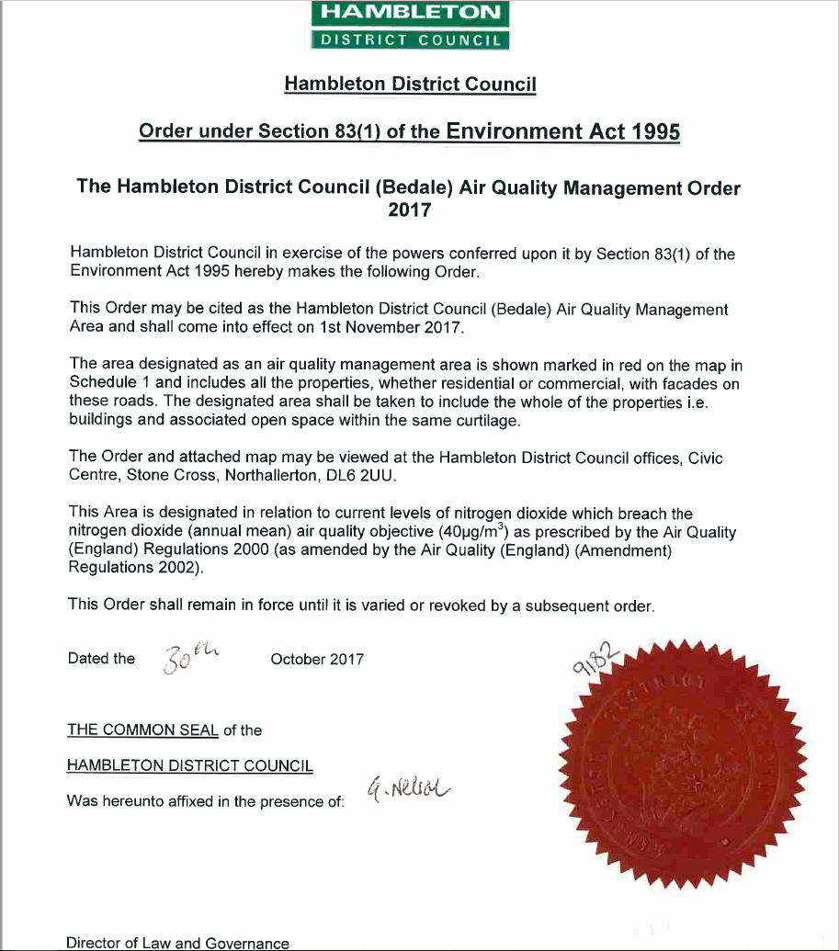

Changes in Two-Way Average Weekday 12-Hour Traffic
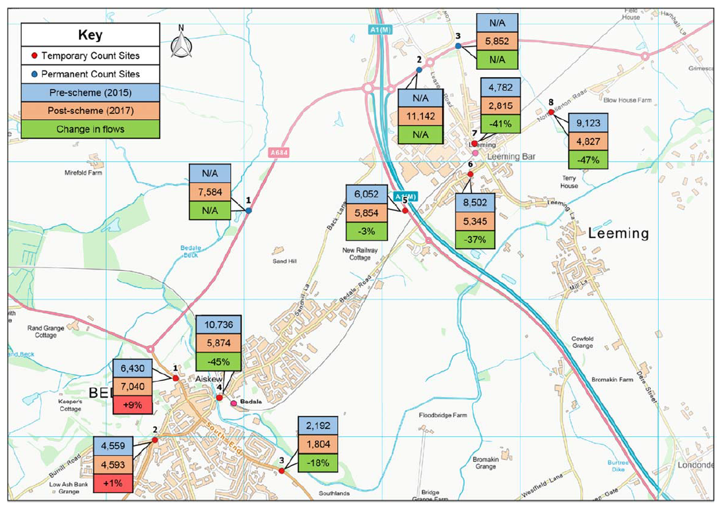
QA/QC of Diffusion Tube Monitoring
All the Council’s diffusion tubes are supplied and analysed by Socotec UK Ltd, (formerly ESG), the analysis branch of AEA Technology at Didcot, Oxfordshire.
The laboratory prepares the tubes by spiking with acetone: triethanolamine (50:50) onto the grids prior to the tubes being assembled. The tubes are desorbed with distilled water and the extract analysed using a segmented flow auto-analyser with ultraviolet detection.
Socotec UK Ltd perform NAMAS accredited testing under the UKAS scheme, and also participate in the AIR NO2 PT intercomparison scheme and currently hold the highest rank of ‘satisfactory’ laboratory (see AIR PT laboratory performance table, below). The laboratory also follows the procedures set out in Defra’s ‘Diffusion Tubes for Ambient NO2 Monitoring: Practical Guidance’, otherwise known as the Harmonisation Practical Guidance.
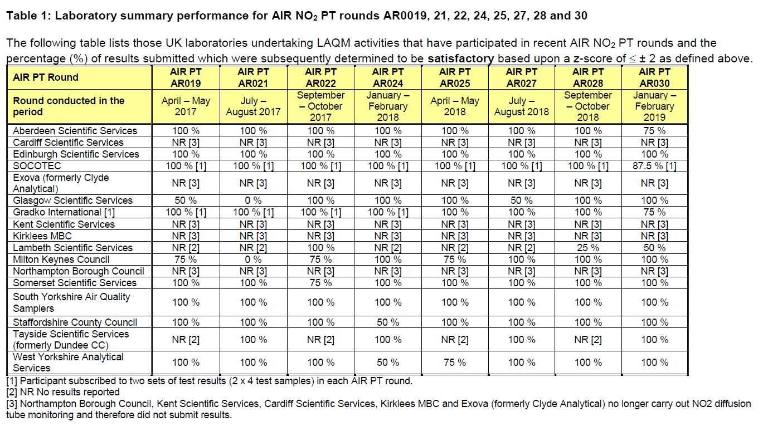
QA/QC of Automatic Monitoring
Logging of Data
The recording of data is carried out by the Envidas data logger installed in the air quality laboratory every 15 minutes. The data logger also controls the operation of the daily auto-calibrations and monitoring the operational status of the analysers. The data is collected, averaged and stored in the logger and then transferred to the Enview software over telephone networks. The data from the analyser is converted into voltages by the logger and converted back into data by the Enview software.
Analyser Calibration
NOx
The calibration of the analysers is carried out daily, fortnightly and six monthly. The analyser carries out an automatic internal calibration on a daily basis. Gas of a known concentration is passed through the analyser; the analyser obtains a reading, registers any drift away from the known values and obtains a correction factor which can be applied to the data accordingly.
The gas consists of a span gas of a specified concentration, supplied by BOC. The zero air generator fitted in November 2010 was replaced with a Purafil zero scrubber in February 2018.
The calibration checks carried out manually consist of a daily check of the data in the Enview software and a fortnightly visit to the air quality unit where the analyser is checked to ensure correct functioning. All details of these visits are recorded on a spreadsheet and sent to Geoff Broughton/Envitech Europe Ltd.
The analyser is serviced every six months to ensure correct functioning of the instrument and to correct any drift away from the known values of the span gas and zero air generator. The analyser is also cleaned, leak checked and recalibrated.
PM₁₀
Hambleton District Council ceased monitoring PM₁₀ at the end of February 2016 and therefore no data or information on QA/QC is presented.
Data
All data from the air quality unit is managed by Geoff Broughton/Envitech Europe Ltd via remote telemetry. Data and calibration records are checked twice a day assessing the real time data over the previous 24 – 48 hours and the daily calibration results. Then a daily check of the following data parameters is also carried out, pollution parameters, meteorological parameters, diagnostic parameters, daily calibration results and the calibration results for analyser stability and all correction for auto scaling data.
The data is released as validated scaled data every 3 months.
The council closed down the automatic analyser at the end of December 2018 for financial reasons and therefore no further NO2 monitoring data is available.
Diffusion Tube Bias Adjustment
Factor from Local Co-location Studies
Hambleton determines its own bias correction factor by co-locating three identical diffusion tubes at the same site as a chemiluminescent analyser. All three tubes are changed on a monthly basis and the results compared to the same monitoring period recorded by the chemiluminescent analyser. The results that are compiled over the course of a year can then be used to determine an annual mean concentration. These figures can then be used in a simple calculation to determine the bias correction factor. The calculation is shown below.
The mean diffusion tube concentration, Dm, is 21.5µg/m³ and the chemiluminescent mean concentration, Cm, for the same period is 18.0µg/m³. Using these results, the bias adjustment factor A can be calculated as follows:
A = C_{m} / D_{m}
If and Cm = 18 and Dm = 21.5
A = 18 / 21.5
then
0.83
Therefore, the bias adjustment factor, A is
This factor can then be applied to all the other diffusion tubes in the district and the results adjusted accordingly.
The diffusion tube bias B can also be calculated. This is simply the bias expressed as a percentage relative to the chemiluminescent analyser results.
B = (D_{m} – C_{m}) / C_{m}
If and Cm = 18 and Dm = 21.5
B = (21.5 – 18) / 18
then
0.194
Therefore, the bias adjustment factor B is
In other words, the diffusion tubes are over-reading by 19.4%.
Diffusion Tube Bias Adjustment Factors
The laboratory co-location study at their Marylebone kerbside site for 2018 gave a bias factor of 0.92, although the combined bias factor on the national bias adjustment factor spreadsheet (version 03/19) is listed as 0.76 for the 50% acetone tubes analysed by Socotec Didcot.
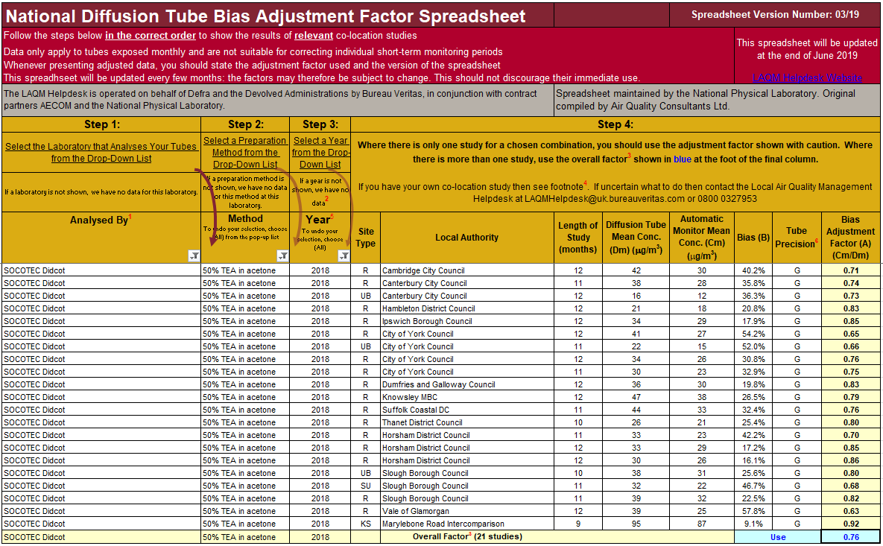
The results from the Hambleton DC survey for 2018 have been assessed for precision using the AEA Energy and Environment diffusion tube spreadsheet, copy below. The diffusion tube results show good precision overall and the automatic monitor also shows good precision overall.
Discussion of Choice of Factor to Use
The Council’s bias adjustment factor of 0.83 in 2018 is lower than the factor generated in 2017 (0.94), however is more in line with previous years. This is likely to be due to the 2018 data for the diffusion tubes and automatic analyser showing good precision, whereas the 2017 data had two periods of poor precision for the automatic analyser and one period of poor precision for the diffusion tubes. The Hambleton factor for 2018 is also lower than the analysing laboratory’s (Socotec Didcot) Marylebone comparison site factor of 0.92, which is higher than previous years, possibly due to their survey only having 9 months of data compared to the Hambleton site having 12 months of data.
The decrease in bias adjustment factor, most likely due to 2018 data showing good precision, is considered valid and Hambleton District Council therefore has confidence that the bias adjustment factor of 0.83 can be relied upon for inclusion in this year’s annual status report.
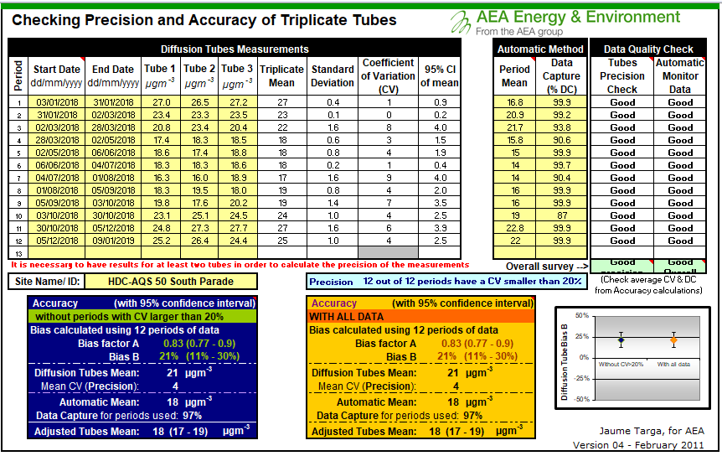
NO2 Fall-Off with Distance Calculator
The council has used the Bureau Veritas calculator, version 4.2, to derive NO2 concentrations at locations relevant for exposure. An example of the single tube calculator is shown below.
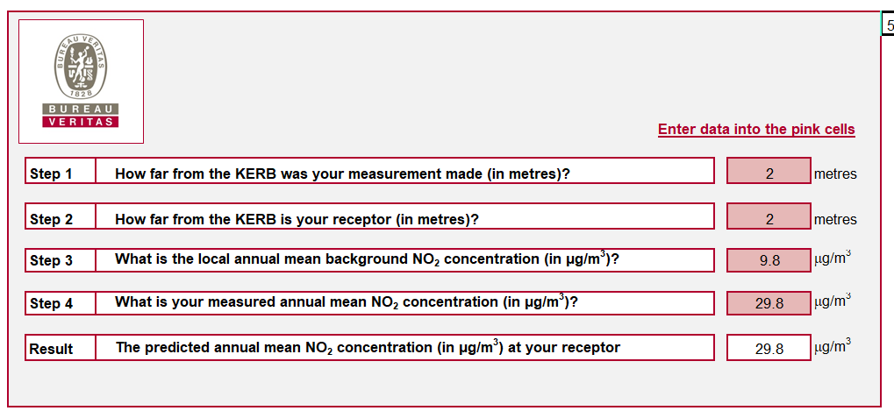
Diffusion Tube Monitoring Sites HDC53 to HDC57
Diffusion tube monitoring sites HDC53 to HDC57 located in Northallerton were deployed in November 2018 and therefore only 2 months of data is available. In line with TG(16) annualisation wasn't performed at these five sites due to the data capture for 2018 being less than 25% and no annual mean has been calculated.

Appendix D: Map(s) of Monitoring Locations and AQMAs
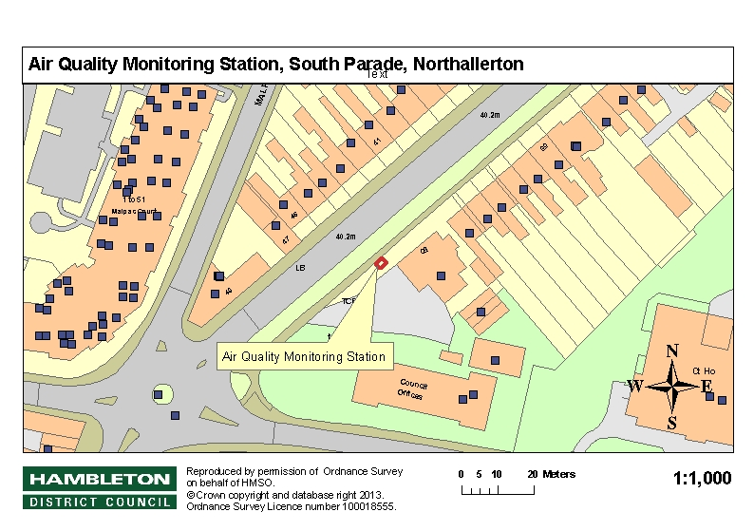

Figure D.1 Map of Automatic Monitoring Site

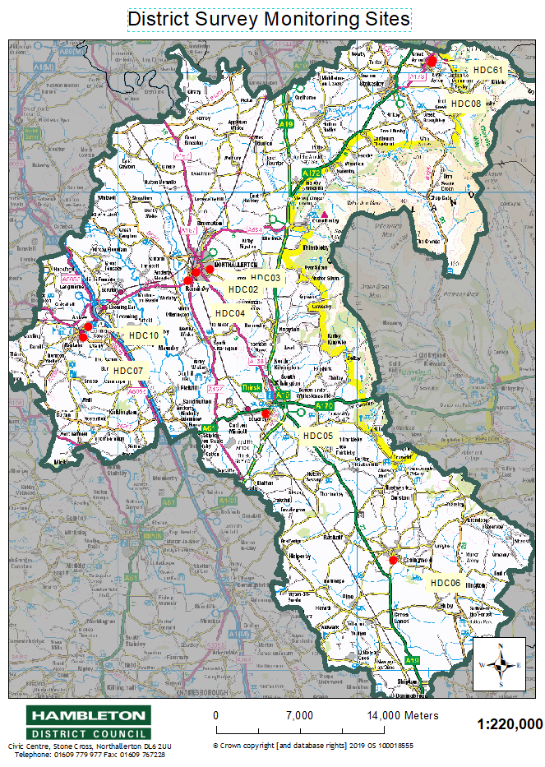

Figure D.2 District Survey Monitoring Sites
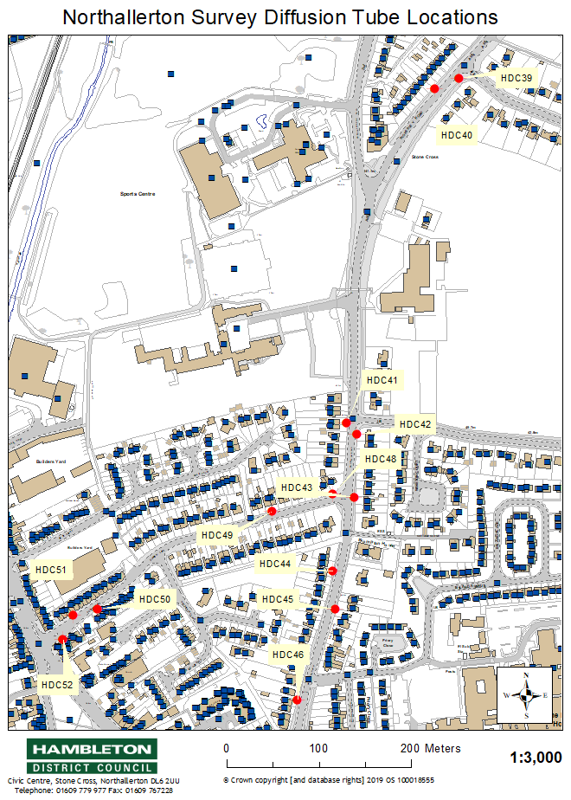

Figure D.3 Northallerton Survey Monitoring Sites
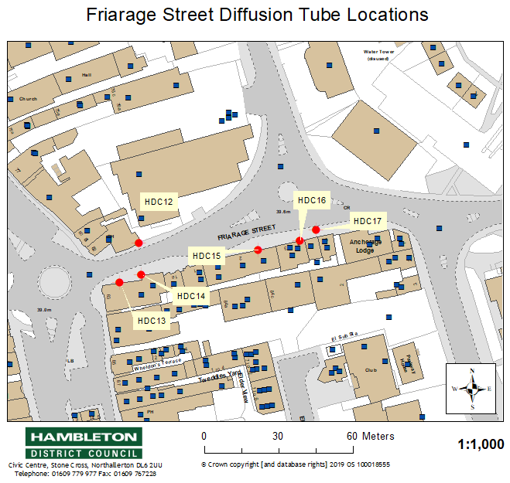

Figure D.4 Friarage Street Survey Monitoring Sites

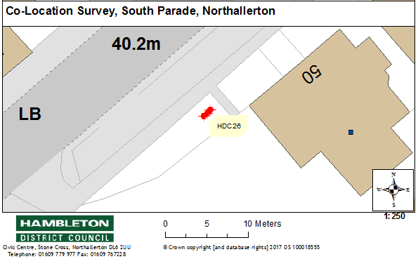

Figure D.5 Co-Location Survey Monitoring Site

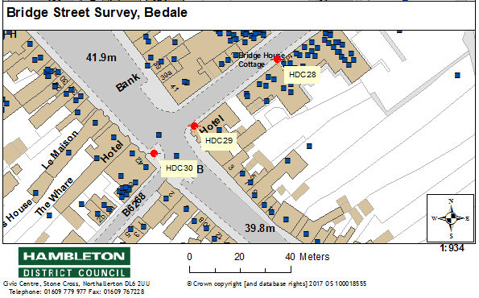

Figure D.6 Bedale Survey Monitoring Sites

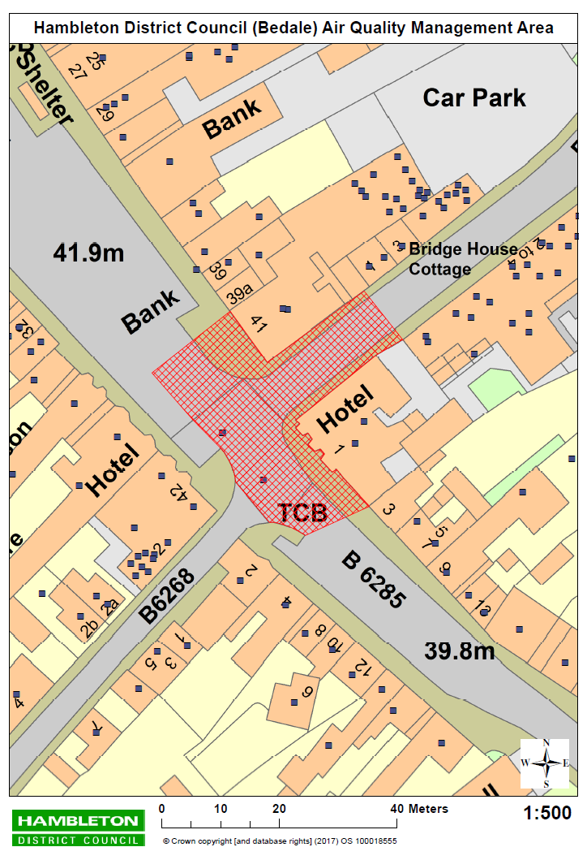

Figure D.7 Bedale Air Quality Management Area

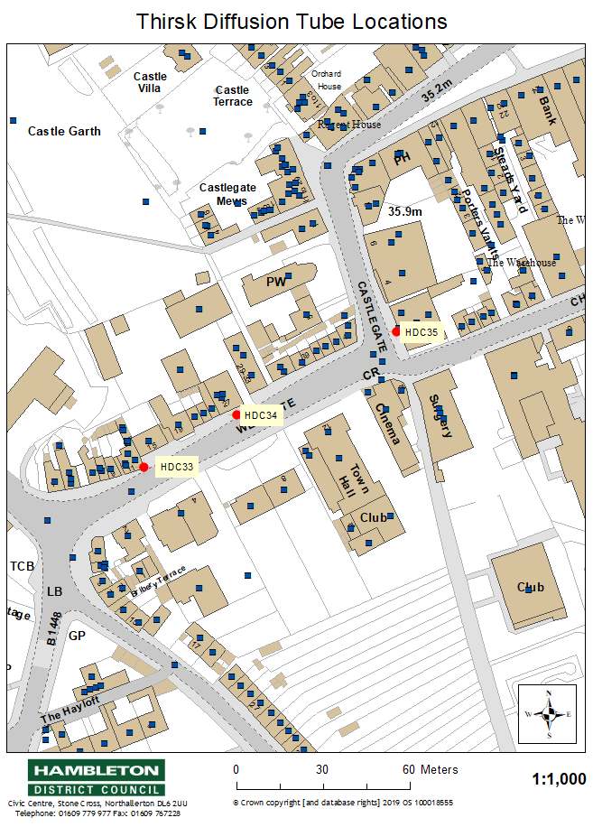

Figure D.8 Thirsk Survey Monitoring Sites

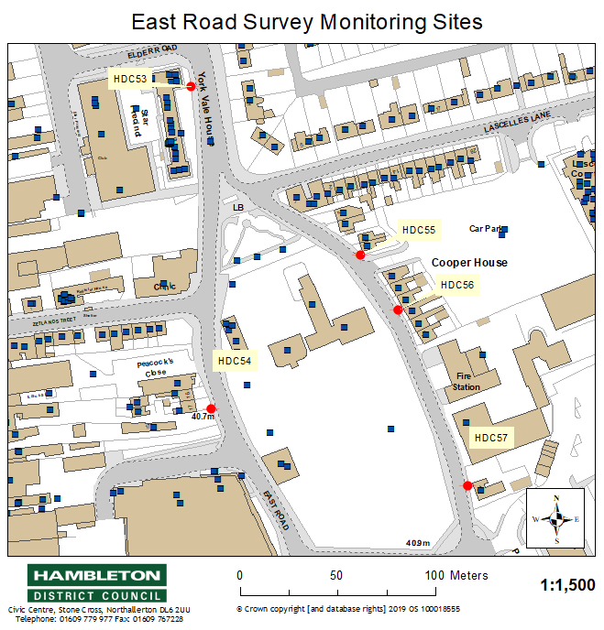

Figure D.9 East Road Survey Monitoring Sites

Appendix E: Summary of Air Quality Objectives in England
Table E.1 Air Quality Objectives in England
Pollutant | Air Quality Objective
 | Concentration | Measured as
Nitrogen Dioxide (NO₂) | 200 µg/m³ not to be exceeded more than 18 times a year | 1-hour mean
 | 40 µg/m³ | Annual mean
Particulate Matter (PM₁₀) | 50 µg/m³, not to be exceeded more than 35 times a year | 24-hour mean
 | 40 µg/m³ | Annual mean
Sulphur Dioxide (SO₂) | 350 µg/m³, not to be exceeded more than 24 times a year | 1-hour mean
 | 125 µg/m³, not to be exceeded more than 3 times a year | 24-hour mean
 | 266 µg/m³, not to be exceeded more than 35 times a year | 15-minute mean

Glossary of Terms
Abbreviation | Description
AQAP | Air Quality Action Plan - A detailed description of measures, outcomes, achievement dates and implementation methods, showing how the local authority intends to achieve air quality limit values’
AQMA | Air Quality Management Area – An area where air pollutant concentrations exceed / are likely to exceed the relevant air quality objectives. AQMAs are declared for specific pollutants and objectives
AQMS | Air Quality Monitoring Station
ASR | Air quality Annual Status Report
BALB | Bedale, Aiskew, Leeming Bar Bypass Scheme
Defra | Department for Environment, Food and Rural Affairs
DMRB | Design Manual for Roads and Bridges – Air quality screening tool produced by Highways England
EU | European Union
FDMS | Filter Dynamics Measurement System
HDC | Hambleton District Council
LAQM | Local Air Quality Management
NO₂ | Nitrogen Dioxide
NO_{x} | Nitrogen Oxides
NYCC | North Yorkshire County Council
PM₁₀ | Airborne particulate matter with an aerodynamic diameter of 10µm (micrometres or microns) or less
PM_{2.5} | Airborne particulate matter with an aerodynamic diameter of 2.5µm or less
QA/QC | Quality Assurance and Quality Control
SO₂ | Sulphur Dioxide
TEOM | Tapered Element Oscillating Microbalance
VCM | Volatile Correction Model

References
Department for Environment Food and Rural Affairs, Part IV of the Environment Act 1995, Local Air Quality Management: Technical Guidance LAQM.TG(16), DEFRA, London, 2016.
Department for Environment Food and Rural Affairs, Part IV of the Environment Act 1995, Local Air Quality Management: Policy Guidance (PG16), DEFRA, London, 2016.
Hambleton District Council, Air Quality Review and Assessment, Annual Status Report, June 2018.
Hambleton District Council, Air Quality Action Plan, October 2018.
Hambleton District Council, Local Development Framework Development Plan Document – Core Strategy, April 2007.
Jacobs Consultancy Ltd, Bedale, Aiskew and Leeming Bar Bypass One Year After Report, June 2018.
North Yorkshire County Council, Local Transport Plan (LTP) 4, February 2016.
Public Health England, Public Health Outcome Framework (PHOF) data tool, 2017.

Environmental equity, air quality, socioeconomic status and respiratory health, 2010
Air quality and social deprivation in the UK: an environmental inequalities analysis, 2006
Defra. Abatement cost guidance for valuing changes in air quality, May 2013
The units are in microgrammes of pollutant per cubic metre of air (µg/m³).

